FOR IMMEDIATE RELEASE
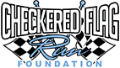
July 31, 2014

Media Contact
Lynn Austin
Cell: 480.442.3496
Email: info@austingroupconsulting.com

Checkered Flag Run Foundation Delivers School Readiness with its 2nd Annual Phoenix Tools 4 School Program
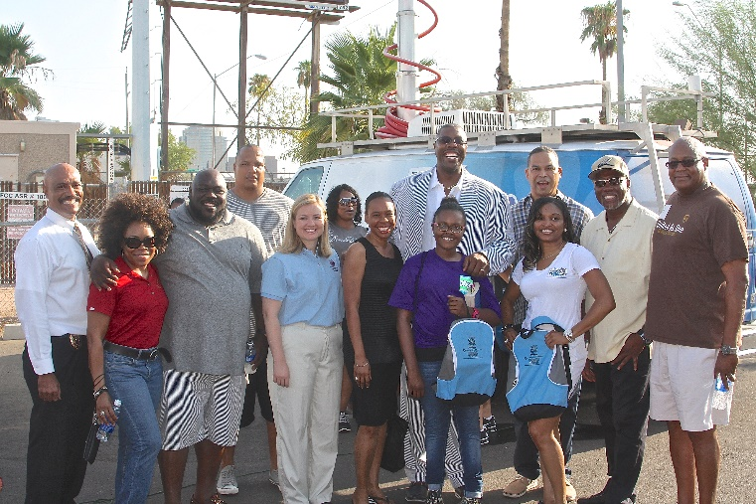

City of Phoenix Assistant to the Chief of Police, Gerald P Richard, II Esq., Deputy Aviation Director, Marchelle Franklin, Actor/Comedian, Faizon Love, Entrepreneur & CFRF Founder, Alan “AP” Powell, District 8 Councilwoman, Kate Gallego, Arizona State Senator, Leah Landrum Taylor, Dealership Owner, Alvin “Big Al” Heggs and daughter, University of Phoenix CFO, Byron Jones, CFRF President, Teniqua Broughton, Maricopa County Supervisor Candidate, Michael Johnson, UPS HR Division Manager, Carl Wesley.
Photo courtesy Michael Kelly.

With 2000 backpacks on hand and crowds lining the building beginning at 4:45AM, backpacks filled with schools supplies were distributed to every K-8 child present. Additionally, the CFRF school readiness initiative served more than 650 meals, and just under 100 haircuts and styles to further investment in educational opportunities that have a positive impact on educational attainment.
###

About Checkered Flag Run Foundation
The Checkered Flag Run Foundation is a charitable organization that serves to make available school readiness tools for elementary and middle school students, career educational resources such as career inventory assessment/workshops as well as college scholarships in 2015 for high school students to close the gap, and increase educational attainment beyond a high school diploma. In 2014, we plan to serve over 2,000 students in two of four of our programs in K-12 schools.

About Tools 4 School
Tools 4 school provides basic school readiness supplies for students whose families cannot afford any or all the necessary items to start off the school year. The initiative provides students with book bags, notebooks, writing utensils and other necessary supplies.

