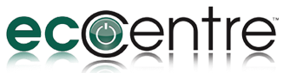
Capabilities Statement
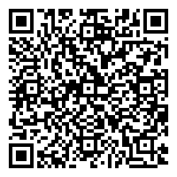

ESTABLISHED: 2010
LOCATION: 6220 River Crest Dr.
Riverside, CA 92507
EIN: 27-4198719
DUNS: 071730693
CAGE: 71AT5

MBE 14010091

NAICS
- 97514 Automobiles
- 07092 Vans/Cargo
- 07093 Vans, Personnel
- 42311 Automobiles

CONTRACT VEHICLES
CA Public Utilities
Metropolitan Water District

Background
Alvarez Electric Motors Company doing business as EcoCentre.us is a minority -owned small electric vehicle distributor located in Riverside, California. We have distributed and sold electric cars, trucks and vans for four years.

Core Competencies
- North and South American distribution rights for the Wuling family of electric vehicles
- Sales and servicing of our 100% electric vehicles
- Local parts depot established

Qualifications and Credentials
- Principal has been in the automotive business for more than 33 years, representing high end domestic OEMs.
  - Has served as President of several automotive related boards
    - Appointed to the California New Motor Vehicle Board by Gov. Arnold Schwarznegger and re-appointed by Governor Edmund G. Brown.
    - California Hispanic Chamber of Commerce
    - Lincoln Marketing Association for California
    - Chairman of the Lincoln Mercury Dealer Association
    - Ford Motor Company Minority Dealer Association
- Letter of satisfaction from the City of Riverside

Differentiatiors
- Full range of products
  - Eco-E, a two - seater car, with removeable doors
  - Eco-Van, a six - seater passenger or cargo van configuration
  - Eco-Truck, a two - seater flatbed truck with payload capacity of ½ ton
  - All with 110 voltage charging capacity

COMPANY CONTACT: Michele De Veaux|| EMAIL: Michele@ecocentre.us ||
TEL: 951.653.1200
VISIT US ONLINE: www.ecocentre.us

