COM610

Integrated Marketing Plan

Prepared for:
Riverside Community College District Board of Trustees

Prepared by:
Lauren Bishop

October 27, 2012

Table of Contents

INTRODUCTION LETTER………………………………………………………………………………………………………………….3
EXECUTIVE SUMMARY…………………………………………………………………………………………………………………4
1. SEGMEMT ONE……………………………………………………………………………………………………………………..5
1.1 Mission Statement…………………………………………………………………………………..………….…..5
1.2 Corporate Objectives……………………………………………………………………………………….………6
1.3 Marketing Audit………………………………………………………………………………………………….……8
A.) External……………………………………………………………………………………………….….8
B.) Internal………………………………………………………………………….……………………….10
1.4 Market Overview…………………………………………………………………………………………………….11
1.5 SWOT Analysis………………………………………………………………………………………………………...12
2. SEGMENT TWO………………………………………………………………………………………………………………….…14
2.1 Assumptions………………………………………………………………………………………………………….…14
2.2 Marketing Objectives……………………………………………………………………………………………...15
3. SEGMENT THREE……………………………………………………………………………………………………………….…15
3.1 Strategies and Expected Results………………………………………………………………………….…..15
3.2 Budget………………………………………………………………………………………………………………….….18
4. SEGMENT FOUR…………………………………………………………………………………………………………….…….19
4.1 Evaluations and Monitoring………………………………………………………………………………….….19
References………………………………………………………………………………………………………………………………………23

2

Introduction Letter

Lauren Bishop
COM610
October 27, 2012

Board of Trustees
Riverside Community College District
Riverside, California

Greetings Members of the Board:
It is my distinct pleasure to introduce myself, Lauren Bishop, as an alumnus of Riverside Community College, class of 2007. The purpose of this letter is to acquaint you with the succeeding document.
As graduate student at National University, and candidate for the Master’s degree in Strategic Communications, I have developed a marketing plan for the expansion of Riverside Community College’s current cosmetology program into a multiple license offering beauty school. As someone who values higher education, and will go on to train for an international career in the beauty industry, I am focused on bringing this same opportunity to individuals in the Inland Empire, specifically high school students seeking an alternative route into college. By expanding RCC’s current cosmetology program into a multi functioning school, the college will generate more opportunities for career training in the beauty industry, while increasing their current marketing segment to include individuals who may not otherwise have chosen to attend, due to a lack of interest in only one program.
Therefore, it is my hope that the included marketing plan will serve as a productive starting point into the planning, development, and launching of the aforementioned school. Thereby, adding to the rich diversity of high quality education, offered by Riverside Community College District.

Respectfully,
Lauren Bishop
3

Executive Summary
I, Lauren Bishop, am a graduate student at National University. My mission is to offer individuals, specifically high school students living within the Inland Empire a broader selection choice in career training options, while simultaneously providing a gateway into college and the opportunity to pursue higher education. In order to achieve this goal, I have enclosed a marketing plan for the expansion of Riverside Community College’s current cosmetology program into a multiple licensing beauty school that offers basic, advanced, and international certification in all applicable skill areas of beauty industry careers. The planning, development, and implementation of this school will transpire in the city of Riverside, California, upon approval from the Board of Trustees of RCCD; of which then marketing efforts will expand reach to surrounding school districts within the Inland Empire. To guarantee consistent ROI and continual fulfillment of marketing objectives, plans include the outline for a partnership occurrence between the beauty school and surrounding school districts to create basic beauty academies within participating high schools. From these academies, qualifying seniors will sign e-enrollment agreements with the beauty school to begin their beauty coursework at the fall semester start date. All efforts will be evaluated and revised whenever necessary to achieve objectives.
The following provides a technical outline of the content of this report. First, I have included a prospective mission statement and set corporate objectives of RCC’s beauty school. Next, I have presented findings from a marketing audit, market overview, and SWOT analysis. Based on current assumptions surrounding the demographics in Riverside, California, and growth opportunities in the beauty industry, I have clarified marketing objectives. Finally, this report includes strategies, an estimate of expected results and budget, and suggestions for evaluation and monitoring. A project schedule timeline can be viewed in the attached document.

4
Segment One
1.1 Mission Statement

Riverside Community College’s beauty school is a multi-licensing program encompassing all areas of the beauty industry including: cosmetology, esthetics, makeup artistry, massage therapy, and nail technician services. We offer both basic and advanced courses, as well as the international certification, ITEC. (www.itecworld.co.uk). As a professional program within the college, we are nationally accredited by both ACCJC/WASC and the NACCAS for cosmetology arts and sciences. Thus, students have the opportunity to earn both a professional certificate and an Associate’s degree in Beauty Therapy. Students, who wish to pursue higher education after graduation may sign a TAG agreement (Transfer Admissions Guarantee) midway through their course work, to ensure placement into a partnering four year university or college.
Riverside Community College’s beauty school is unique in that it has partnered with many outlining school districts to create basic beauty academies within surrounding high schools. Students who maintain the necessary academic standards may sign an e-enrollment agreement with RCC’s beauty school, prior to high school graduation to begin beauty classes at the semester start date. Priority enrollment will first be given to high school academy graduates, and then to the public.
As a leader in beauty education we remain nationally competitive by keeping informed on the most current industry and professional trends, and updating our curriculum to meet those standards. Our students are trained in both classrooms and on sight clinics, by means of highly acclaimed products and internationally revered faculty. We maintain numerous memberships in professional organizations, and hold partnerships with premier resort spas and salons in Southern California, for the purpose of student externships and potential job placement. In addition, students are taught to value their community by participating in outreach events put on by the college and school. Graduates are adequately prepared to pass the state exam.
Ultimately, Riverside Community College’s beauty school is committed to the success of people. By offering another route into higher education through the culmination of career skills, we hope to change the quality of lives for individuals in the Inland Empire.

5
1.2 Corporate Objectives
- To expand the range of influence of Riverside Community College as an institution choice for the pursuit of higher education, by marketing to high school students in the Inland Empire interested in obtaining skill set(s) necessary for careers in the beauty industry.
- To partner with surrounding school districts to create basic beauty academies within participating high schools.
- To provide qualifying students within high school beauty academies the opportunity to sign e-enrollment agreements with the beauty school.
- To offer courses in all aspects of the beauty industry including: cosmetology, esthetics, makeup artistry, massage therapy, and nail technician services.
- To offer multiple certifications within the school including basic, master, and international
certification.
- To offer qualifying college students the option of signing a TAG agreement (Transfer Agreement Guarantee) prior to graduation, for the purpose of pursuing higher education at partnering colleges or universities.
- To maintain a competitive curriculum by input of the school’s advisory board, industry trends, and
state exam requirements; and, by requiring all teachers to maintain continuing education in their respective field by attending seminars, conferences, and/or other informative industry events.
- To maintain a diverse learning environment by instructing students in both classrooms and
professional clinics. Students will complete all theory hours in the classroom before moving into the clinic to begin practicum training.
- To create a rich learning experience by inviting guest presenters, and scheduling applicable field
trips. 6
10.) To establish business to business (B2B) networks with product distribution companies, for both
the products to be used in training, and sold in the professional clinic.
11.) To establish business partnerships with premier resort spas and salons in southern California for
the purpose of student externships and possible job placement services.
12.) To cultivate an attitude within the school that values community, by developing and implementing
industry related community outreach events, and by encouraging students to participate in other
events put on by Riverside Community College District.
13.) To maintain a presence within the Associated Student Body of RCC by electing a student council to
represent the beauty school at senate meetings, should the need arise to make funding requests.
14.) To ensure all applicable students are prepared to pass the state exam by offering mock board
exams for both the written and practical tests.

7
1.3 Marketing Audit / A. External Marketing Audit
Riverside County, California:

- County population in July 2009: 2,125,440
Urban population: 93%
Rural population: 7%
- Males: 769,384 (49.8%)
- Females: 776,000 (50.2%)

- Average household size: Riverside County: 3.0 people
- Median resident age: 33.1 years

- Estimated median household income in 2009: $55,352

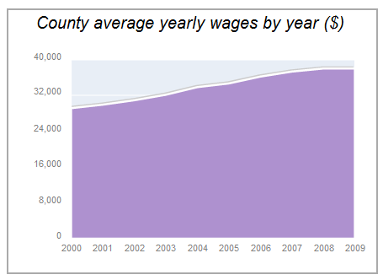

- Unemployment in Apr. 2010: 14.1%
- Compared to the California state average: 12.3%
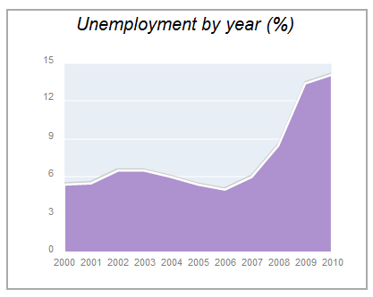
8 (City-data.com/county/Riverside-CA.html)
Educational Attainment of Adults 25 years and older for select cities in the Inland Empire:
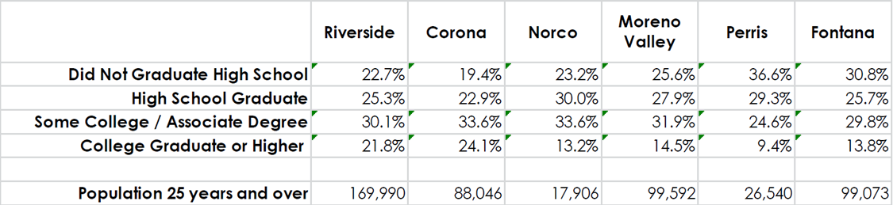
(American Community Survey, 2005-2009 American Community Survey 5-Year Estimates, www.census.gov.)
Population growth for select cities in Riverside County:
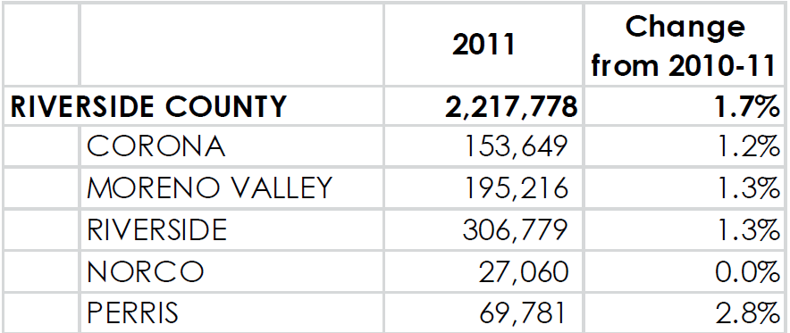
(State of California, Department of Finance, E-1 Population Estimates for Cities, Counties and the State with Annual Percent Change— January 1, 2009 and 2010. Sacramento, California, May 2011.)

Other External Factors relating to the Inland Empire:
- By 2015…about a million more people will live there than in 2005. The Inland Empire will retain its status as the fastest-growing region in Southern California.

• Between 2004 and 2015, the number of jobs in the Inland Empire is expected to grow 28 percent,
outpacing job growth statewide (20%). But population gains will outstrip job gains.

- The share of Inland Empire adults with less than a high school diploma (22.1%) will exceed the share of jobs available for workers at that education level (17.7%).
(Public Policy Institute of California.org)
9

B. Internal Marketing Audit
The following school districts are considered feeder districts to Riverside Community College District:
- Alvord, Corona-Norco, Jurupa, Riverside, Moreno Valley, Val Verde
(Rcc.edu)

The following graph depicts RCCD feeder high school graduates 2003/04-2008/09:

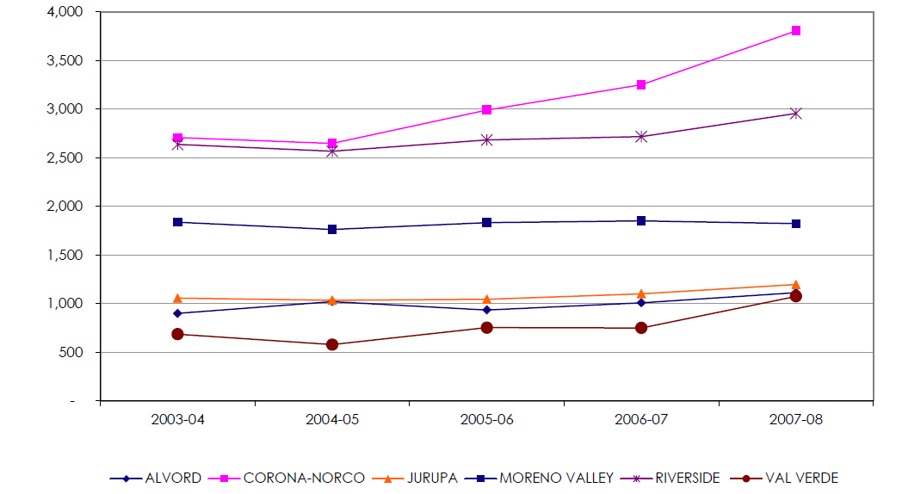
(California Department of Education DataQuest webpage; http://data1cde.ca.gov/dataquest)
Facts:
Capture Rate is the percent of recent high school graduates from a service area who are 19 years and under and attending Riverside Community College during the fall term for the first-time. High school districts in RCCD’s service area include Alvord, Corona-Norco, Jurupa, Moreno Valley, Riverside and Val Verde. As of 2009 RCCD’s capture rate was 26.3 %. (cpec.ca.gov)

As of 2010: 31% of RCCD student were under the age of 20
36% were between the ages of 20-24
67% of students made up RCCD’s program based subtotal
The cosmetology program had a 97.7% retention percentage rate (Rcc.edu)

10

1.4 Market Overview

Riverside Community College District houses three colleges at various locations within the Inland Empire, including Moreno Valley, Riverside, and Norco. City Averages are relatively equal of individuals who have either not completed a high school diploma, or who have, and/or have obtained some college education. Thus, Riverside Community College District recruits high school students from six districts in Riverside County, including: Alvord, Corona-Norco, Jurupa, Riverside, Moreno Valley, and Val Verde. Of these districts, the college’s capture rate consisting of individuals under the age of 19 who attend RCCD was 26.3% three years ago. The average income for households in this area of Riverside County is $55,352, suggesting that most students qualify for financial aid. And, population growth is expected to significantly increase in the Inland Empire, though resulting in an out-grow of job availabilities. Therefore, the addition of RCC’s beauty school will aid in providing individuals the opportunity to obtain career skills that are usable anywhere in the world.

11
1.5 SWOT Analysis
Strengths:
- Riverside Community College District’s geographical reach spans three locations that include all six feeder school districts.
- RCCD’s main location, Riverside City College is centrally located within the Inland Empire, thereby establishing itself as a logistically convenient college choice for high school students residing in the Inland Empire. Students do not have to obtain off campus housing, separate from their existing home.
- The average income for individuals in Riverside County is $55,352, suggesting that most students will qualify for Federal Financial Assistance.
- 67% of RCCD’s students account for their program based subtotal, with the cosmetology program boasting a 97.7% retention rate.

Weaknesses:
- Only about 30% of individuals residing in the Inland Empire over the age of 25 have achieved some college education or an Associates degree, thus suggesting that a college education is not deemed a priority within this region. Percentages are lower for college graduates and higher.
- Significant Funds will be required for the expansion of RCC’s cosmetology program into a beauty school, including: college building cost(s), new hires and curriculum costs for both RCC and school districts.
- Student externships with high end resort spas and salons will occur outside city boundaries, since Riverside only houses one location at the Mission Inn. This may not be convenient for all students.

Opportunities:
- With population growth expected to out-number estimated job availabilities, the beauty school offers the international certification ITEC, qualifying students to work as beauty therapist, makeup artists, cosmetologists, massage therapists, and nail technicians in 38 countries. Thus, students obtain a local education that can launch them worldwide.
- The opportunity exist for RCCD to increase college attendance rates in the Inland Empire, by expanding their penetration influence of an existing segment group e.g. - their six feeder high schools.
12
Threats:
- There are a number of beauty colleges within the Inland Empire who offer basic certification in cosmetology, esthetics, and nail technician services.
- There is a beauty school located in San Diego County that offers all of the same course listings as RCC’s beauty school, including a partnership with a college to obtain an Associates degree. However, the two schools are separate entities and students must obtain off campus housing for each.
- RCCD is experiencing a surge in applicants, thereby resulting in many students being waitlisted for general education requirement classes. This threat is applicable to students who wish to pursue an Associates degree in Beauty Therapy at RCCD.
- The beauty industry is still attempting to change the public’s perception of the field as providing credible and successful careers. Thus, it may be challenging to persuade school districts to align themselves with promoting the industry through the development of high school beauty academies, since high schools are primarily focused on promoting traditional four year colleges and universities.

13
Segment Two
2.1 Assumptions

With Respect to the Inland Empire’s demographics, it is assumed that:
- By 2015, only 35.1% of individuals living in the Northwest Region of Riverside County: [Riverside, Moreno Valley, Corona, Norco, and Perris] will have graduated high school, 31% will have some college education, and only 10.7% will have attained a Bachelors degree.
(www. ppic.org)
- As of present (2012), salary ranges for individuals in the city of Riverside are between $20,072 and $1,048,320, with the average being at $53,466. (salarylist.com)

With respect to the college’s geographical location, it is assumed that:
- The expansion of the college’s current cosmetology program into an a multiple license offering beauty school would influence residents, particularly high school students from Northwest Riverside County; since projected population growth for this region is 1,013,000 by 2015. (www.ppic.org)

With respect to the demand for Beauty and Wellness Professionals, it is assumed that:

- Employment in personal care and service occupations is anticipated to grow by 20 percent over the projection period, adding more than 1 million jobs.
- Skin care specialists will experience an estimated 38% growth
- Cosmetologists will experience a significant 20% increase
- Massage Therapists, Manicurists and Pedicurists employment is expected to grow by 19%
- Employment is expected to grow 17% for Make-up Artists
(US Department of Labor 10 year projections 2008-2018)

14
2.2 Marketing Objectives

- To increase the number of high school students who pursue a college education in the Inland Empire, by increasing RCCD’s capture rate from 26.3% to 30%.
- 50% of RCC’s beauty school enrollment will be filled from the segment group of graduating high school seniors at each fall semester start date.

Segment Three
3.1 Strategies and Expected Results

Possible Product Strategy:

- To meet the marketing objective of filling 50% of available enrollment openings from the targeted segment group, RCC’s beauty school will partner with surrounding school districts in creating basic beauty academies within participating high schools. Students who maintain the academic standards of the academy and other high school graduation requirements, will be given the option of signing an e-enrollment agreement prior to high school graduation, to begin coursework in a selected beauty licensing program at the college semester start date.

Expected Result:
- By partnering with surrounding school districts, Riverside Community College’s beauty school anticipates filling an estimated two thirds of their available seats. One third will be left open to public offering.

- Additionally, the school will host annual events to demonstrate the product of beauty education in action. For example, during “prom season” the beauty school will offer free hair, makeup, and manicures/pedicures to any high school student in the Inland Empire who is attending prom and in need of these services, particularly students from low income families.

15
Expected Result:
- By demonstrating the product of beauty education by way of offering free prom services, the beauty school establishes a known presence within the community, as well as positive relationships between parents and prospective students. It is expected that these two factors will combine to create dialogue in favor of the school, for both parents and students looking for a college/career choice.

Possible Price Strategy:

- To meet the marketing objective of filling 50% of available enrollment openings from the targeted segment group, RCC’s beauty school will partner with surrounding school districts to hold quarterly financial aid seminars at select high schools. Since a college education is associated with high tuition costs, presentations will include information on the following financial aid options:

The Board of Governors Fee Waiver (BOGW) Federal Supplemental Educational Opportunity Grant FSEOG
Pell Grant (FPELL) Federal Direct Loans
Cal Grants Alternative (Private) Loans
CHAFEE Grant Program Veterans Educational Benefits
RCCD Scholarships for High School Seniors RCCD Scholarships

Expected Result:
- By holding quarterly financial aid seminars at numerous high schools in surrounding districts, parents and students have multiple opportunities to receive information about affordable college funding. During these presentations, financial aid counselors from the college will be present to conduct FAFSA workshops, and answer any questions regarding financial aid. It is expected that any student who wishes to enroll in RCC’s beauty college will be able to do so, in terms of cost(s).

Possible Promotion Strategy:
- To meet the marketing objective of filling 50% of available enrollment openings from the targeted segment group, RCC’s beauty school will implement the following promotional phases :

16
*Phase 1: Upon completion of the school’s planning phase and the beginning of facility building- current students enrolled in RCC’s cosmetology program will participate in outreach events to surrounding school districts, to make quarterly presentations on the upcoming multi licensing school.

*Phase 2: During the final phase of building, faculty and counselors of the upcoming school will work with high school counselors and students to sign e-enrollment agreements to make up the inaugural class of RCC’s new beauty school.

*Phase 3A: Within a time period of three to five years from opening, RCC’s beauty school will have partnered with surrounding school districts to create basic beauty academies in participating high schools.

Phase 3B: Seniors who have successfully completed academic standards, both in and out of the academy, will be given the opportunity to sign e-enrollment agreements prior to high school graduation to begin beauty school classes at the college semester start date.

*Upon completion of phase 3A, promotion strategy will be updated to ONLY include phase 3B. Additionally, community outreach events will be conducted by the beauty school as a means to offer community assistance, and promote the school and overall awareness of the industry.

Expected Result:
- By conducting the promotion strategy in phases, RCC’s beauty school is taking a pro-active approach to filling available seats. By implementing phases 1–2, the school is expected to open with a full inaugural class, consisting primarily of recent high school graduates, and existing cosmetology students who were grandfathered in. By continuing the phase into 3A-3B, the school is expected to maintain steady enrollment, due to a direct feed from high school beauty academies.

Possible Place Strategy:
For many high school students in the Inland Empire, the option of pursuing higher education out of the area is not an immediate possibility, for various reasons. The only other academy to offer training comparable to RCC’s beauty school is located in San Diego County.

17
- Thus, to meet the marketing objective of filling 50% of available enrollment openings from the targeted segment group, RCC’s beauty school is conveniently located in the city of Riverside. It maintains both classrooms and on-sight professional training clinics at the Riverside City College location. Thus, students in surrounding cities may attend college without the added stress and cost(s) of off campus housing.

Expected Result:
- By housing classrooms and professional training clinics on-sight at Riverside City College, the beauty school is centrally located for individuals in surrounding cities. Thus, it is expected that more high school students living in the Inland Empire will pursue a higher education through the channel of RCC’s beauty school, due to its logistical convenience.

3.2 Budget

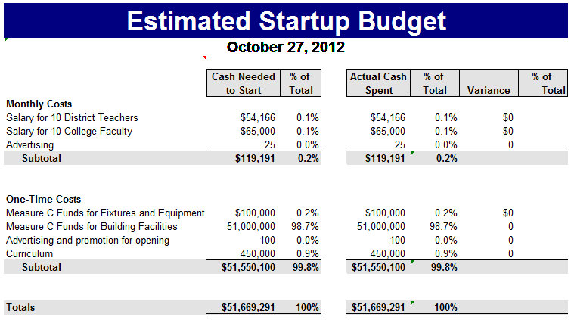

18
Segment Four
4.1 Evaluations and Monitoring
Product Strategy Measurement:

By developing high school beauty academies in surrounding districts in which qualifying students have the opportunity to sign e-enrollment agreements with RCC’s beauty school prior to graduation, the school anticipates filling 50% of its total enrollment goal from this segment, at the fall semester start date.

- Measurement will be accomplished through registration with beauty school counselors, in which each student’s e-agreement will be reviewed and confirmed during meeting and enrollment.

- Prior to enrollment, each prospective academy graduate will be buddied with a currently enrolled beauty school student in their area of study interest. The existing student will be responsible for calling the prospective student at the beginning of summer to inquire about any questions or concerns the student may have upon entering beauty school. Prospective students will also receive two emails from beauty school counselors: [1 immediately after graduation, and 1 towards the impending registration date] to remind them of registration, provide them a link to the school’s social media sites, and provide fun facts about the beauty industry to keep them excited and motivated throughout the summer.

- Finally, students will be invited to an open house prior to registration via email and email RSVP, in which they will have the opportunity to meet faculty and staff, meet with counselors to ask questions, and participate in free beauty services from differing programs of study, including: manicures, chair massages, basic facials, and eyebrow grooming. Students will also receive a gift bag of product samples, as well as information about the school, contact numbers, and a registration reminder!

- If the school fills its targeted enrollment percent by the fall semester start date, this will be determined an effective means of annual recruitment. If the school does not fill 50% of its available seats from students who signed and e-agreement, should the school extend enrollment agreements to other high school students who qualify but are not in an academy? Should a deadline be set for the registration of high school beauty academy graduates, such that if there are available seats after the deadline, registration will be open to the public? Should the school conduct a phone survey after enrollment close date to inquire why students who signed an e-agreement did not register for the fall?
19
Price Strategy Measurement:

- By holding quarterly financial aid seminars at numerous high schools in surrounding districts the beauty school anticipates increasing its pool of applicants by six times the amount: 6 districts.

Success will be measured in three stages:

1.) By the number of students and parents in attendance. A sign in table will be placed by each entrance for individuals to sign in by name of student(s) interested in receiving financial aid. Student(s) will also be asked to provide their email address and telephone number.

2.) By the number of students/parents in attendance who speak with a financial aid counselor following the presentation.

3.) By the number of students who fill out a FAFSA and apply for financial aid, using RCC’s beauty school code. Thus, the beauty school will receive student information and be able to match it to their own records as to whether or not this student participated in a financial aid seminar.

- The beauty school will determine if there is an equal ratio between the names of students who attended seminars and their completed FAFSA, in which case seminars will be deemed effective. If the school does not receive many FAFSA applicants from these students, perhaps the high school did not follow up in offering assistance to students in completing their application. Should the beauty school’s financial aid counselor contact seminar participants via their sign in information to confirm their understanding?

Promotion Strategy Management:
- By conducting initial promotion in phases the beauty school anticipates meeting their targeted goal of opening with an inaugural class in which 50% enrollment is from the segment of recent high school graduates.

- By continuing to offer e-enrollment agreements to high school beauty academy graduates the beauty school anticipates continuing this trend.
20
- By implementing community outreach events such as promoting the school at high school career days and college fairs, and offering free prom services, the school anticipates developing and maintaining relationships with prospective students, thus increasing client value and satisfaction.

Success will be measured by:
1.) The number of school invites in having the beauty school appear on career days and college fairs.
2.) The number of students who fill out an interest card at beauty school’s booth on career days and
college fairs.
3.) The number of high school students who attend the prom services event.
4.) The success of the enrollment goal of the inaugural class- If successful, the development of high
school beauty academies will be deemed productive. If unsuccessful, a focus group will form, and
inaugural promotion strategies will be reviewed and analyzed. Next steps will be based on
evaluations.

Place Strategy Measurement:

- By maintaining the beauty school, both classrooms and clinics, on site at Riverside City College, the beauty school anticipates filling 50% of its available seats from local high school graduates. Riverside City College is centrally located to many surrounding school districts in the Inland Empire, making it easy for recent graduates to attend college, and live at home in order to save on cost(s).

- Place strategy measurement will be confirmed by reviewing the address of beauty school applicants on their college application. Additionally, an entrance survey could be conducted to see if the location of the beauty school encouraged individuals to choose RCC’s beauty school over another, since it offers training competitive to the school in San Diego, and students may also take classes that count towards their Associates degree, simultaneously at Riverside City College.

21

Reporting of Evaluations and Monitoring:

- Confirm that faculty and staff report findings to advisory board.

- Confirm that advisory board is aware of findings to guide future marketing efforts and strategies.

- Report findings to currently enrolled students to receive feedback, since they are primary sources as to how marketing efforts affected them. Do the students have new ideas on how to market in the future based on their own experience?

- Share findings with surrounding school districts to refine marketing efforts between the districts and their students.

- Continue monitoring successful marketing campaigns of other competitors, and report relevant findings to faculty, staff, and advisory board.

22
References

- American Community Survey, 2005-2009 American Community Survey 5-Year Estimates, www.census.gov.

- California Department of Education DataQuest webpage; http://data1cde.ca.gov/dataquest)

- City-data.com/county/Riverside-CA.html

- Public Policy Institute of California.org

- Rcc.edu

- Salarylist.com

- State of California, Department of Finance, E-1 Population Estimates for Cities, Counties and the State with Annual Percent Change— January 1, 2009 and 2010. Sacramento, California, May 2011.

- US Department of Labor 10 year projections 2008-2018

- www.itecworld.co.uk

23

