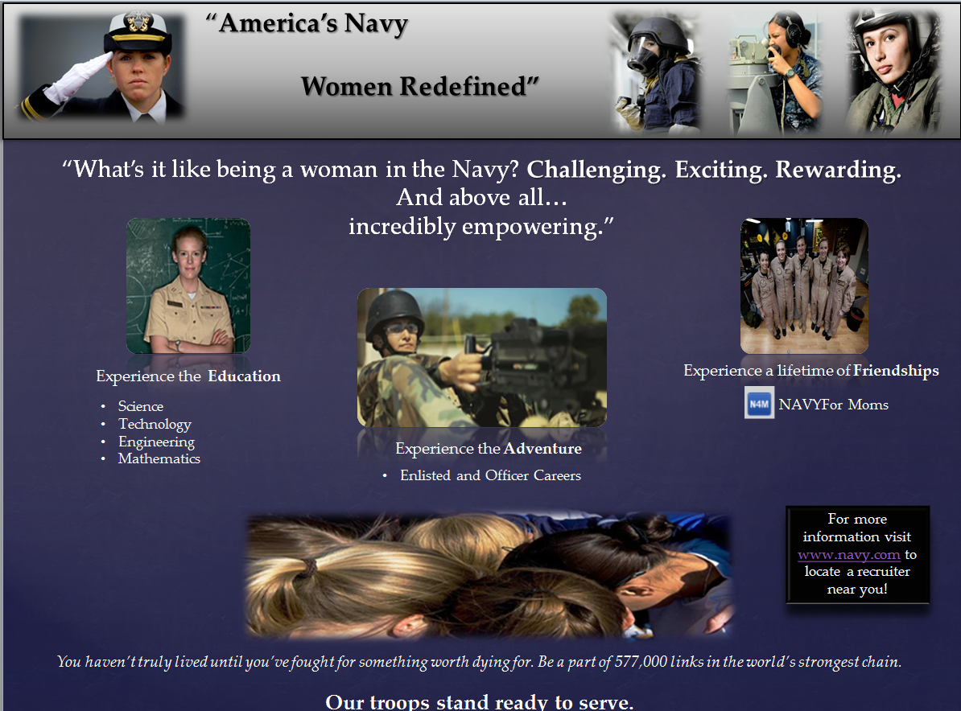
Family? Career? You can have it all.
With so many options to choose from and room to advance, being a woman in the navy means breaking the glass ceiling of your goals. The navy offers training, benefits, and competitive salaries. Reach your potential while making a difference in the world. Join the navy. It’s not just for men!
www.navy.com
Week Three Theory Based Print Ad and Rationale Chart
Group A: Kristina, Reisheid, Lauren
THEORETICAL RATIONALE: ELABORATION LIKELIHOOD METHOD-CENTRAL ROUTE
Target Audience:
Tenet 1: There are two ways to persuade: Through thinking and through feeling | This ad aims to persuade women to join the navy. Since it is a decision that will directly affect one’s life, career, education, family and future, it requires the use of cognitive decision making.
Tenet 2: The central route is one where people think, use cognition: 1) product is expensive; 2) complex; 3) difficult to attain; 4) unfamiliar. | The decision to join the navy or any military branch is not always an easy one. One must weigh various factors. First, expense is measured by one’s commitment. Joining the navy means enlisting for a set period of time. This is not a monetary sacrifice, but rather a sacrifice of self. Second, finding one’s fit within the navy can be a complex endeavor. One may want to research various position opportunities or boot camp expectations prior to enlisting, in order to reflect upon personal skill sets and likelihood to succeed in a military environment. Third, joining the navy means pushing one’s physical and mental limits. In any given situation, fear, fatigue, and/or stress may be present. It may be difficult to attain the courage, strength and focus needed conquer emotions and /or physiological responses in order carry out orders, execute a mission or simply press on. Finally, the navy may be full of experiences unfamiliar to one in various contexts including classroom exams, simulator drills, boot camp, living quarters, fitness and personal hygiene requirements, organizational expectations and respect to higher ranking officers, to name a few.
Tenet 3: The peripheral route is one where people are not motivated to think about the product, service, or idea because it is 1) inexpensive; 2) simple; 3) taken for granted – commodity; 4) easy to find; 5) familiar | Not Applicable to ELM Central Route.
Tenet 4: The central and peripheral routes require different strategies. | As this ad targets women who may be interested in joining the navy, it is assumed they will be willing to put forth the effort to engage in high elaboration. This would require maintaining attention, interest, comprehension, acceptance, motivation, and retention.

THEORETICAL RATIONALE: Message Factors: Source Credibility / Receiver Factor/ Message Factor
Target Audience:
- Research shows that this factor has an effect on persuasion. | According to Frymier and Nadler (2010) central processing controls the persuasive process when one is motivated to think about a message and has the ability to do so.  Motivation is influenced by five factors including personal relevance e.g. (how relevant the topic/message is to the receiver’s interest or goals), accountability, personal responsibility, incongruent information, and need for cognition.  A receiver demonstrates ability to process the ad by comprehending the message. This is influenced by numerous factors including message repetition, written format of the ad, and the amount of prior knowledge the receiver has about the navy.
- This ad incorporates this message factor in several ways: headline, graphic, first paragraph | This ad textually and visually displays a Message Factor for women who may be interested in joining the navy. Headlines, graphics, and first paragraph are utilized to aid to persuasion attempts.  Source Credibility: United States Navy  Receiver Factor: Ad inspires women to think about their future. It targets receivers who are both motivated to think about the content, and have the ability to do so; two factors necessary for central processing to occur (Frymier and Nadler, 2010).
- Why does this appeal work for this target audience? | Central processing works for this target audience because a decision to join the navy requires personal involvement. This topic targets receivers whose interests and goals align with both what the navy has to offer and what they can offer the navy. A decision to enlist will make individuals accountable to the consequences of that decision. In this case, accountability includes personal responsibility. Next, some of the information presented in the ad may be inconsistent with what one thought about the navy. For example, perhaps one didn’t know that so many opportunities exist for females in the navy. This new information may cause them to “consider the content of the message,” leading to a need for cognition (pg.191). According to Frymier and Nadler (2010) “Need for cognition refers to the desire or need to think and engage in information processing” (pg. 192). If a woman is drawn to this ad, she may feel the need or desire to engage in central processing for the purpose of gathering more information, or simply because she finds doing so enjoyable.

Frymier, A. B., & Nadler, M. K. (2010). Persuasion Integrating Theory, Research, and Practice (2nd ed.). Dubuque, IA: Kendall Hunt.

