10 Questions with Interior Designer Liz Caan

Caan tells us about getting inspiration from the subway and why people need to cool it with matching colors.
By Sarah Burke | Roost | February 28, 2014 6:30 am
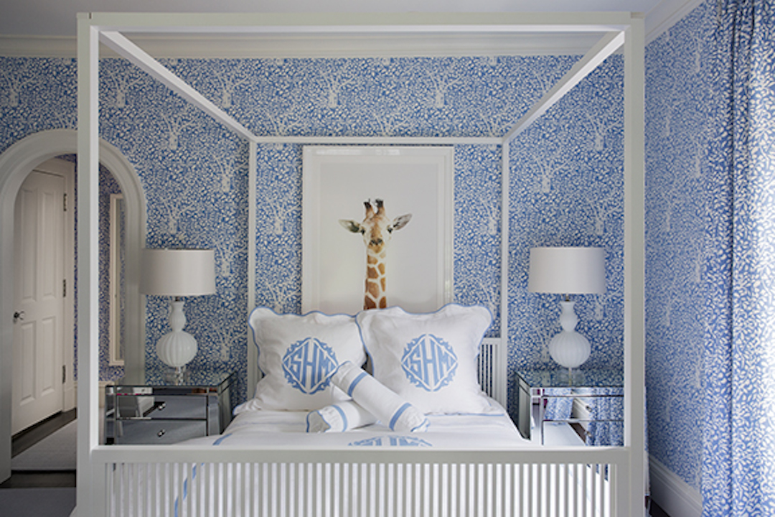
A colorful bedroom design by Liz Caan

Whether she’s on the T or gazing at a beautiful bouquet, Liz Caan finds inspiration all around her. With bold colors and lots of texture, Caan has an innate sense of creativity that she utilizes in all of her projects. We found out her tips and tricks for creating a beautiful, colorful space. Read on to find out.

1. What did you want to be growing up? Was design always in mind?
I was always building and creating. I grew up in an inspired place, so I wanted to be a hairdresser or design packages. Always something along those lines.

2. How did you get started in interior design?
I grew up in a brown, vanilla house. I always tried to make my room my sanctuary, and my parents let me do what I want. I did the same thing with my dorm room in college. I did some really crazy stuff like putting a bamboo tree on the wall over my bed. During my college years, I thought I would do something with computer graphics, then I thought marketing. Always something creative, though. It wasn’t until I moved here that I worked for a designer and learned the ropes.

3. Where are you from originally and how did you decide on Boston?
I was raised in Wisconsin in a small town 40 miles from Milwaukee. I went to school there, and I never wanted to go back. I tried Chicago and New York. And when my husband moved here, it was a chance to reinvent myself.

4. Where do you draw inspiration from now?
Everywhere! Fashion, children’s books, paper products, flowers, things I love. I pay attention, and subconsciously, I start to see patterns. I can be inspired by travel or even the fabric on a subway seat.

5. How did you develop your distinct, bold style?
It was not necessarily developed. It was sort of my base. I didn’t formulate it, it’s just what I liked. I get tons of inspiration from Tricia Guild, who is known for her use of color. I always gravitate to a colorful, bright place.

6. You’ve mastered beautifully bold and eclectic looks. What advice do you have for someone trying to create an eclectic space while still looking cohesive?
It’s hard, but you have to pay attention to color, proportion, and scale. There’s a recipe that needs to happen. Things play off of each other in color and texture, and it takes a while to learn to pay attention. There is no right or wrong, though. There are so many ways to do it. You could have the same five things and arrange them 100 different ways. Trust your gut. Be bold.

7. What do you find most challenging about interior design?
I feel the biggest challenge is that I want to bring in interesting, custom pieces for people, but the biggest barrier is the price tag. It’s difficult to execute different, brilliant designs and be creative as possible within constraints. I try to support local artisans while staying cost-effective. I would much rather get a piece made in Boston as opposed to one made overseas.

8. How do you blend your style with what your client wants?
I try to understand who they are and what they are like in their comfort zone. Then, I try to push them just a little outside their comfort zone because that’s why they called me. I give them what they want, it just goes through my filter. That is what makes it fun and challenging is the problem solving. I give clients what they want but take them to a place they have never been.

9. How can people get the most bang for their buck?
I look to vendors who appeal to a broad array of clients. Vendors with high style and good quality in the client’s price range. I also up-cycle. Buy something, like a table, and have it wrapped in linen. Up-cycle.

10. What is a DIY mistake you see too often?
People have an obsession with matching! It’s not interesting when it’s too coordinated. The color swatches have to match the pillows, which have to match the couch. It doesn’t have to be exactly the same. Personality is needed.

