On the Market: 201 Hinckley Road, Milton

Old English charm meets a highly sought neighborhood in this new listing.
By Sarah Burke | Roost | March 6, 2014 6:24 am
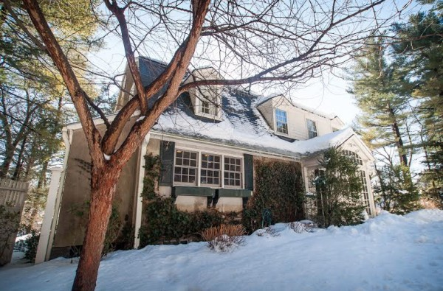
A look at the English Colonial as seen from the front / Photos via NE Floor Plans

Perched on a hill, this English Colonial on Hinckley Road in Milton has four bedrooms, hardwood floors, and plenty to see and do.

“It was custom built in 1922,” Coldwell Banker listing agent Matt Freeman said. “It offers charm, detail—brass knobs, thick molding, fireplaces throughout. It sits up on a knoll in Columbine, which offers privacy in the middle of a million-dollar neighborhood. Not to mention, it’s decorated to the nines.”

With an enchanting appearance and a touch of seclusion, this property is like something straight out of Downton Abbey. “It’s a jump to the public transit, across from Turner Pond,” Freeman said. “It’s near the public school and Milton Academy. A very convenient location on the Boston border. And Milton offers plenty of restaurants like the new Steel & Rye.”

If you enjoy fine detail, old world charm, and a great location, we recommend checking out this home.

201 Hinckley Rd., Milton
Price: $899,000
Type: Single Family
Bedrooms: 4
Bathrooms: 2 full, 1 partial
Lot Size: 0.32 acres
Living Area: 2,503 square feet
Fireplaces: 3

