As manager of zune.net, I introduced several innovative content solutions to business problems and launched them on the website. This document looks at one example: the learning center
zune.net
Learning center
Sandra Faucett
2013

Learning Center
Zune was presented to customers as being a super-simple product. In reality, though the UX was elegant and intuitive, it was very complex, something which only increased as we added more features and delivered the service to Windows Phone and the Xbox console. Very basic concepts were top customer support issues. I introduced the Learning Center as a way to make deeper information more available and enjoyable to customers and to reduce support costs.
The goal of the Learning Center was to present the product in a scannable and visually appealing way that reflected the brand as well as the needs of customers. For example “Sync” and “Collection” were top search terms on the site and top call generators, so they warranted their own sections even though they were not top-level features of the product.
I conceptualized this new section of the site and shopped it to executives to get sponsorship and allocation of resources. I managed the design and content development from landing page headlines and blurbs to article length and content, and launched it in time for the launch of the Zune service on Windows Phone 7. I directed a complete scrub of existing articles for style and tone, and in some cases simplifying them or dividing some into more than one article. Some new articles were written as well. I also brought more imagery into the articles to provide more information to the user and to make those pages more visually appealing.
Below is the main landing page of the Learning Center. Zune is not a supported product and zune.net is no longer live on the web. The cached page I am showing here is unfortunately not rendering properly.
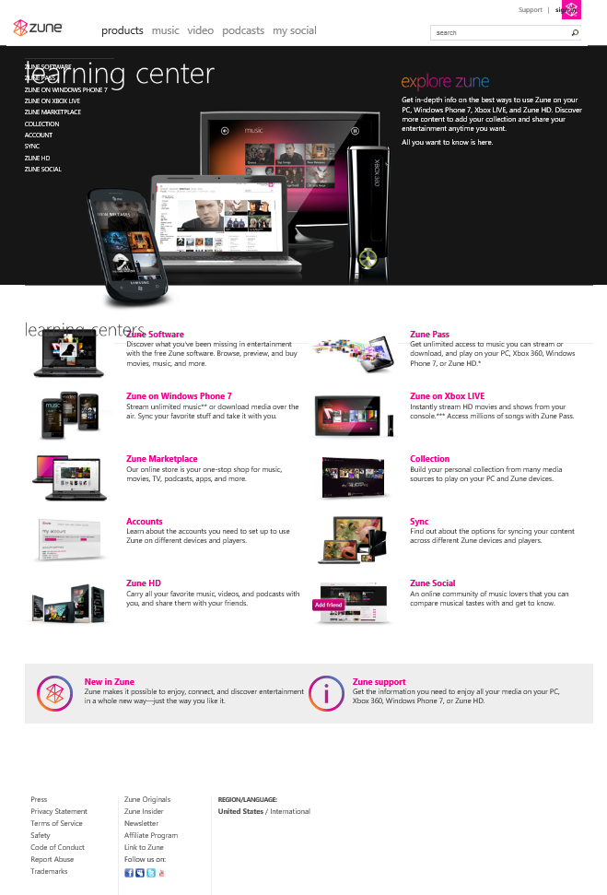
The original source of this content was a section of the site called the “User’s Guide”. It followed some of the Zune style but was ultimately very wordy and complicated. Even the structure of the content was difficult. It was arranged in a deep-tree format much like an encyclopedia. The result was content that was hard to consume on the web and really no fun at all. It ultimately did not serve the customer or business needs.
The main sections of the Learning Center, like the Zune Pass center shown below, sought to get the main steps the customer needed to take to obtain and use the feature right away front and center, and make them as simple as possible. The three main steps were processes unto themselves, but by breaking it in to visible and easy to comprehend steps the customers’ success was more likely. The other information areas for each section were broken down by the key marketing pillars for the product, like “making it yours”, and were consistent for each section as far as was appropriate. The topics under the “making it yours” sections were related to how you can make the product feature work best for you and look and feel according to your individual tastes.
The Learning Center itself and the main centers within it used the same page layout and rich hero imagery as the product pages did, indicating that this was a desired part of using the product and not a boring manual to be ignored or thrown away. These main pages were kept to the most important topics only so that they were not overwhelming and people could find the information they needed most easily. The whole list of articles could be accessed through an “all topics” link or of course through search.
After launching this new section, call volumes were reduced for many of the basic questions that had been top call generators.
