Social Media Strategy for First Friday Wordsmiths
Introduction
First Friday Wordsmiths (FFW) is an organization at Purdue University Calumet. As the name suggests, it is an organization that focuses on the writing community. FFW has done events throughout the past years like open mics and fundraisers. Last year, they participated in the poetry pantry, which is an all-day writing workshop for kids and adults. Current social media usage that FFW tries to take advantage of is Facebook, Twitter, and Tumblr. Every social media platform is connected to Facebook, so one post on twitter or Tumblr will be posted to Facebook. If there is a post created on Facebook, it will only go to Facebook. As of now, the social media usage and activity from FFW is quite low. There was little activity in 2013 that related to social media.
Competition
There are a few organizations that are potential competitors with FFW when it comes to social media. There is Books, Brushes, & Bands, an organization that focuses on education. Part of their focus on education is literature. From the research gathered, they do not have a strong presence in social media. Books, Brushes, & Bands seems to only have a Facebook page and a website.
Another organization is Blotterature Literary Magazine. Blotterature is an online literary journal. In terms of social media, Blotterature is more active than Books, Bands, & Brushes. Blotterature has a Facebook page, a website, a Twitter page, and a Pinterest. Their Faceook page and Twitter page are very active, but their Pinterest is not as great.
One other competitor is Indiana Writer’s Consortium. They are a creative Writing Organization. They have a blogspot and a Facebook Page. They are active on both platforms. Out of these three, Blotterature seems to be the most active in social media.
Audience
The audience FFW is looking at is the students of Purdue Calumet and any alumni that are interested in writing, even if by a small amount. For FFW to keep going as an organization, it needs to recruit new members from the University. Since the demographic of Purdue Calumet is diverse, it would be best to find things that are trending, entertaining, educational, and useful to writers.
Social Media Plan
Holistic Social Structure
For FFW, a holistic approach will be best. Since FFW has a medium range of members coming to the meeting (around ten on average), having those regular members help with social media is ideal and can be efficient if followed through. Each member should be able to contribute in different ways. Furthermore, having each member take a role in social media is better because one person will not get overexerted by trying to handle all of the social media. There should be a director, though, so that there is some direction of where the social media is heading for FFW. There should also be a coordinator to help assist the director in social media. For example, if the director is not sure what is currently trending on Twitter, the coordinator can help assist the director in finding some that is trending and help relate it to literature.

Social Media Platforms
Since one of the main goals of FFW is to recruit members, it needs a strong presence in social media. This means FFW should be on multiple social platforms. FFW will continue to use Tumblr, Facebook, and Twitter as those are essential to have a strong image out on the web. There needs to be a consistent website. For Tumblr, FFW should be looking at famous writers or profiles relating to writing and reblog what they say. It should not stop there, however. FFW should also be reflecting on these reblogs and say what they think. This will give FFW more of a face. FFW should also be looking at more comedic blogs on Tumblr that have to do with Writing like something on writers block with a witty statement about it.
For Twitter, FFW needs to always be looking at what is trending now and find ways to how it can relate to writing. For example, currently trending is #amwriting. FFW can come up with something that can use that hashtag. It can range from what members of FFW are writing so far or images that relates to writing. If there is an article on writing mistakes, FFW can put a link to the article and ask users if they made these mistakes before. This way, FFW is starting a conversation with its followers. FFW should also be looking at retweeting other tweets. A good example is retweeting what Blotterature has to say and give a tweet about the subject as well. Cross promotion will help greatly. For example, if Blotterature has an event going on and they tweet about it, FFW can retweet it. This way FFW increases the chances of Blotterature retweeting an event of FFW.
The website for FFW will provide information about who the organization is and what they do. It will be purely informational content for the organization. There will also be a list of officers and who they are. Events that will happen can also be put on the wesite.
With Facebook, FFW should post what current events are going on, such as the next open mic, to keep members up to date. Posts should not be strictly about business. Posts with memes or a witty post that relates to writing in a fun way is also good. Moreover, if any followers decides to comment on something, there should be interaction going on. An example of interaction would be if FFW posted about an upcoming fundraiser and someone comments that he/she will go. FFW should comment as well and say thanks for participating in the fundraiser. That is one example out of the many possible ways FFW can interact with its followers. There needs to be videos posted as well. Having videos will help build on the visual social media content. The videos can be funny and informational. If there is a workshop that is coming up, FFW can make a video about it. There can also be a mascot in the videos like an Edgar Allen Poe doll to make things more interesting. There needs to be more images of the events FFW has going on. These can be put in photo albums on Facebook, but should also be posted on other social media platforms like Pinterest.
There needs to be a Pinterest account for FFW. Since Pinterest is becoming popular, FFW should have one. Lacking any sort of visual media, having a Pinterest account will be an effective way to show visuals, which FFW is lacking. Pins like a writing tip list, writing prompts, or inspirational writing quotes, will give FFW more content and possibly more followers. Anything that is pinned should be shared on the Facebook profile. This means that Facebook and Twitter will have to be connected to the Pinterest account so Facebook and Twitter show that FFW pinned something on Pinterest. This will create more exposure for the organization. With the multiple events FFW has throughout the year, FFW can upload pictures to Pinterest. There can be a board just for events. In it will be pins from the events FFW will have such as being at convocation at Purdue.

Conclusion
The social media strategy provided will help build FFW into a more recognizable organization around Campus. Using Facebook, Twitter, Tumblr, Pinterest, and a website will be important for FFW. Having visuals and text will help make FFW not stagnant on the Social media platforms. With this approach, FFW will be able to put themselves out there more and require more members, which is one of the main goals for the organization. If this strategy is put in place, the ROI (in terms of recruiting members with zero cost) should be high.

Appendix A

Facebook

- Hi, Everyone! How is everyone doing? There will be an open mic this week so come and read aloud your best, or worst, work! The admission fee is a dollar. Let’s have some fun! I know I will with my worst piece. See everyone there!

Appendix B

Tumblr
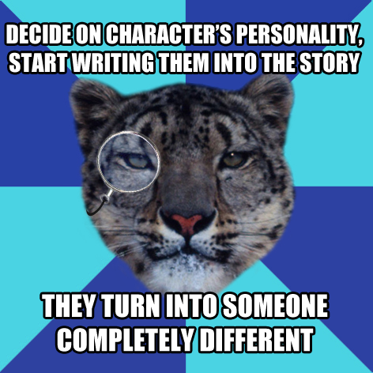

When writing your short story/novel, how often does your characters change and to what extent from the initial thoughts of what their characteristics will be to how they end up being in the end?

Appendix C

Twitter

- Write a short story that includes a spoon and a rabbit. GO! #amwriting #challengeaccepted

Appendix D

Pinterest

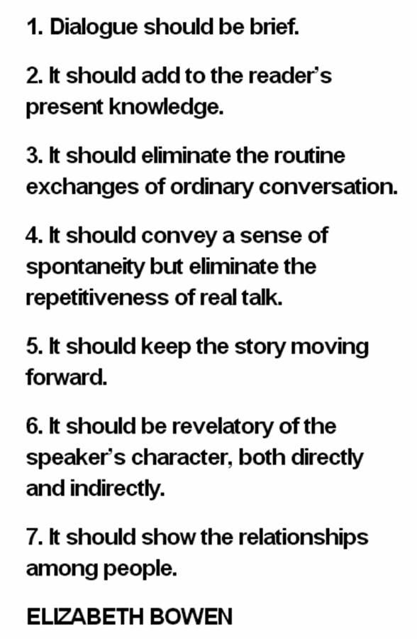

If you are having a hard time writing dialogue, consider these seven tips.

