Design Objective
The objective of this internet site is to help reinforce the English language. The target audience is people trying to learn the English language, such as international students, people which English is a second language to them, and people who just want to brush up on their English speaking skills. The structure of the site will consist of text, audio, animation, video, and simulations. The texts will provide a brief overview on a lesson. Audio will be included so that users can hear the pronunciation of the words. There will be videos to show a scenario or scenery for culture. There will be quizzes to practice English and users will be able to personalize it to suit their level. There will also be a translation guide at the top of every page, so users will be able to figure out what a word means quickly. A simulation will be added that will help users enrich themselves with the culture. Skill level of users can be at different levels. This is because of the personalization of the users. Users will first take a practice test to see where their skill level is at and the program, called EngageEnglish, will adjust accordingly.

Goals
- To reinforce the English Language
- To learn about the culture of English Speaking Countries such as North America
- To provide a supplemental material that that anyone can have access to
- To engage the users in a fun and creative way so that they will not find learning English boring

Flowchart
Homepage
www.englishengage.com
Search Bar
Simulation

Fill in Blank
Multiple Choice
Text
Image Sorting
Audio
Culture
Translator
Full Window
Login
Register
Quizzes
Practice Material
Translator
Mini window
Welcome Page

Online Chat

Treatment
Homepage
The homepage will introduce the viewer with a welcome blurb in the upper left corner of the screen. The welcome blurb will state, “Get Engaged with English Easy”. Below the site identity and welcome blurb, there will be different colored tabs denoting the different sections of the site. These sections will include Practice and quizzes on the left side and culture and a translation page on the right side. At the top right of the homepage, there will be a help button that is bold and is colored yellow. The bright color and bod will help to tell the user that the help button is there. The help button will have information, such as how to contact the people who made the site if they need help with any technical problems. It will also be useful as it will tell the user what each section is and for. The overall color scheme for the homepage will be a mix of different colors that blend well together. This way, users will see the site more fun and interactive.
The Guide

The guide, called Sam, will help the user with a variety of things throughout the site. Sam will be located at the bottom right of the screen that the user can click on. Once clicked, Sam will greet the user and ask what he/she needs help with. Depending on where the user is currently on the site, Sam will provide different options. For instance, if on the homepage, there will be options on what section does what. If on the Practice page, Sam will have options if the user would like help personalizing their practice lessons and to set due dates for encouragement. If the user needs help with the problems, he/she can click on Sam which will provide tips on figuring out the problems. The same principle will apply to the quiz section as well. On both sections, if the user does not understand how to figure out the problem, Sam will show the answer and the reason why it is correct. In the culture section, Sam will provide information on how to explore the simulation. Sam will also remind the player what they can do in the simulation in case the user needs a refresher. Lastly, under the translation page, Sam will help by providing a search function for the user to use and Sam will look up the equivalent word in whatever language.

The homepage for the site can be found at www.EngageEnglish.com.
Once the user has come to the site, a pop up window will show asking what language should be displayed.
Select a language
English
Spanish
German
Arabic
Chinese
Japanese

At the homepage of the site, there will be a background image of students talking. The site identity will be located at the top left of the site and will say EngageEnglish. The welcome blurb will be located next to the site identity to the right of it. It will say, “Engage in English the Fun Way!”

Navigation throughout the site will be handled by colored navigational tabs that will be placed in the upper middle of the site. The tabs will be (in order): practice, quiz, online chat, culture, and translation. Each tab will have a different color. The login prompt will be in the upper right corner of the site for users to login to.

Login
If it is the user’s first time on the site, a login box will pop up asking the user to sign up for an account. There will be a process that users will follow. It will be in text and audio.
Programming | Narration (text)
- Login screen appears | Would you like to sign up?
- Username and password screen appears. | Create a username and password.
- Confirmation page | Please confirm your username and password.
- Language select | Please select the language you would like the default to be.
- Congratulations page | Congratulations! You are now a member of EngageEnglish.

Personalization
Once the user has signed up for an account, the guide Sam, will ask the user how he/she would like to set up their account. Sam will only pop up on screen with text only in the language the user chose at the login screen.
“Hi, I’m glad you signed up for EngageEnglish. How about we personalize some of the options for you”.
- “Would you like audio to be the default option or text first with an option to turn on audio?”
Audio as default/text first
- Would you like audio narration for problems to be an English?
Yes/No
- “For practice material, please define to what percentage you would like to have the practice material formatted.”
___Multiple choice
___Audio problems
___Video Problems
___Animated Problems
- “Would you like deadlines for your practice material and quizzes?”
Yes/No

Practice Material
There will be a number of things the user can do in the practice material. If it is the user’s first time in the practice material section, Sam will greet the user and ask if he/she would like to personalize their profile. The user can decide what they would want to reinforce, such as the present tense or preterit. Users will also be able to decide when and if they want deadlines for the practice material. Alternatively, Sam can provide an automatic deadline system based off of the preferences of the users. This makes it so that a user will feel like it is their own personal site and not a dull repetitive one that every other user goes by.
Content of the material will be diverse and varied, so that users can learn in multiple ways. Since people learn in different ways: for example, some people learn better by hearing than reading, the content will have text, audio, video, and animation. For text, it will be standard. The user reads an overview of the material and will then have the option to answer multiple choice questions or writing. For instance, there might be a page that talks about the different greetings in English like “Hello” or “nice to meet you”. Once that is read, the user will have the option to practice the material with multiple choice questions as an option. One question might ask to fill in the blank and there will be four possible answers. Likewise, the only difference between writing is that there will be no answers given and the user will have to type the answer based on knowledge of the materiel.
Multiple Choice
Question | Narration (text) | Narration (audio) | Program Note
- You come up to Bob to introduce yourself. What do you say? | - Goodbye  - Likewise  - Fine  - Hello | - Goodbye  - Likewise  - Fine  - Hello | The question will be in the language the user has selected. Answers are in English
If user is wrong | Try again. What is the most logical expression to use for a greeting? | Wrong Answer. Please try again. What is the first thing you should say when introducing yourself? | The hint is in the selected language the user chose
If user is wrong again | To relearn greetings, click [here] | To relearn greetings, click on the link. | Hints are in the chosen language.
If user is correct | Yes! Hello is the word most people will use to first greet someone. | Correct! Hello is the word most people will use to greet someone. | Congratulations text is in chosen language. Audio may be in chosen language or in English based on user personalization.

Another option is to look at images of ordinary scenes and environments and type in what the user sees. These images are also clickable. For example, if there is an image of a car and someone washing it with a cloth, the user can click on the car or the cloth and see what that word is in English.
Audio
In the audio portion of the practice material, the user will have to listen to audio and answer the fill in the blank questions.
Program | Narration(text) | Narration(audio) | Program Notes
Instructions | Please listen to the audio narrated by Jack that is given and answer the following questions as best you can. | None | User clicks on play button to start the audio.
Audio | None | I am going to write a letter to my sister Mikasa. I am on vacation right now and miss her. I am sure she will like my letter. | None
Problem one | Jack s going to ____ | Jack is going to. | User fills in the blank.
If answer is wrong | Sorry, try again. Hint: listen for the verb at the start of the narration. | Wrong answer. Try listening again and pay attention to the verb said. | Sam pops up on screen and gives the user a hint.
If wrong again | Wrong answer. It is write a letter. | Sorry, that is incorrect. The answer was write a letter. | Sam provides an answer and moves to the next question.

Video
The practice content that contains video will display scenarios or scenes. The questions that follow will be formatted either with making sentences or multiple choice, depending on the personalization of the user. An example of the video is as follows.
A guy is driving a car into a garage. The man then gets out of the garage and goes to the front door of the house. He grabs his house keys from his pocket and opens the door to the living room.
Program | Narration (text) | Narration (audio) | Program Notes
Instructions | Please answer the following questions. | Please answer the following question. | Audio is in selected language.
Fill in the blank | What was the man doing at the start of the video? | What was the man doing at the start of the video | Audio in selected language.
If answered wrong | That is incorrect. What do people usually drive? | That is incorrect. What do people drive usually? | Sam gives a hint  Audio in selected language
If incorrect again | That is not the right answer. The answer is: He is driving a car. | Sorry, that is not the right answer. The answer is: He is driving a car. | Audio in selected language.  Sam provides the answer in a pop up window and moves to the next question.

Animation
The animation option is the most engaging to the user. With this, the user takes control of an avatar partially. This will be a point and click scenario. Users will have different scenarios presented to them. For instance, the avatar may be in a store and the user will have to shop for food items. The user would click on what the avatar should do, in this case get a buggy first. Then the avatar would go to a list of aisles and the user would have to click on the correct one. This would continue until the user fully completes the scenario in the animation. There will be a number of these scenarios the user can go through (see page 15 for visual representation).
There is an option to turn on or off the audio in the practice material. This will be in every part of the practice options. If the user wants to hear the problems or listen to the animation, he/she can do so. The icon will be at the bottom right of the page. The icon will look like a speaker.
Program | Narration (text) | Narration (audio) | Program notes
Instructions | You are at the grocery store to buy some food because you have ran out. You must click on items that you will need to get through this practice. | You are at a grocery store and must buy some food because you have ran out. You will have to click on the items that the question says to get through this practice. Good luck! | Sam gives the instructions.  Text and audio are in the language the user has chosen.
Step 1 | Pick the cart on screen | Pick the cart. | Images of a cart and shopping basket appear on screen.  Audio in selected language  Text will be in English
Step 2 | Go to the deli | Go to the deli | An image appears of a store with a deli and produce section.  Audio in selected language  Text in English
Step 3 | Grab the ham | Grab the ham | Image of different meats will appear.  Audio in selected language  Text in English
Step 4 | Checkout at sixteen | Checkout at sixteen | Screen of checkout aisles will appear.  Text in English  Audio in selected language
Step 5 | Pay with a twenty | Pay with a twenty | Screen with a five, ten, and twenty dollar bill appear.  Text in English  Audio in selected language.

1 Pick the Cart or
Audio Narration
Produce
Deli
2 Go to the Deli
Audio Narration

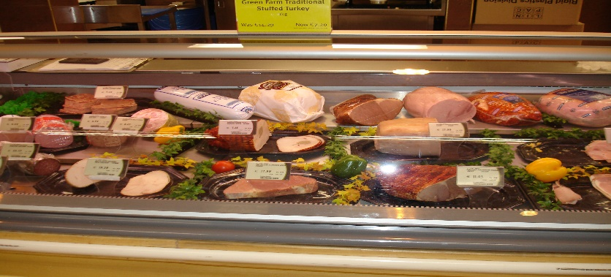
3 Grab the Ham
Audio Narration
Icons

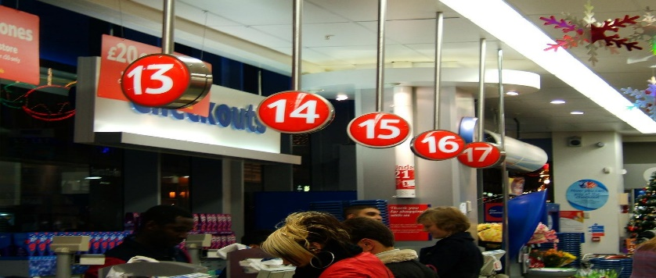
Icons
4 Checkout at sixteen.
Audio Narration

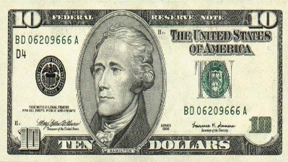
5 Pay with a twenty
Audio Narration
Quizzes
The quizzes, like the practice material can also be personalized. If the user thinks he/she has mastered a part of the English language, he/she can take that portion off of the quizzes. This way, the user will not have to go through problems that are already mastered. Users can decide what type of format the questions will be. They can have video segments, text, listening to audio, or a combination of them all. The structure of the quizzes will be formatted like a puzzle piece going together. To further clarify, users will click on one of the many puzzle pieces. After this, a problem will appear and the format will be one of the options the user has chosen. If the user gets the correct answer for the problem, the puzzle piece will move and align itself to its designated spot on the puzzle. Once all the problems are answered correctly, the puzzle will be finished and show an image of the culture of English native countries. This image could be the Yellowstone National Park. Once more, the image that the user has put together is clickable. The user can click on the different objects that are in the image and it will bring up a window with a description of that object and place. This will be a reward type of system. If the user gets all the puzzle pieces together, the user can interact with the image and learn a bit about English native countries culture,
Icon

Icon
Description of photo

“This is Yellowstone Park, a national landmark located in Wyoming to preserve nature”.
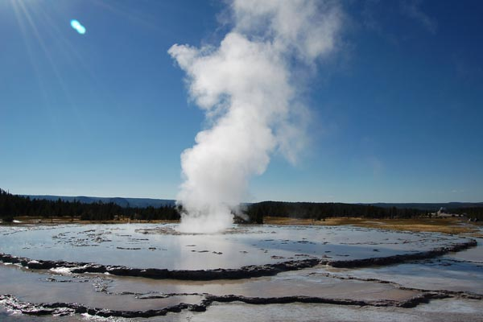

Icon
Description of Geyser
Program | Narration(text) | Narration (audio) | Program Notes
User picks puzzle piece. | Please choose a puzzle piece to solve. | Choose a puzzle piece to answer a problem. | Puzzle pieces will make up the quiz. They can consist from a 10 set, 15 set, or 20 set. Text and audio here will be in chosen language the user has selected.
Puzzle piece 1. | What is brother in English? | What is brother in English | Audio will be the chosen language the user has selected
Answers | - Sister  - Father  - Brother  - Uncle | - Sister  - Father  - Brother  - Uncle
If user gets it wrong | One try left. Remember, this is a male. | One try left. The answer is a male.
If user gets it wrong again. | Sorry. The answer was brother. | Sorry, the answer was brother. Do you want to review before going on? | The avatar guide will provide a link to a review section of the materiel.
If answered correctly | Good job! | Good Job! On to the next question. | User will be redirected to the puzzle pieces and a puzzle piece will be placed, showing part of the image.

Culture
In the culture section of the site, users will be able to enrich themselves with the culture of English Native countries. This will be achieved by a simulation. The simulation would be something like Second Life, but on a much smaller scale and less intensive graphics wise. More specifically, users will see a three fourths top down screen while controlling their avatar. In the simulation, users will be able to pick either a male or female avatar. Once picked, users will be able to choose from a wide variety of environments to choose from. These environments are not limited to the present. They can choose places from the past as well.
Once the environment is chosen, let’s say Niagara Falls, users can then move their avatar around and explore the simulated place. In the simulation, it will try to recreate the place as close as possible. There will be audio, so if the simulation is in Niagara Falls, users will be able to hear the water flowing. Users can also move there mouse around and click on sign posts.
Sign posts will provide different kinds of descriptions. For example, if a user clicks on a sign post near the falls that sign post may say something about the floodlights at night. Other sign posts may provide videos of the place that the user can watch.
The simulation is open to multiple people at once. This can be broken down if a teacher uses it for a class. Teachers can put in the login information from the students and add them to a group. That group will now be private and only people in that group can see each other in the simulation if they are connected to the group page.
Program | Text narration | Audio Narration | Program Notes
Choose a sim | Choose which sim you would like to go to. | Choose which sim you wish to visit. | Language can be adjusted according to the user.
Yellowstone Park Chosen | Please select your avatar. | Please select your avatar. | User can choose between a male and female avatar.
Once in sim | Welcome to Yellowstone park! | Welcome to Yellowstone park! | Text pops up welcoming the user. User can now move around.
Clicking on a signpost near a geyser. | This is a geyser, one of many around Yellowstone park. They are like hot springs, but at times erupt. | This is a geyser, one of many around Yellowstone park. They are like hot springs, but at times erupt. | When moving around the sim, if the user clicks on a signpost, text will pop up with an image. An audio icon will be to the lower left of the text box.

Translation
In this section, users can look up words and translate them. This is a simple tool that users can go to if they need to look up a few words. They can just type up a word in a search box and choose the language it is and what to change it from.
The section also has a list of conjugations users can look at. This is useful so they can refresh on the words and their conjugations. Users will also be linked here if they get the wrong answers in the practice material.
The translation section is also a dictionary. This can also be personalized to an extent. Say a user is trying to remember some vocabulary words and are having trouble. The user can go to the translation page and type in the word. There will then be an option to add that to the hint section. This means that if the user is doing practice material or quizzes, he/she will see a tiny chat icon when the word shows up so that the user will know what that word is.
Sam will help the user by asking him/her questions of what they would like to do. So, a pop up window will be displayed with Sam with text.
“Hi! What would you like to do?”
Translate a word
Look up a word
Look at conjugations
- If user picks “translate a word” Sam will take the user to a translating page with a text box. Text will be above the text box.
“Please type in a word and select the language it is and it will translate to English.
Another smaller box in the upper left above the text box will have a list of languages
Spanish
German
Arabic
Chinese
Japanese

User can then type in any word and it will translate to English.

- If user selects “Look up word”

Sam will take the user to a section to look up a word. A search box will appear with text above it.

“Search a word and its meaning will be looked up.”

Once the user has chosen a word and pressed enter, the meaning will appear.

“(word looked up) means (definition of the word).

- If user clicked on “Look at Conjugations”

Sam will take the user to a page with a search box with text above it.

“Type a word in the box and a list of conjugations will be given.”

Once user has looked for a word and searched for it, different forms of conjugations will pop up.

“Pick the type of conjugation”

Simple Present | Present Progressive
Simple Past | Past Progressive
Present Perfect simple | Present Perfect Progressive
Past Perfect | Past perfect Progressive
Future | Future Progressive
Future Perfect | Future Perfect Continuous

User will click on any type of conjugation and the conjugations of the word will be displayed.

Online Chat
In this section, users can chat online with others. Users can talk to each other by text if they so choose. There is the public chat where user’s text to random users and group chat, where users only chat with people in that group. Group chat can be a private room that teachers may want to use for their class. They may also do video chat if they wish to hear each other. Video chat can go up to four users at one time. The online chat is not just for users though. There will also be tutors that will help any users who need assistance. So, if a user is having trouble with materiel and Sam cannot help, they can make an appointment with a tutor either by text chat or video chat. A teacher with students would be designated as a tutor so they can control more of the online chat. One thing a tutor can do is post images or files in the chat for users to look at. This allows for more flexible teaching in the chat room. This will also allow flexibility for the user and tutor/teacher.
The online chat will feature text and video.
Text Chat
In the text chat, a user can enter a public or group chat room. In the public chat room, users that have signed up for an account can chat with each other and help each other out. The chat window will take up most of the left screen. Here, users will see the text other users have typed up. To text something in the chat window, the user will go to the bottom of the screen to the text box window. Here, the user can type up something and it will go to the chat window. An audio icon will be next to the users name in the chat window. Clicking will have the avatar guide say the words the user has typed.
Program | Text Narration | Audio Narration | Program Notes
Chat window | Hello John, nice to meet you. | Hello, john, nice to meet you. | Audio will be in English by default unless the user has adjusted it for another language.
Text Window | Type here | Type here to send a text in the chat box. | Audio will be in the language the user has selected.

Video Chat
Video chat will be activated if the user has clicked on icon that says video in the text box.
Program | Narration text | Narration Audio | Program Notes
Click on Video Chat | Do you want to video chat? | Do you want to video chat? | Small window will pop up asking user if they would want to chat by video.
Clicking on yes | Welcome to video chat. Wait until someone joins. | Welcome to video chat. Please wait while other people join. | Language is in selected format the user chose for text and audio.
Connected to someone | You have been connected | You have been connected. | Small window will say user has been connected with someone.
Talking to user | Hello there | Hello there | Text box will be at bottom and whatever has been sad will appear there.

Text Room Video Chat

Reference List
(2013). Language guide avatar. Retrieved from http://pixabay.com/en/support-help-avatar-headset-147502/
N.d. shopping cart. Retrieved from http://blog.upshotcommerce.com/designing-the-perfect-shopping-cart/
N.d. shopping basket. Retrieved from http://www.psdgraphics.com/psd-icons/shopping-bag-icon/
(2011). Deli. Retrieved from http://www.flickr.com/photos/i5design/5659518518/
Duane, D. (2006). Deli Meat. Retrieved from http://www.flickr.com/photos/i5design/5659518518/
N.d. 5 dollar bill. Retrieved from http://es.wikipedia.org/wiki/D%C3%B3lar_estadounidense
N.d. 10 dollar bill. Retieved from http://es.wikipedia.org/wiki/D%C3%B3lar_estadounidense
(2012). 20 dollar bill. Retrieved from http://twentydollarbill.info/

