SPSS Handbook
Setting up the Data in Variable View:
Naming
Labeling
Values
Scales of Measurement
Compute a Variable
Recode a Variable
Select Cases
Split File
Histogram with Frequency Table
Descriptive Statistics: Mean, Median, Mode, Standard Deviation, Range, Skew
Dependent Samples t-test
Independent Samples t-test
One-Way ANOVA
One-Way ANOVA post hoc
Repeated Measures ANOVA
Two-Way ANOVA
Correlation
Regression
Scatterplot with Regression Line
Goodness of Fit Chi-Square
Contingency Table Chi-Square
Reliability Analysis

Setting up the Data in Variable View
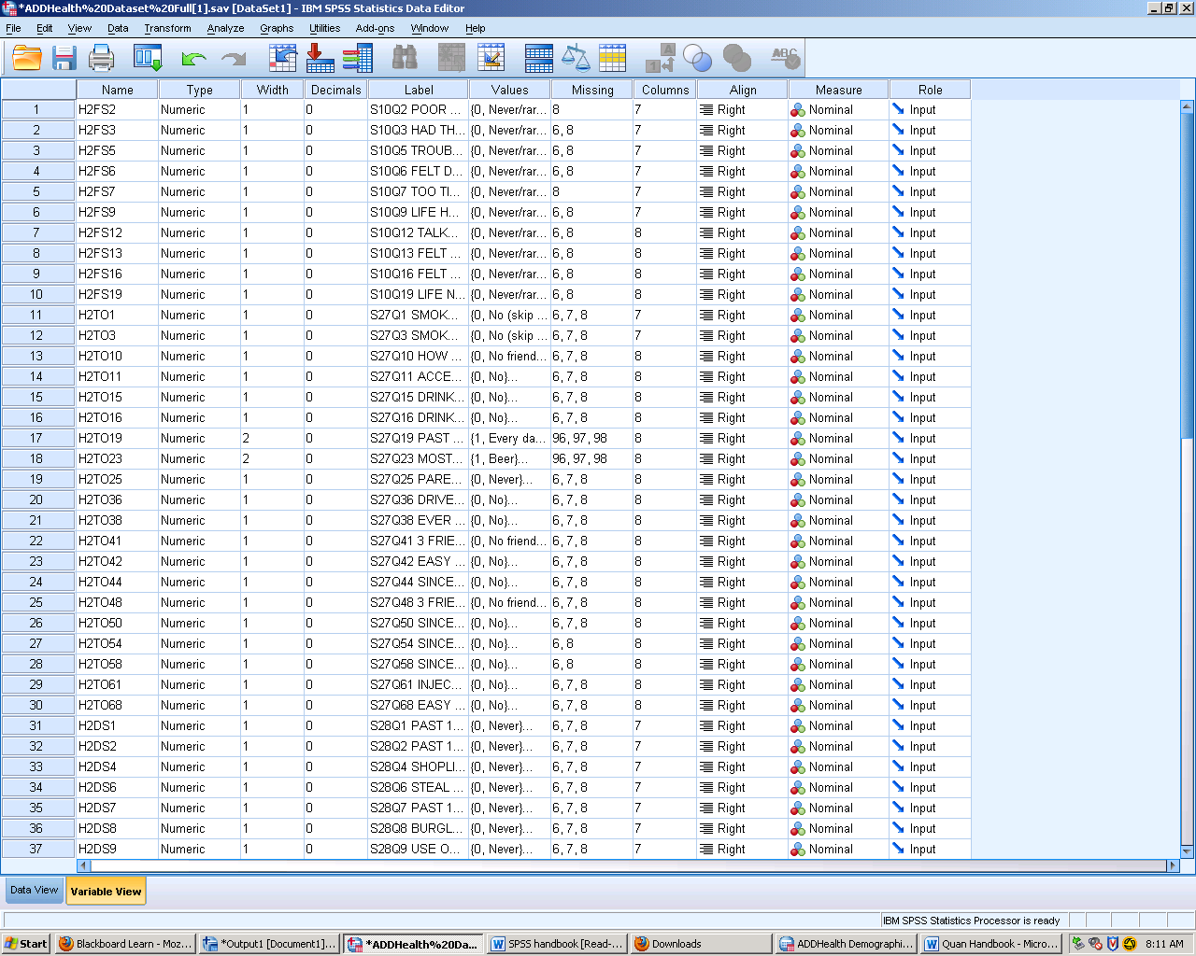
Variable View: The view where you can the names of all the variables, which is different from Data View, which shows each row a separate person.
Naming: This column is the name of the selected variable. Here is where you might give the question asked a “code.”
Labeling: This column gives more information about the question at hand, like the number of the question, what the topic is, and what wave it is in.
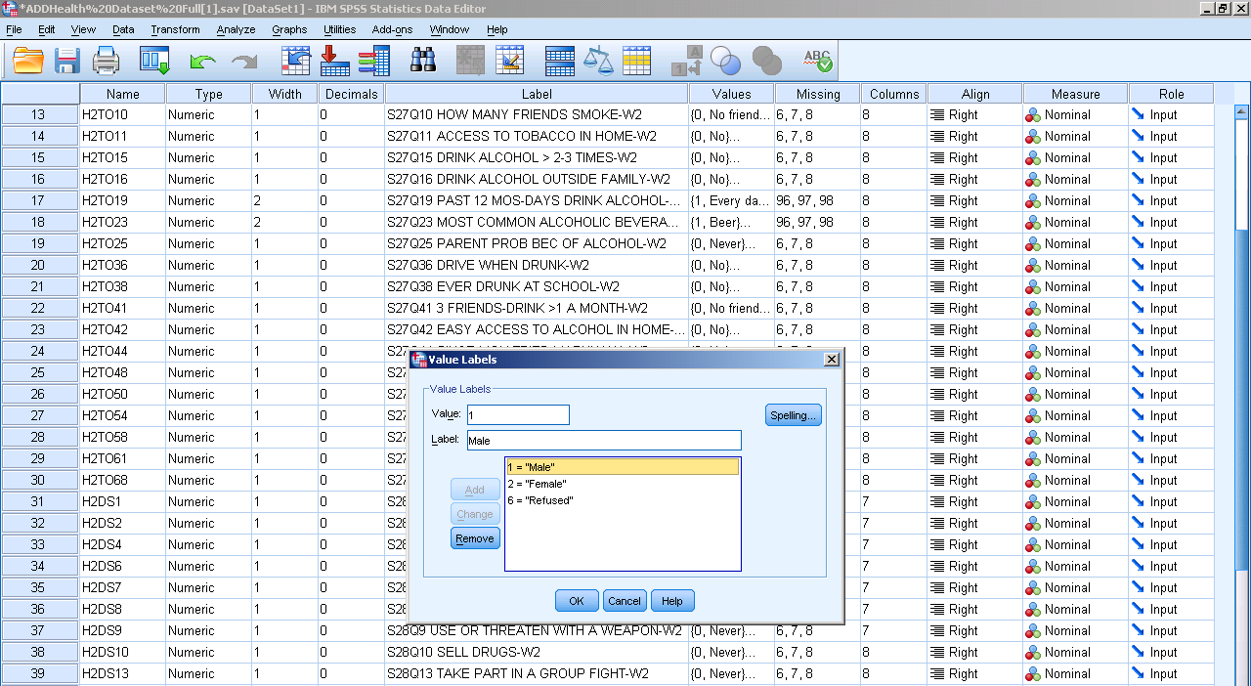
Value: This option shows what the numbers in the value stand for. For example when looking at sex 1: male, 2: female and 6: refused to answer.
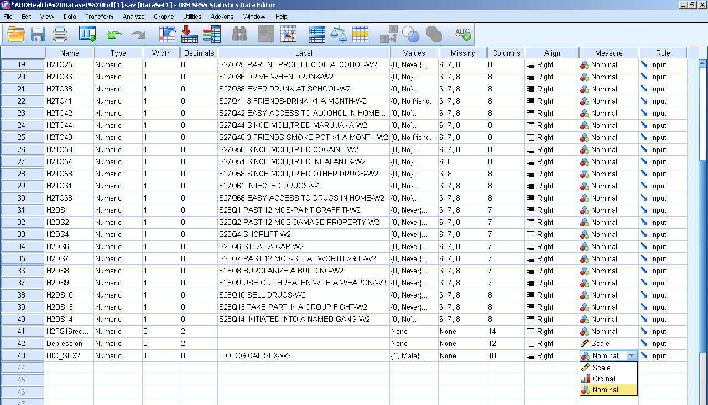
Scales of Measurement: The drop box shows the three examples of measurements: scale which is interval and ratio (quantitative variables), ordinal, and nominal.

Compute a Variable
Description:
Sometimes it is best to isolate cases that have a particular characteristic or set of characteristics before doing any further analysis. This command excludes from further analysis all those cases that do not meet specified selection criteria.

SPSS Steps:
- Transform Compute Variable
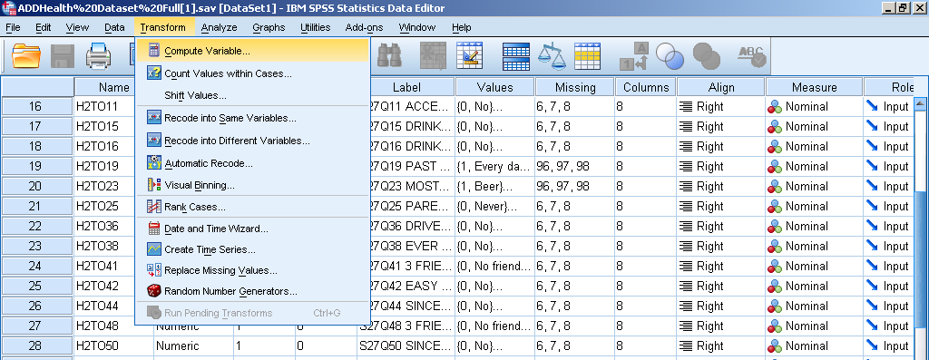
- Make a new name for the combined variables (no spaces allowed instead use the underscore).
- From the left column pick the first variable, then use the “+” button, then add the second variable form the left column.
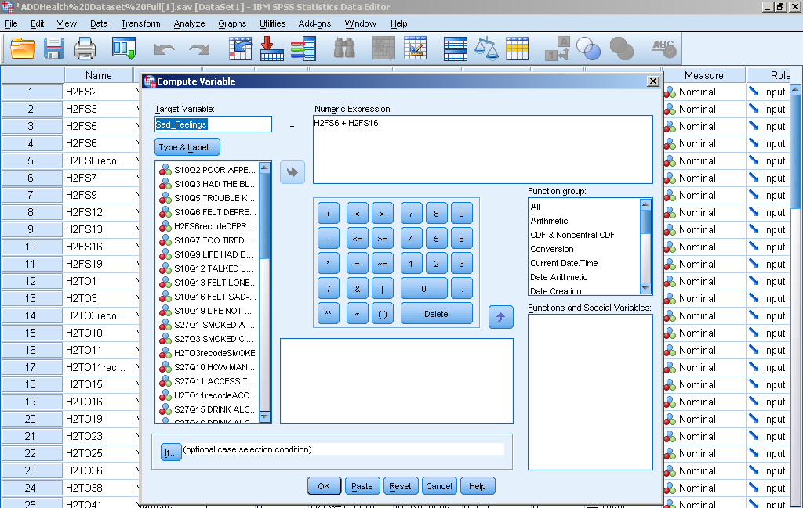
- Click paste and the new variable will be that the bottom of your data set under the new name you gave it.

Recode a Variable
Description:
Recoding is a way to transform the variable and get rid the values you don’t need like if someone don’t answer a question or don’t know the answer to the question you can weed out their responses.
SPSS Steps:
- Transform Recode into Different Variable
- Select the variable of interest and click the arrow to move it from the left hand list of variables to the right hand “Numeric Variable Output Variable” box.
- Under Output Variable on the far right rename the new variable under “Name.” Simply add “recode” after the variable, for example turn BIO_SEX2 into BIO_SEX2recode.
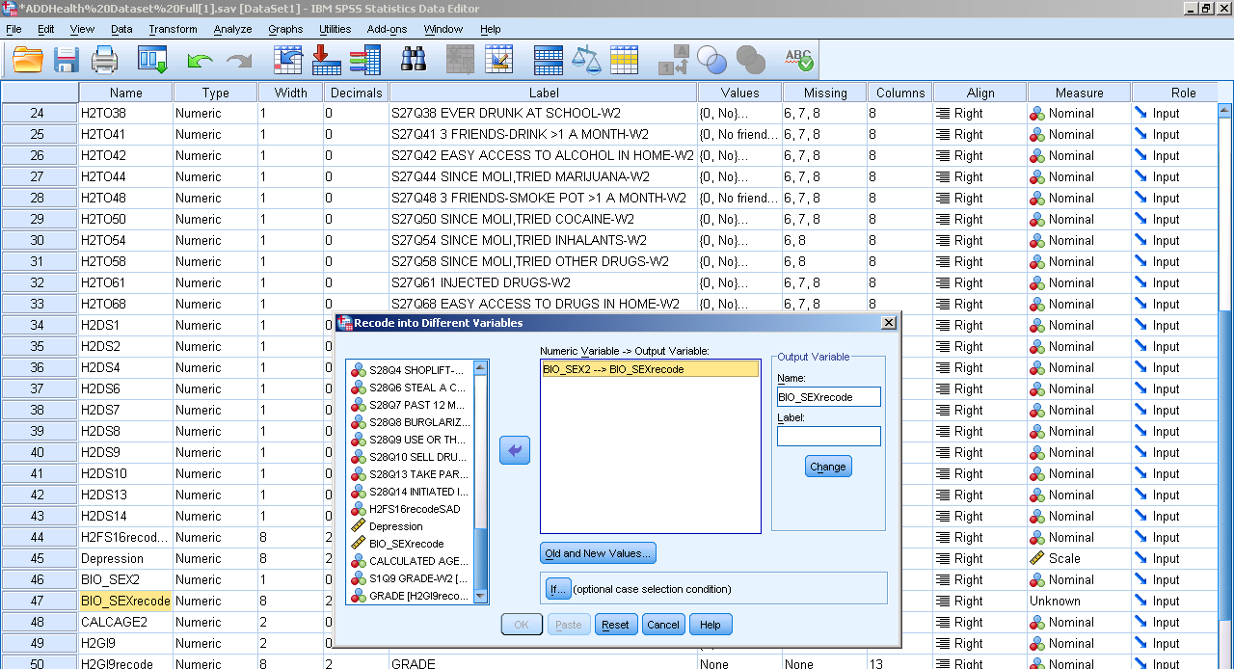
- Click Old and New Variables
- For the vaules you want to keep the same: Under Old Vaule put the vaule in the box labled vaule. In the New Vaule box to the right put the same vaule in the box labled vaule then press add.
- For the vaules you don’t want anymore (don’t know or refuse to answer): Under Old Vaule put the vaule in the box labled vaule. In the New Vaule box to the right select “System-missing” and then press add.
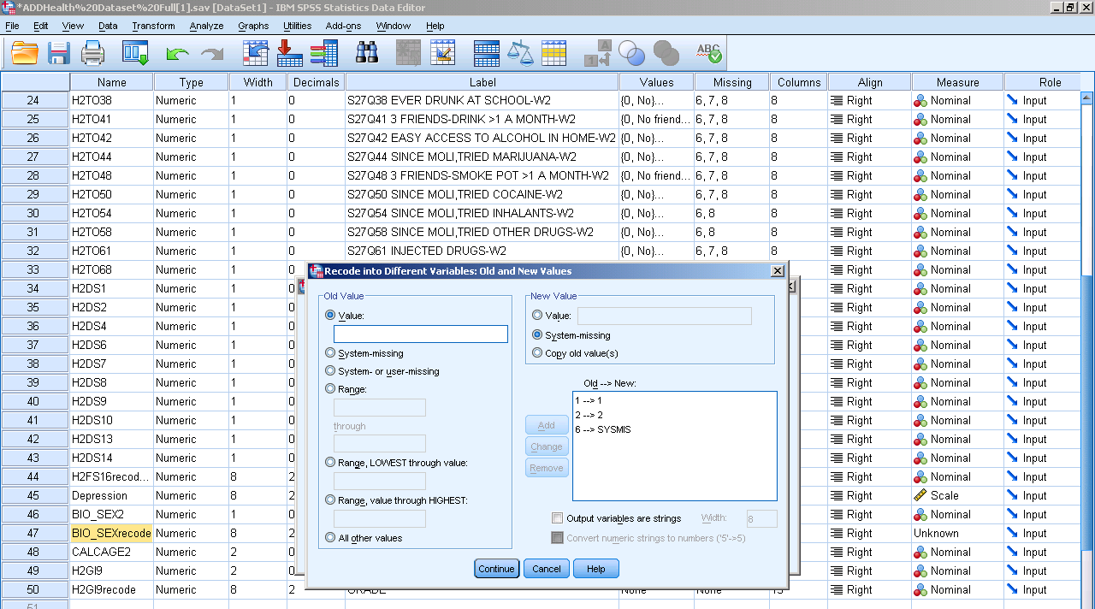
- Press continue then paste. This new variable will be added at the bottom of your data set under the new name.

Select Cases
Description:
Use this command to separate values from a variable that you are interested in. This eliminates the values that you are not interested in.
SPSS Steps:
- Data Select Cases

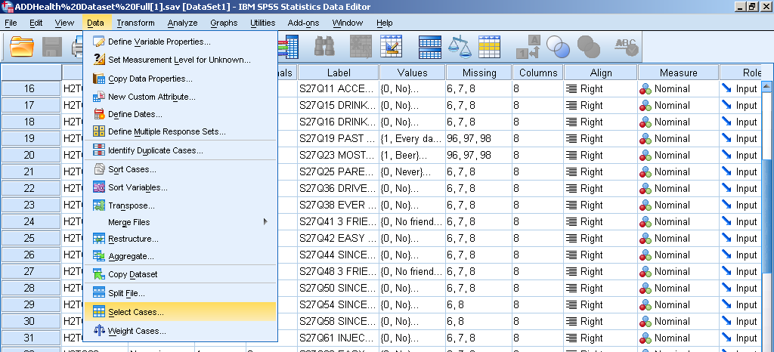
- Select the “If condition is satisfied” button. Then press “If.”
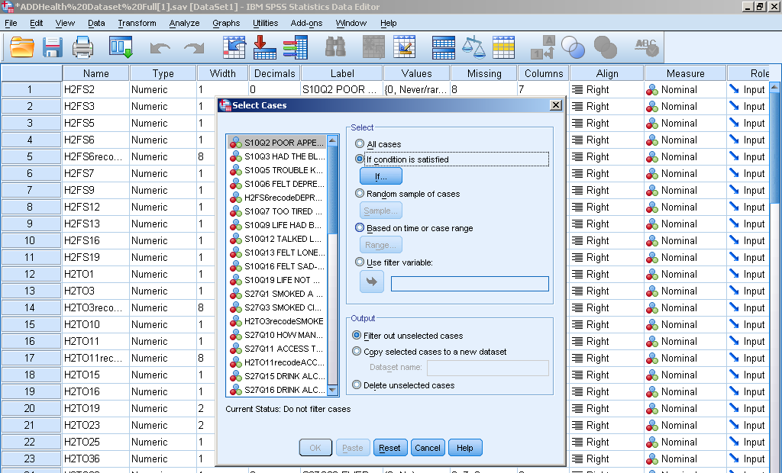

- Select the variable you are interested it and click the button to move it to the box on the right. The hit the “=” button and use the vaule you are interested in. Then press continue.

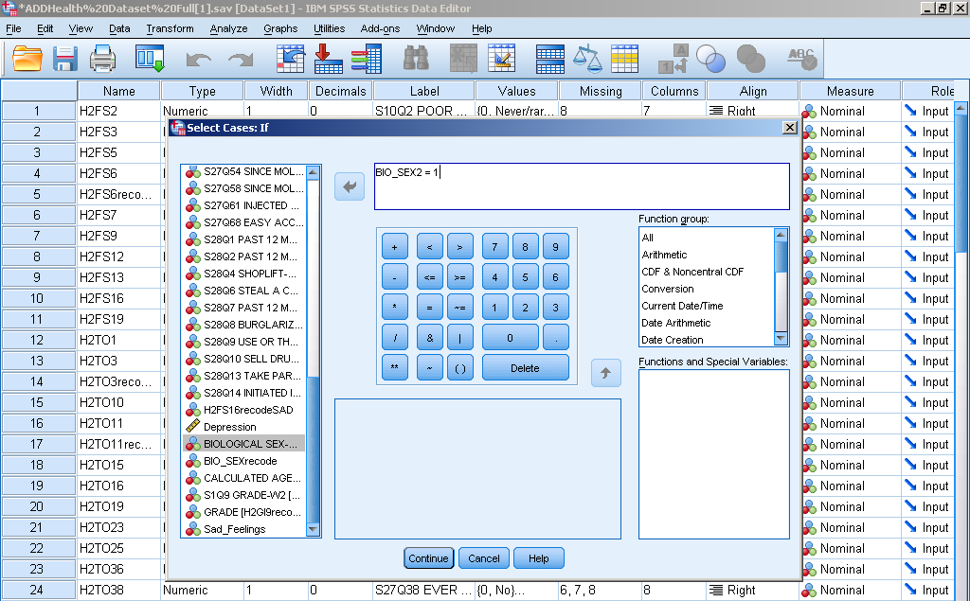
- Press paste.
Spilt File
Description:
Use this command when you want to ‘split’ a file into multiple groups based on certain grouping variables (ex: Sex). If you select more than one grouping variable then they are grouped together within the category of the variable before it.
SPSS Steps:
- Data Spilt File
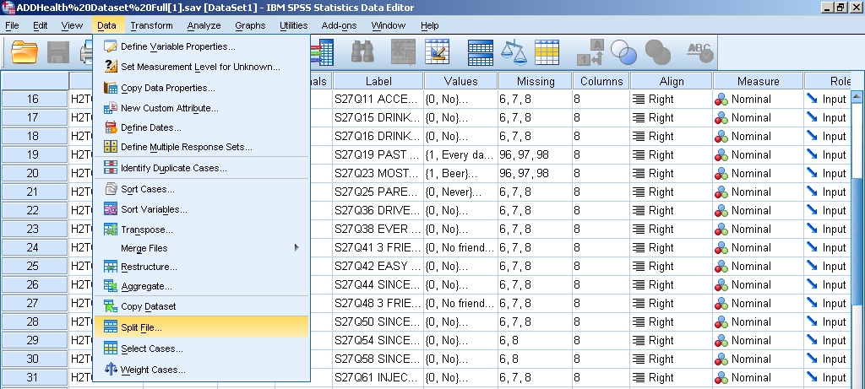
- Select “Organize output by groups.” The add your variable from the left box to the right box under “Groups based on:”
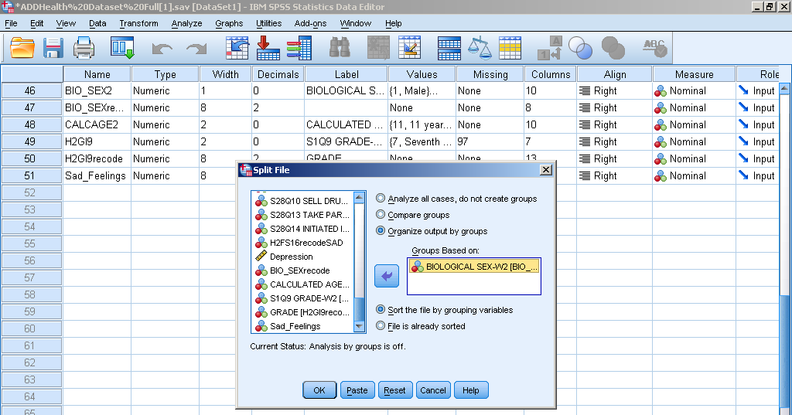
- Click paste.
Histogram with Frequency Table
Description:
This function shows you the distribution of data for a selected variable in a chart and also a table. This allows you to see the skewness and frequency of occurrence (the bars).
SPSS Steps:
- Analyze Descriptive Statistics Frequencies
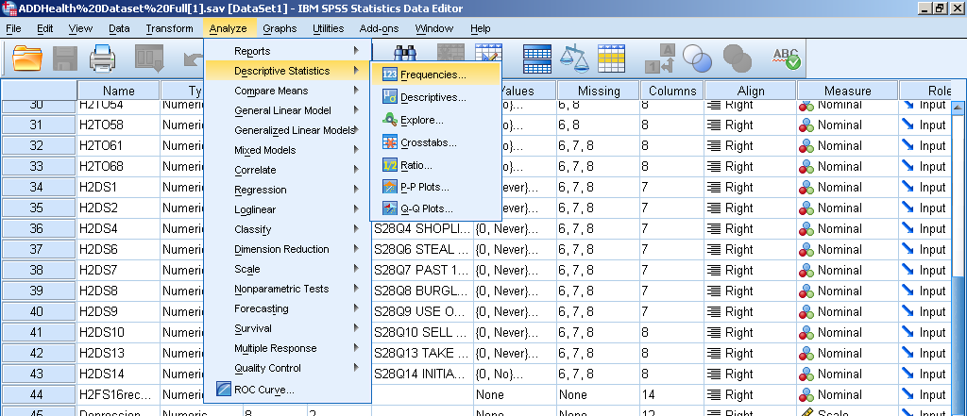
- Select the variable of interest and click the arrow to move it from the left hand list of variables to the right hand “Variable(s)” box.
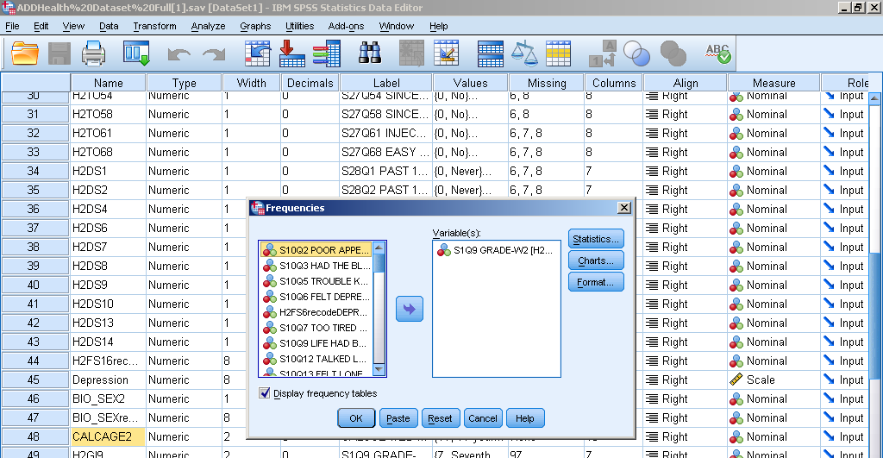
- Under “Statistics,” check all the options checked below and click continue.
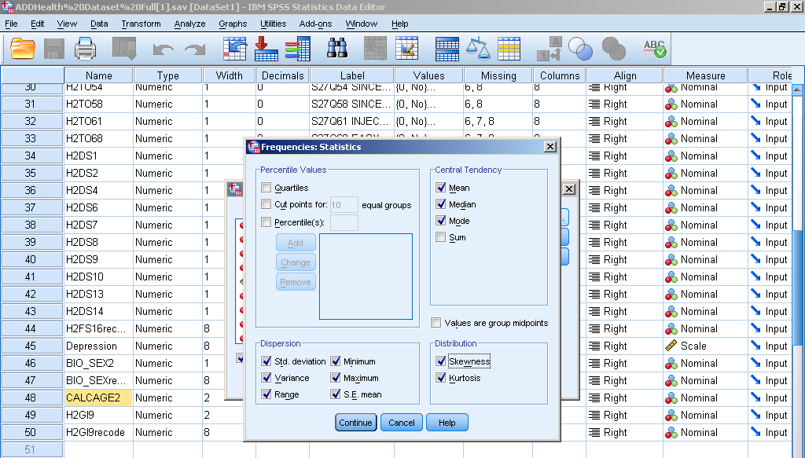
- Under “Charts,” click Histograms and check Show normal curve on histogram.

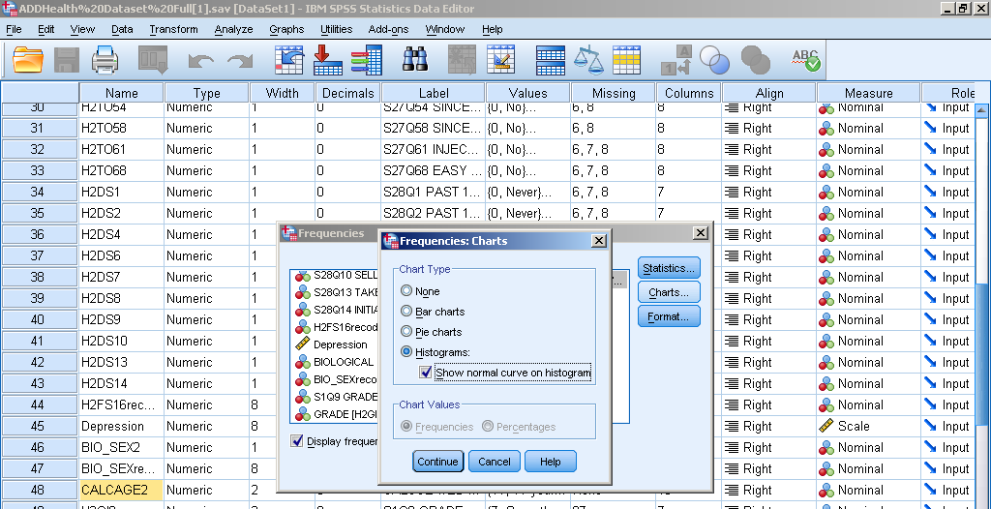

4. Click paste to put it in syntax, and then run the analysis.
Syntax:
FREQUENCIES VARIABLES=H2GI9
/STATISTICS=STDDEV VARIANCE RANGE MINIMUM MAXIMUM SEMEAN MEAN MEDIAN MODE SKEWNESS SESKEW
KURTOSIS SEKURT
/HISTOGRAM NORMAL
/ORDER=ANALYSIS.

Output Interpretation:
Statistics
S1Q9 GRADE-W2
N | Valid | 4449
 | Missing | 385
Mean |  | 10.06
Std. Error of Mean |  | .022
Median |  | 10.00
Mode |  | 11
Std. Deviation |  | 1.471
Variance |  | 2.164
Skewness |  | .077
Std. Error of Skewness |  | .037
Kurtosis |  | -1.005
Std. Error of Kurtosis |  | .073
Range |  | 7
Minimum |  | 7
Maximum |  | 14

S1Q9 GRADE-W2
 |  | Frequency | Percent | Valid Percent | Cumulative Percent
Valid | Seventh Grade | 24 | .5 | .5 | .5
 | Eighth Grade | 826 | 17.1 | 18.6 | 19.1
 | Ninth Grade | 885 | 18.3 | 19.9 | 39.0
 | Tenth Grade | 881 | 18.2 | 19.8 | 58.8
 | Eleventh Grade | 907 | 18.8 | 20.4 | 79.2
 | Twelfth Grade | 836 | 17.3 | 18.8 | 98.0
 | Beyond High School | 65 | 1.3 | 1.5 | 99.4
 | School doesn't have grades of this kind | 25 | .5 | .6 | 100.0
 | Total | 4449 | 92.0 | 100.0
Missing | Legitimate skip | 385 | 8.0
Total |  | 4834 | 100.0

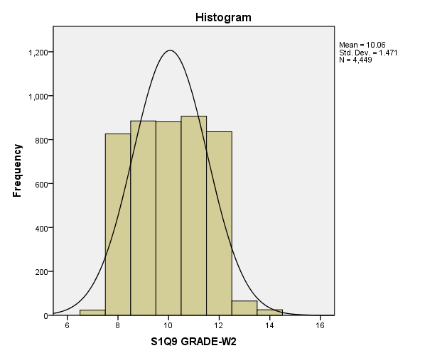
The following are the results of this analysis; N = 4449, M=10.06, SD=1.47. The median= 10.00, mode= 11, and variance= 2.16. The minimum= 7 and maximum= 14, giving it a range= 7.
Descriptive Statistics
Description:
These statistics show you a wide range of information for a variable. Is displays measures of central tendency, measures of variability, and shapes of distributions.
SPSS Steps:
- Analyze Descriptive Statistics Frequencies
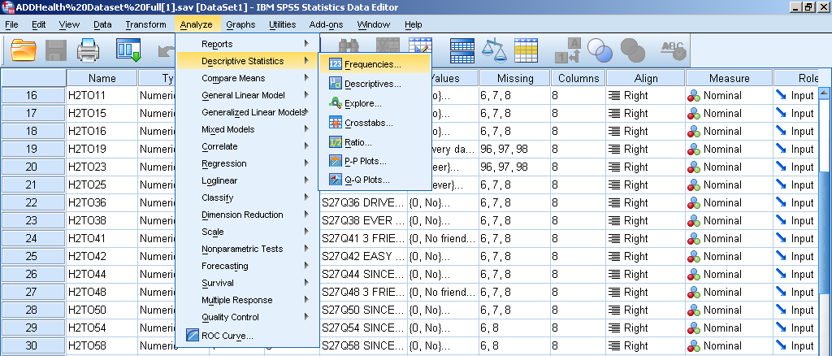
- Select the variable of interest and click the arrow to move it from the left hand list of variables to the right hand “Variable(s)” box.
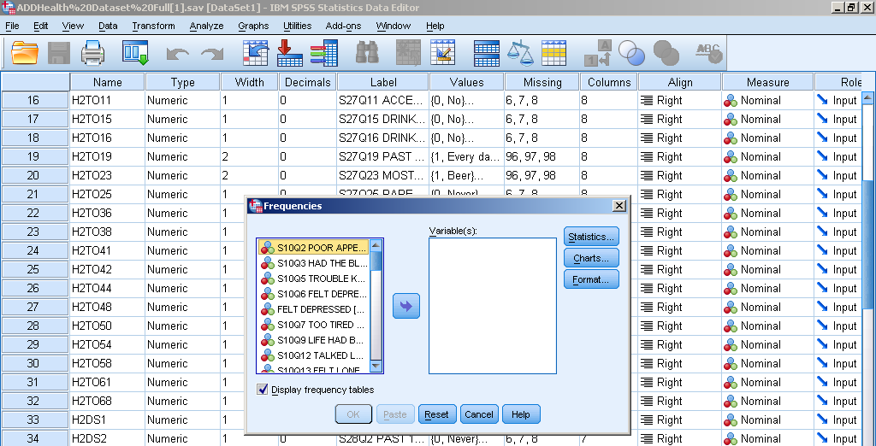
- Under “Statistics” check mean, median, and mode.
- Under “Dispersion” check std. deviation and range.
- Under “Distribution” check Skewness.
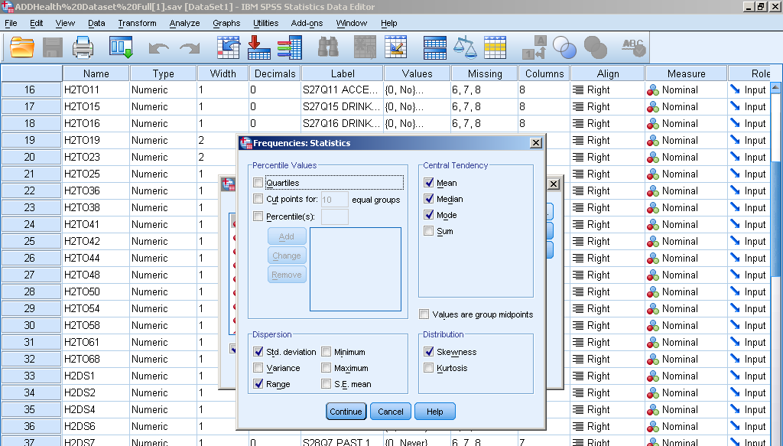
- Click paste to put it in syntax, and then run the analysis.
Syntax:
FREQUENCIES VARIABLES=CALCAGE2
/STATISTICS=STDDEV VARIANCE RANGE MINIMUM MAXIMUM SEMEAN MEAN MEDIAN MODE SKEWNESS SESKEW
/HISTOGRAM NORMAL
/ORDER=ANALYSIS.

Output Interpretation:
Statistics
CALCULATED AGE-W2
N | Valid | 4834
 | Missing | 0
Mean |  | 16.02
Std. Error of Mean |  | .023
Median |  | 16.00
Mode |  | 16
Std. Deviation |  | 1.619
Variance |  | 2.622
Skewness |  | .080
Std. Error of Skewness |  | .035
Range |  | 10
Minimum |  | 11
Maximum |  | 21
Central tendency gives mean (16.02), median (16.00) and mode (16). Measures of variability give range (10), variance (2.62), and standard deviation (1.61). Because the skewness is .08 that shows that the distribution is barely negatively skewed.

Dependent Sample t-test
Description:
These types of tests are used to compare groups that are related in some way. This test is used when the population mean and the population standard deviation are unknown.
SPSS Steps:
- Analyze Compare Means Paired –Samples T Test
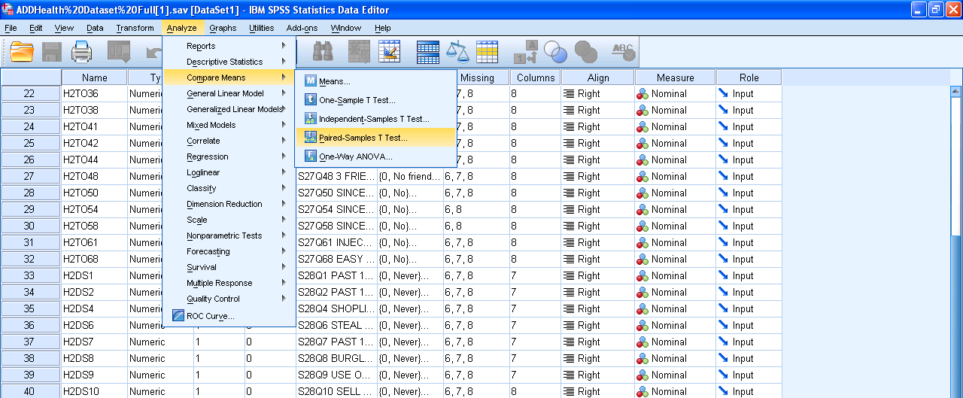
- Select the variable of interest and click the arrow to move it from the left hand list of variables to the right hand “paired variables” box.
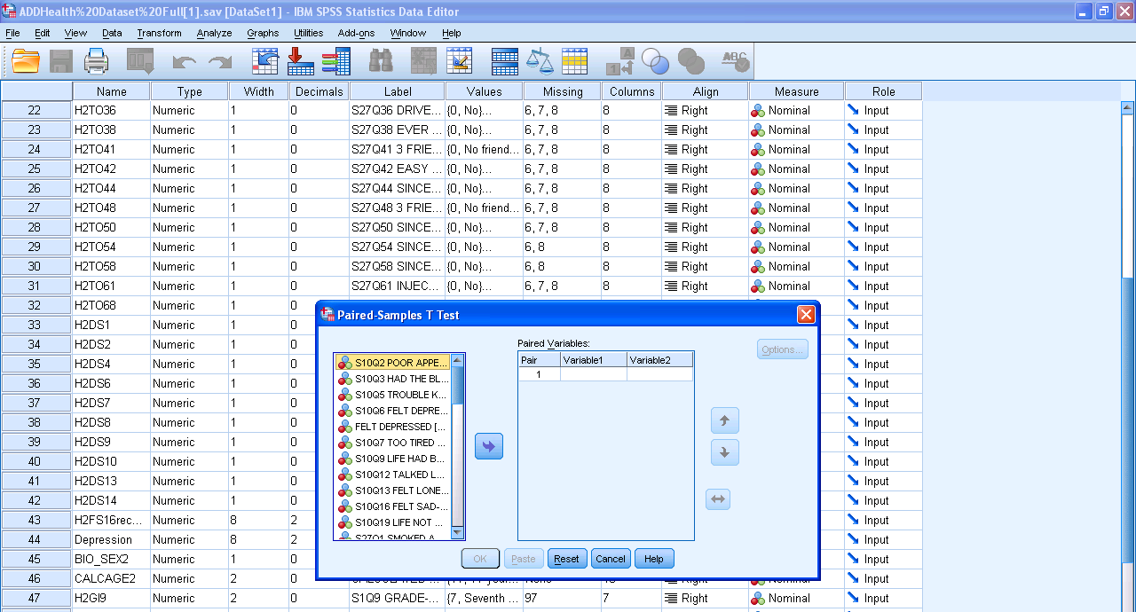
- Click paste to put it in syntax, and then run the analysis.
Syntax:
T-TEST PAIRS=H2FS6recodeDEPRESSED WITH BIO_SEXrecode (PAIRED)
/CRITERIA=CI(.9500)
/MISSING=ANALYSIS.
Output Interpretation:

Paired Samples Statistics
 |  | Mean | N | Std. Deviation | Std. Error Mean
Pair 1 | H2FS6recodeDEPRESSED | .4976 | 4827 | .73494 | .01058
 | BIO_SEXrecode | 1.5212 | 4827 | .49960 | .00719

Paired Samples Correlations
 |  | N | Correlation | Sig.
Pair 1 | H2FS6recodeDEPRESSED & BIO_SEXrecode | 4827 | -.003 | .844

Paired Samples Test
 |  | Paired Differences |  |  |  |  | t | df | Sig. (2-tailed)
 |  | Mean | Std. Deviation | Std. Error Mean | 95% Confidence Interval of the Difference
 |  |  |  |  | Lower | Upper
Pair 1 | H2FS6recodeDEPRESSED - BIO_SEXrecode | -1.02362 | .88984 | .01281 | -1.04873 | -.99851 | -79.922 | 4826 | .000

There was a significant different in the variables of Depression (M= .49, SD= .73) and Biological Sex (M= 1.52, SD= .5), t(4826)= -79.92, p< .01.
Independent Sample t-test
Description:
The independent t-test compares the means between two unrelated groups on the same continuous, dependent variable. The groups are independent from one another. So, participants in one group have no relationship to participants in the second group. The dependent variable is has to be on an interval scale.
SPSS Steps:
- Analyze Compare Means Independent – Sample T Test
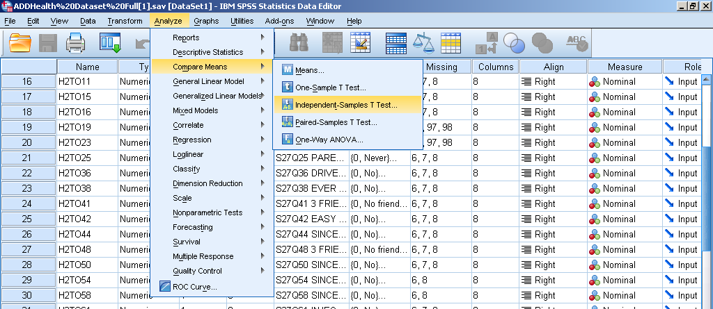
- Select the variable of interest and click the arrow to move it from the left hand list of variables to the right hand “test variables” box. This will be your dependent variable.
- Select the variable of interest and click the arrow to move it from the left hand list of variables to the right hand “Grouping Variable” box. This will be your independent variable and it will also be nominal.
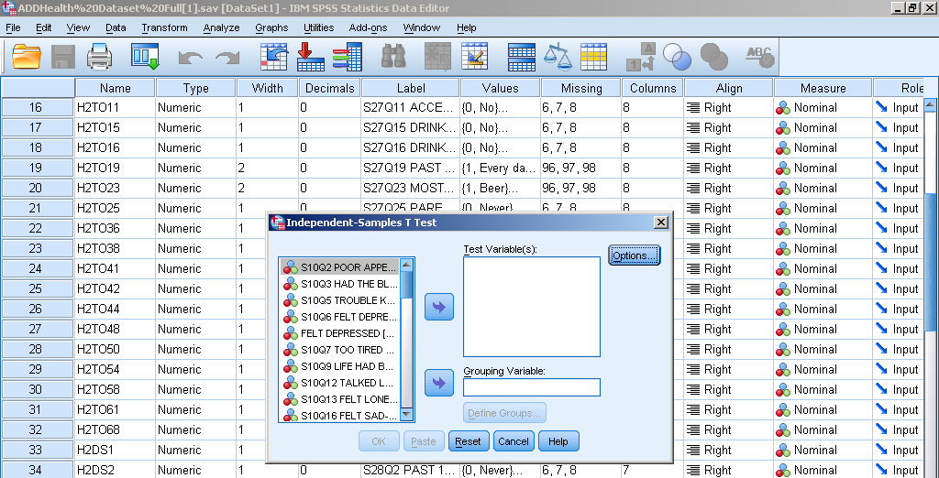
- Click “Define Groups” and fill out what your two groups are and hit continue.
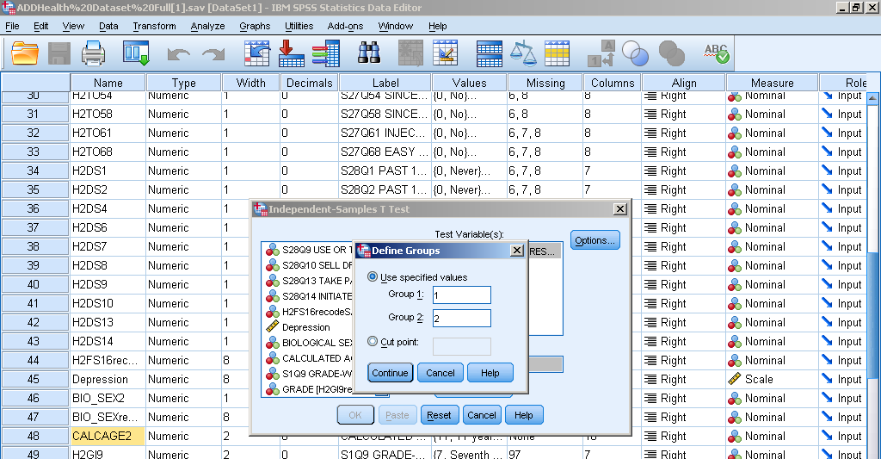
- Click paste to put it in syntax, and then run the analysis.

Syntax:
T-TEST GROUPS=BIO_SEXrecode(1 2)
/MISSING=ANALYSIS
/VARIABLES=H2FS6recodeDEPRESSED
/CRITERIA=CI(.95).
Output Interpretation:

Group Statistics
 | BIO_SEXrecode | N | Mean | Std. Deviation | Std. Error Mean
H2FS6recodeDEPRESSED | 1.00 | 2311 | .4998 | .73554 | .01530
 | 2.00 | 2516 | .4956 | .73454 | .01464

Independent Samples Test
 |  | Levene's Test for Equality of Variances |  | t-test for Equality of Means
 |  | F | Sig. | t | df | Sig. (2-tailed) | Mean Difference | Std. Error Difference | 95% Confidence Interval of the Difference
 |  |  |  |  |  |  |  |  | Lower | Upper
H2FS6recodeDEPRESSED | Equal variances assumed | .008 | .929 | .196 | 4825 | .844 | .00416 | .02118 | -.03736 | .04567
 | Equal variances not assumed |  |  | .196 | 4789.252 | .844 | .00416 | .02118 | -.03736 | .04568

There was a not significant difference in the scores for males (M= .499, SD= .735) and females (M= .495, SD= .734) conditions; t (4825)=.196, p = .844.
One-Way ANOVA
Description:
This test is used to determine whether there are any significant differences between the means of three or more independent (unrelated) groups. This tested is used when the groups of people are entirely separate, the dependent variable is continuous and the independent variable is nominal.
SPSS Steps:
- Analyze General Linear Model Multivariate
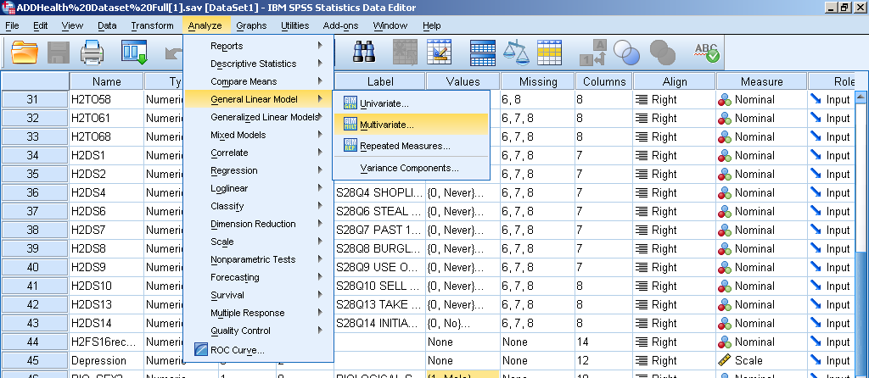
- Put the dependents variable(s) under from the left box to the right just by selecting it and clicking the middle blue arrow.
- Select the independent variable from the left box, click the blue arrow, and it will go under the “Fixed Factor(s).”

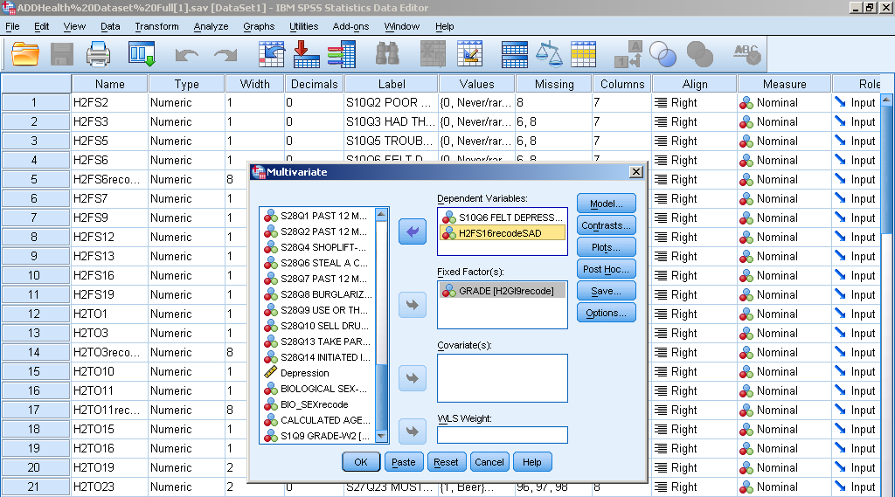
- Click paste to put it in syntax, then run the analysis.
Syntax:
GLM H2FS6 H2FS16recodeSAD BY H2GI9recode
/METHOD=SSTYPE(3)
/INTERCEPT=INCLUDE
/POSTHOC=H2GI9recode(TUKEY)
/EMMEANS=TABLES(H2GI9recode) COMPARE ADJ(LSD)
/CRITERIA=ALPHA(.05)
/DESIGN= H2GI9recode.
Output Interpretation:

Between-Subjects Factors
 |  | N
GRADE | 9.00 | 883
 | 10.00 | 881
 | 11.00 | 906
 | 12.00 | 835
 | 13.00 | 65

Tests of Between-Subjects Effects
Source | Dependent Variable | Type III Sum of Squares | df | Mean Square | F | Sig.
Corrected Model | S10Q6 FELT DEPRESSED-W2 | 10.944ª | 4 | 2.736 | 5.388 | .000
 | H2FS16recodeSAD | 7.764^{b} | 4 | 1.941 | 4.604 | .001
Intercept | S10Q6 FELT DEPRESSED-W2 | 271.823 | 1 | 271.823 | 535.320 | .000
 | H2FS16recodeSAD | 357.420 | 1 | 357.420 | 847.903 | .000
H2GI9recode | S10Q6 FELT DEPRESSED-W2 | 10.944 | 4 | 2.736 | 5.388 | .000
 | H2FS16recodeSAD | 7.764 | 4 | 1.941 | 4.604 | .001
Error | S10Q6 FELT DEPRESSED-W2 | 1810.223 | 3565 | .508
 | H2FS16recodeSAD | 1502.770 | 3565 | .422
Total | S10Q6 FELT DEPRESSED-W2 | 2646.000 | 3570
 | H2FS16recodeSAD | 2526.000 | 3570
Corrected Total | S10Q6 FELT DEPRESSED-W2 | 1821.166 | 3569
 | H2FS16recodeSAD | 1510.533 | 3569
a. R Squared = .006 (Adjusted R Squared = .005)
b. R Squared = .005 (Adjusted R Squared = .004)

There was not a significant effect of grade on feeling depressed or sad, F(4, 3569) = 5.39, p >.001.
One-Way ANOVA post hoc
Description:
If you find a significant effect using a One-Way ANOVA, you can conclude that there is a significant difference between some of the conditions in your experiment and you use a post hoc test to see where the difference is at. Tukey Post Hoc test is commonly used.
SPSS Steps:
- Follow the steps for the One-Way ANOVA
- Click Post Hoc
- Check Tukey
- Click Continue
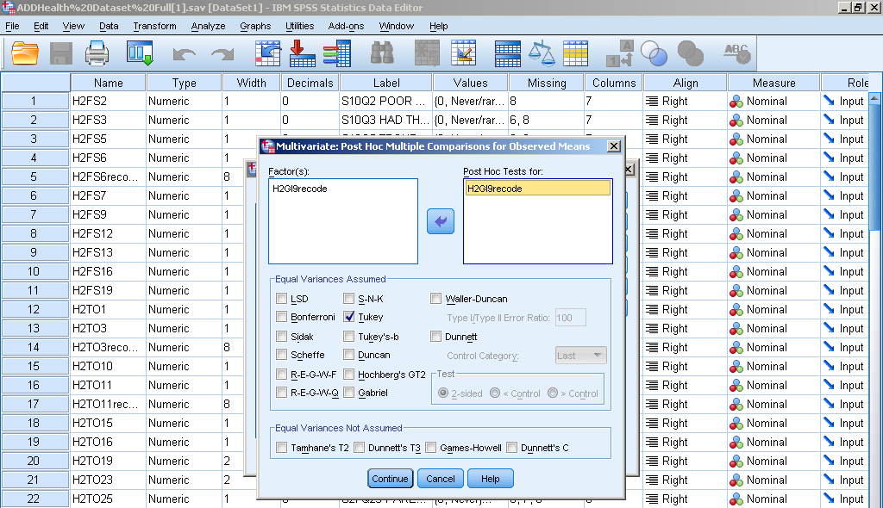

Repeated Measures ANOVA
Description:
This test is for comparing three or more group means where the participants are the same in each group. This usually occurs in two situations - when participants are measured multiple times to see changes to an intervention or when participants are subjected to more than one condition/trial and the response to each of these conditions wants to be compared.
SPSS Steps:
- Analyze General Linear Model Repeated Measures
- In the box under “Within-Subject Factor Name” put a name that sums up what you are testing.
- In the next box “Number of Levels” put how many levels you are testing.
- Press add then press Define.
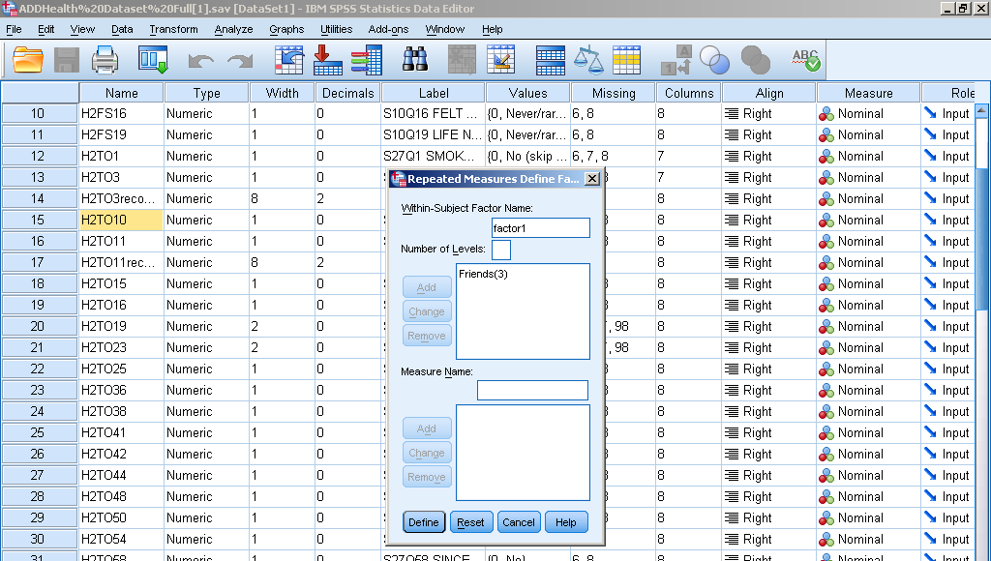
- Pick the variables you are testing from the left box and move them over via the blue arrow to the right box.
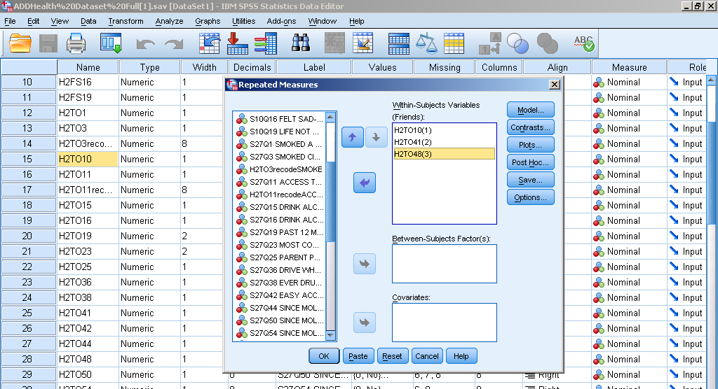
- Click paste to put it in syntax, then run the analysis.
Syntax:
GLM H2TO10 H2TO41 H2TO48
/WSFACTOR=Friends 3 Polynomial
/METHOD=SSTYPE(3)
/EMMEANS=TABLES(Friends)
/PRINT=DESCRIPTIVE HOMOGENEITY
/CRITERIA=ALPHA(.05)
/WSDESIGN=Friends.
Output Interpretation:
Within-Subjects Factors
Measure:MEASURE_1
Friends | Dependent Variable
1 | H2TO10
2 | H2TO41
3 | H2TO48

Descriptive Statistics
 | Mean | Std. Deviation | N
S27Q10 HOW MANY FRIENDS SMOKE-W2 | .92 | 1.102 | 4702
S27Q41 3 FRIENDS-DRINK >1 A MONTH-W2 | 1.14 | 1.175 | 4702
S27Q48 3 FRIENDS-SMOKE POT >1 A MONTH-W2 | .70 | 1.010 | 4702

Multivariate Tests^{b}
Effect |  | Value | F | Hypothesis df | Error df | Sig.
Friends | Pillai's Trace | .146 | 402.687ª | 2.000 | 4700.000 | .000
 | Wilks' Lambda | .854 | 402.687ª | 2.000 | 4700.000 | .000
 | Hotelling's Trace | .171 | 402.687ª | 2.000 | 4700.000 | .000
 | Roy's Largest Root | .171 | 402.687ª | 2.000 | 4700.000 | .000
a. Exact statistic
b. Design: Intercept
Within Subjects Design: Friends

Mauchly's Test of Sphericity^{b}
Measure:MEASURE_1
Within Subjects Effect | Mauchly's W | Approx. Chi-Square | df | Sig. | Epsilonª
 |  |  |  |  | Greenhouse-Geisser | Huynh-Feldt | Lower-bound
Friends | .990 | 48.256 | 2 | .000 | .990 | .990 | .500
Tests the null hypothesis that the error covariance matrix of the orthonormalized transformed dependent variables is proportional to an identity matrix.
a. May be used to adjust the degrees of freedom for the averaged tests of significance. Corrected tests are displayed in the Tests of Within-Subjects Effects table.
b. Design: Intercept
Within Subjects Design: Friends

Tests of Within-Subjects Effects
Measure:MEASURE_1
Source |  | Type III Sum of Squares | df | Mean Square | F | Sig.
Friends | Sphericity Assumed | 456.545 | 2 | 228.272 | 375.161 | .000
 | Greenhouse-Geisser | 456.545 | 1.980 | 230.604 | 375.161 | .000
 | Huynh-Feldt | 456.545 | 1.981 | 230.507 | 375.161 | .000
 | Lower-bound | 456.545 | 1.000 | 456.545 | 375.161 | .000
Error(Friends) | Sphericity Assumed | 5720.789 | 9402 | .608
 | Greenhouse-Geisser | 5720.789 | 9306.932 | .615
 | Huynh-Feldt | 5720.789 | 9310.833 | .614
 | Lower-bound | 5720.789 | 4701.000 | 1.217

Tests of Within-Subjects Contrasts
Measure:MEASURE_1
Source | Friends | Type III Sum of Squares | df | Mean Square | F | Sig.
Friends | Linear | 111.721 | 1 | 111.721 | 190.512 | .000
 | Quadratic | 344.824 | 1 | 344.824 | 546.899 | .000
Error(Friends) | Linear | 2756.779 | 4701 | .586
 | Quadratic | 2964.010 | 4701 | .631

Tests of Between-Subjects Effects
Measure:MEASURE_1
Transformed Variable:Average
Source | Type III Sum of Squares | df | Mean Square | F | Sig.
Intercept | 11892.408 | 1 | 11892.408 | 4956.110 | .000
Error | 11280.259 | 4701 | 2.400

Friends
Measure:MEASURE_1
Friends | Mean | Std. Error | 95% Confidence Interval
 |  |  | Lower Bound | Upper Bound
1 | .917 | .016 | .885 | .948
2 | 1.139 | .017 | 1.106 | 1.173
3 | .699 | .015 | .670 | .728

Two-Way ANOVA
Description:
This test compares the mean differences between groups that have been split on two independent variables (called factors). You need two independent, categorical variables and one continuous, dependent variable.
SPSS steps:
- Analyze General Linear Model Univariate
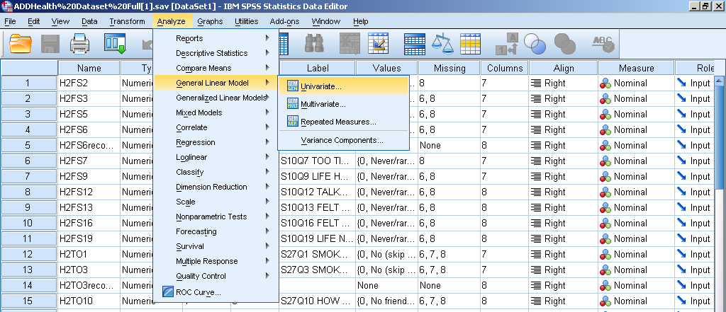
- Select the dependent variable from the left box and click the blue arrow to move it to the right box that says “Dependent Variable.”
- Under “Fixed Factors” put the selected independent variables from the left box to the right box.
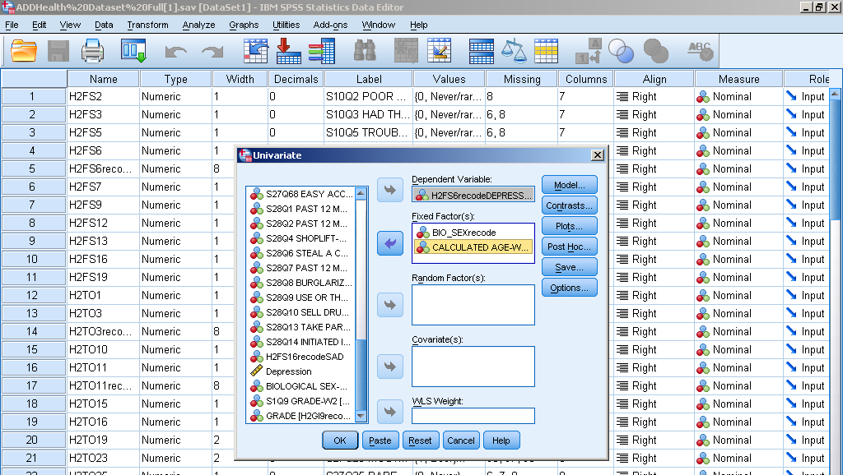
- Click options and select all the options in the left box other than (OVERALL) and more them to the right box using the blue arrow.
- Check off Descriptive Statistics and Homogeneity tests and press continue.
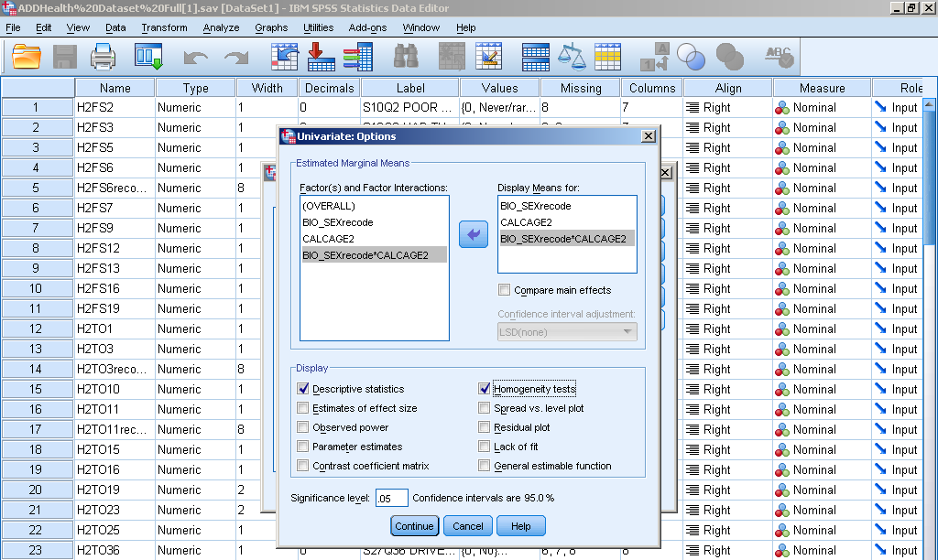
- Click paste to put it in syntax, then run the analysis.
Syntax:
UNIANOVA H2FS6recodeDEPRESSED BY BIO_SEXrecode CALCAGE2
/METHOD=SSTYPE(3)
/INTERCEPT=INCLUDE
/EMMEANS=TABLES(BIO_SEXrecode)
/EMMEANS=TABLES(CALCAGE2)
/EMMEANS=TABLES(BIO_SEXrecode*CALCAGE2)
/PRINT=HOMOGENEITY DESCRIPTIVE
/CRITERIA=ALPHA(.05)
/DESIGN=BIO_SEXrecode CALCAGE2 BIO_SEXrecode*CALCAGE2.
Output Interpretation:

Descriptive Statistics
Dependent Variable:H2FS6recodeDEPRESSED
BIO_SEXrecode | CALCULATED AGE-W2 | Mean | Std. Deviation | N
1.00 | 11 years old | 1.0000 | . | 1
 | 12 years old | .0000 | .00000 | 2
 | 13 years old | .5729 | .80452 | 96
 | 14 years old | .4527 | .68328 | 349
 | 15 years old | .5776 | .85871 | 419
 | 16 years old | .4989 | .72175 | 467
 | 17 years old | .4542 | .69532 | 469
 | 18 years old | .4959 | .70468 | 367
 | 19 years old | .5351 | .66758 | 114
 | 20 years old | .3636 | .65795 | 22
 | 21 years old | .4000 | .54772 | 5
 | Total | .4998 | .73554 | 2311
2.00 | 11 years old | .0000 | . | 1
 | 12 years old | 1.0000 | . | 1
 | 13 years old | .5474 | .74726 | 137
 | 14 years old | .6231 | .88859 | 398
 | 15 years old | .5602 | .78555 | 498
 | 16 years old | .4646 | .68662 | 523
 | 17 years old | .3964 | .62365 | 497
 | 18 years old | .4265 | .65596 | 347
 | 19 years old | .5326 | .71792 | 92
 | 20 years old | .2632 | .56195 | 19
 | 21 years old | .6667 | 1.15470 | 3
 | Total | .4956 | .73454 | 2516
Total | 11 years old | .5000 | .70711 | 2
 | 12 years old | .3333 | .57735 | 3
 | 13 years old | .5579 | .76976 | 233
 | 14 years old | .5435 | .80326 | 747
 | 15 years old | .5682 | .81938 | 917
 | 16 years old | .4808 | .70326 | 990
 | 17 years old | .4244 | .65971 | 966
 | 18 years old | .4622 | .68184 | 714
 | 19 years old | .5340 | .68880 | 206
 | 20 years old | .3171 | .60988 | 41
 | 21 years old | .5000 | .75593 | 8
 | Total | .4976 | .73494 | 4827

Tests of Between-Subjects Effects
Dependent Variable:H2FS6recodeDEPRESSED
Source | Type III Sum of Squares | df | Mean Square | F | Sig.
Corrected Model | 23.886ª | 21 | 1.137 | 2.116 | .002
Intercept | 27.986 | 1 | 27.986 | 52.063 | .000
BIO_SEXrecode | .004 | 1 | .004 | .007 | .931
CALCAGE2 | 14.622 | 10 | 1.462 | 2.720 | .002
BIO_SEXrecode * CALCAGE2 | 8.795 | 10 | .879 | 1.636 | .090
Error | 2582.837 | 4805 | .538
Total | 3802.000 | 4827
Corrected Total | 2606.723 | 4826
a. R Squared = .009 (Adjusted R Squared = .005)

3. BIO_SEXrecode * CALCULATED AGE-W2
Dependent Variable:H2FS6recodeDEPRESSED
BIO_SEXrecode | CALCULATED AGE-W2 | Mean | Std. Error | 95% Confidence Interval
 |  |  |  | Lower Bound | Upper Bound
1.00 | 11 years old | 1.000 | .733 | -.437 | 2.437
 | 12 years old | -3.331E-16 | .518 | -1.016 | 1.016
 | 13 years old | .573 | .075 | .426 | .720
 | 14 years old | .453 | .039 | .376 | .530
 | 15 years old | .578 | .036 | .507 | .648
 | 16 years old | .499 | .034 | .432 | .565
 | 17 years old | .454 | .034 | .388 | .521
 | 18 years old | .496 | .038 | .421 | .571
 | 19 years old | .535 | .069 | .400 | .670
 | 20 years old | .364 | .156 | .057 | .670
 | 21 years old | .400 | .328 | -.243 | 1.043
2.00 | 11 years old | 1.110E-16 | .733 | -1.437 | 1.437
 | 12 years old | 1.000 | .733 | -.437 | 2.437
 | 13 years old | .547 | .063 | .425 | .670
 | 14 years old | .623 | .037 | .551 | .695
 | 15 years old | .560 | .033 | .496 | .625
 | 16 years old | .465 | .032 | .402 | .527
 | 17 years old | .396 | .033 | .332 | .461
 | 18 years old | .427 | .039 | .349 | .504
 | 19 years old | .533 | .076 | .383 | .682
 | 20 years old | .263 | .168 | -.067 | .593
 | 21 years old | .667 | .423 | -.163 | 1.497

There was a significant interaction between the effects of biological sex and age on depression, F (10, 4827) = 1.64, p= .09. There was no significant difference in depression between biological sex (P = .931) but there were significant differences between age (P= .002).

Correlation
Description:
This test is a measure of the strength and direction of association between scores on two (and only two) variables that are considered equal-interval variables. Pearson’s r is a statistic that helps you understand the strength of the linear relationship between two variables.
SPSS Steps:
- Analyze Correlate Bivariate
2. Select the variables of interest and click the arrow to move it from the left hand list of variables to the right hand “variables” box.
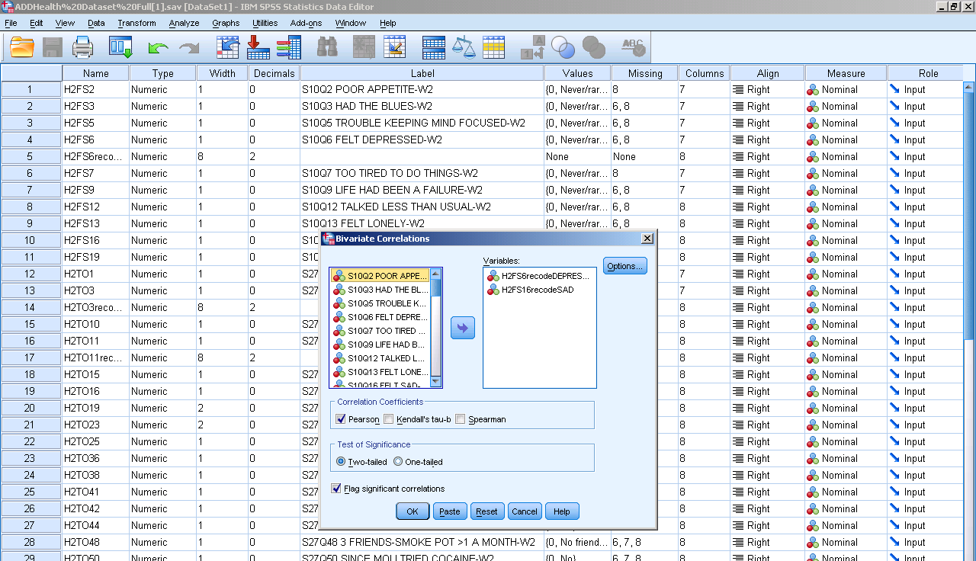
3. Click options, check “Means and standard deviation” and then press continue.

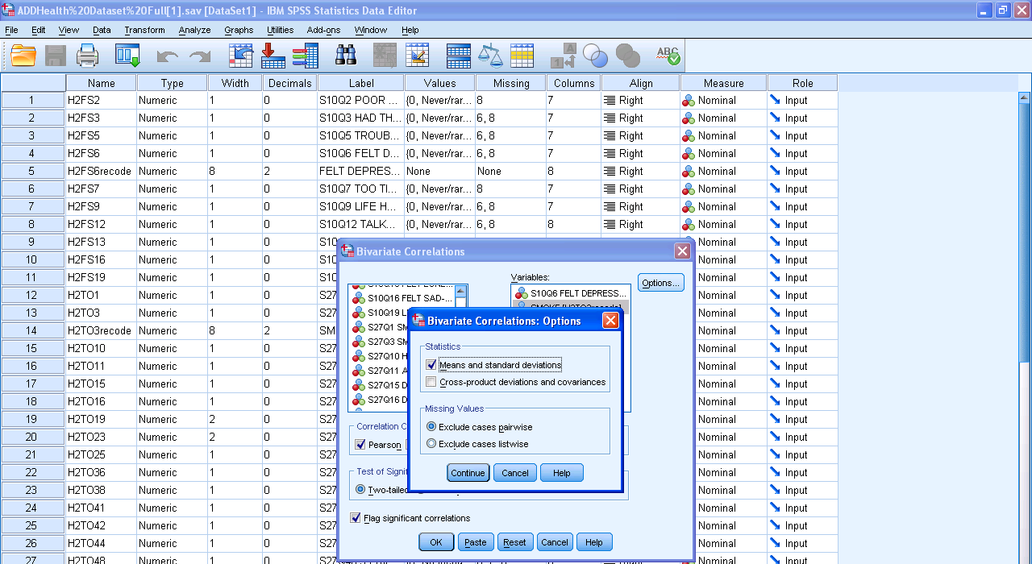

4. Click paste to put it in syntax, then run the analysis.
Syntax:
CORRELATIONS
/VARIABLES=H2FS6recodeDEPRESSED H2FS16recodeSAD
/PRINT=TWOTAIL NOSIG
/STATISTICS DESCRIPTIVES
/MISSING=PAIRWISE.
GRAPH
/SCATTERPLOT(BIVAR)=H2FS16recodeSAD WITH H2FS6recodeDEPRESSED
/MISSING=LISTWISE.

Output:
Descriptive Statistics
 | Mean | Std. Deviation | N
H2FS6recodeDEPRESSED | .4976 | .73494 | 4827
H2FS16recodeSAD | .5507 | .66814 | 4827

Correlations
 |  | H2FS6recodeDEPRESSED | H2FS16recodeSAD
H2FS6recodeDEPRESSED | Pearson Correlation | 1 | .626**
 | Sig. (2-tailed) |  | .000
 | N | 4827 | 4826
H2FS16recodeSAD | Pearson Correlation | .626** | 1
 | Sig. (2-tailed) | .000
 | N | 4826 | 4827
**. Correlation is significant at the 0.01 level (2-tailed).

There was a positive correlation between feeling depression and feeling sad, which was statistically significant (r = .626, n = 4827, p < .001).

Regression
Description:
Regression analysis is the next step up after correlation; it is used when we want to predict the value of a variable based on the value of another variable. Variables are measured at the interval or ratio level (continuous). There is a linear relationship between the two variables.
SPSS Steps:
1. Analyze Regression Linear
2. Pick a variable of interest from the left box and put it in the “Dependent” box on the right side. And do the same for the next variable but put it in the “Independent(s)” box. It doesn’t matter which variable goes in which box.
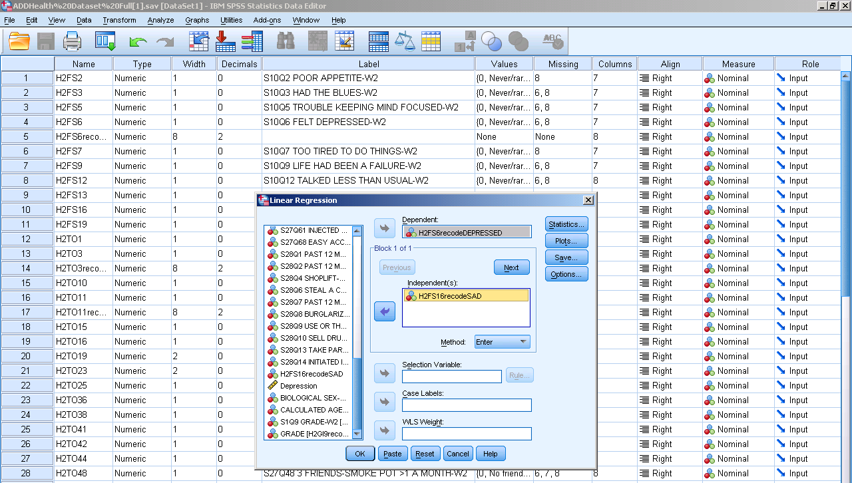
3. Click “Statistics” and check off estimates, model if, and descriptives. Then press contniue.
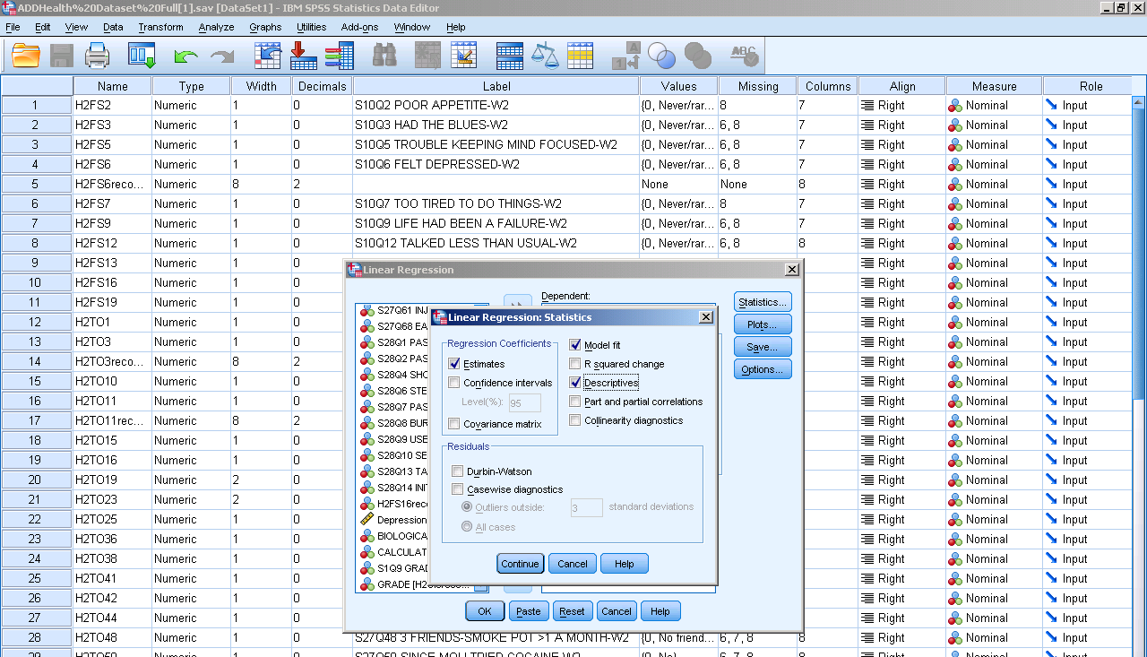
4. Click paste to put it in syntax, then run the analysis.
Syntax:
REGRESSION
/DESCRIPTIVES MEAN STDDEV CORR SIG N
/MISSING LISTWISE
/STATISTICS COEFF OUTS R ANOVA
/CRITERIA=PIN(.05) POUT(.10)
/NOORIGIN
/DEPENDENT H2FS6recodeDEPRESSED
/METHOD=ENTER H2FS16recodeSAD.
Output:
Descriptive Statistics
 | Mean | Std. Deviation | N
H2FS6recodeDEPRESSED | .4977 | .73498 | 4826
H2FS16recodeSAD | .5508 | .66816 | 4826

Correlations
 |  | H2FS6recodeDEPRESSED | H2FS16recodeSAD
Pearson Correlation | H2FS6recodeDEPRESSED | 1.000 | .626
 | H2FS16recodeSAD | .626 | 1.000
Sig. (1-tailed) | H2FS6recodeDEPRESSED | . | .000
 | H2FS16recodeSAD | .000 | .
N | H2FS6recodeDEPRESSED | 4826 | 4826
 | H2FS16recodeSAD | 4826 | 4826

Variables Entered/Removed^{b}
Model | Variables Entered | Variables Removed | Method
1 | H2FS16recodeSAD | . | Enter
a. All requested variables entered.
b. Dependent Variable: H2FS6recodeDEPRESSED

Model Summary
Model | R | R Square | Adjusted R Square | Std. Error of the Estimate
1 | .626ª | .392 | .392 | .57303
a. Predictors: (Constant), H2FS16recodeSAD

ANOVA^{b}
Model |  | Sum of Squares | df | Mean Square | F | Sig.
1 | Regression | 1022.454 | 1 | 1022.454 | 3113.796 | .000ª
 | Residual | 1584.021 | 4824 | .328
 | Total | 2606.475 | 4825
a. Predictors: (Constant), H2FS16recodeSAD
b. Dependent Variable: H2FS6recodeDEPRESSED

Coefficientsª
Model |  | Unstandardized Coefficients |  | Standardized Coefficients | t | Sig.
 |  | B | Std. Error | Beta
1 | (Constant) | .118 | .011 |  | 11.063 | .000
 | H2FS16recodeSAD | .689 | .012 | .626 | 55.801 | .000
a. Dependent Variable: H2FS6recodeDEPRESSED

R= .63, n= 4824, p< .001. R² = .4, F(1, 4824) = 11.06, p < .001. Ŷ= .12 + .69(x)

Scatterplot with Regression Line
Description:
This line is added after doing a correlation test to show a prediction between two variables. The slope is the amount the line moves up for every unit of X it moves up.
SPSS Step:
1. Run a correlation test (look at page 34)
2. Under Output
Graphs Legacy Dialogs Scatter/Dot
3. Click Simple Scatter then press define.
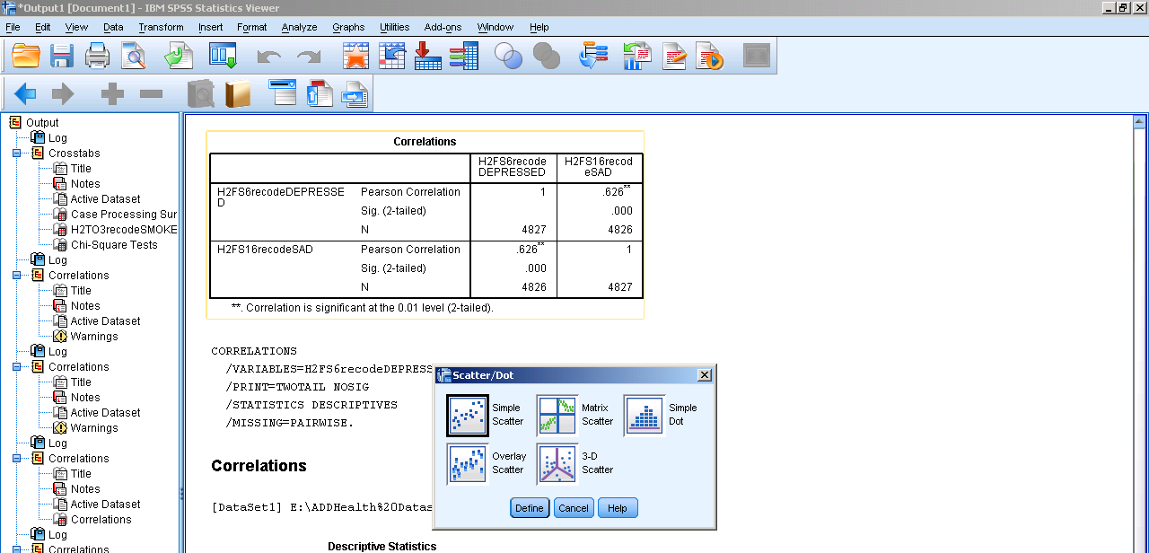
4. Pick your varaibles to go onto your Y and X Axis.
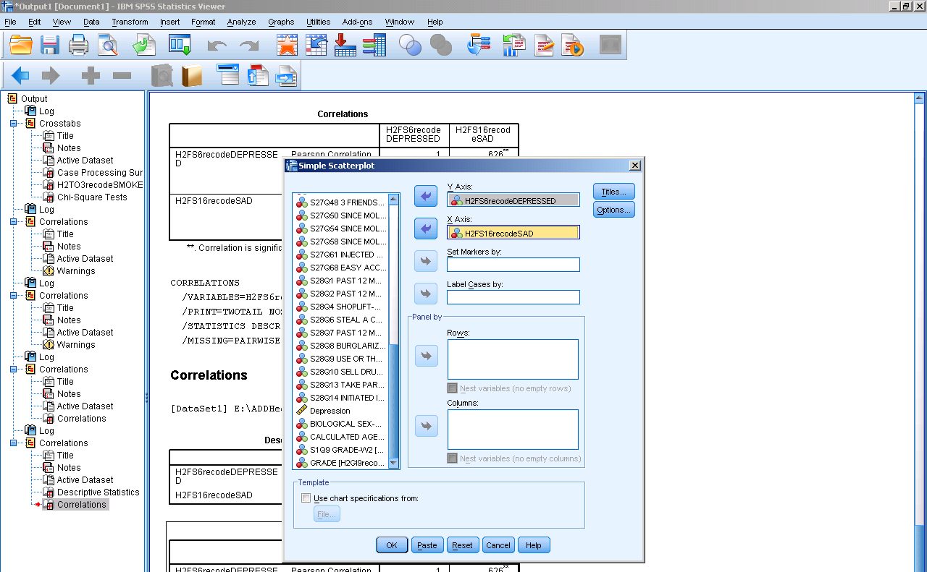
5. Click paste to put it in syntax, then run the analysis.

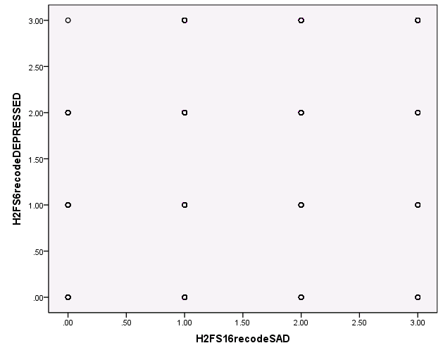
6. Double click the graph.
7. Under Chart Editor
Elements Fit line at Total
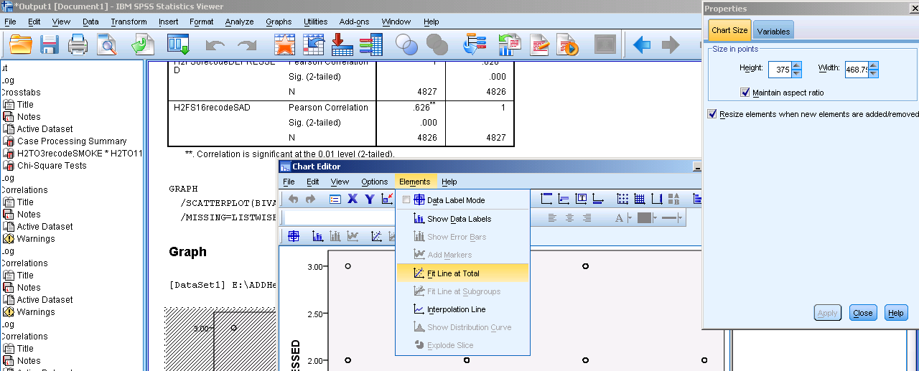
8. Under Properties, click the Fit Line tab and click Linear.

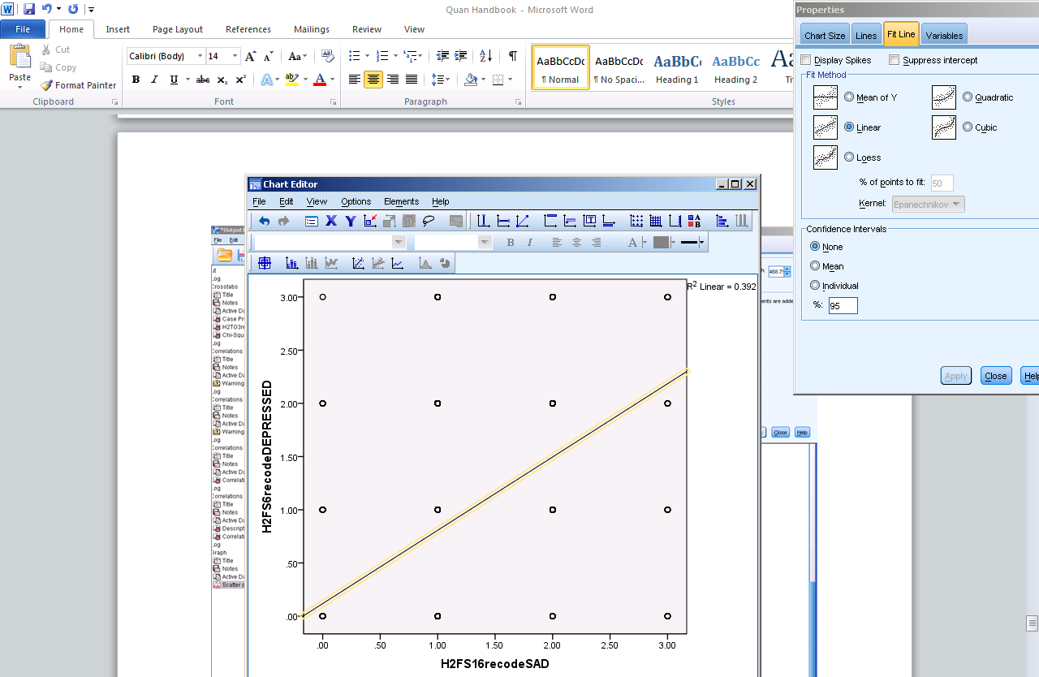
There is a weak positive correlation between the two variables.

Goodness of Fit Chi-Square
Description:
This test is used to determine whether a sample of data came from a population with a specific distribution. This test needs one categorical variable, with two or more categories. For this test you compare actual or observed frequencies to expected frequencies.
SPSS Steps:
1. Analyze Nonparametric Tests Legacy Dialogs Chi-square
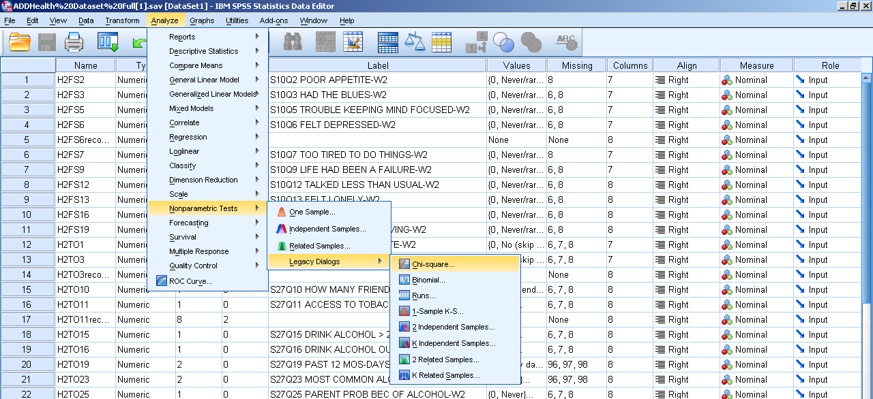
2. Select the variable of interest and click the arrow to move it from the left hand list of variables to the right hand “Test Variables List” box.
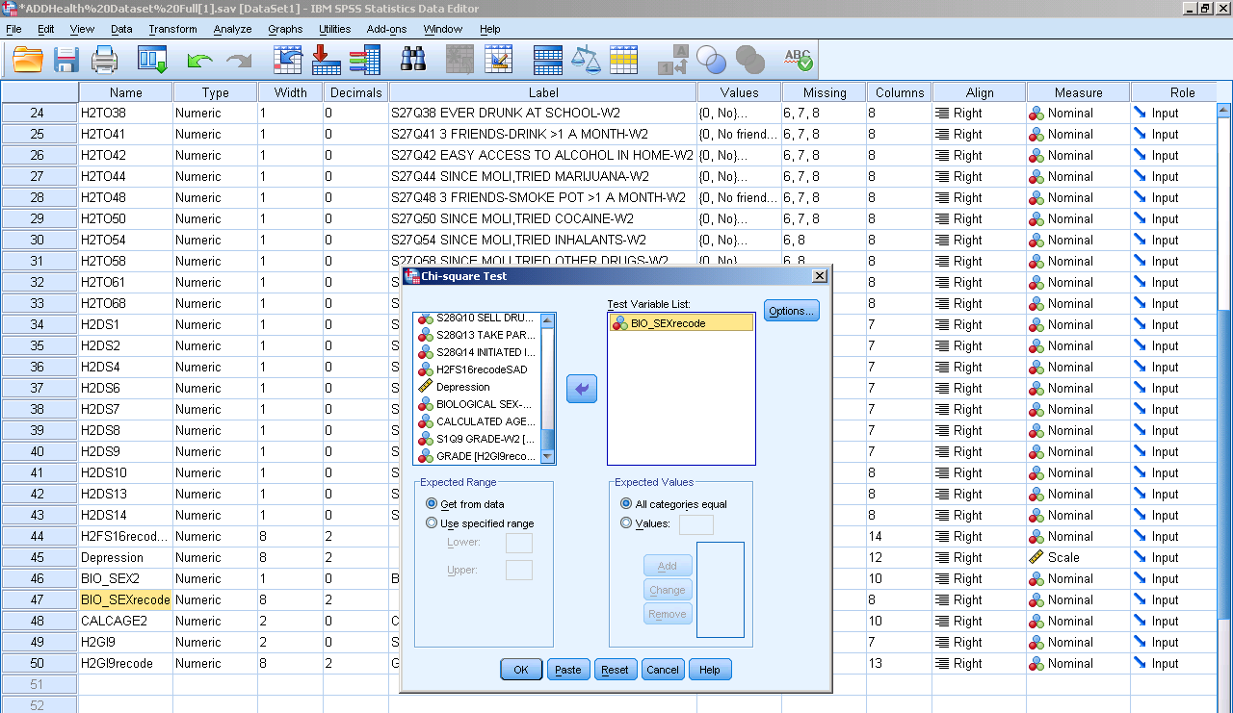
3. Click paste to put it in syntax, then run the analysis.
Syntax:
NPAR TESTS
/CHISQUARE=BIO_SEXrecode
/EXPECTED=EQUAL
/MISSING ANALYSIS.

Output Interpretation:
BIO_SEXrecode
 | Observed N | Expected N | Residual
1.00 | 2315 | 2417.0 | -102.0
2.00 | 2519 | 2417.0 | 102.0
Total | 4834

Test Statistics
 | BIO_SEXrecode
Chi-Square | 8.609ª
df | 1
Asymp. Sig. | .003
a. 0 cells (.0%) have expected frequencies less than 5. The minimum expected cell frequency is 2417.0.

Χ²(1, 4834)=8.6, p<.003
Contingency Table Chi-Square
Description:
The Chi-Square test for independence, also called Pearson's Chi-square test or the Chi-square test of association is used to discover if there is a relationship between two categorical variables. This test requires that you have two variables that are on the nominal scale. This test focuses on the difference of people in the different combinations rather than simple frequencies.
SPSS Steps:
1. Analyze Descriptive Statistics Crosstabs
- Select a variable of interest and click the arrow to move it from the left hand list of variables to the right hand “Row(s)” box.
- Select a variable of interest and click the arrow to move it from the left hand list of variables to the right hand “Column(s)” box.
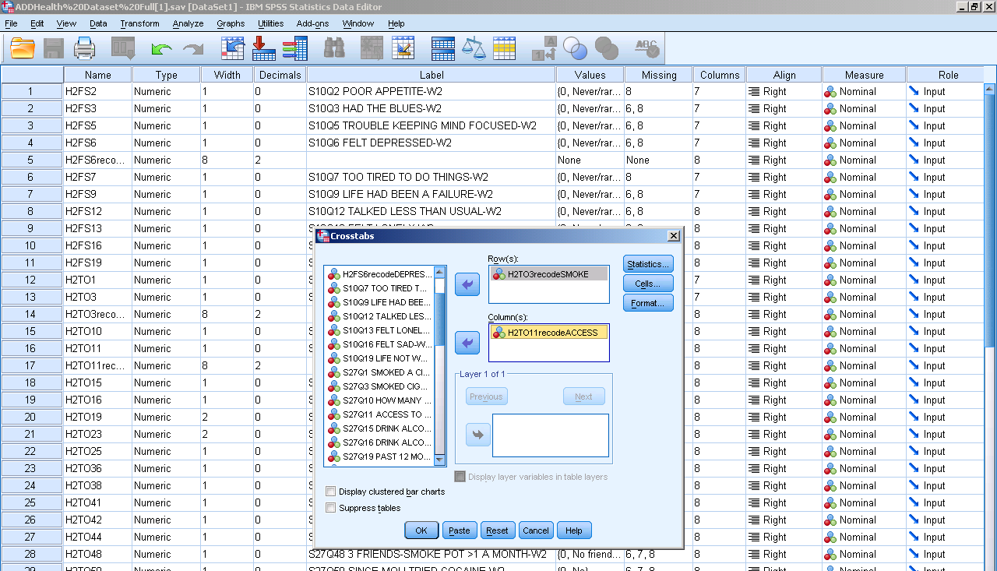
4. Under Statistics, check Chi-square then press continue.
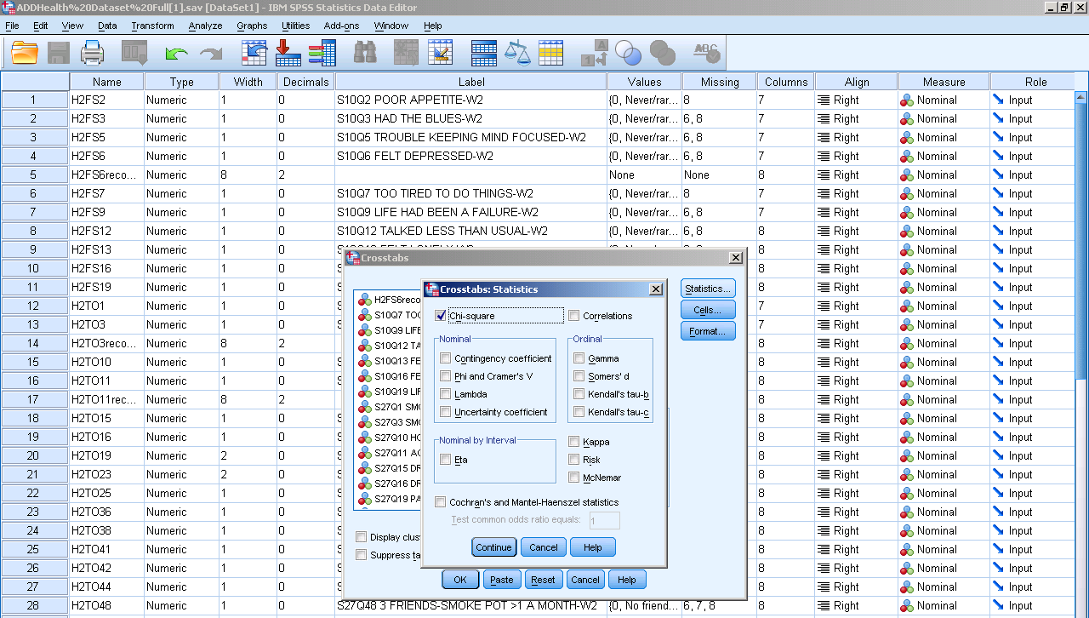
5. Under Cells, check off Observed, Expected, Row, Column, and Total then press continue.
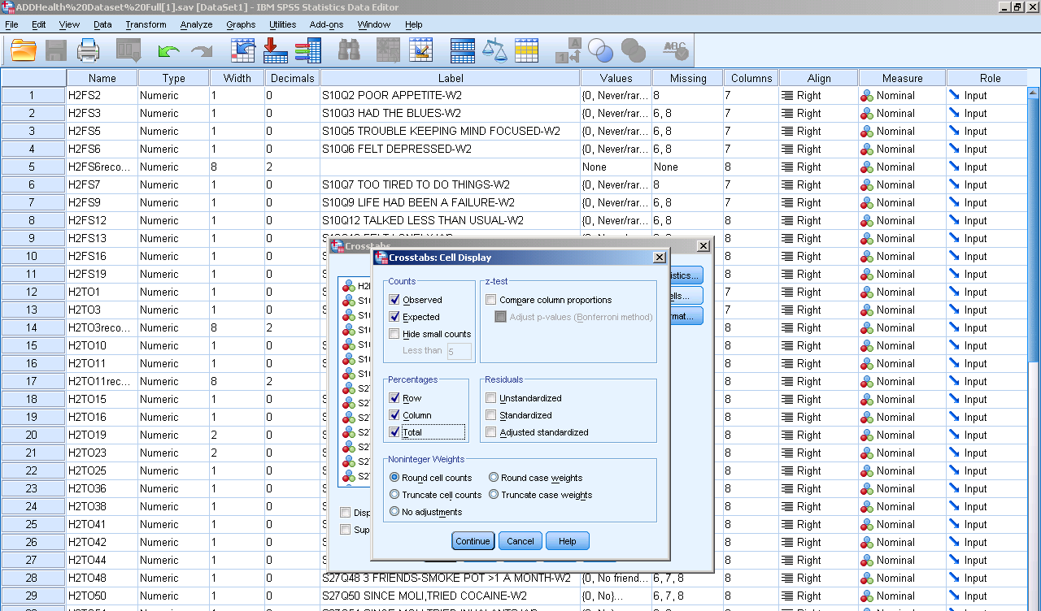
6. Click paste to put it in syntax, then run the analysis.

Syntax:
DATASET ACTIVATE DataSet1.
CROSSTABS
/TABLES=H2TO3recodeSMOKE BY H2TO11recodeACCESS
/FORMAT=AVALUE TABLES
/STATISTICS=CHISQ
/CELLS=COUNT EXPECTED ROW COLUMN TOTAL
/COUNT ROUND CELL.
Output Interpretation:
Case Processing Summary
 | Cases
 | Valid |  | Missing |  | Total
 | N | Percent | N | Percent | N | Percent
H2TO3recodeSMOKE * H2TO11recodeACCESS | 2127 | 44.0% | 2707 | 56.0% | 4834 | 100.0%

H2TO3recodeSMOKE * H2TO11recodeACCESS Crosstabulation
 |  |  | H2TO11recodeACCESS |  | Total
 |  |  | .00 | 1.00
H2TO3recodeSMOKE | .00 | Count | 822 | 320 | 1142
 |  | Expected Count | 724.8 | 417.2 | 1142.0
 |  | % within H2TO3recodeSMOKE | 72.0% | 28.0% | 100.0%
 |  | % within H2TO11recodeACCESS | 60.9% | 41.2% | 53.7%
 |  | % of Total | 38.6% | 15.0% | 53.7%
 | 1.00 | Count | 528 | 457 | 985
 |  | Expected Count | 625.2 | 359.8 | 985.0
 |  | % within H2TO3recodeSMOKE | 53.6% | 46.4% | 100.0%
 |  | % within H2TO11recodeACCESS | 39.1% | 58.8% | 46.3%
 |  | % of Total | 24.8% | 21.5% | 46.3%
Total |  | Count | 1350 | 777 | 2127
 |  | Expected Count | 1350.0 | 777.0 | 2127.0
 |  | % within H2TO3recodeSMOKE | 63.5% | 36.5% | 100.0%
 |  | % within H2TO11recodeACCESS | 100.0% | 100.0% | 100.0%
 |  | % of Total | 63.5% | 36.5% | 100.0%

Chi-Square Tests
 | Value | df | Asymp. Sig. (2-sided) | Exact Sig. (2-sided) | Exact Sig. (1-sided)
Pearson Chi-Square | 77.013ª | 1 | .000
Continuity Correction^{b} | 76.223 | 1 | .000
Likelihood Ratio | 77.226 | 1 | .000
Fisher's Exact Test |  |  |  | .000 | .000
Linear-by-Linear Association | 76.977 | 1 | .000
N of Valid Cases | 2127
a. 0 cells (.0%) have expected count less than 5. The minimum expected count is 359.82.
b. Computed only for a 2x2 table

Χ²(1, 4834)=77.01, p<.001

Reliability Analysis
Description:
Cronbach's alpha is the most common measure of internal consistency ("reliability"). It is most commonly used when you have multiple Likert questions in a survey/questionnaire that form a scale and you wish to determine if the scale is reliable.
SPSS Steps:
1. Analyze Scale Reliability Analysis
2. Select the variables of interest and click the arrow to move it from the left hand list of variables to the right hand “Items” box.
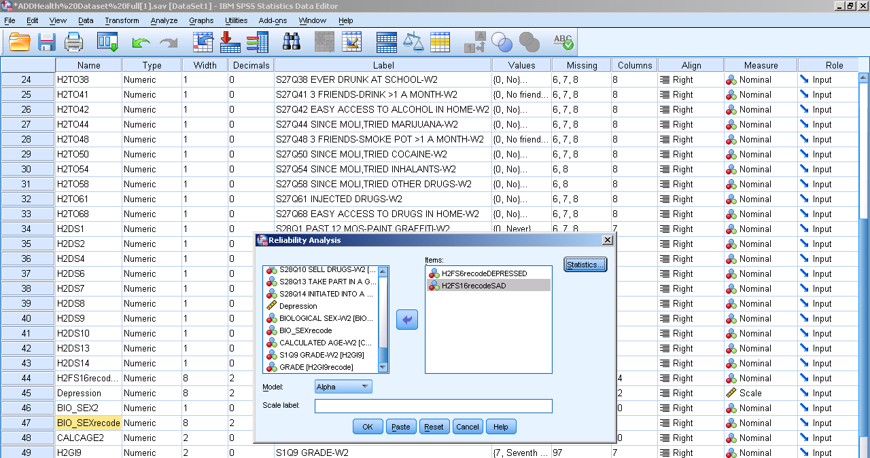
3. Click paste to put it in syntax, then run the analysis.
Syntax:
RELIABILITY
/VARIABLES=H2FS6recodeDEPRESSED H2FS16recodeSAD
/SCALE('ALL VARIABLES') ALL
/MODEL=ALPHA
/STATISTICS=DESCRIPTIVE CORR
/SUMMARY=MEANS VARIANCE CORR.

Output Interpretation:
Case Processing Summary
 |  | N | %
Cases | Valid | 4826 | 99.8
 | Excludedª | 8 | .2
 | Total | 4834 | 100.0
a. Listwise deletion based on all variables in the procedure.

Reliability Statistics
Cronbach's Alpha | Cronbach's Alpha Based on Standardized Items | N of Items
.768 | .770 | 2

Cronbach's alpha is 0.77, which indicates a high level of internal consistency for our scale with this specific sample.

