The Effect of Sorority Membership on Perceived Eating Disorder Probability
Sydney N. Gaver
Longwood University
Abstract
This experiment is designed to examine to effect of sorority membership on perceived eating disorder probability. Participants will be male and female students of traditional university age who attend a small liberal arts university. I will randomly assign the participants to either a Greek condition or a non-Greek condition. Depending on the assigned condition, I will show the participants a photograph of a woman who is either wearing a plain black shirt or a shirt with Greek letters on it. The participants will complete a Likert scale assessing personality traits and other informational hypotheses about the woman in the picture. I expect to find that participants will be significantly more likely to perceive the sorority woman as having an eating disorder than the woman who is not in a sorority.
Keywords: eating disorder, sorority membership, college women

The Effect of Sorority Membership on Perceived Eating Disorder Probability
While eating disorders have the potential to affect anyone, regardless of weight, sex, or gender, they are multifaceted disorders with many potential causes. Social, psychological, and biological variables have all been identified in the development of eating disorders. Although these variables are able to affect anyone in the general population, previous research has shown that women score higher on scales intended to measure concern about body size, drive for thinness, social physique anxiety, and dietary restriction (Bungam & Lofton, 2003). Considering these results, it has been found that college women are especially vulnerable to developing eating disorders due to the cultural pressure to be thin (Trautman, Worthy, & Lokken, 2007). College women are also more likely to need interventions in order to seek treatment for heir eating disorders (Schwitzer et al., 2008). There is no clear explanation as to why this is the case, but further research has shown that vulnerability to the development of eating disorders is even more amplified within the population of college women that are members of sororities (Basow, Foran, & Bookwala, 2007).
Sororities are thought to attract women that are already susceptible to eating disorders (Basow et al., 2007). Rolnik, Maddox, & Miller (2010) found that women who intended to go through sorority recruitment scored higher on measures indicating self-objectification and eating disordered behavior and attitudes when compared with their peers who did not intend on participating in recruitment. Although these data indicate that only women going through sorority recruitment view themselves critically, it has been found that women in general show a preference for an underweight standing on the Body Mass Index (BMI) scale (Bungum & Lofton, 2003). These findings indicate that while it is possible that sororities only attract women who are already overly self-critical, that the sororities themselves may be to blame for the significant difference in self-objectification and eating disordered behaviors in their organizations.
Trautman et al. (2007) suggest that a higher BMI and greater body dissatisfaction are significant predictors of later eating disordered behaviors, while Rolnik et al. (2010) found that women who joined a sorority gained more weight than women who did not and showed a consequent increase in body shame. These data support each other in that sorority women are likely to engage in more eating disordered behaviors if their sorority has caused them to gain weight and feel dissatisfied. Sorority women are also subjected to greater social pressure, which has been shown to increase the pressure felt to be thin (Basow et al., 2007). Basow et al. (2007) have also suggested that the longer a sorority member lives in her organization’s house, the higher her score on bulimia and body dissatisfaction measures will be. These data indicate that while sororities may, in fact, attract women that are predisposed to eating disordered behavior, that living in the presence of like-minded individuals may exacerbate these predispositions and lead to clinically significant eating disordered behaviors. Sorority women in one study showed an increase in body shame only one month after joining their organization compared to their peers who did not join a sorority (Rolnik et al., 2010). This may be due to the indication that sororities continue an existing preoccupation with weight and dieting, whereas their non-sorority counterparts decrease their attention to the same factors over time (Allison & Park, 2003).
The purpose of this study is to ascertain whether or not a student’s perception of whether or not a woman in affiliated with a Greek organization affects his or her perceptions of the woman’s probability of having an eating disorder. The previous research on this subject has shown mixed results as to whether or not being a sorority member has an effect on eating disorder prevalence, which leads to differential stereotypes in the general population. No research has been done on whether or not a student’s membership in a Greek organization affects the perceptions of her peers pertaining to her vulnerability and probability of developing or already having an eating disorder or engaging in disordered eating behaviors. I hypothesize that students will find that women who are members of sororities are more likely to either have or develop an eating disorder or disordered behaviors.
Research has previously indicated that the increasing social pressure felt by sorority women may contribute to the significantly higher occurrences of eating disorders and disordered behavior when compared to their non-sorority peers. This study is important because it measures the responses of peers to Greek membership, which could identify the causes of these social pressures. If this study suggests, as I assume that it will, that students are more likely to assume that a sorority woman is more likely to have an eating disorder, future interventions can be made to change the views of these students to make them more positive. If the views of sorority women’s peers can be changed, there is a possibility that the social pressures that contribute to these higher instances of eating disorders can be diminished thus diminishing the instances themselves.
Method
Participants
Participants will be male and female students of traditional college age at a small liberal arts university who are receiving extra credit for participation for psychology courses. I will ask the participants to identify whether or not they are affiliated with a Greek organization. I will treat the participants ethically in accordance with the Institutional Review Board (see Appendix A).
Materials and Procedure
I will provide a picture that will be revealed to each group during their research time slot. One picture will be a young woman neck-down in a plain t-shirt (see Appendix B), while the other picture will show a young woman from only the shoulders down in a t-shirt bearing the Greek letters of a fictional sorority (see Appendix C). I will also provide an identical Likert scale (see Appendix D) to each group. The Likert scale will contain statements regarding the target question of eating disorders along with statements regarding personality traits. Participants will provide their own pen or pencil.
I will use a random numbers table to randomly assign half of the groups to the Greek-letter-free condition and the other half to the Greek letter condition. In accordance with which condition the group has been assigned to, I will show the corresponding picture for a total of one minute. At the end of the minute, the picture will be hidden and I will ask participants to complete their Likert scale. I will ask that participants turn over their scale once they have completed it.
Proposed Results

I will use an independent-samples t-test to analyze the data as there is only one independent variable being measured. I expect to find that participants will suspect the sorority woman to have an eating disorder significantly more than the non-sorority woman is suspected to have an eating disorder (see Figure 1).

Proposed Discussion

I hope to find that my hypothesis that students will find that women who are members of sororities more likely to either have or develop an eating disorder or disordered behaviors is supported. I believe that the participants will significantly attribute an eating disorder to a sorority woman more than a woman who is not in a sorority, as past research has shown that sorority women feel more social pressures from their peers to appear a certain way. I expect that the results will remain consistent with past research. For follow-up studies, I would propose adding a second independent variable by accounting for whether or not participants are members of social Greek organizations themselves. While past research has shown that sorority women are more preoccupied with weight loss, I believe that a future study would benefit from comparing the beliefs of the general student body about sorority women and eating disorder likelihood and sorority women and eating disorder likelihood among their sorority peers. This research could be used in the future to target specific subgroups of college campuses in health programming, especially for the prevention of eating disorders.

References
Allison, K. C., & Park, C. L. (2004). Prospective study of disordered eating among sorority and nonsorority women. International Journal of Eating Disorders, 35, 354-358. Retrieved from http://onlinelibrary.wiley.com/doi/10.1002/eat.10255/abstract;jsessionid=FBA033A913F841797994B1AF771E2F5E.f03t03
Basow, S. A., Foran, K. A., & Bookwala, J. (2007). Body objectification, social pressure, and disordered eating behavior in college women: The role of sorority membership. Psychology of Women Quarterly, 31, 394-400.
Bungum, T. J., & Lofton, S. (2003). The association of body mass index, perceived body mass index, and predictors of eating disorders among a sample of college students. American Journal of Health Education, 34(6), 337-342.
Rolnik, A. M., Engeln-Maddox, R., & Miller, S. A. (2010). Here’s looking at you: Self-objectification, body image disturbance, and sorority rush. Sex Roles, 63, 6-17. doi:10.007/s11199-010-9745-y
Schwitzer, A., Hatfield, T., Jones, A. R., Duggan, M. H., Jurgens, J., & Winninger, A. (2008). Confirmation among college women: Eating disorders not otherwise specified diagnostic profile. Journal of American College Health, 56(6), 607-615.
Trautman, J., Worthy, S. L., & Lokken, K. L. (2007). Body dissatisfaction, bulimic symptoms, and clothing practices among college women. The Journal of Psychology, 141(5), 485-498.

Figure 1. Proposed results for perceived eating disorder probability between sorority and non-sorority women. I propose that a sorority woman will be perceived as having an eating disorder more often than a non-sorority woman.

Appendix A
IRB Forms
LONGWOOD UNIVERSITY
Institutional Review Board
Committee Action Form

(To Be Completed By Researcher)
Proposal Title: The Effect of Sorority Membership on Perceived Eating Disorder Probability

Principal
Investigator: Sydney N. Gaver
................................................................................................................................................
(For IRB Use Only)
[ ] Meets the criteria for making research exempt from obtaining written informed consent and Committee review.
[ ] Approved by the Longwood University Institutional Review Board.
[ ] Approved with revisions by the Longwood University Institutional Review Board.
[ ] Rejected by the Longwood University Institutional Review Board.
Date:_______________________

Signature of IRB (circle one) Member/Chair:___________________________________

Comments:

Longwood University Institutional Review Board
Research Proposal Submission Form
I. Proposal
All Longwood University administration, faculty, and students conducting investigations involving human subjects, and all other researchers conducting investigations involving human subjects at Longwood University, must submit a research proposal to be reviewed and approved by the Human Subject Research Review Committee prior to the commencement of research. Research involving children should conform to the ethical standards found at http://www.srcd.org/ethicalstandards.html. Some types of human subjects research are exempt from the provisions of state and federal law, however, even research exempt from these provisions must be reviewed by the committee to determine that they are indeed exempt. Research proposals submitted to the committee must follow the protocols contained in this form and include the following information. Check those that are included.
[ x ] A description of the research, including:
1) A Title,
2) The purpose of the research, and
3) The methods or procedures to be employed including descriptions of:
a) The human subjects and the criteria for including them in the research,
b) What is to be done with or to them,
c) Any possible risks, stress, or requests for information subjects might consider personal or sensitive, or which may be illegal, and whether or not the only risk to the subjects is the harm resulting from a breach of confidentiality,
d) the steps that will be taken to ensure the anonymity and confidentiality of the subjects,
e) the permissions from other institutions, if required, that will be obtained.
[ x ] A signed, completed copy of this submission form.
In addition, the research proposal may have to include the following documents. Check those that are included.
[ x ] A copy of the test, survey, or questionnaire, if employed, and if it is not a standardized professional diagnostic tool otherwise specified in the proposal.
[ x ] A copy of the written statement explaining the research indicating that participation is voluntary, if required. (See III. A. below.)
[ ] A copy of what will be said to subjects before and after the research is conducted, if the methodology requires that the subjects be misled in any way. (See III. B.)
[ x ] A copy of the informed consent statement that will be used, if required. (See Sec. IV. below.) A model informed consent statement can be found at the end of this form.
II. Exemptions
If your research falls into any of the categories of research below, it is exempt from the requirement of obtaining written informed consent and being reviewed by the entire Committee, and only 1 copy of the proposal need be submitted. All others must submit 3 copies of their proposal. If your project conforms to any of the following descriptions, check those which apply:

[ ] Research or student learning outcomes assessments conducted in educational settings involving regular or special education instructional strategies, the effectiveness of or the comparison among instructional techniques, curricula, or classroom management methods, or the use of educational tests, whether cognitive, diagnostic, aptitude, or achievement, if the data from such tests are recorded in a manner so that subjects cannot be identified, directly or through identifiers linked to the subjects.

[ ] Research involving survey or interview procedures unless responses are recorded in such a manner that the subjects can be identified, directly or through identifiers linked to the subjects, and either (i) the subject's responses, if they became known outside the research, could reasonably place the subject at risk of criminal or civil liability or be damaging to the subject's financial standing or employability or (ii) the research deals with sensitive aspects of the subject's own behavior, such as sexual behavior, drug or alcohol use, or illegal conduct.

[ ] Research involving survey or interview procedures, when the respondents are elected or appointed public officials or candidates for public office.

[ ] Research involving solely the observation of public behavior, including observation by participants, unless observations are recorded in such a manner that the subjects can be identified, directly or through identifiers linked to the subjects, and either (i) the subject's responses, if they became known outside the research, could reasonably place the subject at risk of criminal or civil liability or be damaging to the subject's financial standing or employability or (ii) the research deals with sensitive aspects of the subject's own behavior, such as sexual behavior, drug or alcohol use, or illegal conduct.

[ ] Research involving the collection or study of existing data, documents, records, pathological specimens, or diagnostic specimens, if these sources are publicly available or if the information is recorded by the investigator in a manner so that subjects cannot be identified, directly or through identifiers linked to the subjects.

III. Special Types of Research

A. In addition to the above types of research that are exempt from the requirement to obtain written informed consent and full committee review, the committee may waive the requirement that the investigator obtain written informed consent for some or all subjects for the following type of research. If your research conforms to the following description, indicate by checking.

[ ] Research in which the only record linking the subject and the research would be the consent document, and the principal risk would be potential harm resulting from a breach of confidentiality.

In the forgoing type of research, the committee may require the investigator to provide the subjects with a written statement explaining the research and indicating that their participation is voluntary. In addition, each subject shall be asked whether s/he wants documentation linking him or her to the research, and the subject’s wishes shall govern. In the case that the subject agrees to be identified in the research, her or his written permission to do so shall be obtained by the researcher.

B. Some research methodologies may require that the subjects be initially misled regarding the purpose of the research, and so require that the consent procedure omit or alter some or all of the basic elements of informed consent, or waive the requirement to obtain informed consent. If your research conforms to the following description, indicate by checking.

[ ] Research involves no more than "minimal risk" or risk of harm not greater than those ordinarily encountered in daily life or during the performance of routine physical or psychological examinations or tests, research could not practicably be performed without the omission, alteration or waiver, and the omission, alteration or waiver will not adversely affect the rights and welfare of the subjects.

In the forgoing type of research, the committee requires the researcher to provide the subjects with an adequate post-investigative explanation of the purpose and methods of the research, or explanatory debriefing procedure to be undertaken immediately after the conclusion of each subject's participation. The committee requires investigators undertaking this sort of research to furnish the committee with copies of the information that will be supplied to the subject before and after the investigation.
IV. Written Informed Consent
Research engaged in all other types of research must obtain written informed consent from the research subjects. Informed consent means the knowing and voluntary agreement, without undue inducement or any element of force, fraud, deceit, duress, or other form of constraint or coercion, of a person who is capable of exercising free power of choice.
The basic elements of information necessary to such consent are:
• 1. A reasonable and comprehensible explanation to the person of the proposed procedures of protocols to be followed, their purposes, including descriptions of any attendant discomforts, and risks and benefits reasonably to be expected;
• 2. A disclosure of any appropriate alternative procedures or therapies that might be advantageous for the person;
• 3. An instruction that the person may withdraw his consent and discontinue participation in the human research at any time without prejudice to her or him;
• 4. An explanation of any costs or compensation which may accrue to the person and, if applicable, the availability of third party reimbursement for the proposed procedures or protocols; and
• 5. An offer to answer and answers to any inquiries by the person concerning the procedures and protocols.
Informed consent must be obtained in the following manners for the following types of human subjects: (a) competent, then it shall be subscribed to in writing by the person and witnessed; (b) not competent at the time consent is required, then it shall be subscribed to in writing by the person’s legally authorized representative and witnessed; or (c) a minor otherwise capable of rendering informed consent, then it shall be subscribed to in writing by both the minor and her or his legally authorized representative.
Legally authorized representative means (a) the parent or parents having custody of a prospective subject, (b) the legal guardian of a prospective subject, or (c) any person or judicial or other body authorized by law or regulation to consent on behalf of a prospective subject to such subject’s participation in the particular human research.
Any person authorized by law or regulation to consent on behalf of a prospective subject to such subject’s participation in the particular human research shall include an attorney in fact appointed under a durable power of attorney, to the extent the power grants the authority to make such a decision. The attorney in fact shall not be employed by the person, institution, or agency conducting the human research. No official or employee of the institution or agency conducting or authorizing the research shall be qualified to act as a legally authorized representative.
A legally authorized representative may not consent to nontherapeutic research, or research in which there is no reasonable expectation of direct benefit to the physical or mental condition of the human subject, unless it is determined by the human subject research review committee that such research will present no more than a minor increase over minimal risk to the human subject.
Notwithstanding consent by a legally authorized representative, no person who is otherwise capable of rendering informed consent shall be forced to participate in any human research.
In the case of persons suffering from organic brain diseases causing progressive deterioration of cognition for which there is no known cure or medically accepted treatment, the implementation of experimental courses of therapeutic treatment to which a legally authorized representative has given informed consent shall not constitute the use of force.
No informed consent form shall include any language through which the person who is to be the human subject waives or appears to waive any of her or his legal rights, including any release of any individual, institution, or agency or any agents thereof from liability for negligence.
Human subject research investigators are responsible for obtaining written informed consent from research subjects in accordance with these specifications, and for obtaining permissions from any other institutions that may be involved in informed consent statement which conforms to these specifications.
The Longwood University Institutional Review Board must be informed of any violation or alteration of the research protocol. Continuing research projects must be re-approved annually.
The undersigned researcher(s) indicate that the information provided to the committee is accurate and true to the best knowledge of the researcher(s), and that the researcher(s) have conformed to the above guidelines to the best abilities of the researcher(s).
Date: _04/03/2014_____________ Signed (legibly): __Sydney N. Gaver_________________________________
Date: ______________ Signed (legibly):___________________________________
If this research is being completed in partial fulfillment of a Masters degree, the thesis committee must approve of your project prior to submission of these forms. The signature(s) of your committee chair/advisor on the appropriate form constitutes acknowledgement of this prior approval by your committee.
Please indicate the address where you would like the approval form sent (along with phone # and/or e-mail address):
Sydney Gaver
Longwood University Box 439
Farmville, VA 23909
sydney.gaver@live.longwood.edu
Further information of the status of proposals may be found at the following:
Dr. Eric Laws, Department of Psychology; Phone: (434)395-2841; e-mail: lawsel@longwood.edu

<!doctype html public "-//w3c//dtd html 4.0 transitional//en">
DESCRIPTION OF RESEARCH
Title of Research: The Effects of Sorority Membership on Perceived Eating Disorder Probability
- Purpose of Research: The goal of this research is to ascertain whether or not a student’s perception of whether or not a woman in affiliated with a Greek organization affects his or her perceptions of the woman’s probability of having an eating disorder. The research is being conducted as a between subjects design, under the supervision of Dr. Laws.
- Methods and Procedures:
- Participants: Participants will be Longwood University students who agree to voluntarily participate in the research. The purpose of the research will be explained to the students and they will be asked to participate with the provision that they are free to withdraw at any time without penalty.
- Procedures: I will use a random numbers table to randomly assign half of the groups to the Greek-letter-free condition and the other half to the Greek letter condition. In accordance with which condition the group has been assigned to, I will show the corresponding picture for a total of one minute. At the end of the minute, the picture will be hidden and I will ask participants to complete their Likert scale. I will ask that participants turn over their scale once they have completed it.
- Possible Risks: It is anticipated that participants will be at no physical, psychological, or emotional risk at any time during the research. Nor is it anticipated that participation in the research will place the participants at any risk of criminal or civil liability, or damage the participants' financial standing or employability.
- Assurance of Anonymity and Confidentiality: Participants will be informed of the voluntary and confidential nature of the research via instructions on the data collection instrument. Participants will also be instructed not to put their name or any identifying information on the instrument. When collecting data from participants, the researcher will immediately place the data in a large envelope, and will not examine any of the data until all data have been collected. Once collected, the raw data will only be accessible to Sydney Gaver & Dr. Laws. In the event that any information provided by a participant should become known outside the research, it is unlikely that any harm would come to the participant.

Longwood University
Consent for Participation in Social and Behavioral Research

I consent to participate in the research project entitled:
The Effects of Sorority Membership on Perceived Eating Disorder Probability
being conducted in the Department of Psychology by
Sydney N. Gaver
- I understand that my participation in this research is voluntary, and that I am free to withdraw my consent at any time and to discontinue participation in this project without penalty.
- I acknowledge that the general purpose of this study, the procedures to be followed, and the expected duration of my participation have been explained to me.
- I acknowledge that I have the opportunity to obtain information regarding this research project, and that any questions I have will be answered to my full satisfaction.
- I understand that no information will be presented which will identify me as the subject of this study unless I give my permission in writing.
- I acknowledge that I have read and fully understand this consent form. I sign it freely and voluntarily. A copy of this form will be given to me.
Name (Print): _________________________________________
Date: _________________ Signed: ________________________

I understand that if I have concerns or complaints about my treatment in this study, I am encouraged to contact the Office of Academic Affairs at Longwood University at (434) 395-2010

Appendix B
Picture used in non-Greek condition
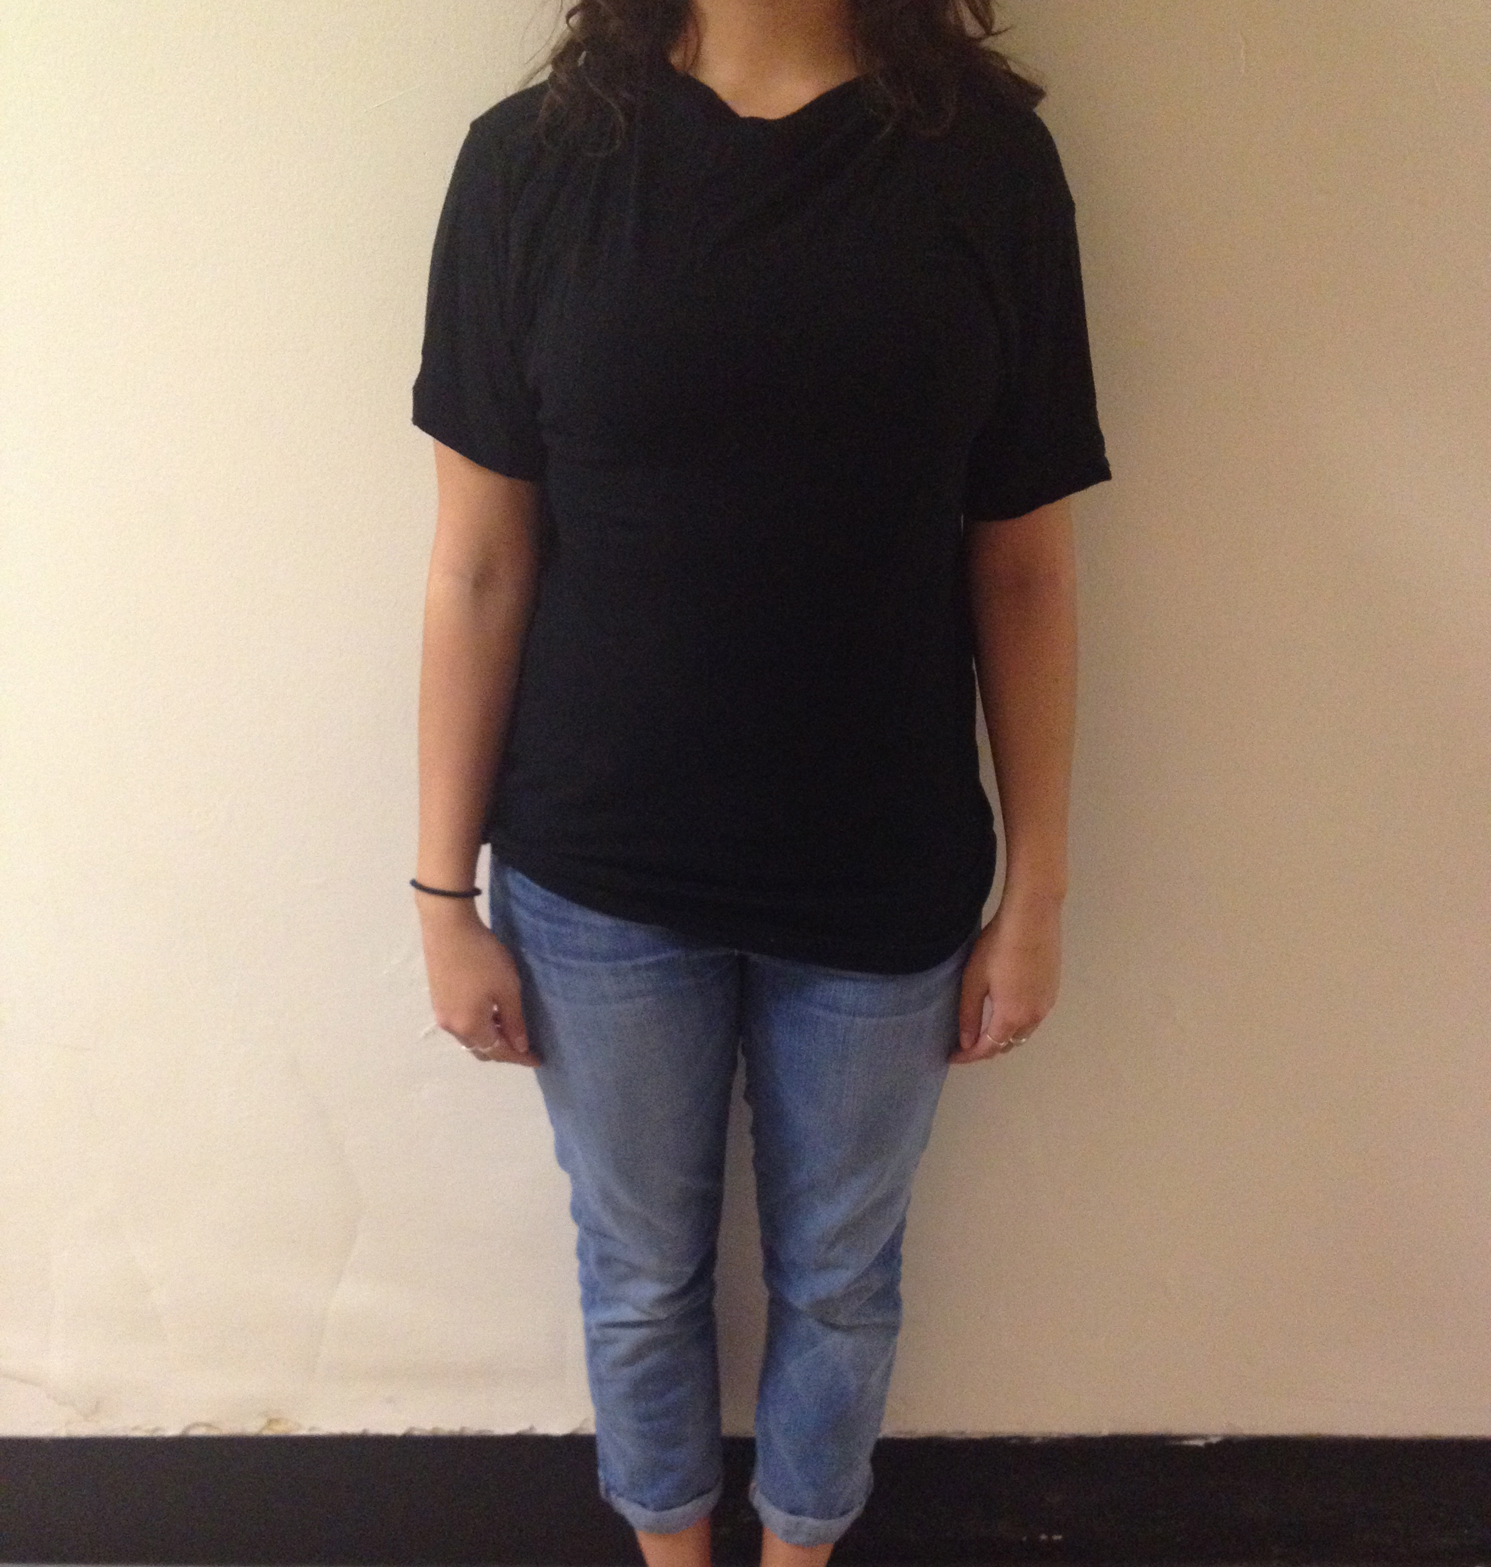

Appendix C
Picture used in Greek condition
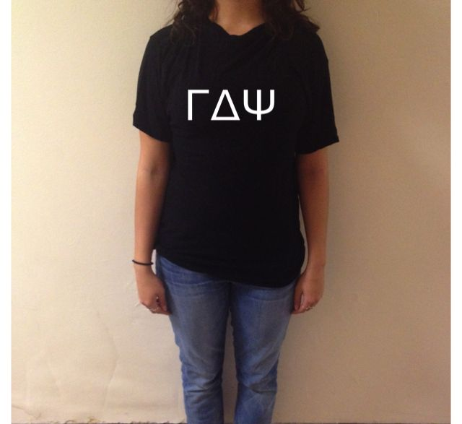

Appendix D
Questionnaire to be used in the study
Please answer the following questions using this scale:

Not At All Likely 1----------2----------3----------4----------5 Very Likely

- How likely is this woman to be assertive?

Not At All Likely 1----------2----------3----------4----------5 Very Likely

- How likely is it that this woman is dedicated?

Not At All Likely 1----------2----------3----------4----------5 Very Likely

- How likely is it that this woman is judged by her peers?

Not At All Likely 1----------2----------3----------4----------5 Very Likely

- How likely is it that this woman is confident in herself?

Not At All Likely 1----------2----------3----------4----------5 Very Likely

- How likely is it that this woman has an eating disorder?

Not At All Likely 1----------2----------3----------4----------5 Very Likely

- How likely is it that this woman has many friends?

Not At All Likely 1----------2----------3----------4----------5 Very Likely

- How likely is it that this woman is well-known on campus?

Not At All Likely 1----------2----------3----------4----------5 Very Likely

- How likely is it that this woman is sexually promiscuous?

Not At All Likely 1----------2----------3----------4----------5 Very Likely

- How likely is it that this woman is a good friend?

Not At All Likely 1----------2----------3----------4----------5 Very Likely

- How likely is it that this woman holds herself to high standards?

Not At All Likely 1----------2----------3----------4----------5 Very Likely

Is this woman a member of a Greek letter organization? (Circle one) Yes No

