The Effect of One Deprived Sense on the Remaining Senses
Jessica L. Wagner
Longwood University

Abstract
This study will examine how the deprivation of one’s vision affects the rest of one’s other senses, specifically focusing on the effect on hearing. The sample will include 20 men and 20 women from Longwood University. The participants in the control group will view and hear a theatrical trailer while the experimental group will be blindfolded and only hear the trailer. Afterwards, all participants will be quizzed on information revealed through auditory stimuli in the trailer. My hypothesis is that if a person is deprived of their sense of sight, their sense of sound will become more effective and they will become more aware of their surroundings. For this study, I believe that if the participants are deprived of their vision, it will be easier for them to focus on the auditory stimuli in the theatrical trailer. I anticipate the findings will suggest that the deprivation of vision will heighten one’s sense of sound, supporting my hypothesis.
Keywords: sight, sound, vision, hearing, deprivation

The Effect of One Deprived Sense on the Remaining Senses
In situations that occur frequently in a person’s daily routine, there are distractions that take place and can lead to sensory overload. Due to sensory overload, I believe that the general public may often choose to neglect auditory information in order to direct most of their attention to visual information. Most importantly, I propose that if people are deprived of their sense of sight, it will become easier for them to focus their attention to their sense of sound due to sensory compensation.
In the first experiment related to the proposed study, 40 individuals participated (Lewald, 2007). The experimental group was blindfolded while the control group was not blindfolded. Their task consisted of finding the general direction in the room in which a sound was played from a speaker. Speakers were set up around the participant in a semicircle. There were several tones that played one at a time in a chance order. When the participants believed they localized the sound, the researcher instructed them to turn their heads to the direction in which they believed they heard the sound. Following this, the participants pressed a button to finalize their head position. The researcher took measure of how closely they localized the sound. The results provide support that the head pointing of the participants was not as accurate as the researchers anticipated. However, light deprivation seemed to have had a positive effect on the sound localization skills of the participants.
Eight participants who lost their sight after they were 14 years old were in this experiment related to the proposed study (Cohen, Weeks, Sadato, Celnik, Ishii, & Hallett, 1999). The purpose for this experiment was to determine whether sensory compensation is still effective when a person loses their sense later on in their life. Their operational definition in this study is physiological by the use of PET scans and rTMS procedures. The results of this study show that it is easier for the early blind or people with congenital blindness to compensate for their sensory loss. With this said, it is more difficult for the late blind to adjust to the loss of their senses.
The next experiment related to the current study involved ten participants who lacked one of their eyes (Hoover, Harris, & Steeves, 2011). Despite their missing eye, all participants had normal vision otherwise, as well as normal hearing. There were two experimental groups: The binaural group and the monaural group. The binaural participants sat down in the middle of speakers in the form of a semi circle. The monaural participants did the same, except they were in the middle of speakers formed into half of a semi circle. White noise was played through the speakers and the participants had to localize the sound. The control group consisted of fifteen participants with both eyes fully functional. The results supports that compared to the control group, the one eyed participants were able to better locate the area in which they heard the white noise.
This study related to the proposed experiment consisted of 15 participants with average hearing and vision (Saupe, Widmann, Bendixen, Müller, & Schröger, 2009). The procedure involved participants listening to tones with amplitude of 40-Hz while also viewing a fixation cross as a point of focus on a screen. The experiment consisted of two groups. The first group was told to focus on both visual and auditory stimuli, but only to respond to the auditory stimuli by pressing a button when the participants heard tones with amplitude of 30-Hz. The second group focused only on visual stimuli and pressed a button when the fixation cross grew bigger or smaller on the screen. The results show support that both groups were very close in accuracy. This experiment relates to my current study in the sense that there is an element of distraction that could affect the outcome.
This experiment related to the current study consisted of 16 participants who lost their vision early in life and a control group consisting of participants with fully functioning vision (Liu, Yu, Liang, Li, Tian, Zhou, Qin, Li, & Jiang 2007). This experiment tried to determine whether functional connectivity of the early blind were due to one of two hypotheses: The general loss hypothesis and the compensatory plasticity theory. The results show that both theories might play a factor in functional connectivity of people who lost their vision early in life.
Seven early blind and six sighted people participated in this experiment related to the proposed study (Lewis, Saenz, & Fine, 2010). The six participants with fully functional vision were the control group. The researchers hypothesized that if a person is deprived of their vision, it will lead to them becoming more aware of their remaining senses due to crossmodal plasticity. They do, however, acknowledge that early blind cross-modal plasticity tests may produce different outcomes than those resulting from temporary blindness by wearing a blindfold. Their results supported their hypothesis due to the fact that the early blind participants and the sighted participants performed on comparable levels of success during the experiment.
The participants in this experiment, related to the current study, consisted of 10 people (Lazzouni, Voss, & Lepore, 2012). The researchers tested for evidence of cross-modal plasticity, specifically in sighted individuals. They wanted to observe whether or not short-term blindness simulated by a blindfold would result in cross-modal plasticity. The researchers used monaural and dichotic tones for the participants to listen to through headphones. The participants were tested on how well they were able to localize sound. The behavioral results showed that the participants overall felt that they were more conscious of their sense of sound while they were blindfolded. Physiological results also support their hypothesis that there are positive changes in short-term responses in blindfolded individuals resulting in cross-modal plasticity.
In the last study related to the proposed study, 40 people participated, 20 sighted individuals and 20 participants with congenital blindness (Tinti, Adenzato,Tamietto, & Cornoldi, 2006). The researchers wanted to test whether or not it is necessary to have vision in order to fully perceive things as others do with their remaining senses. Researchers tested this by instructing participants to walk one of two pathways in a room and recorded their abilities to complete the walk accurately. They were also instructed to draw the path they took. Sighted individuals were blindfolded. The results support their hypothesis that visual deprivation in early blindness did not affect one’s ability to complete the tasks.
The purpose of my current study is to test temporary deprivation of sight on one’s sense of sound and their adaptation and awareness of their surroundings. My hypothesis is that if a person is deprived of their sense of sight, their sense of sound will become heightened and they will adapt to their remaining surroundings. The independent variable in this study is the deprivation of sight, while the dependent variable is the ability of the participants to determine important auditory stimuli in a short video clip. I hypothesize that the visual deprivation of the participants will positively impact their remaining senses due to sensory compensation and cross-modal plasticity.
Method
Participants
Participants will include 40 Longwood University students (Mage: 19.81; age range= 18-22 years). The sample will ideally include 20 men and 20 women selected randomly through an online sign-up system website. The participants will receive one extra credit point as compensation. If the participants in the control group regularly use corrective eyewear, such as glasses or contacts, they will bring them to the study.
Materials and Procedure
For this experiment, the participants in the control group will view a theatrical trailer by use of a projector installed in the classroom. The experimental group will wear blindfolds during the trailer (Figure 2). After the trailer, research will be conducted through a quiz including questions such as, “Complete the following quote: […].” There will be six multiple-choice questions on this quiz (Appendix). The quiz will be provided to the participants. The independent variable in this study is the deprivation of the participants’ sense of sight. There are two levels of the independent variable: the control group will view and hear the trailer, while the experimental group will only hear the trailer due to the use of blindfolds. The dependent variable is the ability of the participants to determine the important auditory stimuli in the trailer. Their performances will be measured by how many questions they answered correctly on the quiz based on auditory stimuli that they recognize.
Results
The statistical analysis used for this experiment will be an independent t. My hypothesis is that if a person is deprived of their sense of sight, their sense of sound will become more effective and they will become more aware of their surroundings.
Discussion
For this study, I believe that if the participants are temporarily deprived of their vision, it will be easier for them to focus on the auditory stimuli in the theatrical trailer. I anticipate the findings will suggest that the deprivation of vision will heighten one’s sense of sound. I hypothesize that visual deprivation will impact one’s sense of sound because of sensory compensation. Sensory compensation is the process in which one makes up for the lack of vision by the use of the remaining four senses.
I also believe that overall distraction will be decreased by the deprivation of one’s vision. Generally, while watching a theatrical trailer, one may focus more on the visual aspects shown on the screen rather than the conversations formed in the background of the theatrical preview. Due to the emphasized attention on the visual features, the general public may be more prone to disregarding auditory information in theatrical trailers, and also possibly in their daily lives.
In this experiment, I anticipate that the results will support my hypothesis in that the experimental group will perform better on the quiz compared to the control group. If the results did, in fact, support my hypothesis, one could gather that the deprivation of a sense could enhance the remaining senses.

References
Arno, P. P., Vanlierde, A. A., Streel, E. E., Wanet-Defalque, M. C., Sanabria-Bohorquez, S. S., & Veraart, C. C. (2001). Auditory substitution of vision: pattern recognition by the blind. Applied Cognitive Psychology, 15(5), 509-519. doi:10.1002/acp.720
Cohen, L. G., Weeks, R. A., Sadato, N., Celnik, P., Ishii, K., & Hallett, M. (1999). Period of susceptibility for cross-modal plasticity in the blind. Annals of Neurology, 45(4), 451-460.
Hoover, A. E. N., Harris, L. R., & Steeves, J. K. E. (2011). Sensory compensation in sound localization in people with one eye. Experimental brain research, 216, 565-574. doi: 10.1007/s00221-011-2960-0
Lazzouni, L., Voss, P., & Lepore, F. (2012). Short-term crossmodal plasticity of the auditory steady-state response in blindfolded sighted individuals. European Journal of Neuroscience, 35, 1630-1636. doi: 10.1111/j.1460-9568.2012.08088.x
Lewald, J. (2007). More accurate sound localization induced by short-term light depriation. Neuropsychologia, 45, 1215-1222. doi: 10.1016/j.neuropsychologia.2006.10.006
Lewis, B. L., Saenz, M., & Fine, I. (2010). Mechanisms of Cross-Modal Plasticity in Early-Blind Subjects. J Neurophysiol, 104, 2995-3008. doi: 10.1152/jn.00983.2009
Liu, Y., Yu, C., Liang, M., Li, J., Tian, L., Zhou, Y., Qin, W., Li, K., & Jiang, T. (2007). Whole brain functional connectivity in the early blind. Oxford Journals, 130(8), 2085-2096. doi: 10.1093/brain/awm121
Saupe, K., Widmann, A., Bendixen, A., Müller, M. M., & Schröger. (2009). Effects of intermodal attention on the auditory steady-state response and the event-related potential. Psychophysiology, 46, 321-27. doi: 10.1111/j.1469-8986.2008.00765.x
Tinti, C., Adenzato, M., Tamietto, M., & Cornoldi, C. (2006). Visual experience is not necessary for efficient survey spatial cognition: Evidence from blindness. The Quarterly Journal of Experimental Psychology, 59(7), 1306-1328. doi: 10.1080/17470210500214275

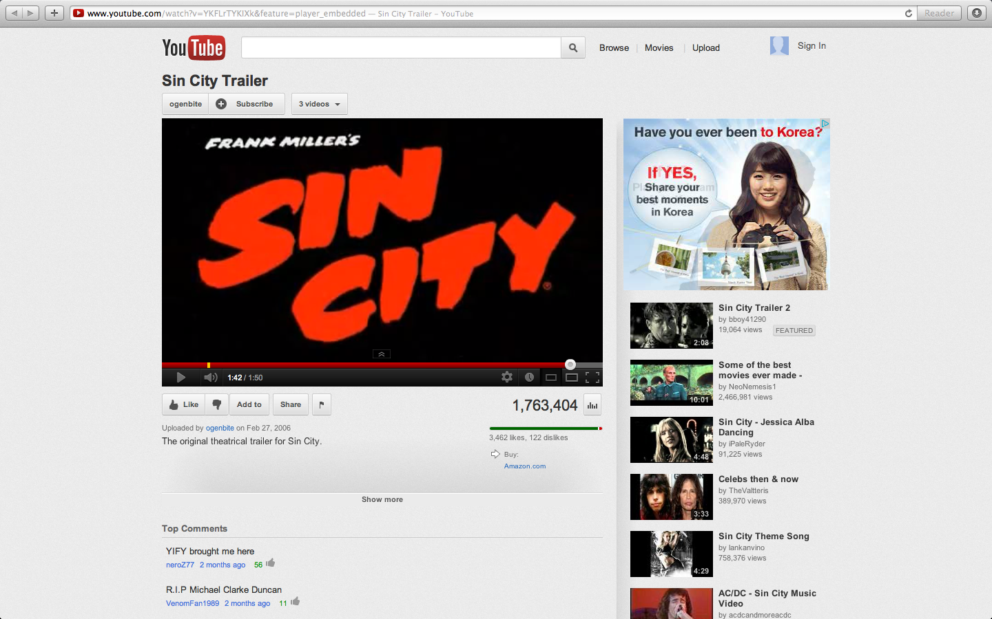
Figure 1. Control group will view the theatrical trailer for the movie “Sin City”, while the experimental group will listen to the trailer. Retrieved from http://www.youtube.com/watch?v=YKFLrTYKIXk&feature=player_embedded

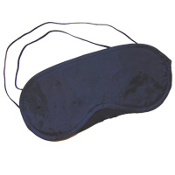
Figure 2. Participants in the experimental group will wear blindfolds during the theatrical trailer. Retrieved from http://www.blindfolds.co.uk/navyblueblindfolds.htm

Appendix

Questionnaire for the Effect of One Deprived Sense on the Remaining Senses

- In the beginning of the trailer, what is the name of the character that is dead?
- Blondie
- Bonnie
- Goldie
- What is the name of the girl that the man is looking for?
- Sandy Calaher
- Nancy Callahan
- Sarah O’Brien
- Complete this quote: “I followed him here to make sure he-“
- Got what he deserved
- Didn’t harm himself in any way
- Didn’t hurt any of the girls
- Complete this quote: “It’s time to prove to your friends that-“
- You’re worth a damn
- You’re better than them
- They can trust you
- According to the trailer, what alley should you walk down in Sin City?
- Right back alley
- South side alley
- West back alley
- What will you find down this alley?
- Your worst nightmare
- Anything
- The meaning to life

LONGWOOD UNIVERSITY Human Subjects Research Review Committee Committee Action Form
(To Be Completed By Researcher)
Proposal Title: The Effect of One Deprived Sense on the Remaining Senses
Principal Investigator: Jessica L. Wagner
................................................................................................................................................
(For Committee Use Only)
[ ] Meets the criteria for making research exempt from obtaining written informed consent and Committee review.
[ ] Approved by the Longwood University Human Subjects Research Review Committee.
[ ] Approved with revisions by the Longwood University Human Subjects Research Review Committee. The researcher(s) must provide a revised copy of the proposal to the Committee before commencing research.
[ ] Rejected by the Longwood University Human Subjects Research Review Committee.
Date:_______________________
Signature of Committee (circle one) Member/Chair:____________________________________
Comments:

