Mixed Model ANOVA
A. A Mixed Model ANOVA is used when there are two independent variables and at least two independent variables each with two levels. One of the independent variables is a within groups design.
B.
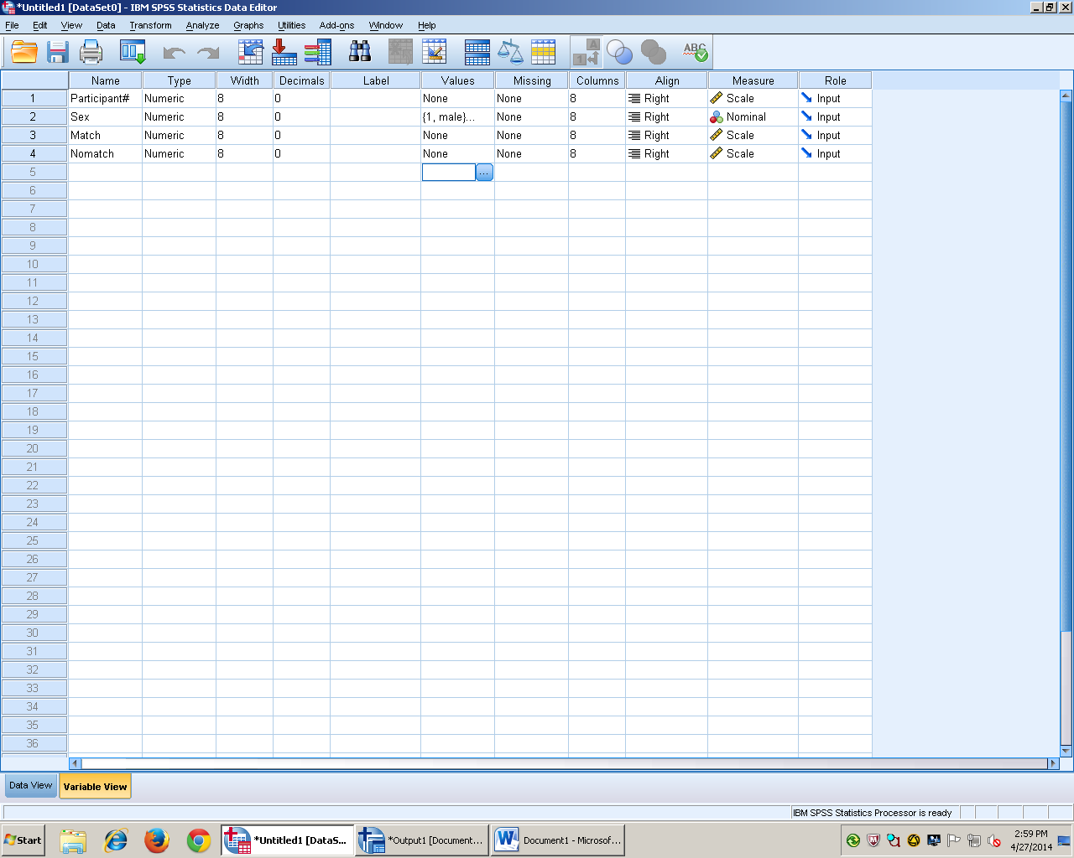
Under Variable view, there will be at least four columns. The first is always the participant number, then one column for the between groups design independent variable, and at least one column for the within groups independent variable. Assign value labels accordingly.
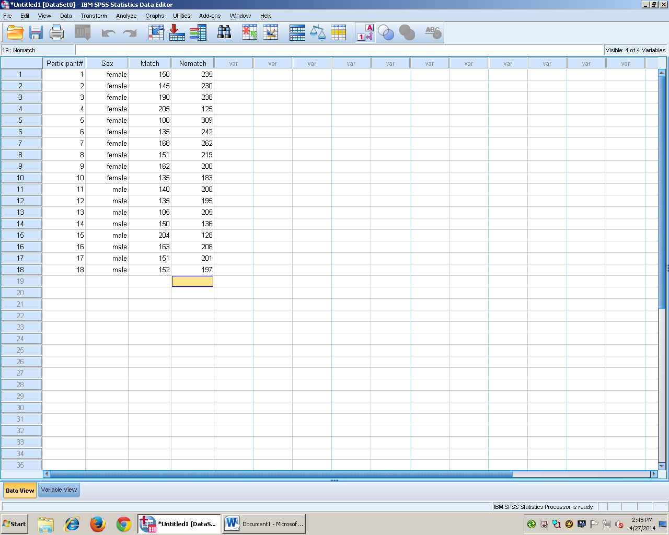
Under data view, enter all of the data.
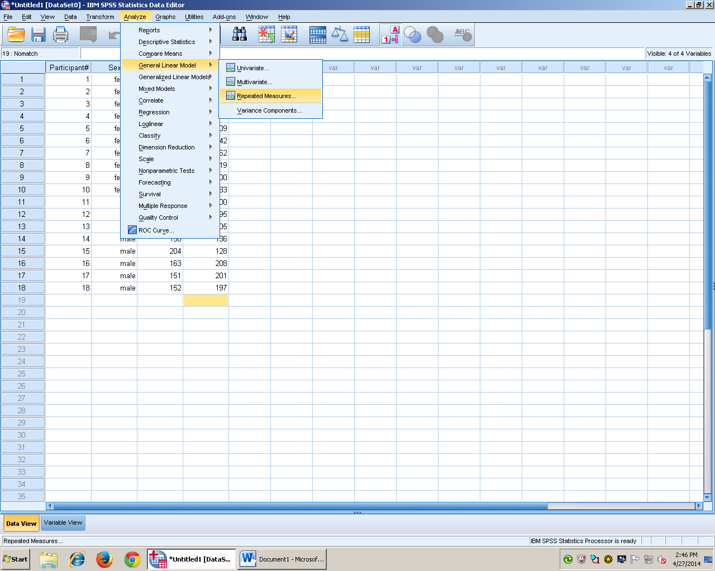
Go to analyze, general linear model, then repeated measures.
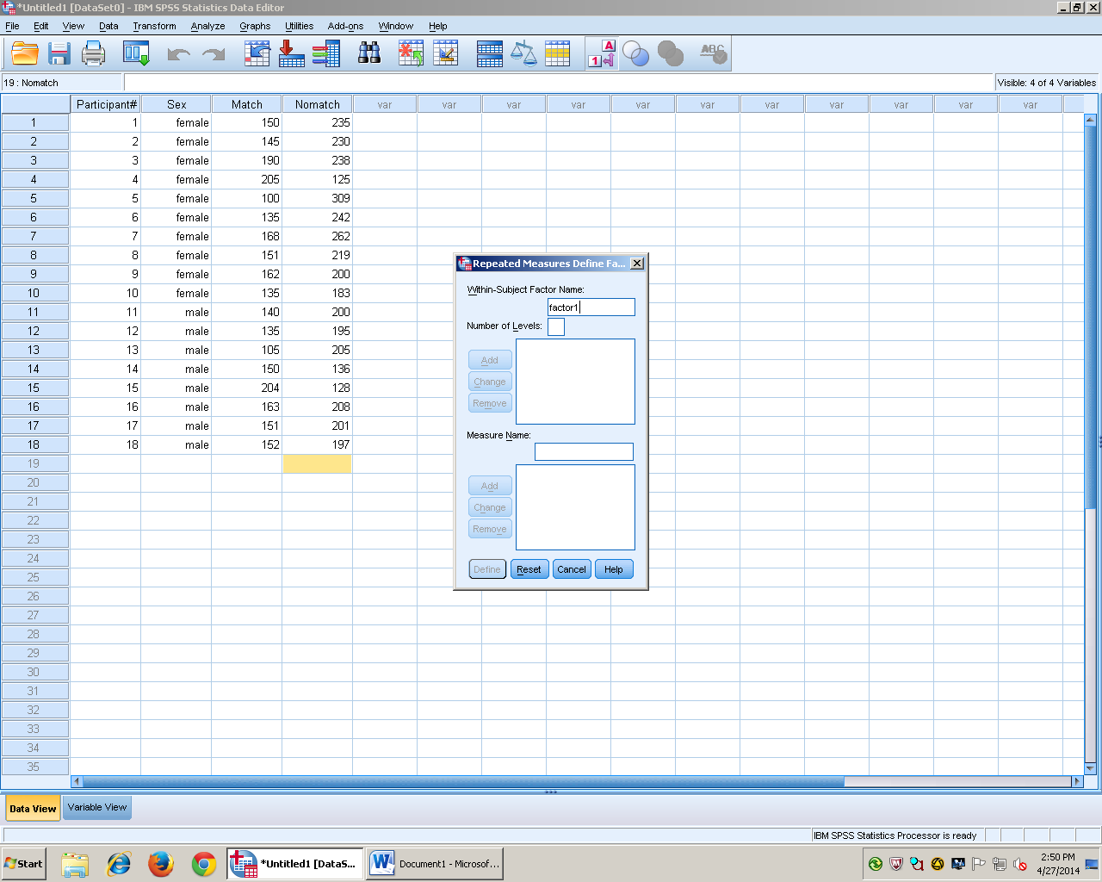
Change the factor name to the within groups independent variable. The put the number of levels and click add then define.
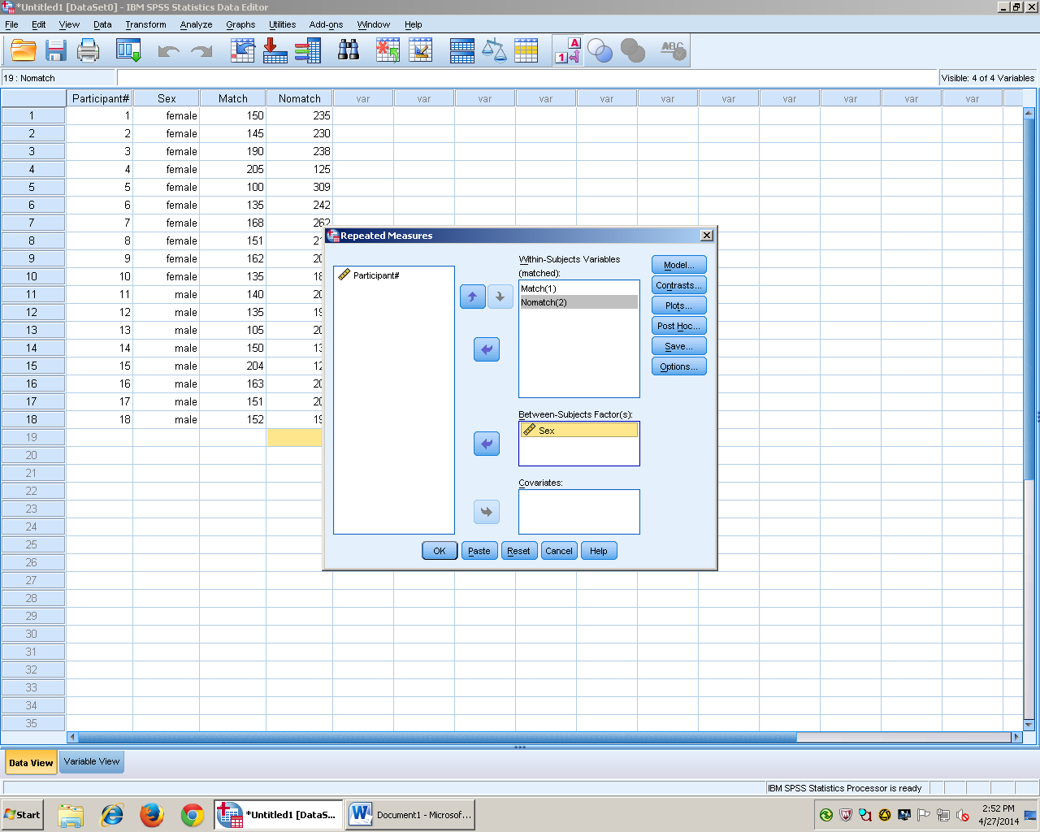
Put the variables in the appropriate boxes. Arrow the within groups independent variables over to the within subject variables box. Then arrow over the between groups independent variable to the between subject factors box.
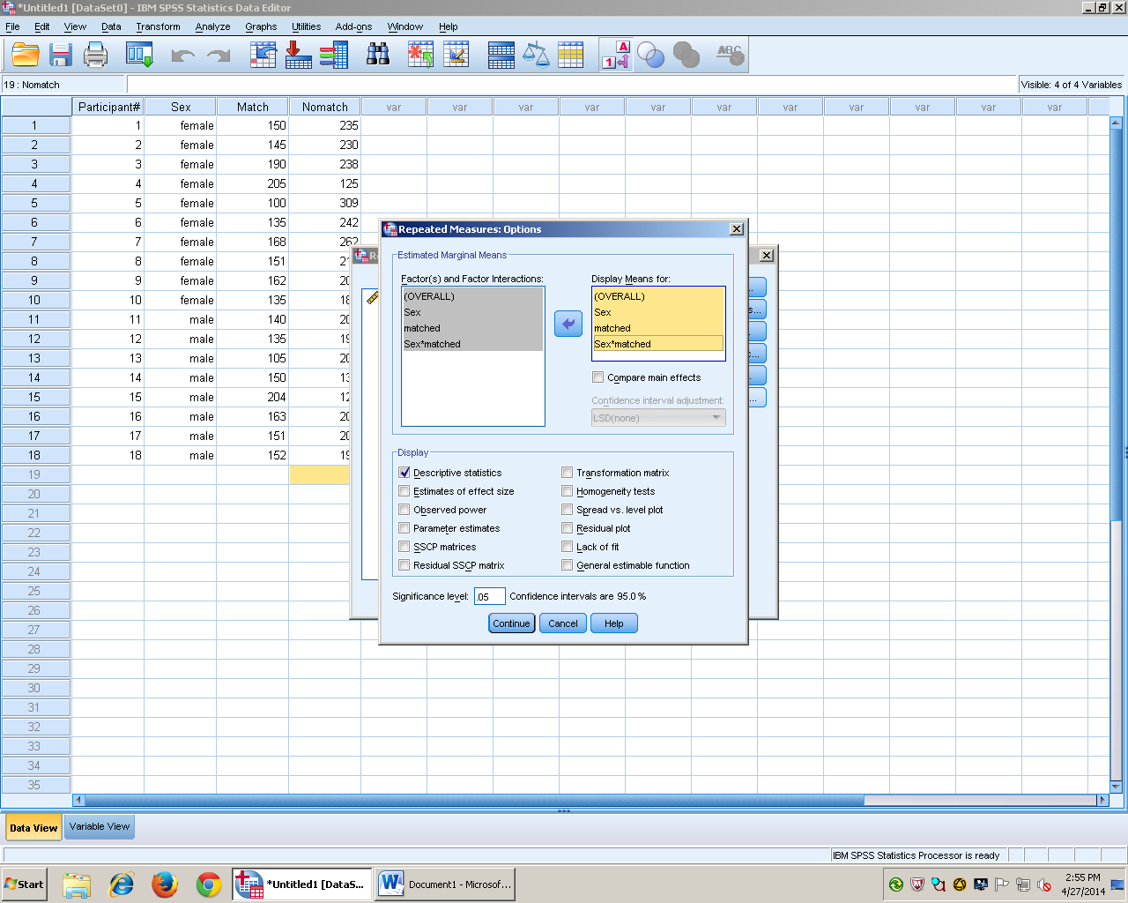
Click on options and this box will appear. Arrow over all of the variables into the display means for box. Check the descriptive statistics box for the mean and standard deviation. Press continue then OK for the results.
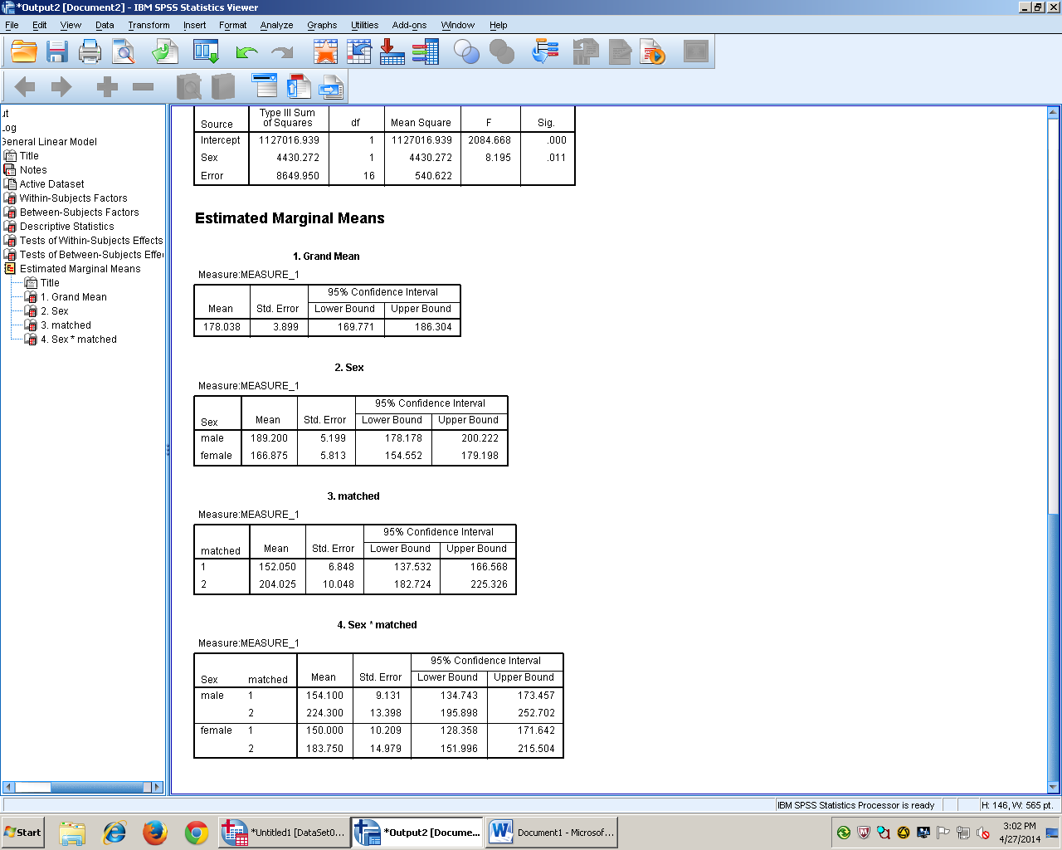
C. The Mixed Model ANOVA showed the sex of the participant affected how quickly they matched F(1, 16) = 11.50, p = .004. Females (M = 150.00, SD = 27.88) matched faster than males (M = 154.10, SD = 29.63). Between both sexes, match (M = 152.20, SD = 28.09) was lower than no match (M = 206.28, SD = 46.04).

