Table of Contents

Histogram with Frequency Table……………………………………………………………………………………………2-3

Descriptive Statistics………………………………………………………………………………………………………………4-5

Recode……………………………………………………………………………………………………………………………………5-6

Select Cases……………………………………………………………………………………………………………………………7-8

Split File…………………………………………………………………………………………………………………………………8-9

Compute a variable……………………………………………………………………………………………………………..9-10

Internal Reliability Analysis…………………………………………………………………………………………………..11-12

Dependent Samples t-test…………………………………………………………………………………………………..12-13

Independent Samples t-test………………………………………………………………………………………………..13-14

One-Way ANOVA with post hoc test…………………………………………………………….......................15-16

Factorial (2-way) ANOVA……………………………………………………………………………………………………16-18

Repeated Measures ANOVA……………………………………………………………………………………………….18-20

Correlation……………………………………………………………………………………………………………………………20-21
Regression…………………………………………………………………………………………………………………………..21-23
Scatterplot with Regression Line………………………………………………………………………………………….24-25
Goodness of Fit Chi-Square…………………………………………………………………………………………………25-26
Contingency Table Chi-Square…………………………………………………………………………………………….27-29

Histogram with Frequency table
Description of statistic
The histogram with frequency table shows both a picture graph and a numerical table with all of the values you are looking at for a specific variable. This will allow you to see where the mean lies and how far away your answers are from the mean. The histogram will display the frequency of a certain variable. In the example below, the graph will display how many people answered the question and which answer they chose.
SPSS steps
- Analyze Descriptive Statistics Frequencies

- After clicking on frequency, select a variable that interest you and hit the arrow that will move it to the right box labeled “variables”. Then click charts and make sure that histograms is selected and that the box underneath histograms is checked. (This will allow you to see the normal curve)
- Click continue.
- Click paste.
Syntax
DATASET ACTIVATE DataSet1.
FREQUENCIES VARIABLES=H3RE31
/HISTOGRAM NORMAL
/ORDER=ANALYSIS.

- Highlight the selected information and hit the green play button.

Output

The output for this variable describes an in-depth look at how the participants answered those questions. For example, the variable of interest was how important religion is and we want to look at the people who answered “very important”. The frequency column tells us that out of 4,713 people who actually answered, 2,093 people said religion was very important. When we look over to the right, the other columns add the participants who didn’t answer.
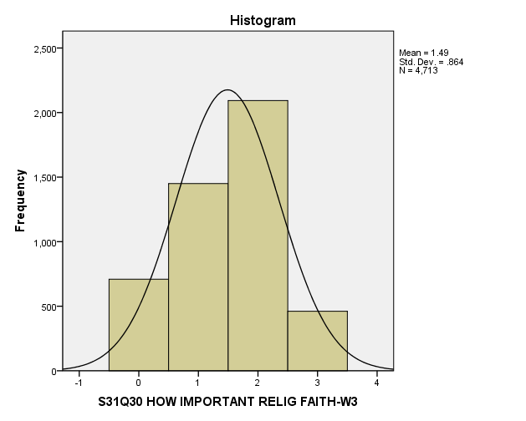

The histogram graph shows a visual picture of what is being described above and how close the normal curve is to our picture. The x-axis is the range of answers (0 being not important to 4 being extremely important) and the y-axis is a count of how many people chose that specific answer). By looking at the graph, we can confirm that the highest number of participants were the ones who answered very important.

Descriptive Statistics
Description of statistic
The descriptive statistics gives us all of the statistics we need to look at in order to compare our variables. Some of the statistics listed are mean, median, maximum, minimum, range, and standard deviation. A more in depth description of each term is listed below under the output section. The descriptive statistics also gives us distribution options so we can look at the skewness of our variables.
SPSS steps
- Analyze Descriptive Statistics Descriptive options
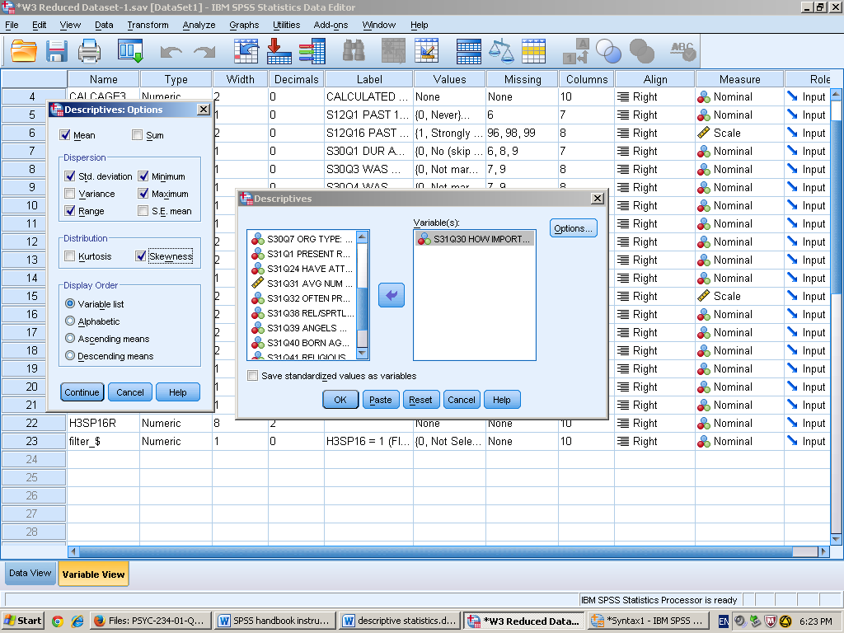

- After picking the variable of interest and moving it to the right, click the options button. This will bring you to the specific descriptive statistics where you can check off what you want to look at. As the example shows, we want to look at the mean, maximum, minimum, standard deviation, and range. This is also where you can check the distribution of the graph; in this example, we want to look at skewness.
- Hit continue, then paste.

Syntax
FREQUENCIES VARIABLES=H3RE30
DESCRIPTIVES VARIABLES=H3RE30
/STATISTICS=MEAN STDDEV RANGE MIN MAX SKEWNESS.

- Highlight the selected information and hit the green play button.

Output

Descriptive Statistics
 | N | Range | Minimum | Maximum | Mean | Std. Deviation | Skewness
 | Statistic | Statistic | Statistic | Statistic | Statistic | Statistic | Statistic | Std. Error
S31Q30 HOW IMPORTANT RELIG FAITH-W3 | 4713 | 3 | 0 | 3 | 1.49 | .864 | -.212 | .036
Valid N (listwise) | 4713
Above is what will show up in the output. The chart is simply a breakdown of the statistics you are looking at. The mean, 1.49, is simply the average of all the data and the standard deviation is how spread out the data is around the mean. The chart above explains that most people are .864 std. deviations around the mean. The minimum and maximum is the highest and lowest score, while the range is the minimum score subtracted from the maximum score.

Recode
Description of statistic
Recode is a way to change an interval variable so that you could look at it a different way. For example, if the variable is happiness on a scale of 1(very) to 5(not at all), you would flip it so that 1 would change to not at all and 5 would be very. You could also use a ratio and change it into a nominal scale. However, the example being described is on an interval scale.

SPSS steps

- Transform Recode into different variables

- Pick an interval variable of interest and label your “new” variable. In this example, H3SP16 has now become H3SP16R.
- Depending on the numbers of your variable’s scale, change the values so that it will reverse the order. The variable in the example had 5 values so 1 would change to 5, 2 would change to 4, and so on.
- Click continue.
- Hit change.
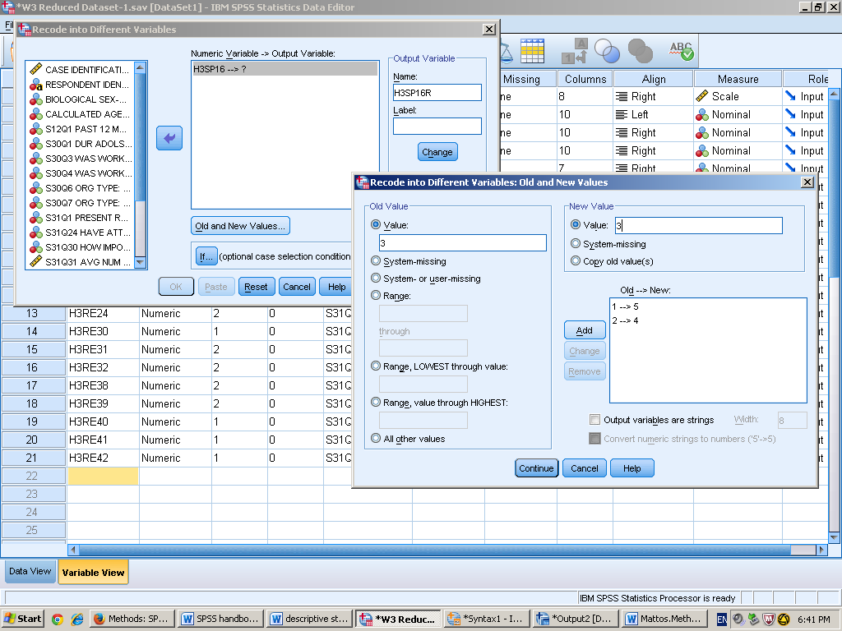

Select Cases
Description of statistic
If you want to look at a specific variable, you can filter out the other variables using select cases. This tells SPSS that you will only be focusing on certain variables within variables.
SPSS steps
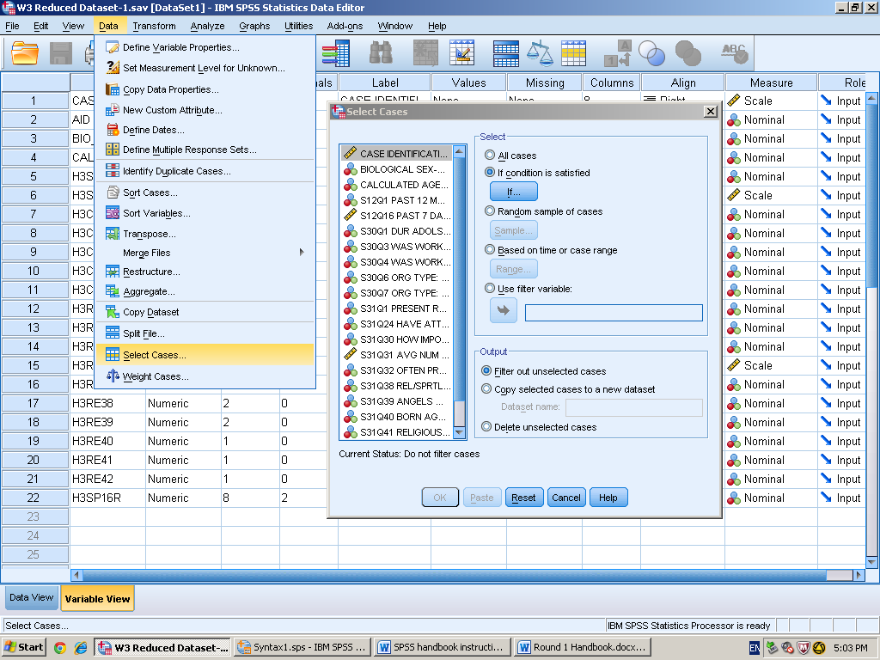
- Data Select cases if condition is satisfied press if

- Pick an interval variable that you would like to focus on and use the key pad if needed. For this example, I am interested in anyone who is less than or equal to 2. (anyone who strongly agrees or agrees that they never swear) Afterwards, you will hit continue and it will bring you back to

Syntax
DATASET ACTIVATE DataSet1.
USE ALL.
COMPUTE filter_$=(H3SP16 <= 2).
VARIABLE LABELS filter_$ 'H3SP16 <= 2 (FILTER)'.
VALUE LABELS filter_$ 0 'Not Selected' 1 'Selected'.
FORMATS filter_$ (f1.0).
FILTER BY filter_$.
EXECUTE.

-In the syntax, it will automatically filter what you want to look at using the above formula. It is saying what variable you are computing and filtering. After checking that everything is right, you highlight the information and hit the green play button.

Split File
Description of statistic
After doing select cases, split file will help get output on more than one subgroup variable by using nominal variables. For example, our variable that we used was for happiness, but we only want to look at men. Split file makes it so that all of the men will be together and all the female will be together. This makes it easier to separate and look for the variables that you want.

SPSS steps
- Data Split File organize output by group

- Pick a nominal variable (like sex or age) and move it to the right with the arrow.
- Select organize output by groups and click paste.

Syntax
SORT CASES BY BIO_SEX3.
SPLIT FILE SEPARATE BY BIO_SEX3.

- In the syntax, highlight this and press the green play button. This will split the file so that in the data view of SPSS, it will separate all of the data by female and male. This will also tell SPSS that when looking at a certain variable, it will do it once with women, and then again with men.

Compute a variable
Description of statistic
By computing a variable, you can combine them in order to look at one bigger variable. For instance, if we wanted to look at happiness in general, we could take different variables like swearing, laughing, and crying and combine them to all fit with happiness.

SPSS steps
- Transform Compute a variable
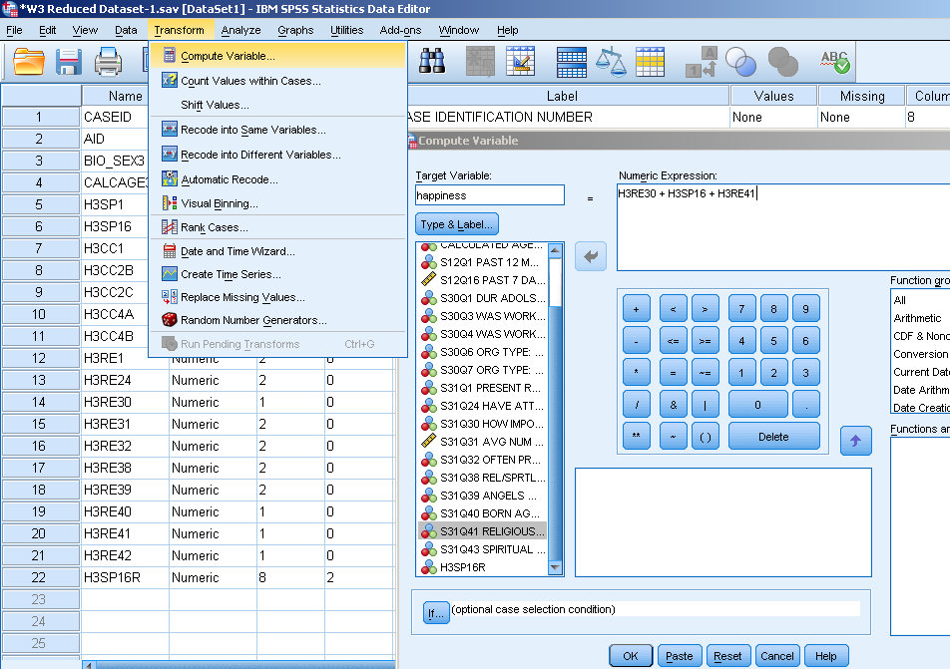

- Name your target variable
- Pick the variables that you will use to combine in order to create a general variable. Use the keypad in order to add other variables.
Syntax
COMPUTE happiness=H3RE30 + H3SP16 + H3RE41.
EXECUTE.
- After highlighting and pressing the green play button, this will tell SPSS that you have combined those certain variables.

Internal Reliability Analysis
Description of statistic
When we want to see how compatible two research questions or variables will be, we will use an internal reliability analysis. The test will tell us the consistency or strength of the measures. A key to remember is that using three or more items will increase your internal reliability. A way to see if a variable has good internal reliability is to look at the chronbach’s alpha level. The number we want to shoot for is close to .80 or above. If it is .70, it is decent. However, anything below is considered to have low internal reliability.
SPSS steps
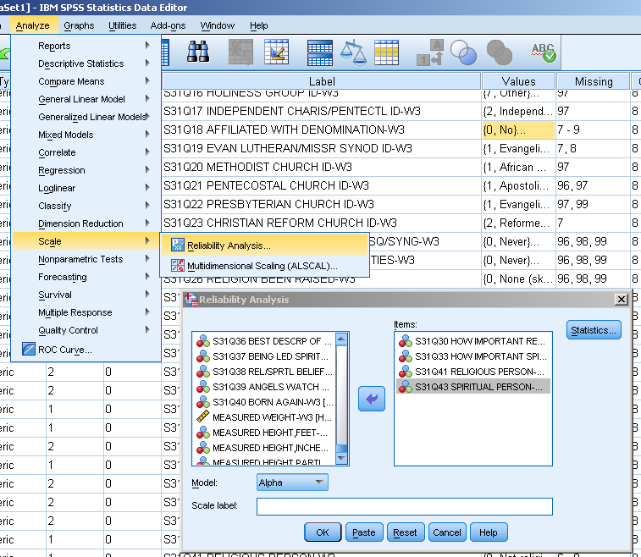
- Analyze Scale reliability analysis

- Pick the variables of interest that you want to compare and move them from the variable list on the left to the “items” box on the right. Click the statistics button.
- Check the boxes listed under “Descriptives for”. This will give you the following information in the output.

- Click continue, then paste.
Syntax
RELIABILITY
/VARIABLES=H3RE33 H3RE30 H3RE41 H3RE42
/SCALE('ALL VARIABLES') ALL
/MODEL=ALPHA
/SUMMARY=TOTAL MEANS VARIANCE COV CORR.

- Highlight the information and click the green button.
Output
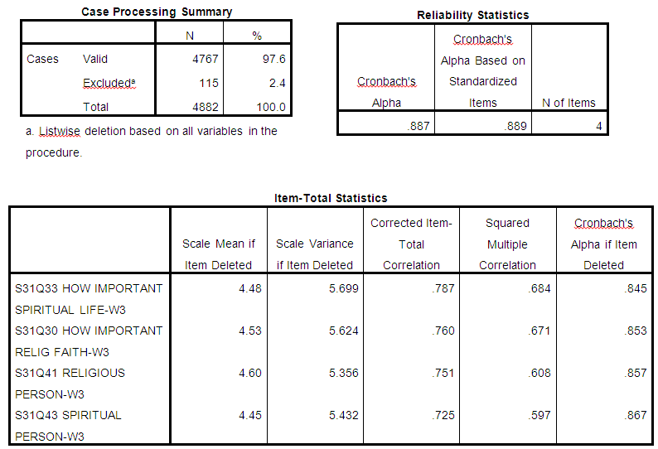
From reading the output data, we can conclude that the variables we have chosen are very compatible after looking at Cronbach’s Alpha under the “reliability statistics” box. If there was an instance where they weren’t, the last column under “item-total statistics” would give us the alpha level it would be if we were to get rid of one of the variables. For example, if S31Q43 was taken off of the list, the alpha level would go from .887 to .867. This would actually decrease our internal reliability.

Dependent Samples t-test
Description of statistic
Also known as a paired samples t-test, the dependent samples t-test is used when you want to compare two different means from the same population. For instance, if you wanted to see if studying a certain number of hours increase students’ test scores, you would compare the mean before and after the test. The population would be the students from the class and the means that will be compared are the test scores before and after the students study. An important thing to remember is that both the population mean and the population standard deviation are unknown for the dependent samples t-test.
SPSS steps
- Analyze compare means Paired-Samples T-Test
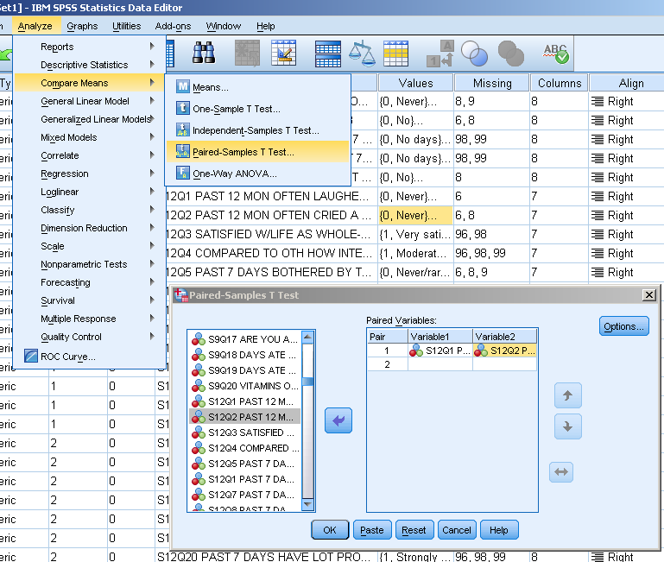

- Pick the two variables of interest that you want to compare and move them from the left list of variables to the right “paired variable” box. It does not matter which variable you pick first.

Syntax
DATASET ACTIVATE DataSet1.
T-TEST PAIRS=H3SP1 WITH H3SP2 (PAIRED)
/CRITERIA=CI(.9500)
/MISSING=ANALYSIS.

- Click paste and the information listed above will appear in the syntax box. Highlight the information and hit the green play button.

Output
The test was significant, t (4877) = 152.720, p < .001. This means that the mean score of people who smile (M = 3.38, SD = .789) was greater than the mean score of people who cry (M = .97, SD = .728).
Independent Samples t-test
Description of statistics
The independent t-test is used when you are trying to see if your sample means are extreme with the sampling distribution. In another way, you want to find the sampling distribution of differences between means. For your grouping variable (DV), you want a variable on the nominal scale and an interval scale for the test variable (IV).
SPSS steps
- Analyze Compare means Independent-Samples T Test

- Pick an interval variable that is of interest to you and move it from the left variable list box to the “test variable” box. Likewise, pick a nominal variable and move it to the “grouping variable” box.

- Click the define groups button after moving the variable over to the “grouping variables” box. You will then write which two groups you want to compare. In this instance, we are looking at “0” and “1” to look at the people who view their religion as important and people who don’t view their religion as important.
Syntax
DATASET ACTIVATE DataSet1.
T-TEST GROUPS=H3CC2A(0 1)
/MISSING=ANALYSIS
/VARIABLES=H3RE30
/CRITERIA=CI(.95).

- Hit paste and the information listed above will appear in the syntax. Highlight the information and click the green play button.

Output

The output given indicates that there is no significance, t (2181) = -1.74, p > .05. Thus, we will fail to reject the null. People who find faith important (M=1.64, SD=.865) volunteer more than people who don’t find faith important (M=1.56, SD=.809).
One-Way ANOVA with post hoc test
Description of statistic
A one-way ANOVA test is used when we are comparing more than two groups of scores; the groups must be entirely separate from each other. After finding the results, we would use a post hoc test if we reject the null. The post hoc test will compare each mean of one group to the other groups. There are several post hoc tests that we can use, but the one in this example will be Tukey’s HSD (Honestly significant difference) test.

SPSS steps
- Analyze Compare Means One-Way ANOVA

- Pick an interval variable of interest and move it from the variable list on the left to the “dependent list” box on the right. Likewise, move a nominal variable from the left and put it in the “factor” box on the right.
- Click the Post Hoc button.

- Check the box that is labeled Tukey. Press the continue button and then paste.

Syntax
ONEWAY H3RE30 BY H3RE28
/MISSING ANALYSIS
/POSTHOC=TUKEY ALPHA(0.05).

- Highlight the information and then press the green play button.

Output

By first looking at the ANOVA box, we would say to reject the null because it is significant between groups, F (3, 1240) = 3.90, p = .009. When looking at the multiple comparison table and the column labeled “sig.” from the post hoc-test, the data suggest that there is a significance between traditional and none of these groups.

Factorial (2-way) ANOVA
Description of statistic

A factorial ANOVA is used when we have more than one independent variable. For this test, we want to compare the main effects (each independent level) and then the interaction between the main effects. It is also considered a between subject design

SPSS steps
1. Analyze General Linear Model Univariate
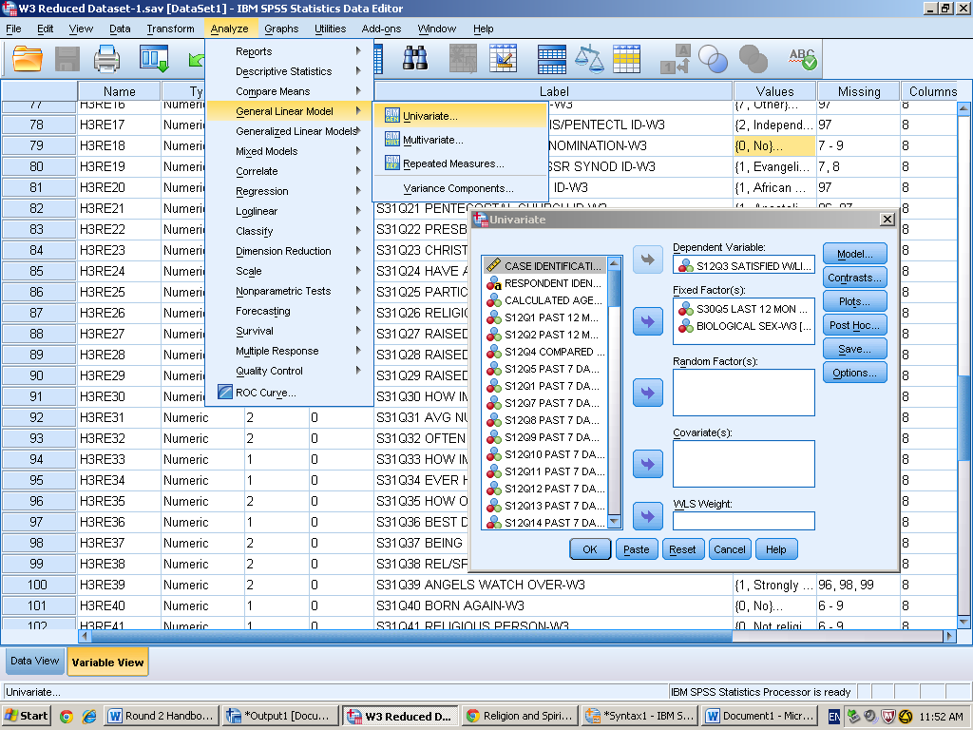

- Pick the variables of interest to and move them from the variable list box on the left to the “fixed factor(s)” box on the right. The variables that are placed in the “fixed factor(s)” box will be nominal variables. Then, pick an interval variable of interest and move it to the “dependent variable” box.
- Click the blue “options” button.

- In options, move all of the variables from the left box to the “display means for” box. Check the boxes listed “compare main effects” and “descriptive statistics”.
- Click paste.
Syntax
UNIANOVA H3SP3 BY H3CC3 BIO_SEX3
/METHOD=SSTYPE(3)
/INTERCEPT=INCLUDE
/EMMEANS=TABLES(H3CC3) COMPARE ADJ(LSD)
/EMMEANS=TABLES(BIO_SEX3) COMPARE ADJ(LSD)
/EMMEANS=TABLES(H3CC3*BIO_SEX3)
/PRINT=DESCRIPTIVE
/CRITERIA=ALPHA(.05)
/DESIGN=H3CC3 BIO_SEX3 H3CC3*BIO_SEX3.

- After making sure the steps are written correctly in the syntax, highlight the information and click the green play button.
Output

-The main effect of people who volunteer on satisfaction was significant, F (1, 4855) = 30.98, p = .000. However, the main effect of gender on satisfaction was not significant, F (1, 4855) = 1.23, p = .268. The interaction between the main effects was also not significant, F (1, 4855) = .002, p = .968.

Repeated Measures ANOVA
Description of statistics
A repeated measures ANOVA is used when you have one or more independent variables and want to compare a certain variable within the same level. In other words, doing the same thing over a period of time and comparing the different means.

SPSS steps
- Analyze General Linear Model Repeated Measures

- Label the independent variable in the “within-subject factor name” box. Also, write how many levels it will have and then click add and then define.
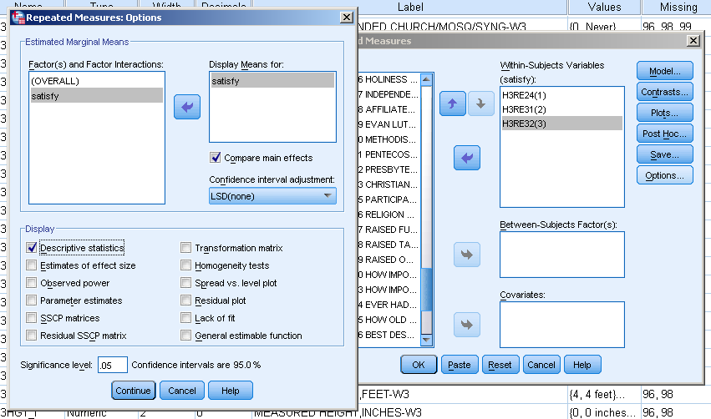

- After clicking the define button, pick the specific variables you will use for each level from the variable list on the left to the right. Click options.
- Move the interaction you named from the left box to the right box labeled “display means for”. Check the boxes labeled compare main effects and descriptive statistics. Click the continue button and then paste.
Syntax
GLM H3RE24 H3RE31 H3RE32
/WSFACTOR=satisfy 3 Polynomial
/METHOD=SSTYPE(3)
/EMMEANS=TABLES(satisfy) COMPARE ADJ(LSD)
/PRINT=DESCRIPTIVE
/CRITERIA=ALPHA(.05)
/WSDESIGN=satisfy.

- Highlight the information listed and then click the green play button.

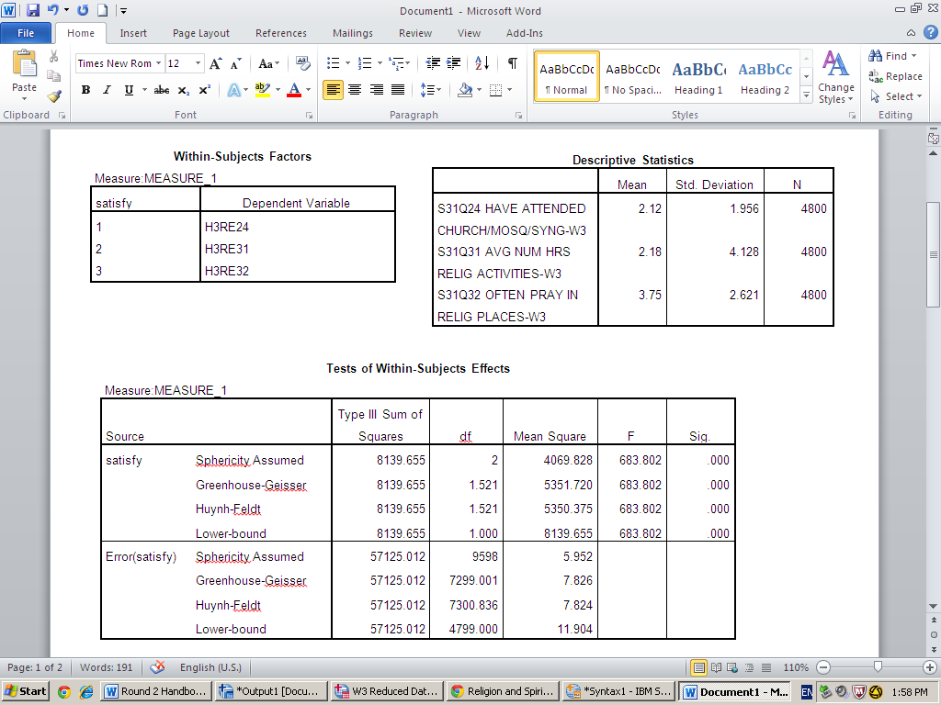
Output

The question that is being asked is if the three means of satisfaction differ from each other or not. By looking at the test of within-subjects effects table, we would reject the null because the test was significant, F (2, 9598) = 683.80, p = .000. However, from the post hoc test (pairwise comparisons table), we can conclude that the mean of praying often in other places besides church (M = 3.75, SD = 2.62) was significantly higher than the mean of attending church associated places (M = 2.12, SD = 1.96) and hours of praying outside of church (M = 2.18, SD = 4.13).

Correlation
Description of Statistics
A correlation is used when wanting to look at an association between scores on two variables. There are two requirements for doing a correlation: having two variables and having equal-interval variables (ex: degrees in temperature).
SPSS steps
- Analyze Correlate Bivariate

- Pick the two variables that you want to use for your correlation. Remember, the variables must be on a continuous scale.
- Move the variables from the variable list box on the left to the right box.
- Click paste.

Syntax
CORRELATIONS
/VARIABLES=H3RE32 H3RE30
/PRINT=TWOTAIL NOSIG
/MISSING=PAIRWISE.

- Highlight the selected information and click the green play button.

Output

The output in SPSS labels the possible relationship or association between the selected variables. In this example, the test suggest that there is a strong relationship between how often one prays to how important they find their religion, r (4813) = .645, p < .01. Because of this information, we would reject the null.

Regression
Description of statistic
A linear regression is used when we want to find a linear equation to model the relationship between two variables. In order to use this test, it is beneficial to do a correlation test first. By doing that test first, it allows you to see if there is in fact a relationship. An easy way to remember is to think of the variables like the IV and DV. One variable (IV) will predict or cause the other (DV). The linear regression also allows us to predict future outcomes.

SPSS steps
- Analyze Regression Linear

- Use the variable list on the left to choose your variables of interest. If we wanted to use the same variables as the correlation test, we would put how important religion is under the independent box and how often one prays under the dependent box. We are saying that how importance of religion will predict or cause how often someone prays.
- Click the statistics button

- Make sure that the above checkmarks are checked: estimates, model fit, and descriptives (descriptives is not necessary, but is always good to have).
- Click continue. The plots and save button can be ignored. If you click on options, make sure the default box is checked: include constant.
- Click paste.
Syntax
REGRESSION
/DESCRIPTIVES MEAN STDDEV CORR SIG N
/MISSING LISTWISE
/STATISTICS COEFF OUTS R ANOVA
/CRITERIA=PIN(.05) POUT(.10)
/NOORIGIN
/DEPENDENT H3RE32
/METHOD=ENTER H3RE30.

- Highlight the selected information and press the green play button.

Output

By using the information given, we can conclude that there is a relationship between how often someone prays and how important they find religion, r (4813) = .65, p < .01. By looking at the coefficients box, we can also come up with an equation to predict future activities: y = .85 + 1.96 (x). If we wanted to predict a different result, we could simply plug that value into our equation. For instance, if our new value was 2, our equation would look like this; y = .85 + 1.96 (2), which equals 2.85.

Scatterplot with Regression Line
Description of statistic
A scatterplot tells us the pattern and strength of a correlation. If the scatterplot shows a relationship between variables, then we can do both a correlation test and regression test. A scatterplot has three different kinds of patterns: linear, curvilinear, and no pattern. A scatterplot also has either has a perfect, strong, or weak strength to it.
SPSS steps
- Graphs Legacy dialogs scatterplot

- Click the simple scatter box and hit define.

- Choose your variables and move them to the y-axis and x-axis on the right. (It does not matter which variable goes where. Click the titles button and create a title for your graph. Click continue, then options.
- Make sure the default box labeled “Exclude case listwise” is checked.
- Click continue, then paste.

Syntax
GRAPH
/SCATTERPLOT(BIVAR)=H3RE30 WITH H3RE32
/MISSING=LISTWISE
/TITLE='Association Between How Often You Pray and Religious Activities'.

- Highlight the selected information and press the green play button.
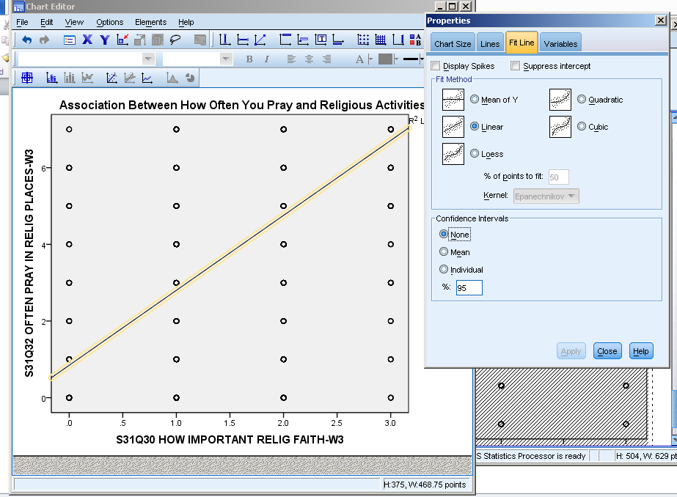
Output

Depending on your sample size, each dot on a scatterplot represents a single individual. For this example, the dots represent a group of people for the answers they chose. From looking at the scatterplot, we can conclude that there is a linear correlation with no pattern for the strength.
Chi-square
Description of statistic
The chi-square test is used when you want to compare actual or observed data to expected data. The word data could also be described as frequencies. The one or two variables chosen must be on a nominal scale.
SPSS steps
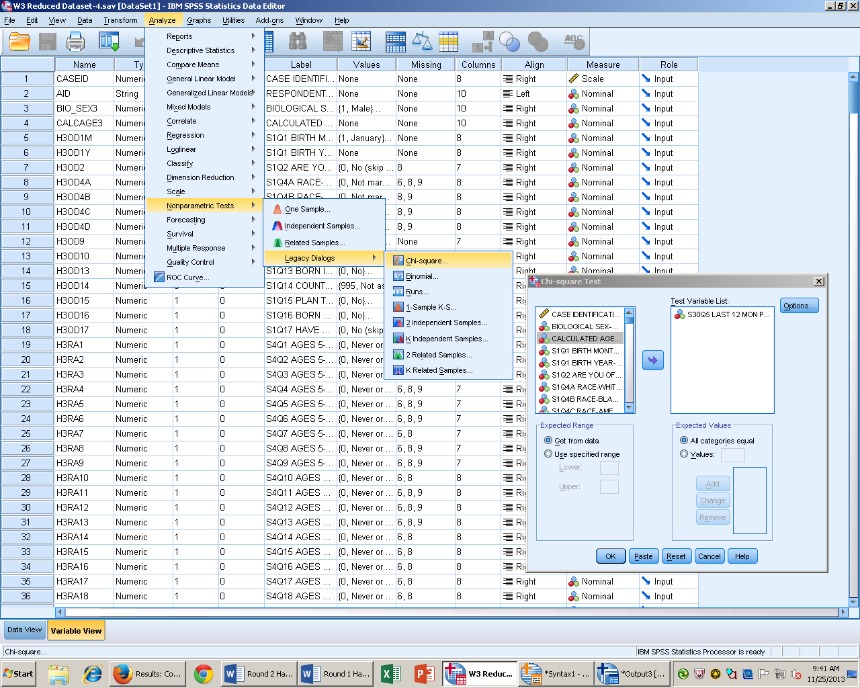
- Analyze Nonparametric tests Legacy dialogs Chi-Square

- Move the variable(s) of interest from the variable list on the left to the box on the right labeled “test variable list”.
- Click the options button.
- Check the box labeled descriptive.
- Click continue.
- Click paste.

Syntax

NPAR TESTS
/CHISQUARE=H3CC3
/EXPECTED=EQUAL
/STATISTICS DESCRIPTIVES
/MISSING ANALYSIS.

- Highlight the selected information and click the green play button.
Output

-X^2 (1, 4861) = 862.006, p < .01. People who said no to if they have performed any volunteer work in the last year was less than expected, while people who said yes were less than expected.
Contingency Table Chi-Square
Description of statistic
This specific chi-square test is used when you want to see if two variables are independent from each other. In this test, we want to focus on proportions of people instead of the frequency or data. For example, we want to see if the sex of a person (M or F) is independent from whether they volunteer or not.
SPSS steps
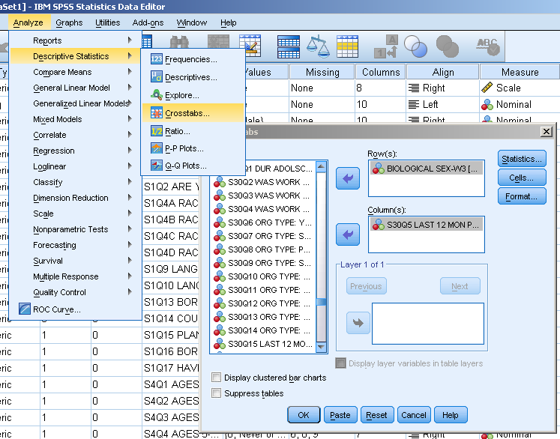
- Analyze Descriptive stats Crosstabs

- Move variables from the variable list on the left to the boxes on the right (it does not matter which variable goes in which box).
- Click the statistics button. Check the box labeled “chi-square”. Hit continue.

- Click the cell button. Check the boxes listed in the picture. Hit continue, then paste.

Syntax
CROSSTABS
/TABLES=BIO_SEX3 BY H3CC3
/FORMAT=AVALUE TABLES
/STATISTICS=CHISQ
/CELLS=COUNT EXPECTED ROW COLUMN TOTAL
/COUNT ROUND CELL.

- Highlight the selected information and press the green play button.

Output

The test shows that it is not independent between whether a person volunteers or not and sex, X^2 (1, N = 4861) = 8.03, p < .005. Males who volunteer are less than expected, while females who volunteer are more than expected.

