SPSS Handbook
R. Julian Barber
Longwood University

Table of Contents

Basics of SPSS....................................................................................................................3

Frequency Polygon……………………………………………………………………….7

Histogram……………………………………………………………………………….10

Bar Graph……………………………………………………………………………….12

Single Sample t………………………………………………………………………….14

Independent t …………………………………………………………………………...17

Dependent t……………………………………………………………………………...22

One-Way ANOVA……………………………………………………………………...25

One-Way ANOVA Post hocs…………………………………………………………...29

Repeated Measures ANOVA…………………………………………………………..34

2-Way ANOVA………………………………………………………………………….39

Mixed Model ANOVA …………………………………………………………………44

Pearson r ………………………………………………………………………………..50

Goodness of Fit X² …………………………………………………………………………….......53

Contingency Table X² …………………………………………………………………………….55

Basics of SPSS

- Abuses of Statistics:
-Bad Samples – ex: Biased design: Systematically favors certain outcomes.
-Misleading Graphs – Graphs that are not to scale, or too spaced out.
-Not giving enough information.
-Misleading conclusions.
- Descriptive vs. Inferential Statistics:
-Descriptive – Summarize a population sample.
-Inferential – Uses data to analyze and learn about the population that the sample is meant to represent.
- Four Different Types of Data that can be Collected:
-Nominal – Categories.
-Ordinal – The order of numbers with no equal distance between them.
-Interval – The order of numbers with equal distance between them.
- No absolute zero.
-Ratio – Has all of the properties above.
- Always use order of operations (PEMDAS - Parenthesis, Exponent, Multiplication, Division, Addition, and Subtraction).
- Round if >.5, and round two decimal places.
- Statistical Notation – N= Number of people in population. n= Number of people in a sample.
- ∑= Sum of…
- Formulas for Standard Deviation:
-Sx = Sample standard deviation.

sample:

s_{x} = Σ (X – X)²

n – 1

-σ = Population standard deviation.

population:

σ = Σ (X – μ)²

N
- Variance – The standard deviation squared.
-Sx² = Sample variance.
- ∑= (x-$\overline{x}$)²
n-1
-σ² = Population variance.
- ∑= (x-µ)²
N
- Descriptive Statistics SPSS:
- Click Variable View and type in what you want each column’s name to be (Participant number, DV, IV, etc.).
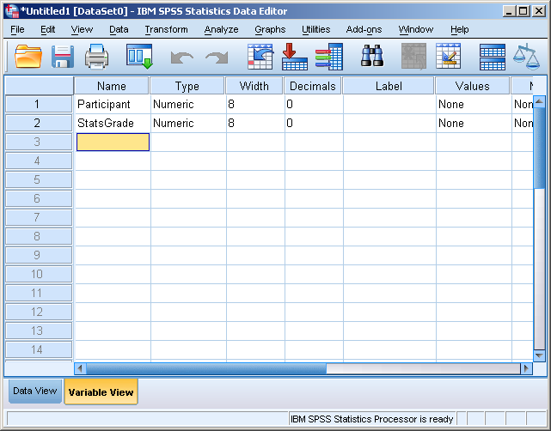

- Go to Data View and type in your data.
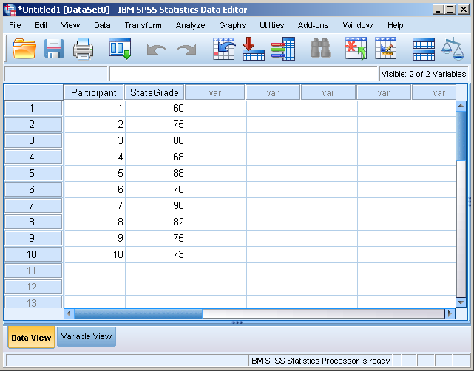

- Click Analyze - Descriptive Statistics – Descriptives.
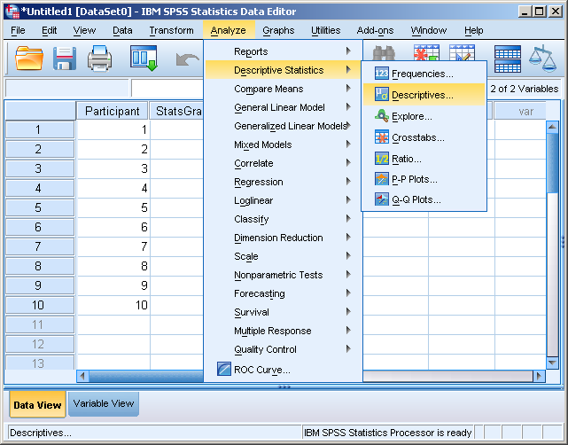

- Highlight and then arrow over the variable you want to analyze.
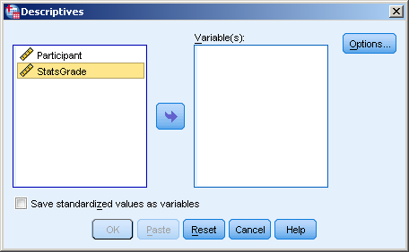

- Click on options – Click all the descriptive statistics you would like to be analyzed.
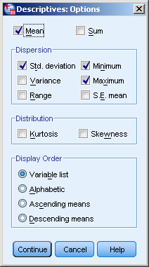

- Click continue – Okay, and then you get the final result.

Descriptive Statistics
 | N | Minimum | Maximum | Mean | Std. Deviation
StatsGrade | 10 | 60 | 90 | 76.10 | 9.183
Valid N (listwise) | 10

Frequency Polygon
- Frequency Polygon – A graph of a frequency distribution that has values of the variable on the x-axis and the number of observations on the y-axis.
- SPSS
- Go to variable view and type in labels appropriately (Participant number, Dependent variable, Independent variable, etc.) you want the column to be named under “Name.”
- When typing in the name column there cannot be any spaces or symbols (!,@,#,$, etc.).
- You can change how many decimal places you want under the “Decimal” section.
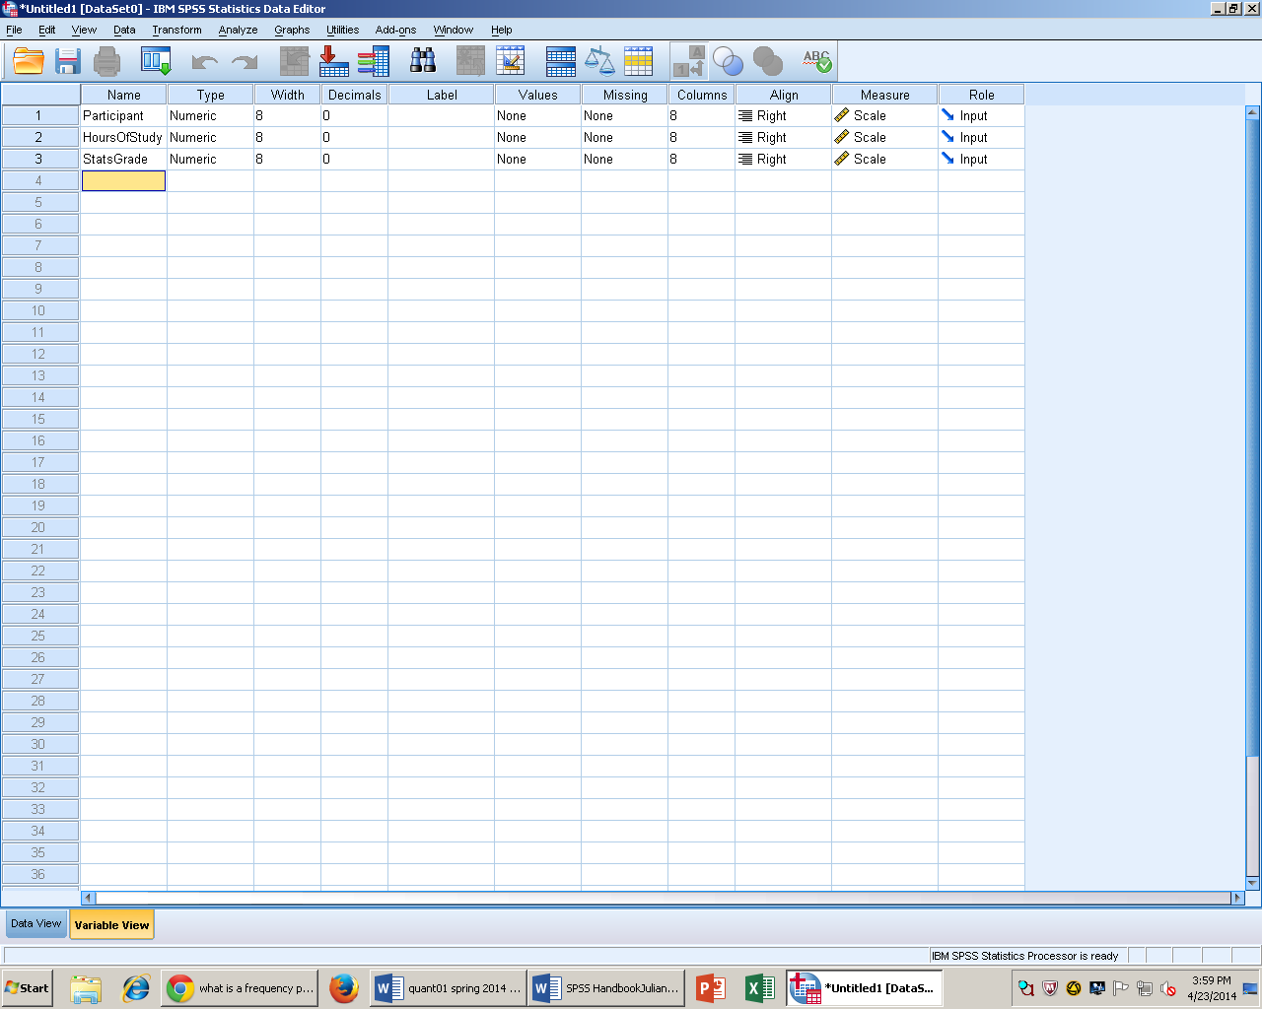

- Switch back to “Data View,” and type in the appropriate data into the appropriate columns.
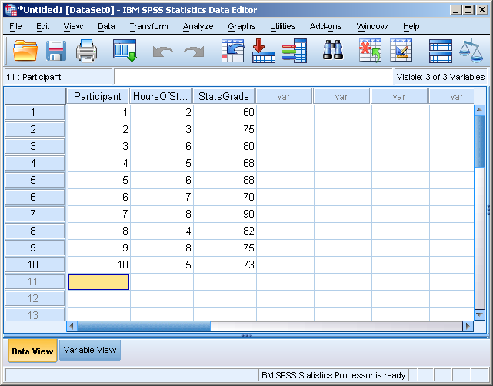

- After entering your data click on Graphs then Chart builder.
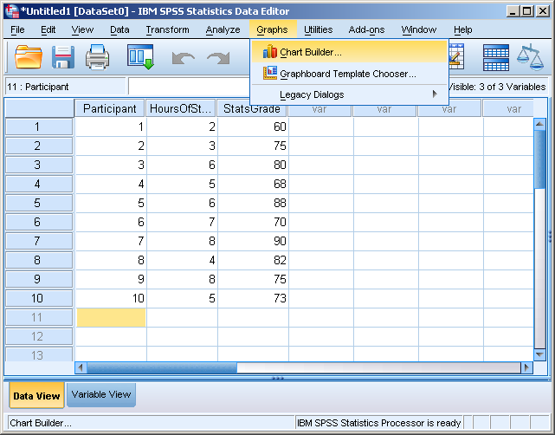

- Click on Histogram, then to the right of that click on the frequency polygon chart and drag it to the box above it. In the box to the left is where the variables are located, simply drag them to the appropriate place in the box to the right (x-axis, and y-axis).
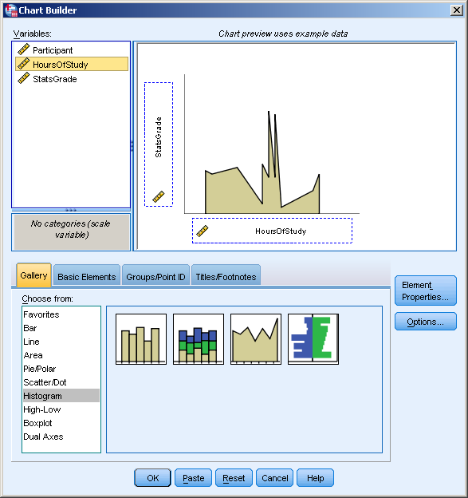

- Click OK, and the final result of the frequency polygon will look like this.
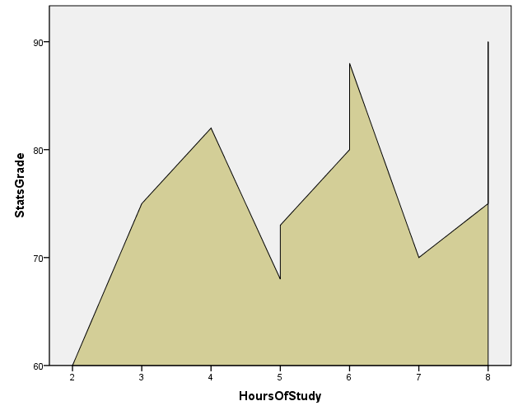

Histogram
- The purpose of a histogram is to display the frequency of a variable, with no spaces between the bars like in a bar graph.
- SPSS:
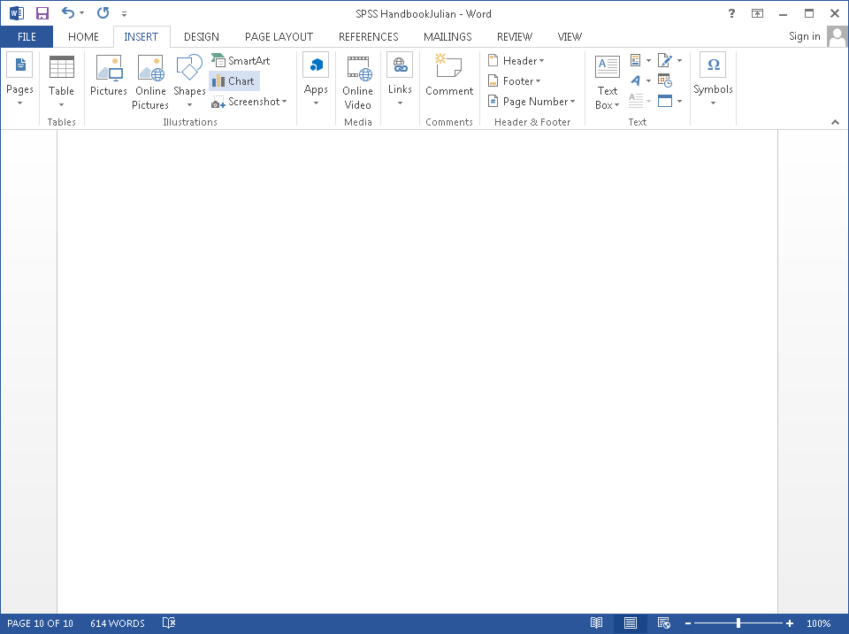
- In Word click on insert – Chart.

- A screen will pop up – select Line – OK.

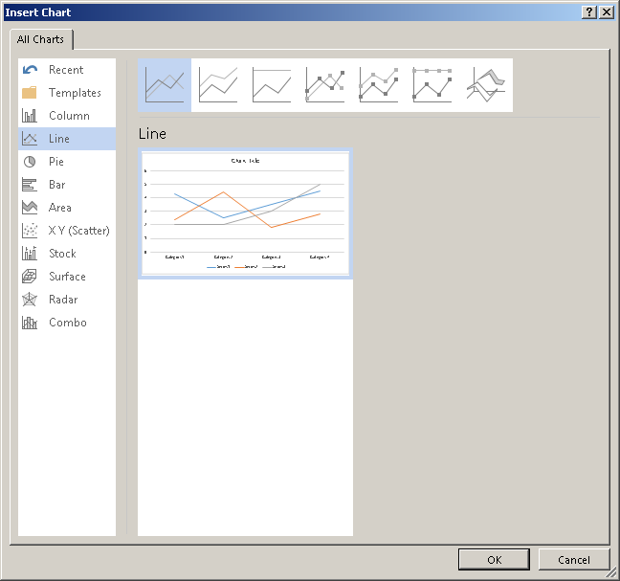

- Enter your data in the appropriate columns.
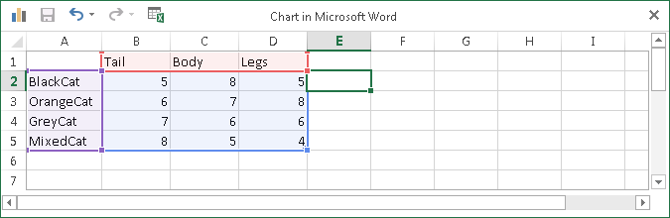

- The chart will pop up under the data box.
- No title.
- No background lines.
- No outline.
- No key or legend.
- Label x-axis and y-axis appropriately.

Length of Tail (inches)

Type of Cat

Bar Graph
- A diagram in which the numerical values of variables are represented by the height or length of lines or rectangles of equal width.
- SPSS:
- In Word click on insert – Chart.

- A screen will pop up – Column – OK.

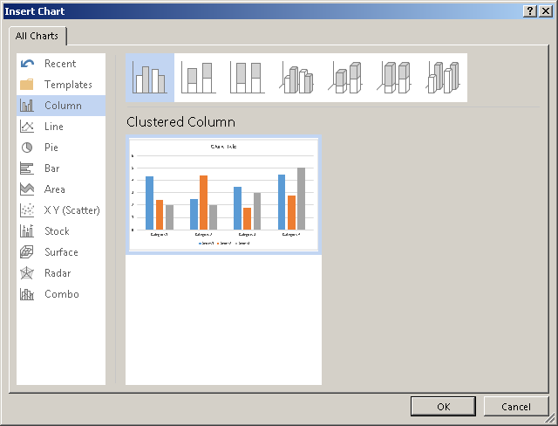

- Enter the data in the appropriate columns.

- The graph will pop up under the data box.
- No title.
- No background lines.
- No outline.
- No key or legend.
- Label x-axis and y-axis appropriately.

Length of Tail (inches)

Type of Cat

Single Sample t-test
- Single Sample t-test – Examining two groups to see if they are significantly different from each other.
- Amount of variability is similar in all groups being compared.
- The shape of the distribution changes with n.
- The larger the n, the closer the distribution looks to a standard normal distribution.
- We want to find out if our sample mean is different from the general population.
- We compare our one sample with the general population.
- Sample mean – Population mean
Standard error of the mean
- SPSS:
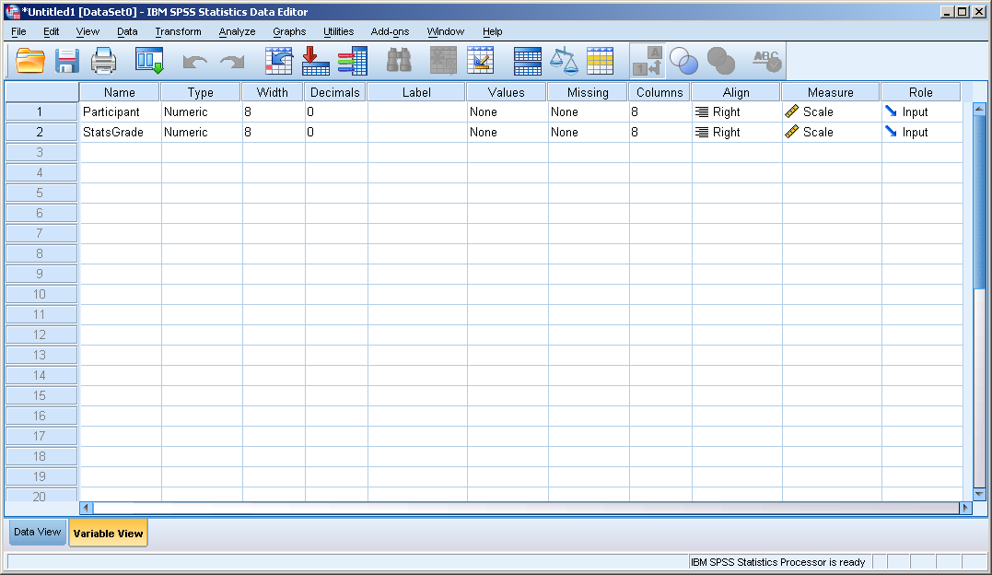
- Go to Variable View – Label your columns appropriately.

- Switch back to Data View – Analyze – Compare Means – One Sample T Test.

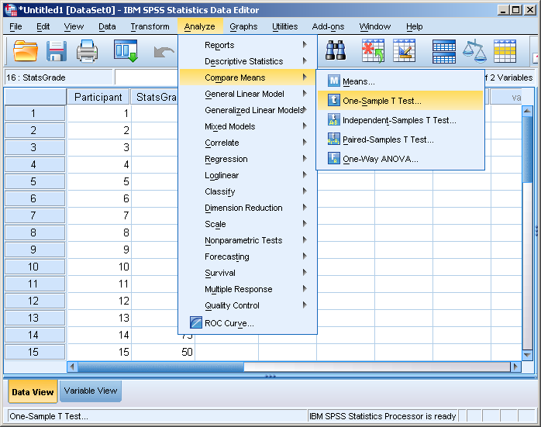

- Highlight the variable you want to test – Arrow it over to variable.
- Click options if you want to change your confidence level.
- Press OK
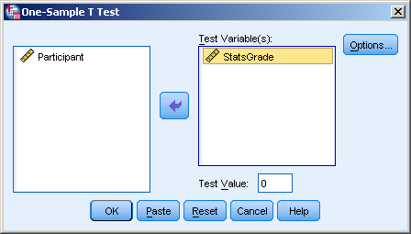
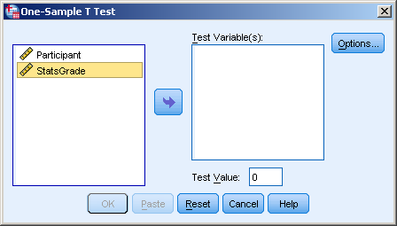

- Results should look like this.

One-Sample Statistics
 | N | Mean | Std. Deviation | Std. Error Mean
StatsGrade | 15 | 73.80 | 10.339 | 2.669

One-Sample Test
 | Test Value = 0
 | t | df | Sig. (2-tailed) | Mean Difference | 95% Confidence Interval of the Difference
 |  |  |  |  | Lower | Upper
StatsGrade | 27.647 | 14 | .000 | 73.800 | 68.07 | 79.53

- APA Results:
- t (degrees of freedom) = t value , p = Sig. Value , 1 – tailed.

Independent t-test
- Independent t-test – We want to find out if our two samples are different from each other.
- Do the sample represent different populations?
- Each group is made of up separate people (between groups design).
- n₁ – Number of participants in first sample (usually experimental).
- n₂ – Number of participants in second sample (usually control group).
- SPSS:
- Go to Variable View and enter data in appropriate columns (Participants, IV, DV, etc.).
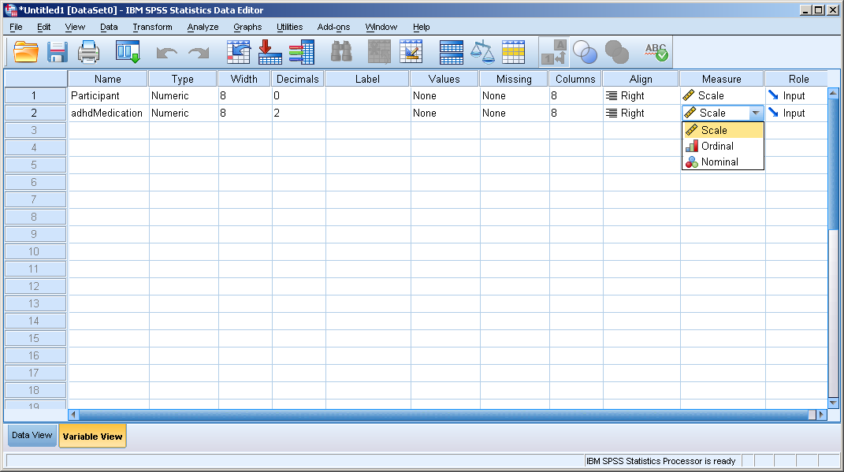
- Switch the measurements to Scale.

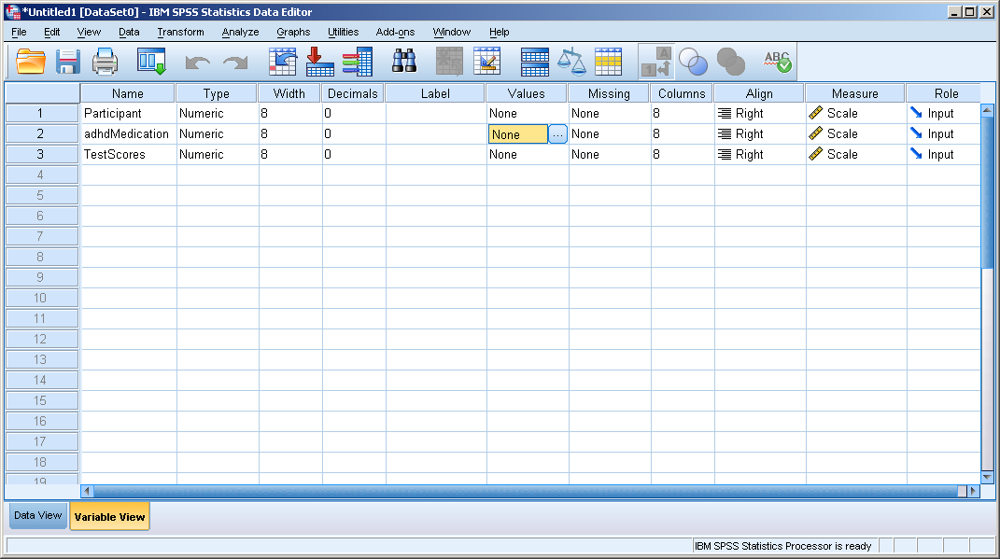
- We can then add our value labels – Click inside the box where it says Values.

- A box will pop up – put a number value in the value box – put a word in the label box – press add – press OK.

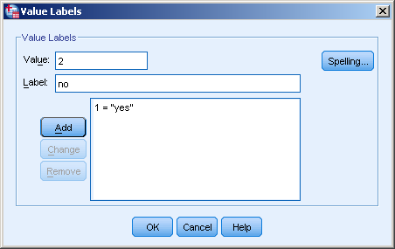

- Go to Data View and enter the data in the appropriate columns (should look like this 1 = yes 2 = no).

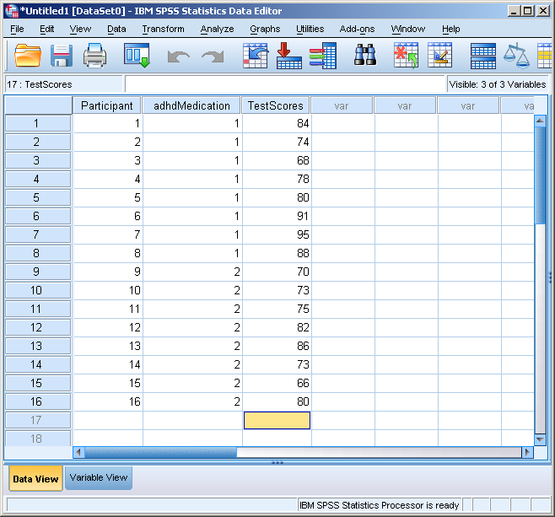

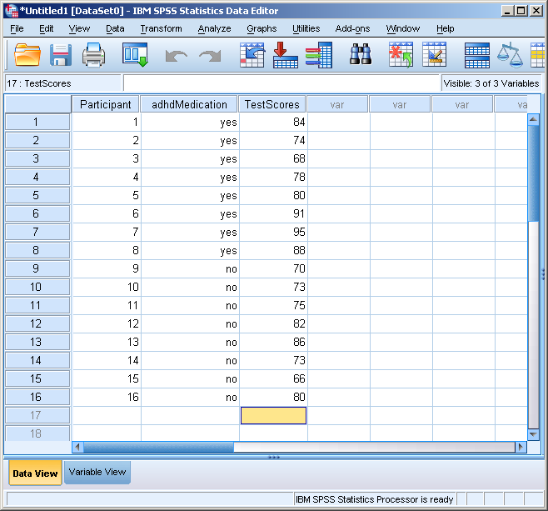
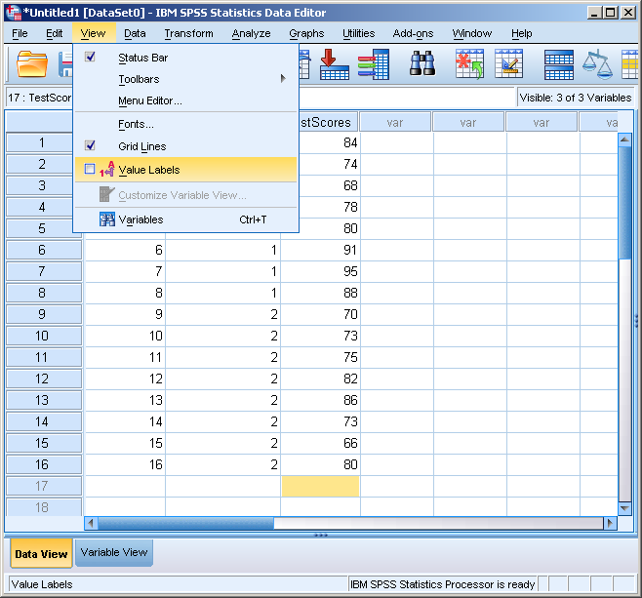
- Click on View – check the box that says Value Labels and then it should look like this.
- Click Analyze – Compare Means – Independent Samples T Test.
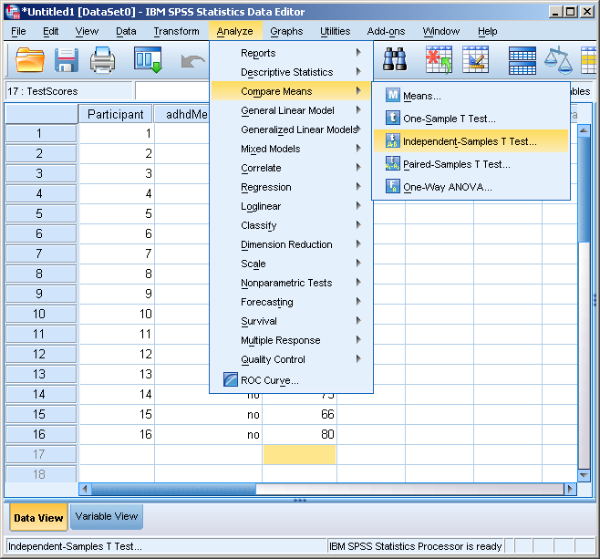

- A box will pop up – arrow over the Independent Variable to grouping variable.
- Click Define Groups
- Enter in the amounts you put for your value labels in Group 1 then Group 2 – Press continue.
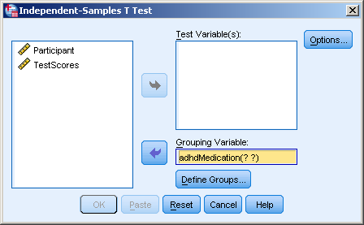
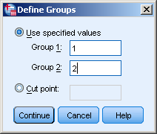

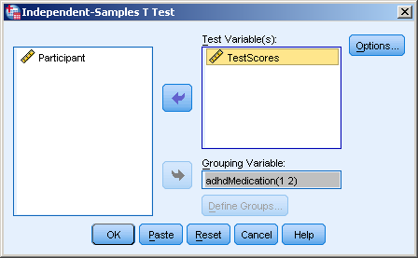
- Arrow over the Dependent Variable into Test Variables – Press OK.

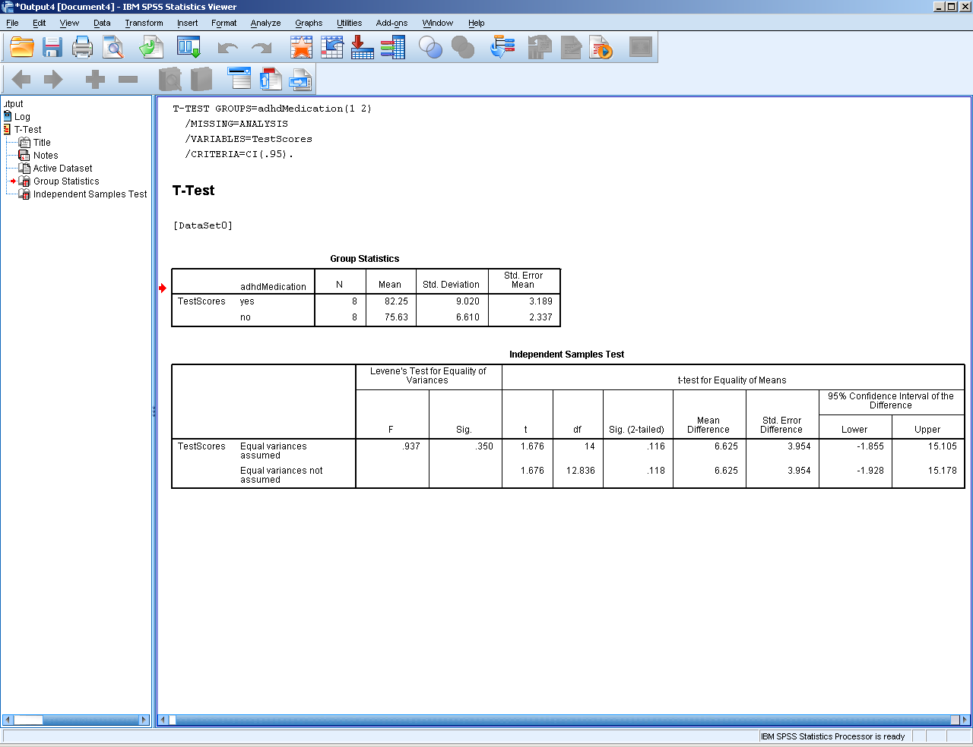
- The results should look like this.

- Reporting in APA:
- Independent t results showed that (the IV had a significant/not significant effect on the DV), t (degrees of freedom) = t value, p = .Sig. Value, Confidence Interval% CI[Lower, Upper] (two-tailed/one-tailed). The (First Variable Group DV) (M = X, SD = X) (Had Less/More of an effect on the Second Variable Group DV) (M = X, SD = X).

Dependent t-test
- Dependent t-test – Compares two groups.
- Each group is made up of the same people.
- Sample of participants is tested twice (2 samples).
- SPSS:
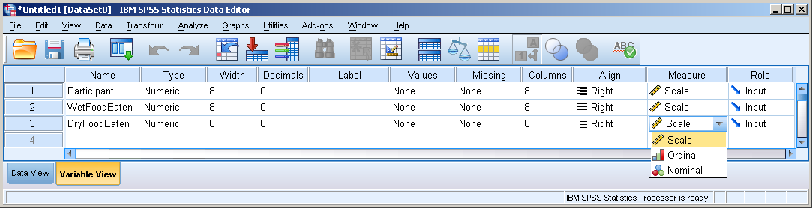
- Enter columns appropriately in Variable View (same participants tested twice, within subjects design) – Change measurements to Scale.

- Go to Data View – enter data appropriately – Click Analyze – Compare Means – Paired Samples T Test.
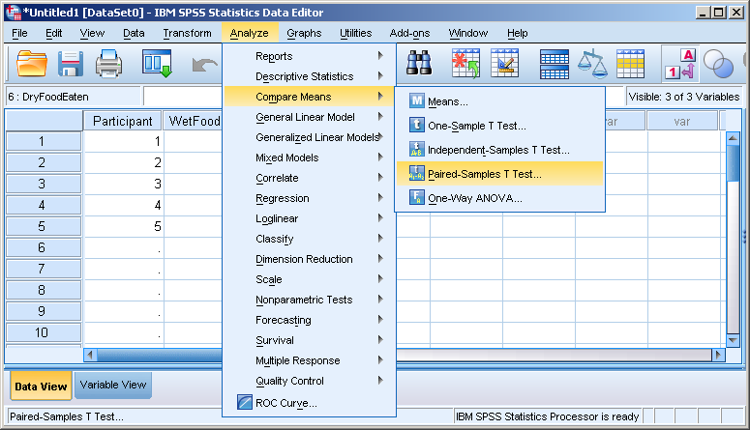

- In the box arrow over the two variables into the variable 1 and variable 2 columns – Click OK.
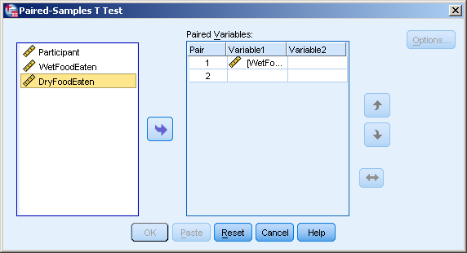

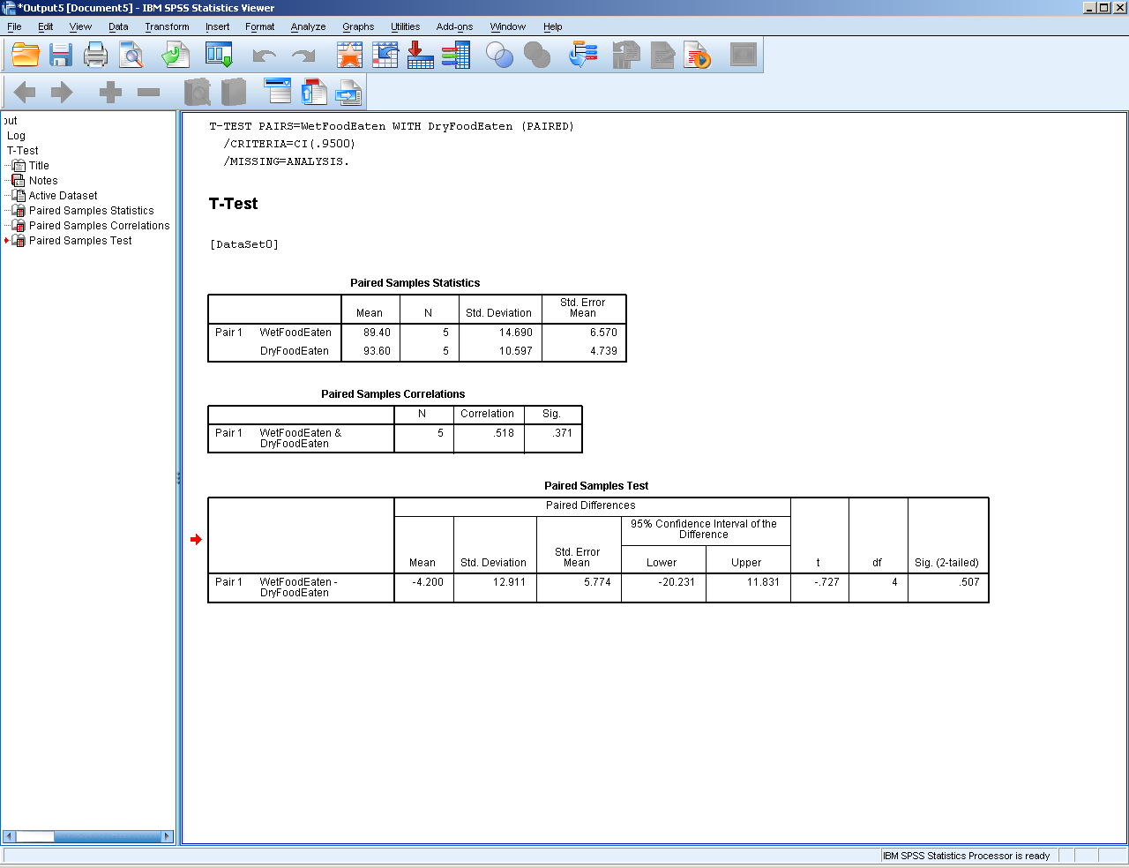
- The results should look like this.
- Reporting in APA:
- We conducted a dependent t-test to find out if there was a significant difference in (Insert Independent Variables). The results show that there (Was or wasn’t a significant difference between the two variables). First variable (M = X, SD = X) and second variable (M = X, SD = X) conditions; t(degrees of freedom) = t-value, p = Sig. value. These data suggest that there is/is not significant difference (Insert Variables).

One-way Analysis of Variance (ANOVA)
- One-way ANOVA – Shown as “F” in the output section.
- Cannot be negative, 0 is the lowest.
- Only one-tailed.
- Use when:
- There is only one Independent Variable
- Three or more groups (levels).
- Between subjects design.
- F = Variability Between Treatments
Variability Within Treatments
- SPSS:
- Go to Variable View – enter information in appropriate columns – switch measurement to scale.
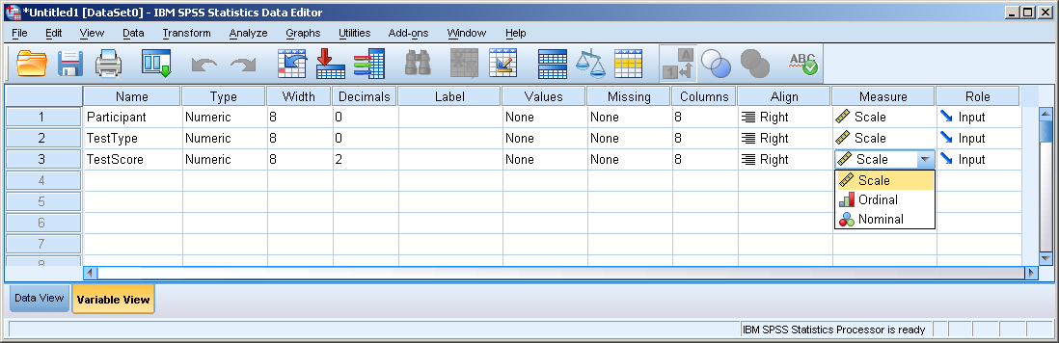

- Enter appropriate Value Labels – click values – enter a number to represent your label in the Value box – enter the label in the Label box.
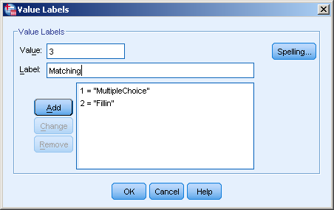

- Go to Data View – enter data appropriately – click view – check the box that says Value Labels.
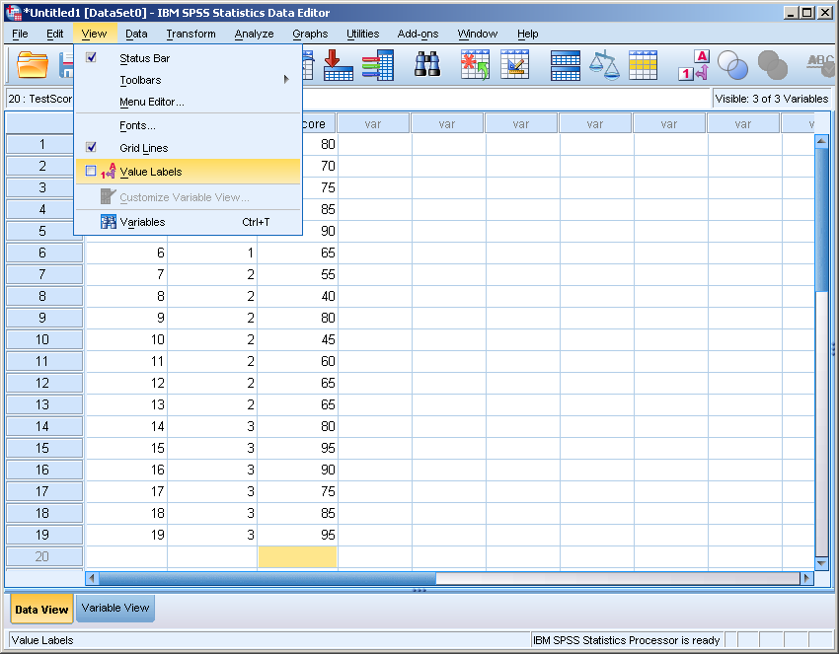
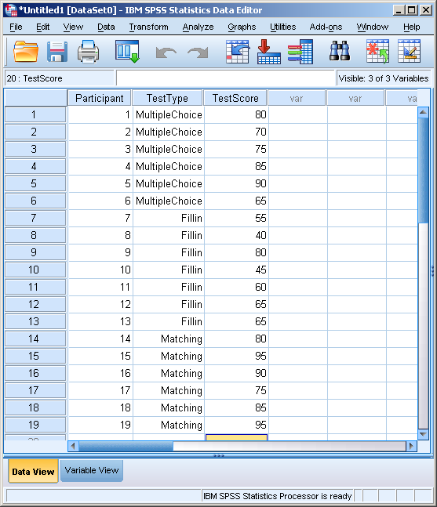

- Click Analyze – Compare Means – One-way ANOVA.
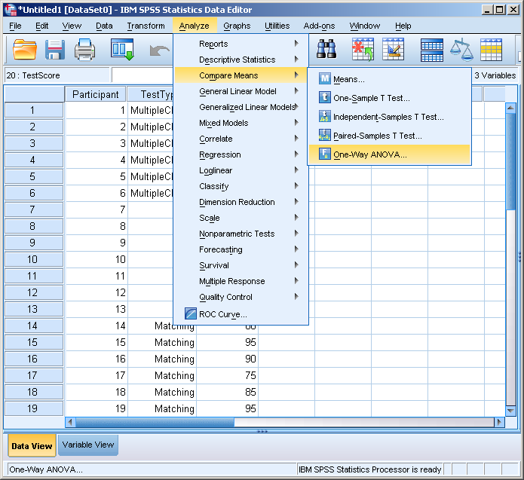

- Arrow the Independent Variable over to the box labeled Factor – arrow the Dependent Variable over to the box labeled Dependent List.
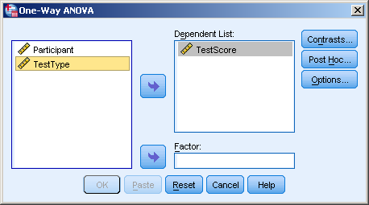
- Click Options - check the box labeled Descriptive – click continue – OK.
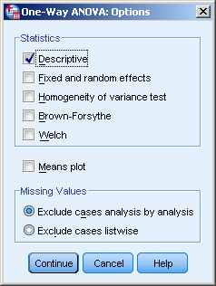

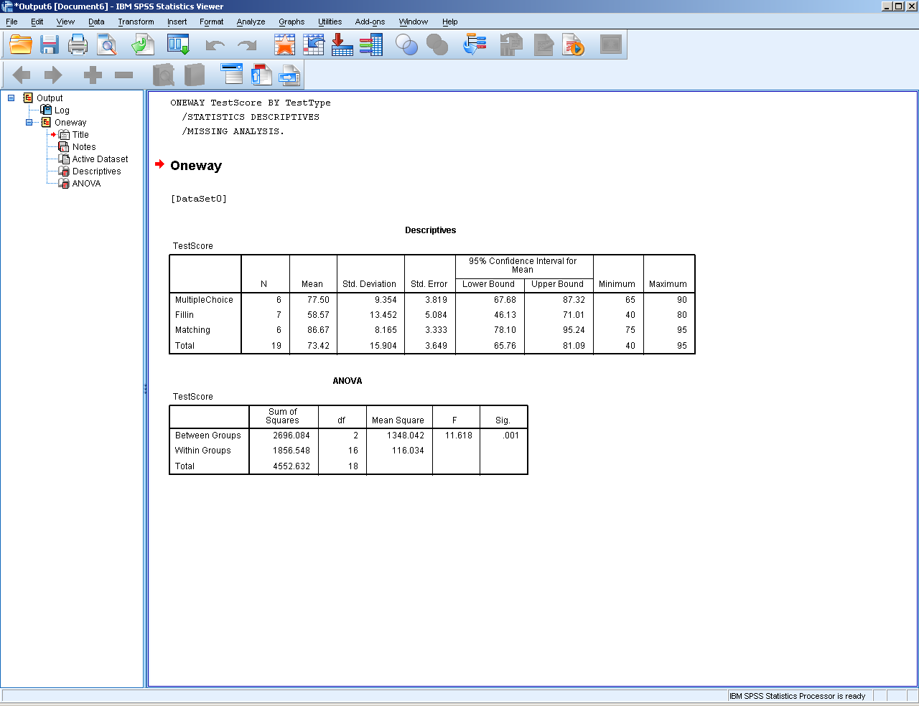
- The results page looks like this.
Reporting in APA:
- A one-way Analysis of Variance (ANOVA) showed that (significantly different/same Independent Variable depending on the Dependent Variable), F(degrees of freedom between groups, degrees of freedom within groups) = F value, p (<,>,=) Sig. value.

One-way ANOVA post hoc tests
- One-way ANOVA post hoc tests – Fisher’s LSD (Least Significant Difference), Scheffé, and Tukey.
- After a one-way ANOVA, you want to compare the mean of one group, or Independent Variable, with the mean of another.
- Fisher’s LSD – A set of individual tests but does not correct for multiple comparisons.
- It is the more liberal or general post hoc test.
- Scheffé’s Method – Adjusts significance levels in a linear regression analysis, and does correct for multiple comparisons.
- It is a comparison procedure that applies to the set of estimates of all possible contrasts to the means.
- It is the more conservative post hoc test.
- Tukey’s Test – Finds means that are significantly different from each other by comparing all the possible pairs means in the data.
- It identifies any difference between two means that is greater than the expected standard error.
- It is the median of the post hoc tests, and the most commonly used.

- SPSS:
- After you enter all the data appropriately in Variable View then in Data View click Analyze – Compare means – One way ANOVA.
- Arrow over the variables in the appropriate boxes (DV in the Dependent List box, IV in the Factor box) – Make sure you check the Descriptive box in options.
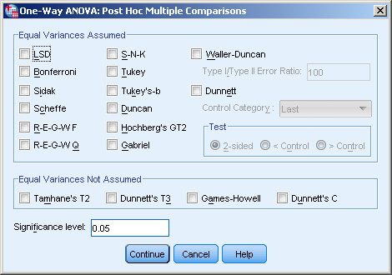
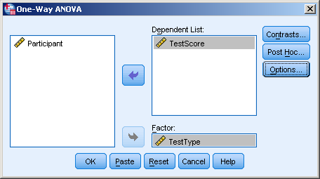
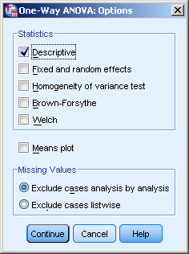
- Click on Post Hoc – check the box of the post hoc test you want to run depending on your data.

- Make sure the significance level is what you want to run – press continue – OK.

- This shows all the post hoc tests with a 95% confidence interval in one results section.
Multiple Comparisons
Dependent Variable:TestScore
 | (I) TestType | (J) TestType | Mean Difference (I-J) | Std. Error | Sig. | 95% Confidence Interval
 |  |  |  |  |  | Lower Bound | Upper Bound
Tukey HSD | MultipleChoice | Fill-in | 18.929* | 5.993 | .016 | 3.46 | 34.39
 |  | Matching | -9.167 | 6.219 | .329 | -25.21 | 6.88
 | Fill-in | MultipleChoice | -18.929* | 5.993 | .016 | -34.39 | -3.46
 |  | Matching | -28.095* | 5.993 | .001 | -43.56 | -12.63
 | Matching | MultipleChoice | 9.167 | 6.219 | .329 | -6.88 | 25.21
 |  | Fill-in | 28.095* | 5.993 | .001 | 12.63 | 43.56
Scheffe | MultipleChoice | Fill-in | 18.929* | 5.993 | .021 | 2.77 | 35.08
 |  | Matching | -9.167 | 6.219 | .361 | -25.93 | 7.60
 | Fill-in | MultipleChoice | -18.929* | 5.993 | .021 | -35.08 | -2.77
 |  | Matching | -28.095* | 5.993 | .001 | -44.25 | -11.94
 | Matching | MultipleChoice | 9.167 | 6.219 | .361 | -7.60 | 25.93
 |  | Fill-in | 28.095* | 5.993 | .001 | 11.94 | 44.25
LSD | MultipleChoice | Fill-in | 18.929* | 5.993 | .006 | 6.22 | 31.63
 |  | Matching | -9.167 | 6.219 | .160 | -22.35 | 4.02
 | Fill-in | MultipleChoice | -18.929* | 5.993 | .006 | -31.63 | -6.22
 |  | Matching | -28.095* | 5.993 | .000 | -40.80 | -15.39
 | Matching | MultipleChoice | 9.167 | 6.219 | .160 | -4.02 | 22.35
 |  | Fill-in | 28.095* | 5.993 | .000 | 15.39 | 40.80
*. The mean difference is significant at the 0.05 level.

- Reporting in APA:
- (Insert post hoc test) analysis of variance (ANOVA) suggested that when participants (Independent Variable), they (Dependent Variable) significantly more/less or similar/different (M = X; SD = X, Confidence Interval% CI[lower bound, upper bound]) than (Other Independent Variable condition), t(Degrees of Freedom) = t value, p = Sig. value, or/as in the (Other Independent Variable condition), t(Degrees of Freedom) = t value, p </>/= Sig. value. Participants produced significantly similar/different (Dependent Variable) when (Other Independent Variable condition) (M = X; SD = X, Confidence Interval% CI[lower bound, upper bound]) and (Other Independent Variable condition) (M = X; SD = X, Confidence Interval% CI[lower bound, upper bound]), p = Sig. value.

Repeated Measures Analysis of Variance (ANOVA)
- Repeated Measures ANOVA – Compares related groups, instead of comparing independent groups like a one-way ANOVA.
- Within subjects design.
- Only one Independent Variable.
- Has three or more groups (levels) of the Independent Variable.
- Every participant participates in every level.
- SPSS:
- Each level of the Independent Variable gets its own column in Variable View.
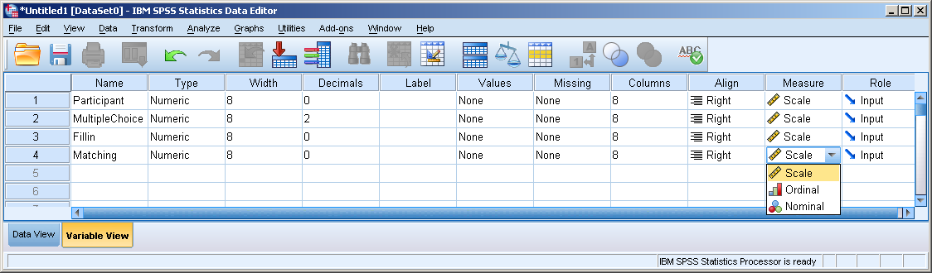
- Change the Measures to Scale.

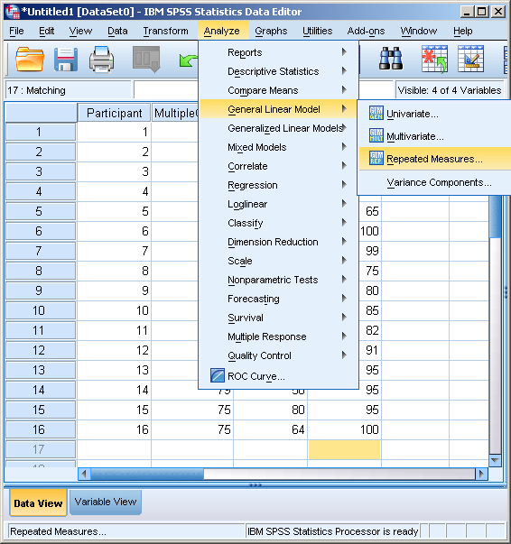
- Enter your data appropriately in Data View – click Analyze – General linear model – Repeated Measures.

- When the Repeated measures define factors box comes up type the Independent Variable into the within subject factor name – add the appropriate number of levels – click Add.
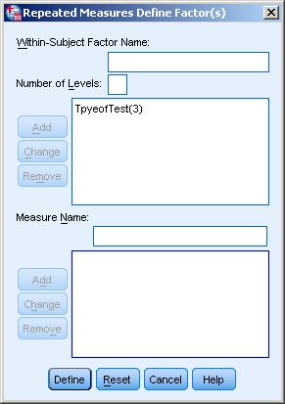
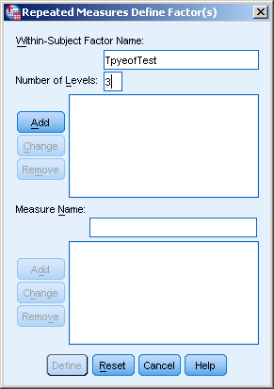

- Click Define – arrow over the Dependent Variables to Within Subjects Variables.
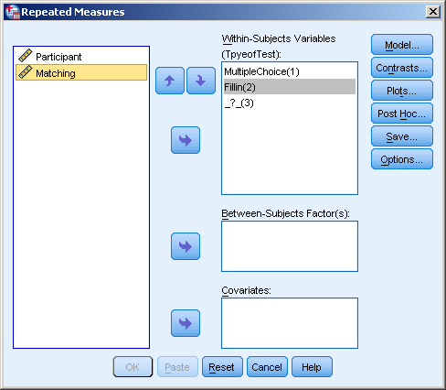

- Click Options – check Descriptive Statistics – check Estimates of Effect Size – Arrow over the Independent Variable to Display Means for – check Compare Main Effects – adjust the confidence interval to Bonferroni – Continue – OK.
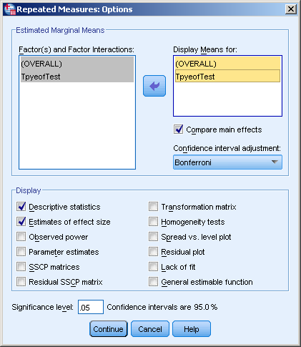

- The results section should look like this.
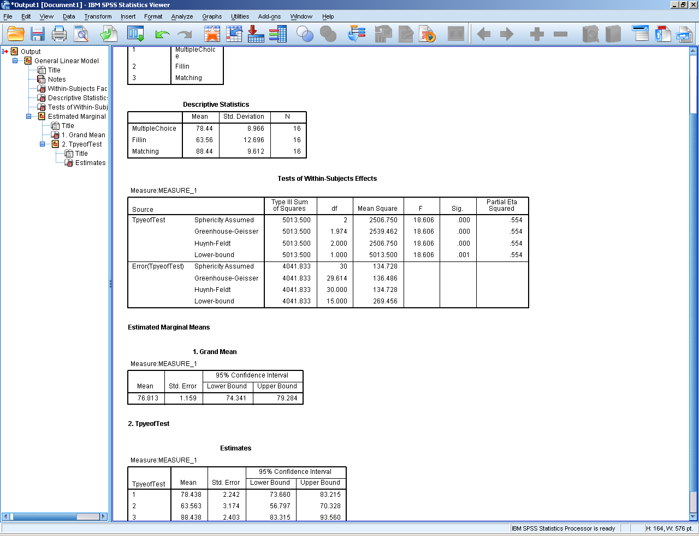
- Can Delete: Multivariate Tests, Mauchly’s Test of Sphericity, Tests of Within Subjects Contrast, Tests of Between Subjects Effects, Parawise Comparisons, and Multivariate Tests.

Two-Way Analysis of Variance (ANOVA)
- Two-Way ANOVA - Analyzes the effect of the Independent Variables on the expected outcome, and with the relationship to the outcome.
- Has two Independent Variables.
- Two or more groups (levels) for each Independent Variable.
- It is a between subjects design.
- SPSS:
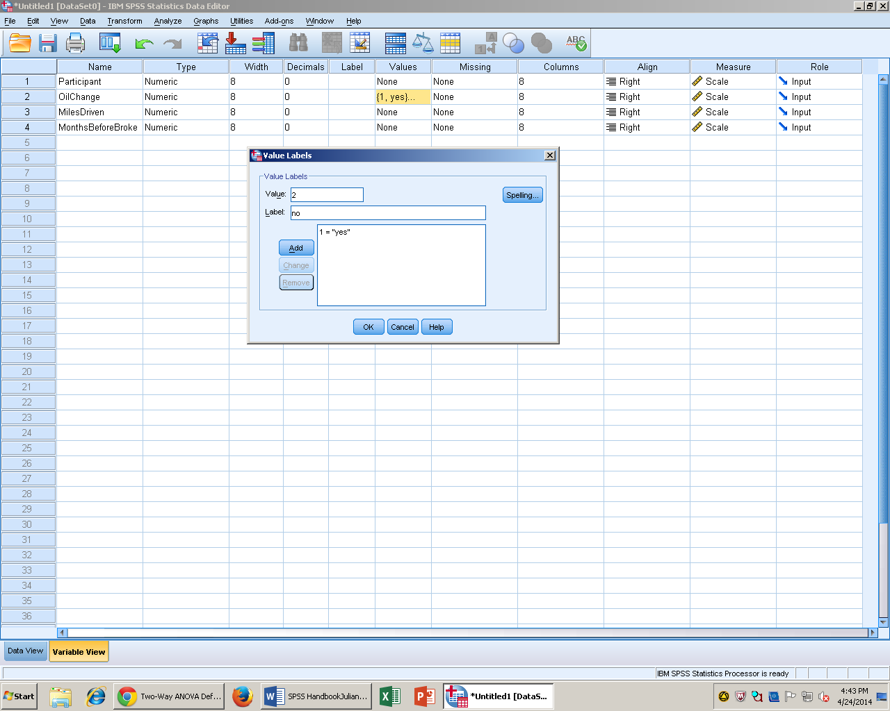
- Enter information appropriately in Variable View – add value labels if necessary.
- Two Independent Variable conditions.

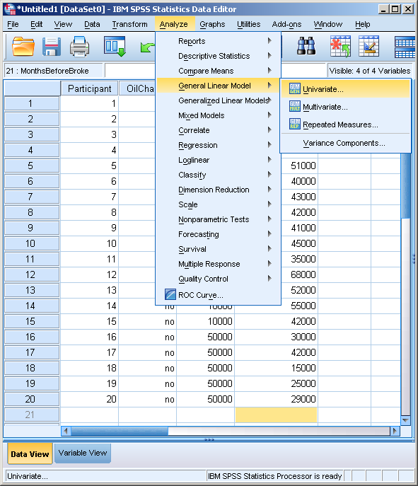
- Enter data appropriately in Data View – click Analyze – General Linear Model – Univariate.

- In the Univariate box arrow over the Dependent Variable to Dependent Variable – arrow over the Independent Variables to Fixed Factor(s).
- Click Options – check Descriptives – check Estimates of effect size – arrow over everything from Factor(s) and Factor Interactions to Display Means For – check Compare Main Effects – adjust confidence interval to Bonferroni.
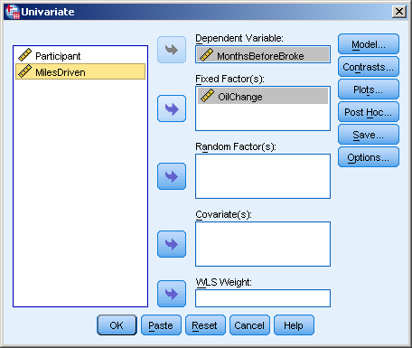
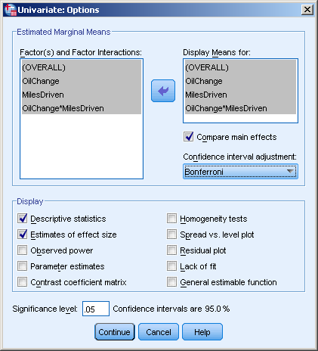

- Click Continue – OK – the results page looks like this.
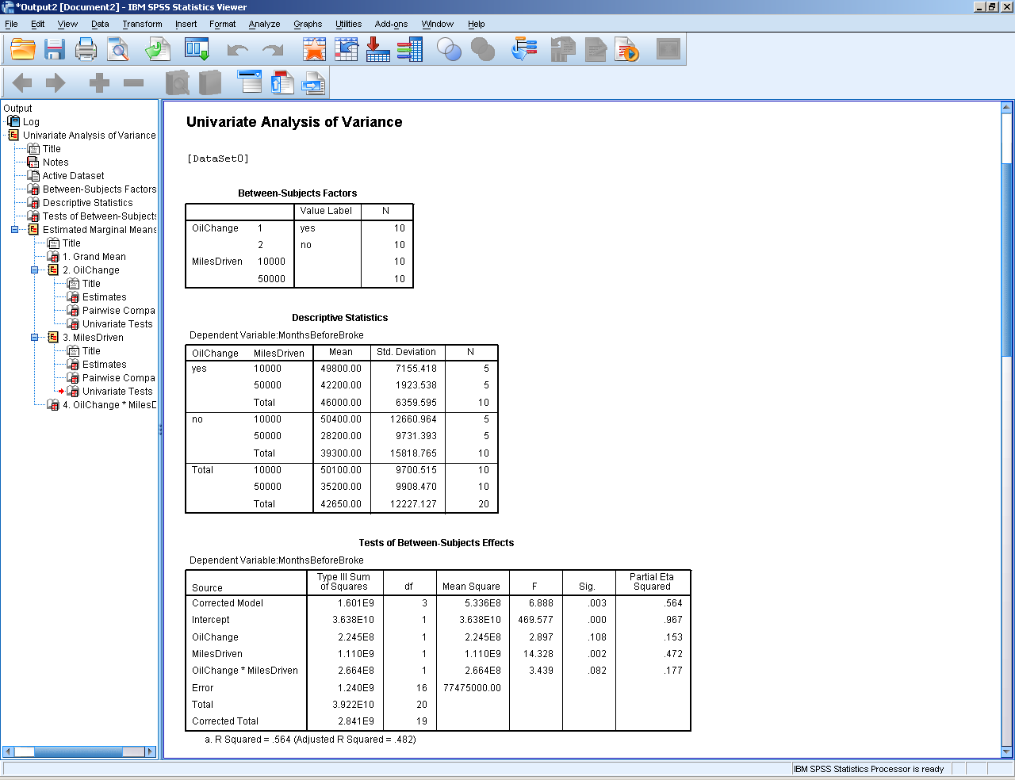
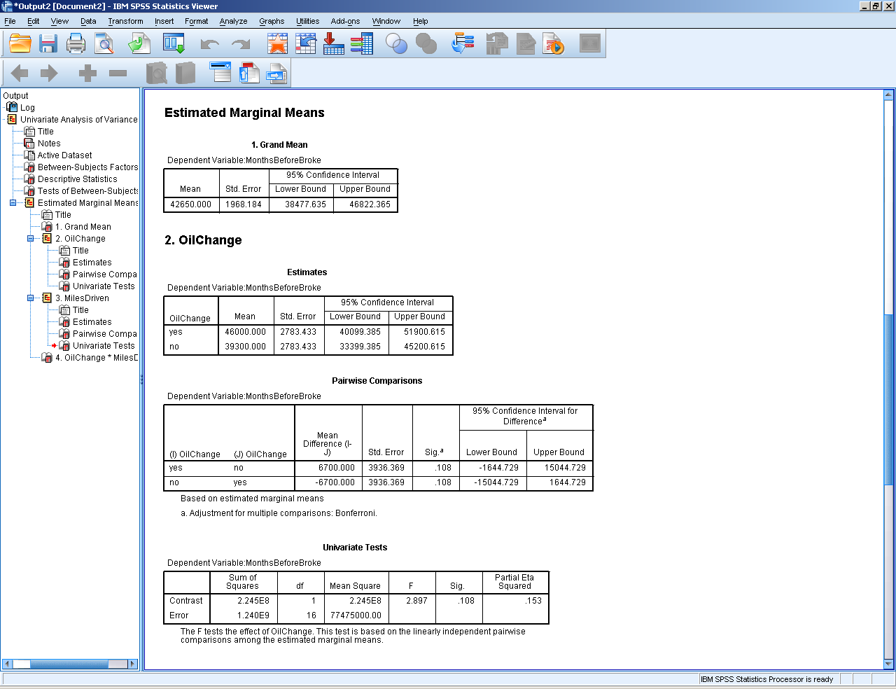

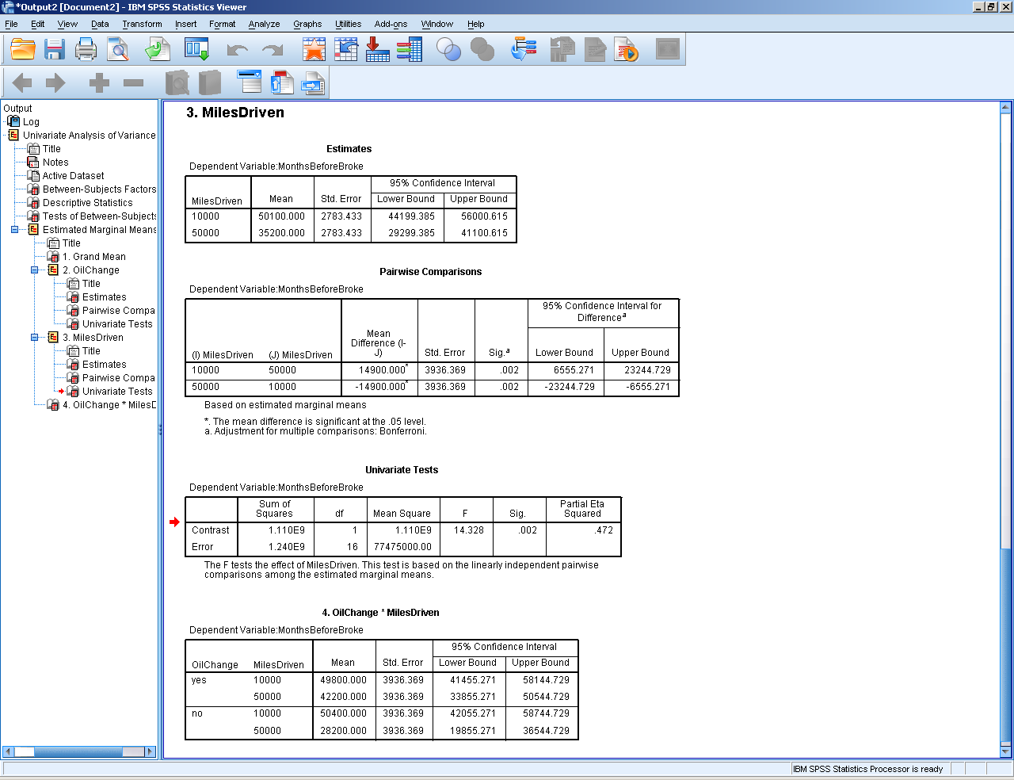

- Reporting in APA:
- We conducted a two-way Analysis of Variance (ANOVA) to determine whether there were any group differences. The participants (Independent Variable Condition 1) (M = X; SD = X, Confidence Interval% CI[lower bound, upper bound]) and (Independent Variable Condition 2) (M = X; SD = X, Confidence Interval% CI[lower bound, upper bound]), F(Degrees of Freedom, Error) = t value, p = Sig. value. There was/was not significant main effect for the size of the (Dependent Variable), F(Degrees of Freedom, Error) = t value, p = Sig. value, with the (Dependent Variable being higher/lower) (M = X; SD = X, Confidence Interval% CI[lower bound, upper bound]) than the (Dependent Variable being higher/lower) (M = X; SD = X, Confidence Interval% CI[lower bound, upper bound]). The ANOVA also indicated a significant/not significant interaction between (IV & DV), F(Degrees of Freedom, Error) = t value, p < Sig. value. Participants (Independent Variable Condition) (M = X; SD = X, Confidence Interval% CI[lower bound, upper bound]) as higher/lower than (Other Independent Condition) (M = X; SD = X, Confidence Interval% CI[lower bound, upper bound]) overall conclusion sentence.

Mixed Model Analysis of Variance (ANOVA)
- Mixed Model ANOVA – Compares the mean differences between groups that have been split on two within-subjects Independent Variables.
- Has two or more groups (levels) for each Independent Variable.
- There are two Independent Variables.
- At least one Independent Variable is dependent (Within subjects).
- SPSS:
- Enter participants – Independent Variables – Dependent Variables.
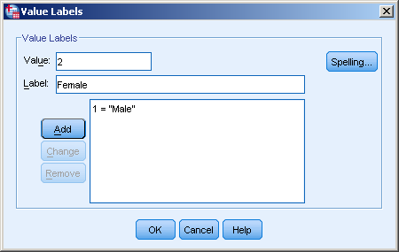
- Insert value labels if needed – change all measurements to Scale.
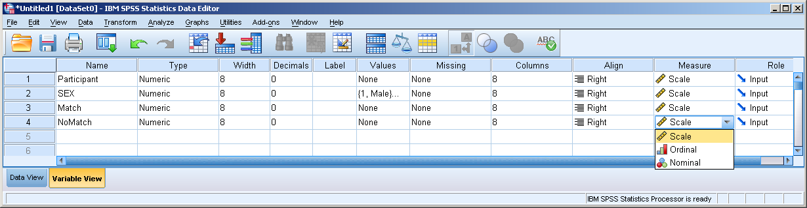

- Enter data appropriately in Data View – Click Analyze – General Linear Model – Repeated Measures.
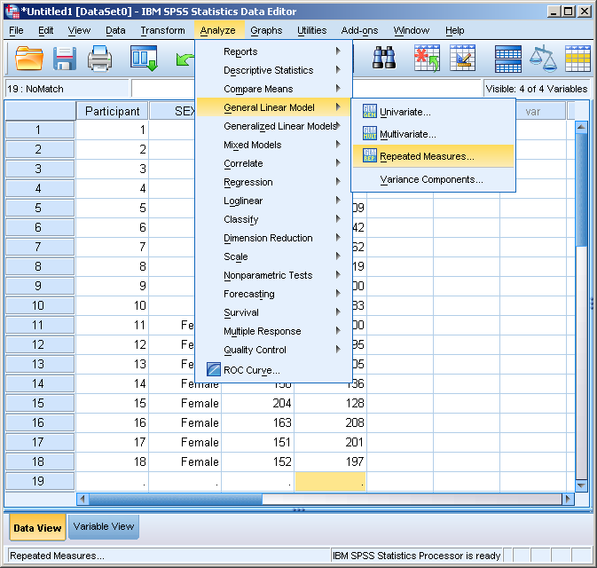

- Label Within Subject Factor name appropriately – insert number of levels for within factors – Add.

- Independent Variables go into the between subjects factor box.
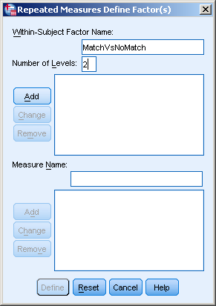
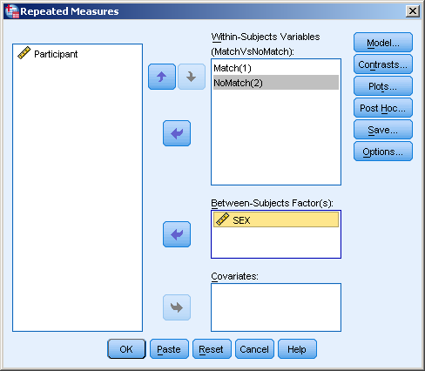
- Dependent Variables go into the within subjects variables box.

- Click options – check the descriptive statistics box – check the estimates of effect size box.
- Arrow over all variables from the Factor(s) and Factor Interactions box to the Display Means for box.
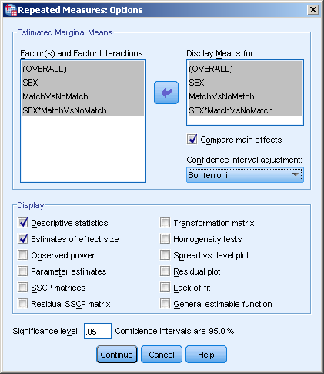
- Check Compare Main Effects – select the Bonferroni Confidence Interval Adjustment.

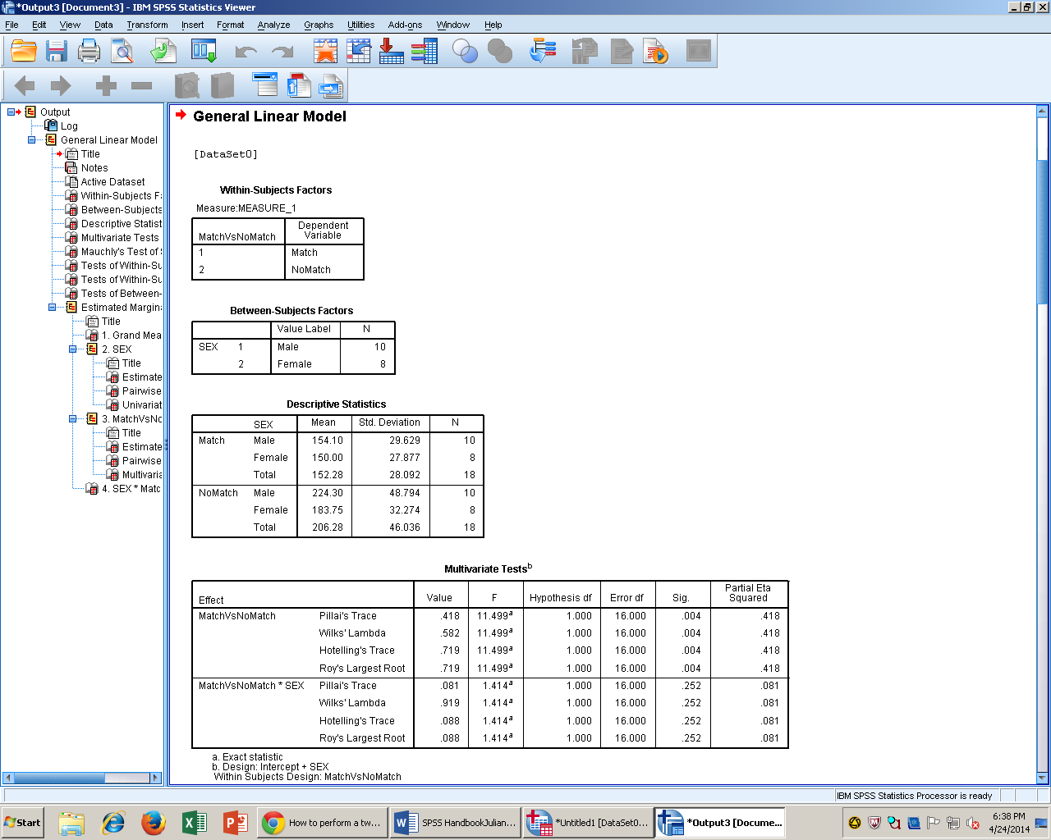
- Click Continue – OK – the results should look like this.

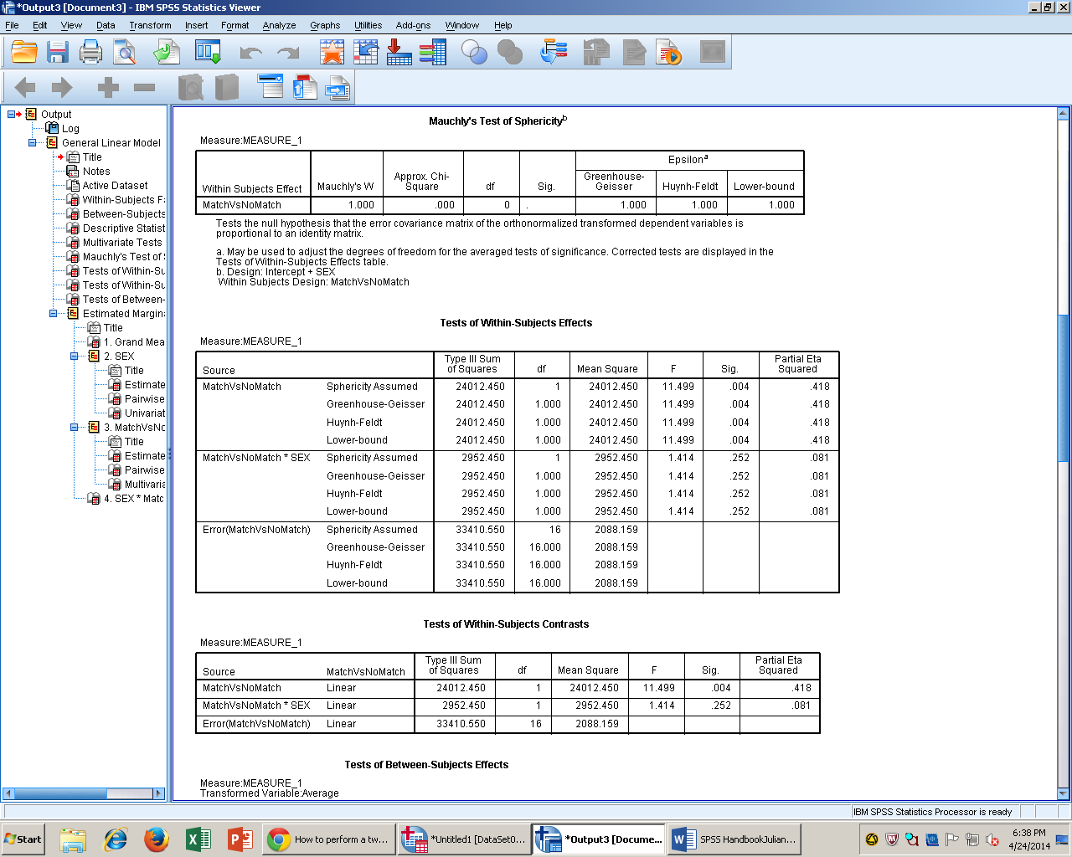

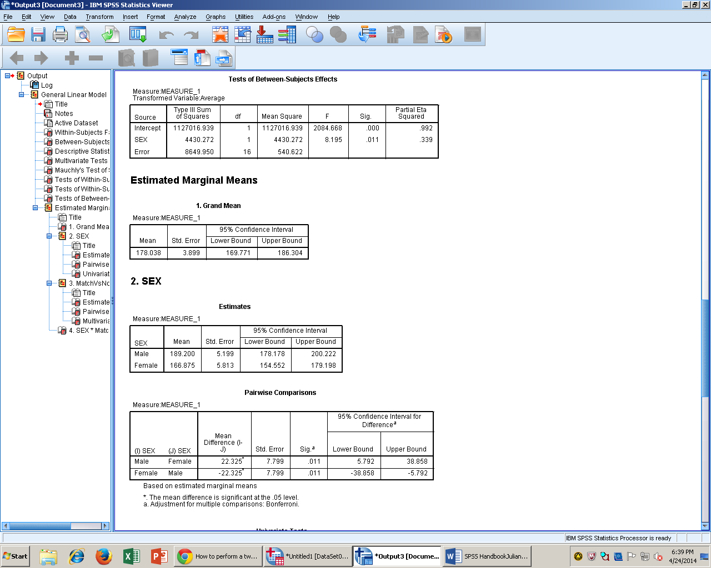

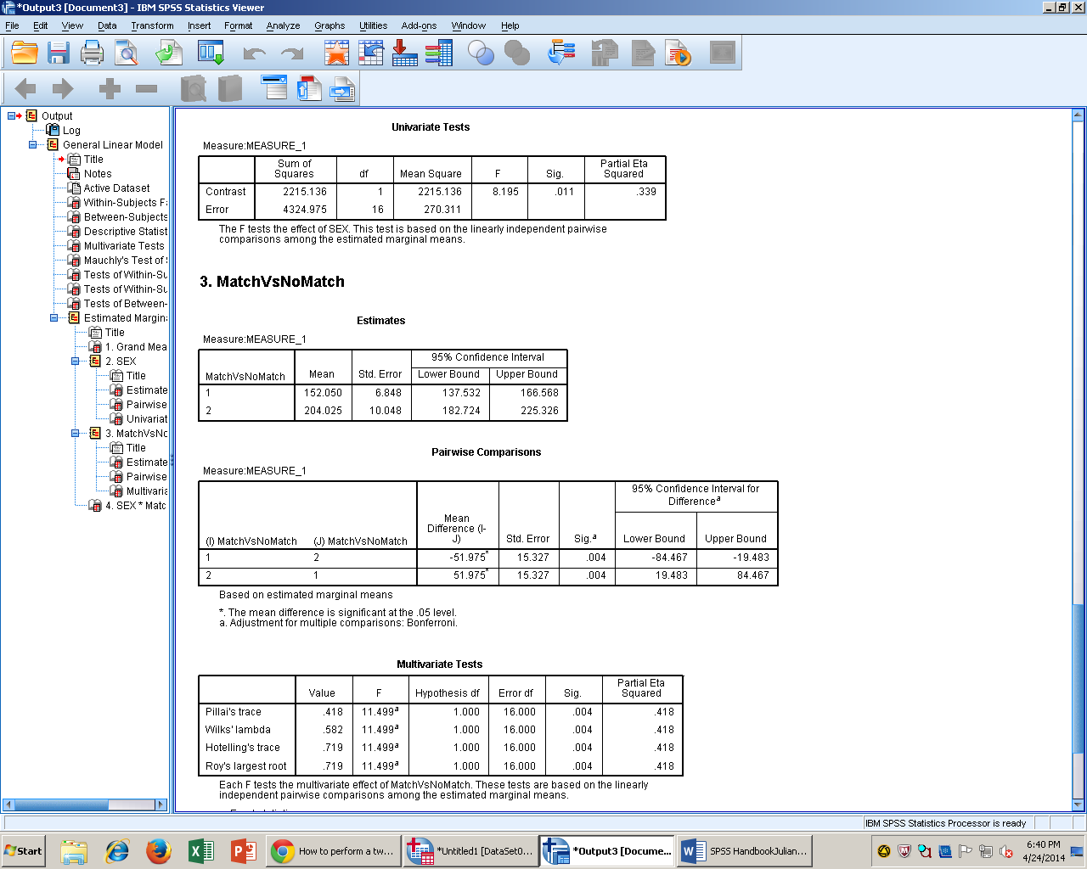

4. SEX * MatchVsNoMatch
Measure:MEASURE_1
SEX | MatchVsNoMatch | Mean | Std. Error | 95% Confidence Interval
 |  |  |  | Lower Bound | Upper Bound
Male | 1 | 154.100 | 9.131 | 134.743 | 173.457
 | 2 | 224.300 | 13.398 | 195.898 | 252.702
Female | 1 | 150.000 | 10.209 | 128.358 | 171.642
 | 2 | 183.750 | 14.979 | 151.996 | 215.504

- Reporting in APA:
- We conducted a Mixed Model Analysis of Variance (ANOVA) to determine whether there were any group differences. The participants (Independent Variable Condition 1) (M = X; SD = X, Confidence Interval% CI[lower bound, upper bound]) and (Independent Variable Condition 2) (M = X; SD = X, Confidence Interval% CI[lower bound, upper bound]), F(Degrees of Freedom, Error) = t value, p = Sig. value. There was/was not significant main effect for the size of the (Dependent Variable), F(Degrees of Freedom, Error) = t value, p = Sig. value, with the (Dependent Variable being higher/lower) (M = X; SD = X, Confidence Interval% CI[lower bound, upper bound]) than the (Dependent Variable being higher/lower) (M = X; SD = X, Confidence Interval% CI[lower bound, upper bound]). The ANOVA also indicated a significant/not significant interaction between (IV & DV), F(Degrees of Freedom, Error) = t value, p < Sig. value. Participants (Independent Variable Condition) (M = X; SD = X, Confidence Interval% CI[lower bound, upper bound]) as higher/lower than (Other Independent Condition) (M = X; SD = X, Confidence Interval% CI[lower bound, upper bound]) overall conclusion sentence.

Pearson r
- Pearson r – Gives information about the direction of the relationship, and strength of relationship between variables.
-Examines the relationship between two continuous variables, and how related they are.
- It is descriptive, not inferential.

- SPSS:
- Enter participant number – enter Independent and Dependent Variables – switch measurement to Scale.
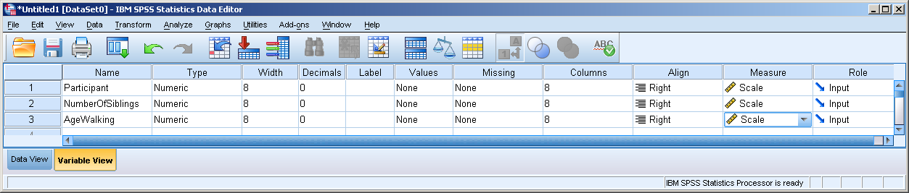

- Enter data appropriately in Data view – click Analyze – Correlate – Bivariate.

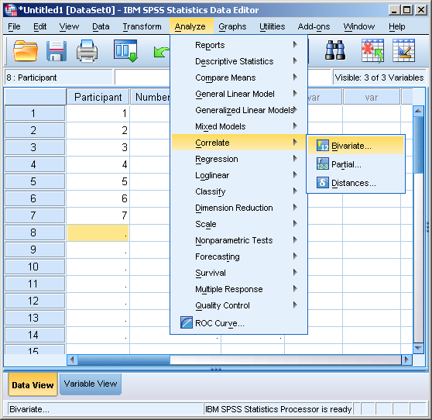

- In the Bivariate Correlations box arrow the variables over to the Variables box – check the box labeled pearson – click two-tailed – check the box that says Flag Significant Correlations.
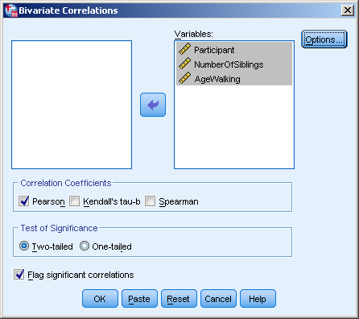
- Click options – check the Means and Standard Deviations box.
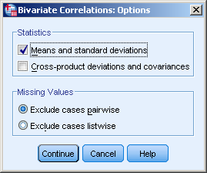

- Click Continue – OK – the results should look like this.
Correlations

Descriptive Statistics
 | Mean | Std. Deviation | N
Participant | 4.00 | 2.160 | 7
NumberOfSiblings | 1.86 | 1.345 | 7
AgeWalking | 11.571 | 3.0880 | 7

Correlations
 |  | Participant | NumberOfSiblings | AgeWalking
Participant | Pearson Correlation | 1 | .574 | -.512
 | Sig. (2-tailed) |  | .178 | .240
 | N | 7 | 7 | 7
NumberOfSiblings | Pearson Correlation | .574 | 1 | -.599
 | Sig. (2-tailed) | .178 |  | .155
 | N | 7 | 7 | 7
AgeWalking | Pearson Correlation | -.512 | -.599 | 1
 | Sig. (2-tailed) | .240 | .155
 | N | 7 | 7 | 7

- Reporting in APA:
- There was a correlation/no correlation between the Independent Variable and Dependent Variable r(Degrees of Freedom) = r value, p = Sig. value r² = r value²

Goodness of Fit Chi-Square (χ²)
- Goodness of Fit χ² – Used to determine if what you observe in a sample distribution of frequencies would be what you would expect to observe by chance in a population.
- Null Hypothesis:
- “No Preference” – Population distribution will be divided into equal parts.
- “No Difference” – Used for demining if the sample will be the same in the population. Also it determines if a change in difference has occurred over time.
- SPSS:
- Enter appropriate columns and value labels in Variable view – switch the predictor variable to Nominal (under Measures).

- Go to Data View and enter data appropriately – click Analyze – Nonparametreic Tests – Legacy Dialogs – Chi-Square.

- Arrow over the predictor variable to the Test Variable List – type in appropriate values in the Values box (Ex: Percentages need to equal 100) – click Add.

- Click OK – the results page should look like this.

- Reporting in APA:
- Description of study, significant or not significant χ²(Degrees of Freedom) = Chi-Square Value, p = Sig. value.

Contingency Table Chi-Square (χ²)
- Contingency Table χ² – Has two classification variables, and is nominal data.
- SPSS:
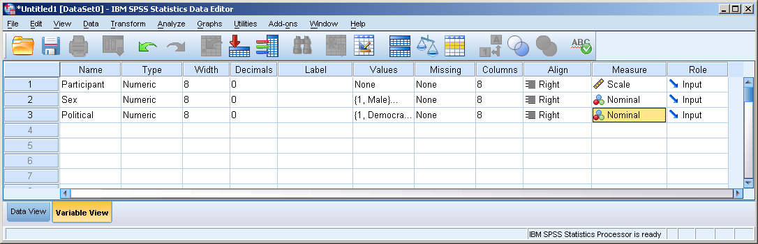
- Enter Participants and variables into the columns in Variable View – Add value labels if needed – change the variable to Nominal under Measurements.
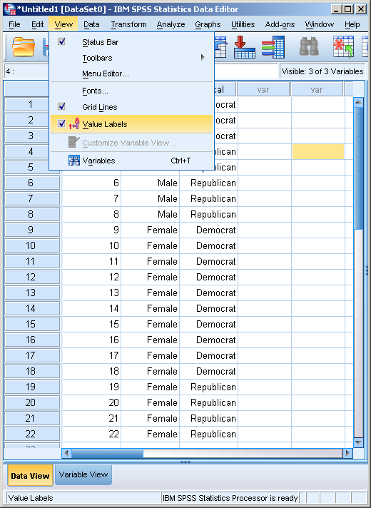
- Enter data in Data View appropriately – click View – check the box for Value labels.

- Click Analyze – Descriptive Statistics – Crosstabs.
- Arrow Independent Variable to Rows – arrow other variable to Column(s)
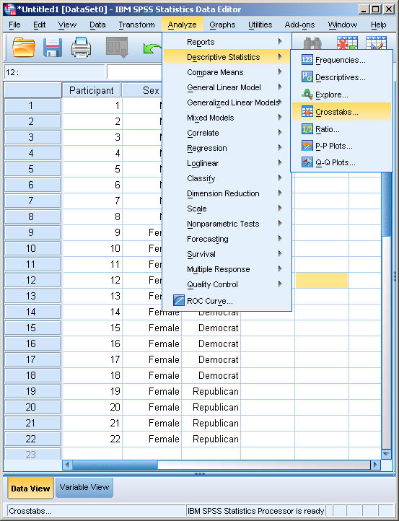

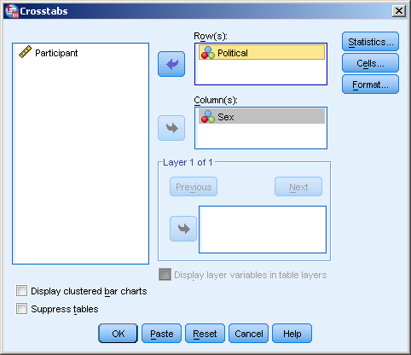

- Click Statistics – check the box that says Chi-Square.
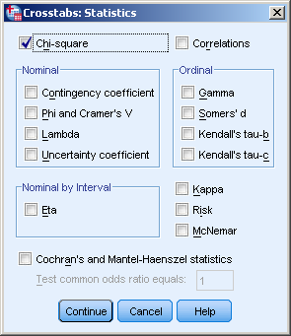

- Press Continue – OK – the results should look like this.

Crosstabs

Case Processing Summary
 | Cases
 | Valid |  | Missing |  | Total
 | N | Percent | N | Percent | N | Percent
Political * Sex | 22 | 100.0% | 0 | .0% | 22 | 100.0%

Political * Sex Crosstabulation
Count
 |  | Sex |  | Total
 |  | Male | Female
Political | Democrat | 3 | 10 | 13
 | Republican | 5 | 4 | 9
Total |  | 8 | 14 | 22

Chi-Square Tests
 | Value | df | Asymp. Sig. (2-sided) | Exact Sig. (2-sided) | Exact Sig. (1-sided)
Pearson Chi-Square | 2.424ª | 1 | .119
Continuity Correction^{b} | 1.224 | 1 | .269
Likelihood Ratio | 2.431 | 1 | .119
Fisher's Exact Test |  |  |  | .187 | .135
Linear-by-Linear Association | 2.314 | 1 | .128
N of Valid Cases | 22
a. 2 cells (50.0%) have expected count less than 5. The minimum expected count is 3.27.
b. Computed only for a 2x2 table

- Reporting in APA:
- Description of study, significant or not significant χ²(Degrees of Freedom) = Chi-Square Value, p = Sig. value.

