The Effect of Mood on Sports Performance
R. Julian Barber
Longwood University
Abstract
Sports are abundantly prevalent around the world, and are important to most cultures. The main reason we watch sports is to see the team we cheer for succeed and play well in whatever sport they are participating in. This study looks at the mood of the athletes and their performance during the game they play. To execute this study I am looking at mood on reaction time, because reaction time is a fundamental part of every sport. I am showing two different types of videos, happy and anxious, to the participants then testing their reaction times using an online test. There will be a control group who will not be shown a video and just take the reaction time test. I hypothesize that the students in the happy and control group will have significantly better reaction times than students in the anxious group. I think that if an athlete is stressed or anxious during a game then he or she will perform significantly worse than usual.
Keywords: Sports, Performance, Anxiety, Reaction

The Effect of Mood on Sports Performance
Sports are a prevalent entity around the world in many forms, and are a significant part of most cultures. It does not matter what the sport or team is, they all have fans that watch and cheer for the team they are interested in to win. People watch and play sports to entertain themselves and others that watch. Performance is a crucial component to the sport industry because playing well and winning is the main objective in any game. If a team does not play well or win then it is not entertaining to the people watching, and not pleasant for the players to endure. I believe that cognitive thought and mood can have a positive or negative impact on sports performance.
There are different methods used to calm athletes down using conscious thought that relate to their performance that help block out distractions, anxiety, and other significant problems they undergo. A tactic commonly used to reduce anxiety among athletes is basic relaxation, which induces a rested and tranquil state of mind. Increased activity in the medial prefrontal cortex contributes to improve coping mechanisms with feelings of self-regulation and prompts feelings of relaxation (Prinsloo, Derman, Lambert & Rauch, 2013). Sports performance focuses on the correlation of a specific set of skills, accuracy, and execution that pertain to each sport. Automaticity is defined as fast, effortless and requires little, or no technical attention on the player’s part (Winter, Macpherson & Collins, 2013). This is contrasting with the essential qualities of conscious processing, which are mental actions that athletes are conscious of, and involve effort and control (Logan, Van Zandt, Verbruggen & Wagenmakers, 2013). Impairment in sports functioning is usually because there is an interference with the athlete’s automatic task control process, which significantly worsens sports performance.
The objective of this study is to look at the relationship between the anxiety or mood of athletes and their performance in the sport in which they are participating. A major confounding variable is because they are professional athletes, they may be able to put aside their anxiety or mood while performing, and their mood will have no effect on their performance. If there is an effect on an athlete’s mood then he or she may be able to counter it with specific coping skills previously learned. If the athlete can avoid being distracted by extraneous variables then the automaticity of their performance should be significantly better than if they are anxious, or stressed.
Athletes are not always able to control their mood when they need to due to extraneous confounding variables. These variables could be anything from past experiences or problems they have endured to present problems that are occurring during the game they are participating in. One of the prevalent cognitive dilemmas with professional athletes is the risk of reinjuring themselves after a successful recovery. This causes a substantial problem because it has a significantly negative affect on the player’s performance (Tripp, Stanish, Brewer & Birchard, (2011). The fact that the athlete has suffered a painful injury in the past has a direct effect on the nervousness to perform the same way in the present. This is constantly contemplated in the player’s mind and can have a drastic effect on his or her automaticity or reaction time.
Reaction time is a key component of sports because it combines accuracy, skill, and control to all movements while playing. If a player’s anxiety or mood is not what it ordinarily is during a game situation then it can drastically impair their reaction time, which weakens the other skills involved with participating in a specific sport. If observing something stressful can affect mood then I hypothesize that it will have a significant effect on reaction time, in turn worsening an athlete’s performance, and automaticity. Past research shows when players are happy they tend to have more involvement during the game they are participating in, and perform better (Dewar, Kavussanu & Ring, 2013). My design is to have participants watch different types of videos, stressful or not stressful, and test their reaction times after the video is complete. If the participant is unable to avoid the cognitive thought of the anxious video while taking the reaction time test then I believe that he or she will have a significantly slower reaction speed than the participant’s reaction time that watch the happy video. I hypothesize that if a player is in an anxious, or stressful mood before, or during a game then the athlete will perform significantly worse than usual.
Method
Participants
30 college students will sign up through the psychology research participation system at a University, will be volunteering to participate in my between subjects designed study. There will be three conditions in this study, ten in each condition, to which the different participants will be randomly designated depending on the day they sign up. The three conditions will be happy, anxious, and a control group that is just taking the reaction time test with no stimulus.
Materials and Procedure
The study will be held in a classroom with computers at a University. The classroom will have a functioning Dell computer (Model DE051 Dimension 3100) at each station. Each computer will have an online reaction time test (see Appendix D) on the screen, but the monitor will be off for the first portion of the study. In the first condition of this study the participants will be shown an anxious video that is about two minutes (see Appendix B). In the second condition of this study the participants will be shown a happy video that is about one minute and 30 seconds (see Appendix C). The third group will simply be testing their reaction time without a stimulus. Each video will be shown on an eight by eight projector screen at the front of the classroom that is visible to everyone. The condition each student will be in will depend on the time he or she signs up for my study. The first ten students to sign up will be in the happy condition. The second ten students to sign up will be in the anxious condition. The third ten students to sign up will be in the control group, in which they will not watch a video and only take the reaction time test. Upon the students arrival I will deceive them by telling them I am studying the effects of color combinations on reaction time. The ten students in the happy condition will be shown a video, I will then tell them to turn on the monitor where he or she is stationed, and complete the online reaction time test. The ten students in the anxious condition will be shown a video, I will then tell them to turn on the monitor where he or she is stationed, and complete the online reaction time test. The ten students in the control group will be stationed at a computer and complete the online reaction time test with no video stimulus (see Appendix A). Before the students leave I will debrief them on the true nature of my study, which is the effects of mood on sports performance.
Proposed Discussion
In this study I am testing mood on reaction time because in every sport reaction time is a crucial component. To analyze the data I will use a one-way analysis of variance (ANOVA) because I want to compare means and see if they are significantly different in my between groups three level design. I believe that the control group and the happy condition will have significantly better reaction times than the anxious condition. I hypothesize that if stress and anxiety increase then reaction time, accuracy, and performance in sports will decrease.

References
Dewar, A.J., Kavussanu, M., Ring, C. (2013). The effects of achievement goals on emotions and performance in a competitive agility task. Sport, Exercise, and Performance Psychology, 4, 250-264. doi: 10.1037/a0032291
Logan, G. D., Van Zandt, T., Verbruggen, F., Wagenmakers, E.J. (2013). On the ability to inhibit thought and action: General and special theories of an act of control. Psychological Review, 121, 66–95. doi: 10.1037/a0035230
Prinsloo, G. E., Derman, W. E., Lambert, M. I., Rauch, H. G. (2013). The effect of a single episode of short duration heart rate variability biofeedback on measures of anxiety and relaxation states. International Journal of Stress Management, 20, 391-411. doi: 10.1037/a0034777
Tripp, D.A., Stanish, W., Ebel-Lam, A., Brewer, B.W., Birchard, J. (2011). Fear of reinjury, negative affect, and catastrophizing predicting return to sport in recreational athletes with anterior cruciate ligament injuries at 1 year postsurgery. Sport, Exercise, and Performance Psychology, 1, 38-48. doi: 10.1037/2157-3905.1.S.38
Winter, S., MacPherson, A. C., & Collins, D. (2013). To think, or not to think, that is the question. Sport, Exercise, and Performance Psychology. Advance online
publication. doi: 10.1037/spy0000007

Reaction Time (seconds)

Type of Video

Figure 1. A graph consisting of the 3 video conditions of data collected.
Appendix A
LONGWOOD UNIVERSITY
Institutional Review Board
Committee Action Form

(To Be Completed By Researcher)
Proposal Title:_________________________________________________________________
_____________________________________________________________________
Principal
Investigator:__________________________________________________________
................................................................................................................................................
(For IRB Use Only)
[ ] Meets the criteria for making research exempt from obtaining written informed consent and Committee review.
[ ] Approved by the Longwood University Institutional Review Board.
[ ] Approved with revisions by the Longwood University Institutional Review Board.
[ ] Rejected by the Longwood University Institutional Review Board.
Date:_______________________

Signature of IRB (circle one) Member/Chair:___________________________________

Comments:

Longwood University
Consent for Participation in Social and Behavioral Research

I consent to participate in the research project entitled:
The Effect of Mood on Sports Performance
being conducted in the Department of Psychology by
R. Julian Barber
- I understand that my participation in this research is voluntary, and that I am free to withdraw my consent at any time and to discontinue participation in this project without penalty.
- I acknowledge that the general purpose of this study, the procedures to be followed, and the expected duration of my participation have been explained to me.
- I acknowledge that I have the opportunity to obtain information regarding this research project, and that any questions I have will be answered to my full satisfaction.
- I understand that no information will be presented which will identify me as the subject of this study unless I give my permission in writing.
- I acknowledge that I have read and fully understand this consent form. I sign it freely and voluntarily. A copy of this form will be given to me.
Name (Print): _________________________________________
Date: _________________ Signed: ________________________

I understand that if I have concerns or complaints about my treatment in this study, I am encouraged to contact the Office of Academic Affairs at Longwood University at (434)395-2010.
Longwood University Institutional Review Board
Research Proposal Submission Form
I. Proposal
All Longwood University administration, faculty, and students conducting investigations involving human subjects, and all other researchers conducting investigations involving human subjects at Longwood University, must submit a research proposal to be reviewed and approved by the Human Subject Research Review Committee prior to the commencement of research. Research involving children should conform to the ethical standards found at http://www.srcd.org/ethicalstandards.html. Some types of human subjects research are exempt from the provisions of state and federal law, however, even research exempt from these provisions must be reviewed by the committee to determine that they are indeed exempt. Research proposals submitted to the committee must follow the protocols contained in this form and include the following information. Check those that are included.
[ ] A description of the research, including:
1) A Title,
2) The purpose of the research, and
3) The methods or procedures to be employed including descriptions of:
a) The human subjects and the criteria for including them in the research,
b) What is to be done with or to them,
c) Any possible risks, stress, or requests for information subjects might consider personal or sensitive, or which may be illegal, and whether or not the only risk to the subjects is the harm resulting from a breach of confidentiality,
d) the steps that will be taken to ensure the anonymity and confidentiality of the subjects,
e) the permissions from other institutions, if required, that will be obtained.
[ ] A signed, completed copy of this submission form.
In addition, the research proposal may have to include the following documents. Check those that are included.
[ ] A copy of the test, survey, or questionnaire, if employed, and if it is not a standardized professional diagnostic tool otherwise specified in the proposal.
[ ] A copy of the written statement explaining the research indicating that participation is voluntary, if required. (See III. A. below.)
[ ] A copy of what will be said to subjects before and after the research is conducted, if the methodology requires that the subjects be misled in any way. (See III. B.)
[ ] A copy of the informed consent statement that will be used, if required. (See Sec. IV. below.) A model informed consent statement can be found at the end of this form.
II. Exemptions
If your research falls into any of the categories of research below, it is exempt from the requirement of obtaining written informed consent and being reviewed by the entire Committee, and only 1 copy of the proposal need be submitted. All others must submit 3 copies of their proposal. If your project conforms to any of the following descriptions, check those which apply:

[ ] Research or student learning outcomes assessments conducted in educational settings involving regular or special education instructional strategies, the effectiveness of or the comparison among instructional techniques, curricula, or classroom management methods, or the use of educational tests, whether cognitive, diagnostic, aptitude, or achievement, if the data from such tests are recorded in a manner so that subjects cannot be identified, directly or through identifiers linked to the subjects.

[ ] Research involving survey or interview procedures unless responses are recorded in such a manner that the subjects can be identified, directly or through identifiers linked to the subjects, and either (i) the subject's responses, if they became known outside the research, could reasonably place the subject at risk of criminal or civil liability or be damaging to the subject's financial standing or employability or (ii) the research deals with sensitive aspects of the subject's own behavior, such as sexual behavior, drug or alcohol use, or illegal conduct.

[ ] Research involving survey or interview procedures, when the respondents are elected or appointed public officials or candidates for public office.

[ ] Research involving solely the observation of public behavior, including observation by participants, unless observations are recorded in such a manner that the subjects can be identified, directly or through identifiers linked to the subjects, and either (i) the subject's responses, if they became known outside the research, could reasonably place the subject at risk of criminal or civil liability or be damaging to the subject's financial standing or employability or (ii) the research deals with sensitive aspects of the subject's own behavior, such as sexual behavior, drug or alcohol use, or illegal conduct.

[ ] Research involving the collection or study of existing data, documents, records, pathological specimens, or diagnostic specimens, if these sources are publicly available or if the information is recorded by the investigator in a manner so that subjects cannot be identified, directly or through identifiers linked to the subjects.

III. Special Types of Research

A. In addition to the above types of research that are exempt from the requirement to obtain written informed consent and full committee review, the committee may waive the requirement that the investigator obtain written informed consent for some or all subjects for the following type of research. If your research conforms to the following description, indicate by checking.

[ ] Research in which the only record linking the subject and the research would be the consent document, and the principal risk would be potential harm resulting from a breach of confidentiality.

In the forgoing type of research, the committee may require the investigator to provide the subjects with a written statement explaining the research and indicating that their participation is voluntary. In addition, each subject shall be asked whether s/he wants documentation linking him or her to the research, and the subject’s wishes shall govern. In the case that the subject agrees to be identified in the research, her or his written permission to do so shall be obtained by the researcher.

B. Some research methodologies may require that the subjects be initially misled regarding the purpose of the research, and so require that the consent procedure omit or alter some or all of the basic elements of informed consent, or waive the requirement to obtain informed consent. If your research conforms to the following description, indicate by checking.

[ ] Research involves no more than "minimal risk" or risk of harm not greater than those ordinarily encountered in daily life or during the performance of routine physical or psychological examinations or tests, research could not practicably be performed without the omission, alteration or waiver, and the omission, alteration or waiver will not adversely affect the rights and welfare of the subjects.

In the forgoing type of research, the committee requires the researcher to provide the subjects with an adequate post-investigative explanation of the purpose and methods of the research, or explanatory debriefing procedure to be undertaken immediately after the conclusion of each subject's participation. The committee requires investigators undertaking this sort of research to furnish the committee with copies of the information that will be supplied to the subject before and after the investigation.
IV. Written Informed Consent
Research engaged in all other types of research must obtain written informed consent from the research subjects. Informed consent means the knowing and voluntary agreement, without undue inducement or any element of force, fraud, deceit, duress, or other form of constraint or coercion, of a person who is capable of exercising free power of choice.
The basic elements of information necessary to such consent are:
• 1. A reasonable and comprehensible explanation to the person of the proposed procedures of protocols to be followed, their purposes, including descriptions of any attendant discomforts, and risks and benefits reasonably to be expected;
• 2. A disclosure of any appropriate alternative procedures or therapies that might be advantageous for the person;
• 3. An instruction that the person may withdraw his consent and discontinue participation in the human research at any time without prejudice to her or him;
• 4. An explanation of any costs or compensation which may accrue to the person and, if applicable, the availability of third party reimbursement for the proposed procedures or protocols; and
• 5. An offer to answer and answers to any inquiries by the person concerning the procedures and protocols.
Informed consent must be obtained in the following manners for the following types of human subjects: (a) competent, then it shall be subscribed to in writing by the person and witnessed; (b) not competent at the time consent is required, then it shall be subscribed to in writing by the person’s legally authorized representative and witnessed; or (c) a minor otherwise capable of rendering informed consent, then it shall be subscribed to in writing by both the minor and her or his legally authorized representative.
Legally authorized representative means (a) the parent or parents having custody of a prospective subject, (b) the legal guardian of a prospective subject, or (c) any person or judicial or other body authorized by law or regulation to consent on behalf of a prospective subject to such subject’s participation in the particular human research.
Any person authorized by law or regulation to consent on behalf of a prospective subject to such subject’s participation in the particular human research shall include an attorney in fact appointed under a durable power of attorney, to the extent the power grants the authority to make such a decision. The attorney in fact shall not be employed by the person, institution, or agency conducting the human research. No official or employee of the institution or agency conducting or authorizing the research shall be qualified to act as a legally authorized representative.
A legally authorized representative may not consent to nontherapeutic research, or research in which there is no reasonable expectation of direct benefit to the physical or mental condition of the human subject, unless it is determined by the human subject research review committee that such research will present no more than a minor increase over minimal risk to the human subject.
Notwithstanding consent by a legally authorized representative, no person who is otherwise capable of rendering informed consent shall be forced to participate in any human research.
In the case of persons suffering from organic brain diseases causing progressive deterioration of cognition for which there is no known cure or medically accepted treatment, the implementation of experimental courses of therapeutic treatment to which a legally authorized representative has given informed consent shall not constitute the use of force.
No informed consent form shall include any language through which the person who is to be the human subject waives or appears to waive any of her or his legal rights, including any release of any individual, institution, or agency or any agents thereof from liability for negligence.
Human subject research investigators are responsible for obtaining written informed consent from research subjects in accordance with these specifications, and for obtaining permissions from any other institutions that may be involved in informed consent statement which conforms to these specifications.
The Longwood University Institutional Review Board must be informed of any violation or alteration of the research protocol. Continuing research projects must be re-approved annually.
The undersigned researcher(s) indicate that the information provided to the committee is accurate and true to the best knowledge of the researcher(s), and that the researcher(s) have conformed to the above guidelines to the best abilities of the researcher(s).
Date: ______________ Signed (legibly): ___________________________________
Date: ______________ Signed (legibly):___________________________________
If this research is being completed in partial fulfillment of a Masters degree, the thesis committee must approve of your project prior to submission of these forms. The signature(s) of your committee chair/advisor on the appropriate form constitutes acknowledgement of this prior approval by your committee.
Please indicate the address where you would like the approval form sent (along with phone # and/or e-mail address):

Further information of the status of proposals may be found at the following:
Dr. Eric Laws, Department of Psychology; Phone: (434)395-2841; e-mail: lawsel@longwood.edu
Longwood University
Consent for Participation in Social and Behavioral Research

I consent to participate in the research project entitled:
The Effect of Mood on Sports Performance
being conducted in the Department of Psychology by
R. Julian Barber
- I understand that my participation in this research is voluntary, and that I am free to withdraw my consent at any time and to discontinue participation in this project without penalty.
- I acknowledge that the general purpose of this study, the procedures to be followed, and the expected duration of my participation have been explained to me.
- I acknowledge that I have the opportunity to obtain information regarding this research project, and that any questions I have will be answered to my full satisfaction.
- I understand that no information will be presented which will identify me as the subject of this study unless I give my permission in writing.
- I acknowledge that I have read and fully understand this consent form. I sign it freely and voluntarily. A copy of this form will be given to me.
Name (Print): _________________________________________
Date: _________________ Signed: ________________________

I understand that if I have concerns or complaints about my treatment in this study, I am encouraged to contact the Office of Academic Affairs at Longwood University at (434)395-2010.

Appendix B
The stressed condition video, which was shown before completing the reaction time test.

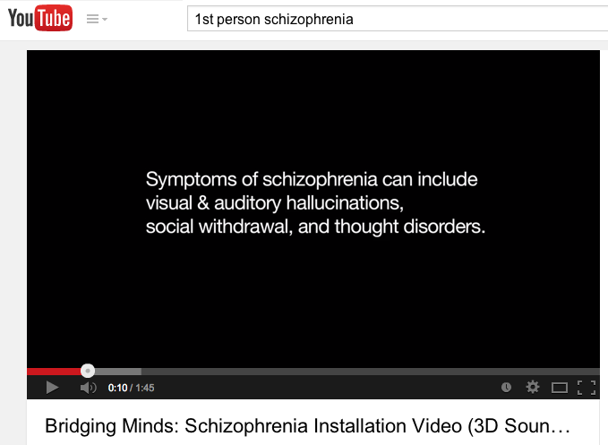
http://www.youtube.com/watch?v=PyYmbvKlSgs

Appendix C
The happy condition video, which was shown before completing the reaction time test.
http://www.youtube.com/watch?v=7YmXdeRXqv8
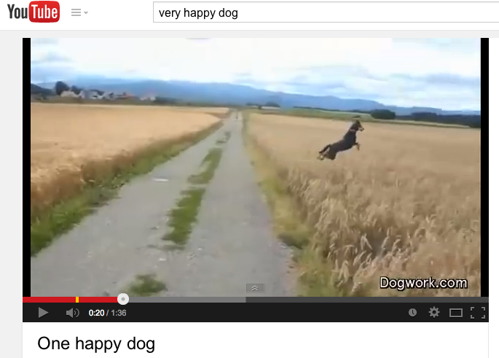

Appendix D
The online reaction time test the participants took after watching the video of the specific condition he or she was assigned to.
http://faculty.washington.edu/chudler/java/redgreen.html
