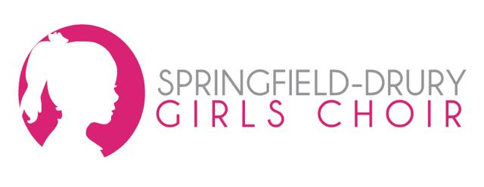

Project Evaluation
Springfield Drury Girls Choir
Natasha Sanford
November 1, 2014

Project Objectives:
This project contains three objectives:
- To make quality promotional materials for SDGC to use to promote their October concert this semester, as well as their program.
- To present these materials to Mark Lawley for SDGC to review.
- Increase awareness in the Drury community and area music teachers and enthusiasts about SDGC and its performances.

Project Results:
This project achieved a mixture of results. I completed a flier for SDGC’s concert in October, as well as a general brochure that can be used for various reasons. In my charter proposal I stated that I would create copy for the SDGC website. Instead of creating copy I decided to create an entirely new website.
The website that SDGC is currently using is just a page on the Drury website. I was able to get a microsite with the Drury website using Wordpress. This site is easy on the eyes and is very informative for the audience.
Although I designed an advertisement for The Mirror, I was not able to get it into the paper. At the last minute my advertisement had to be pulled due to space.

Learning Outcomes:
This signature project has taught me a lot about project management. Project management is all about the timing and deadlines you set for yourself. You have to hold yourself accountable to get everything done and stay on top of it all. As an extremely involved college student, I found myself having to balance a million different things at once while keeping up with my schoolwork and signature project. I think that was the hardest obstacle and learning outcome I encountered while working on this project.

