UNIVERSITY of EAST MAINE
Campus Safety Guide
Your reference to campus safety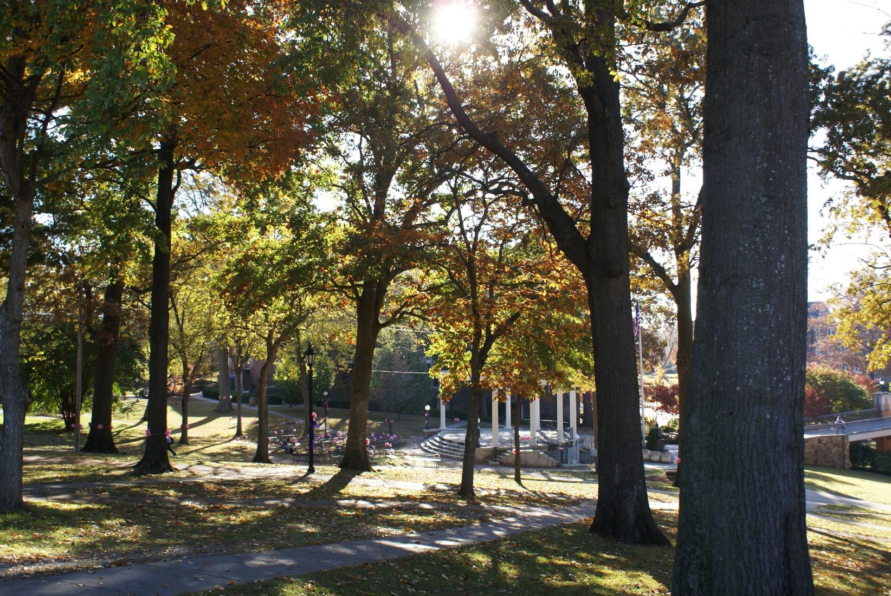

University of East Maine
Police Department

Mission Statement
The mission of the University of East Maine Police Department is to provide a safe and secure campus environment where learning and educational activities are supported with safe surroundings.
Vision
The vision of a safe and secure campus is in partnership with the University community, which includes students, faculty, staff, and visitors.
- University police officers are committed to preventing crime and disorder.
- We will strive to maintain a secure environment, free from the distraction of criminal activity and disorder, for the pursuit of education at the University of East Maine.
- We encourage interaction with the community and surrounding law enforcement agencies to address and solve problems.
- The core components of our problem-solving philosophy are prevention, partnerships, and problem solving.

The University of East Maine has a comprehensive safety plan in place to address any crisis that may occur on campus. Our police department is a fully accredited law enforcement agency, staffed with highly trained professional officers who are prepared to respond to emergencies of all types, including gunmen or shootings. Our primary goal in emergency preparedness is to ensure that the campus community is aware of emergency procedures and is confident in our ability to address emergency situations. All university police officers have undergone specific training regarding emergencies, and regularly participate in training exercises. In addition, the University of East Maine Police Department has a mutual agreement with the Anderton Police Department, the Anderton Fire and Rescue, and the Mary County Sheriff’s Office, drawing upon those resources if needed.
In a crisis or emergency, the primary focus of the University Police Department (UPD) will be to locate and confront the threat immediately.

Emergency Notifications
In the event of an emergency, the University will notify students, faculty, and staff through a variety of methods:
- Phone
- Email
- Web sites
- Broadcast media
- Local radio and television stations will be enlisted to provide additional information.

Personal Safety
In an emergency situation, the initial reaction of those affected is crucial. Any violent act is tense, uncertain, and rapidly evolving. Although there is no specific set of steps to defuse every situation, each individual must evaluate the immediate situation and make the best decision(s) regarding his or her own safety. Witnesses who can provide immediate and accurate information will be instrumental to the mitigation of the incident.
At the onset of a critical situation, take the following steps:
- Seek a safe location.
- Notify UPD at (466) 555-7676, or call 911.
- When you call for assistance, remain calm and provide your present building location and specific room number.
- Provide a complete description of the situation and suspect(s), including any weapons observed.
- Provide the location of any injured victims.
- Remain on the phone with the UPD or 911 operators until you are advised that you are no longer needed.
- When officers arrive, follow all directions immediately.

Summary
Familiarizing yourself with the information contained in this safety guide will help you and others in a time of crisis. The UPD is well prepared to deal with all aspects of an emergency, including mitigation, response, and recovery. However, you can make the difference in a positive or negative outcome in any situation by the decision(s) you make. Before an emergency arises, you should give thorough and consideration to what you would do in various situations.

Medical Emergencies
The first step in securing help for someone in need of emergency medical care is to call 911. The call will reach both the Anderton Police and the UPD. Most often, the first person on the scene will be a police officer. In addition, a local emergency service and paramedics from the Anderton Fire Department will respond. When you make an emergency call, remember:
- The victim should not be moved, unless a move is necessary from life-threatening conditions.
- The victim should never be left alone.
- Give complete directions to the victim’s location.
- Accurately describe what happened.
- Remain on the phone until the dispatcher tells you it is safe to disconnect.
- Be on hand to guide emergency workers to the victim.
- Once help has arrived, remain out of the way and keep others away from the area. Before leaving the scene, ask a police officer if any further information is needed.

Fire Emergencies
In the event of a fire, sound the nearest fire alarm in the building. Then exit the building and call 911. Provide the dispatcher with your name and address, and the location and extent of the fire. If you are aware that anyone with a disability is in the building, provide that information to the dispatcher. Only if it is safely possible, confine the fire by closing nearby windows and doors. Exit the building quickly and calmly. Do not use elevators, but follow the lighted exit signs to the nearest exit. Meet emergency officials outside the building and inform them of the location of the fire. Remain outside at a safe distance and keep others away from the building.

Homeland Security
Any threat to the safety or well-being of a person or the University community is taken very seriously. Contact the UPD immediately by calling 911 or (466) 555-7676. Provide as much information about the situation as possible. At that point, UPD will evaluate the situation to determine the best course of action.

Personal Safety on Campus

Emergency Phones
Bright blue poles are located across campus—each containing an emergency phone. Each phone is clearly marked, and each provides direct access to emergency officials. Learn the locations of those phones and make use of one in an emergency situation.

Security and Access to Campus Facilities
All academic and administrative buildings, classrooms, and offices are locked after business hours. Students and staff with access to buildings for after-hours work must lock doors after they enter and must follow all safety precautions. Above all, no one should be granted admittance to a building without appropriate credentials.
If you find yourself alone at night in a building or on campus, be sure a friend knows where you are and when you will return home. Never prop a door open in a residence hall or other campus building. Close any doors you see that are propped open. Campus police are on hand to escort anyone between locations, so please call (466) 555-0999 and ask for a police escort.

