JAMS 201 Has Ross Lowinske as a Guest Speaker
Milwaukee, Wis. – Ross Lowinske, Laughlin Constable Vice President and Creative Director, talked to UWM JAMS students at a lecture on Monday. Lowinske discussed what it takes to create a good idea, become a good writer, and start a career in advertising.

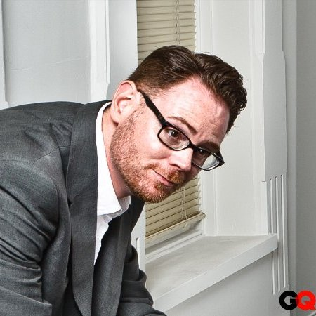
Ross Lowinske, taken from his LinkedIn profile.
A graduate of UWM, Ross Lowinske has his masters in film. After graduation, he went to work at first DreamWorks as a script writer. He would later work in Minneapolis before coming to Milwaukee. His past experiences include Cramer-Krasselt, BKV and Laughlin Constable.
“The development of the idea defines the tone, the voice and the story.”
Lowinske emphasized the basis of advertising writing as a great idea, not structure. He defined his title as executive creative director as refining ideas: making sure the idea is simple and concise. “If your idea can’t fit on a post-it note,” Lowinske said, “then it’s not a good idea.” According to him, a good idea should be shareable and participatory – just like writing.
“You should hang around other writers, not those who talk about writing, but who are actively writing,” he advised the students when talking about his time in California.
500 headlines: That’s what Lowinske said he wanted. Not five, but 500. Like most when asked what it takes to be a good writer, Lowinske emphasized that it takes practice. In his slide show, it stated that to write is similar to crunches: you have to do it more than once to be good at it. He advised the students to write every day, to write in different styles, and start work on their portfolios right now. Lowinske said that if he was back in college, he would create ads. He advised to create ads, blogs and integrated tweets when it came to their portfolios.
As far as what Lowinske looks for in future employees, he said inspiration is a must. “You do want to hire people who are better than you: who will inspire you.”
When asked about advertising career possibilities in Milwaukee, he said that Milwaukee is a great city with many agencies, from the small hip startups he once worked at to the major corporations, such as Laughlin Constable. “I won’t ever move. I’m a lifer.” He said to the students.

