Trainers Manual
Created on 11/18/2014
Last updated on 11/18/2014

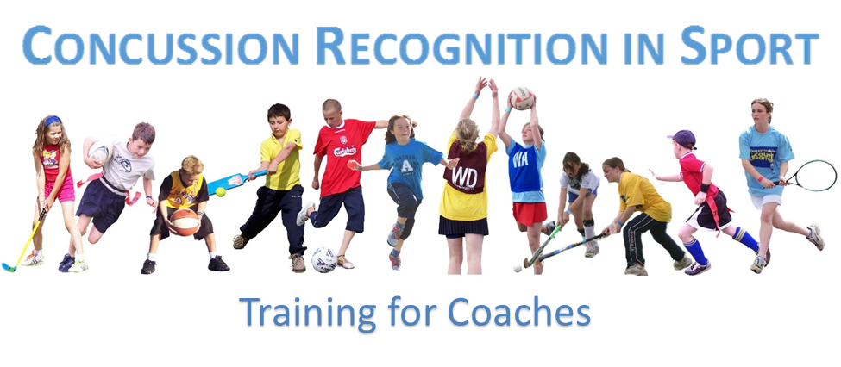

- Brandon Eldridge
- Jake Krupp
- Bart Karnes

Table of Contents
Instructional and behavioral Objectives 3
Icon Key 4
Training Manual Script 5-23
Case Study handout 24-25
Role Play Activity 26
Assessment and Evaluation Handout 27
Trainee Manual 28-40
Diploma 41
PowerPoint 42

Instructional and Behavioral Objectives
Instructional Objectives (IO)
Upon completion of this training module, participants will:
IO #1: Understand what a concussion is, the causes and consequences of concussions
IO #2: Understand and know what to watch for to recognize a concussion
IO#3: Understand what to do when you suspect a player has a concussion
IO#4: Understand why to take time off and how to integrate back into the activity
IO#5: Understand how to implement this training into your coaching

Behavior Objectives (BO)
Upon completion of this training module, participants will:
BO#1: Better recognize and act when a concussion could be apparent.
BO#2: Have an improved awareness of what to watch for to recognize a concussion
BO#3: Effectively respond when they suspect a player has a concussion
BO#4: Properly integrate the player back into the sport
BO#5: implement this training into their coaching and handle concussions correctly

Icon Key
Turn to PowerPoint Slide

Activity

Switch to Next Trainer

Ask a Question

Point to Information on Slide

Important information

Give Handout to Trainees
Lesson Content | Notes for the Instructor
The following are needed in order to conduct this training:
- Instructors manual
- Trainee manual, one for each trainee and one extra copy for the instructor to reference
- PowerPoint capabilities
- Handouts, one per person
- Name Tags and markers, one per person
- Rewards for achievement in activities
- Certificates of Completion, one per person
- Evaluation forms, one per person
Hello, here is a brochure and name tag. Please fill it out and have a seat we will begin shortly and thank you for joining us on this wonderful day. (Smile) | 20 minutes before the start time  1. Have a Trainer at the door to welcome people as they arrive and hand out materials and instruct them to make a name tag.  2. Open PowerPoint and make sure all equipment in working.
2 minutes before the start time
Ensure that your book is ready and that you are ready to go.
Start time
1. Close the door
2. Turn PowerPoint to cover page
Welcome, My name is ______. I would like to thank all of you in attendance today for our training on concussion recognition. I hope that we can all leave here today with a heightened knowledge of concussions. In this session we will have #___ trainers they are _______. | - Let’s begin!  - Introduce all the trainers
Before we get started, Does everyone have a brochure, name-tag and training manual? | - If someone needs something have one of the other trainers pass it out.
Let’s start with covering the objectives of the training today.  You have been given a manual and I ask that you follow along with the PowerPoint and discussion. You can feel free to write notes in you manual as it is yours to keep. | - Turn PowerPoint to Page #2
Instructional Objective #1: Participants will understand what a concussion is, the causes and consequences of concussions | - PowerPoint on Page #2
Behavioral Objective #1: upon completion of this training trainees will b etter recognize and act when a concussion could be apparent.
Instructional Objective #2: Participants will be able to Understand and know what to watch for to recognize a concussion | - PowerPoint to #3
Behavioral Objective #2:
This objective will teach you techniques so you can have an improved awareness of what to watch for to recognize a concussion
Instructional Objective #3: Participants will be able to understand what to do when you suspect a player has a concussion | - PowerPoint to #4
Behavioral Objective #3: After carrying out this training you will be trained to effectively respond when they suspect a player has a concussion
Instructional Objective #4: you will understand why the athlete needs to take time off and how to integrate back into the activity | - PowerPoint #5
Behavioral Objective #4: This training will teach you the process to properly integrate the player back into the sport
Instructional Objective #5: After this training you will understand how to implement this training into your coaching to help your players. | - PowerPoint #6
Behavior Objective #5: In coaching you will know how implement this training into your coaching and handle concussions correctly and quickly.
Objective Number One:  Now we will begin our discussion with the topic of the first outcome, Understanding what a concussion is.  A concussion is a type of traumatic brain injury caused by a bump, blow, or jolt to the head or by a hit to the body that causes your head and brain to move rapidly back and forth.  This sudden movement can literally cause the brain to bounce around and even twist in one’s skull. This movement stretches and damages brain cells, thus creating chemical changes in the brain.  The thing that most people do not know is that with these chemical changes the brain becomes much more vulnerable to further injury. The brain becomes more sensitive to any stress or injury until it fully recovers.  Concussions are not an injury that you can see like a broken leg or torn knee. No x-ray or MRI can see any damage. A concussion changes how the brain works it does not look any different.  Concussions are just not limited to the playing field. One can get a concussion in daily life from falling on a wet floor to a car crash. | - PowerPoint #7  - Have First Instructor start.
The Potential Consequences of a concussion.  Concussions affect people in different ways. Most athletes can recover rather quickly. Some will only have symptoms for only a few days or a week while for some a serious concussion can last for months or longer.  Often people not letting the brain recover long enough is a problem, this is very dangerous. After having a concussion having a repeat concussion slows the recovery process and more importantly increases ones  Chance for long term problems. Repeat concussions are responsible for brain swelling, permanent brain damage and in rare cases can be deadly.  The athlete always comes first. No matter the situation if you expect an athlete could have a concussion you need to pull them out of the game. There is no game worth gambling the future of an athlete’s life on. | - PowerPoint #8
Objective Number Two:  Now let’s move on to Objective number two. In this section we will delve deeper into what to watch for in recognizing a concussion. As a coach it is your responsibility to be aware of your players and know if something feels off. In most cases the athlete is unwilling to admit they feel “off” or have concussion like symptoms.  We have already learned how one cannot see a concussion like a broken bone. Here you will be learning more sings and signals to look for.  There are two main alarms to watch for.  - A forceful bump or jolt to the head or body that creates a whip like action of the body.  - Any signs or symptoms, for example a change in behavior or attitude of the player or the physical functioning of the athlete. (read through the list on the power point)  Now with that list in mind as we continue it is important to remember that the athlete may have a concussion.  Signs and symptoms of a concussion can become apparent right after a hit but might not seem as strong. Over time into the next hour or even the next day the symptoms can worsen and grow stronger.  It is often found that after a big hit the athlete seems okay or just a bit dazed but an hour later cannot recall the game or being hit at all.  From this we need to remember that it is important that if suspect a concussion to not only evaluate the athlete after it happens but to also reevaluate the athlete latter as well. It is also a good idea to talk to the parent about watching for symptoms in the next day. Also it is recommended that the concussed is supervised for the next few hours. | 1.PowerPoint # 9  2. Switch to next Instructor
It is very important to watch an athlete after a concussion because if the symptoms get worse or exhibits a DANGER SIGN the situation needs to be handled as a medical emergency. This is because in rare occasions a blood clot can form on the brain. It is crucial to dial 9-1-1 if the athlete exhibits one or more of the Danger Signs (go over list on PowerPoint)  The CDC recommends that coaches keep a copy of these list on their clipboard for reference. We have included one in your packet as the last page.  (Play video now) | - PowerPoint #10  - Point to list on PowerPoint.  - Play Video once the rest of the information has been covered. Link is on the bottom of the PowerPoint slide
Objective Number Three  Building on objective two, objective three is the next step. In this objective you will learn what to do once you suspect that an athlete has a concussion. It is no easy task to pull someone out of a game. In most concussion cases the athlete fights against this because they feel that nothing is wrong. It is always important to keep in mind the future of the athlete and keeping them safe. Know that this is always more important than risking farther injury or death.  There are four steps that are widely used when suspecting a concussion:  - Remove the athlete from play look for the signs and symptoms of a concussion when your athlete has encountered a situation when a concussion could happen. And fallow the phrase when in doubt, sit them out.  - Ensure the athlete is evaluated by a health care professional experienced in evaluating for a concussion. Do not try to judge the severity of a concussion yourself. Have a qualified health care professional evaluate the athlete, they are much more knowledgeable and have more methods to assess the injury. In is important for you to take note of what kind of hit or force caused it and the symptoms following that you noticed. This information is helpful to the health care provider.  - Inform the athlete’s parents or guardians about the possible concussion and inform them of the procedures to follow to help their athlete. In this step you are explaining what happened and why you pulled them out, and what to do in the next step so they can help their athlete.  - Keep the athlete out of play from the moment a concussion is suspected until a health care professional has cleared them for play and says it is okay. This is to protect the athlete from themselves and outside pressure to return until it is safe to do so. This is strictly a medical decision.  It is important to remember that “Toughing it out is not string it is dangerous. There is a culture in sports the playing injured shows strength and courage. Doing this just puts the athlete in risk on more serious injury or serious harm. It is always important to keep this is mind when facing outside pressure to let the athlete return to play before they are cleared to do so by a medical professional. | - PowerPoint #11  - Switch to next instructor
Objective Number Four:  In the Fourth Objective we come to learn why it is important to take time out and how to return to activity.  Resting is very important after have experienced a concussion. The brain needs a lot of energy to heal all of the brain cells. In the recovery process. It is not just physical activity that can cause a drain on one’s energy, cognitive activities can be just as hard to do and as draining. With this in mind it is important that the concussed keeps away from working on the computer, playing video games and intense studying. It is up to the health care provider when it is okay to return to activities. Having to be sidelined and kept from other daily activities can be very hard on the athlete, it is essential to stay positive with them and be honest about why coming back to soon can be harmful. Be sure to be there to offer support and encouragement. | - PowerPoint #12  - Switch to next instructor
When returning to activity it is always important to progressively return. It is always best to work through this process with a health professional or the team trainer.  There are five steps for a safe and healthy return to the field or court.  Step 1, begin with light aerobic exercise. This should only be hard enough to raise the heart rate. For example 5 to 10 minutes on an exercise bike or light jogging.  Step2, Add more activities to increase the heart rate. This is just ramping up from step one increase the pace and intensity to a more moderate level.  Step 3, In this step we reintroduce high intensity activities but refrain from contact at this point. Examples of this would be all-out sprinting and drills they would normally preform.  Step 4, Here the athlete gets to become integrated into full practice and full contact just in a controlled drill appropriate for the sport at hand.  Step 5, Put the athlete back into play at this point they should be ready to compete at a high level just as before.  At each step be watching for returning symptoms. If symptoms do return they will need take a break again and then proceed to start over at step one. It is highly recommended that you as coach do not make this determination though this process but that a certified trainer handles this procedure. | - PowerPoint #13
Objective Number Five:  In our last Objective, Number Five, you will learn a few last ideas to leave here with today to not only help you out in implementing this training into your coaching but to help your athletes out in the situation a concussion does occur.  - Find out the concussion policy for you school or association. This will ensure that you handle a concussion the proper way for your team. Many districts have policies to follow in the incident of a player getting a concussion.  - Have athlete I.C.E. Cards filled out and on hand at all times. This information is invaluable if something happens and you need to reach the parent or guardian. The time it takes to get this information can make a huge difference in a medical emergency.  - Educate your players and parents about concussions before season. Educated parents and athletes will make the process much smother if the fully understand what a concussion is and how to treat it before one happens. A 20 minute meeting to inform everyone about this could potentially reduce the number of concussions, make for a better recovery, and create a much better experience if you have to pull their kid in “the big game” because you feel they have a concussion. | - PowerPoint #14  - Switch to next Instructor
Now that we are all educated on this subject let’s look at a few case studies to see how to react to the different situations that we as coaches can be put into. | - PowerPoint #15  - Switch to next Instructor
Case study number one  Our first case study can be found in your manual on page ______. You can read along and then write your answers down on the space provided.  Coach Teddy is driving Billy, one of his players, home after a football game that the team won. Coach Teddy likes to listen to very loud music in his car when his team wins. Coach Teddy notices that Billy is acting unusual, so he asks him if he is feeling alright. Billy says to his coach “I am feeling dizzy, can you turn the radio down?”  Please take the next few minutes to respond to the questions posed in your manual to this case study.  Okay now that everyone has had time to respond let’s have a volunteer to read what they have written. (ask someone to read)  Thank you. Now we will move onto our next Case study. | - Open discussion over the answers from trainees to case study number one after they have had time to read and respond.  - Give a few moments for the trainees to respond. Resume once you feel that everyone is completed.
Case Study Number Two:  During their basketball game Coach Jim sees his point guard, Ron, hit his head against the mat underneath the basketball hoop. Coach Jim yells to Ron “Are you okay?” Ron looks at Coach Jim with a confused look on his face and runs down the court. During the next break in the game, Ron goes to Coach Jim and asks him “When does class start?”  Again, Please take the next few minutes to respond to the questions posed in your manual to this case study.  Okay now that everyone has had time to respond let’s have a volunteer to read what they have written. (ask someone to read) | - PowerPoint #16  - Open discussion over the answers from trainees to case study number one after they have had time to read and respond.  - Give a few moments for the trainees to respond. Resume once you feel that everyone is completed.
Role Play Activity One:  Now we will be doing a Role Play Activity. Our first scenario will be from Case Study Number One.  (Two of the instructors sit in chairs beside each other)  Teddy: Act like you are driving a car. Play loud music on your phone.  Billy: Act like you are dizzy and sensitive to noise.  Teddy: Ask Billy “Are you feeling alright?”  Billy: Respond by saying “I feel dizzy. Coach Teddy, can you turn the radio down.”  Okay, now we will take time to discuss this scenario. | Role Play Activity One  - Have a brief discussion about the proper protocol for handling this scenario.
Role Play Activity Two:  Now we will have a Role Play Activity for the second Case Study that we talked about previously.  (Have one instructor be Coach Jim and have another instructor be Ron)  Ron: Act like you are running and hit your head on the wall.  Jim: Ask Ron “Are you okay?”  Ron: Look at Coach Jim with a confused look on your face and continue walking. Then, go over to Coach Jim and say “When does class start?”  (Have discussion about the two Role Play Activities)  Concussion Evaluation:  Now please turn to the Concussion Evaluation page in your manual. Take a few minutes to answer the questions that are listed on the page.  (Give trainees a few minutes to complete the evaluation.) | 1.Role Play Activity Two  - Have a brief discussion about the proper protocol for handling this scenario.  PowerPoint #17
Conclusion:  Thank you all for participating in our Concussion Recognition in Sport Training. We hope all of you gained useful knowledge about every aspect of concussions and that you can use this knowledge in your coaching. Please make sure you receive your diploma of completion before leaving. | - PowerPoint # 18

Case Study Number One

Coach Teddy is driving Billy, one of his players, home after a football game that the team won. Coach Teddy likes to listen to very loud music in his car when his team wins. Coach Teddy notices that Billy is acting unusual, so he asks him if he is feeling alright. Billy says to his coach “I am feeling dizzy, can you turn the radio down?”

What should Coach Teddy do?

______________________________________________________________________________

What warning signs did Coach Teddy notice about Billy?

______________________________________________________________________________

Case Study Number Two

During their basketball game Coach Jim sees his point guard, Ron, hit his head against the mat underneath the basketball hoop. Coach Jim yells to Ron “Are you okay?” Ron looks at Coach Jim with a confused look on his face and runs down the court. During the next break in the game, Ron goes to Coach Jim and asks him “When does class start?”

What warning signs did Coach Jim notice about Ron?

______________________________________________________________________________

What should Coach Jim do in this situation?

______________________________________________________________________________

Role Play Activity
The instructors will act out the two scenarios that we discussed previously. For each of the scenarios, there will be one that is correct and one that is incorrect. For each of the scenarios that will be acted out, the group must determine which scenario is correct and which scenario is incorrect. At the conclusion, we will all discuss the decisions of the group. Then, we will debate what was done correctly or incorrectly. In closing, this will allow for a better understanding of what should have been done or what should not have been done in these situations.

Notes:

Concussion Evaluation
Please circle the best answer given.
1. Concussions are visible to the eye, similarly to a swollen ankle?
True False
2. A common cause of a concussion is a blow to the head?
True False
3. It is important for a health care professional to evaluate a person that is showing symptoms of a concussion?
True False
4. If a person is diagnosed with a concussion, they can immediately return to the activity that caused their concussion?
True False
5. As a coach, you should educate your players and parents about concussions?
True False
What information did you find to be most important during this training session?

Is there anything about this training session that you would change?

Would you refer others to this training session?

Trainee Manual
Created on 11/18/2014
Last updated on 11/18/2014

- Brandon Eldridge
- Jake Krupp
- Bart Karnes

Table of Contents
Instructional and behavioral Objectives 30
Case Study handout 31-32
Role Play Activity 33
Assessment and Evaluation Handout 34

Instructional and Behavioral Objectives
Instructional Objectives (IO)
Upon completion of this training module, participants will:
IO #1: Understand what a concussion is, the causes and consequences of concussions
IO #2: Understand and know what to watch for to recognize a concussion
IO#3: Understand what to do when you suspect a player has a concussion
IO#4: Understand why to take time off and how to integrate back into the activity
IO#5: Understand how to implement this training into your coaching

Behavior Objectives (BO)
Upon completion of this training module, participants will:
BO#1: Better recognize and act when a concussion could be apparent.
BO#2: Have an improved awareness of what to watch for to recognize a concussion
BO#3: Effectively respond when they suspect a player has a concussion
BO#4: Properly integrate the player back into the sport
BO#5: implement this training into their coaching and handle concussions correctly

Objective One
- Understanding Concussions
  - Concussion by definition
    - A concussion is a type of traumatic brain injury caused by a bump, blow, or jolt to the head or by a hit to the body that causes your head and brain to move rapidly back and forth.
- Causes of a Concussion
  - A knock to the head from a fall…
  - A Jolt to the torso from a collision…
  - A hit to the head from a stick or ball…
- Don’t be fooled
  - Even what may seem like a mild bump to the head can actually be serious.
- Potential Consequences of a Concussion
  - Brain Swelling
  - Permanent Brain Damage
  - Death, rare
    - All of these reasons are why it is extremely important to pull an athlete out if you suspect he or she has a concussion. No circumstance or importance of the game will ever outweigh the risk.

________________________________________________________________________________________________________________________________________________________________________________________________________________________________________________________________________________________________________________________

Objective Two
- Things to watch for in recognizing a concussion:
  - 1. A forceful bump or jolt to the head or body that creates a whip like action of the body.
  - 2. Any signs or symptoms, for example a change in behavior or attitude of the player or the physical functioning of the athlete.
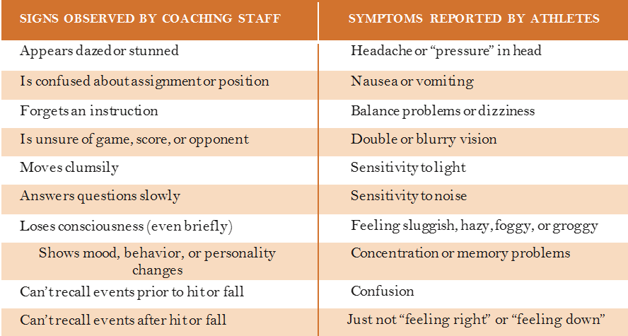

- Danger Signs
  - Although rare a blood clot can form on the brain. This causes the brain to squeeze against the skull. If your athlete exhibits one or more of the fallowing symptoms call 9-1-1 and treat the situation as a medical emergency.
  - One pupil larger than the other
  - Downiness or inability to wake up
  - A headache that gets worse and does not go away
  - Weakness, numbness, or decreased coordination
  - Repeated vomiting or nausea
  - Slurred speech
  - Convulsions or seizures
  - Inability to recognize people or places
  - Increasing confusion or agitation
  - Unusual behavior
  - Loss of consciousness

Objective Three
- What to do when you suspect a concussion
  - Remove the athlete from play

  - Ensure the athlete is evaluated by a health care professional experienced in evaluating concussions

  - Inform the athletes parents or guardians about the possible concussion and inform them of the procedures to follow to help their athlete

  - Keep the athlete out of play until a health care professional clears the athlete to return.

________________________________________________________________________________________________________________________________________________________________________________________________________________________________________

Objective Four
- Why Take Time Off
  - The brain needs energy to heal
    - All of the injured brain cells require large amounts of energy to heal itself.
    - Physical activity
    - Cognitive strain
    - Player Resistance
    - Be honest and offer your support and encouragement
- Progressive Return to Activity Program
  - Five gradual steps are used in reintroducing an athlete back into the sport after a concussion. The athlete must pass each step without any concussion like symptoms returning. If symptoms do return they will start over at Step one.
  - Light Aerobic
  - Moderate Aerobic
  - High-Intensity, Aerobic
  - Controlled Contact
  - Full Contact

________________________________________________________________________________________________________________________________________________________________________________________________________________________________________

Objective Five
- Now it is time for you to put to use everything you learned today into your coaching. Please take these last few tips with you to help in the case of injury with your players.

- Find out concussion policy for you school or association

- Have athlete I.C.E. Cards filled out and on hand at all times

- Educate your players and parents about concussions before season.

________________________________________________________________________________________________________________________________________________________________________________________________________________________________________

Case Study Number One

Coach Teddy is driving Billy, one of his players, home after a football game that the team won. Coach Teddy likes to listen to very loud music in his car when his team wins. Coach Teddy notices that Billy is acting unusual, so he asks him if he is feeling alright. Billy says to his coach “I am feeling dizzy, can you turn the radio down?”

What should Coach Teddy do?

______________________________________________________________________________

What warning signs did Coach Teddy notice about Billy?

______________________________________________________________________________

Case Study Number Two
During their basketball game Coach Jim sees his point guard, Ron, hit his head against the mat underneath the basketball hoop. Coach Jim yells to Ron “Are you okay?” Ron looks at Coach Jim with a confused look on his face and runs down the court. During the next break in the game, Ron goes to Coach Jim and asks him “When does class start?”

What warning signs did Coach Jim notice about Ron?

______________________________________________________________________________

What should Coach Jim do in this situation?

______________________________________________________________________________

Role Play

The instructors will act out the two scenarios that we discussed previously. For each of the scenarios, there will be one that is correct and one that is incorrect. For each of the scenarios that will be acted out, the group must determine which scenario is correct and which scenario is incorrect. At the conclusion, we will all discuss the decisions of the group. Then, we will debate what was done correctly or incorrectly. In closing, this will allow for a better understanding of what should have been done or what should not have been done in these situations.

Notes:

Concussion Training Evaluation
Please circle the best answer given.
1. Concussions are visible to the eye, similarly to a swollen ankle?
True False
2. A common cause of a concussion is a blow to the head?
True False
3. It is important for a health care professional to evaluate a person that is showing symptoms of a concussion?
True False
4. If a person is diagnosed with a concussion, they can immediately return to the activity that caused their concussion?
True False
5. As a coach, you should educate your players and parents about concussions?
True False
What information did you find to be most important during this training session?

Is there anything about this training session that you would change?

Would you refer others to this training session?

