Lorraine Barker
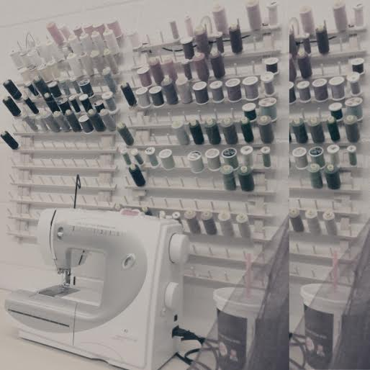
Objective: To obtain a career in costume design and construction in the theatre industry.
Skills:
- Seamstressing; costume design, apparel repair, hand sewing and machine sewing, visual design
- Computer software; Adobe Photoshop, Microsoft Office, Final Cut
Summary:
I have plenty of experience in costuming - I have completed Fashion Design and Merchandising I & II at school and know how to assemble garments and such. I also produced, directed, modeled in, designed, and presented my Fashion Design II class final - a fashion show of my designs and a "Fashion Through The Ages" segment on how trends have changed throughout the years. I also have vast knowledge of the theatre - I have taken Theatre I-III and am currently in Advanced Theatre IV at Centennial, and I also have been in many shows at school and at Theater Works. I also have costuming experience. Through an internship at Theater Works Live, I have learned repair and design skills for apparel. I have a creative, functional mind for the job and will be a friendly intern to the Theater Works community.

