Lorraine Barker
Internship Sample Work
Professional Internship
Leon
Period 5
12-9-14

Sample Work Completed at Internship

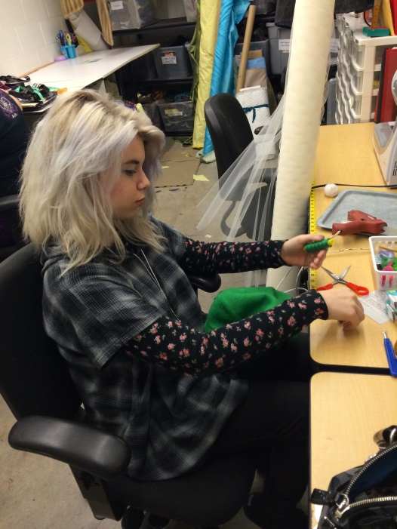
Seen in this picture is myself working on soldier hats for the Theater Works Christmas
show, The Quiltmaker’s Gift. In the background is the work environment I deal with on a daily basis at my internship. The costume shop is full of shelves and supplies galore, also with many rolls and folds of fabric lying around. The procedure for making the soldier hats was fairly simple, but time consuming. It took me 3 hours total to complete 5 soldier hats. I was instructed by my mentor on how to assemble them. Assembly started with a simple blue military hat with a flat top. I hand stitched on a green beret to the top of it, and when the stitching still had a few inches left to go, I stuffed the beret with light tulle, to give the puffy look to the hat. After the puffy beret was secured, I hot glued a white large cotton puff ball to the top of the beret. I also then hot glued two golden ribbons across the side of the blue hats. The finished product looked spectacular onstage; as the soldiers danced and bobbled around in their satirical way, the hats followed suit and enhanced the silly ensemble.

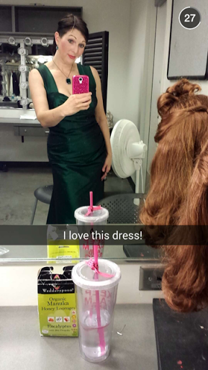
Photographed here is one of my best friends, posing in her newly repaired and tailored evening gown for the season opener I Get a Kick Out of Cole. This show involved 1930’s jazz music, as it was a revue of Cole Porter’s life and musical works in the theatre industry. This dress was a total mess onstage and how it was constructed when I first got my hands on it. I was just starting out my internship when this show debuted, so this assignment was quite a tackle for me. The dress had previously been taken out in the back, as a panel was added. It was also taken in on the sides, which was rather excessive and defeating the purpose of the back panel. This whole ordeal on the rental dress made it look lopsided when worn, and the actress could not even hold the straps entirely up – they were loose. So, to fix this issue, I used my skills quite carefully – I ripped the back panel out and reattached the original dress piece to the back zipper. I also ripped out the seams holding in the fabric taken in on the sides. I then measured the actress’s shoulders and such, and fixed the straps to fit her. It turned out perfectly. This was my first official project as the Theater Works costume intern, and I was quite happy with the final result.

