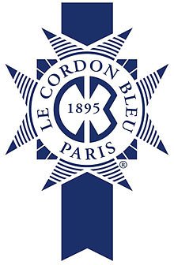

I would like to go to school to be a pastry chef.

