**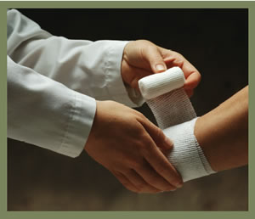******

5959 Health Street  
Bethesda, MD, 20889

301-999-9999

General Hospital

Guide to Surgery

# Postop Wound Care

Fever after the day of surgery higher than 101° F (it is not uncommon to have a low-grade fever after surgery).

You have new redness around the incision or if pus drains from the incision.

Severe bleeding occurs. Apply direct pressure to the area.

Severe abdominal pain, vomiting, or jaundice occurs (yellow tint to eyes or skin)

Call 911 in an emergency

🙞 🙜

## Seek help if:

If you have a gauze bandage over the incision, you may remove it in 48 hours. At that time you may shower.

If you have narrow white tape strips over the incision (steri-strips), keep them dry for 48 hours. Do not remove them unless they are curling up at the side and almost falling off (if you remove them sooner, you risk pulling the incision apart). You may shower after 48 hours.

What to expect on the day of surgery

Wear loose fitting clothing on the day of surgery

The hospital will provide you clothing and an ID bracelet

You will be asked to confirm your surgery before you are given any medications

Once your surgery is complete, you will be taken to the recovery room and monitored by a nurse until you are fully awake

Shower & Shaving

Use the chlorohexidine soap (4% CHG) packet that you received from the preoperative nurse to shower.

Shower the night before surgery and the morning of surgery

Showers will reduce the risk of infections at the site of the incision.

Do not shave or use hair removal creams on the surgical site before surgery. Removing hair at the surgical site may increase risk of infection.

Helpful Websites

http://www.hopkinsmedicine.org/plastic_reconstructive_surgery/_downloads/pre_operative_instructions.pdf

www.facs.org

Medications and NPO

Do not eat or drink 8 hours before you are scheduled to report for your surgery.

The rationale of not eating before surgery is to reduce the chance of aspirating stomach contents

Below is a list of some of the medications that should be stopped 14 days before surgery. Discuss with your surgeon any other herbals, supplements, prescription, and over-the-counter medication you are taking.

Aspirin Heparin

Coumadin Vitamin E

Garlic St. Johns Wart

Ginseng Ibuprofen

Pain Management

Learn about possible side effects of pain medication and what you can do about them.

Get out of bed as soon as you can. Staying active will decrease pain and speed up recovery.

Stay ahead of your pain curve.

Embrace a pillow to reduce pain while deep breathing and coughing to keep lungs clear.

Individual Plan of Care

________________________________________________________________________________________________________________________________________________________________________________________________________________________________________________________________________________________________