

**Opportunities at Ambassador Clubs in the North-West**

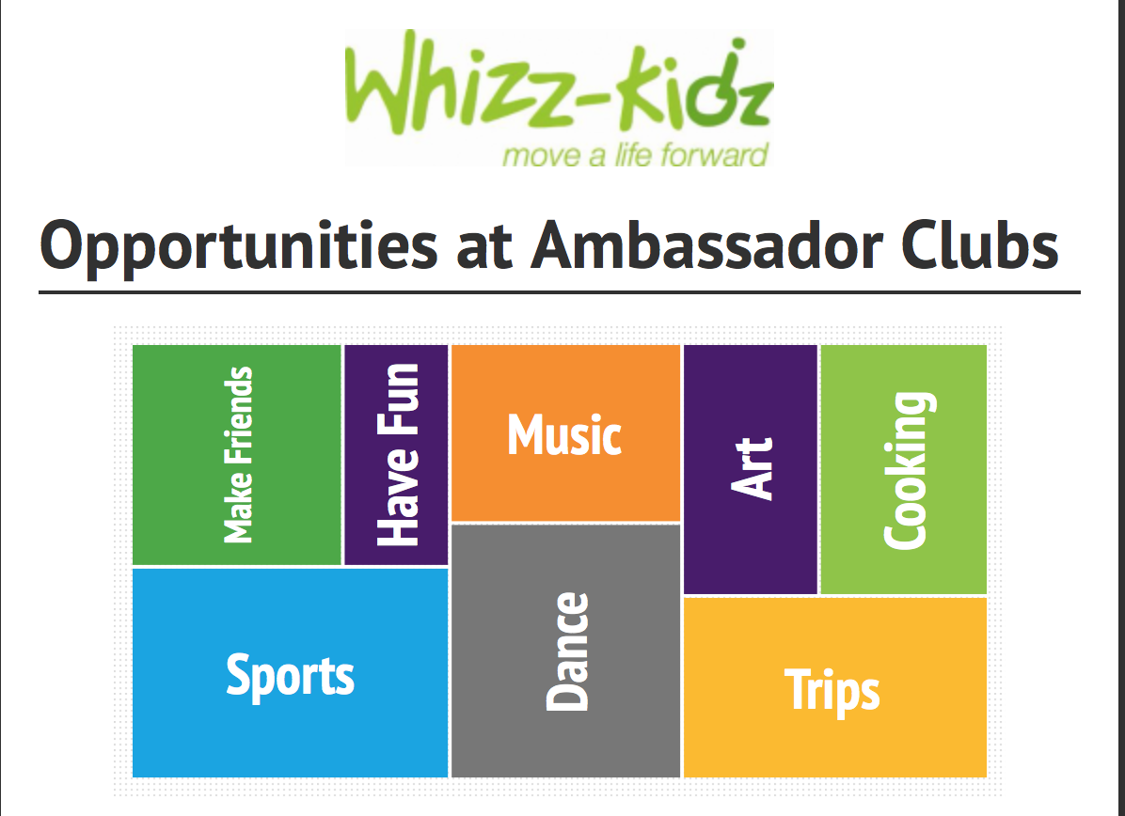

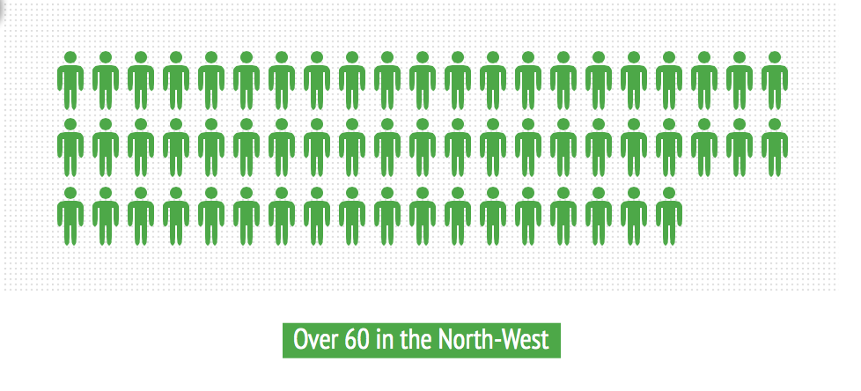**Participants of Wheelchair Skills Training Sessions in 2013**



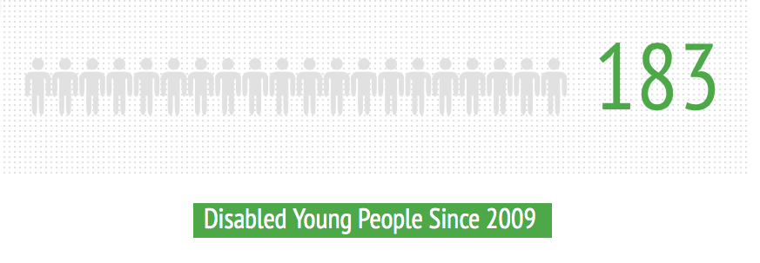**Whizz-Kidz Helps Children in the North-West**

**Disabled young people have received life-changing mobility equipment since 2009since 2009bility equipment since 2009**

