Review Article
October 7, 2013

Derek: Netflix’s Heartwarming and Funny New Series
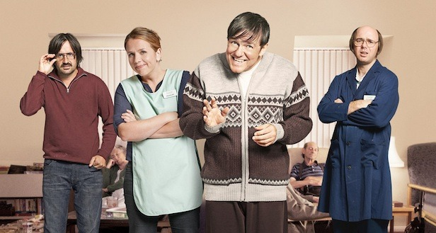
For those looking for a much-needed break from their hectic life and busy schedule, an episode of Derek, one of the latest series to be picked up by Netflix, will be sure to make you smile. Originally aired on Channel 4 in the U.K., Derek, which is written, produced, directed by and staring Rickey Gervais, follows the 49 year-old Derek Noakes (Gervais) though his daily life as an aid at Broad Hill Nursing Home.
Derek’s funny, kind and compassionate attitude shines. He always thinks of others before himself. In the pilot episode, Derek introduces viewers to his friends, co-workers and the elderly living in the home. To Derek, who has undiagnosed autism, the workers and residents of Broad Hill are his family and the love he has for them is apparent within the first few minutes of the episode.
The series focuses on the characters and the relationships among the residents and staff rather than on a complex plot. Set up in a similar way to The Office, the cast is aware of a film-crew presence and small one-on-one moments between the characters and the camera are dispersed throughout each episode.
Early in the series, we meet Hannah, played by Kerry Godliam, who has run Broad Hill for the past fifteen years. She is a simple woman who worries about others before herself and always has the best interest of Derek and the residents of Broad Hill in mind as they navigate their way through ups and downs. Hannah loves her job and her kindness and selflessness rubs off on others.
Dougie (Karl Pilkington), another caretaker at the home who’s notorious for being able to fix anything and having the world’s worst haircut, gets annoyed with Derek and his crazy antics but eventually shows a softer side, proving he is not really a bad guy despite his sarcastic comments. And finally, Kev (David Earl) who does not actually work at the home but is always there drinking beer and making rude comments, completes the main cast.
The series is full of smile-worthy moments: Derek trying to set-up Hannah on a date and young convicts, completing their community service as volunteers, realizing the elderly residents and overly generous workers at Broad Hill aren’t as bad as they initially seemed.
Although there are many funny moments as well, such as Derek’s obsession with singing along with YouTube videos about animals and a cabaret-style talent show, the series is not intended to be solely comedic. With Derek as its center, the show aims to shed light on the elderly community, often overlooked not only in television but also in society. Derek, along with the rest of the cast, demonstrates kindness, compassion and selflessness despite the situation, and encourages others to do the same. Derek is a show that will stay with you long after it’s over.

