Feature Article
December 9, 2013
For Carnivores
Could there ever be a world where people didn’t eat meat? It seems unfathomable today but eventually, everyone may be forced to switch to an entirely plant based diet as a way to mediate environmental and health effects.
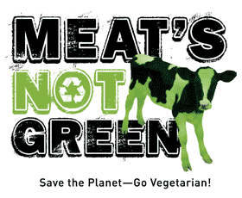
For as long as I can remember I never liked meat. As a kid, I was a fussy eater spending more time dissecting meat than I would actually eat. I am uncertain if the veins or the tough chewy parts were what I disliked so much but I refused to eat it.
vegetarianzen.com
Looking at meat made me sick to my stomach and at dinner I would eat all of the sides first, hoping the meat would somehow magically disappear. It was awful.
Luckily for me, my parents never forced me to eat meat if I didn’t want to. They would beg me to try it and tell me to close my eyes and eat but I refused. When I was fourteen years old, after years of struggling at mealtimes, I became a vegetarian.
I realized you could still be healthy and eat satisfying foods without consuming any meat. It was a revelation and I am not sure why I waited so long to make the switch.
Despite the growing number of people opting for a vegetarian lifestyle, a stigma in society against cutting meat from one’s diet exists. Many fear the inconvenience it may cause when going out to a restaurant or dining in other people’s homes. Pressures from family or friends who don’t quite understand the choice to not eat meat can also cause hesitation. Others may just be afraid of failing and admitting it was more work than they initially thought. But none of these reasons should stop people from making a conscious life decision to become a vegetarian. Although it is not always easy and some restaurants offer slim to none vegetarian options, that’s when it gets exciting. You have the opportunity to improvise and try new things in order to create a meatless meal.
Healthy Sources of Protein For a Vegetarian

- Nuts and Nut Butter
- Seeds
- Vegetables
- Beans
- Quinoa
- Chickpeas
- Tofu or Tempeh
- Seitan
- Non-dairy Milk
- Unsweetened Coco Powder
Even with the stigma towards vegetarians, people are much more accepting and adaptable to eating meatless than ever before. Countless restaurants offer a vegetarian section or go completely vegetarian. When I cut meat from my diet my family was accepting and helped me make alternative dishes. However, they did not fully understand my decision. To some, not eating meat seems wrong and unimaginable but is a lifestyle many choose to live despite the challenges.
The reasons behind becoming a vegetarian differ for everyone. Some do it for ethical reasons, others for environmental or health concerns. For me, I just didn’t like the taste or the idea of killing animals for consumption when there are other alternatives.
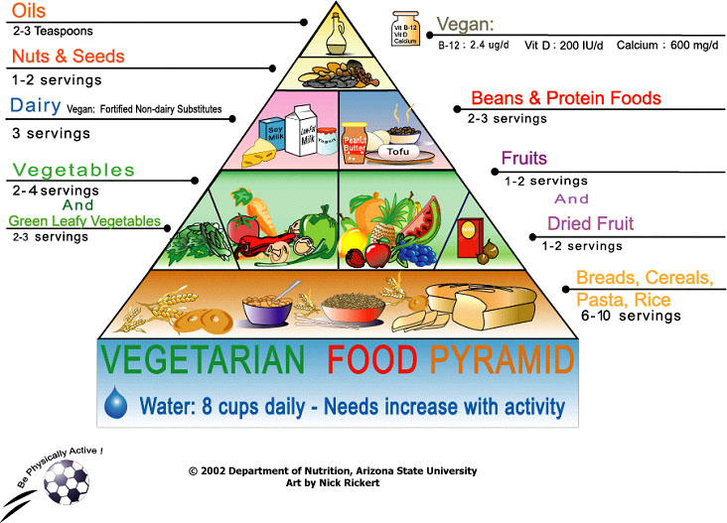
The rising number of environmental and health concerns with eating meat causes some to take a second look and make the change to a meatless lifestyle. According to Jim Matavalli, a writer for Foreign Policy, the 2006 report by the United Nations’ Food and Agriculture Organization entitled, “Livestock’s Long Shadow” states, “livestock is a major player in climate change, accounting for eighteen percent of all greenhouse gas emissions.” By eliminating meat from our diets this number would decrease drastically.
In regards to health concerns, red meat being problematic to one’s health is no secret. In a report by a National Cancer Institute published last March in the New York Times, it was stated people who ate the most red meat were “most likely to die from cancer, heart disease and other causes.” In addition, those who eat five ounces of meat daily, increase their risk for cancer or heart disease by thirty percent.
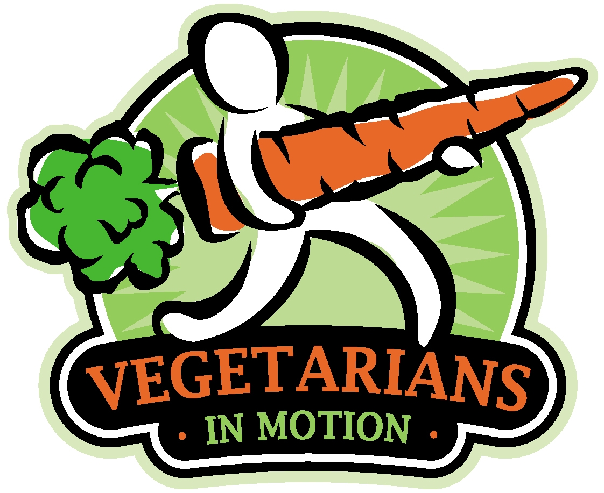
Despite the obvious and alarming facts about environmental and health problems eating meat causes only 2.3 percent of American adults eighteen and older claim to be vegetarians according to Foreign Policy. This makes you wonder if a world without meat is possible. Could there ever be a time when everyone ate a complete plant based diet without any meat?
Vimlife.org

Some experts speculate by 2025 the world will be entirely meatless, not by choice but because we won’t have the resources to keep up the habit. We can already see an increase in the number of vegetarians and the barriers and stigmas dissolving between meat eaters and non-meat eaters. Maybe a meatless world is feasible. But if so, it does not seem likely to happen any time soon.

