Greece and Rome Weekend was all about Immersing Oneself in the Arts, Culture and Lifestyle of the Ancient Mediterranean World

VENI, VIDI, VICI (I came, I saw, I conquered)

Many brave souls were given the opportunity to take on the role of a ROMAN CENTURION, following the orders instructed by their legion commander. Marching forward and backward and left and right, these soldiers-in-the-making learned just what it takes to become a Roman soldier.
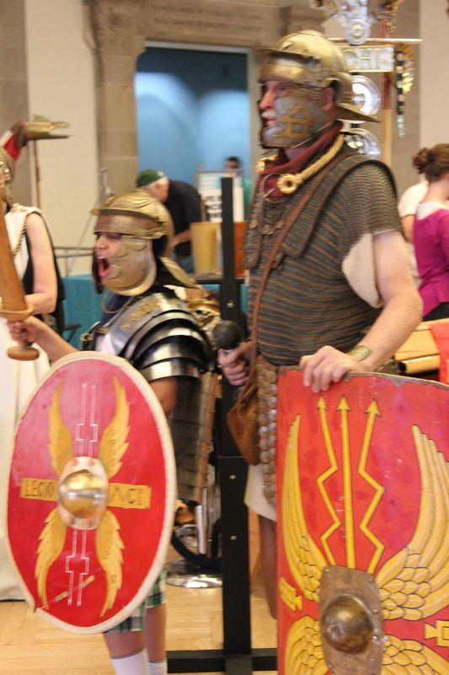Photo by Kay

Fellow intern Lindsay Britton fearlessly took on the position as a recruit within the legion amongst many fellow Romans, swearing an oath AD MORTEM to fight until death.
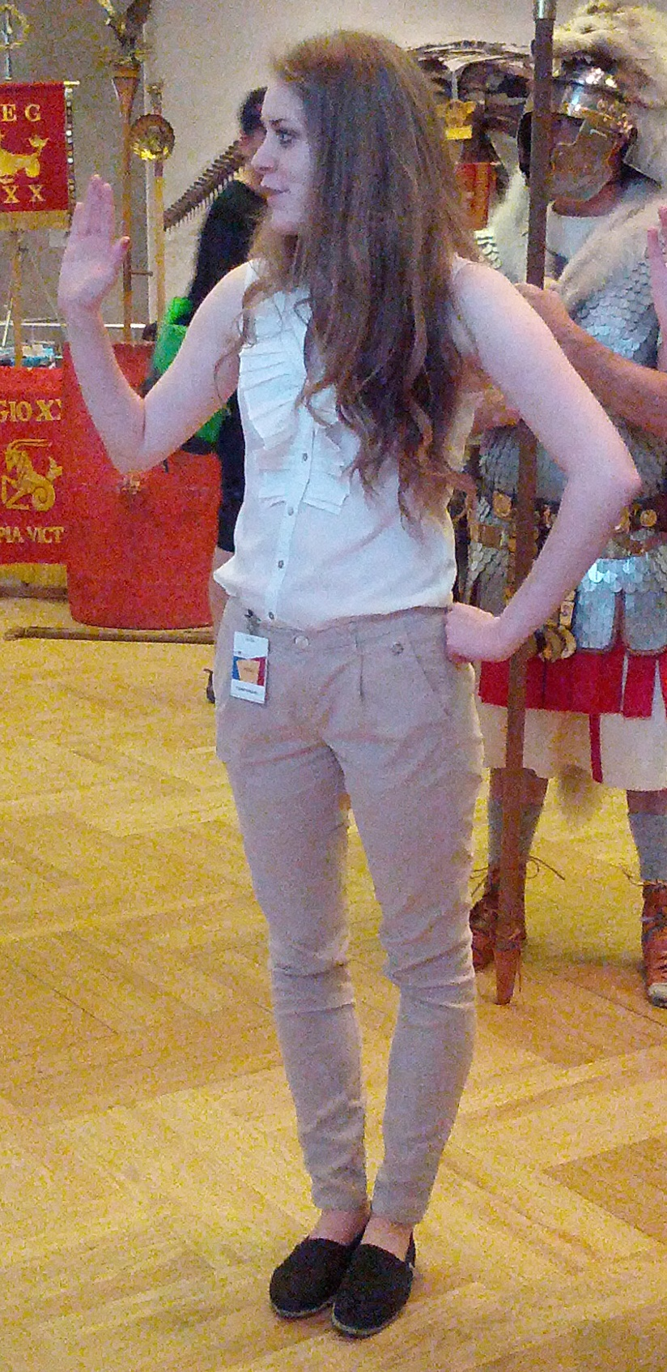 Photo by Natasha

While the Roman centurions worked hard to find strong recruits, the blacksmith (?) hammered away, toiling tirelessly over the soldier’s armour.
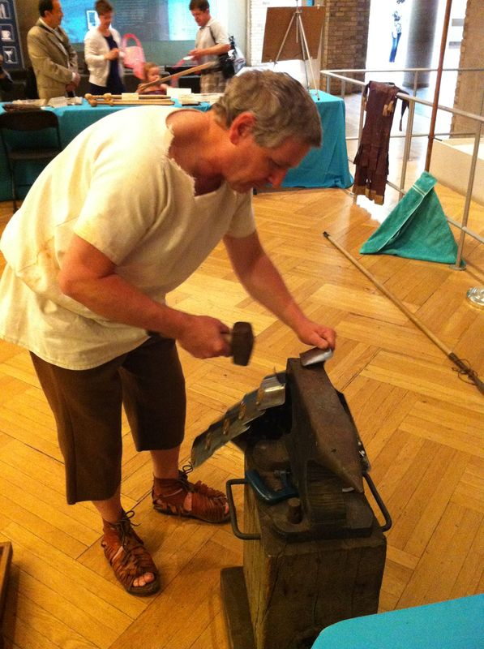 Photo by Lindsay

Over in the Greek and Roman galleries, both kids and their parents were introduced to the world of preservation and scholarship within the ancient Mediterranean.

Kate Cooper, a Rebanks Research Fellow in Classical Archaeology, and expert in Greek pottery in the archaic and classical periods, mystified the ROM visitors with black and red-figure style pottery. Discussing the many stories associated with the pieces, Kate posed questions surrounding the use and purpose of such items.
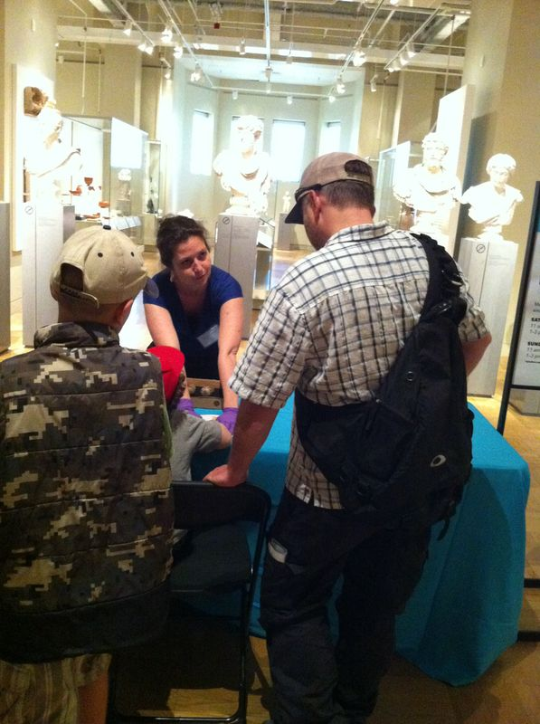Photo by Lindsay

Paul Denis, the Assistant Curator of the Greek, Etruscan, Roman and Byzantine galleries, caught the attention of many passer-bys as he discussed the minting of coins within the Roman period, mesmerizing visitors with the decorative designs and richness of the material.
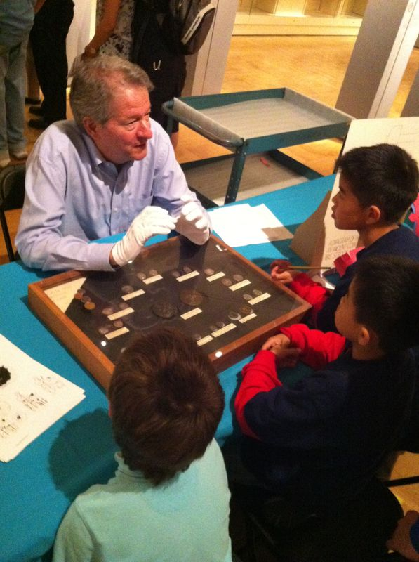 Photo by Lindsay

As the excitement built amongst the parents and children both took on the role as explorers of the ancient world hunting down Greek and Roman lamps and drinking vessels on the scavenger hunts made by myself and fellow intern Lindsay.

