Ahmed Mohamed Refat 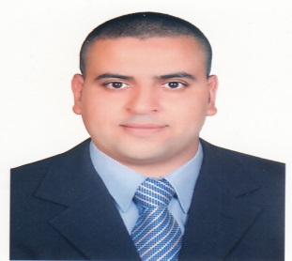

PERSONAL DETAILS

Residential Address: Dubai. U A E
Mobile: +971 56 7955363
Date of Birth: 1 Aug 1985
Nationality: Egyptian
Email: ahmed_rafat36@yahoo.com
CAREER OBJECTIVE

To expand skills and experience within the administrative department of an international company.

EDUCATION HISTORY
May 2002 - 2006 faculty of arts
Bachelor of Arts, Department of Psychology
Zagazig University
Expected graduation: Oct 2006

WORK EXPERIENCE

May 2013- Current  Feb 2009 – Dec 2012  Dec 2007 – Dec 2008 | Eastland international tourism Dubai http://www.eastland-tourism.ae  Administrative and Visa Consultant & (pro).  Responsibilities and achievements:  My responsibilities include  -Providing UAE Visa assistance for 14 days, 30 days to all nationalities  -finish all government transactions relating to the Department of Immigration and Foreigners Affairs  - work with all government departments  - prepare all documents to apply for employment visas, residence visas for employees  -Process and renew of permits and licenses including trade license, chamber of commerce certificates of registration, civil defense certificate for the company etc.  -Dealing with corporate clients worldwide in order to provide packages for individuals, families and groups intending to visit Dubai, UAE  -Promoting our Tours on Social Networking web and placing them on offers as Travel Deals.  New Sabi Company for General Contracting (Siemen's) Cairo, Power plant construction. As Financial and administrative officer site  Responsibilities and achievements:  - Assisted in the work of site-specific accounts  - Assisted in the providing all the requirements of the site and the requirements of building materials and living.  Coral Beach Rotana Resort Cairo.  As a witter

SKILLS AND CERTIFICATES

Computer Skills:
- Microsoft Office applications (Word, Excel, Office, PowerPoint, Outlook, Access) – Advanced
- Microsoft Office Document Imaging and Scanning - Advanced
- Acrobat Reader – Intermediate

Language Skills:
- Arabic: Mother Tongue
- English: reading and writing skills

Other:
- I have a Egyptian driving license 2010

PERSONAL COMPETENCIES

- Ability to work in a fast-paced environment to set deadlines
- Excellent oral and written correspondence with an exceptional attention to detail
- Highly organised with a creative flair for project work
- Enthusiastic self-starter who contributes well to the team

REFEREES

Mr Mustafa Othman  General Manager  New Sabi Company for General Contracting  Cairo.heliopolis  Ph.: +201222151914 | Mr Abd-el-Kader ammari  General Manager  Eastland international tourism  Dubai U.A.E  Ph.: + 971507262719  Fax: +97142504337  Email: info@eastland-tourism.ae

