What to Know About Teething….
Teething

Although the timing of teething varies, the average a baby will teeth is around 6 months when they are transitioning to eat solid foods. The two bottom front teeth are the first to appear, followed by the two top front teeth. Some babies can teeth as early as 3-4 months or as late as 13 months. However, in some cases, late teething can be a result of poor nutrition, thyroid problems, an obstruction in the gums or other medical issues, and it’s best to consult a doctor.

Signs and symptoms of teething include:
Drooling
Chewing on solid foods
Irritability or crankiness
Sore or tender gums
Many parents suspect that teething causes fever and diarrhea, but researchers say this is not true. Teething can cause signs and symptoms in the mouth and gums, no elsewhere in the body.

Tips for Soothing Sore Gums:
Understanding how to soothe sore gums and care for your baby’s new teeth is important. If your teething baby seems uncomfortable, consider these simple tips:

- Rub your babies gums. Use a clean finger, moistened gauze pad or damp washcloth to massage the gums. Applying pressure can ease discomfort.
- Try using cold items like a washcloth or chilled teething ring. This will soothe the gums.
- Wipe away drool. Drying the drool on your babies face will prevent skin irritation. Excessive drooling is part of the teething process, so keep a clean, dry cloth on hand.
- Try hard food. If your baby is eating solids, consider something edible for gnawing. However, keep careful watch since food can be a choking hazard.

How to care for new teeth?
Use a clean, damp washcloth over your baby’s gums every day. When the teeth first start to appear, switch to a small, soft-bristled toothbrush. The American Dental Association says there is no need to use toothpaste until the age of 2. Water is all you need until your child learns to spit.
It is recommended from the American Dental Association and the American Academy of Pediatric Dentistry to schedule a child’s first dental visit after the first tooth erupts and no later than their first birthday.

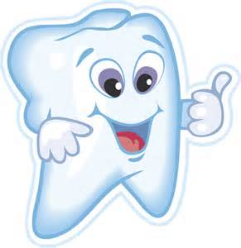
Resources:
American Academy of Pediatric Dentistry: www.aapd.org
American Dental Association: www.ada.org
Mayo Clinic: http://www.mayoclinic.com/health/teething

