Focus on Fruits Lesson Plan
Activity: Banana Snowmen

1. Cut banana into pennies and place 3 pennies on skewer stick.
2. Using dots of sun butter, “glue” blueberries to banana for eyes (2) and buttons (3-4).
3. “Glue” carrot piece for nose (1).
4. Place apple half and grape on top of snowman for hat.
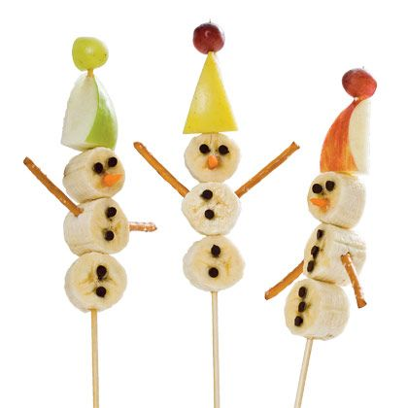

“Do any of you ever eat fruit?”

“What are some examples?”

“Fruits are fun and delicious and they are made of vitamins and minerals that make us grow strong and feel healthy. Fruits come in a rainbow of colors. Can we name fruits for every color of the rainbow?”

Red: Apple, pomegranate
Orange: Oranges, clementines
Yellow: Bananas, lemons
Green: Green grapes, green apples, pears
Blue: Blueberries
Purple: Red grapes, plums

Kids should eat 2 or 3 different fruits every day for a total of 1½ cups of fruit. This looks like the size of 1 tennis ball or 1 computer mouse. Can you draw three different fruits that would count as your servings?

Fruit Riddles
I am orange.
I grow on a tree.
I taste tangy and sweet.
I can be squeezed to make juice.
I am red, yellow, or green.
I grow on a tree.
I sometimes taste sweet or sour.
It is said if you eat one of me a day it keeps the doctor away.
Fruits and Vegetables Are Good for Me!
(see below for printout)
(Tune: Twinkle, Twinkle Little Star)
Apples, pears, and oranges too,
fruits are sweet for me and you.
Carrots, peas, and broccoli,
vegetables are good for me.

Fruits and vegetables
are good for you.
They keep you healthy
and are yummy too! (Rub bellies)

