SPSS Handbook
Table of Contents
Compute a Variable……………………………………………………………….pg.2
Recode a Variable….……………………………………………………………...pg.3
Select Cases.……………………………………………………………………...pg.5
Split File…………………………………………………………………...……...pg.7
Histograms with Frequency Table.……………………………………………….pg.8
Descriptive Statistics..………………………………………………………….....pg.11
Mean, Median, Mode, Standard Deviation, Range, Skew
Internal Reliability Analysis..……………………… ……………………………pg.13
Independent Samples t-test..………………………………………………….…..pg.16
Dependent Samples t-test..……………………………………………...….…….pg.19
One Way ANOVA with post hoc test…………………………………….…...….pg.21
Factorial (2-way) ANOVA..………………………………………………...……pg.25
Repeated Measures ANOVA………………………………………………….….pg.29
Correlation……………………………………………………………………...…pg.33
Linear Regression……………………………………………………………….....pg.36
Scatterplot with Regression Line…………………………………………….…....pg.39
Goodness of Fit Chi-Square………………………………………………….…....pg.44
Contingency Table Chi-Square…………………………………………………....pg.46

Compute a Variable
Description
This tool is used to transform data into a new variable. Can select several variables from the data set and make them into one variable.
SPSS Steps
- Transform 2. Compute Variable
- Give the new variable a name in the “Target Variable” box. This should contain all parts of the new variable.
- Transfer variable into the “Numeric Expression” box by clicking on the variable and moving over with the arrow key.
- Click “OK” and the new variable will be presented under the new name.

Recode a Variable
Description
This tool is used to reassign values to produce different values for a varibale. Use for grouping to change into a nominal scale of measurment. (Ex. Scale 1-5 recoded into 5-1)
SPSS Steps
- Transform Recode into Different Variables
- Add desired variable into the “Numeric Variable Output Variable” box by selecting varaible and moving it with the arrow key.
- Give the new variable a name and label in the “Output Variable” section of this window. The name show contain some difference from the original variable to distinguish it.
- Click the Old and New Variables button.
- For grouping several variables to make one variable, mark the “Range” circle and add the values that you want to be grouped. Give them a new value in the “New value” section, then click add. Repeat this process until all the variables are in the “Old New” box.
- Then click, Continue.
- Click the Change button in the “Output Variable” section then press, “OK”.
- The new variable will appear at the bottom of the data set.
Select Cases
Description
This tool is used to select subsets and filter data to examine.(Ex. Filter to only look at males in the date)
SPSS Steps
- Data Select Cases
- Select variable desired to filter into a subset.
- Mark “If condition is satisfied” then click the “If…” button.
- Add variable by transfering with the arrow button. Mark what filter is desired with the buttons in the center of this screen.
- Press Continue, then click the “OK” button.

Split File
Description
This tool organizes data into groups into subgroups of the data set. It will organize data into related categories, this can be used for one or several groups.
SPSS Steps
- Data Split File
- Select variable you wish to compare and add to the “Groups Based on” box by moving with the arrow button.
- Mark “Organize output by groups” and click “OK.”
Histogram with Frequency Tables
Description of Statistics
A histogram shows the shape of a distribution of a set of continuous data. It allows an examination of outliers and skewness while determining it’s the distribution is normal.
SPSS Steps
- Analyze Descriptive Statistics Frequencies
- Select a continuous variable to run and move into the “Variable” box using the arrow key.
- Click the “Statistics” button. Check “Std. deviation, variance, and range” in the “Description” section. Check “Mean, median, mode, and sum” in the “Central Tendency” section. Then press, continue.
- Click “Charts” button and select Histograms” then press, continue.
- Paste into Output, and then run analysis.
Syntax
FREQUENCIES VARIABLES=H3TO38
/STATISTICS=STDDEV VARIANCE RANGE MEAN MEDIAN MODE SUM SKEWNESS SESKEW
/HISTOGRAM
/ORDER=ANALYSIS.
Output Interpretation

Statistics
S28Q38 PST 12 MON # DAYS DRINK ALCOH-W3
N | Valid | 1959
 | Missing | 670
Mean |  | 2.50
Median |  | 2.00
Mode |  | 2
Std. Deviation |  | 1.379
Variance |  | 1.901
Skewness |  | .142
Std. Error of Skewness |  | .055
Range |  | 6
Sum |  | 4895

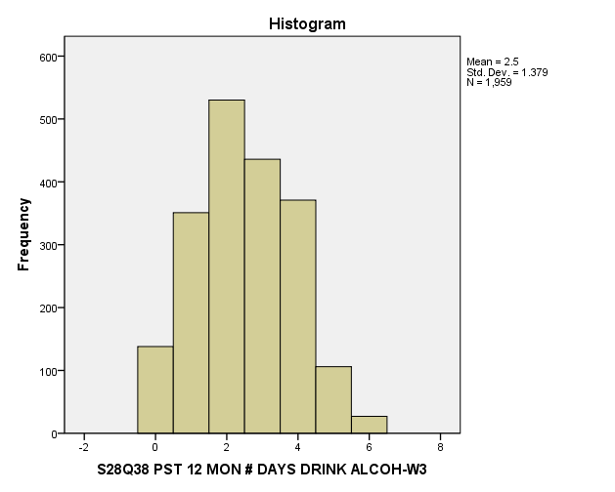

The output gives a mean of 2.5 with a standard deviation of 1.38. The histogram shows a relatively normal curve with a slight right skew. It shows the frequency of the variable and has a range of six.
Descriptive Statistics
Description

This test is used to assess the normality of the data before running further tests. It helps determine if the assumptions can be met for future statistical tests and can give a variety of information to determine the appropriate test. It will give the dispersion and distribution to best describe the variable given.

SPSS Steps

- Analyze Descriptive Statistics Descriptives
- Add desired variable to the “Variables” box by using the arrow key. Then click, “Options” button.
- Check the boxes to receive the descriptions desired. Would like to have the mean, std. deviation, variance, range and skewness as definite factors to check off. The other boxes are optional depending on the description.
- Press continue, then paste into syntax and run analysis.

Syntax
DESCRIPTIVES VARIABLES=H3GH19
/STATISTICS=MEAN STDDEV VARIANCE RANGE MIN MAX SKEWNESS.
Output Interpretation

Descriptive Statistics
 | N | Range | Minimum | Maximum | Mean | Std. Deviation | Variance | Skewness
 | Statistic | Statistic | Statistic | Statistic | Statistic | Statistic | Statistic | Statistic | Std. Error
S9Q19 DAYS ATE BREAKFAST LAST 7 DAYS-W3 | 4881 | 7 | 0 | 7 | 3.10 | 2.769 | 7.670 | .280 | .035
Valid N (listwise) | 4881

The output shows a range from zero to seven with a mean of 3.10 and standard deviation of 2.77. This shows a fairly normal distribution of the number of day’s people ate breakfast over the last seven days with a range of seven.

Internal Reliability Analysis
Description

This test analyzes the degree of consistency or stability of a measure; use three or more items to increase internal consistency. Measures how well the questions correlate to each other (scale from zero to one) wanting a measurement .80 or greater. The numbers mean the same and all scales of measurement are the same (ordinal, nominal, ratio, interval). Use Cronbachs Alpha (α) on correlations only, cannot be used for ordinal or nominal variables.

SPSS Steps

- Analyze Scale Reliability Analysis
- Select desired variables and move into “Items” box by using the arrow key then click, Statistics.

- Select all boxes for “Descriptivces” section and click, Continue.
- Click paste, then run analysis.

Syntax

DATASET ACTIVATE DataSet1.
RELIABILITY
/VARIABLES=H3TO50 H3TO51 H3TO58 H3TO62 H3TO63 H3TO71 H3TO72 H3TO76 H3TO79 H3TO83 H3TO84 H3TO86
H3TO88 H3TO91
/SCALE('ALL VARIABLES') ALL
/MODEL=ALPHA
/STATISTICS=DESCRIPTIVE SCALE
/SUMMARY=TOTAL.

Output Interpretation
Item Statistics
 | Mean | Std. Deviation | N
S28Q50 BINGE-HOW FAVOURABLE FEEL-W3 | 4.02 | 1.287 | 428
S28Q51 BINGE-IMP PEOPLE DISAPPROVE-W3 | 1.83 | 1.218 | 428
S28Q58 BINGE-HELP RELAX BETTER-W3 | 3.91 | 1.182 | 428
S28Q62 BINGE-DAMAGE HEALTH-W3 | 1.65 | .991 | 428
S28Q63 BINGE-HELP LOSE CONTROL-W3 | 1.97 | 1.220 | 428
S28Q71 BINGE-WHO DOES IS CONFIDENT-W3 | 3.23 | .928 | 428
S28Q72 BINGE-WHO DOES IS INDEPENDENT-W3 | 3.09 | .966 | 428
S28Q76 BINGE-WHO DOES IS SLF-CENTERED-W3 | 2.54 | 1.085 | 428
S28Q79 BINGE-HOW POS IF HELP RELAX-W3 | 3.91 | 1.218 | 428
S28Q83 BINGE-HOW POS IF DAMAGE HEALTH-W3 | 4.29 | 1.216 | 428
S28Q84 BINGE-HOW POS IF LOSE CONTROL-W3 | 4.22 | 1.227 | 428
S28Q86 BINGE-HOW POS IF MEET PEOPLE-W3 | 3.80 | 1.294 | 428
S28Q88 BINGE-GOING OUT HOW PLEASED-W3 | 3.42 | .844 | 428
S28Q91 BINGE-HOW POS IF ENGAGING-W3 | 4.02 | 1.235 | 428

Item-Total Statistics
 | Scale Mean if Item Deleted | Scale Variance if Item Deleted | Corrected Item-Total Correlation | Cronbach's Alpha if Item Deleted
S28Q50 BINGE-HOW FAVOURABLE FEEL-W3 | 41.86 | 45.628 | .544 | .687
S28Q51 BINGE-IMP PEOPLE DISAPPROVE-W3 | 44.04 | 56.814 | -.085 | .762
S28Q58 BINGE-HELP RELAX BETTER-W3 | 41.96 | 46.713 | .535 | .690
S28Q62 BINGE-DAMAGE HEALTH-W3 | 44.22 | 58.263 | -.165 | .760
S28Q63 BINGE-HELP LOSE CONTROL-W3 | 43.90 | 59.792 | -.240 | .778
S28Q71 BINGE-WHO DOES IS CONFIDENT-W3 | 42.64 | 49.429 | .495 | .700
S28Q72 BINGE-WHO DOES IS INDEPENDENT-W3 | 42.78 | 50.007 | .425 | .706
S28Q76 BINGE-WHO DOES IS SLF-CENTERED-W3 | 43.33 | 54.837 | .046 | .744
S28Q79 BINGE-HOW POS IF HELP RELAX-W3 | 41.96 | 45.001 | .628 | .677
S28Q83 BINGE-HOW POS IF DAMAGE HEALTH-W3 | 41.59 | 47.419 | .469 | .698
S28Q84 BINGE-HOW POS IF LOSE CONTROL-W3 | 41.65 | 47.309 | .470 | .698
S28Q86 BINGE-HOW POS IF MEET PEOPLE-W3 | 42.07 | 44.550 | .609 | .678
S28Q88 BINGE-GOING OUT HOW PLEASED-W3 | 42.46 | 48.502 | .641 | .689
S28Q91 BINGE-HOW POS IF ENGAGING-W3 | 41.86 | 45.028 | .615 | .678

Use “Cronbach’s Alpha if deleted” to compare what questions do not correlate as well with others, can increase consistency if the number is higher after the question is deleted. These questions correlate fairly well but did not meet the .80 mark to be adequate enough for consistency; I would probably delete several low variables to increase consistency.

Independent t-Test
Description
The Independent t-test is used to compare two different samples of unrelated groups on the same continuous, dependent variable. The population mean and standard deviation is not known. Used when we want to compare sample means to a distribution, of differences between means. We assume normality and homogeneity of variance.
SPSS Steps
- Analyze Compare Means Independent Samples t-test
- Select a dependent variable to move into “Test Variables” box and select an independent variable to move into the “Grouping Variable” box by using the arrow keys. (Test variables are continuous variables and Grouping variables are nominal)
- Click Define Groups, and label each group. “Group 1” and “Group 2” should be labeled with numbers to represent the different testing groups. Then press, continue.

- Click paste, and then run the analysis.
Syntax
T-TEST GROUPS=H3GH2(2 4)
/MISSING=ANALYSIS
/VARIABLES=BIO_SEX3
/CRITERIA=CI(.95).
Output Interpretation

Group Statistics
 | BIOLOGICAL SEX-W3 | N | Mean | Std. Deviation | Std. Error Mean
S9Q02 WHAT YOU THINK OF YOUR WEIGHT-W3 | Male | 2252 | 3.14 | .757 | .016
 | Female | 2625 | 3.52 | .766 | .015

Independent Samples Test
 |  | Levene's Test for Equality of Variances |  | t-test for Equality of Means
 |  | F | Sig. | t | df | Sig. (2-tailed) | Mean Difference | Std. Error Difference | 95% Confidence Interval of the Difference
 |  |  |  |  |  |  |  |  | Lower | Upper
S9Q02 WHAT YOU THINK OF YOUR WEIGHT-W3 | Equal variances assumed | 52.558 | .000 | -17.081 | 4875 | .000 | -.374 | .022 | -.417 | -.331
 | Equal variances not assumed |  |  | -17.097 | 4779.161 | .000 | -.374 | .022 | -.417 | -.331

To test the hypothesis that males and females will differ when determining thoughts about their own weight, I conducted an Independent-samples T-Test on self-report thoughts about weight. The test was significant, t(4875) = -17.081, p = .001. We reject the null hypothesis in support there is a significant difference between men (M = 3.14, SD = .757) and women (M = 3.52, SD = .766) when determining their own weight.

Dependent T-Test
Description
The dependent t-test is used to compare scores from the population mean and standard deviations are unknown. The groups are related (linked) on the same continuous, dependent variable. This test requires a repeated measure or within subjects design. We assume normality and homogeneity of variance.
SPSS Steps

- Analyze Compare Means Paired Samples t-test
- Select variables to compare and move into appropriate variable box by using the arrow key. Variables need to be placed in either the “Variable 1” or “Variable 2” box. Click paste. (If the confidence level needs to be changed, click options button and change to a confidence level other than .05).
- Click paste, and then run analysis.
Syntax
T-TEST PAIRS=H3TO71 WITH H3TO97 (PAIRED)
/CRITERIA=CI(.9500)
/MISSING=ANALYSIS.
Output Interpretation

Paired Samples Statistics
 |  | Mean | N | Std. Deviation | Std. Error Mean
Pair 1 | S28Q71 BINGE-WHO DOES IS CONFIDENT-W3 | 3.26 | 549 | .912 | .039
 | S28Q97 SELF-HOW CONFIDENT-W3 | 1.72 | 549 | .778 | .033

Paired Samples Test
 |  | Paired Differences |  |  |  |  | t | df | Sig. (2-tailed)
 |  | Mean | Std. Deviation | Std. Error Mean | 95% Confidence Interval of the Difference
 |  |  |  |  | Lower | Upper
Pair 1 | S28Q71 BINGE-WHO DOES IS CONFIDENT-W3 - S28Q97 SELF-HOW CONFIDENT-W3 | 1.546 | 1.228 | .052 | 1.444 | 1.649 | 29.512 | 548 | .000

To test the hypothesis that the mean rating of confidence will differ between those rating their own confidence to rating binge drinker’s confidence, I conducted paired samples t-test on self-report measures of confidence. The test was significant, t(548) = 29.512, p = .001. We reject the null hypothesis and conclude that reporting their own confidence (M = 1.72, SD = .778) will not be different than rating others who binge drink confidence (M = 3.26, SD = .912).

One Way ANOVA with Post Hoc
Description of Statistics
The one-way ANOVA is used to compare more than two groups of scores, with the groups being entirely separate and unrelated. The dependent variable is continuous and the independent variable is nominal. This test does not tell which specific groups were significantly different, it only tells two groups were different, determining which groups differ a post hoc test is used. We do not know the population variance but assume homogeneity. It is a between-subjects design.
SPSS Steps
- Analyze Compare Means One-Way ANOVA
- Move continuous variable of choice into the “Dependent list” box by using the arrow key.
- Select a nominal variable and move into the “factor” box by using the arrow key. Then click, Post Hoc
- Click “Tukey” box and press continue
- Select Option and click “Descriptive” then click continue. Paste into Output and run analysis.
Syntax
DATASET ACTIVATE DataSet1.
ONEWAY H3GH4B BY H3GH1
/STATISTICS DESCRIPTIVES
/MISSING ANALYSIS
/POSTHOC=TUKEY ALPHA(0.05).
Output Interpretation

Descriptives
S9Q04B DID YOU EXERCISE CHANGE WEIGHT-W3
 | N | Mean | Std. Deviation | Std. Error | 95% Confidence Interval for Mean |  | Minimum | Maximum
 |  |  |  |  | Lower Bound | Upper Bound
Excellent | 718 | .83 | .373 | .014 | .81 | .86 | 0 | 1
Very good | 991 | .78 | .412 | .013 | .76 | .81 | 0 | 1
Good | 517 | .70 | .460 | .020 | .66 | .74 | 0 | 1
Fair | 105 | .67 | .474 | .046 | .58 | .76 | 0 | 1
Poor | 8 | .88 | .354 | .125 | .58 | 1.17 | 0 | 1
Total | 2339 | .77 | .418 | .009 | .76 | .79 | 0 | 1

ANOVA
S9Q04B DID YOU EXERCISE CHANGE WEIGHT-W3
 | Sum of Squares | df | Mean Square | F | Sig.
Between Groups | 6.980 | 4 | 1.745 | 10.135 | .000
Within Groups | 401.831 | 2334 | .172
Total | 408.811 | 2338

Multiple Comparisons
S9Q04B DID YOU EXERCISE CHANGE WEIGHT-W3
Tukey HSD
(I) S9Q01 HOW IS GENERAL HEALTH-W3 | (J) S9Q01 HOW IS GENERAL HEALTH-W3 | Mean Difference (I-J) | Std. Error | Sig. | 95% Confidence Interval
 |  |  |  |  | Lower Bound | Upper Bound
Excellent | Very good | .050 | .020 | .103 | -.01 | .11
 | Good | .137* | .024 | .000 | .07 | .20
 | Fair | .166* | .043 | .001 | .05 | .28
 | Poor | -.042 | .148 | .999 | -.44 | .36
Very good | Excellent | -.050 | .020 | .103 | -.11 | .01
 | Good | .087* | .023 | .001 | .03 | .15
 | Fair | .116* | .043 | .050 | .00 | .23
 | Poor | -.092 | .147 | .971 | -.49 | .31
Good | Excellent | -.137* | .024 | .000 | -.20 | -.07
 | Very good | -.087* | .023 | .001 | -.15 | -.03
 | Fair | .030 | .044 | .963 | -.09 | .15
 | Poor | -.179 | .148 | .746 | -.58 | .22
Fair | Excellent | -.166* | .043 | .001 | -.28 | -.05
 | Very good | -.116* | .043 | .050 | -.23 | .00
 | Good | -.030 | .044 | .963 | -.15 | .09
 | Poor | -.208 | .152 | .648 | -.62 | .21
Poor | Excellent | .042 | .148 | .999 | -.36 | .44
 | Very good | .092 | .147 | .971 | -.31 | .49
 | Good | .179 | .148 | .746 | -.22 | .58
 | Fair | .208 | .152 | .648 | -.21 | .62
*. The mean difference is significant at the 0.05 level.

S9Q04B DID YOU EXERCISE CHANGE WEIGHT-W3
Tukey HSD^{a,b}
S9Q01 HOW IS GENERAL HEALTH-W3 | N | Subset for alpha = 0.05
 |  | 1
Fair | 105 | .67
Good | 517 | .70
Very good | 991 | .78
Excellent | 718 | .83
Poor | 8 | .88
Sig. |  | .207
Means for groups in homogeneous subsets are displayed.
a. Uses Harmonic Mean Sample Size = 36.008.
b. The group sizes are unequal. The harmonic mean of the group sizes is used. Type I error levels are not guaranteed.

In conducting a one-way ANOVA comparing general health and exercise to change weight, we can determine there is a significant difference F(4, 2338) = 10.135, p < .001. A post hoc test revealed several significant results; there is a significant difference between excellent health and good health, p < .001. There was also a significant difference between excellent health and fair health, p = .001. Lastly, there is a significant difference between very good health and fair health, p = .05.
Factorial ANOVA
Description of Statistics
We use a factorial ANOVA when comparing two or more independent variables, with main effects focusing on isolation of the variables, on the dependent variable. The sample means should be similar for comparing. Use multiple nominal independent variables with a continuous dependent variable. To avoid violating assumptions of homogeneity use large, similar sample sizes. This test will not tell which specific groups are significantly different, but only show that two groups differed. A post hoc test can be conducted to show where the main effects are different if there is more than two groups and examine the interaction.
SPSS Steps
- Analyze General Linear Model Univariate
- Select variables. “Dependent Variables” are continuous variables and “Fixed factors” are nominal variables, move appropriate variable into boxes by using the arrow keys.
- Click Options and move variables from factors box to “Display Means” box then select compare main effects, descriptive statistics, and homogeneity tests. Then click, continue.
- Paste into syntax, and then run analysis.
Syntax
UNIANOVA H3GH1 BY H3GH20 BIO_SEX3
/METHOD=SSTYPE(3)
/INTERCEPT=INCLUDE
/PLOT=PROFILE(H3GH20*BIO_SEX3)
/EMMEANS=TABLES(H3GH20) COMPARE ADJ(LSD)
/EMMEANS=TABLES(BIO_SEX3) COMPARE ADJ(LSD)
/EMMEANS=TABLES(H3GH20*BIO_SEX3)
/PRINT=DESCRIPTIVE
/CRITERIA=ALPHA(.05)
/DESIGN=H3GH20 BIO_SEX3 H3GH20*BIO_SEX3.

Output Interpretation
Between-Subjects Factors
 |  | Value Label | N
S9Q20 VITAMINS OR MINERALS LAST MON-W3 | 0 | No | 2793
 | 1 | Yes | 2088
BIOLOGICAL SEX-W3 | 1 | Male | 2252
 | 2 | Female | 2629

Tests of Between-Subjects Effects
Dependent Variable:S9Q01 HOW IS GENERAL HEALTH-W3
Source | Type III Sum of Squares | df | Mean Square | F | Sig.
Corrected Model | 40.410ª | 3 | 13.470 | 18.155 | .000
Intercept | 18254.954 | 1 | 18254.954 | 24604.173 | .000
H3GH20 | 13.102 | 1 | 13.102 | 17.659 | .000
BIO_SEX3 | 29.714 | 1 | 29.714 | 40.049 | .000
H3GH20 * BIO_SEX3 | .027 | 1 | .027 | .036 | .850
Error | 3618.468 | 4877 | .742
Total | 22888.000 | 4881
Corrected Total | 3658.878 | 4880
a. R Squared = .011 (Adjusted R Squared = .010)

Pairwise Comparisons
Dependent Variable:S9Q01 HOW IS GENERAL HEALTH-W3
(I) S9Q20 VITAMINS OR MINERALS LAST MON-W3 | (J) S9Q20 VITAMINS OR MINERALS LAST MON-W3 | Mean Difference (I-J) | Std. Error | Sig.ª | 95% Confidence Interval for Differenceª
 |  |  |  |  | Lower Bound | Upper Bound
No | Yes | .106* | .025 | .000 | .056 | .155
Yes | No | -.106* | .025 | .000 | -.155 | -.056
Based on estimated marginal means
*. The mean difference is significant at the .05 level.
a. Adjustment for multiple comparisons: Least Significant Difference (equivalent to no adjustments).

Pairwise Comparisons
Dependent Variable:S9Q01 HOW IS GENERAL HEALTH-W3
(I) BIOLOGICAL SEX-W3 | (J) BIOLOGICAL SEX-W3 | Mean Difference (I-J) | Std. Error | Sig.ª | 95% Confidence Interval for Differenceª
 |  |  |  |  | Lower Bound |  | Upper Bound
Male | Female | -.159* | .025 | .000 | -.208 |  | -.110
Female | Male | .159* | .025 | .000 | .110 |  | .208
Based on estimated marginal means
*. The mean difference is significant at the .05 level.
a. Adjustment for multiple comparisons: Least Significant Difference (equivalent to no adjustments).

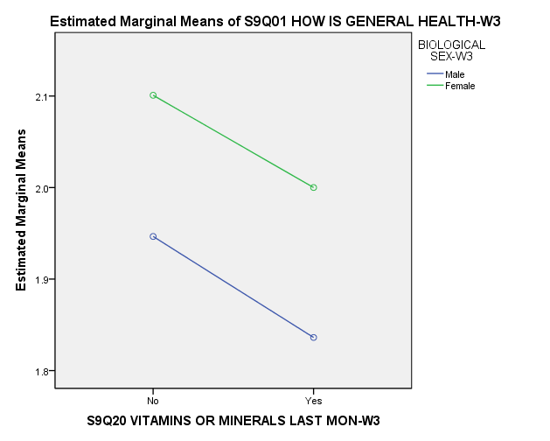
To test the prediction that mean general health will not differ from sex of vitamin usage, I conducted a 2 (gender: male vs. female) x 2 (vitamin usage) factorial ANOVA on self-report measures of general health. The main effect of vitamin usage on health was significant, F(1, 4877) = 17.66, p = .001. The main effect of biological sex on health was significant, F(1, 4877) = 29.71, p = .001. The interaction between biological sex and vitamin usage was significant, F(1, 4877) = .036, p = .850.
Repeated Measures ANOVA
Description of Statistics
This test is used when comparing one or more independent variables (think of as an extended dependent t-test) and shows any differences between related means. This test is a within-subjects design. The Independent variable is continuous and dependent variable is nominal. The Independent variable has levels or related groups measured on the same scale.
SPSS Steps
- Analyze General Linear Model Repeated Measures
- Name the variable in the “Within-subjects Factor name” box and add the number of levels desired then click, Add.
- Click Define then add variables to the “Within-Subjects Variables” box by using the arrow key.
- Click Options, move variable into “Display Means For” box by using the arrow key. In the display section, select “Descriptive statistics” box. Then click, continue.
- Paste into syntax, then run analysis.
Syntax
GLM H3TO71 H3TO72 H3TO76
/WSFACTOR=Perceptioin_BingeDrinkers 3 Polynomial
/METHOD=SSTYPE(3)
/EMMEANS=TABLES(Perceptioin_BingeDrinkers) COMPARE ADJ(LSD)
/PRINT=DESCRIPTIVE
/CRITERIA=ALPHA(.05)
/WSDESIGN=Perceptioin_BingeDrinkers.

Output Interpretation
Within-Subjects Factors
Measure:MEASURE_1
Perceptioin_BingeDrinkers | Dependent Variable
1 | H3TO71
2 | H3TO72
3 | H3TO76

Descriptive Statistics
 | Mean | Std. Deviation | N
S28Q71 BINGE-WHO DOES IS CONFIDENT-W3 | 3.25 | .931 | 501
S28Q72 BINGE-WHO DOES IS INDEPENDENT-W3 | 3.11 | .955 | 501
S28Q76 BINGE-WHO DOES IS SLF-CENTERED-W3 | 2.53 | 1.111 | 501

Tests of Within-Subjects Effects
Measure:MEASURE_1
Source |  | Type III Sum of Squares | df | Mean Square | F | Sig.
Perceptioin_BingeDrinkers | Sphericity Assumed | 144.579 | 2 | 72.289 | 95.694 | .000
 | Greenhouse-Geisser | 144.579 | 1.488 | 97.174 | 95.694 | .000
 | Huynh-Feldt | 144.579 | 1.491 | 96.952 | 95.694 | .000
 | Lower-bound | 144.579 | 1.000 | 144.579 | 95.694 | .000
Error(Perceptioin_BingeDrinkers) | Sphericity Assumed | 755.421 | 1000 | .755
 | Greenhouse-Geisser | 755.421 | 743.917 | 1.015
 | Huynh-Feldt | 755.421 | 745.624 | 1.013
 | Lower-bound | 755.421 | 500.000 | 1.511

Pairwise Comparisons
Measure:MEASURE_1
(I) Perceptioin_BingeDrinkers | (J) Perceptioin_BingeDrinkers | Mean Difference (I-J) | Std. Error | Sig.ª | 95% Confidence Interval for Differenceª
 |  |  |  |  | Lower Bound | Upper Bound
1 | 2 | .140* | .035 | .000 | .070 | .209
 | 3 | .717* | .062 | .000 | .594 | .839
2 | 1 | -.140* | .035 | .000 | -.209 | -.070
 | 3 | .577* | .063 | .000 | .454 | .700
3 | 1 | -.717* | .062 | .000 | -.839 | -.594
 | 2 | -.577* | .063 | .000 | -.700 | -.454
Based on estimated marginal means
*. The mean difference is significant at the .05 level.
a. Adjustment for multiple comparisons: Least Significant Difference (equivalent to no adjustments).

I conducted a repeated measure ANOVA on the perception of binge drinkers with three types of perception (confidence, independence, and self-centeredness). The ANOVA was significant, F(2, 1000) = 95.694, p = .001. There was a significant difference between confidence (M= 3.25, SD = .93), independence (M = 3.11, SD = .96), and self-centeredness (M = 2.53, SD = 1.11).

Correlation
Description of Statistics
This test is used to measure the strength and direction of association between two variables. It uses the interval scale of measurement and ONLY has two variables. There are three patterns: Linear (follows close to a straight line), curvilinear (U shaped), and no pattern (no correlation). It can have a perfect, strong, or weak correlation which is represented by a scatterplot. Things that we don’t want in this test is: curvilinear, outliers (pulling data), and restriction of range (only looking at a section of data). Use Pearson unless correlating multiple variable, in which case Bonferroni is used.
SPSS Steps
- Analyze Correlate Bivariate
- Transfer the variables desired to test associate into the “Variables” box by using the arrow key. (Remember variables must be interval scale). Then click, Options.
- Select “Means and standard deviation” box and “Exclude cases pairwise” circle. Then press, continue.
- Click paste, and then run analysis.

Syntax

CORRELATIONS
/VARIABLES=H3TO43 H3TO45
/PRINT=TWOTAIL NOSIG
/STATISTICS DESCRIPTIVES
/MISSING=PAIRWISE.
Output Interpretation
Descriptive Statistics
 | Mean | Std. Deviation | N
S28Q43 PST 12 MON # DAYS BEEN DRUNK-W3 | 1.58 | 1.465 | 3466
S28Q45 PST 12 MON PROB WORK DUE DRINK-W3 | .14 | .556 | 3470

Correlations
 |  | S28Q43 PST 12 MON # DAYS BEEN DRUNK-W3 | S28Q45 PST 12 MON PROB WORK DUE DRINK-W3
S28Q43 PST 12 MON # DAYS BEEN DRUNK-W3 | Pearson Correlation | 1 | .288**
 | Sig. (2-tailed) |  | .000
 | N | 3466 | 3458
S28Q45 PST 12 MON PROB WORK DUE DRINK-W3 | Pearson Correlation | .288** | 1
 | Sig. (2-tailed) | .000
 | N | 3458 | 3470
**. Correlation is significant at the 0.01 level (2-tailed).

I conducted a correlation test on the number of days being drunk and the number of times there has been problems at work due to drinking in the past 12 months. The correlation was significant, r (3458) = .28, p < .05. There appears to be a positive relationship between number of days being drunk (M = 1.58, SD = 1.47) and number of problems at work due to being drinking (M = .14, SD = .56). This positive relationship means as days being drunk increase, problems at work due to drinking also increase.
Linear Regression
Description of Statistics
This test is the nest step after correlation. It is used to predict the value of one variable based on the information from a second variable. If the variables are not correlated this test cannot be used. The variable we want to predict is the dependent variable and the predictor variable is the independent variable. Variables need to be continuous and have a linear relationship (check using a scatterplot).
SPSS Steps
- Analyze Regression Linear
- Add the desired predicted variable to the “Dependent” box my using the arrow key. Add the predictor variable to the “Independent” box by using the arrow key.
- Click, Statistics button. Check mark “Descriptives” box. Then press, continue.
- The default settings that are chosen under “Plots, Save, and Options” do not need to be changed to run this test.
- Click paste, and then run analysis.
Syntax
REGRESSION
/DESCRIPTIVES MEAN STDDEV CORR SIG N
/MISSING LISTWISE
/STATISTICS COEFF OUTS R ANOVA
/CRITERIA=PIN(.05) POUT(.10)
/NOORIGIN
/DEPENDENT H3TO45
/METHOD=ENTER H3TO43.
Output Interpretation

Descriptive Statistics
 | Mean | Std. Deviation | N
S28Q45 PST 12 MON PROB WORK DUE DRINK-W3 | .14 | .557 | 3458
S28Q43 PST 12 MON # DAYS BEEN DRUNK-W3 | 1.58 | 1.465 | 3458

Correlations
 |  |  |  |  |  |  |  |  | S28Q45 PST 12 MON PROB WORK DUE DRINK-W3 |  |  |  | S28Q43 PST 12 MON # DAYS BEEN DRUNK-W3
Pearson Correlation |  |  |  |  | S28Q45 PST 12 MON PROB WORK DUE DRINK-W3 |  |  |  | 1.000 |  |  |  | .288
 |  |  |  |  | S28Q43 PST 12 MON # DAYS BEEN DRUNK-W3 |  |  |  | .288 |  |  |  | 1.000
Sig. (1-tailed) |  |  |  |  | S28Q45 PST 12 MON PROB WORK DUE DRINK-W3 |  |  |  | . |  |  |  | .000
 |  |  |  |  | S28Q43 PST 12 MON # DAYS BEEN DRUNK-W3 |  |  |  | .000 |  |  |  | .
N |  |  |  |  | S28Q45 PST 12 MON PROB WORK DUE DRINK-W3 |  |  |  | 3458 |  |  |  | 3458
 |  |  |  |  | S28Q43 PST 12 MON # DAYS BEEN DRUNK-W3 |  |  |  | 3458 |  |  |  | 3458
 | Model Summary
 | Model |  | R | R Square |  | Adjusted R Square |  | Std. Error of the Estimate
 | 1 |  | .288ª | .083 |  | .083 |  | .534
 | a. Predictors: (Constant), S28Q43 PST 12 MON # DAYS BEEN DRUNK-W3
 | Coefficientsª
 | Model |  |  |  |  |  | Unstandardized Coefficients |  |  |  |  | Standardized Coefficients |  | t |  | Sig.
 |  |  |  |  |  |  | B |  |  | Std. Error |  | Beta
 | 1 | (Constant) |  |  |  |  | -.033 |  |  | .013 |  |  |  | -2.492 |  | .013
 |  | S28Q43 PST 12 MON # DAYS BEEN DRUNK-W3 |  |  |  |  | .109 |  |  | .006 |  | .288 |  | 17.667 |  | .000
I conducted a linear regression test on the relationship between the number of days being drunk and the number of work problems due to drinking. There is a significant correlation, r(3458) = .29, p < .01. The correlation indicates there is not much variability on the number of work problems due to drinking that can be explained by the number of days being drunk, R² = .28. There is a relationship in the regression, the number of days being drunk is a predictor of the number of work problems due to being drunk, ŷ = -.03 + .11 (days being drunk). If someone was to answer number of days being drunk as 5 the rating for their problems would be ŷ = -.03 +.11(5) ŷ = .52.
Scatterplot with Regression Line
Description of Statistics
The scatterplot is used to determine the relationship of the correlation. It can show whether the relationship is linear and if there are outliers. It gives a graphical representation of the data by using points. The Regression line shows how strong the relationship of the data is but can be affected by outliers.
SPSS Steps
- Graphs Legacy Dialogs Scatter/Dot
- Select Simple Scatter. Click, Define.
- Select a continuous variable to move with the arrow key to the “Y Axis” box. Then, select a second continuous variable to move with the arrow key to the “X axis” box. Then press, Titles.
- Give the scatterplot a title that includes the variables being correlated. Then press, continue.
- Click paste, and then run analysis.
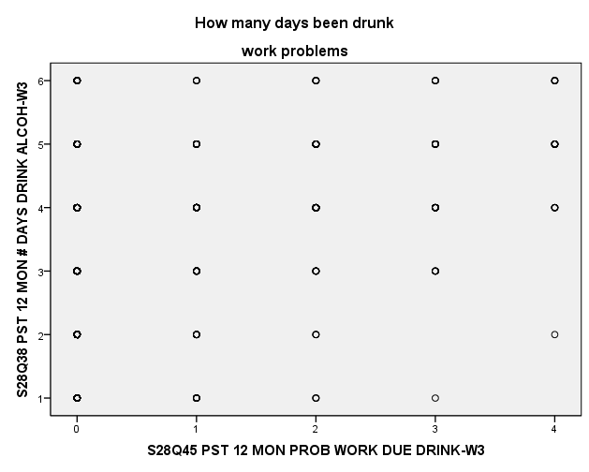
- To create the regression line, right click on the scatterplot. Edit content In a Separate Window
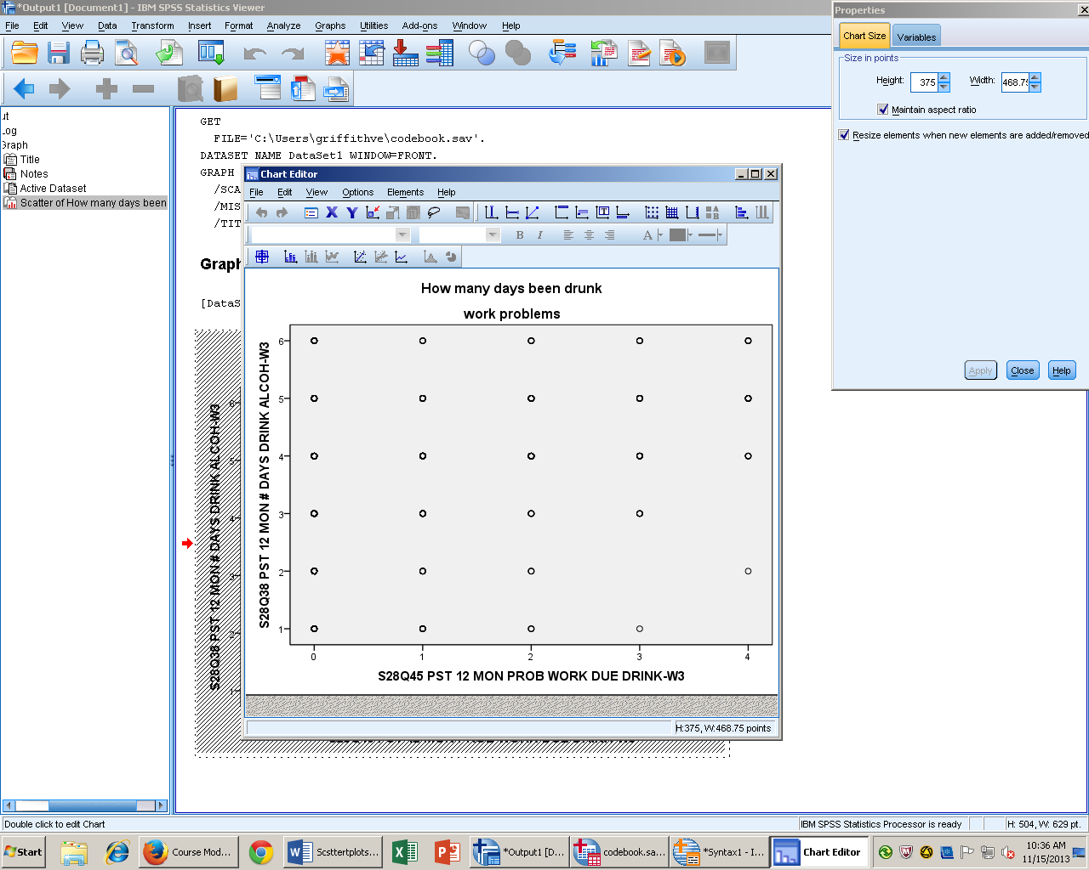
- In the bottom line of Tool Bar, select “Add Fit Line”
- Then press, apply.
Syntax
GRAPH
/SCATTERPLOT(BIVAR)=H3TO45 WITH H3TO38
/MISSING=LISTWISE
/TITLE='How many days been drunk' 'work problems'.

Output Interpretation
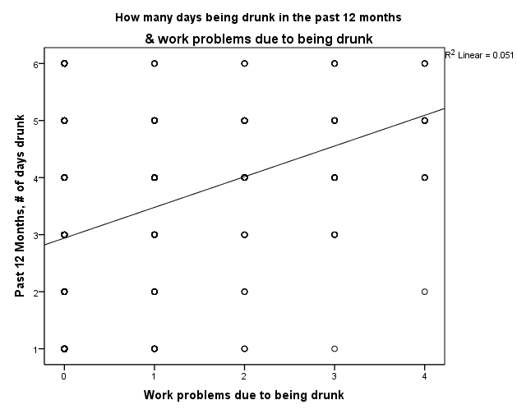
There is a positive correlation between the number of days drunk in the past twelve months and the number of work problems due to being drunk. As number of days being drunk increases, the number of work problems due to being drunk increases.

Goodness of Fit Chi-Square
Description of Statistics
This test is used to determine whether the distribution of participants in one or two variables follows a distribution. The variable must be on the nominal scale of measurement. It compares the actual (observed) frequencies to the expected frequencies. The distribution cannot be less than zero and is shaped in a right skew. Watch for curvilinear distributions, outliers, and restriction of range (we do not want these).
SPSS Steps
- Analyze Nonparametric Tests Legacy Dialogs Chi-square
- Move desired variable into the “Test Variable List” box with the arrow key.
- In the “Expected Values” section, select “Values” and add the numbers of the expected values. Then press, paste.
Syntax
NPAR TESTS
/CHISQUARE=H3GH20
/EXPECTED=40 60
/MISSING ANALYSIS.
Output Interpretation
S9Q20 VITAMINS OR MINERALS LAST MON-W3
 | Observed N | Expected N | Residual
No | 2793 | 1952.4 | 840.6
Yes | 2088 | 2928.6 | -840.6
Total | 4881

Test Statistics
 | S9Q20 VITAMINS OR MINERALS LAST MON-W3
Chi-Square | 603.196ª
df | 1
Asymp. Sig. | .000
a. 0 cells (.0%) have expected frequencies less than 5. The minimum expected cell frequency is 1952.4.

I conducted a chi-square test on vitamins usage. The results were significant for vitamin usage, x² (1, N = 4881) = 603.19, p < .01. Vitamin usage is different from what was expected.
Contingency Table Chi-Square
Description of Statistics

This test is used to determine whether the distribution of participants in two variables follows a distribution. The variable must be on the nominal scale of measurement and must be linked. It compares the actual (observed) frequencies to the expected frequencies. It looks at the proportions of data in different combinations. The distribution cannot be less than zero and is shaped in a right skew. Watch for curvilinear distributions, outliers, and restriction of range (we do not want these).
SPSS Steps

- Analyze Descriptive Statistics Crosstabs

- Select the variables to compare. Move the independent variable into the “Rows” box and the dependent variable into the “Columns” box. Then click, statistics.
- Check off “Chi-square” box. Then click, continue.
- Click, cells button. In the counts section mark “Observed” and “Expected” boxes. In the percentages section mark the “Row” and “Column” boxes. Then click, continue.
- Click paste, and then run analysis.

Syntax
CROSSTABS
/TABLES=BIO_SEX3 BY H3GH20
/FORMAT=AVALUE TABLES
/STATISTICS=CHISQ
/CELLS=COUNT EXPECTED ROW COLUMN
/COUNT ROUND CELL.
Output Interpretation
Case Processing Summary
 | Cases
 | Valid |  | Missing |  | Total
 | N | Percent | N | Percent | N | Percent
BIOLOGICAL SEX-W3 * S9Q20 VITAMINS OR MINERALS LAST MON-W3 | 4881 | 100.0% | 1 | .0% | 4882 | 100.0%

BIOLOGICAL SEX-W3 * S9Q20 VITAMINS OR MINERALS LAST MON-W3 Crosstabulation
 |  |  | S9Q20 VITAMINS OR MINERALS LAST MON-W3 |  | Total
 |  |  | No | Yes
BIOLOGICAL SEX-W3 | Male | Count | 1385 | 867 | 2252
 |  | Expected Count | 1288.6 | 963.4 | 2252.0
 |  | % within BIOLOGICAL SEX-W3 | 61.5% | 38.5% | 100.0%
 |  | % within S9Q20 VITAMINS OR MINERALS LAST MON-W3 | 49.6% | 41.5% | 46.1%
 | Female | Count | 1408 | 1221 | 2629
 |  | Expected Count | 1504.4 | 1124.6 | 2629.0
 |  | % within BIOLOGICAL SEX-W3 | 53.6% | 46.4% | 100.0%
 |  | % within S9Q20 VITAMINS OR MINERALS LAST MON-W3 | 50.4% | 58.5% | 53.9%
Total |  | Count | 2793 | 2088 | 4881
 |  | Expected Count | 2793.0 | 2088.0 | 4881.0
 |  | % within BIOLOGICAL SEX-W3 | 57.2% | 42.8% | 100.0%
 |  | % within S9Q20 VITAMINS OR MINERALS LAST MON-W3 | 100.0% | 100.0% | 100.0%

Chi-Square Tests
 | Value | df | Asymp. Sig. (2-sided) | Exact Sig. (2-sided) | Exact Sig. (1-sided)
Pearson Chi-Square | 31.274ª | 1 | .000
Continuity Correction^{b} | 30.951 | 1 | .000
Likelihood Ratio | 31.350 | 1 | .000
Fisher's Exact Test |  |  |  | .000 | .000
Linear-by-Linear Association | 31.268 | 1 | .000
N of Valid Cases | 4881
a. 0 cells (.0%) have expected count less than 5. The minimum expected count is 963.36.
b. Computed only for a 2x2 table

I conducted a chi-squared to test the relationship between vitamin use and biological sex. The chi-square was significant, x²(1, N = 4881) = 31.274, p < .05. Biological sex lacks independence from vitamin use; there is a difference between observed and expected counts for both variables.

