Table of Contents

Basics of SPSS……………………………………………………………………………2
Frequency Polygon………………………………………………………………………13
Histogram………………………………………………………………………………. 16
Bar Graph……………………………………………………………………………….. 21
Simple Sample t…………………………………………………………………………..25
Independent t……………………………………………………………………………..31
Dependent t…….…………………………………………………………………………44
One-Way ANOVA………………………………………………………………………..50
One-Way ANOVA post hocs…………………………………………………………… .59
Repeated Measures ANOVA……………………………………………………………. 64
Repeated Measures ANOVA post hocs………………………………………………….67
2-Way ANOVA …………………………………………………………………………. .71
Mixed Model ANOVA……………………………………………………………………78
Pearson r…………………………………………………………………………………..88
Goodness of Fit X^{2…}………………………………………………………………………94
Contingency Table X² ...…………………………………………………………………. 101

Basics of SPSS

- Open up SPSS
- On the opening screen, you can either choose an existing data set, or you can choose to type in new data

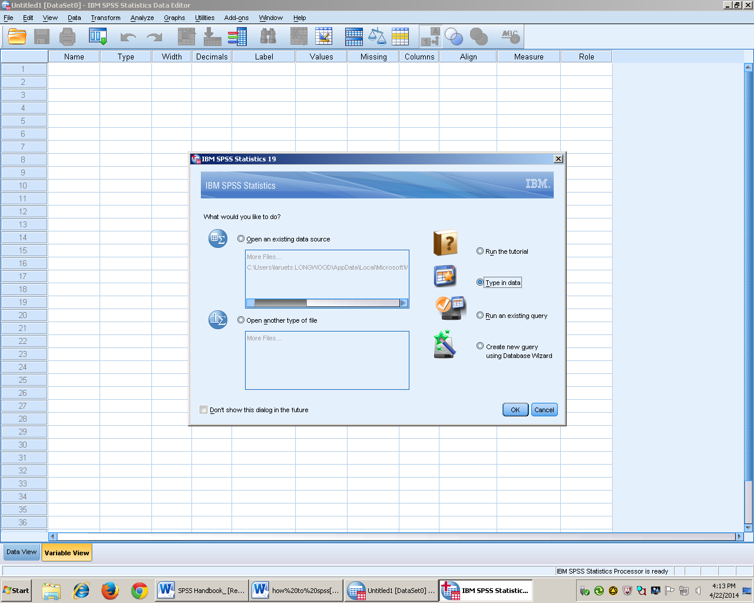

- Once you have your dataset that you want to work with, you can put your variables in the Variable view

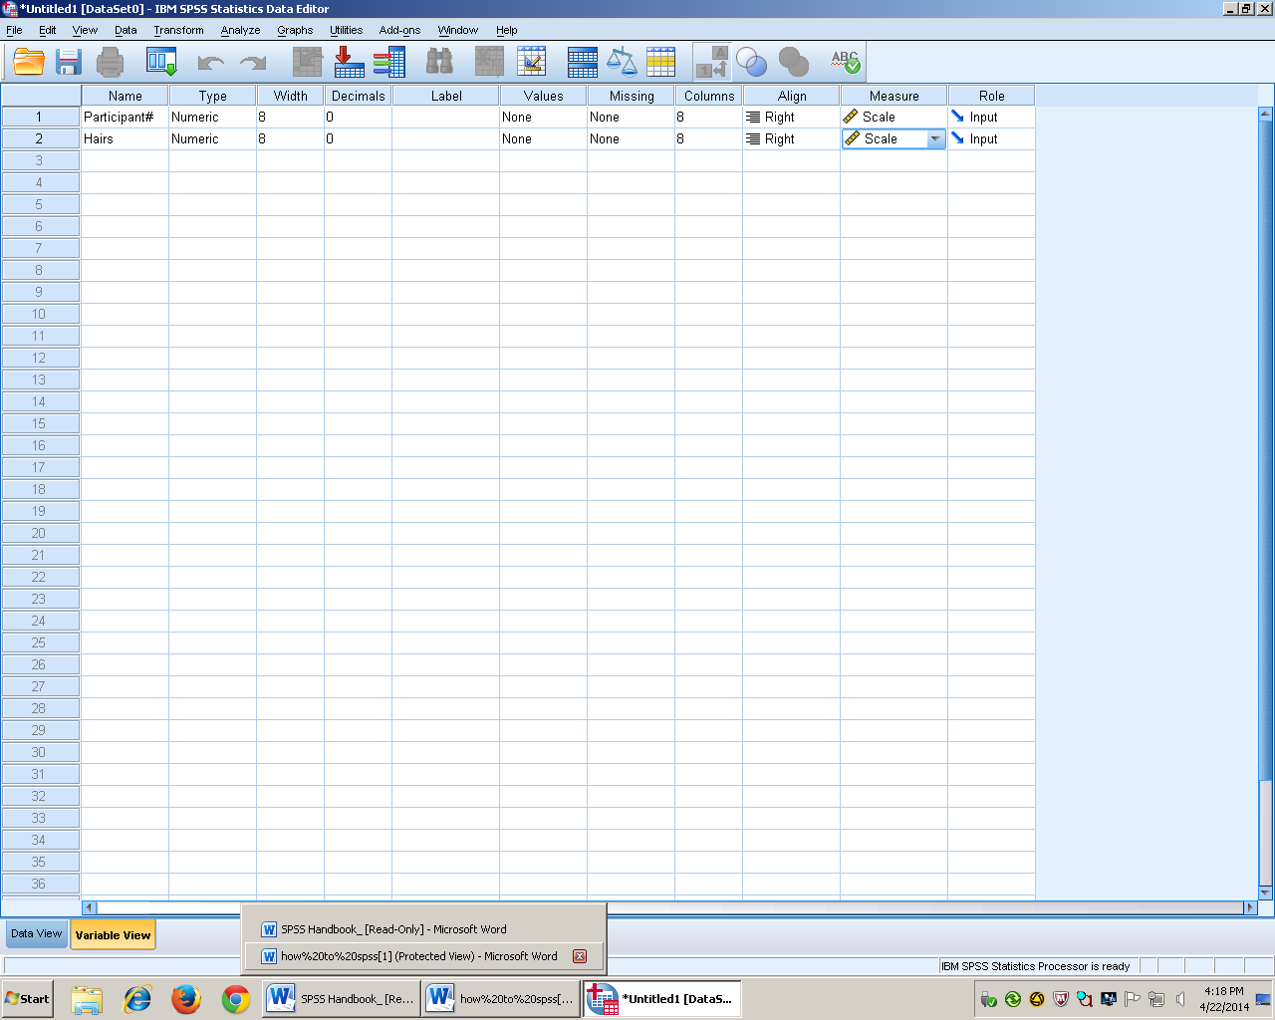
- In the name column, put the names of your variables. In this case I entered “Participant#” to represent my population or sample in the example, and I put “Hairs” in the second column
- In the type column, it will always be numeric unless told to put otherwise
- The decimal column will be adjusted depending on how many decimal places you need
- Value column is if you need to add words that are needed within that column.
- You will click on the ellipses to add value labels and you will enter a number that represent the word you want to show up. For example 1 = “Female” and 2 = “male”

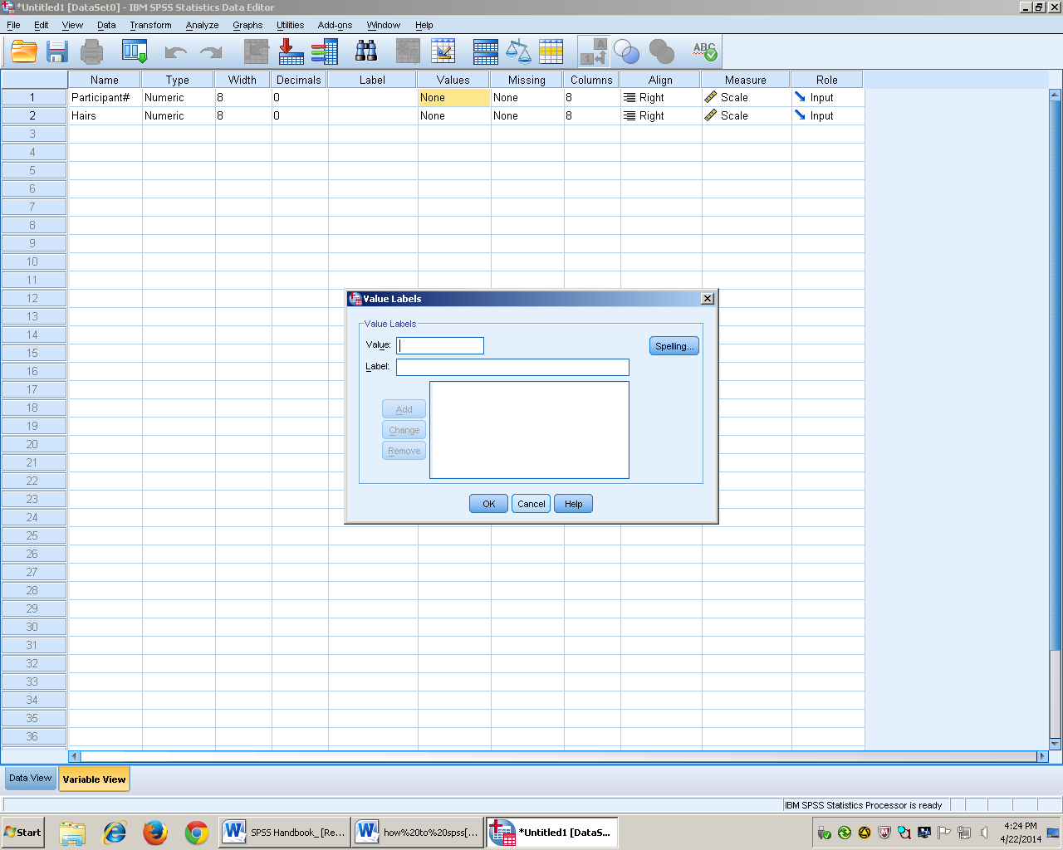

- Measure column is used to represent the type of data that you are analyzing
  - Scale represents Ratio and interval data
    - Ratio- has all properties, has an absolute zero (ex. Weight in pounds)
    - Interval – Order of #’s and equal distance between numbers, No absolute zero (ex. Temp in Fahrenheit or Celsius)
  - Ordinal order of #’s, no equal distance between numbers (ex. Place you finish in a race
  - Nominal Categories

Things to remember
- When given a one tailed test divide the (Sig 2 tailed Value) by 2
- When the p value is lower than the alpha level then reject the null. That means it falls within the region of rejection, and that there is a significant difference
- When the p value is higher than the alpha level then fail to reject the null. That means that it does not fall within the region of rejection, and there isn’t a significant difference.
- One –tailed test – the IV will cause the DV to increase, The IV will cause the DV to decrease , and used of we are sure
- Two-tailed test - (most common in psych) The IV will have an effect on the DV. Don’t know if it is going to increase or decrease so it goes in both tails.
- Alpha level determines how big the region of rejection is

Important terms
- Null hypothesis
- Nothing changed, the IV had no effect on the DV
- H₀ = X̅

- Alternative Hypothesis
- IV had an effect on the DV
- H₁ = X̅

- Within groups vs. Between groups
- Within Groups – all the participants participates in all of the level of the IV (In SPSS it will receive its own column)
- Between groups- Different groups that are designed to different levels of the IV

Difference between the Analysis
Z test
- Know the population mean and standard deviation
Single Sample t test
- Population mean is known (µ ) and population Standard deviation () is not known
Independent t
- Two groups
- Between groups
- To find effect size: use Cohen’s d
- Don’t know anything about the population, but you have two samples
Dependent t
- Within groups design (one set of the participants participating in all levels)
- Use a Cohen’s d

One Way ANOVA
- 1 IV
- 3+ groups
- Between groups design (within groups)
- Closer to an independent t b/c it’s a between groups design

One-way repeated measures design
- 1 IV
- 3+ groups
- Within groups designs (repeated measures design)
- Counterbalance (not in SPSS, so that they aren’t getting it in a particular order)

Two-Way ANOVA
- 2 IV’s
  - 2+ groups (levels) of the IV
- Within Groups design (repeated measures design)
- Minimum of 4 levels total

Mixed Model ANOVA
- 2 IV’s
  - 2 Levels of the IV
- 1 IV = within (level, level), 1 IV = Between (IV, DV)

Pearson r
- No assignment of groups
- 2 groups
- No manipulations of the variables

Chi- square
- Works with Categorical data

Reordering variables/columns
- Move the “sex column
- To move the sex column, you click on it until its highlighted and move it to where it is desired. You will know that it is the right place when the red line shows up

Sort Cases
- Go to data, and sort cases
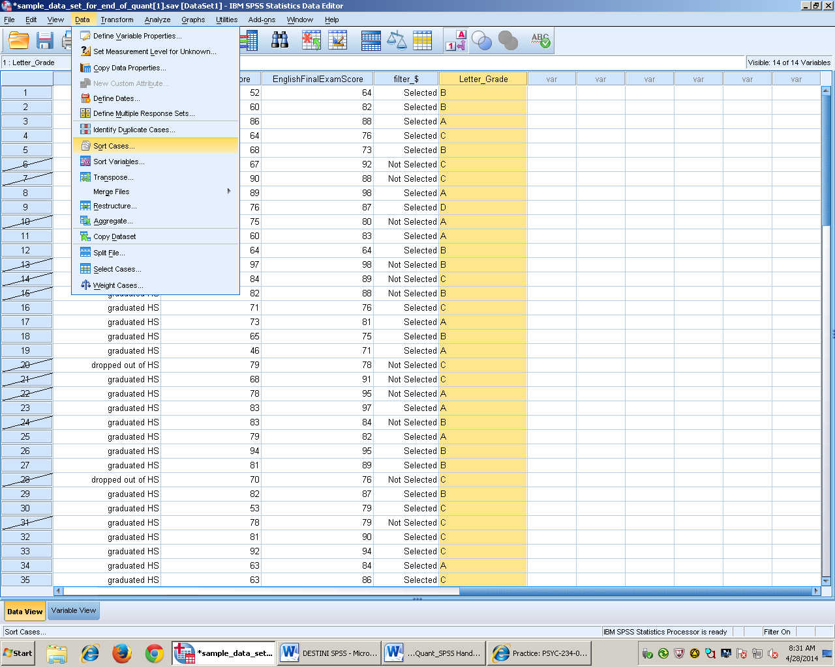

- Choose the variable you are sorting and then arrow it over and press okay
- And whether it is in ascending or descending order

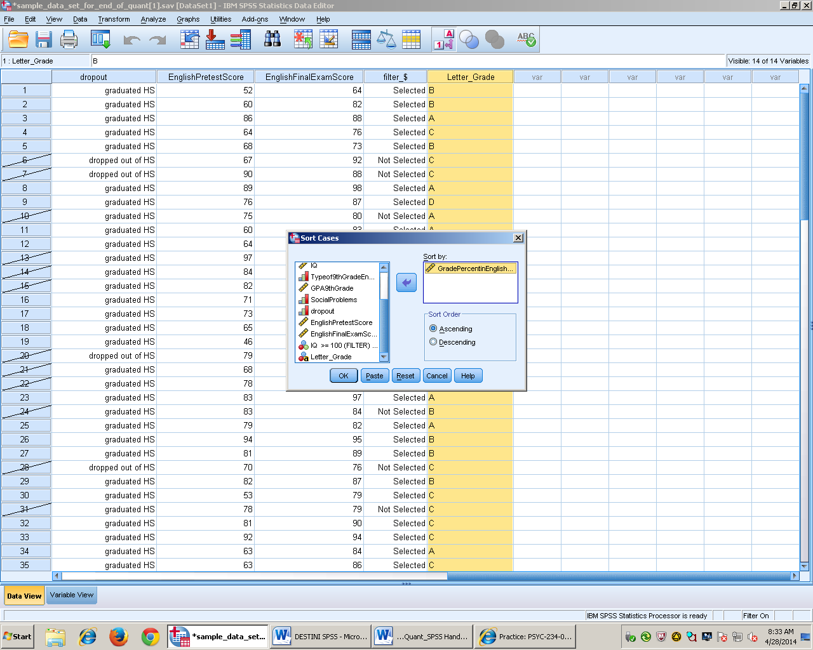
Exclude cases
- Go to data then down to select cases

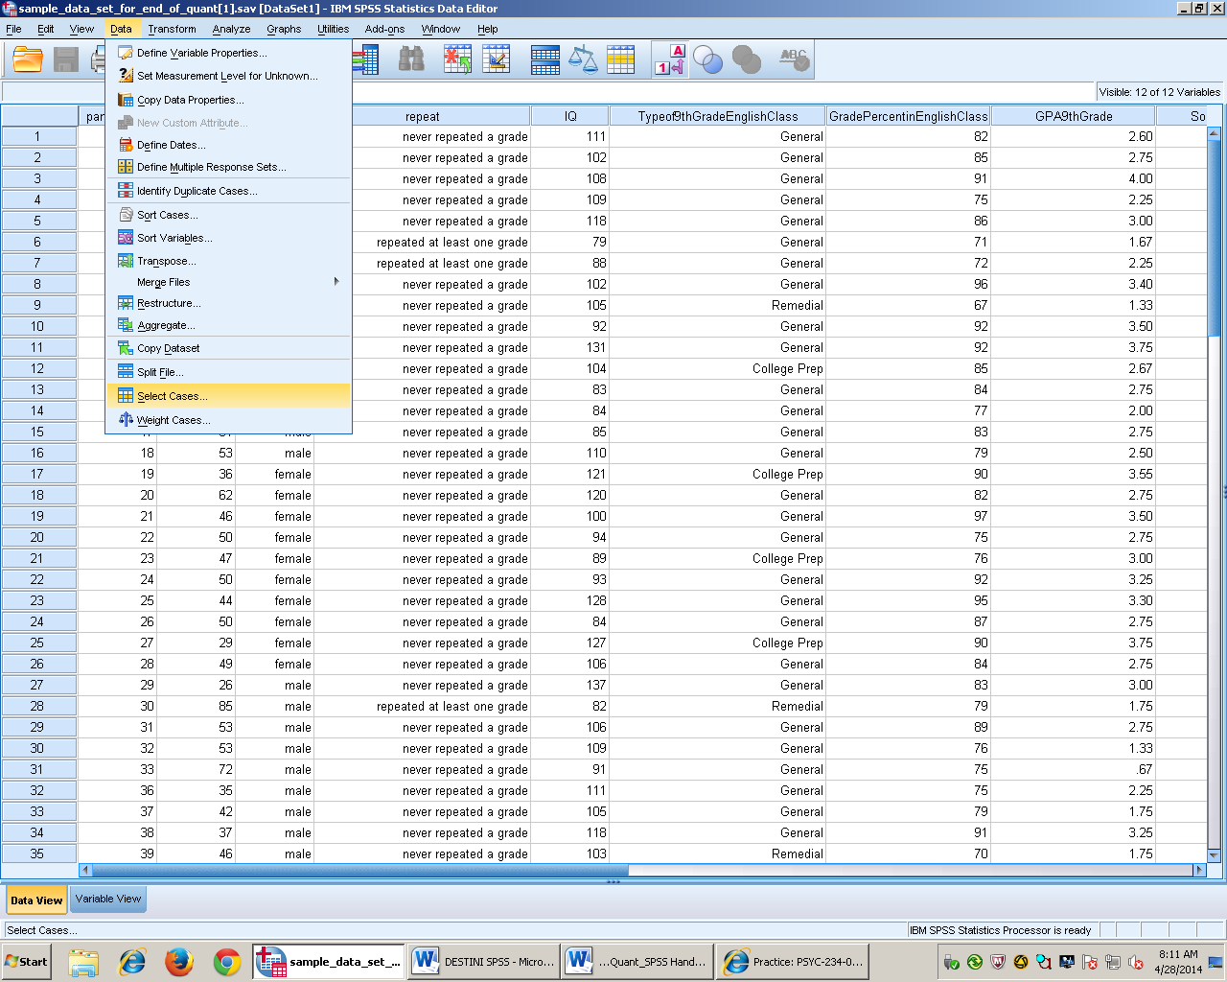
- Click the if condition if (it is asking what you are keeping)

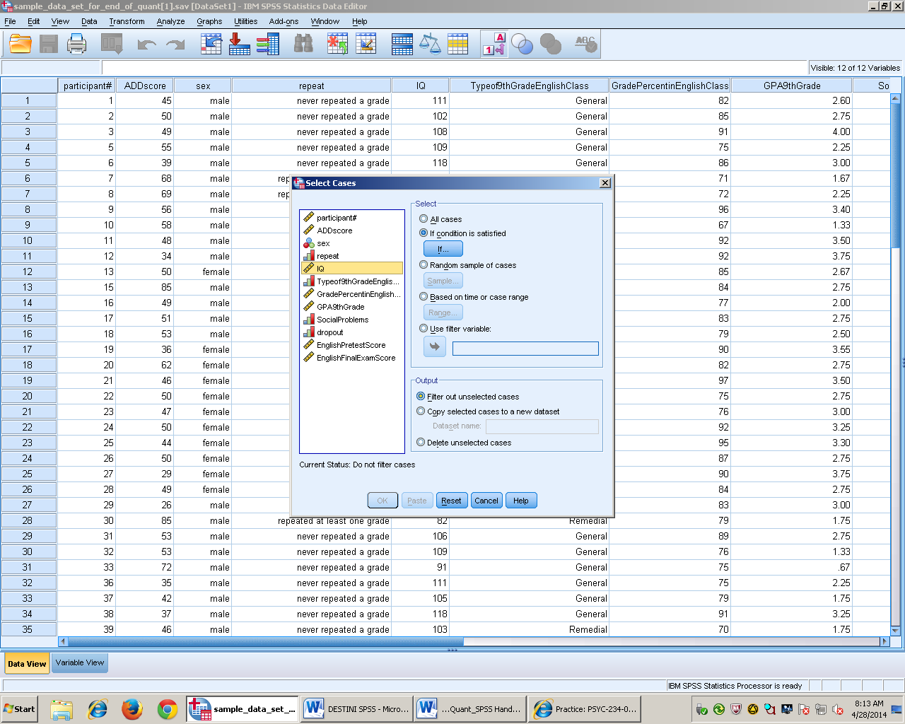

- Tab IQ over
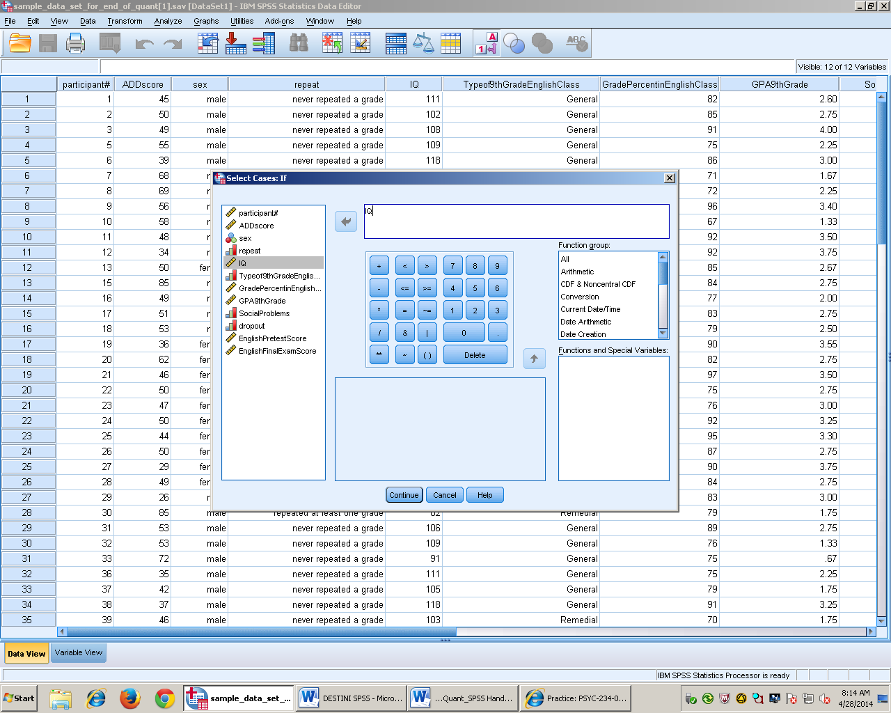

- In this case we want to exclude anyone with an IQ lower than 100
- Tab over IQ then click (greater than or equal to 100)
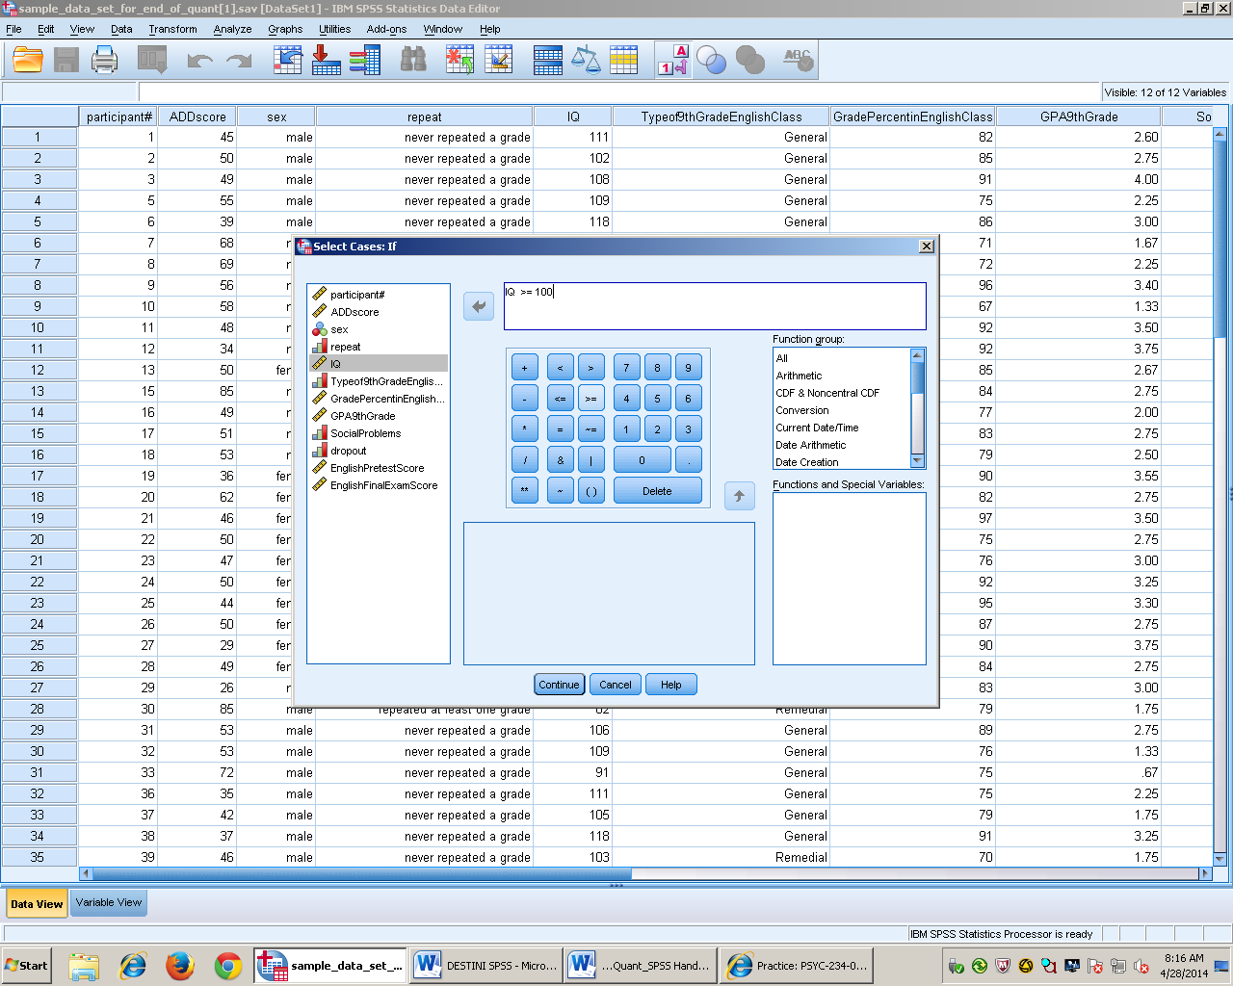

- Press continue than okay
- Final Results

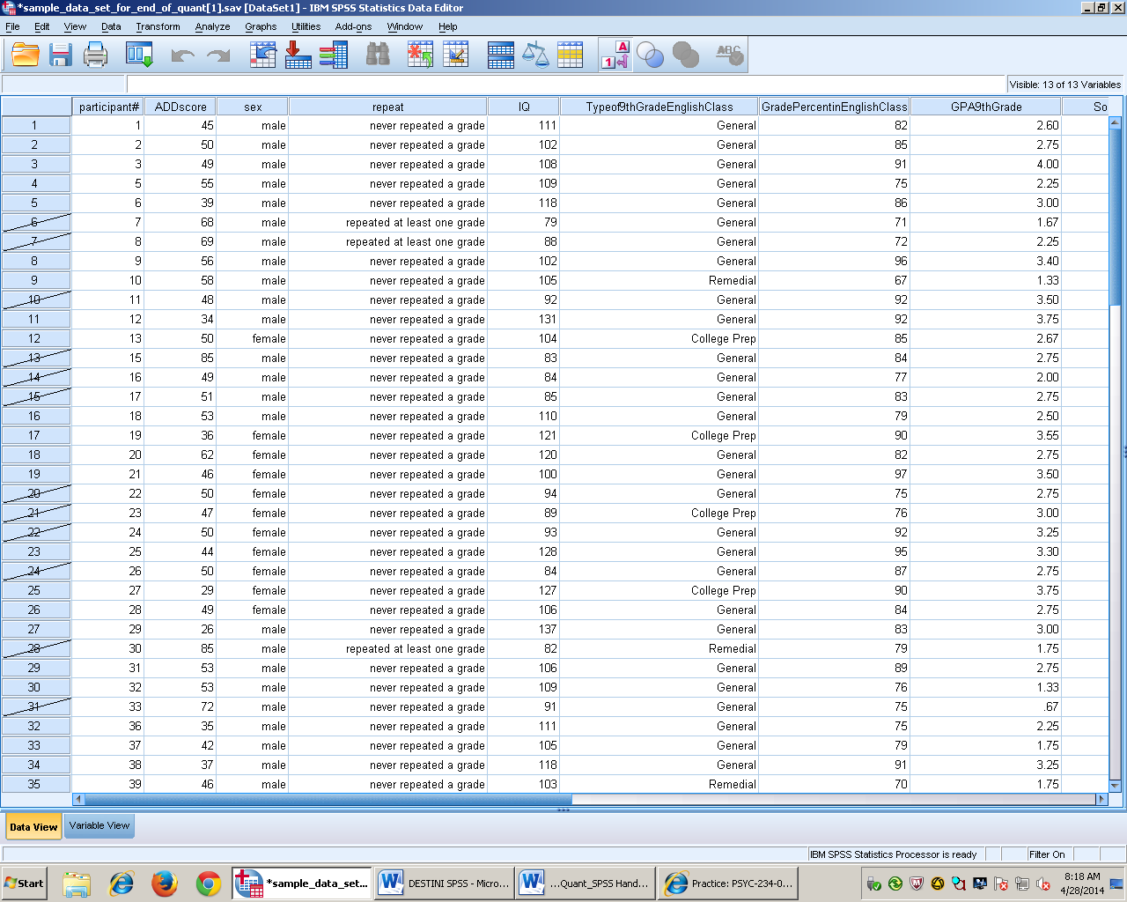

Transform/record Variables
- Highlight gradepercentageinclass
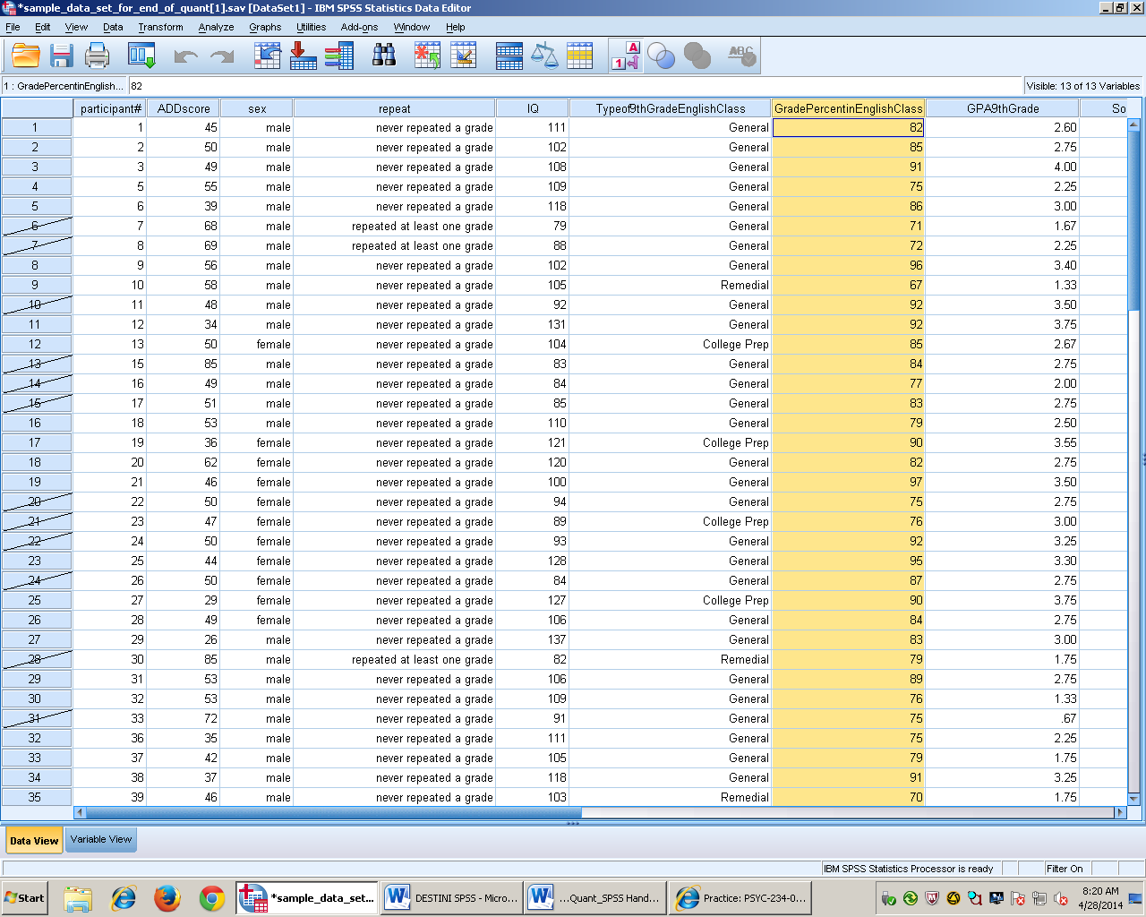

- Go to transform, recode into different variables

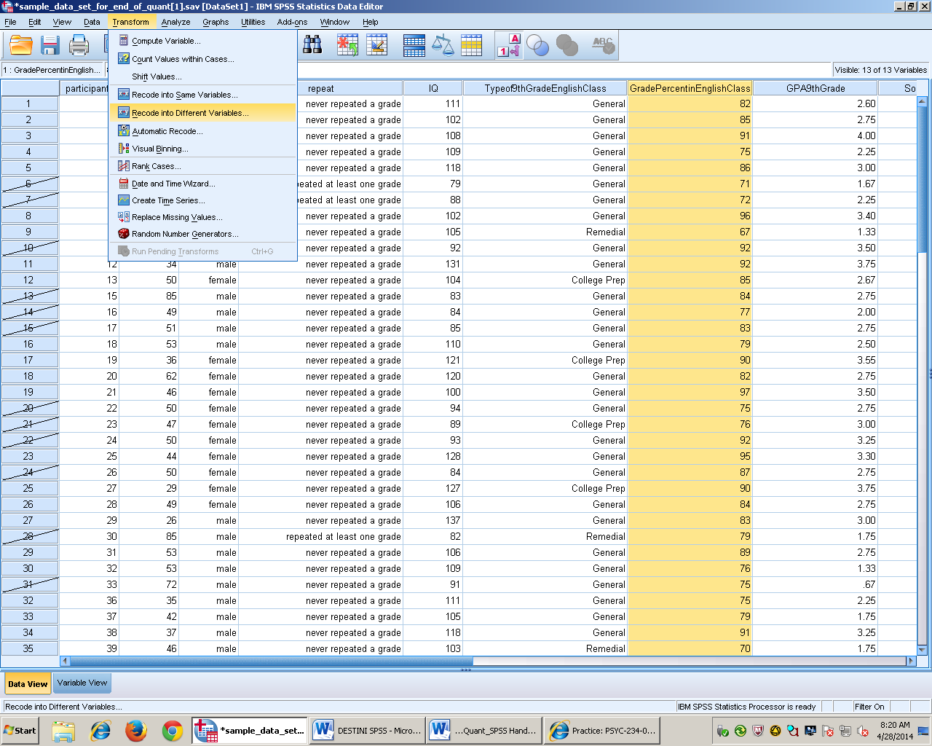
- Tab over the variable, then in the right corner you put the new name of the column

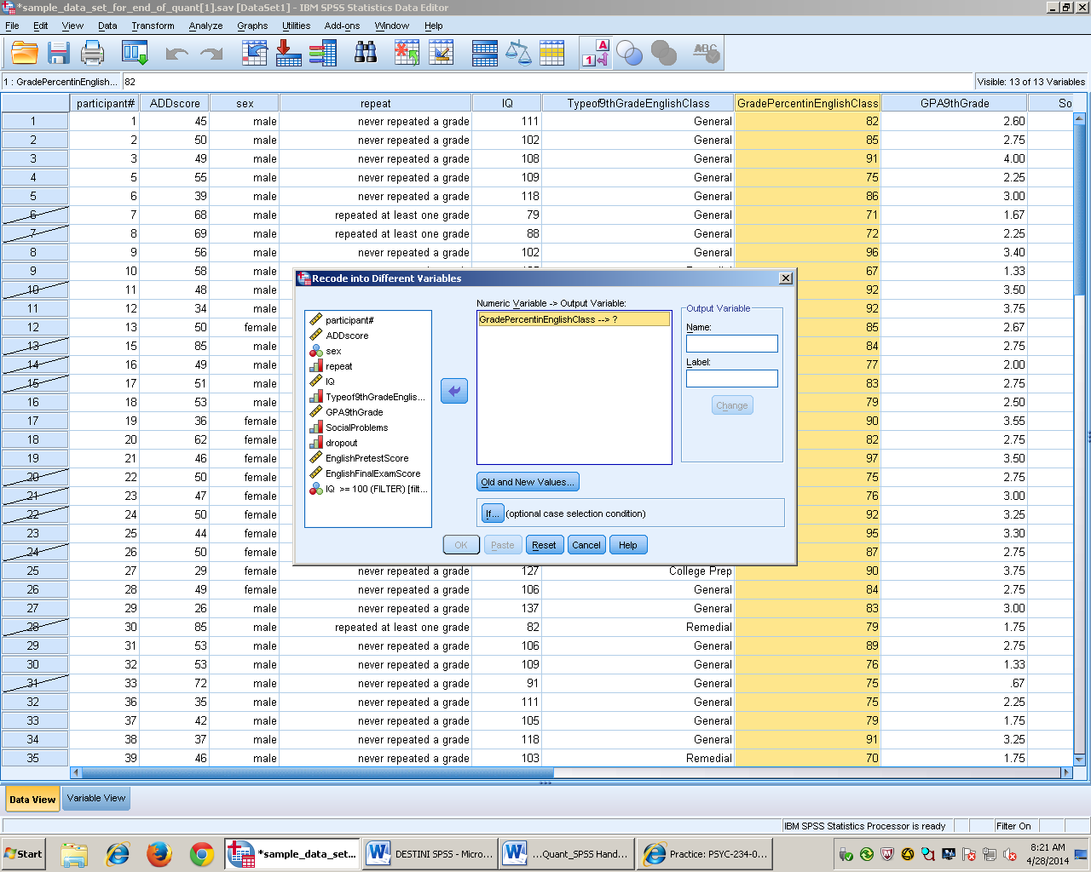

- Type in the new name
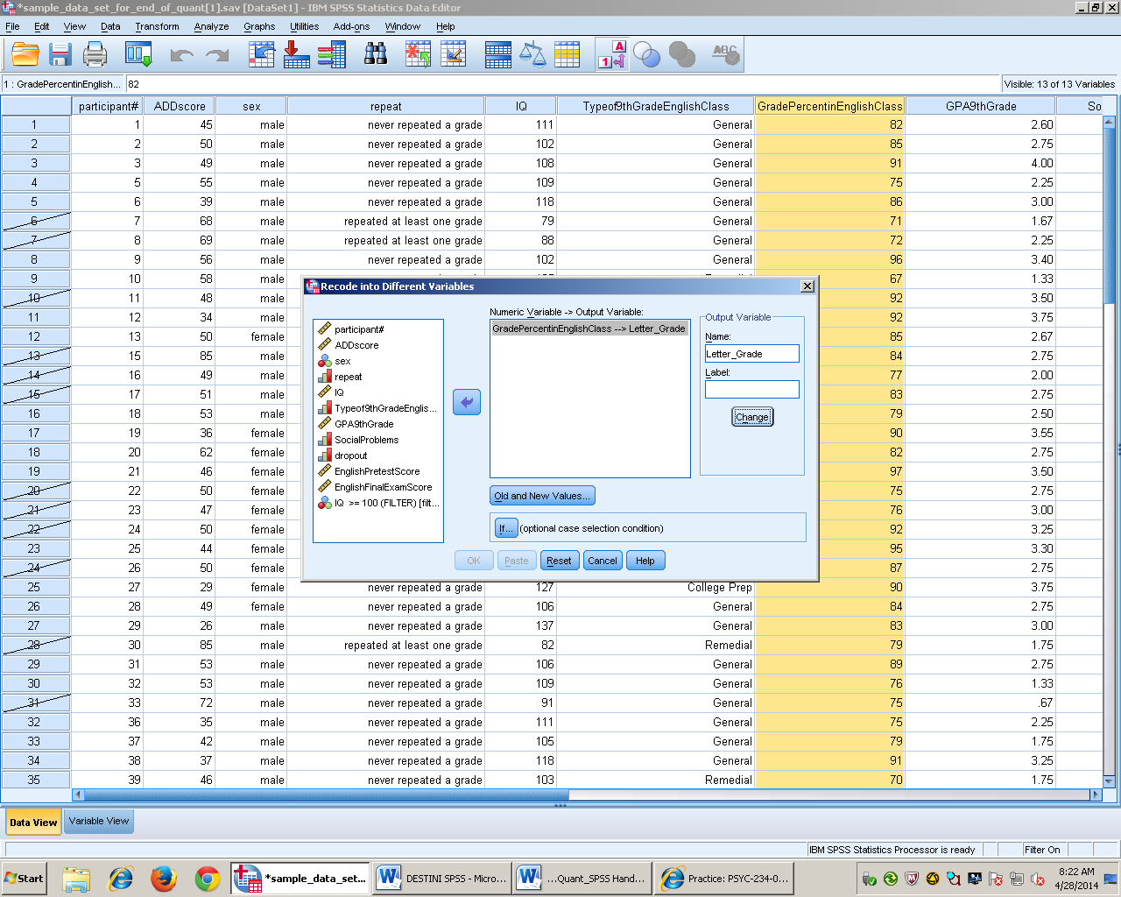
- Press old and new values

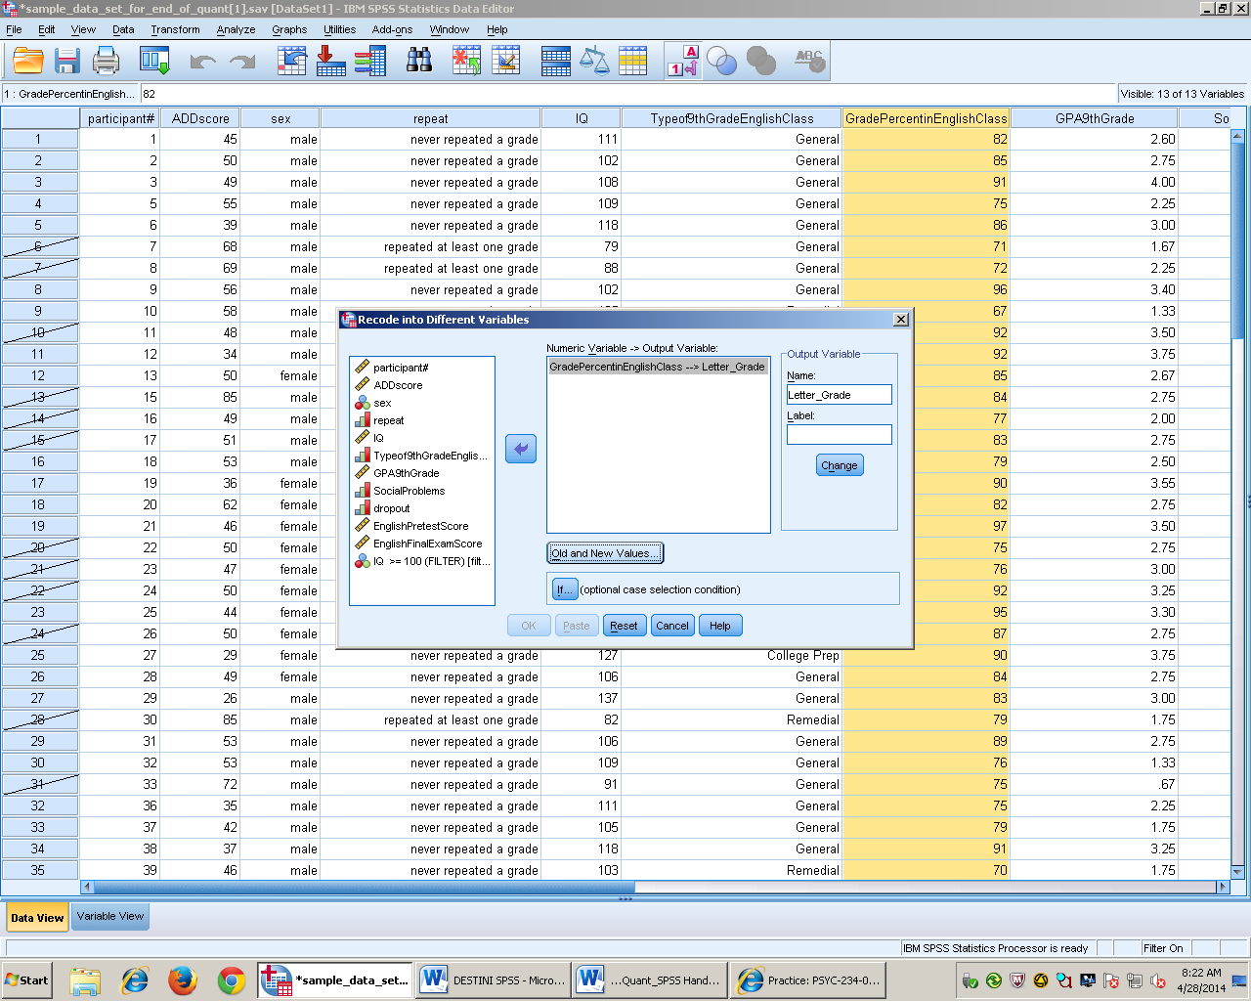

- Click on range, then on the right side enter the numbers that you want the letters to represent
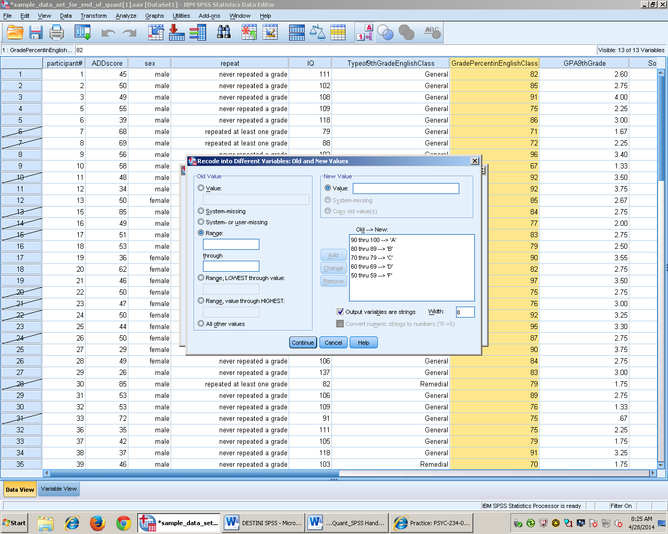
- Final product

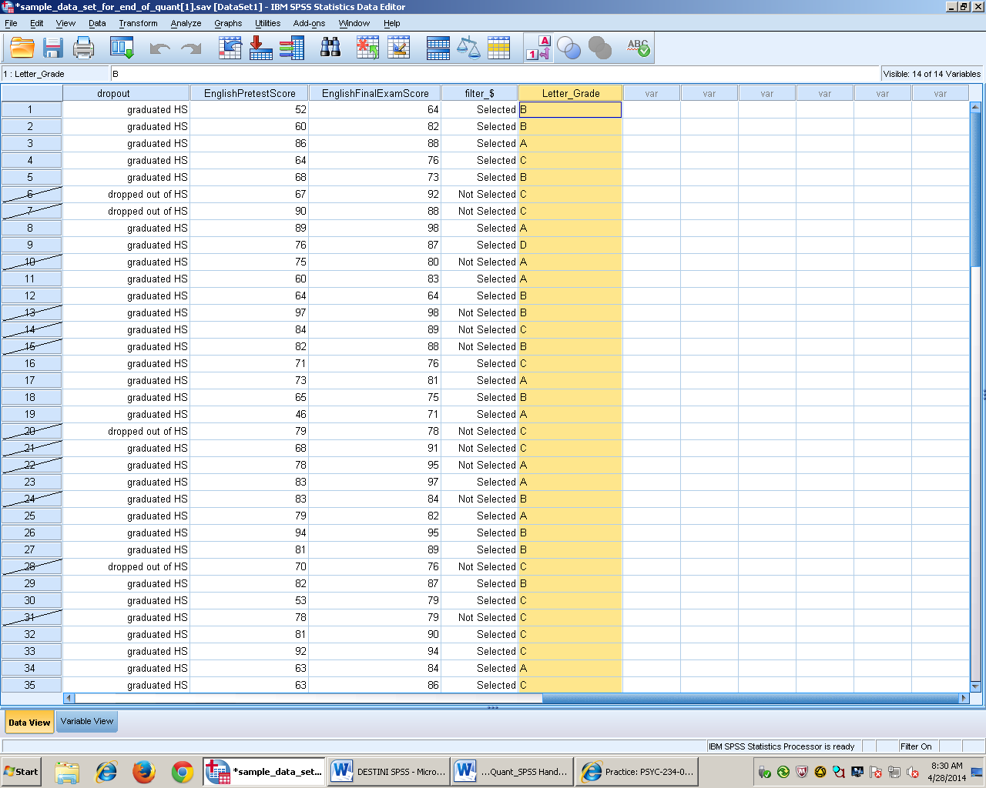

Frequency Polygon
- Go to the insert tab in word, and click on Chart
- Choose a line chart, then press okay
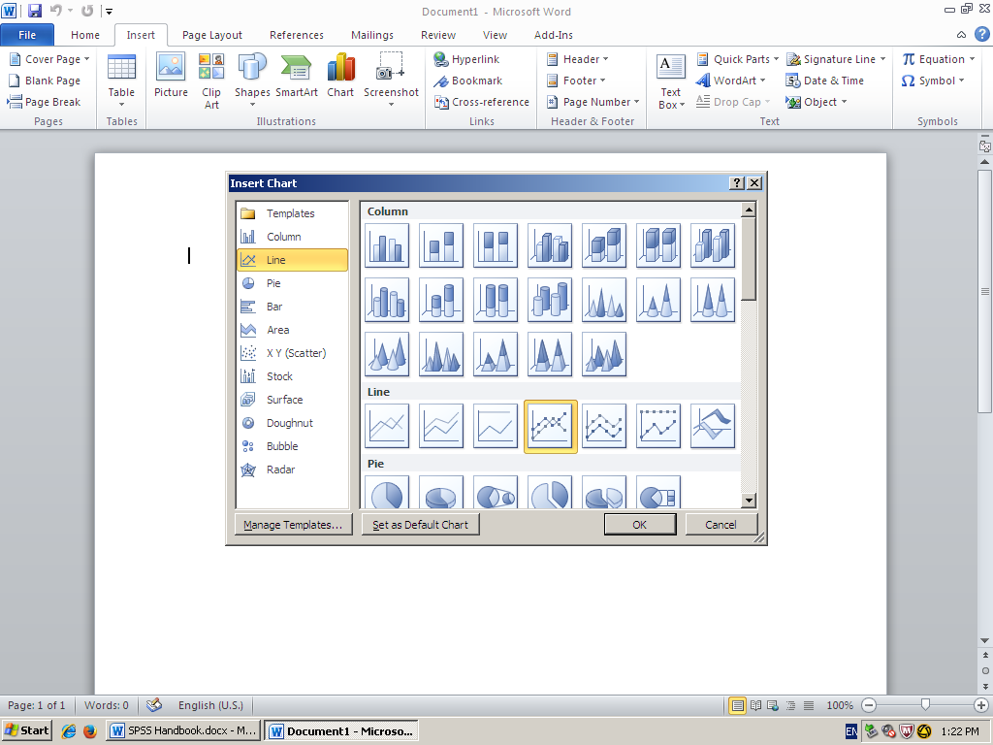
- Minimize the series to only one, so that you only have one visible line.
- Enter all of your data points, and make sure that there is an extra point above and below. The first and the last frequency should always be zero.
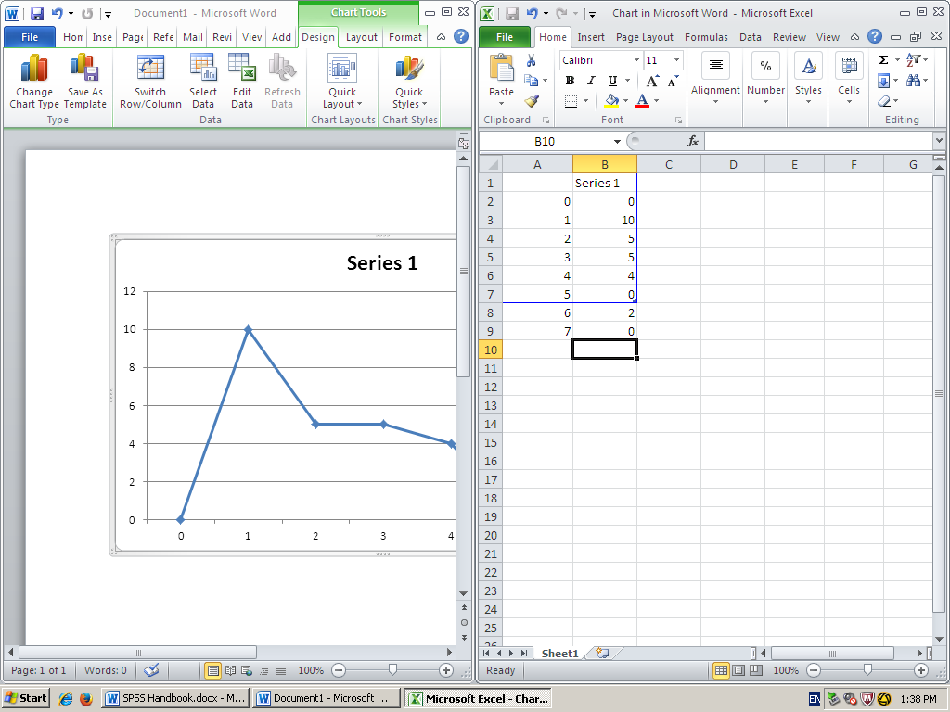
- Double click on the chart so that you can format it.
- Make sure that under the fill tab you choose No fill, and under the border color tab you choose no line.
- Then press close
- Make sure that you have an x and y axis. The Y axis should always be frequency and the X axis should explain what the numbers represent.

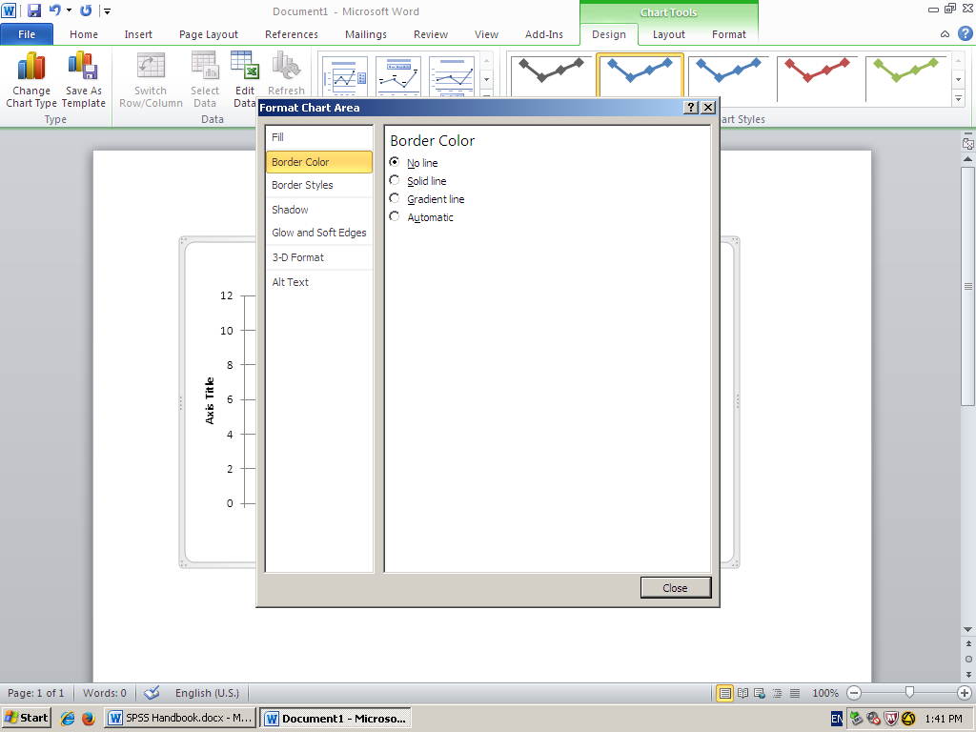

C. Final Frequency Polygon

Figure 1. The frequency of the different ages of the children that are in daycare.

Histogram
A. Histograms
- The bars represent the amount of frequency
- The bars are touching each other because it represents interval or ratio data.

B. SPSS
- Open SPSS
- In Variable view, Title your variable in Column 1, Row 1
- Then in Data view Type in every data point (no specific order)
- Make sure all data is in the same column
- Click on graphs
- Then go to Legacy Dialogs
- On the drop down menu click on Histogram

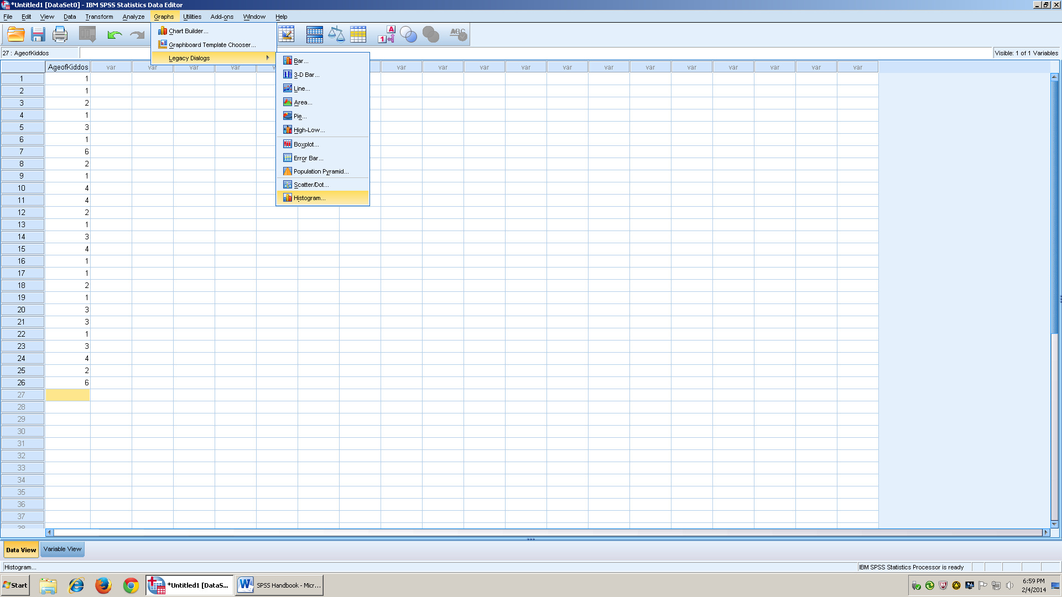
This is the data view which shows the numbers that you entered

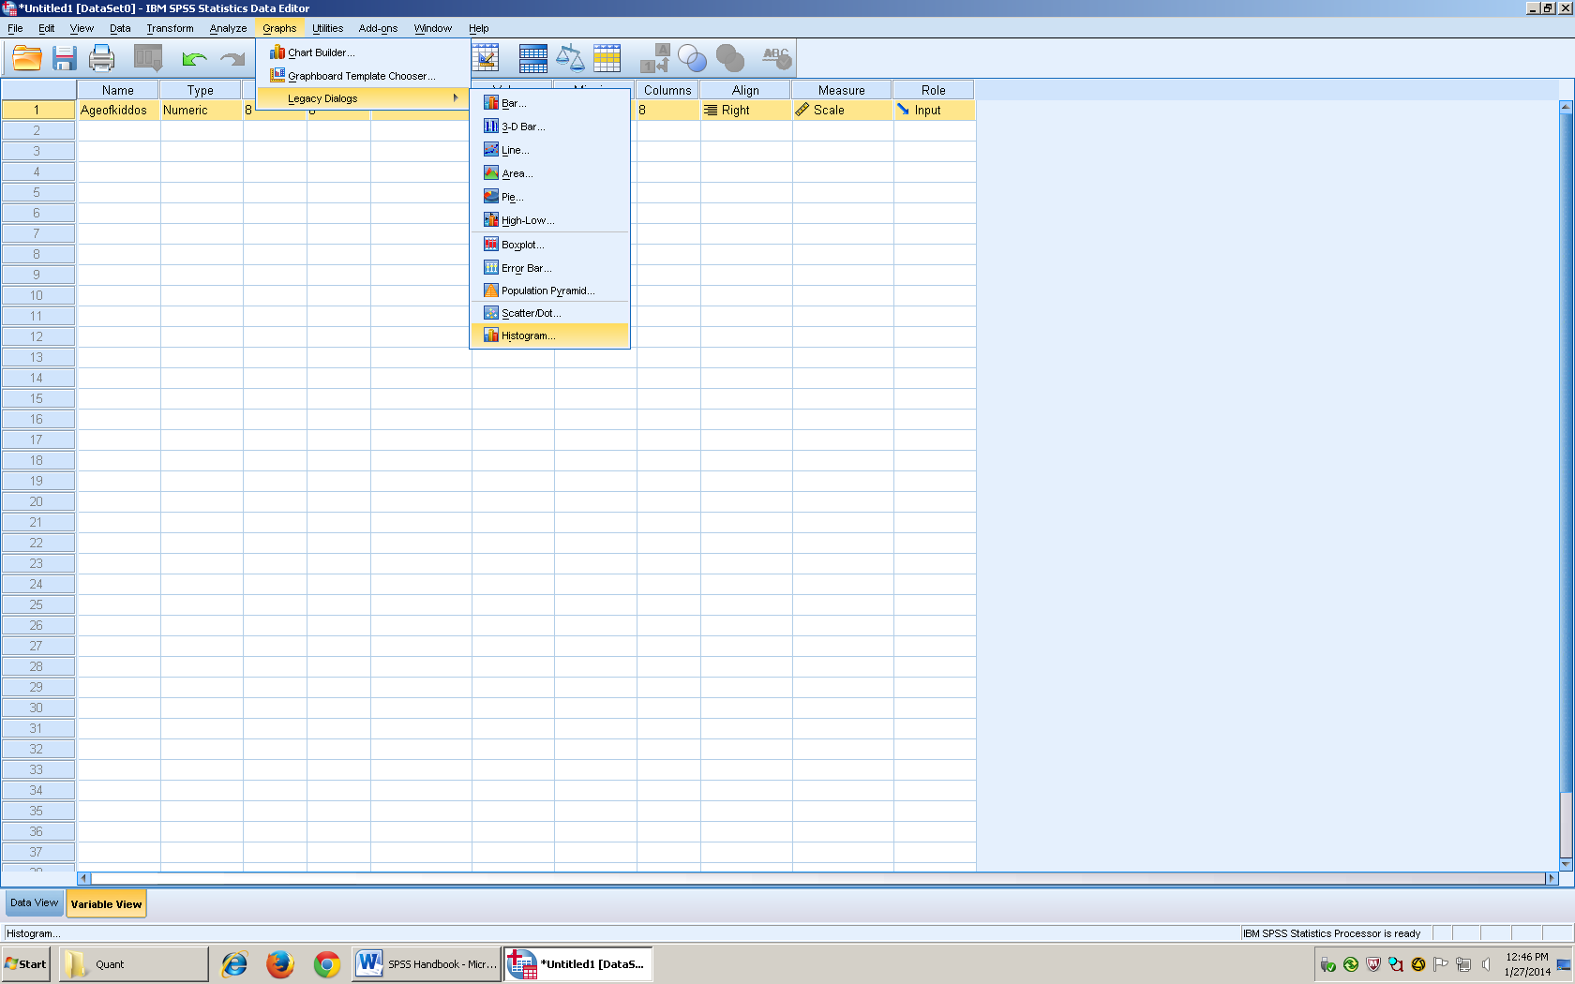
This is the Variable view which allows you to choose how want your data to be shown.
- After you click on Histogram, then a box will appear.
- On the left hand side, it shows the data that has been entered
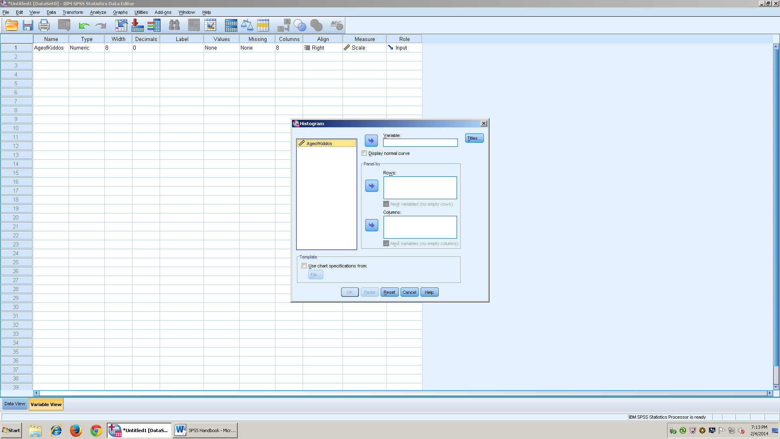

- Take the data set and arrow it into where it says variable
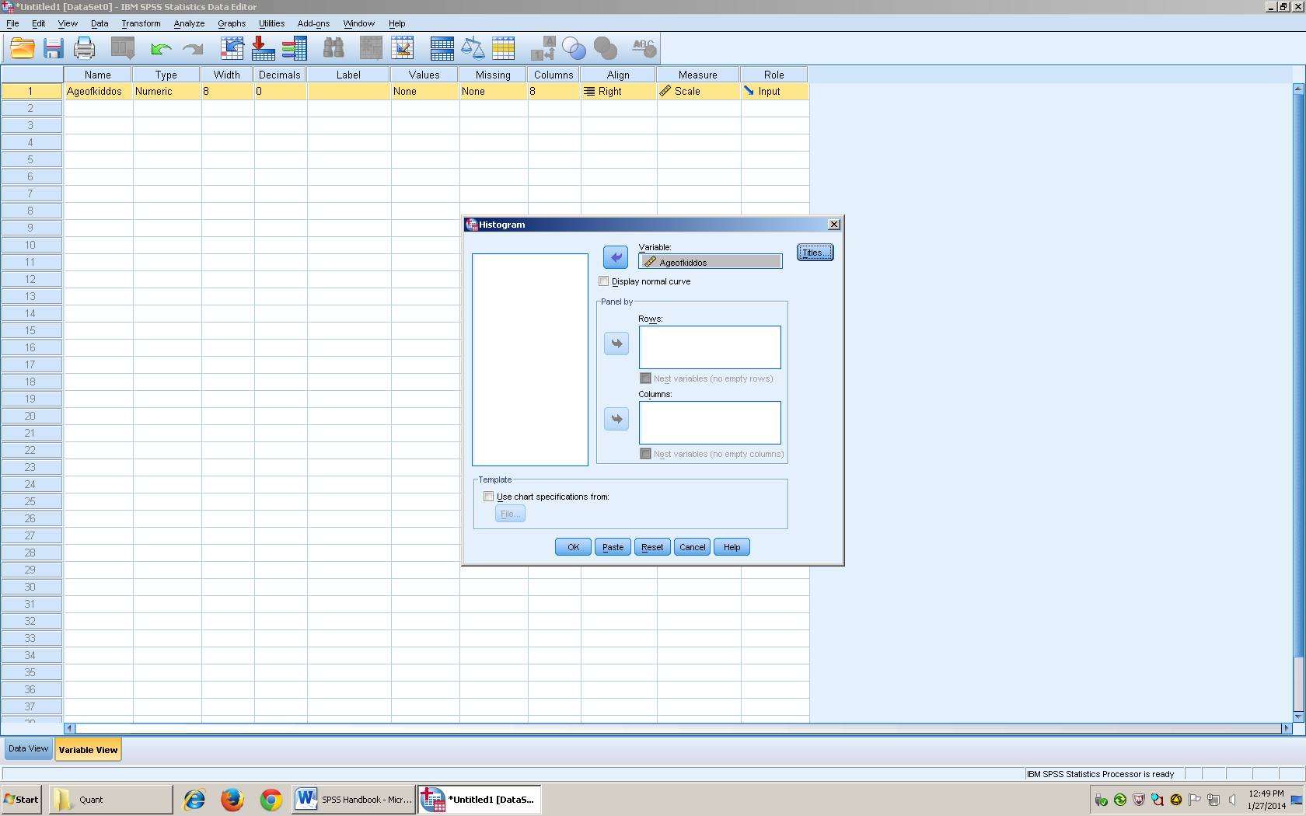

- Click on Title, next to the variable box.
- In line 1 then you enter the title of your Histogram and click continue
- Next, click the box that says Display normal Curve (under the variable box)
- Click okay

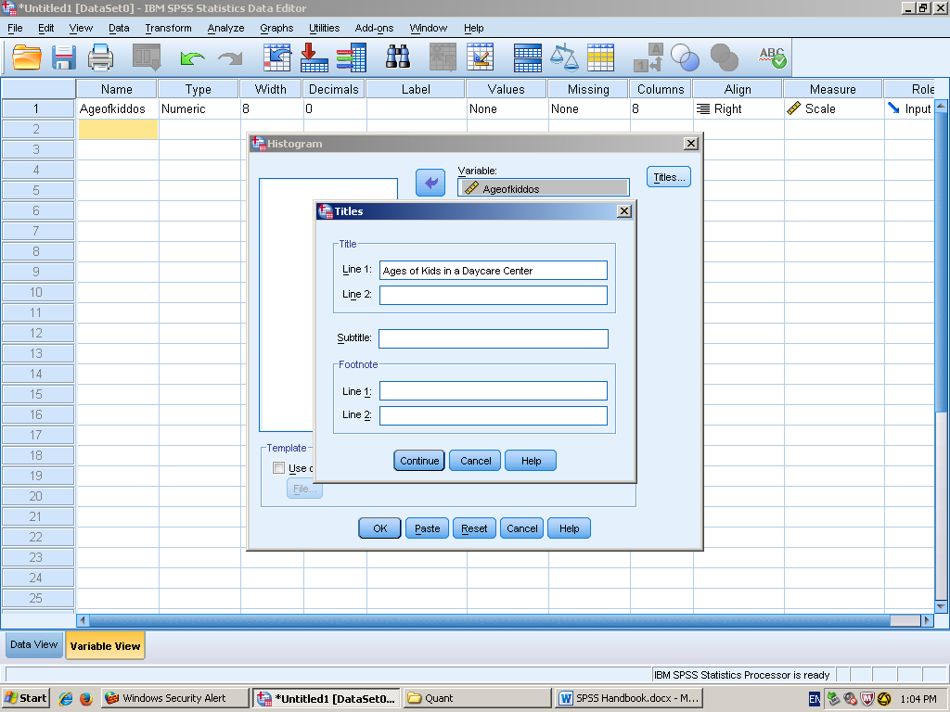

- Click continue
- Make sure that the display normal curve box is checked
- Then click okay. This is the view you will have
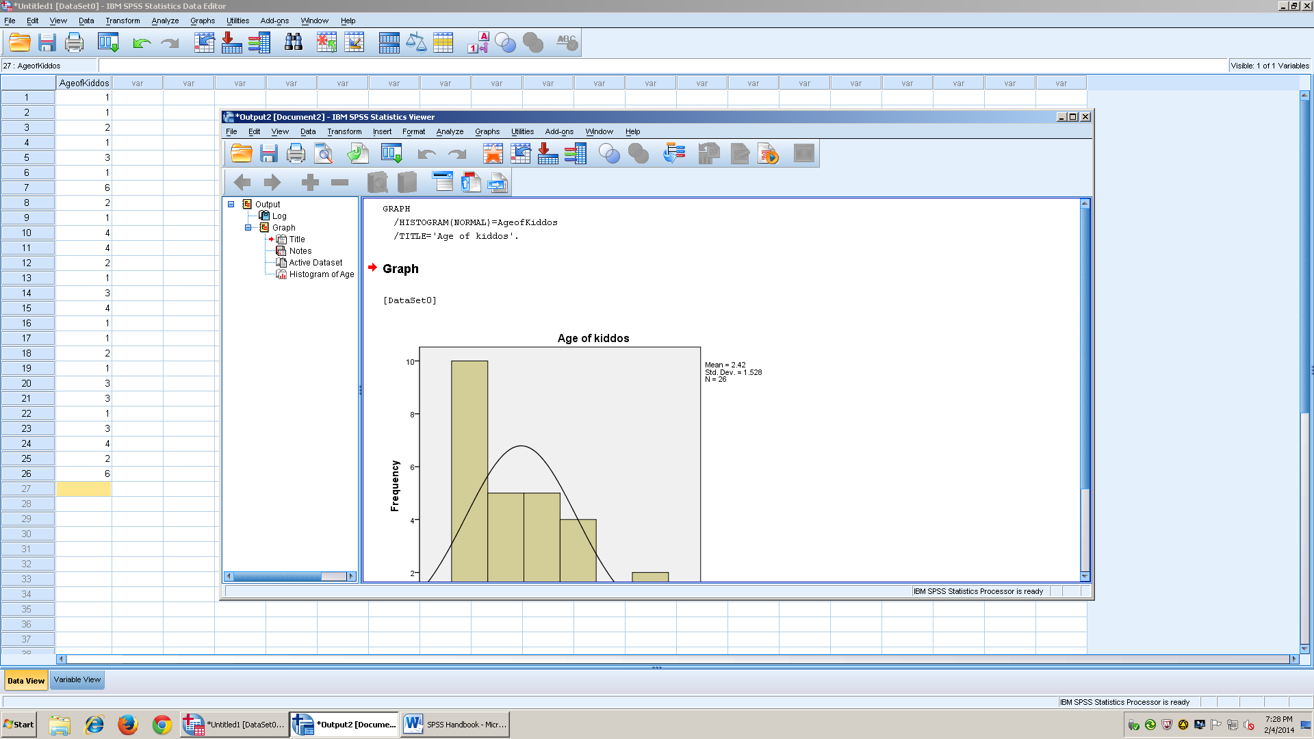
- Once you have the output of the graph, then you double click on the bars to make the changes you desire
- Make sure to delete the curve, the side legend that tells you the mean, standard deviation, and the total number of data points.
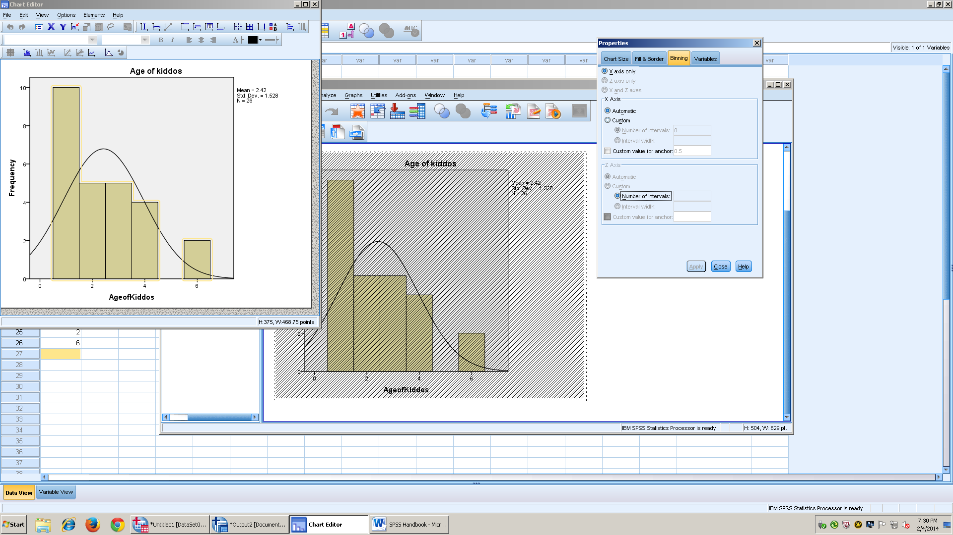

- Make last minute changes, and spruce it up how you would like
- Then copy and paste in your final product
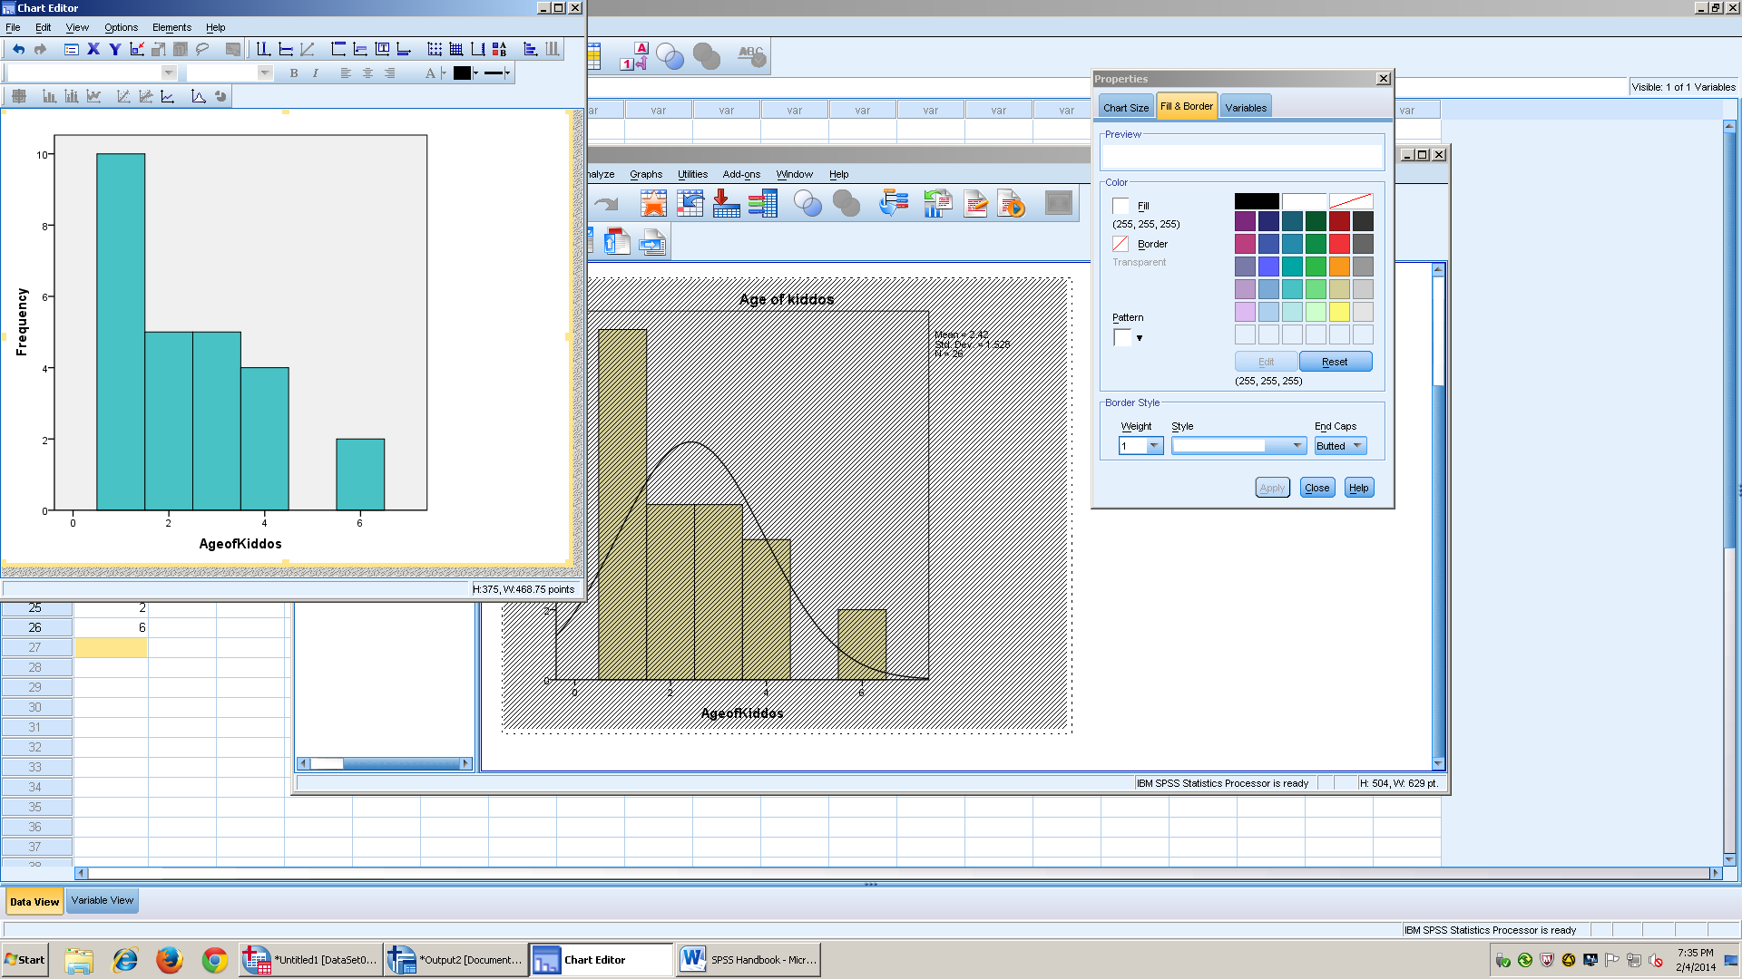

C. Final Histogram
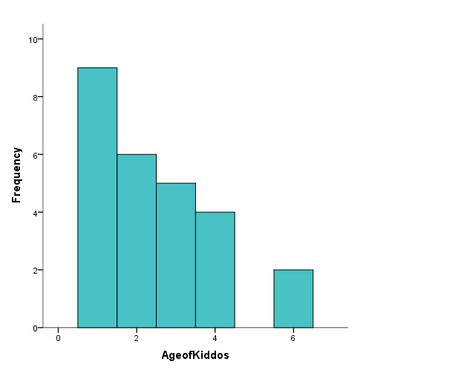
Figure 1. The frequency of the Age of Children in a daycare center

Bar Graph
A. Description of Bar Graphs
- Has to be 12 Point Font.
- Reflects Categorical Data
- Usually Nominal or Ordinal Data
- There are spaces between the bars
- Error Bars- (what percent of errors we have either way)
- The Y axis will always be labeled frequency and the X axis will be the variable being represented

B. SPSS
- Go to the insert tab on the tool bar
- Then click Insert: Chart
- Choose a Column Chart with all of the bars touching (usually it’s the first option) and click ok
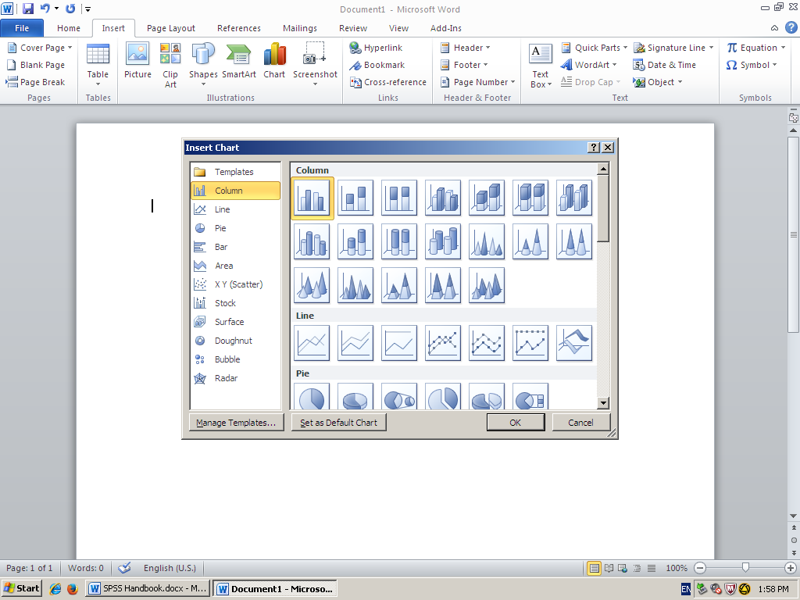

- Click the (+) sign beside the chart. Make sure you delete the chart title, and legend.

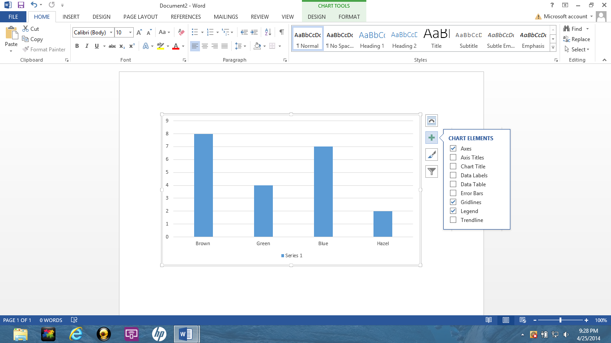
- Make sure you choose error bars

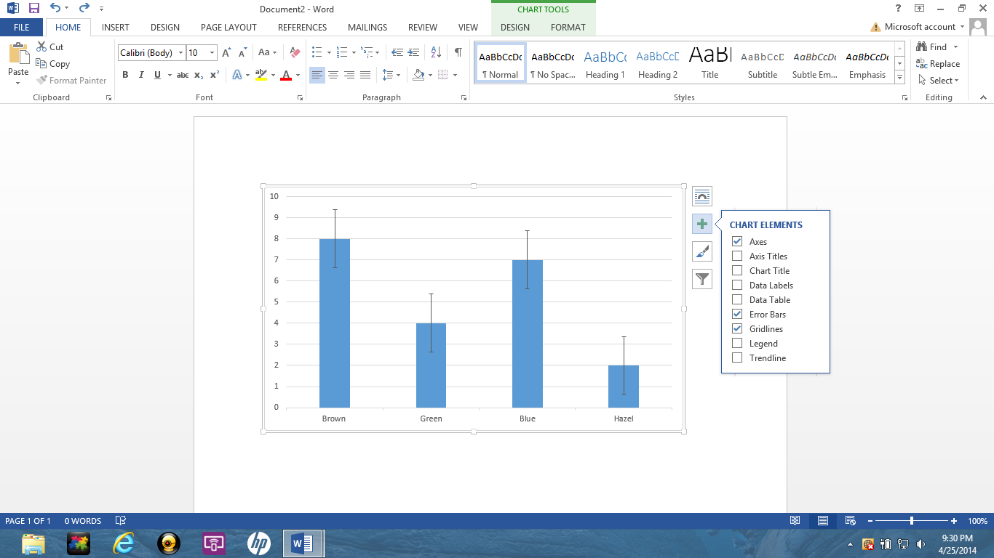

- Double click on the line, then choose border and then choose the no line option

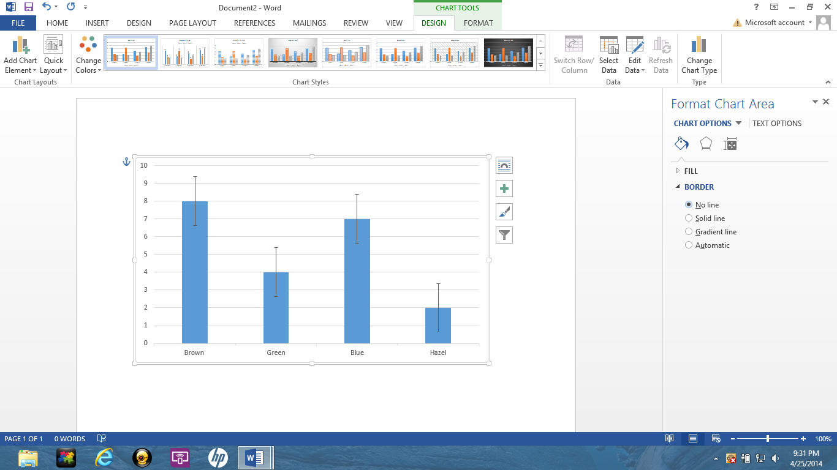

- Make sure you click no line so that there isn’t a border around the output, and then click okay

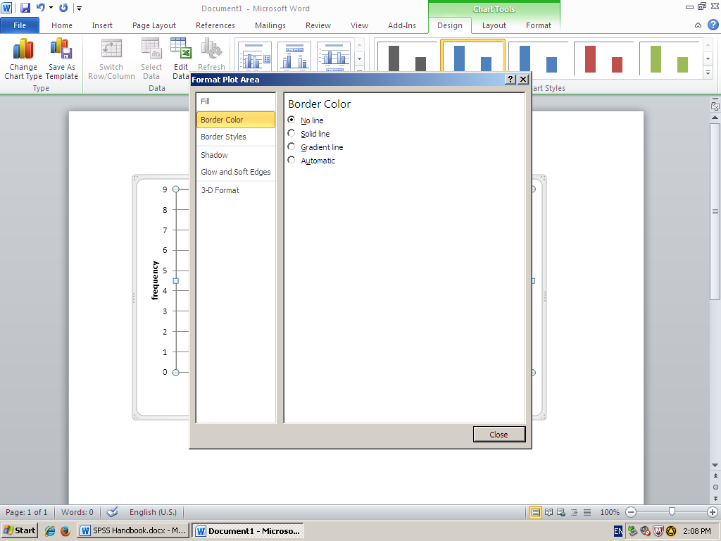

C. Final Bar Graph

Figure 2. The frequency of eye colors in the best Quantitative Methods class ever.

Simple Sample t
- Background Of Simple Sample t (make sure t is always italicized and lowercase)
When to use a t test:
- When you are examining two groups to see if they are significantly different from one another.
- When you don’t have the population standard deviation.

Assumptions for all of the t tests:
- The amount of variability is similar in the groups being compared (homogeneity of variance)
- The shape of the Distribution changes with the n
  - The larger the n, the closer the distribution looks to a standard normal distribution

Goal of the single sample t test: the sample is different from the population mean
- You compare 1 sample with the general population

Formula for single sample t:

t = X - µ
sx Standard error of mean (estimates the population standard deviation)
Almost exactly like the z test but you have to estimate the standard deviation.

sx = Sx Standard error of the mean
n

- SPSS
- Open up SPSS, then click on the Variable view tab (highlighted at the bottom in yellow) to name your Variable.
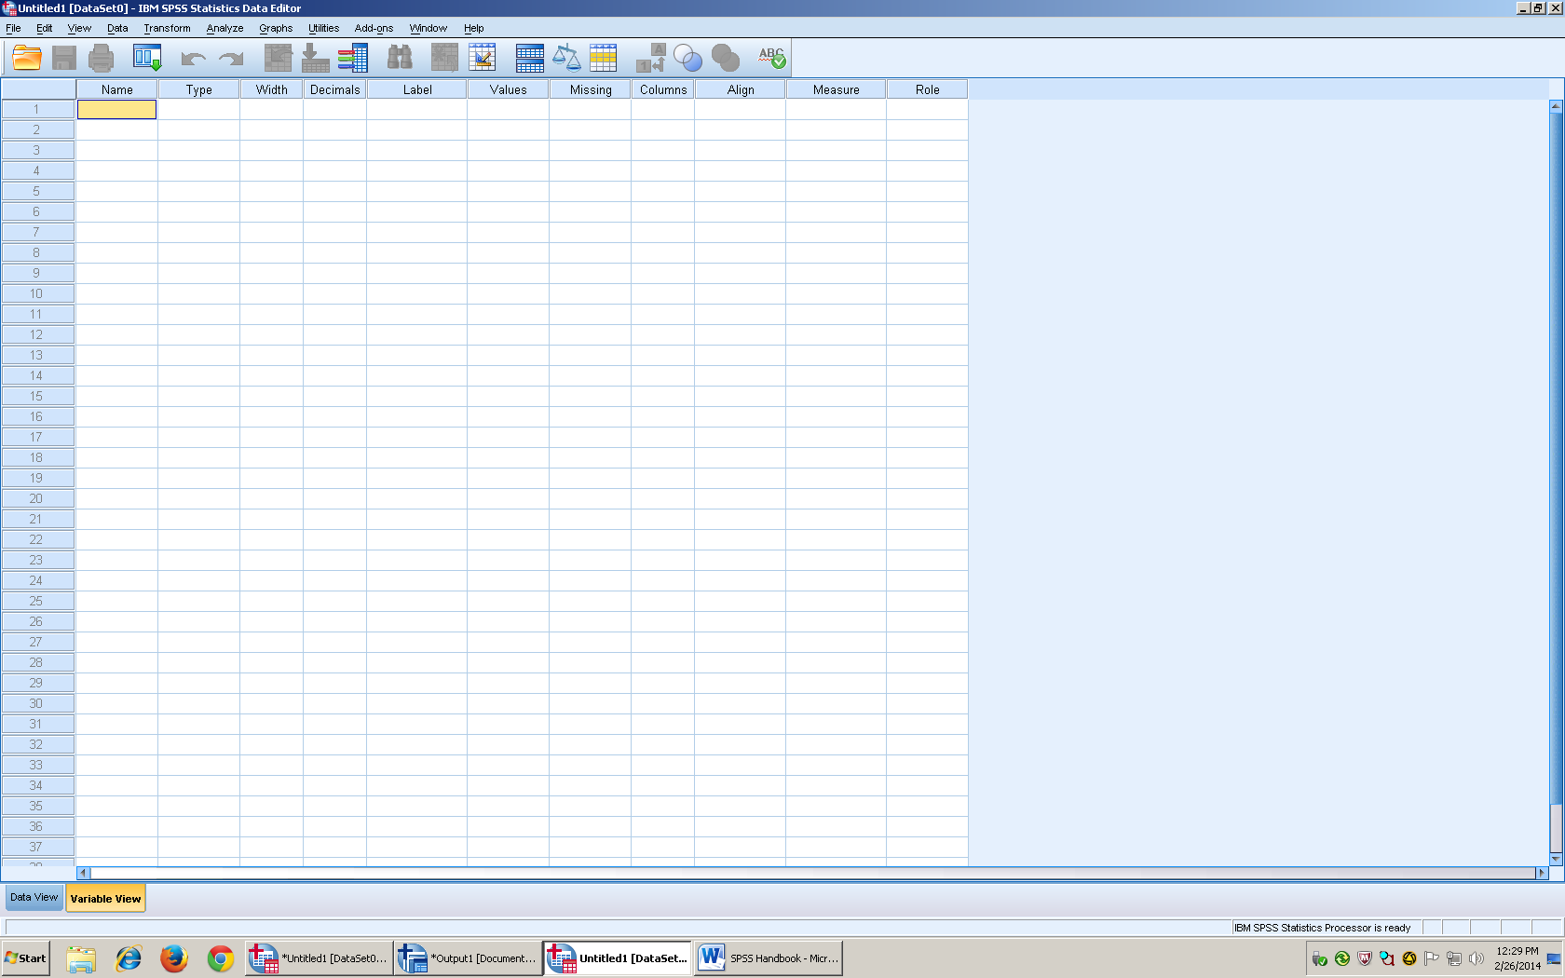

- In Column A, Row 1: enter the title you wish to use.
- There aren’t any decimals, so you can change the decimal places to 0
- Make sure your measure is on scale (represents ratio and interval data)
- The type column has to stay in Numeric, so make sure it is on that setting before you enter the data
- Go back to Data view

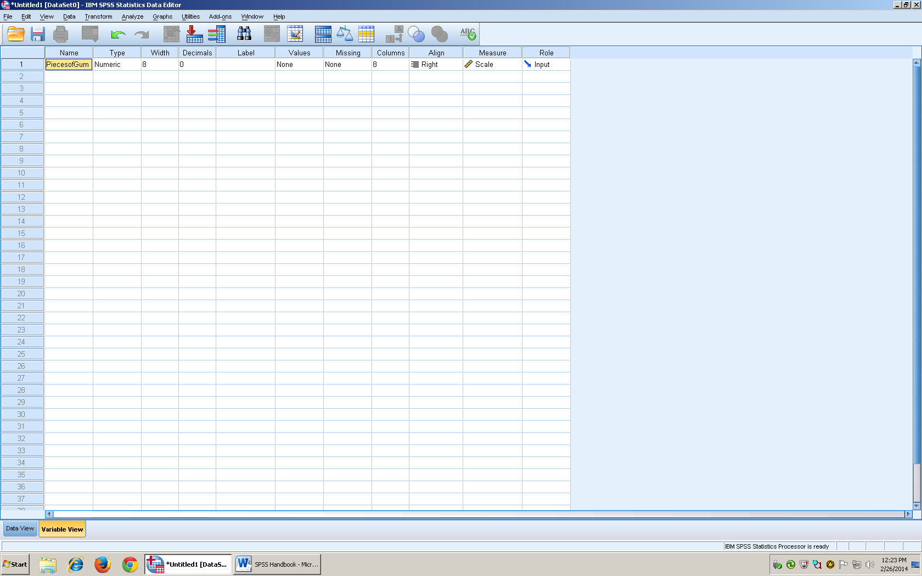

- Once you switch back to data view, you can enter your data in Column A

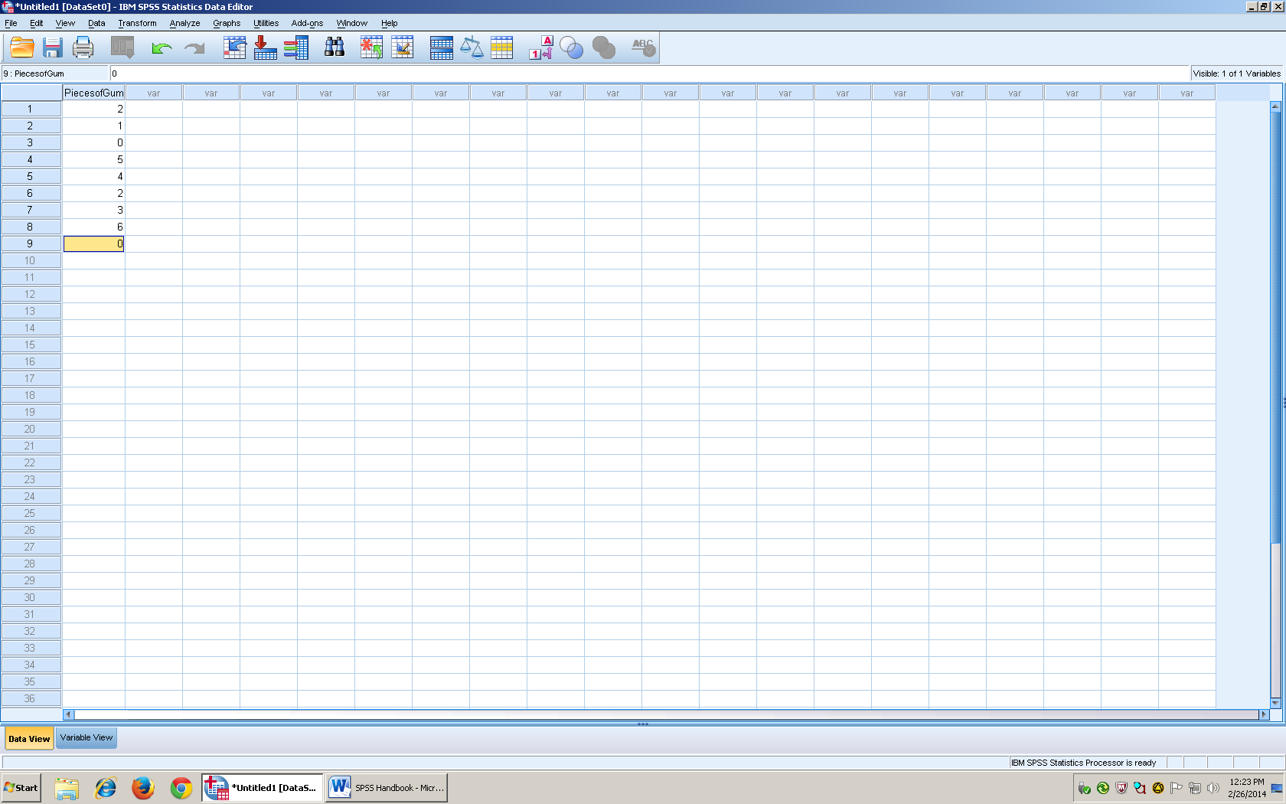

- After you have checked to make sure your data points are correct, go to the menu at the top and click on analyze

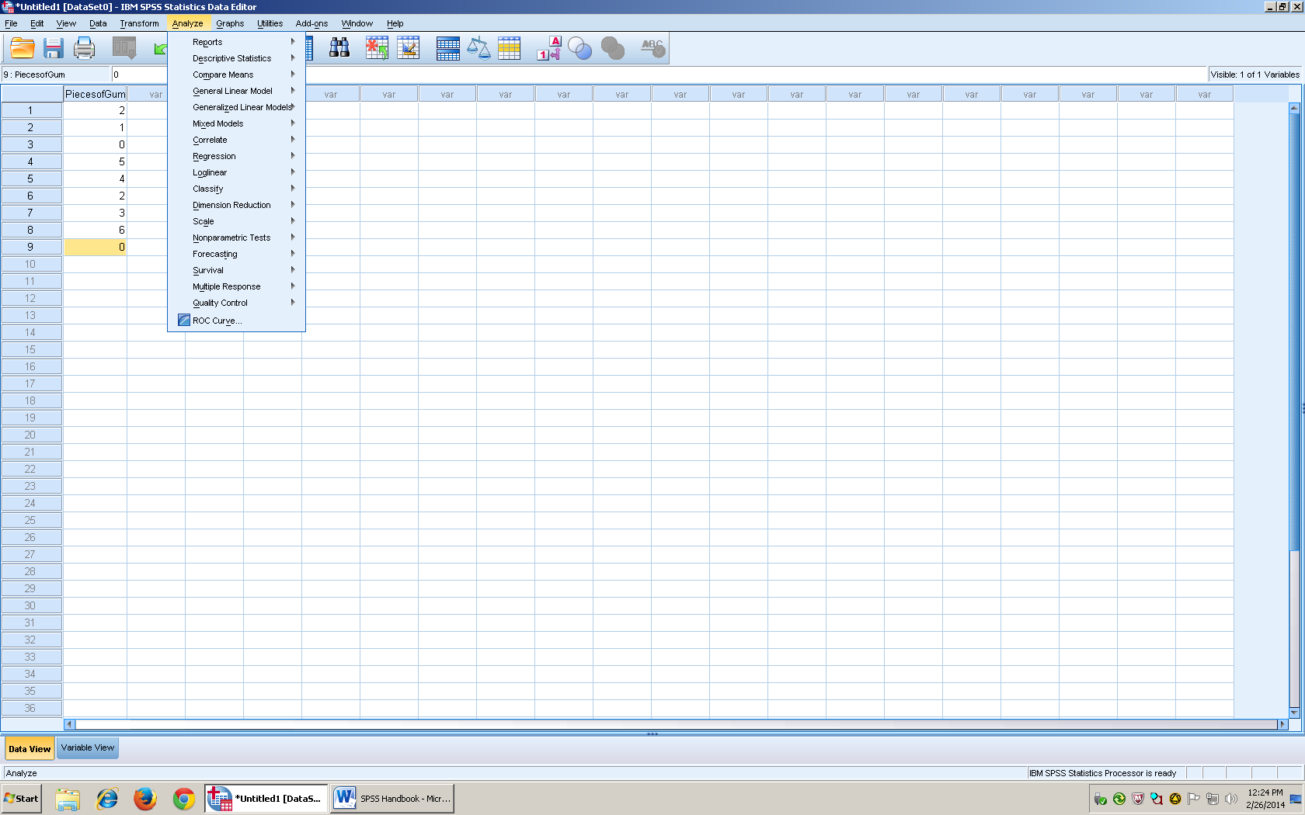

- Once you click on analyze, there will be a drop down menu and the third one down will be compare means
- Run your arrow over compare means, and then another drop down menu will pop up.
- From that menu you will click on One sample t

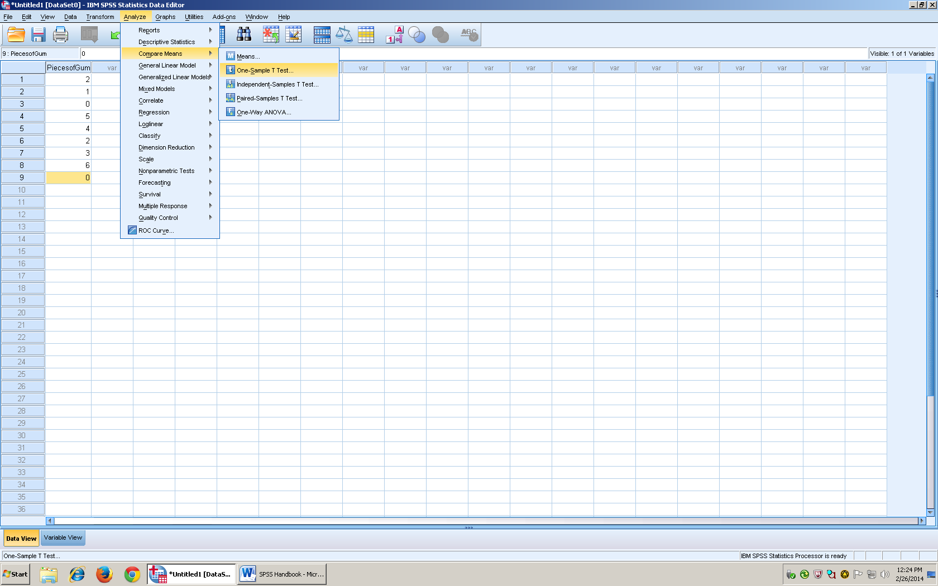

- Once you click on One Sample t test, the box below will pop up with the data in it
- The data set has to be shifted to the right so that the variables can be tested, so click on the arrow and it will move it under where it says test variables.

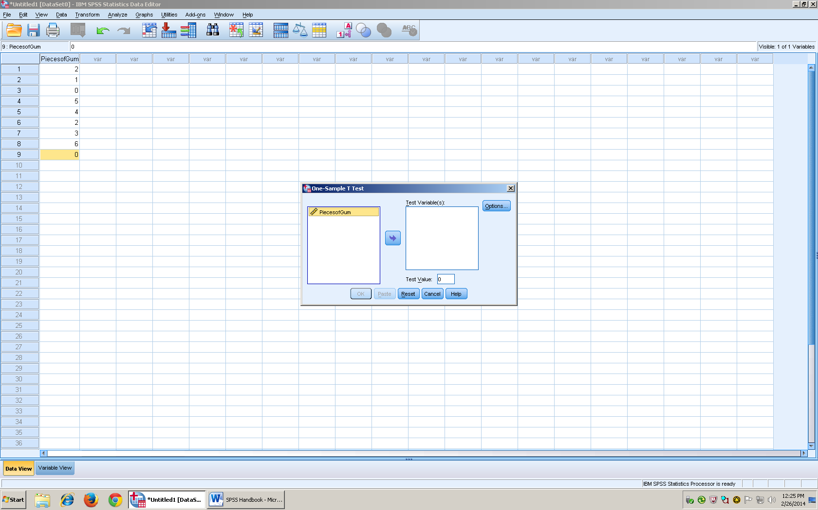

- Once the data set is under test variable, make sure that you change the box under that section that says Test value.
- In this example, the test value was changed from 0 to 1.1 because 1.1 is the population mean
- Test value is always the pop mean
- Then click okay

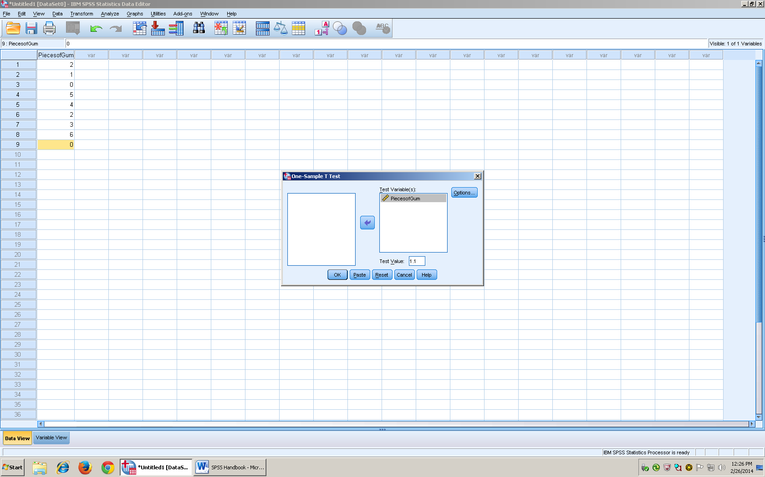

- The output will show up within SPSS, and also in a separate window

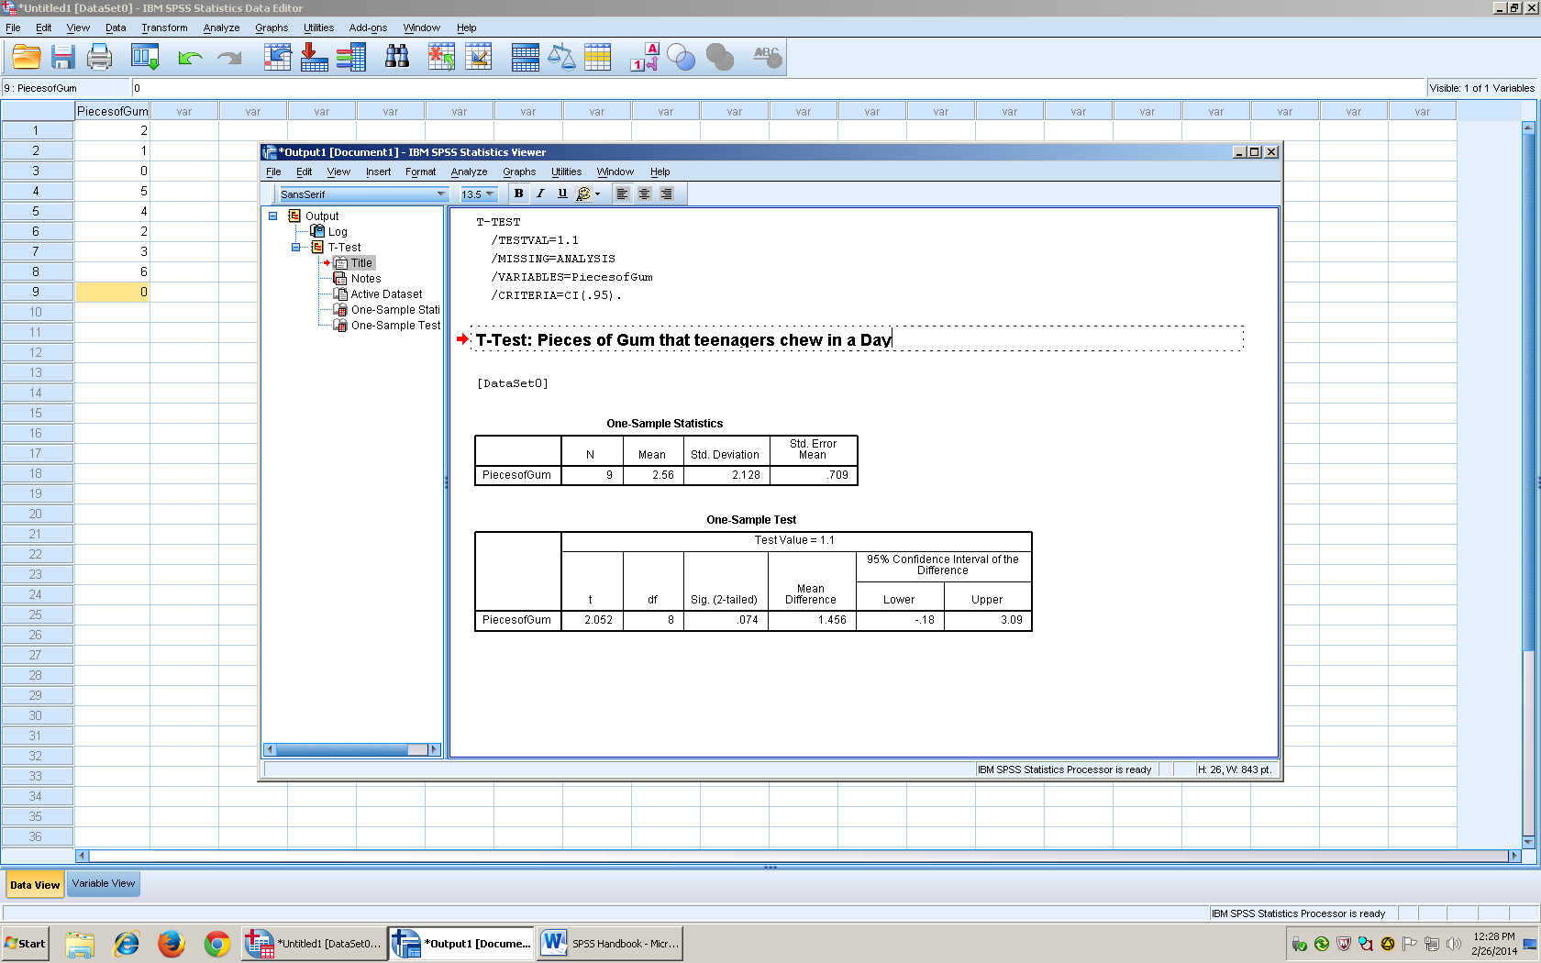

- N= # of people
- Mean = the average
- df = Degrees of freedom (n-1)
- Sig (2-tailed) = % chance of type 1 error. You look at this number to determine whether for reject or fail to reject the null. If you do a one tail then you have to divide that number in half.
- Std. dev = how far away an individual score is from the mean

Results
A single sample t showed that there was a significant difference between the students that chewed gum (M = 2.58, SD = 2.128) than compared to the rest of the population t(8) = 2.052, p = .074, 95%CI[-.18, 3.09]

Independent t
A. Description of Statistics
- Goal: Are our two samples different from one another? (Do the samples represent the different populations)
- Used if the population mean or population standard deviation is unknown (no pop info is known)
- n₁ = # of participants in 1st sample (usually experimental group)
- n₂ = # of participants in 2nd sample (Usually control group)
Independent Samples t test
- Each group is made up of 2 samples
- Usually Between groups design

- H₀ = (Null Hypothesis)
  - X₁ = X₂ The mean of group 1 (is equal too) mean of group 2
  - X₁ –X₂ = 0
  - The IV will have no effect on the DV
- H₁ = (Alternative Hypothesis)
  - X₁ = X₂ The mean of group 1 (is not equal too) mean of group 2
  - X₁ – X₂ = 0
  - IV will have an effect on the DV
Formula:
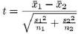
S₁ = Variance of the 1st group
S₂ = Variance of the 2nd group
The denominator of the formula is the Standard error of the difference (Pooled Variance). It estimates the population standard deviation
Degrees of freedom = (N-2) The whole population minus 2

Strength of the IV on the DV (How well the treatment works)
S = Variance
Df = n-1

B. SPSS
- In Variable view, enter the title “Participant#” in column 1.
- Then make sure it is changed to 0 decimal places, and change the measure to scale. Only change decimals places according to your data.
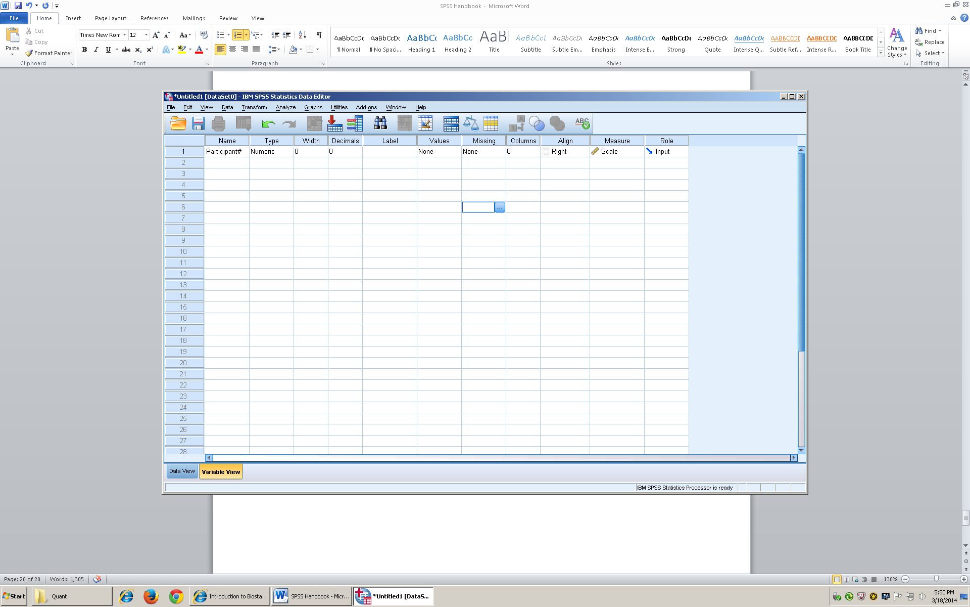
- Switch to data view, then enter the number of participants (should equal the number of people that are included in the population
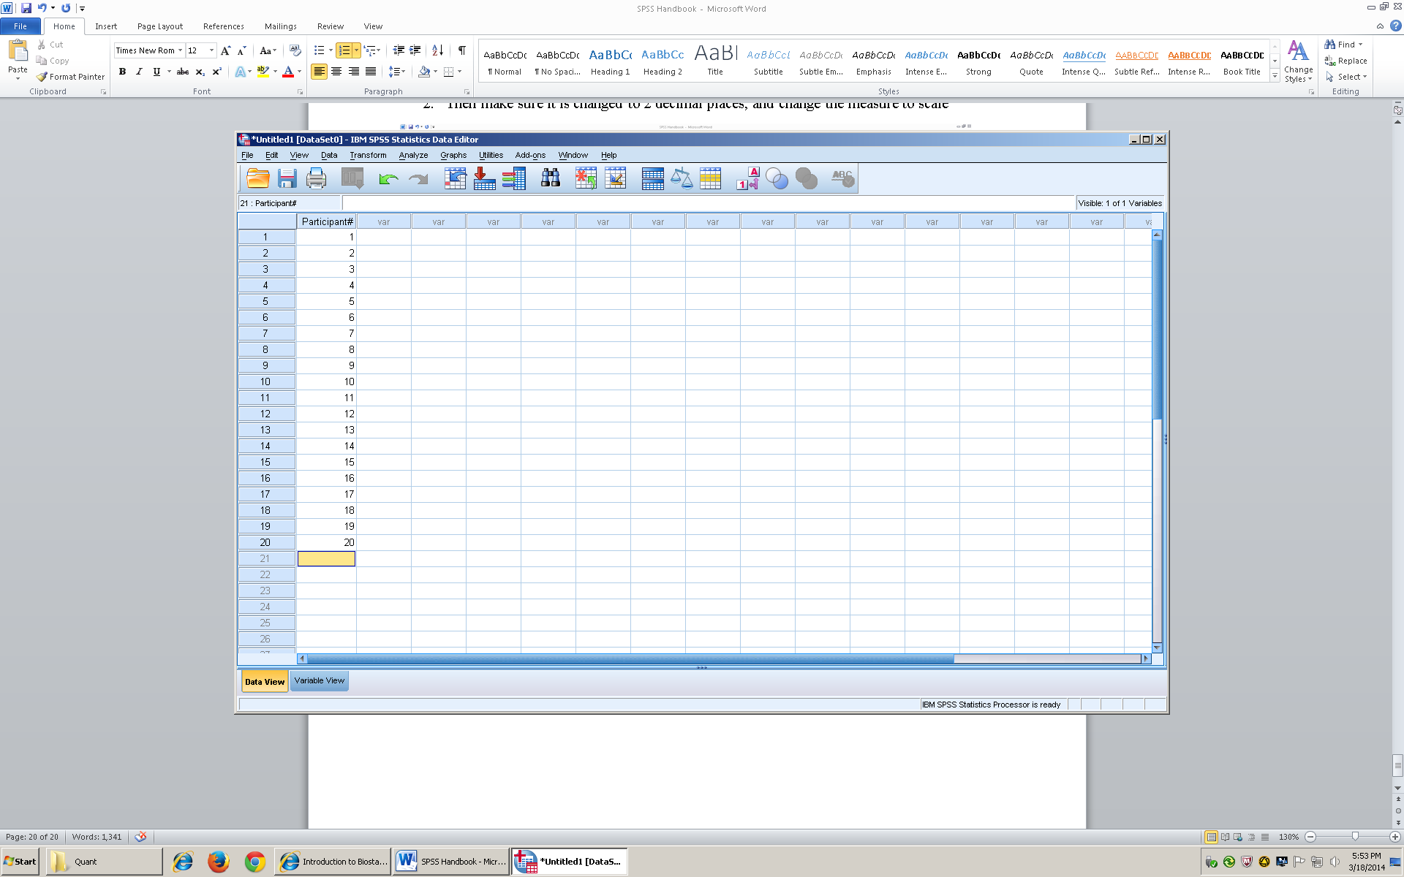
- Switch back to variable view, then enter “typeofmovie” into row 2 because that is my independent variable. Set decimal place to 0
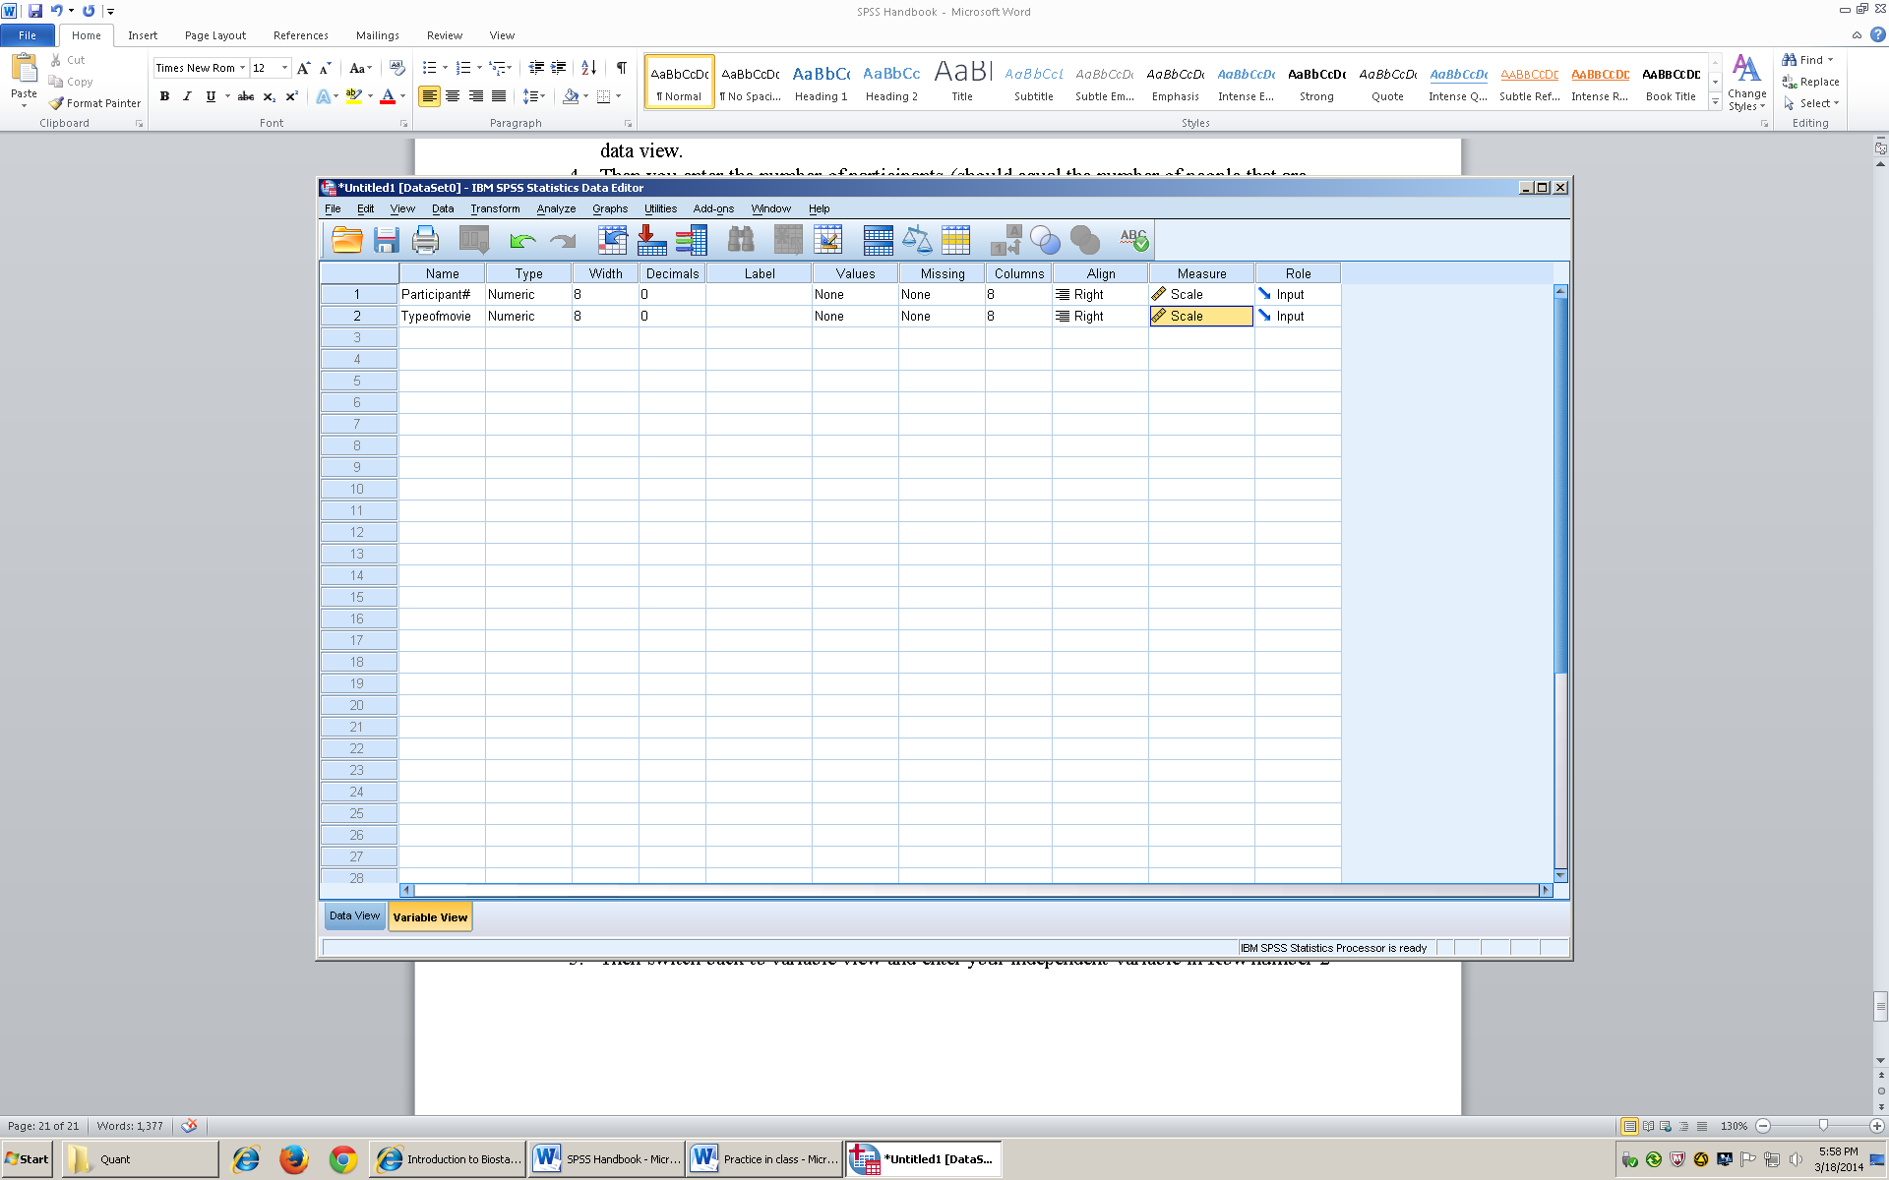

- Then I will enter my dependent “numofnights” variable in row 3, and change the settings
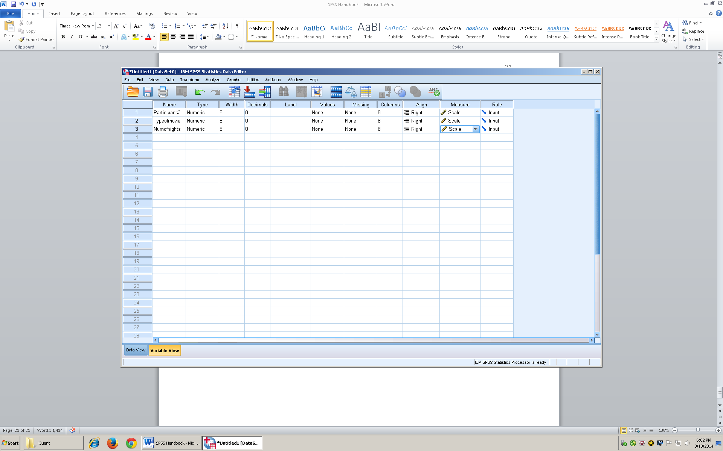

- In the typeofmovies columns, click on the ellipses in the value box
- We use values because we want to put words into our data
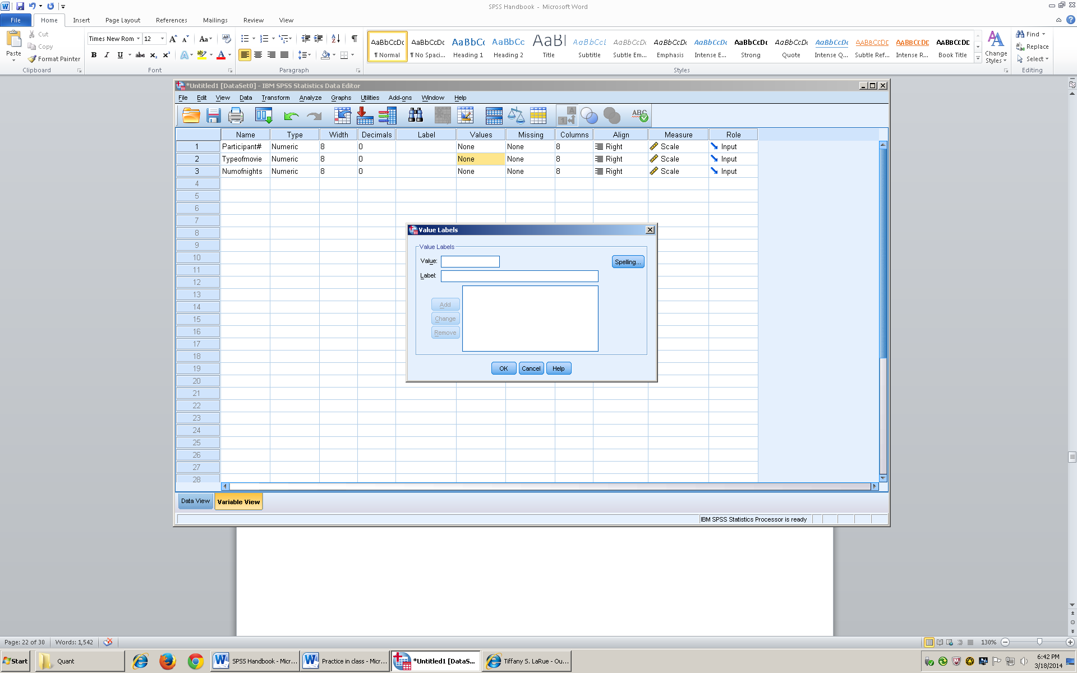

- In the value box enter 1, and in label I will put my independent variable “Poltergeist”

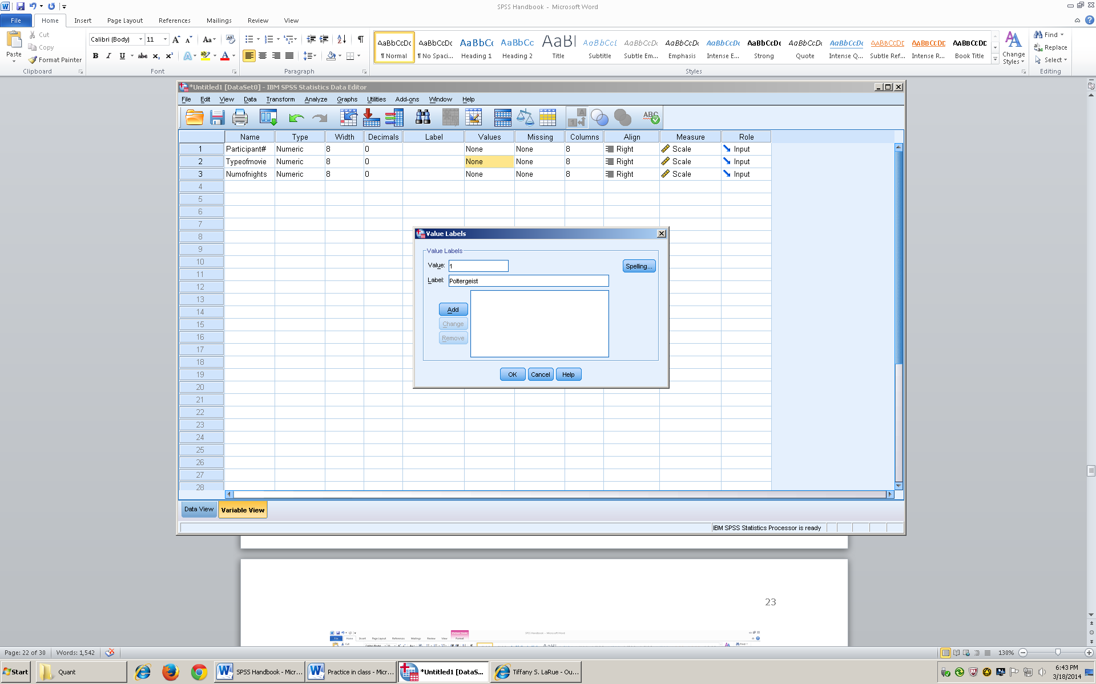

- Then click add, and it will show in the box as 1 representing the movie “poltergeist”
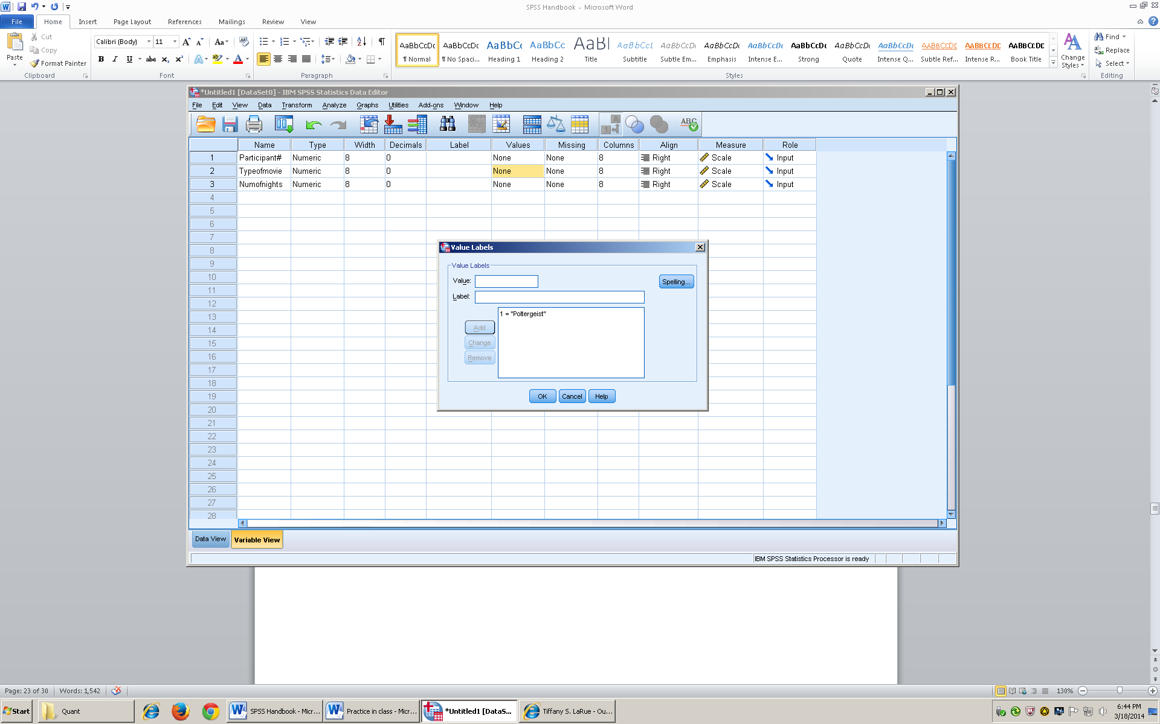

- Then I will put 2 in the value box, and the movie Nemo in the label box
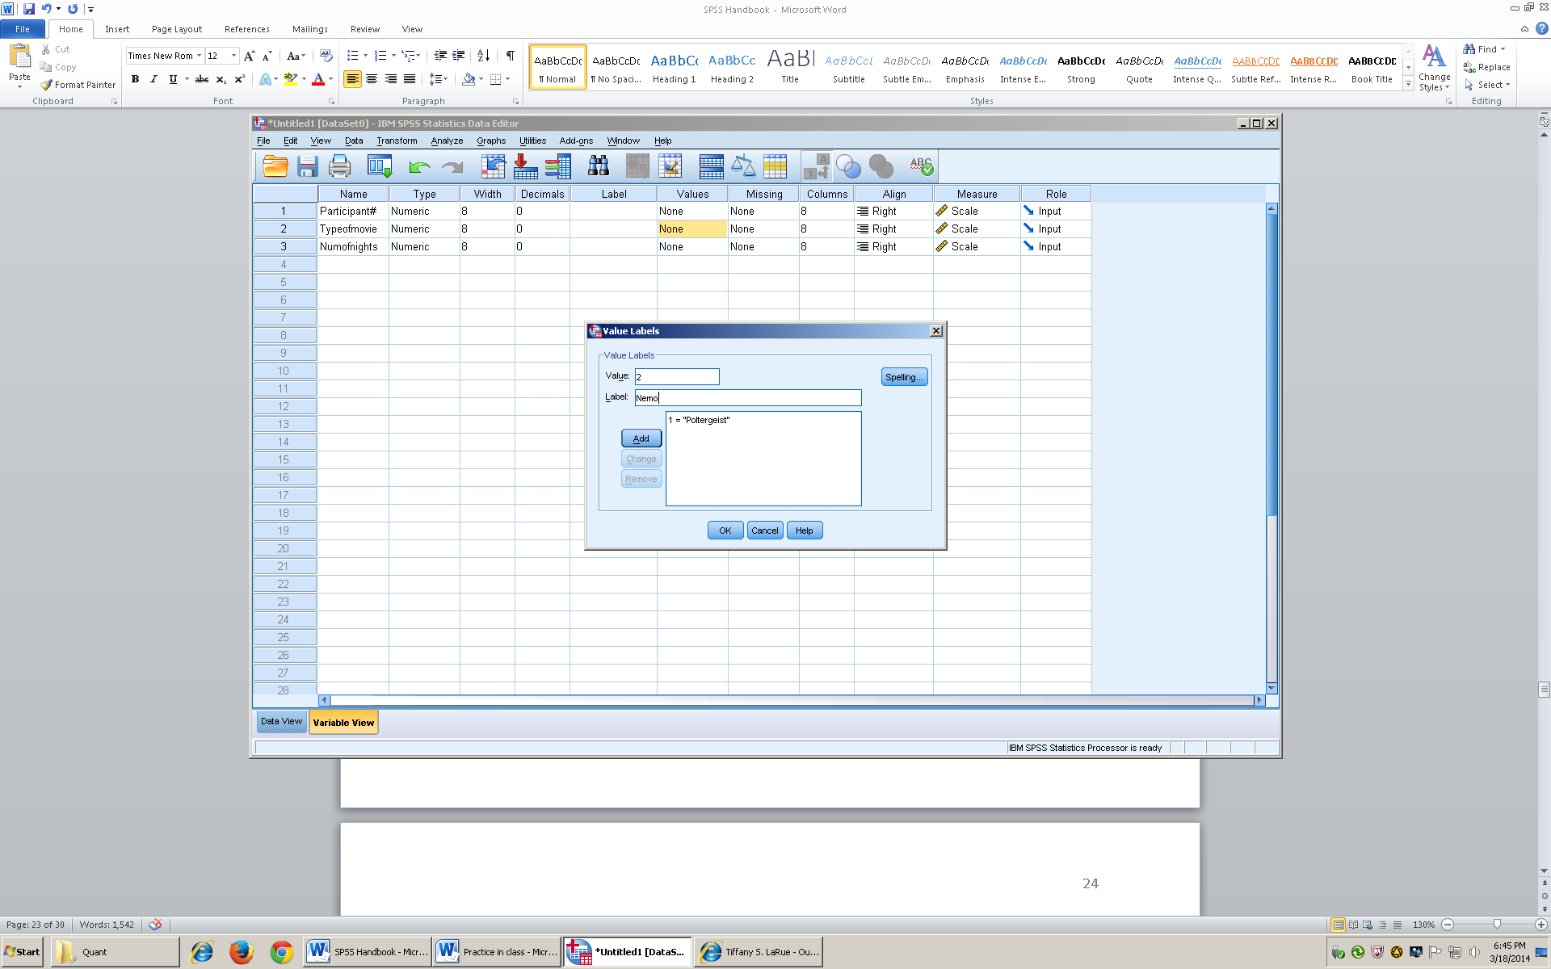
- Then I will click add, and it will show that 2 represents the movie “Nemo”
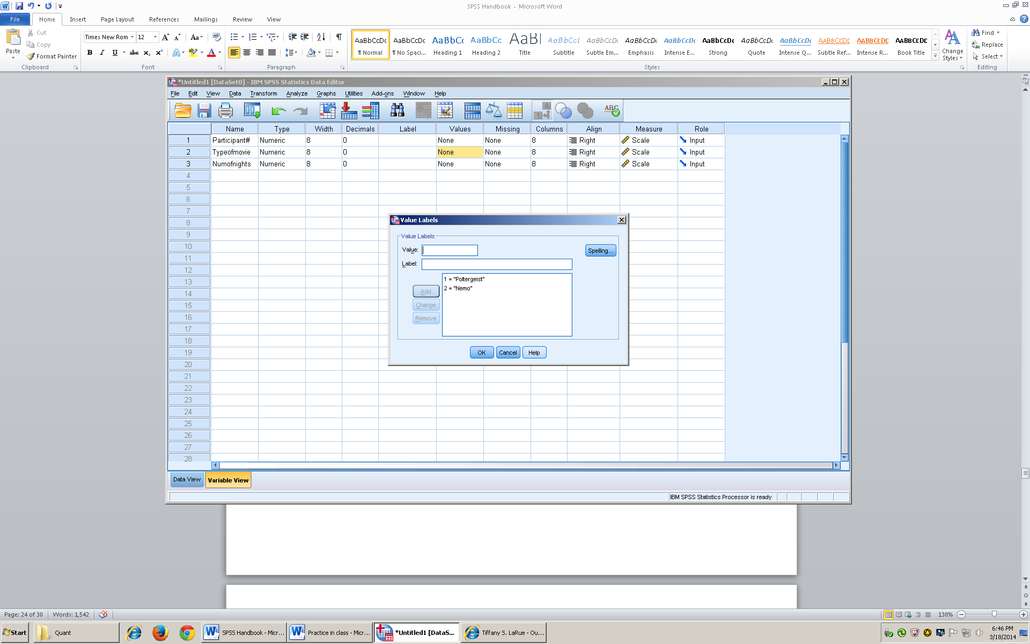

- Click okay, and switch back to data view
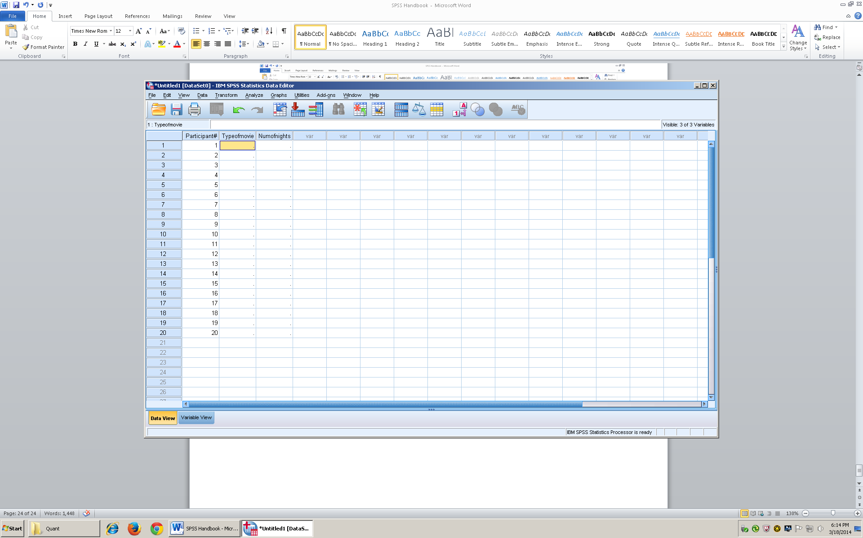

- For the independent variable (type of movie) I will enter 1 for number 1-10 to represent the participants that watched Poltergeist
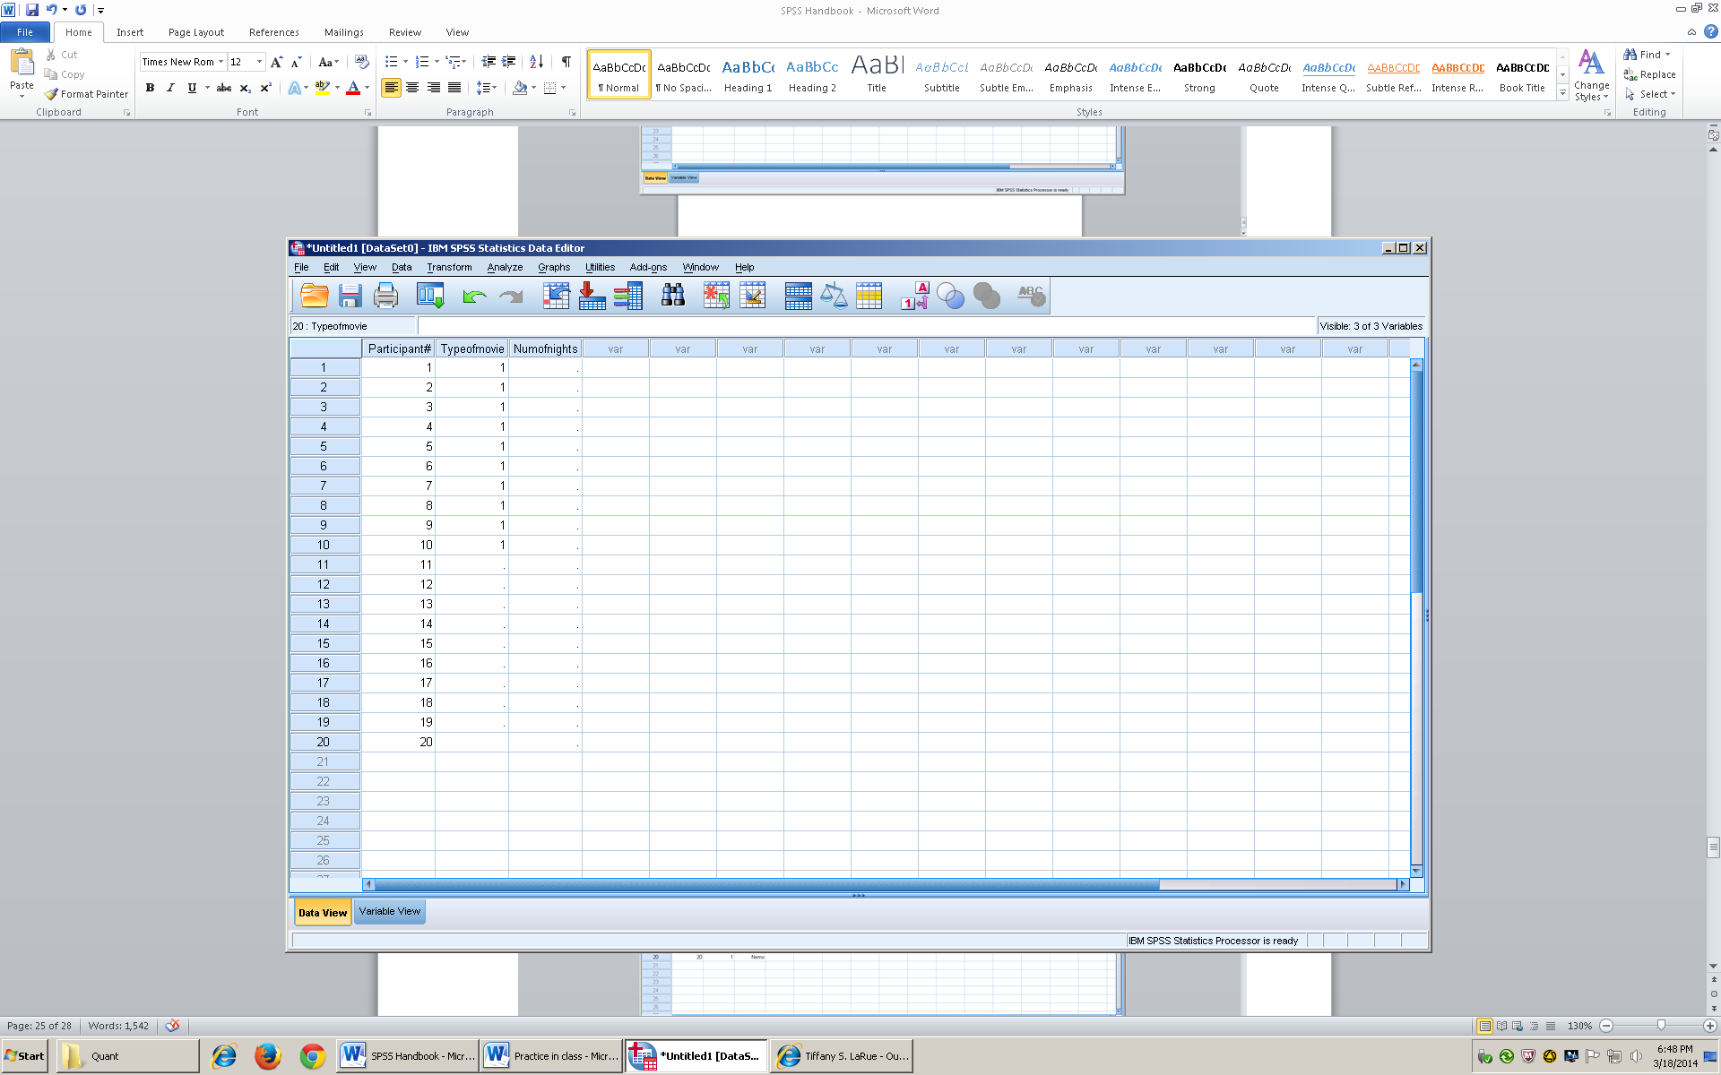
- For the independent variable (type of movie) I will enter 2 for numbers 11-20 to represent the participants that watched Nemo
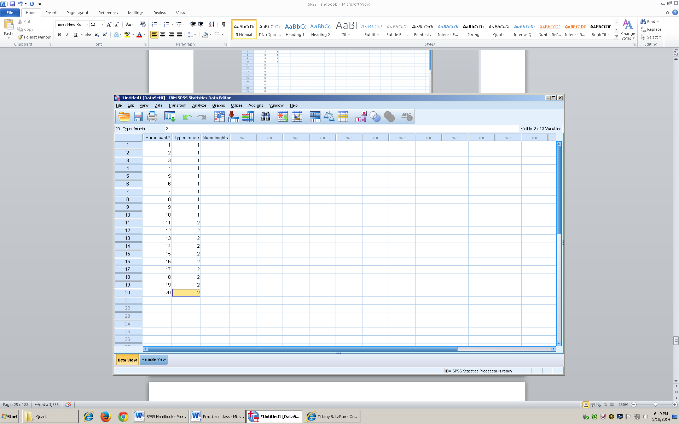

- Enter the data for Dependent variable ( Num of Nights)
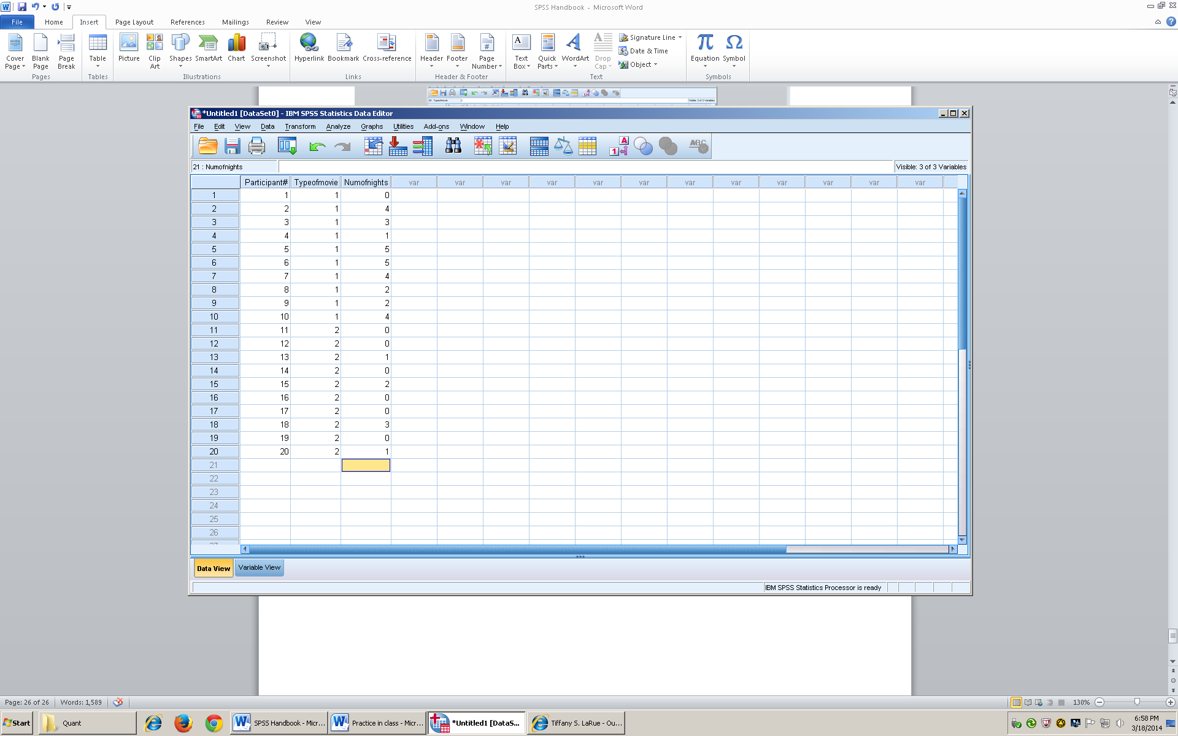

- Then go to view, and make sure the box for value label is checked
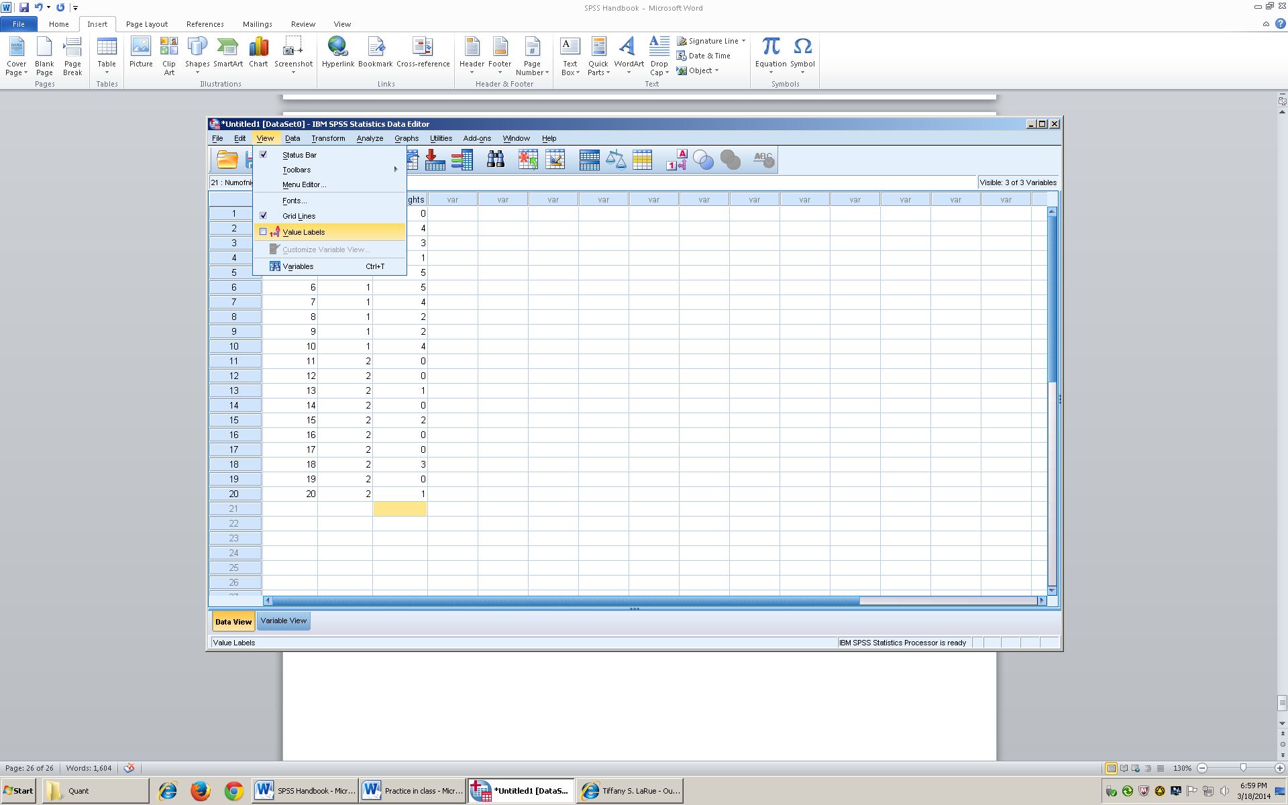
- Once you check the value label box, you will notice that the numbers turned into words.
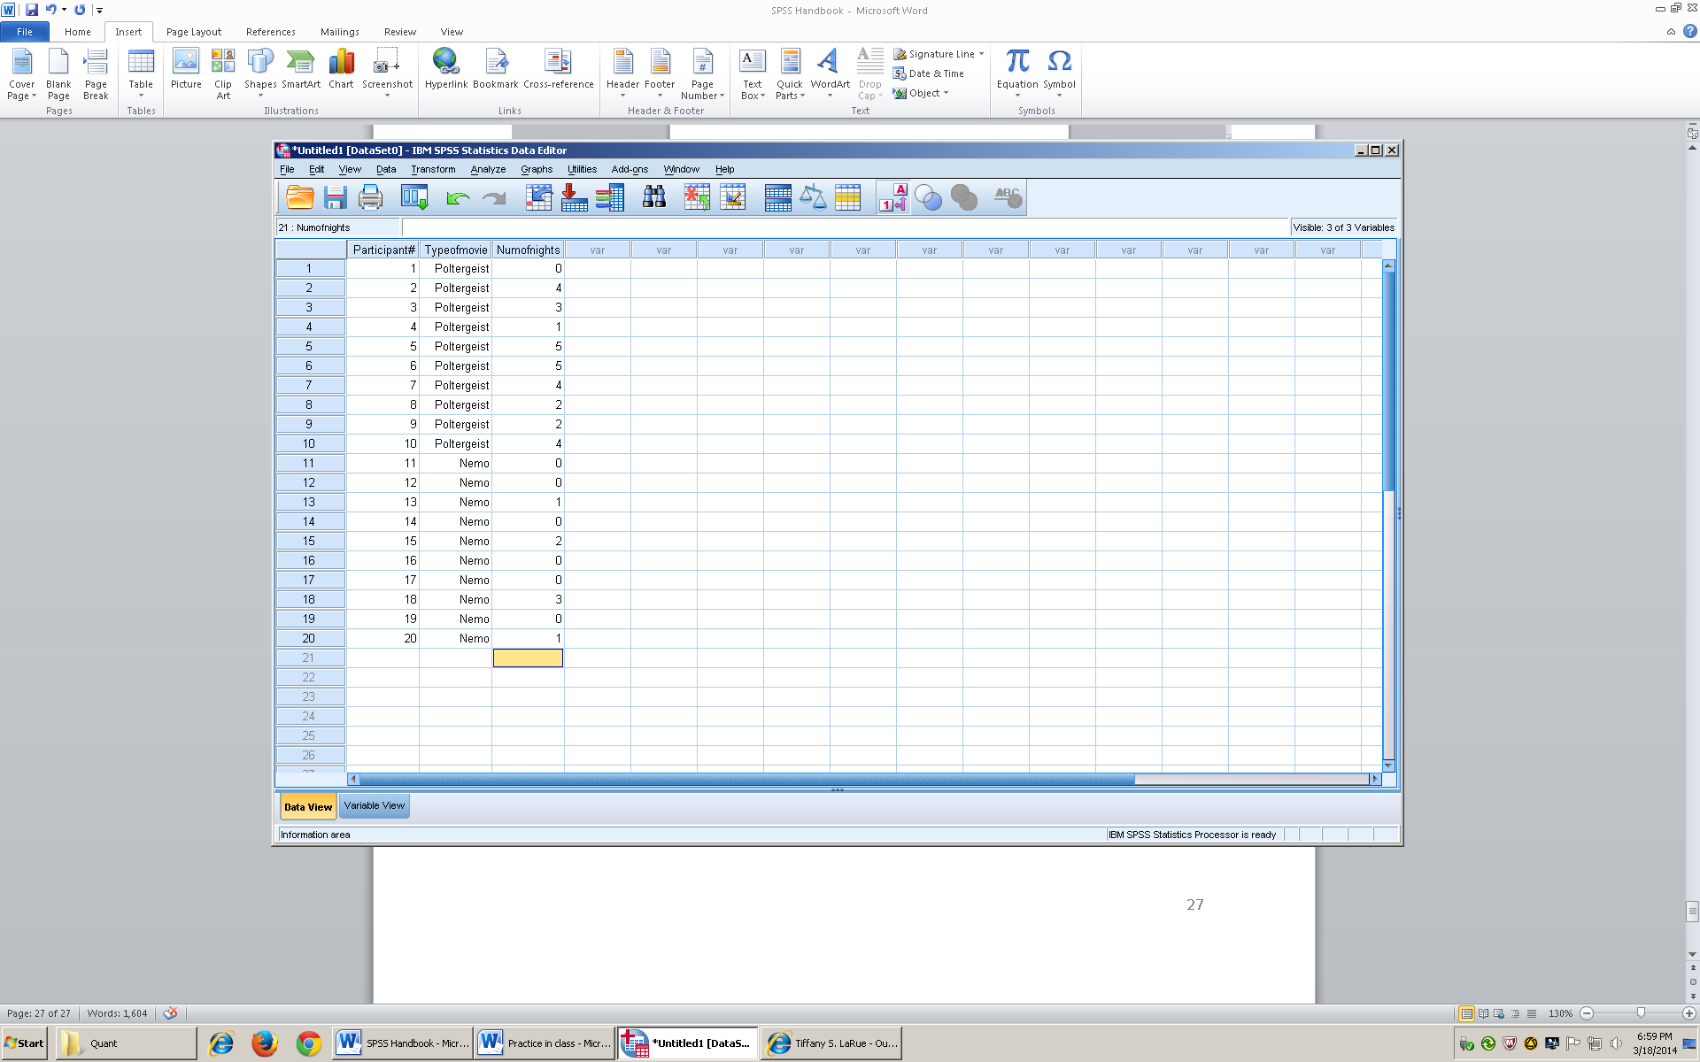

- Next, Go to Analyze. On the drop down menu choose compare means, then arrow over to Independent sample t test
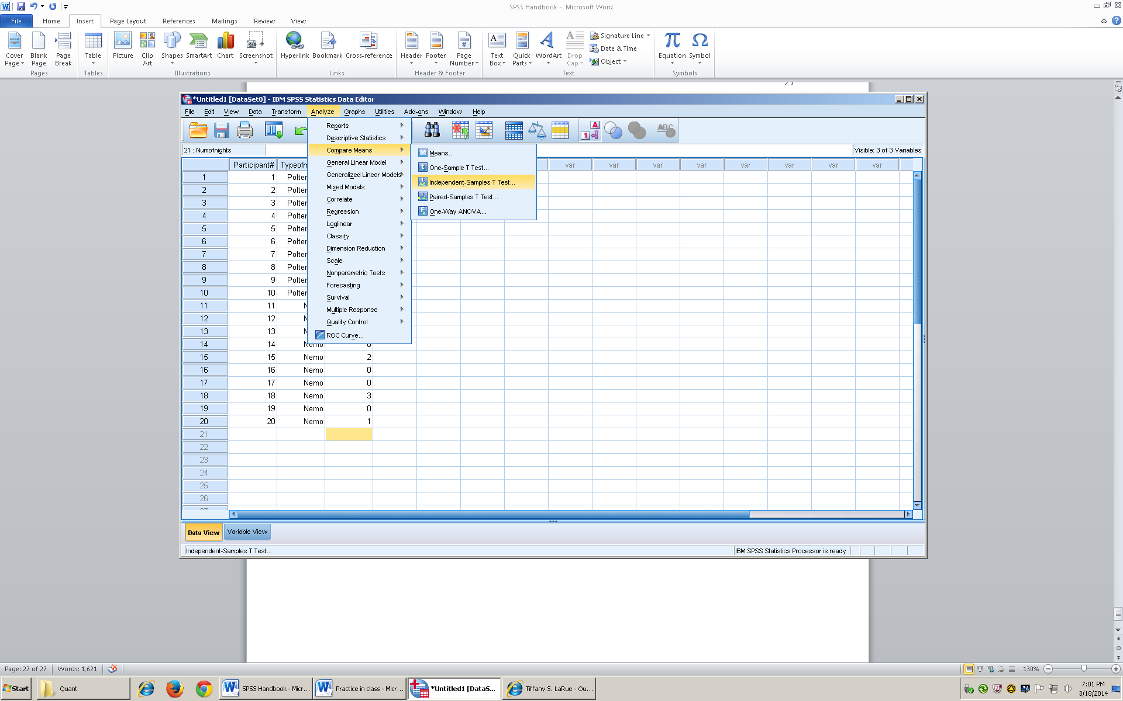
- After you click on Independent sample t test, then a box with all of your variable will come up
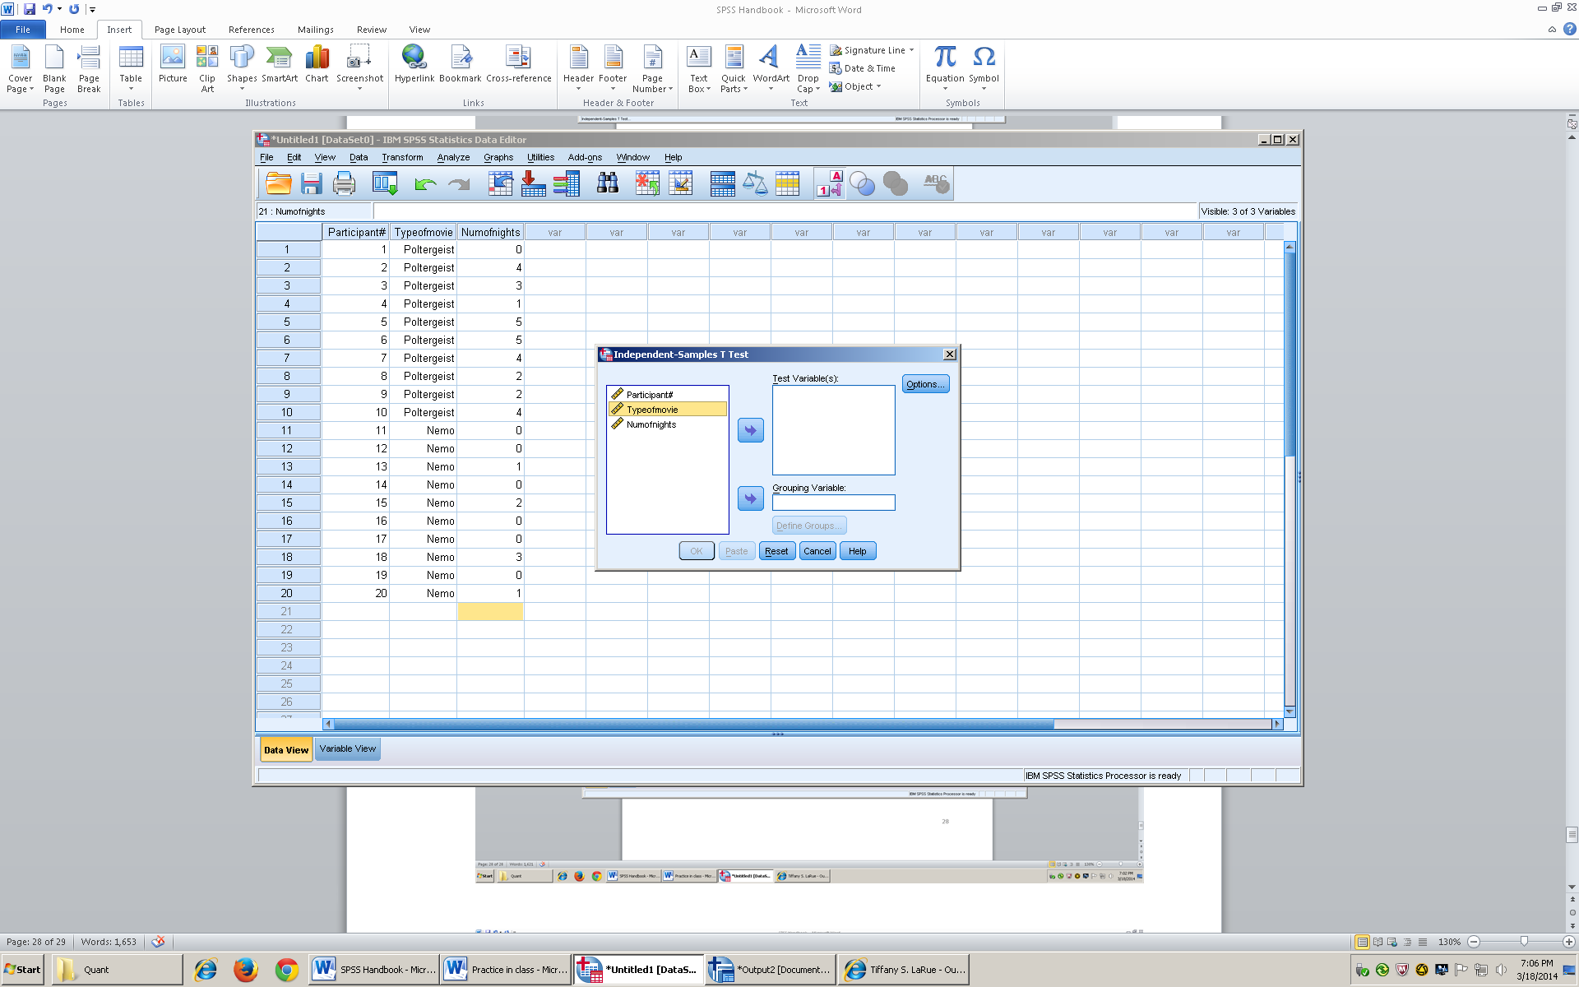

- Take the DV (Num of nights) and arrow it over to test variable
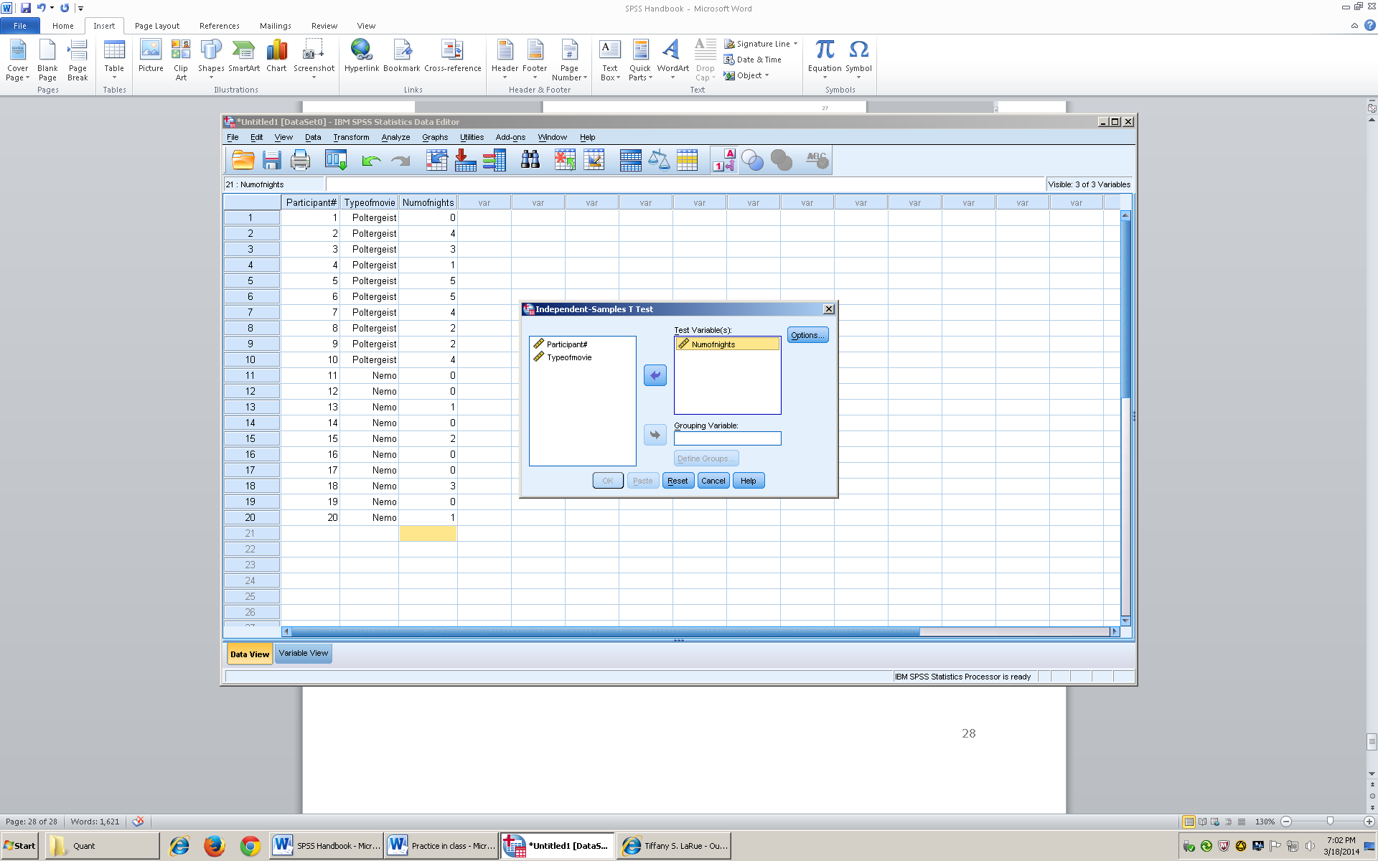
- Take the IV (type of movie) and arrow it over to grouping variable. You will notice that there are two question marks besides type of movie. That means you have to define groups.
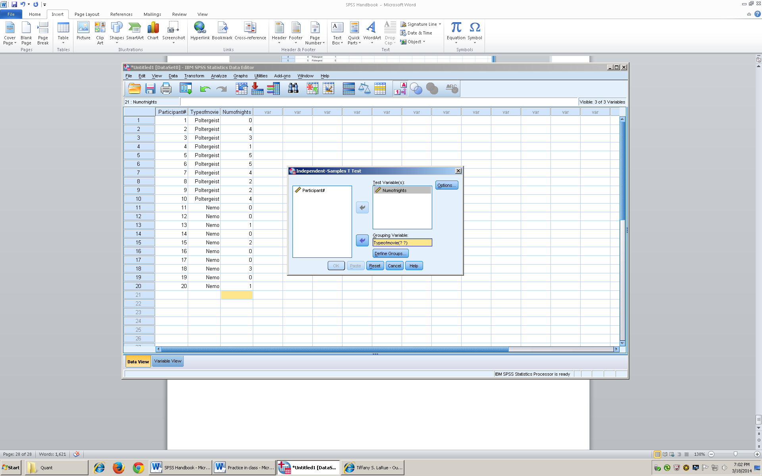
- To define groups, you click on define groups under grouping variables
- Group 1: Experimental group (Poltergeist) (enter 1)
- Group 2: Control Group (Nemo) (enter 2)

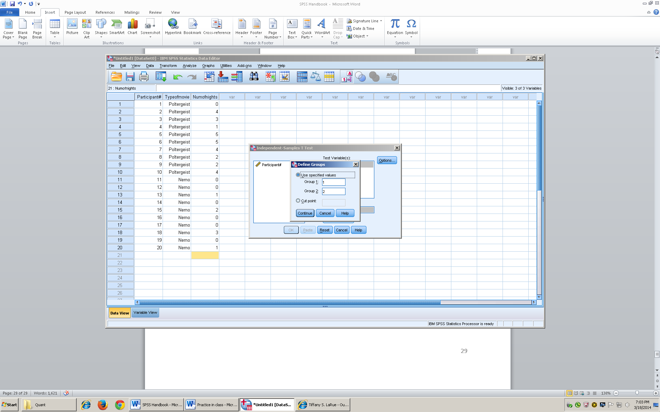

- Then click continue, and okay, then your results will pop up
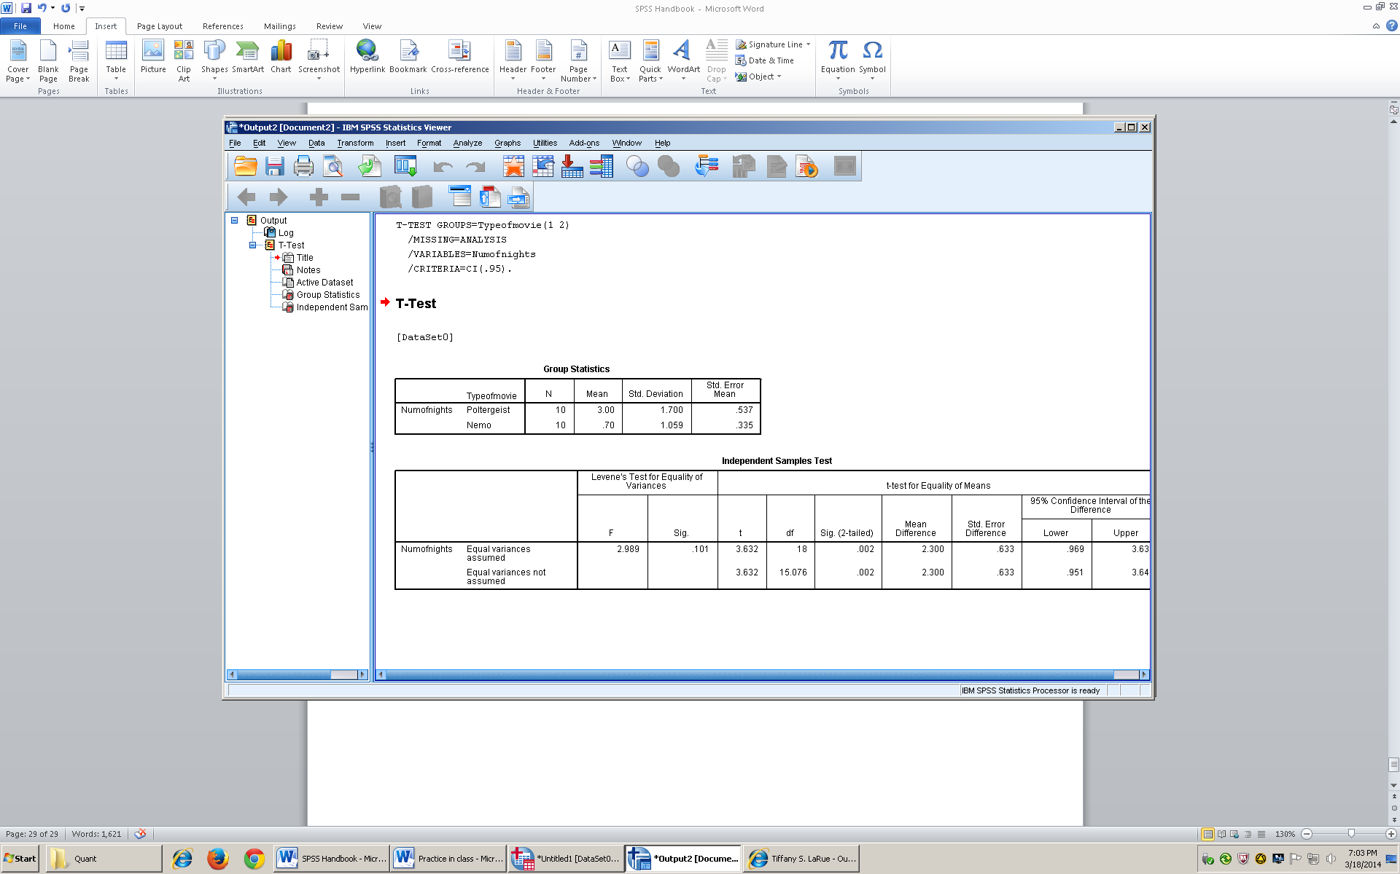
- We must always assume that the variances are equal so make sure you look in the row labeled equal variance (top row), excluding the numbers in Levene’s test for equality of variances.
- The sig (2-tailed) tells whether you reject or fail to reject the null. If the number is under the alpha level that you predicted then there will be a difference (reject the null)

C.
Results
An Independent t test showed a significant difference between the groups, t(18) = 3.63, p = .002, 95% CI[.969, 3.63] (two-tailed). Those who watched the scary movie poltergeist spent significantly more nights in bed with their parents (M =3.0, SD = 1.7) than those who watched Finding Nemo (M= .70, SD =1.06).

Dependent t
- Descriptive Statistics

Dependent t
- It is a Within Groups Design (Repeated measures/Paired samples
  - All of the participants participate in all of the levels
- (2 samples)
- We have no population information

Formula:
t = X₁-X₂ (Sample Mean 1- Sample Mean 2)
S_{D} (Estimate of the Standard Deviation)

Cohen’s d formula:
d = X₁ – X₂ (Mean Sample 1- Mean Sample 2)
S₁² – S₂² (Variance of group 1+ Variance of Group 2)
2 2

Strength of the IV on the DV (How well the treatment works)
S = Variance
df= n-1

- SPSS
- In variable view, enter the titles for you Columns. Column 1= Participant#, Column # 2= 1st level of the IV, Column# 3=2nd level of the IV
- Make sure that you do not enter names because you want to keep your participants anonymous
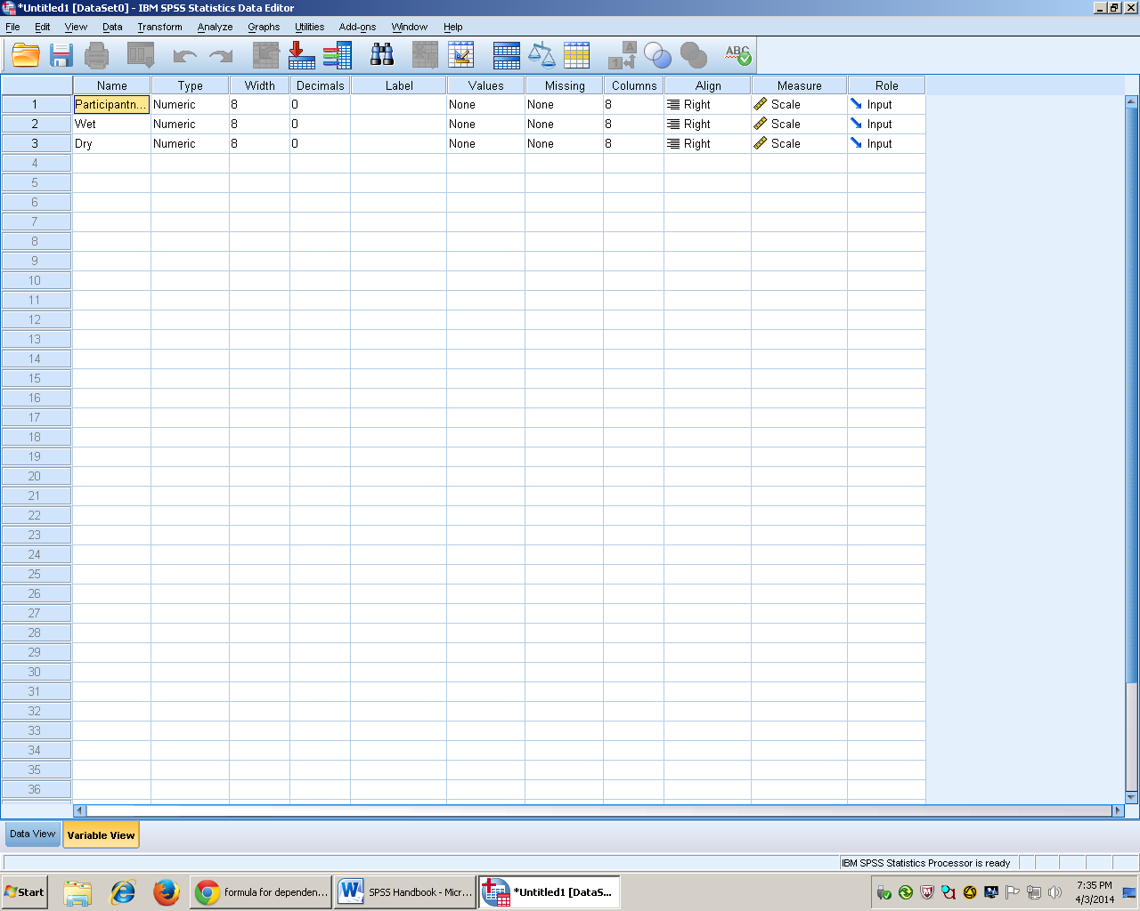

- Enter your data into variable view
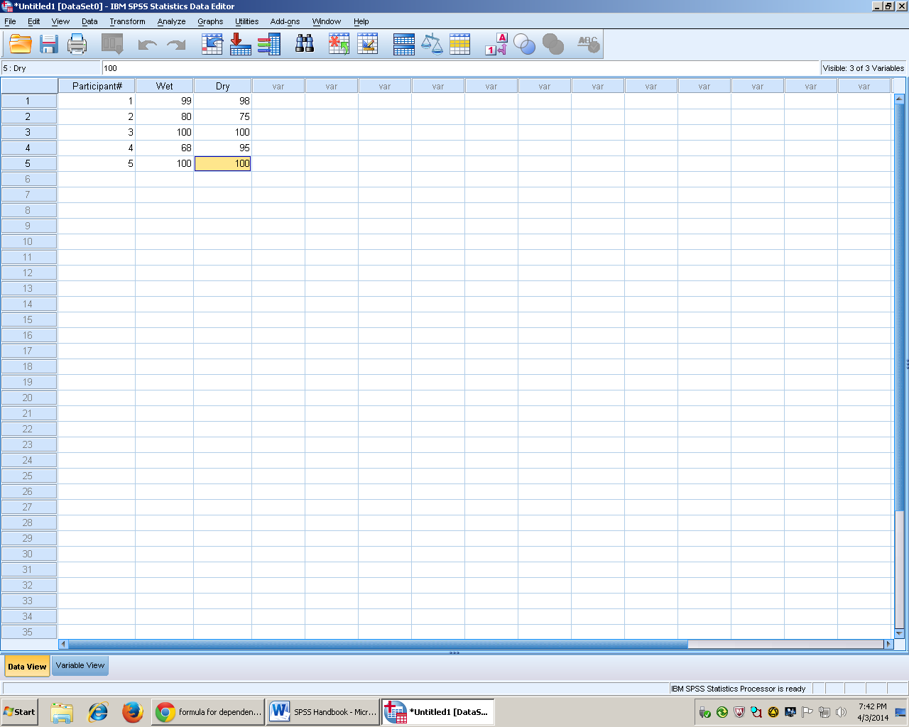
- To run the analysis scroll over the Analyze drop down menu.
- Go to compare means, then click on Paired-sam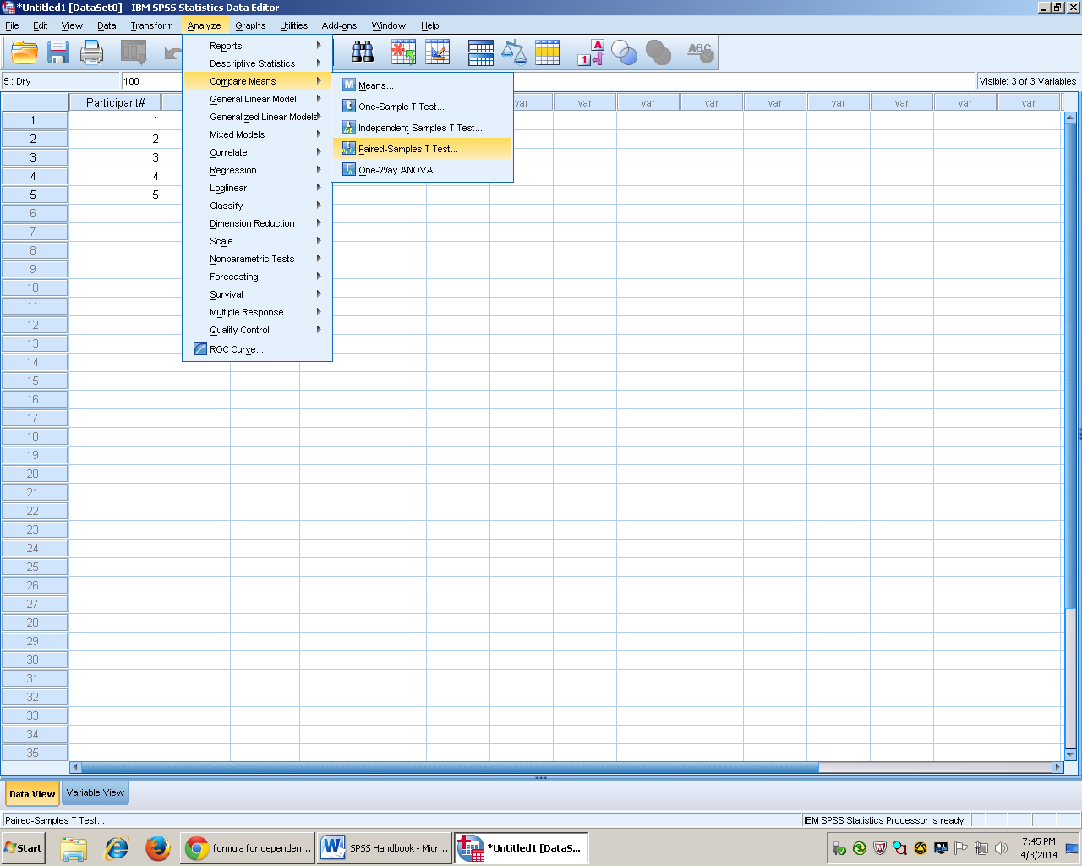
- After you click on paired sample T test, then the box below will pop up
- To get both groups in at the same time you click on the 1st level, then press control and press the second level. You know that you did it right if both are highlighted
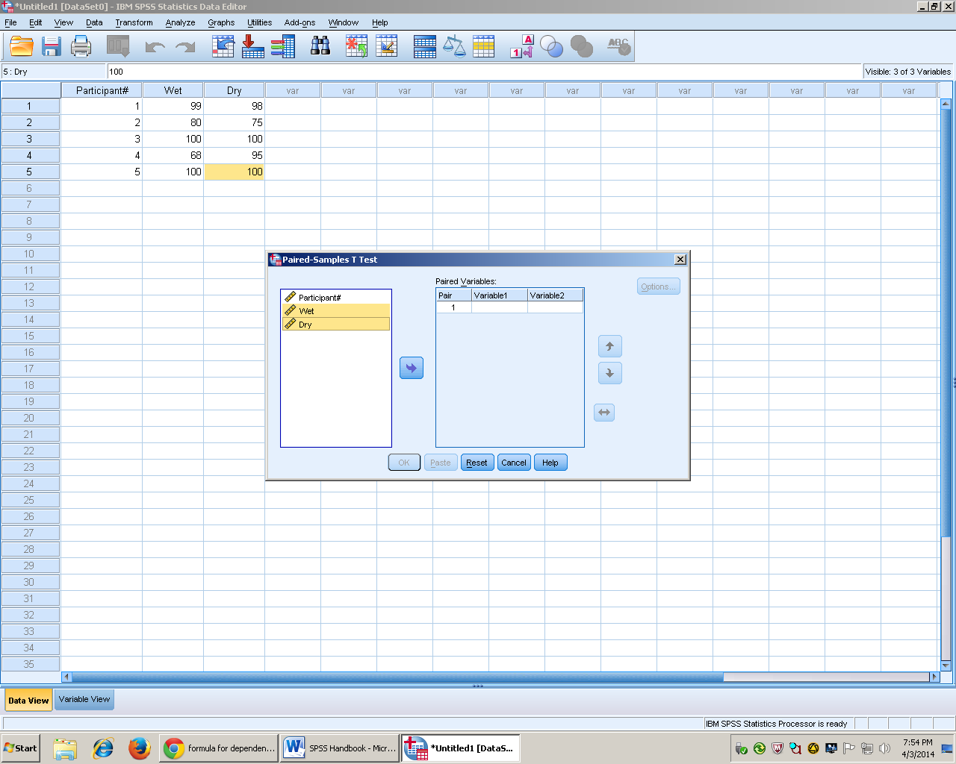

- Arrow the two groups into the box on the right named paired variables
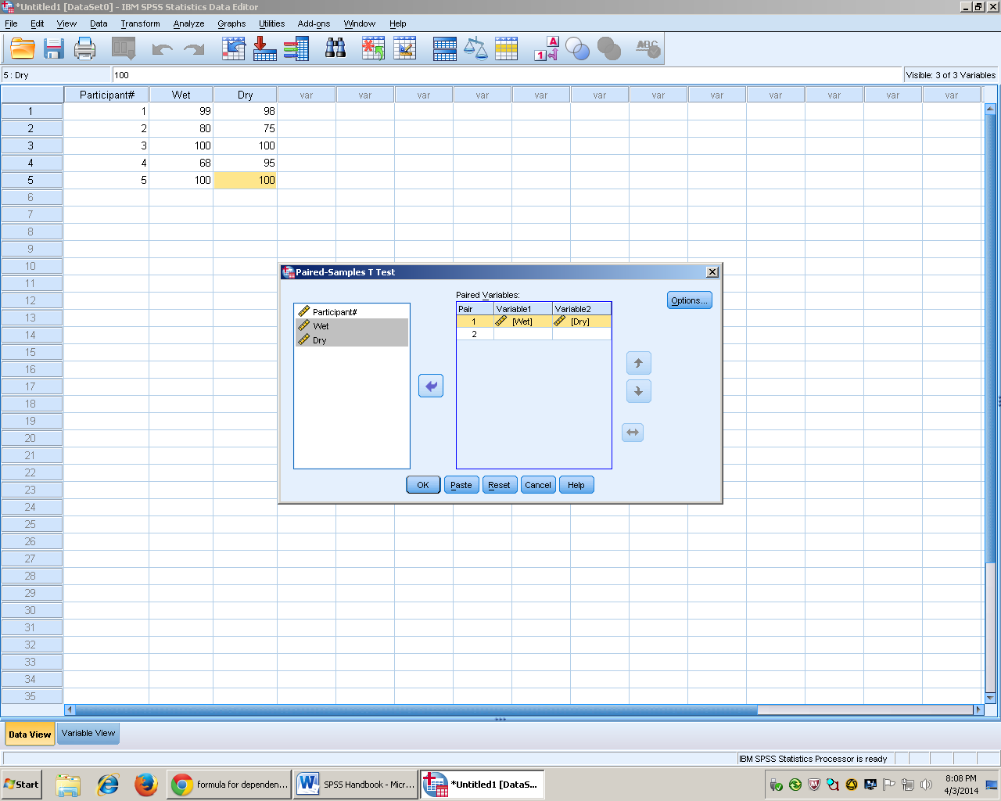
- Click options and make sure your confidence interval percentage is correct according to your alpha level.
- Then click continue
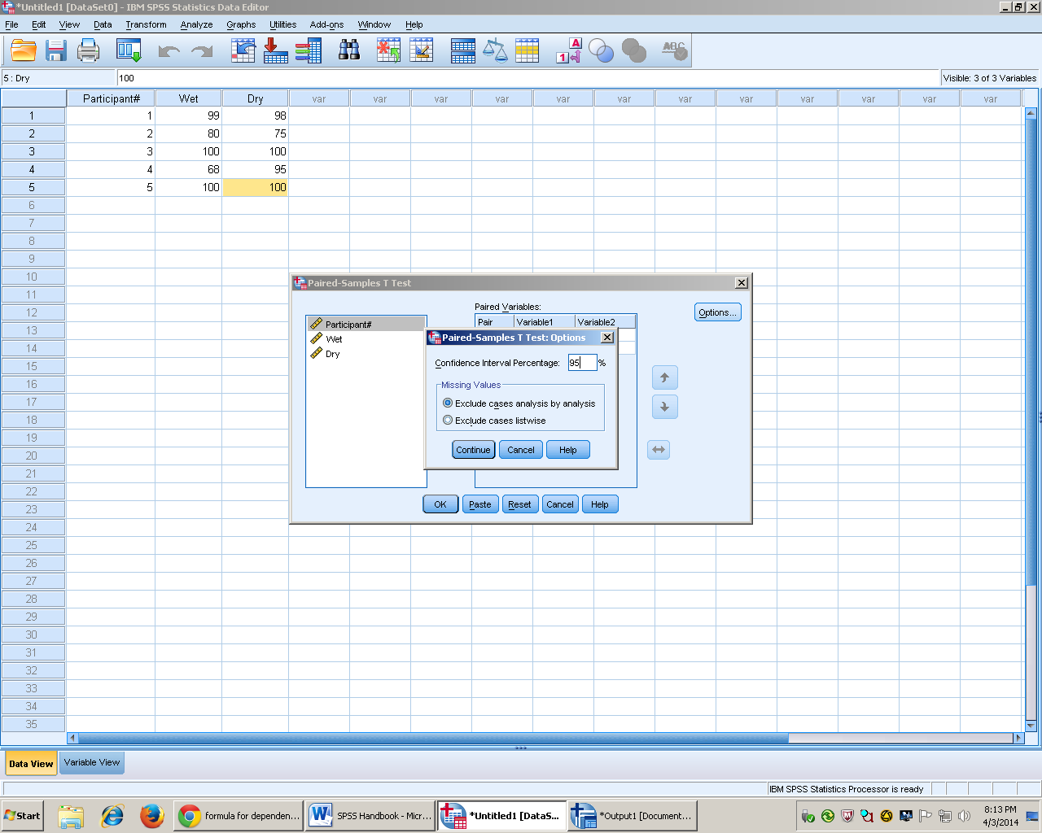

- Then the results section will pop up
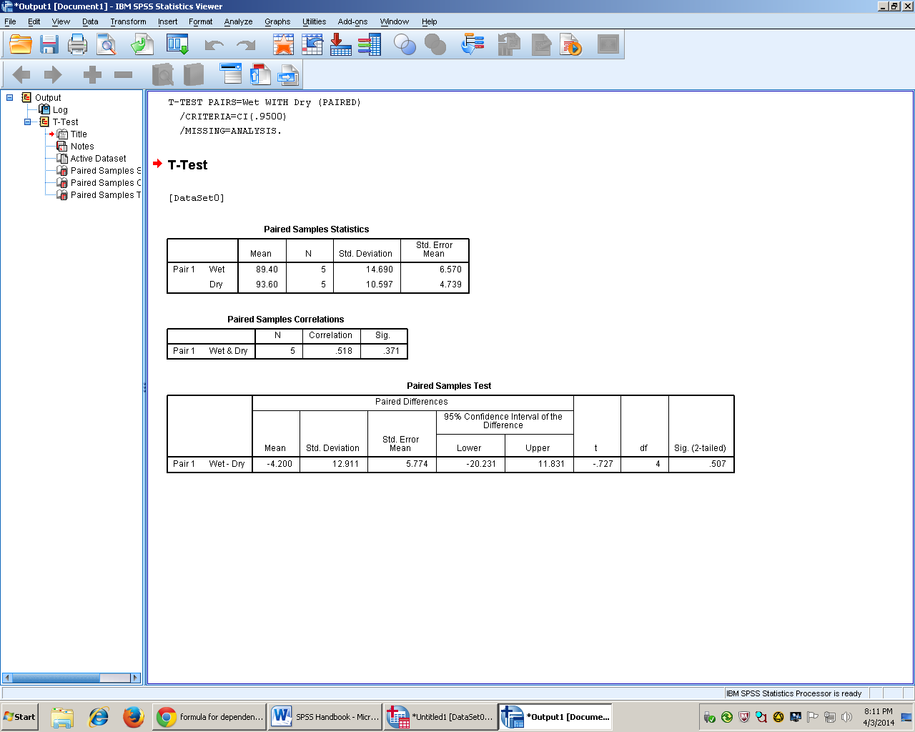
- Delete the middle box because it is not needed (optional).
- Final Product

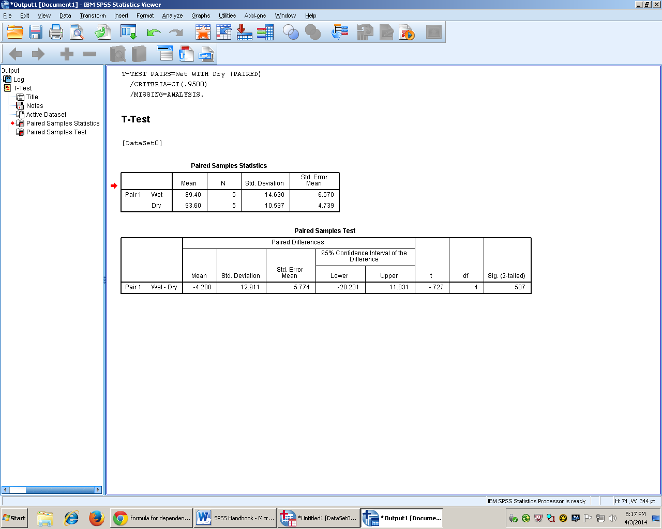

C.
Results
A dependent t showed that the dogs that ate dry dog food (M = 93.60, SD = 10.597) preferred it over wet dog food (M = 89.40, SD = 14.690) out of the bowl. This data did not show a significant difference t(4) = .727, p = .507, 95%CI[.20.231, 11.831], Cohen’s d = .026.

