SPSS: Handbook

Alvin Wood

Contents
Basics 3
SPSS Basics 3
Stats basics 9
Symbols 12
Frequency Polygon 13
Histogram 18
Bar-Graph 24
Single Sample t Test 27
Independent t test 33
Dependent t test 43
One- Way Analysis of Variance 47
One-Way Repeated Measures Analysis of Variance 60
Two-Way ANOVA 68
Mixed Model or Two Way Repeated Measures Analysis of Variance 76
Pearson r 82
Chi-Square χ² 88

Basics

SPSS Basics
  - SPSS does not use spaces use underscores instead to denote spaces
  - change the types of data in SPSS by clicking type and selecting the data needed
    - Can change types to Scale, Nominal, Ordinal
- Data view vs Variable view
  - Variable view is used to put your variables into SPSS
  - Data view is used to insert data for variables ( for examples see Independent t test)
- Value Labels
  - Used for denoting words in SPSS
  - Uses a number as a representative of the words used for nominal data
  - Click view, value labels to see the word representative in SPSS
- Always check the options menu to see if there is anything that needs to be altered
  - Such as confidence intervals or checking for descriptive statistics
- Participant Number is the first variable always
  - Keeps track of participants
  - Useful if you have to drop participants from the study
- Reordering variables
  - Click and drag the header of the column a red line will show were the column is being moved to
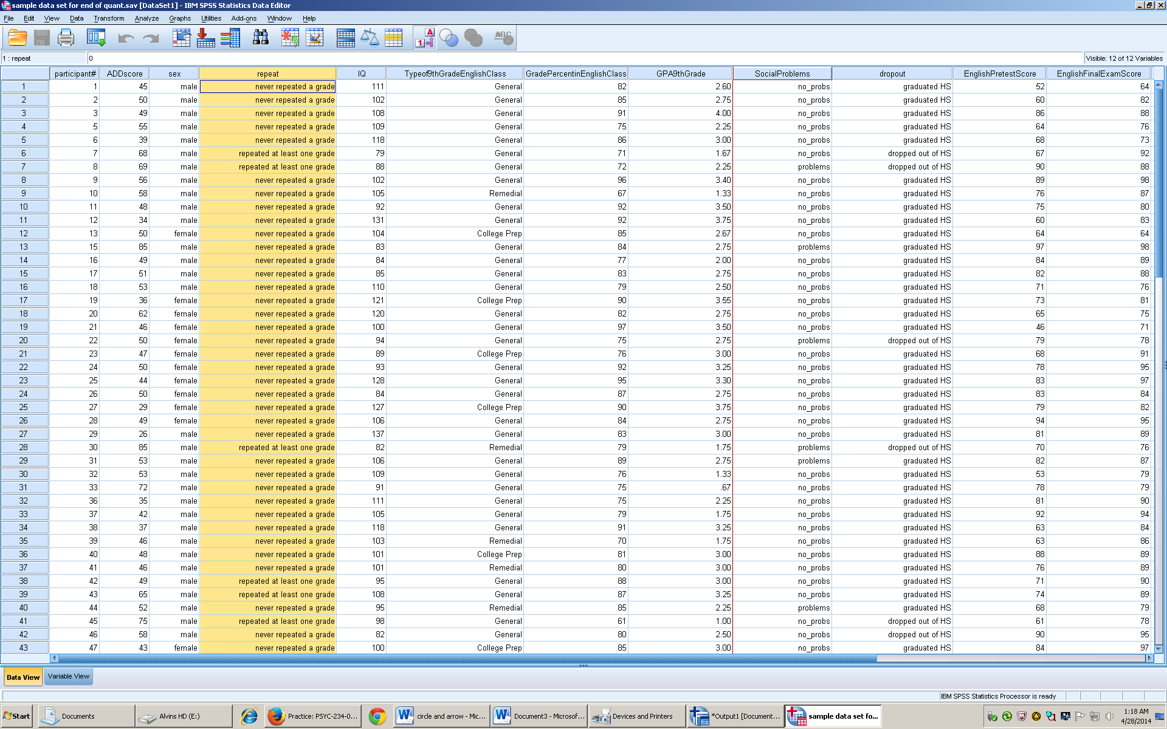
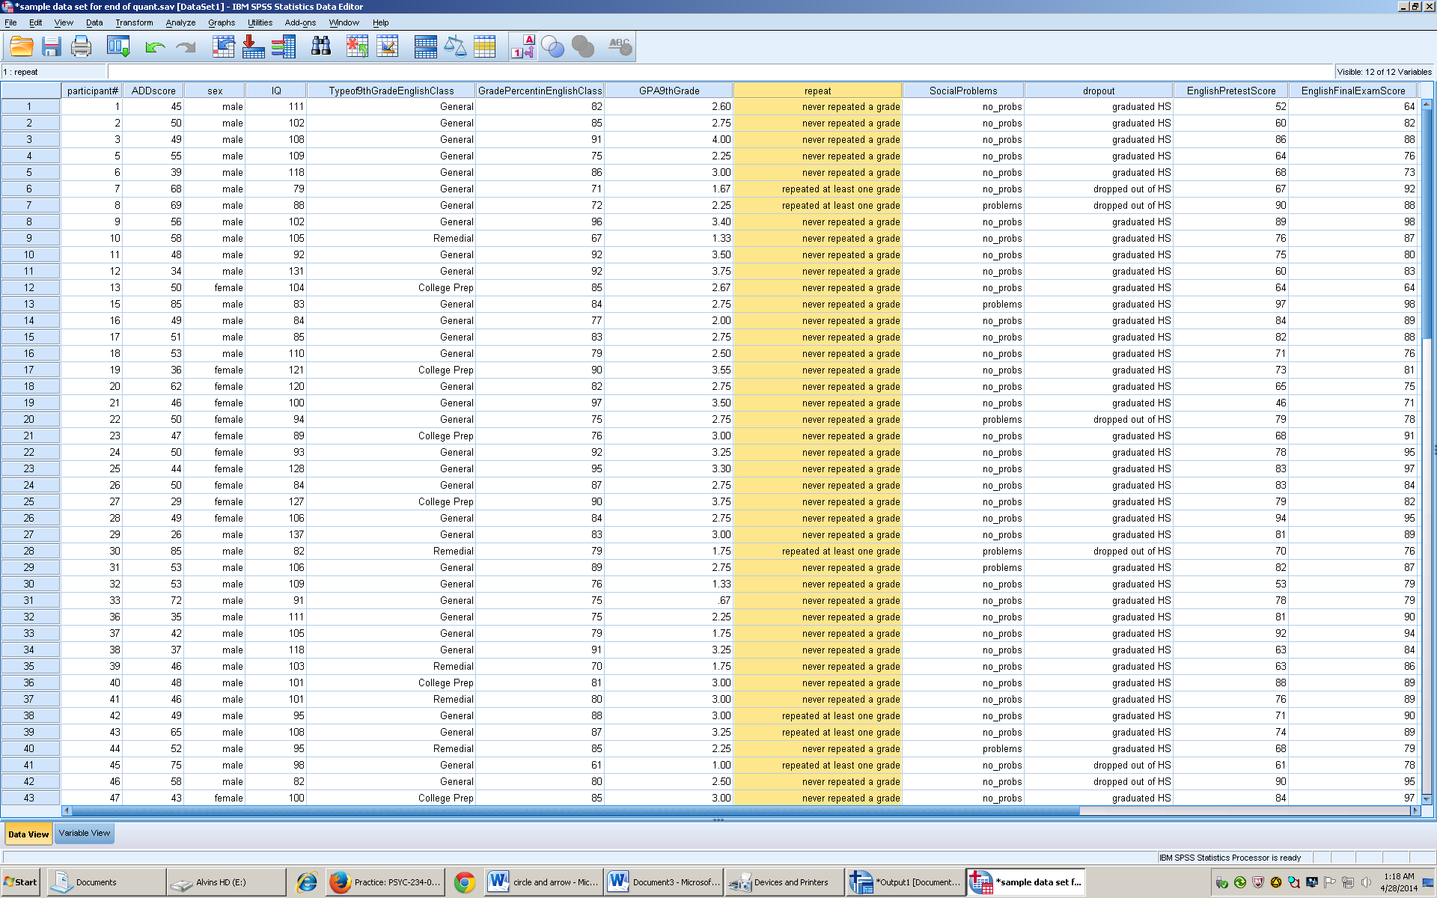
- How to sort cases
  - Go to data
  - Sort cases
  - Arrow over the variable that is to be sorted by
  - Choose ascending or descending
  - 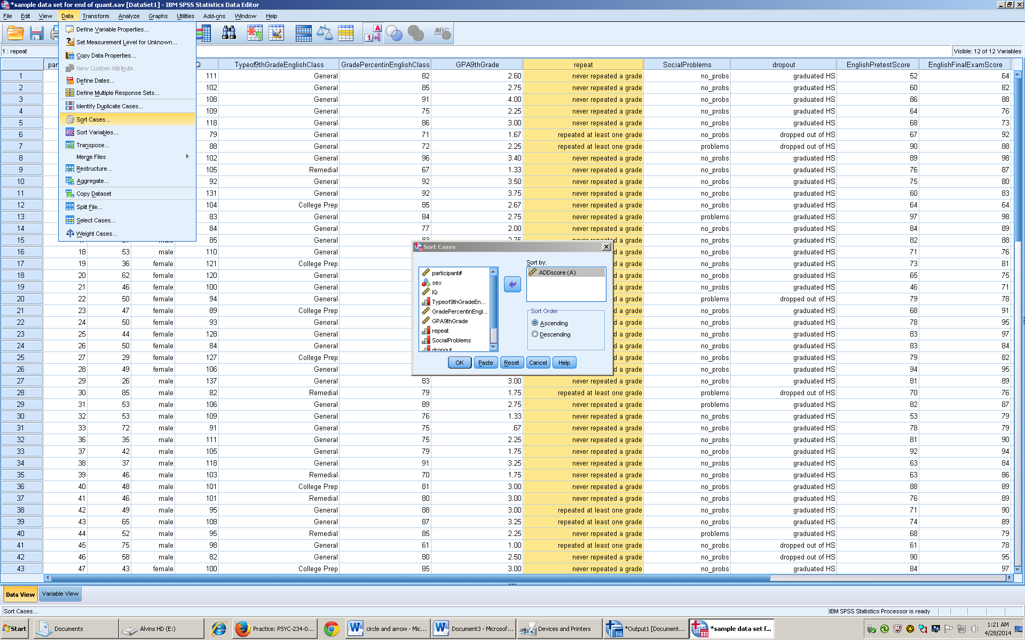
  - Click ok
  - Shortcut : hover over header of a column
  - Right click and choose ascending of descending
- Excluding Cases
  - Click Data
  - Select cases
  - 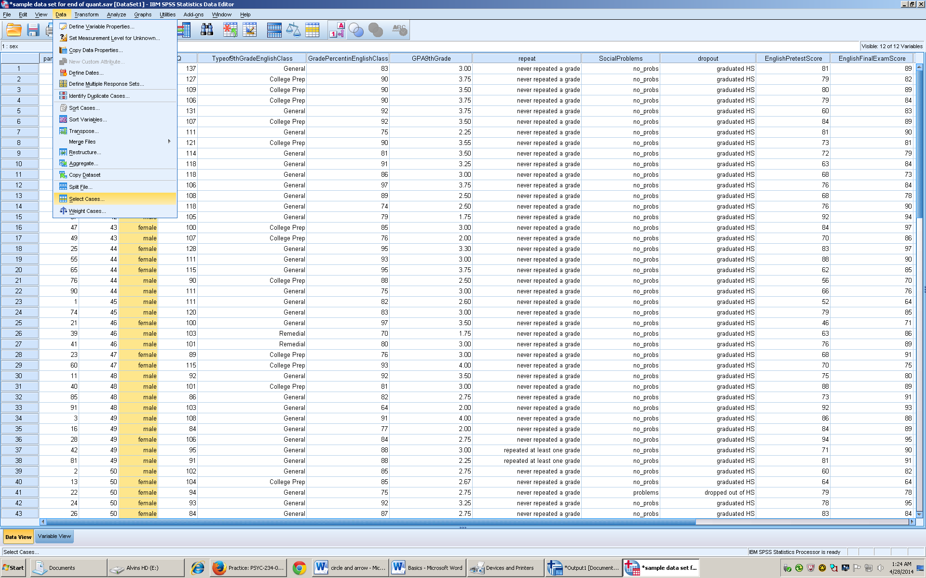
  - Here change the conditions for exclusion
  - Pick which variable is to be excluded
  - Click an exclusion
  - Click if
  - 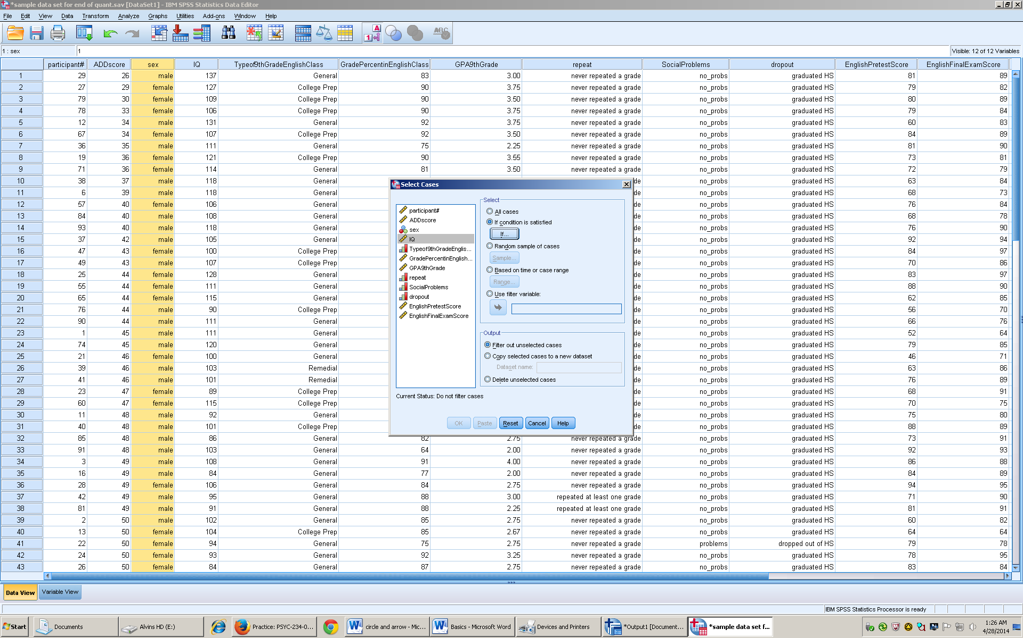
  - Put in the conditions that need to be statisfied for INCLUSION in the data set
  - 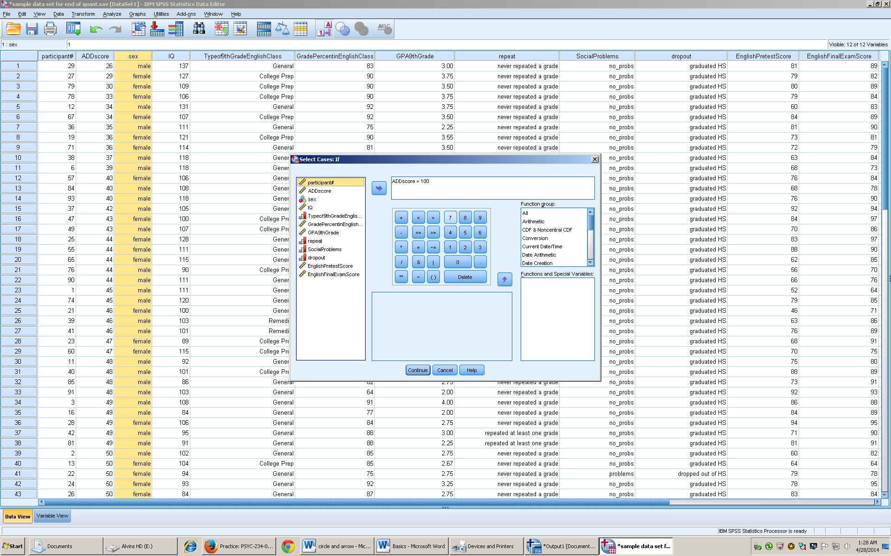
  - Click continue
  - Click ok
  - The boxes with slashes through them are now excluded
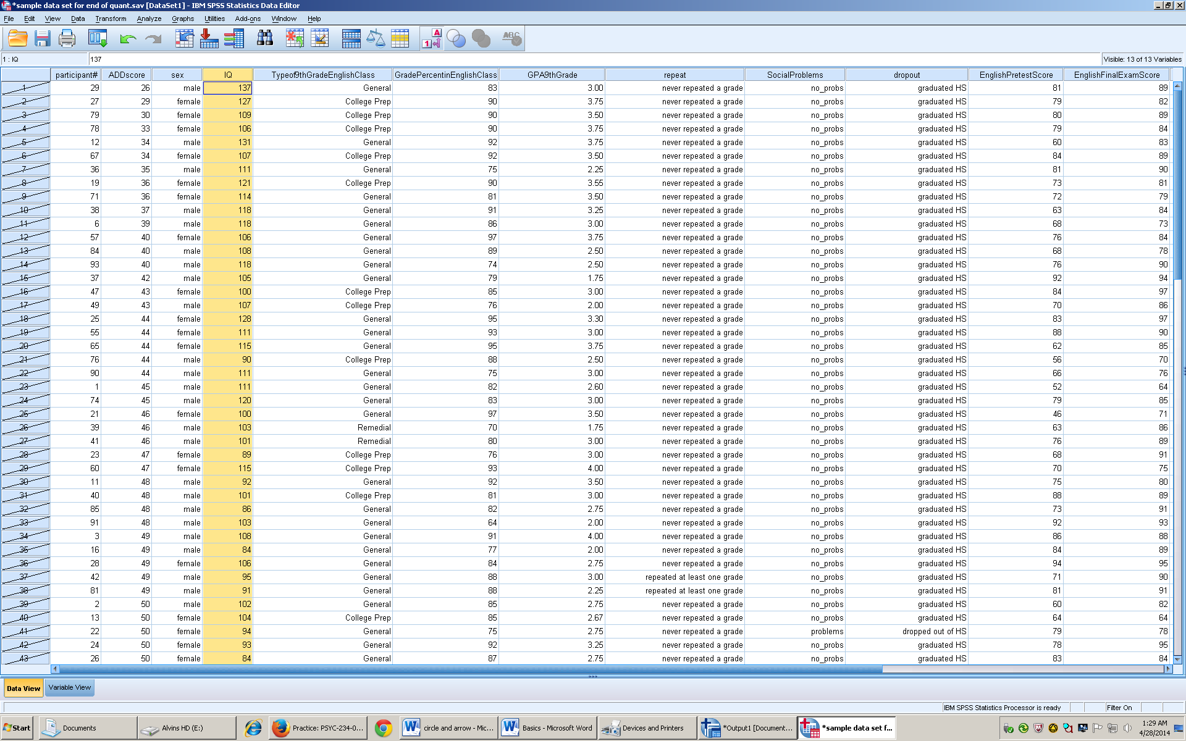
- How to Transcode a variable
  - Highlight variable in data view
  - Click transform tab
  - Recode into different variables
  - 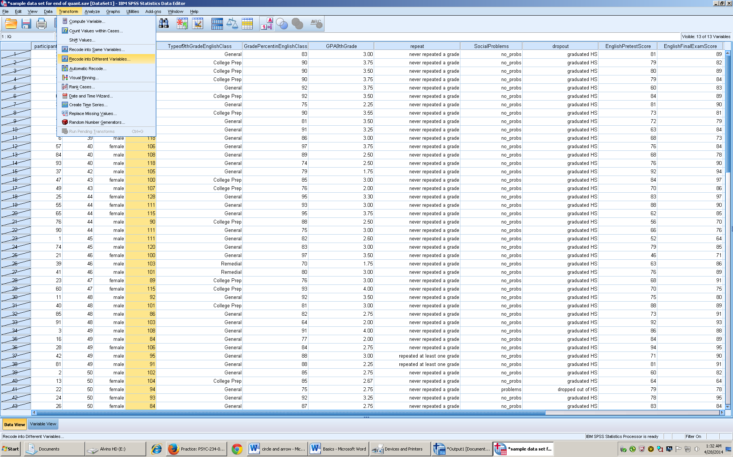
  - Arrow over the variable to be transformed
  - Rename the new column under output variable
  - Click change
  - 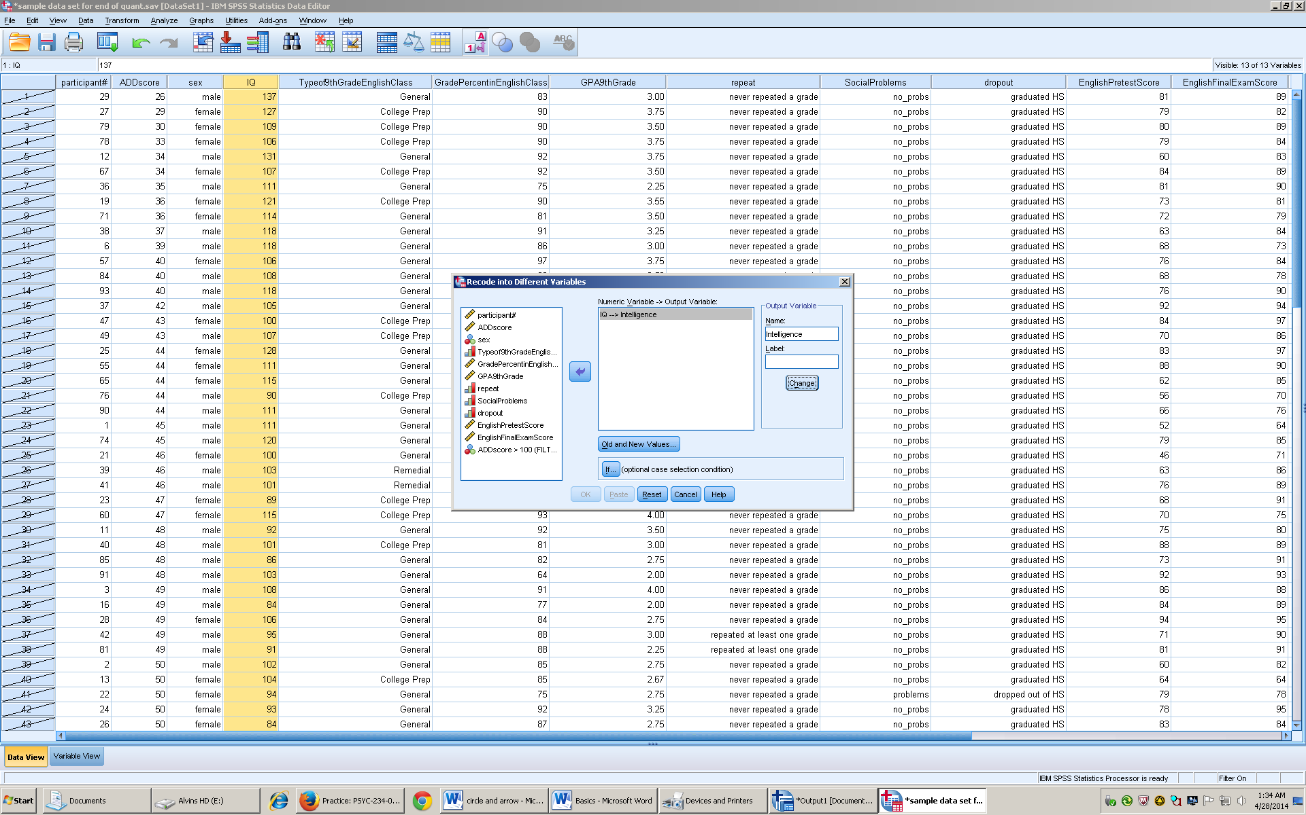
  - Click old and new values
  - 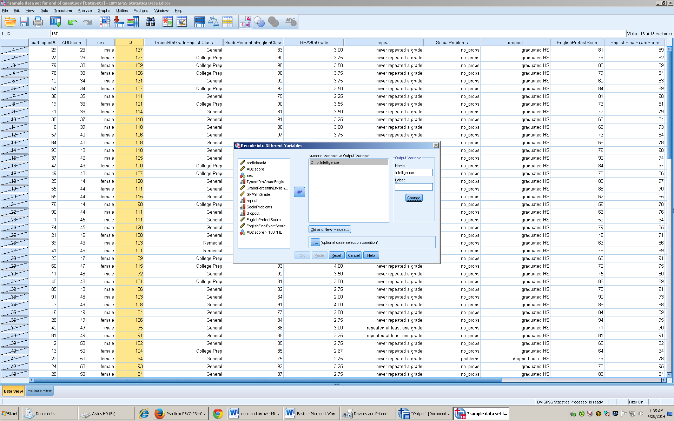
  - Click one of the ranges and input the data you want to fall into the transformed data set
  - Click output variables are strings (letters)
  - Type the new value under new value box
  - Click add
  - Then continue
  - 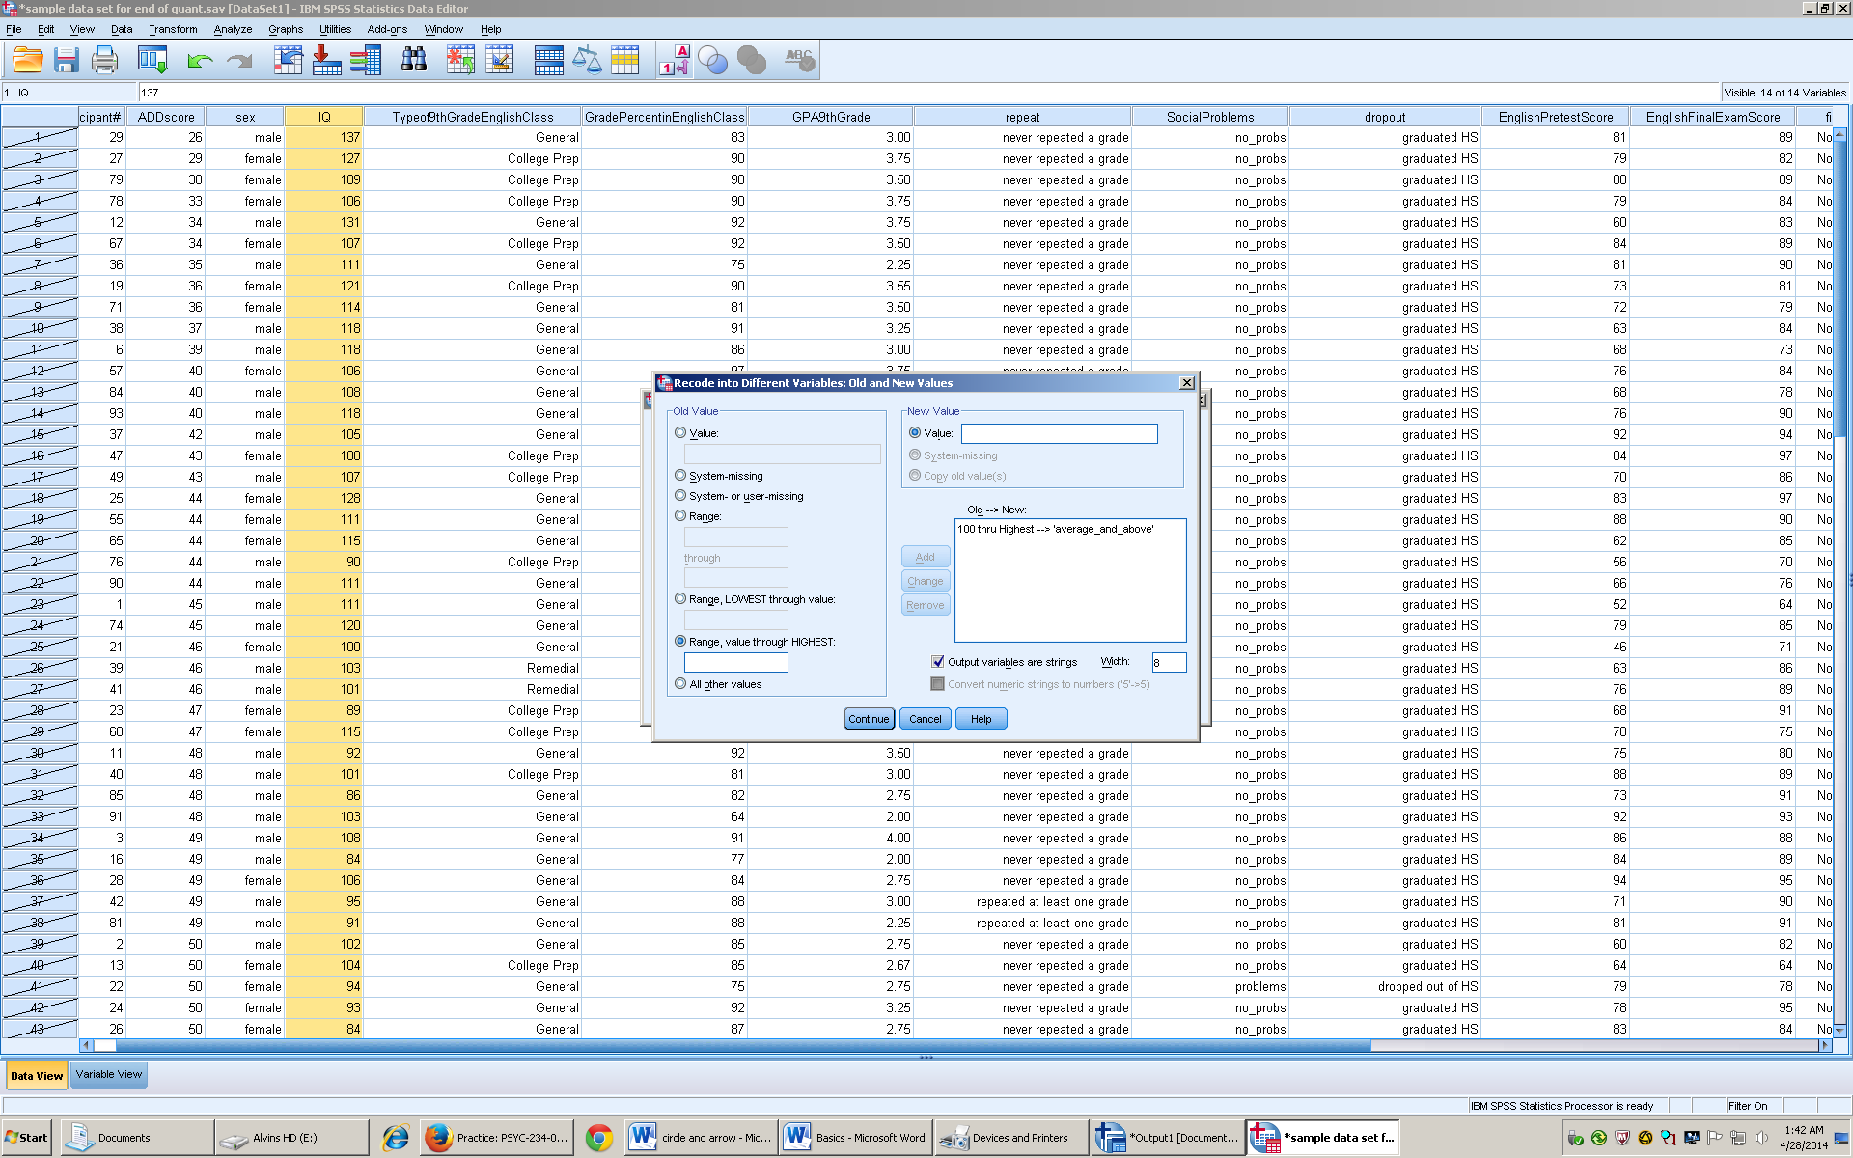
  - Click ok
  - 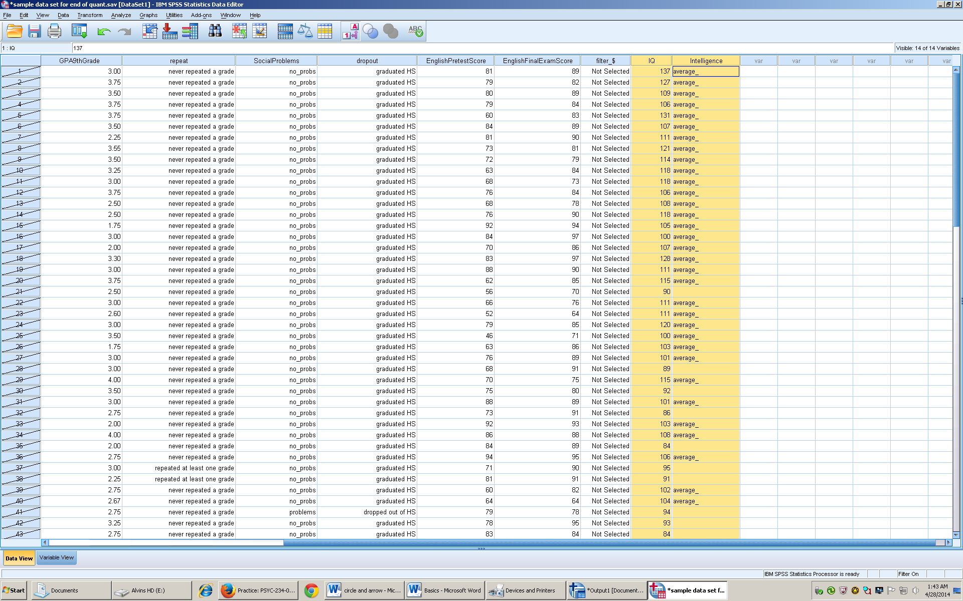

Stats basics
- Descriptive vs inferential data
  - Descriptive – offers descriptive without applying to the population
  - Inferential – tries to obtain an accurate sample to represent the population
- Measurement scales
  - Nominal- categorical data
  - Ordinal – numbers of order but not equidistant
  - Interval- order of numbers that are equal in distance but do not have an absolute zero
  - Ratio – order of number that are equal in distance but have an absolute zero
- Descriptive Stats
  - Mean- The average of scores or data
- Variability
  - Deviation Score- how far is one score away from the mean 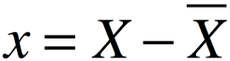
  - Standard deviation – average distance of all scores from the mean 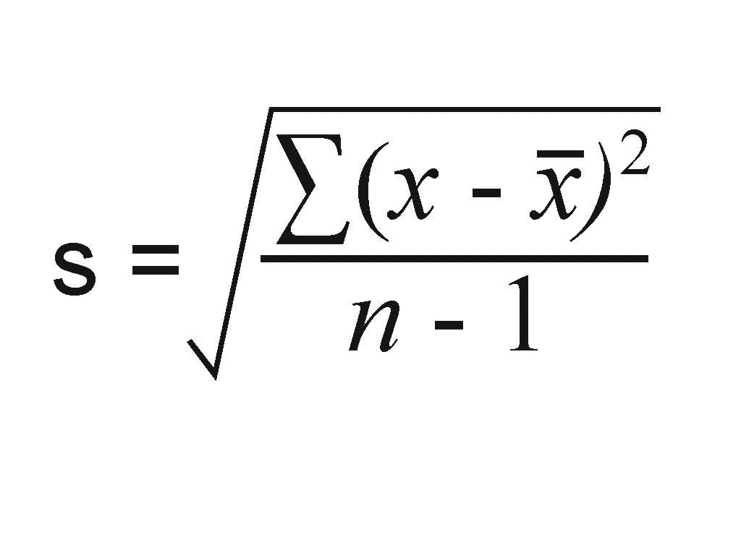sample 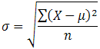population
    - Sum of Squares = the adding of all the squared sums 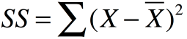
  - Variance – shows difference within a sample or population
  - Sample 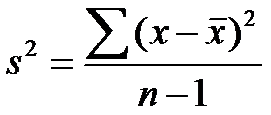population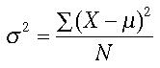
- Standard Distribution 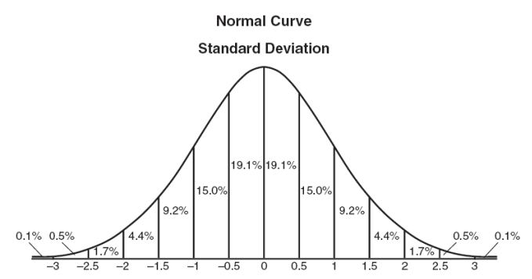
  - Symmetrical
  - Central score occurs most frequently
  - Tails
  - Asymptotic – never touches the x axis
  - Theoretical distribution
  - Population values
- Z- scores
  - Transform normally distributed variables into standard normal distribution
  - 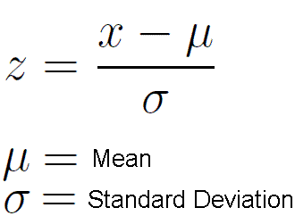
- Hypothesis
  - Independent Variable (IV)– the variable that will be manipulated causes change in DV
  - Dependent Variable (DV)- the variable that will be measured
    - Operational DV- how you are measuring the DV
  - Null Hypothesis – The IV will not Change the DV - H₀ = X̅₁ = X̅₂
  - Alternative Hypothesis – The IV will change the DV- H₁ = X̅₁ ≠ X̅₂
- Types of error
  - Type 1 – False positive
  - Type 2 – False negative
- Alpha Level α- The chance of type 1 error, picked arbitrarily but .05 and .01 are most common
- Statistical Power
  - Increases the chances of rejecting null
  - Sample size increase
  - Higher alpha level
  - Lower variability
  - One tail testing

Symbols
  - Σ= summation (add all numbers)
  - σ = population
  - s = sample
  - α= alpha level or chance of type 1 error
  - f – f values for ANOVA
  - t – t values for t tests
  - z – Z-scores
  - η² = eta squared effect size for ANOVA
  - Cohens d = effect size for samples

Frequency Polygon
- Background
- Shows the shape of distribution
- Shows the frequency of numbers in a set
- End points are joined to the x-axis
- Excel
- Open excel
- Make two columns that show the variable in one and the frequency of variable in the other
- 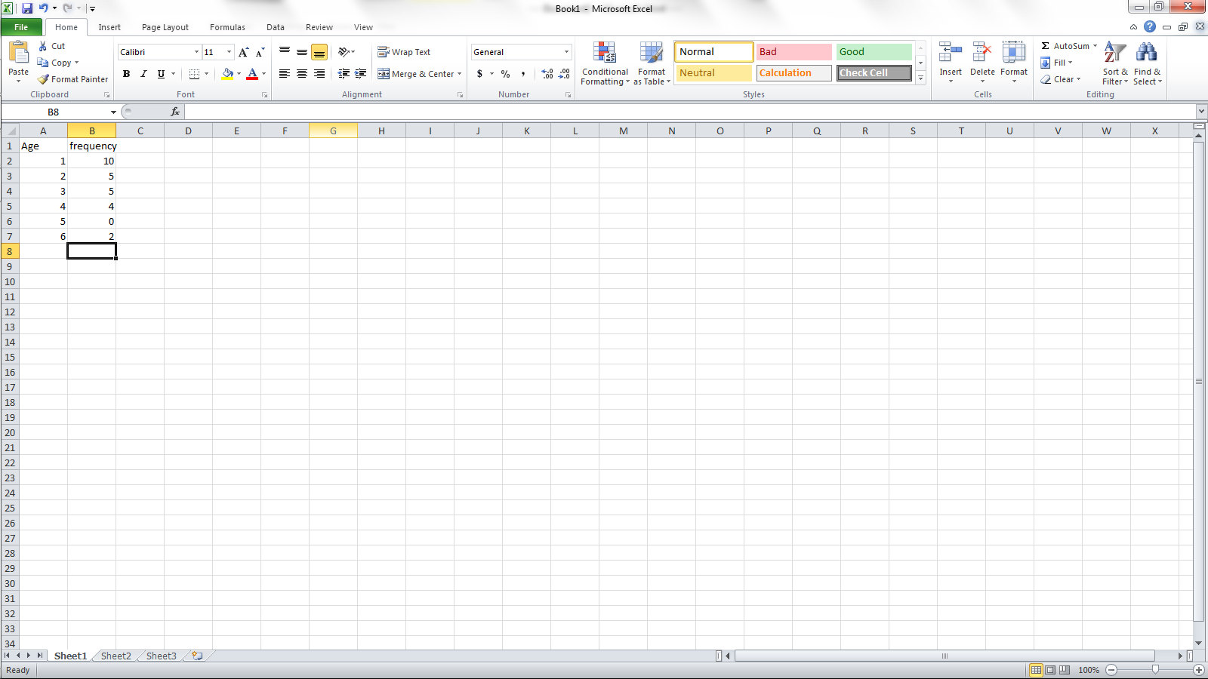
- Use ctrl to highlight all the cells in your data
- 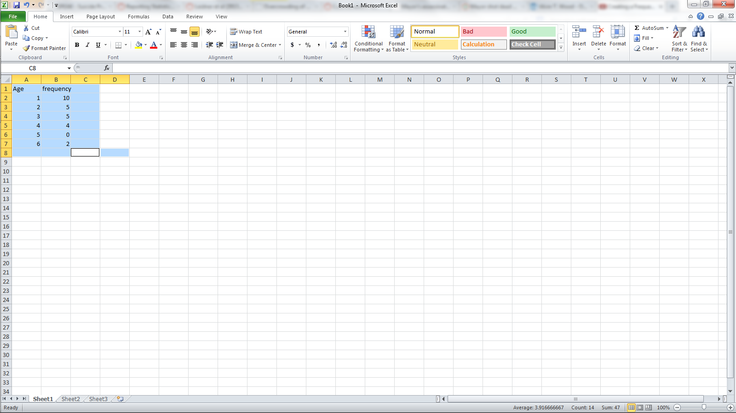
- Click insert on the menu bar
- Choose line
- Choose line with markers
- 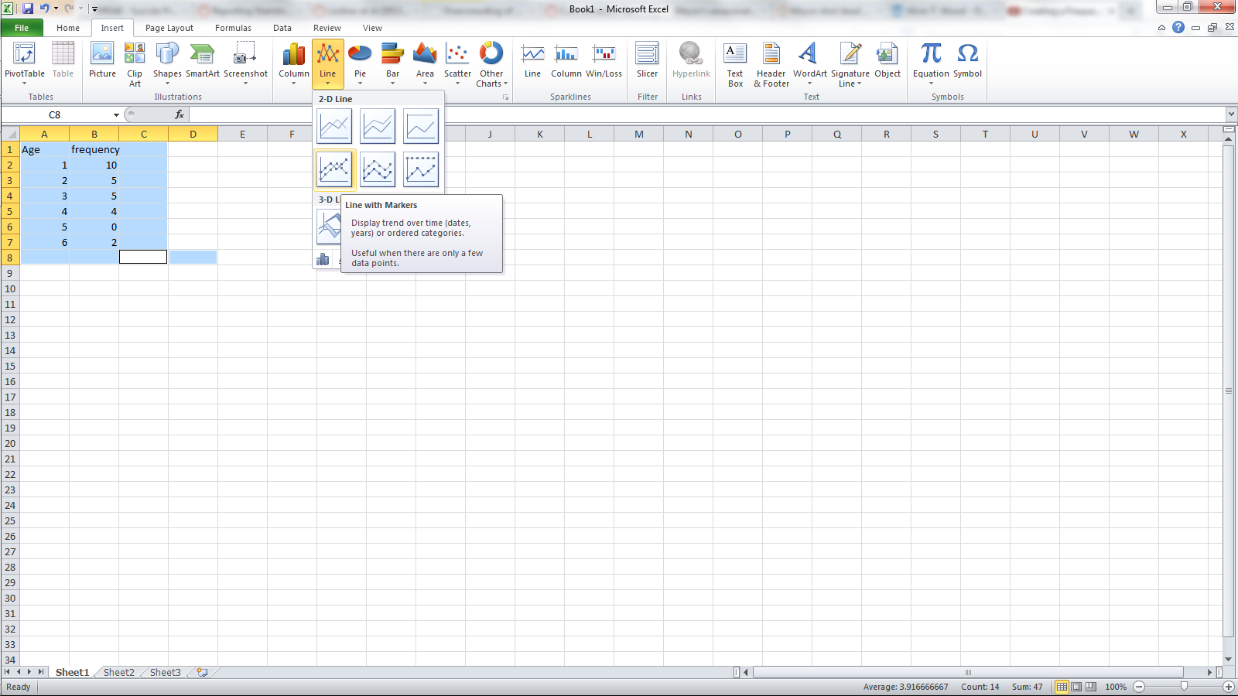
- When the graph comes up right click
- Select data
- 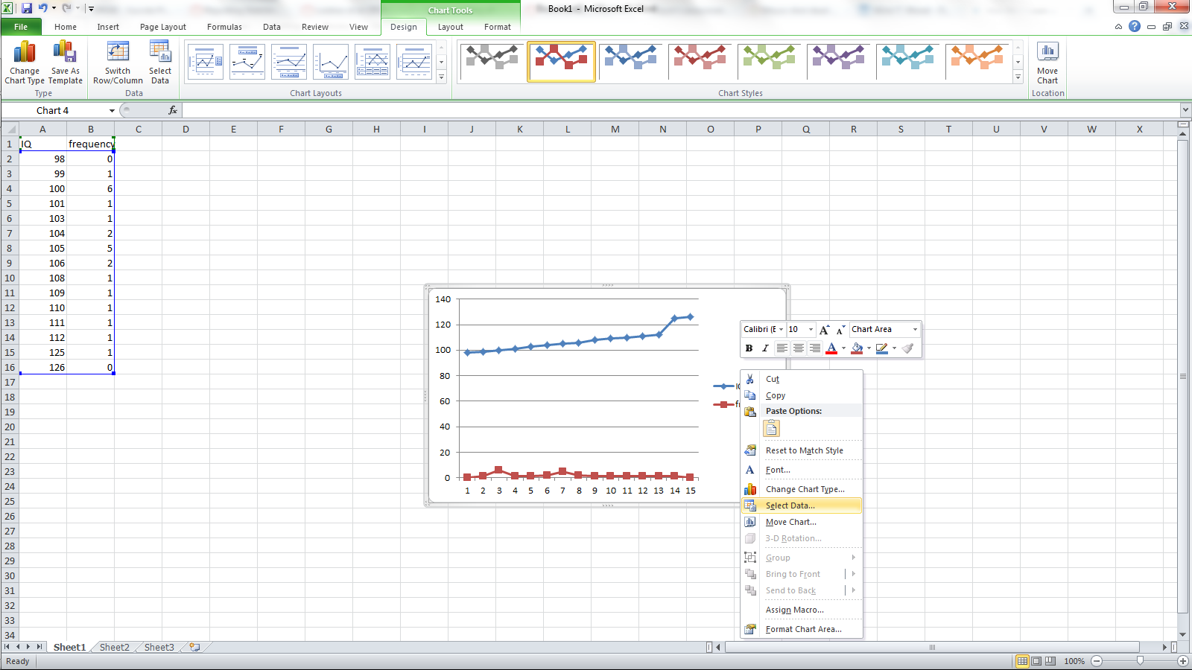
- Then choose your variable in the list and click remove
- 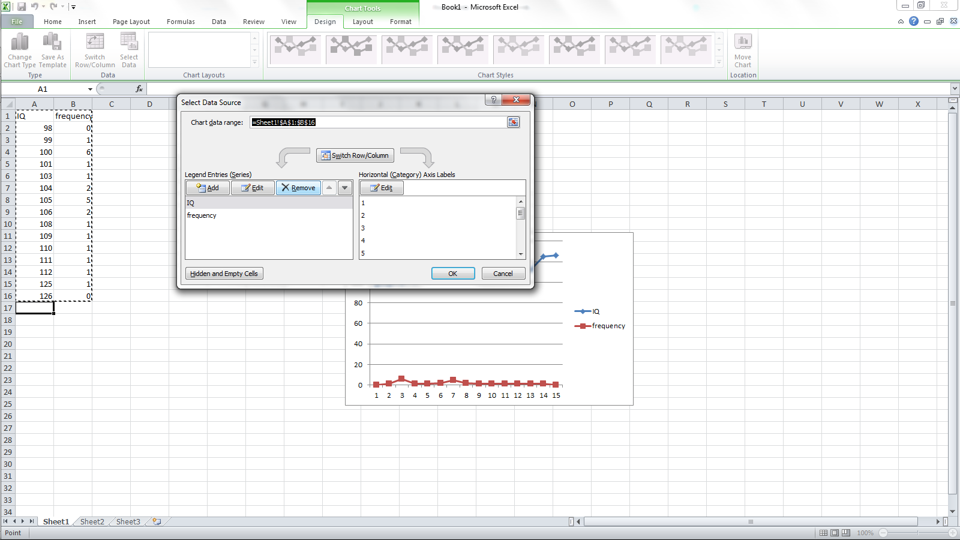
- Under horizontal category click edit
- Highlight your variable(just the numbers) in the table and click ok
- 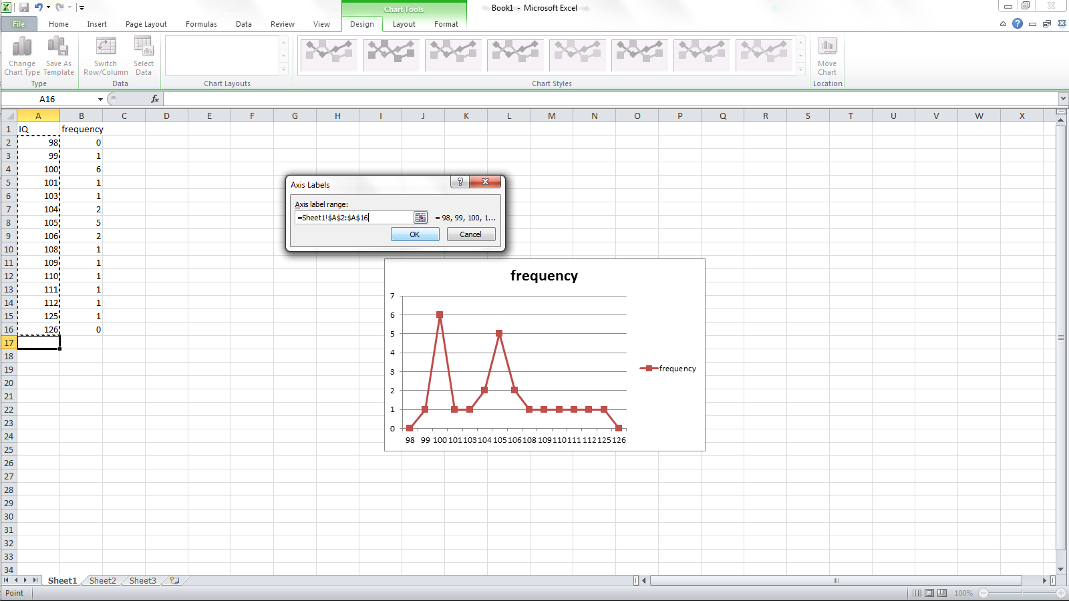
- Click ok
- Choose chart layout that has titles for the axis
- Label the axis

- Figure

Figure 1. Frequency polygon of IQ scores in Principals of Geology class

Histogram
- Background

- Uses ratio and interval data
- Bars touch in continuous data set
- Bars represent frequency

- SPSS
- Open SPSS
- Switch to variable view and enter name of data.
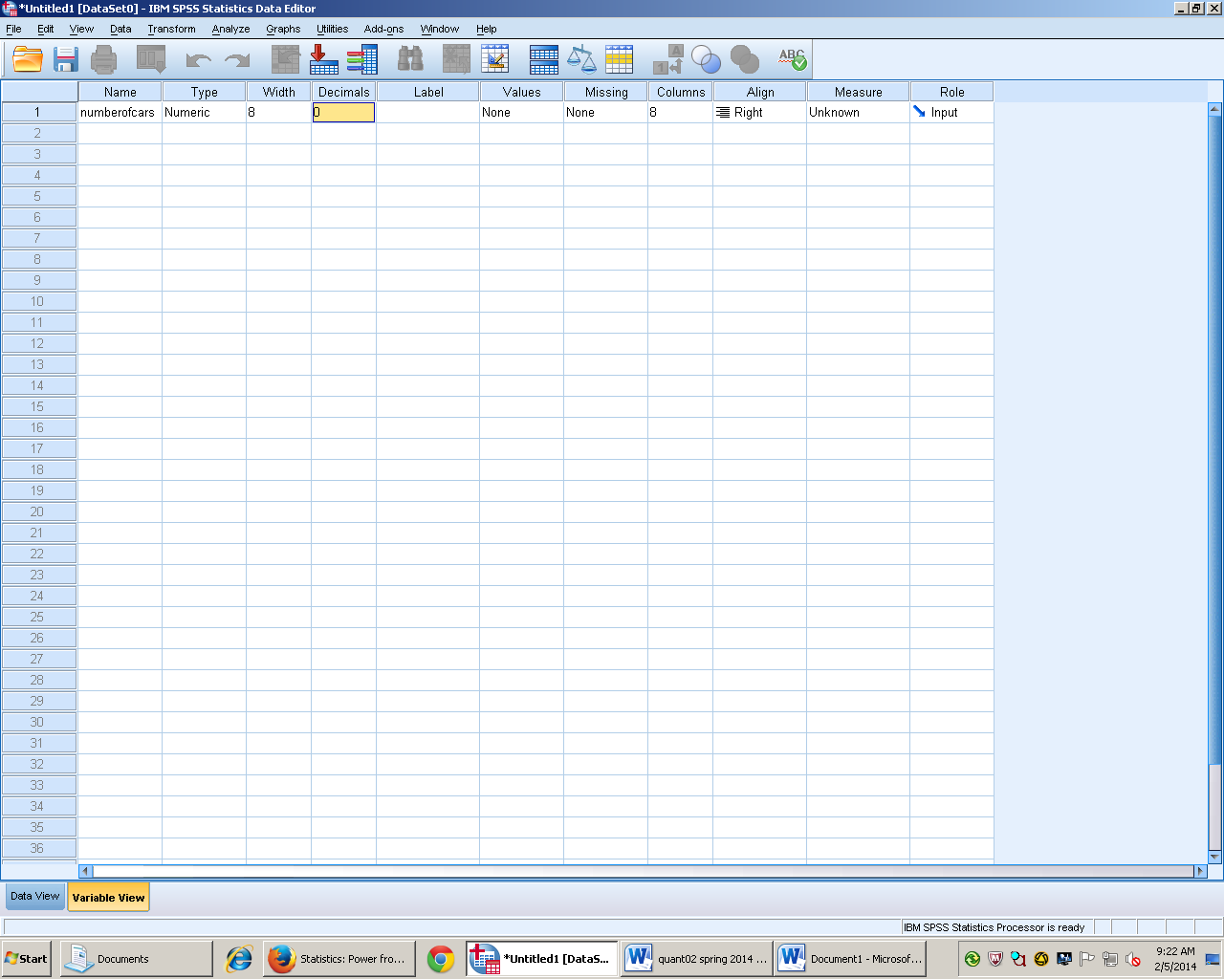

- Switch to data view and enter data
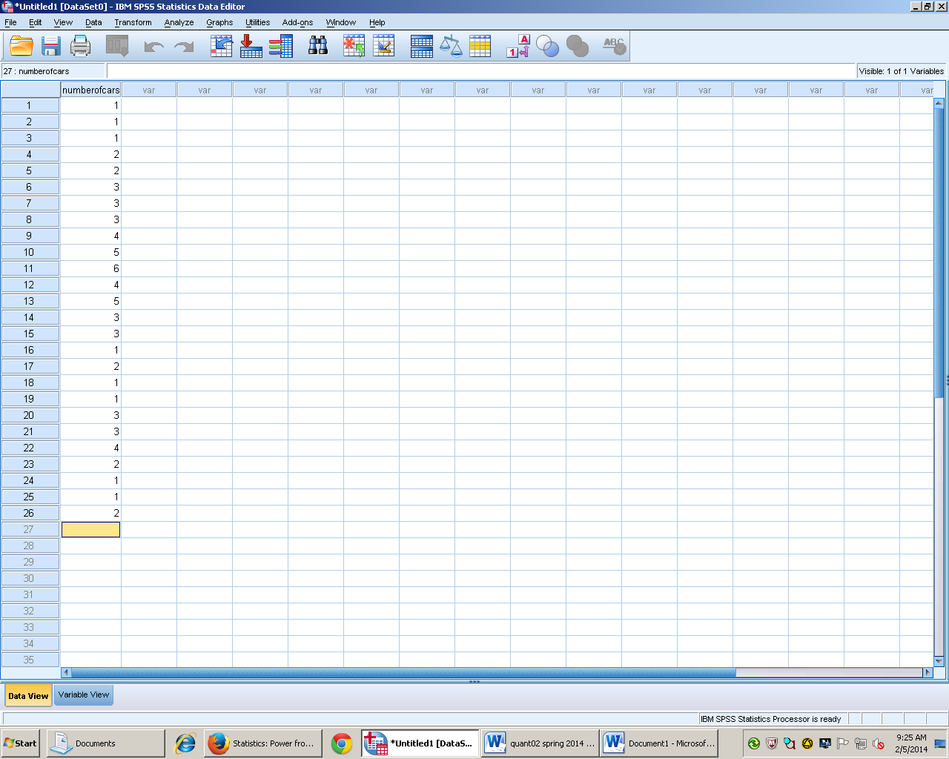
- Go to graphs tab
- Then highlight legacy dialogs
- Then click Histogram
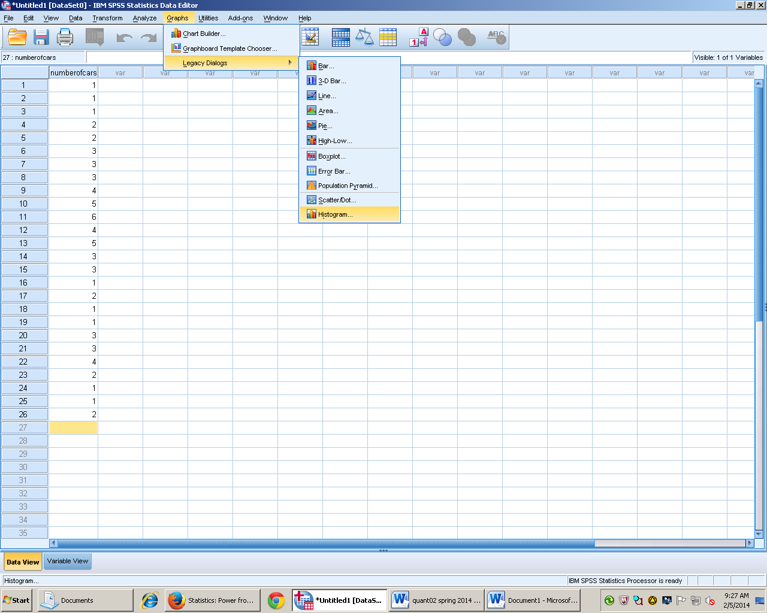
- Click arrow to add data set to variable
- (optional) click box that say display normal curve.
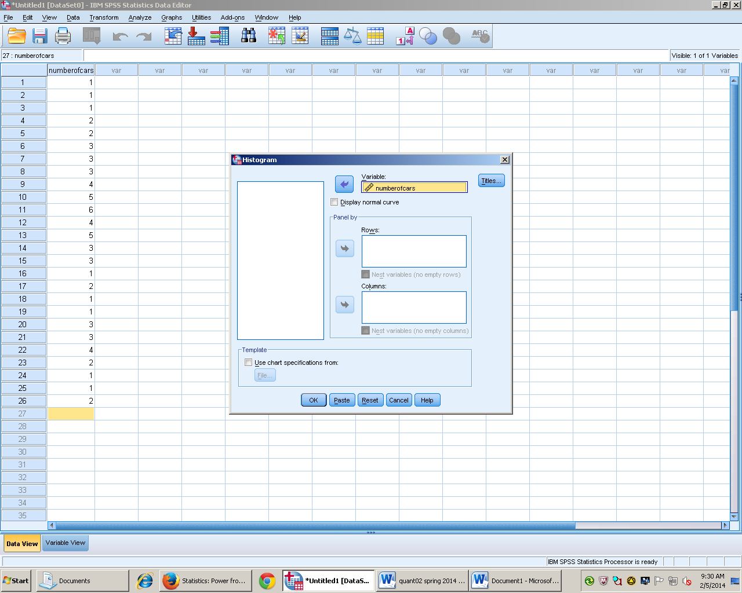
- Click on ok to create graph
- (optional) double click bars to make any changes.
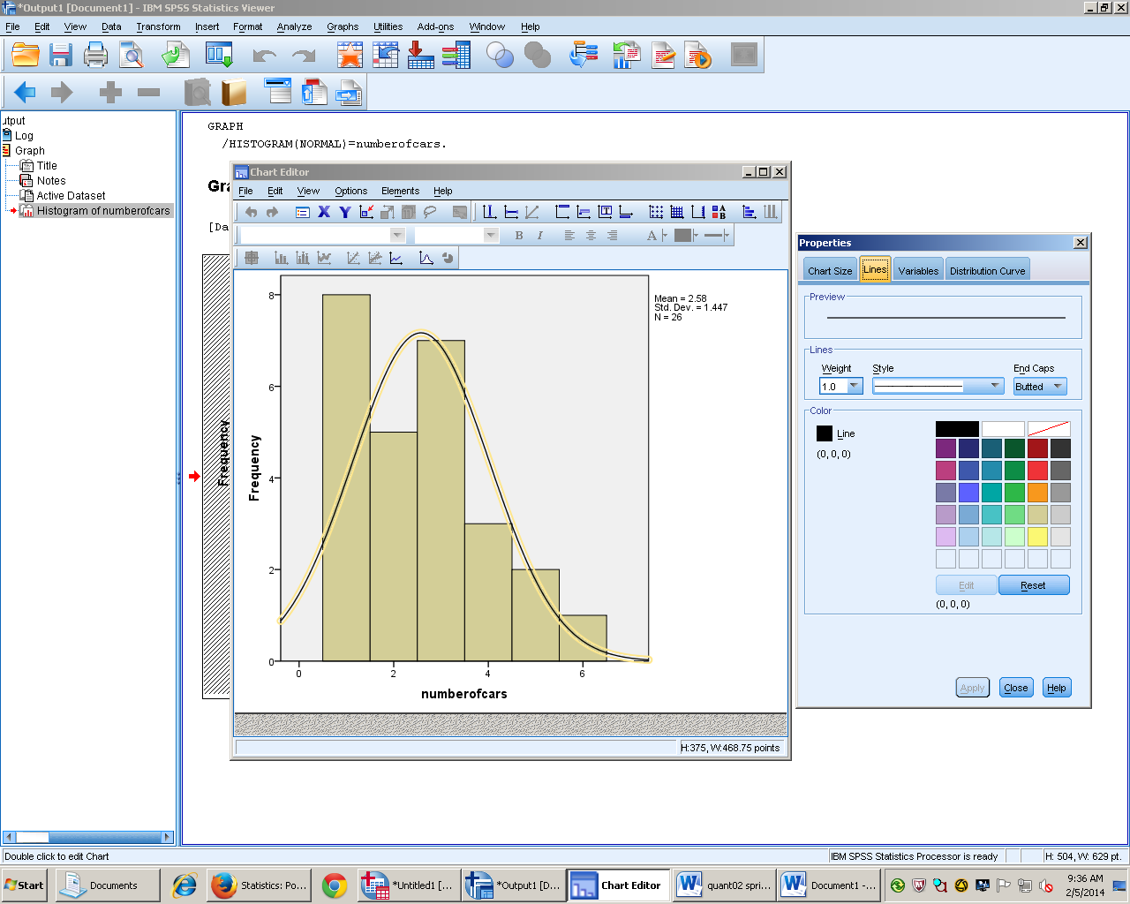

- Make sure to delete statistics on the side to make APA figure.
- Import to Word and add the figure number and description
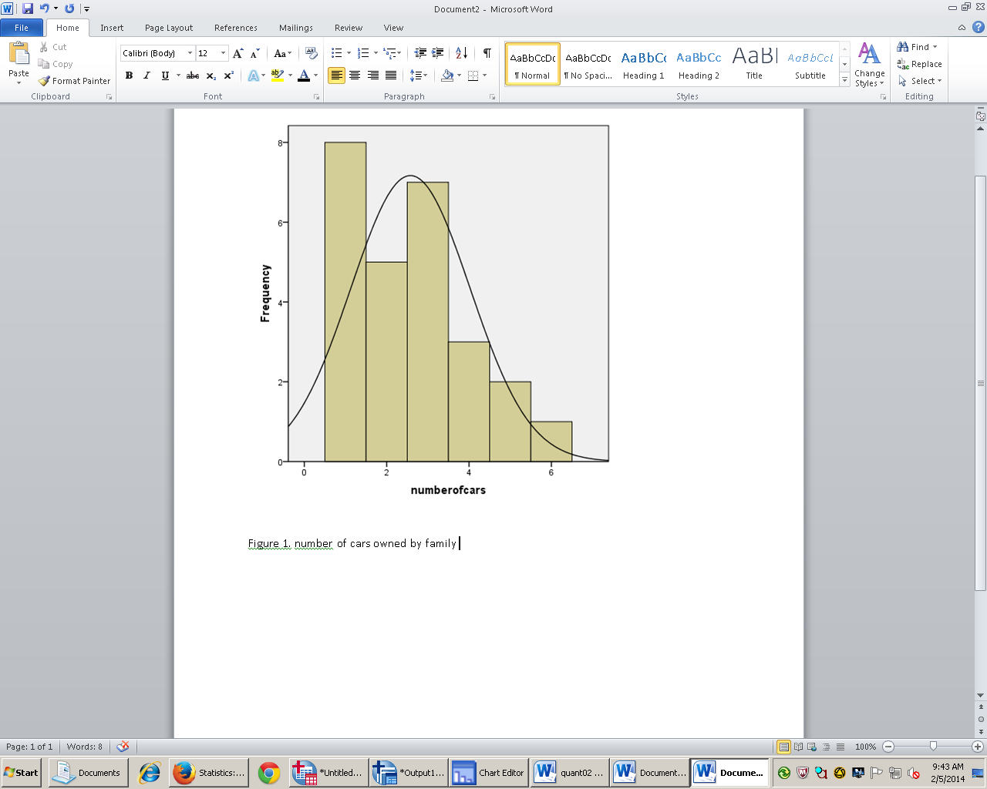

- Results
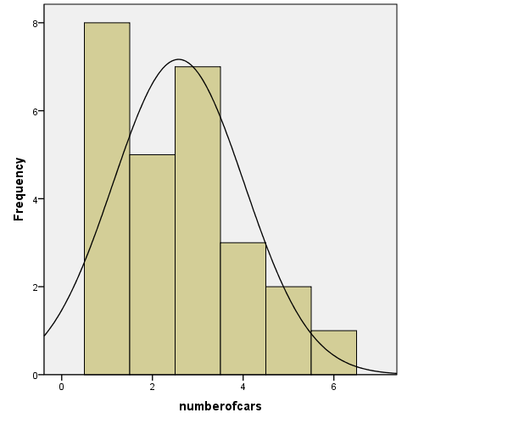
Figure 1. Number of cars in Williamsburg family

Bar-Graph
- Background
- Shows the frequency of occurance in data
- Bars do not touch
- Quickly able to compare data
- Excel
- Open Excel
- Input the variable in one cell and the frequency in another
- Input data into cells below the different categories and the frequencies that they occur
- 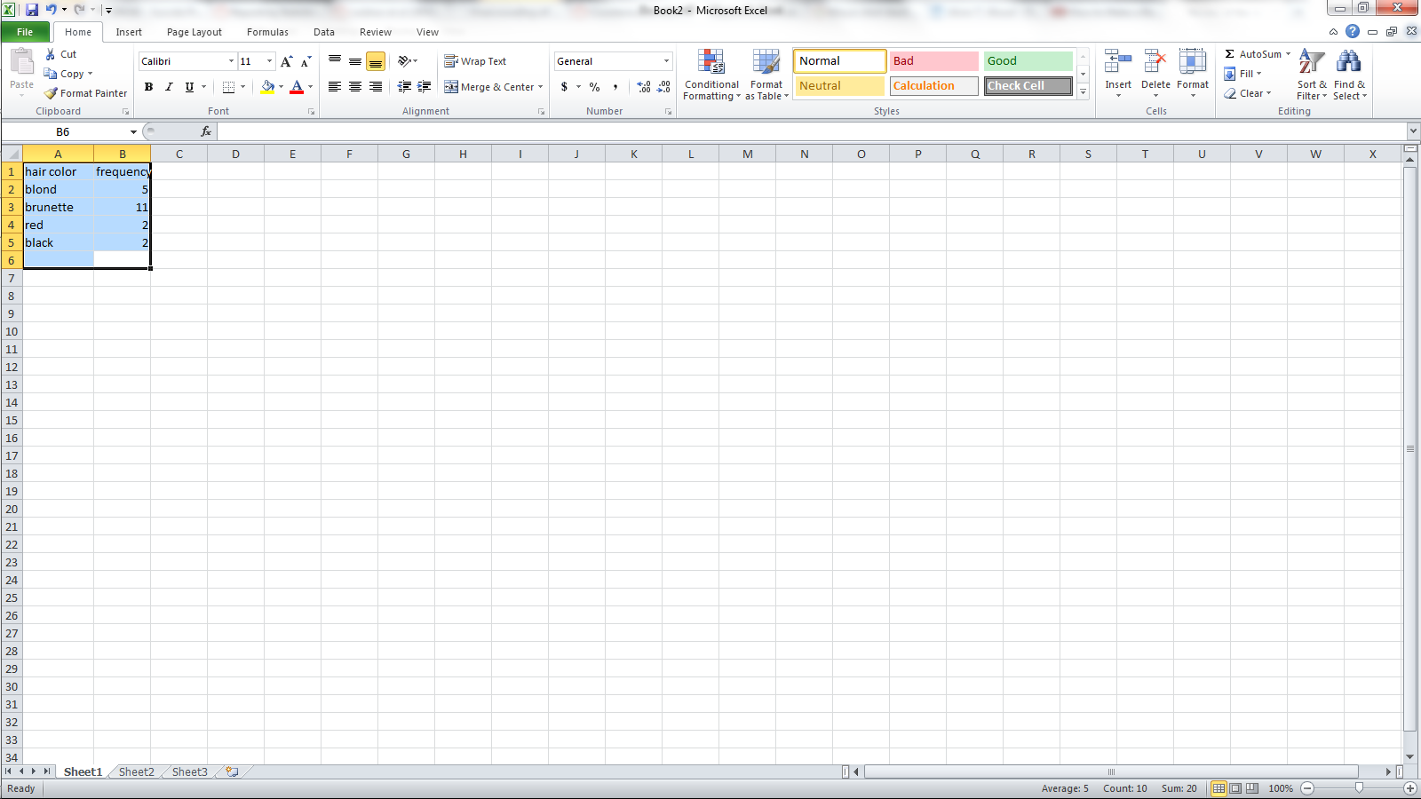
- Select all of the data input
- Click insert
- Click column, cluster column
- 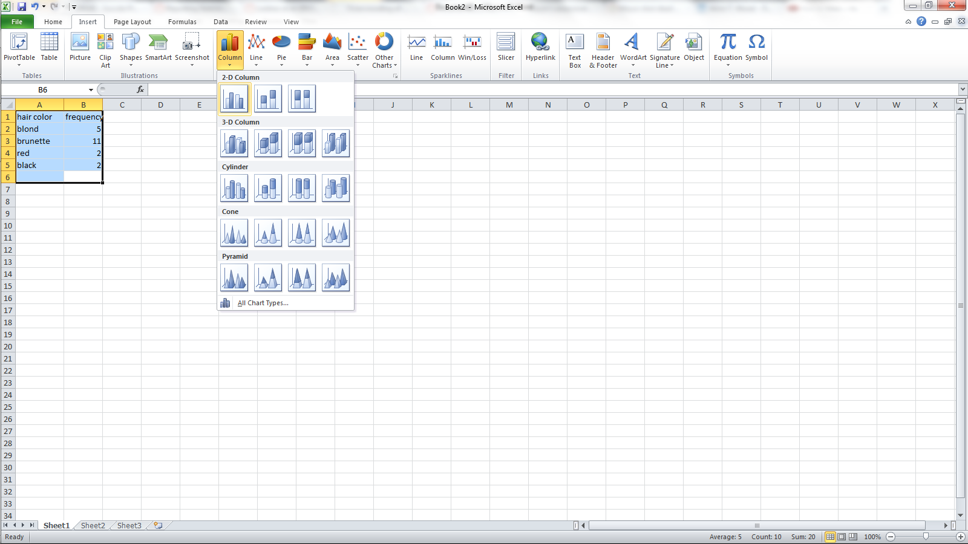
- Click the design tab and scroll until the layout with both axis labeled choose this one
- 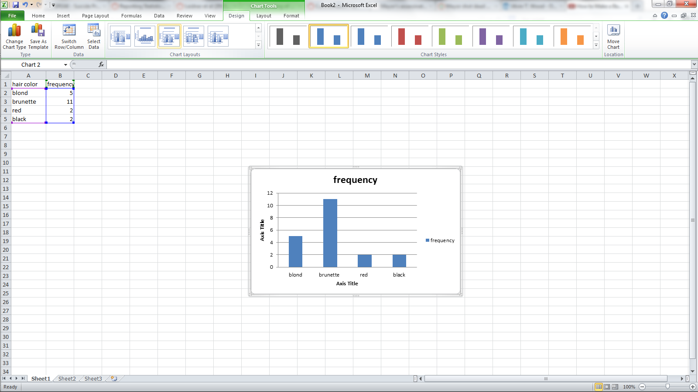
- Delete title and frequency box in table along with the boarder
- Add titles to the axis

- Results

Figure 1. Natural hair color of people wanting to dye their hair

Single Sample t Test
- Background
- Used when examining two groups of to see if they are significantly different
- Use when μ is known but σ is not
- Assume that variance is similar in the comparison group
(homogeneity)
- X bar = 0 and Sx = 1
- The shape of distribution changes unlike standard normal distribution the smaller size makes it flatter on the top
- Compares 1 sample group with the general population
- Formulate H₀ and H₁

- Open SPSS
- Go to variable view
- Name data
- Change measurement to scale (if required)

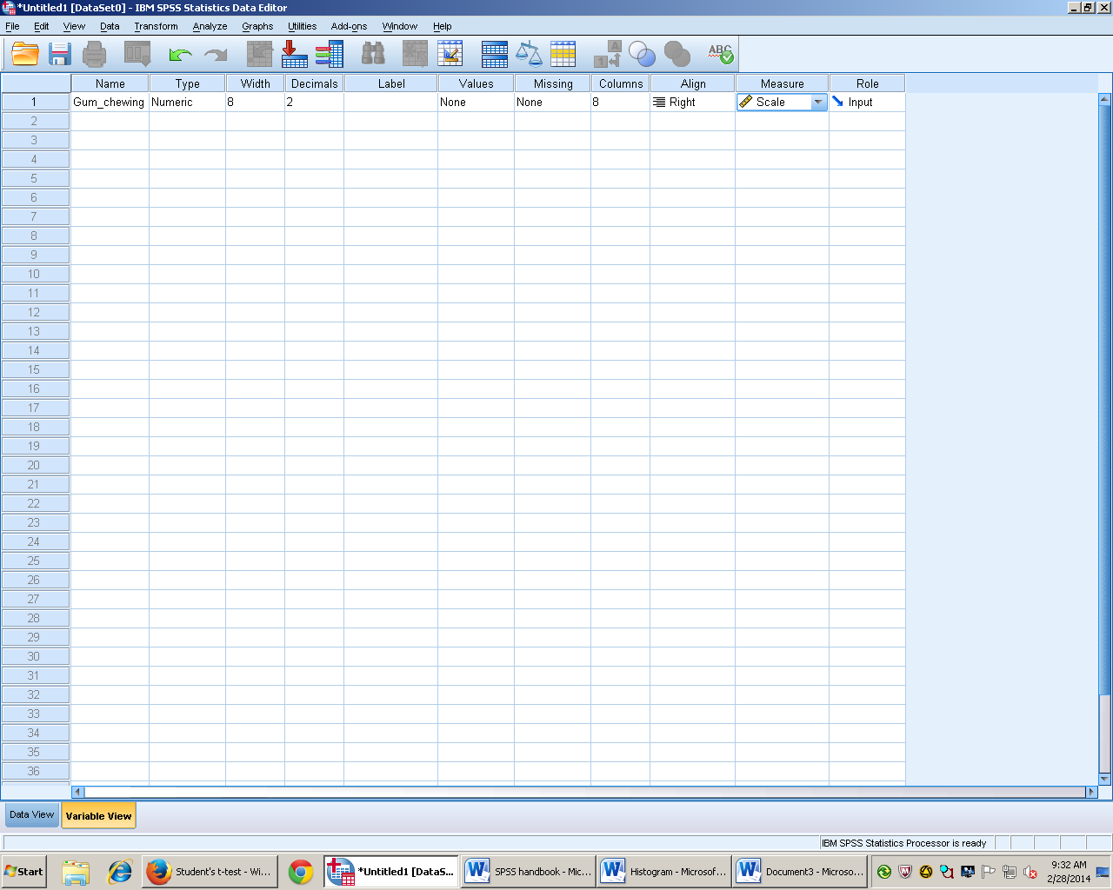

- go back to data view and enter data
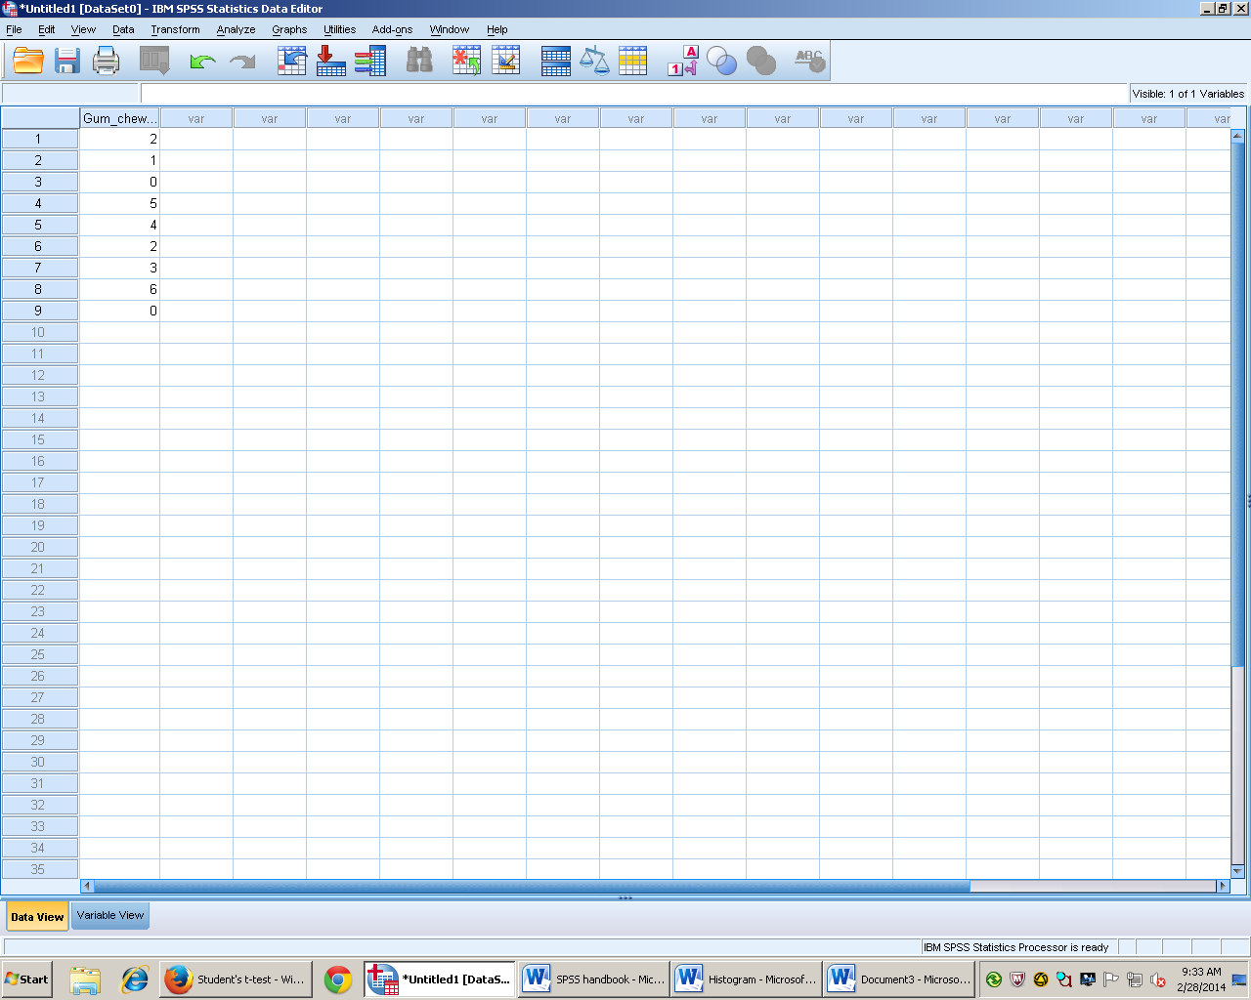

- go to analyze
- then compare means
- and one- sample t test
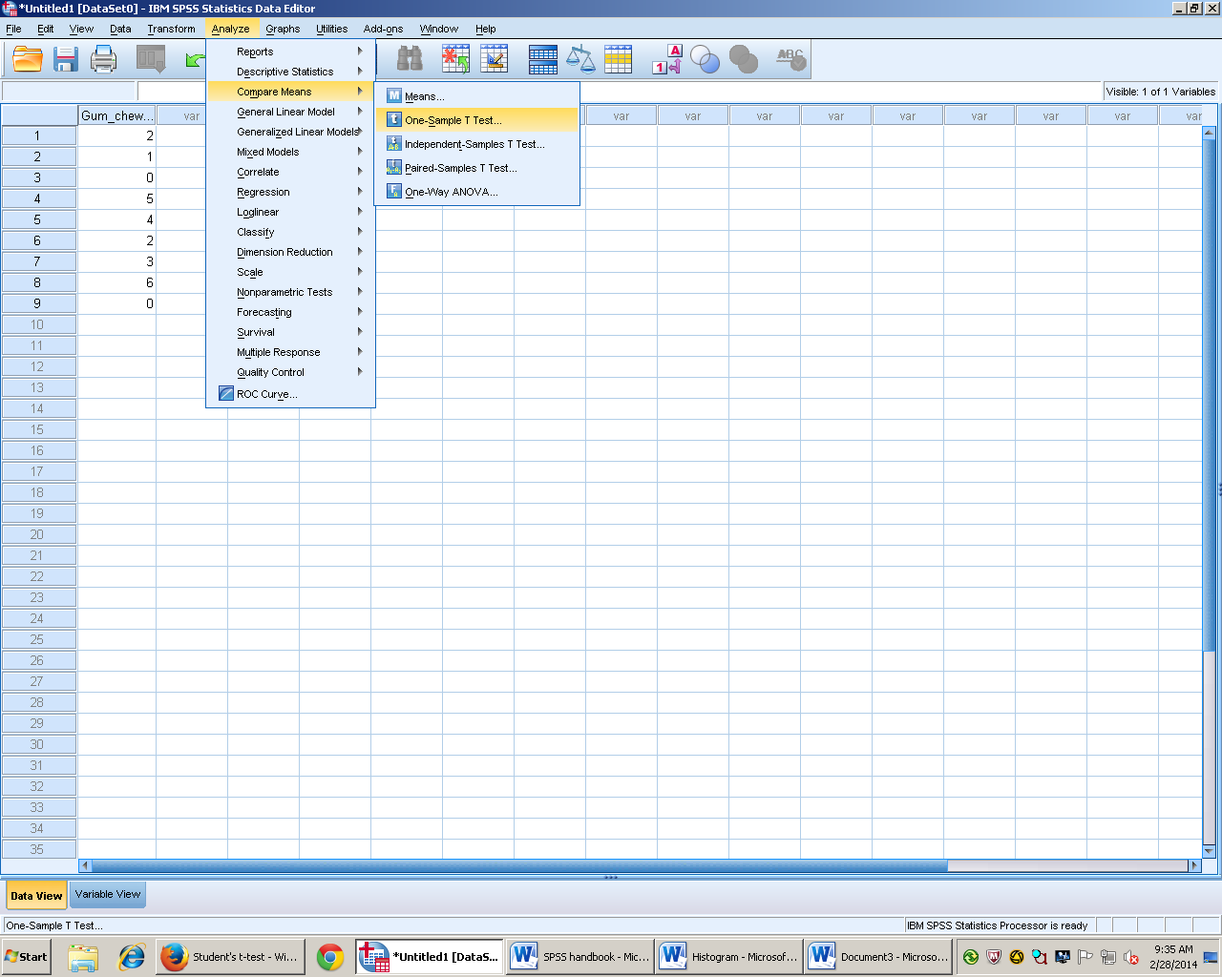

- move sample name over
- give sample test value which equals population mean
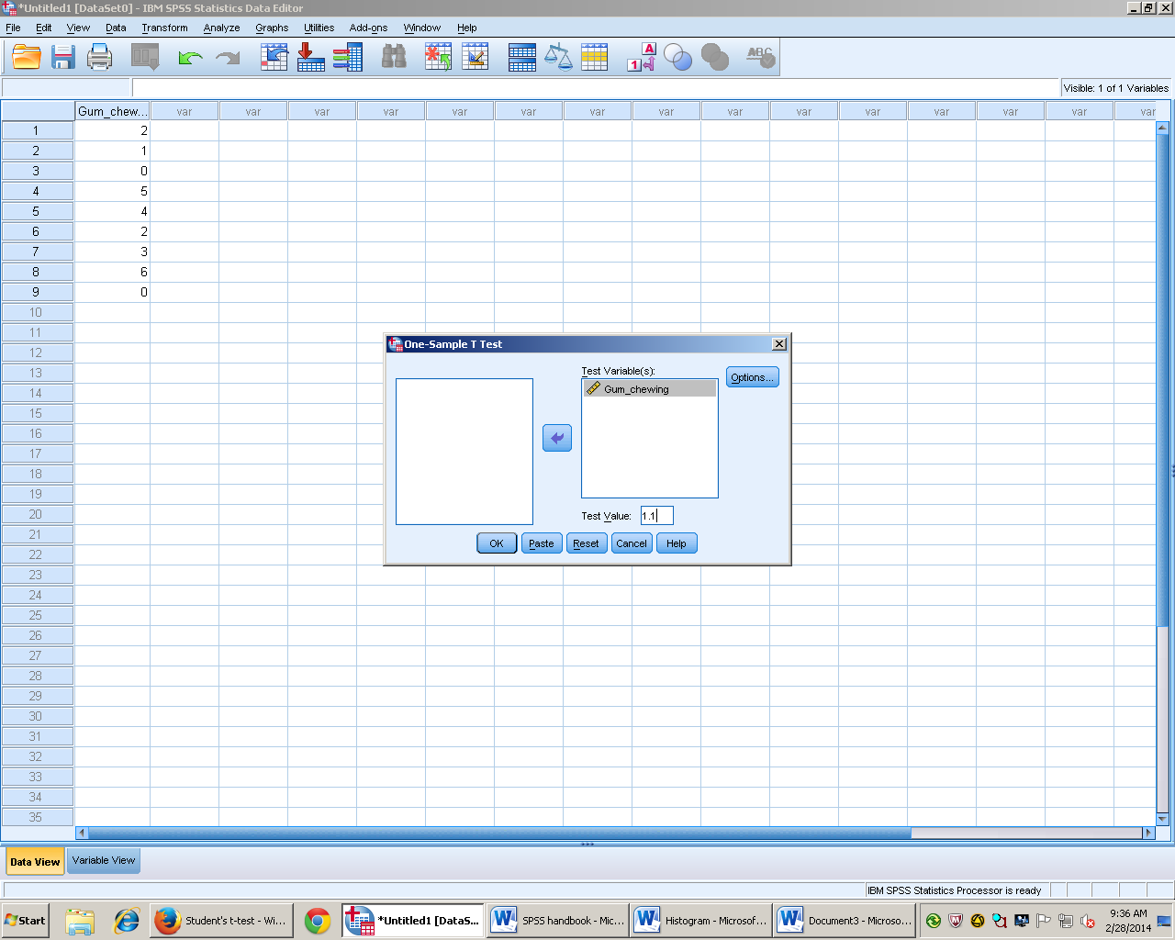

- Click OK
- Two Boxes will show results
- If the t test title is double clicked the title can be changed
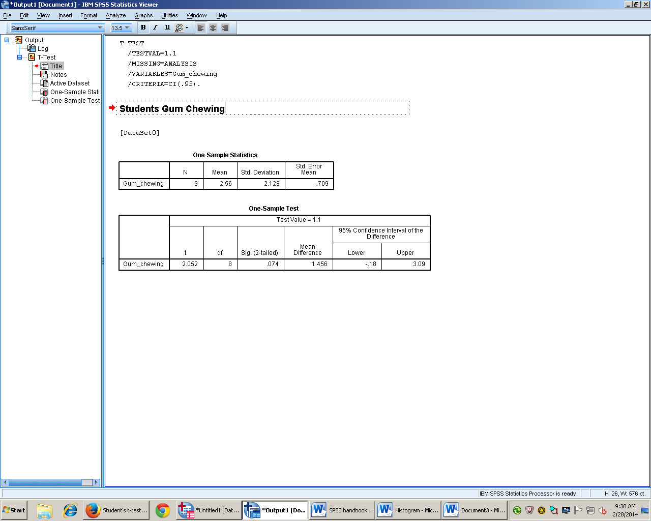

- T value shows how many S_{x} away the sample is
- Calculates the DF or degrees of freedom for n-1
- Sig 2 Tailed calculates exact chance of type 1 error
- Results
Results
A single sample t test showed no difference between our sample (M= 2.56, SD = 2.128) and the population, t(8) = 2.052, p = .074, 95% CI[-.18, 3.09].

Independent t test

- Background

- Used when examining two samples to see if they significantly differ from one another
- Between groups design- two different samples
- μ, and σ are not known
- Assume that variance is similar between samples
- 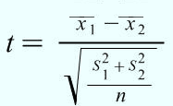 Standard area of the difference or Pooled Variance
- Degrees of freedom= N-2 ( sample number minus 2)
- Open SPSS

- Go to variable view and make participant number column

- 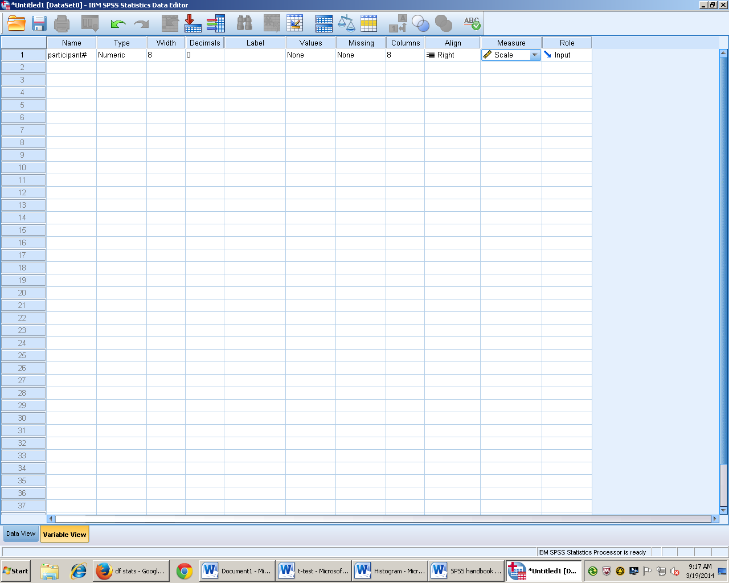
- Fill in participant numbers in data view
- Go back to variable view and in the next row fill in IV
- 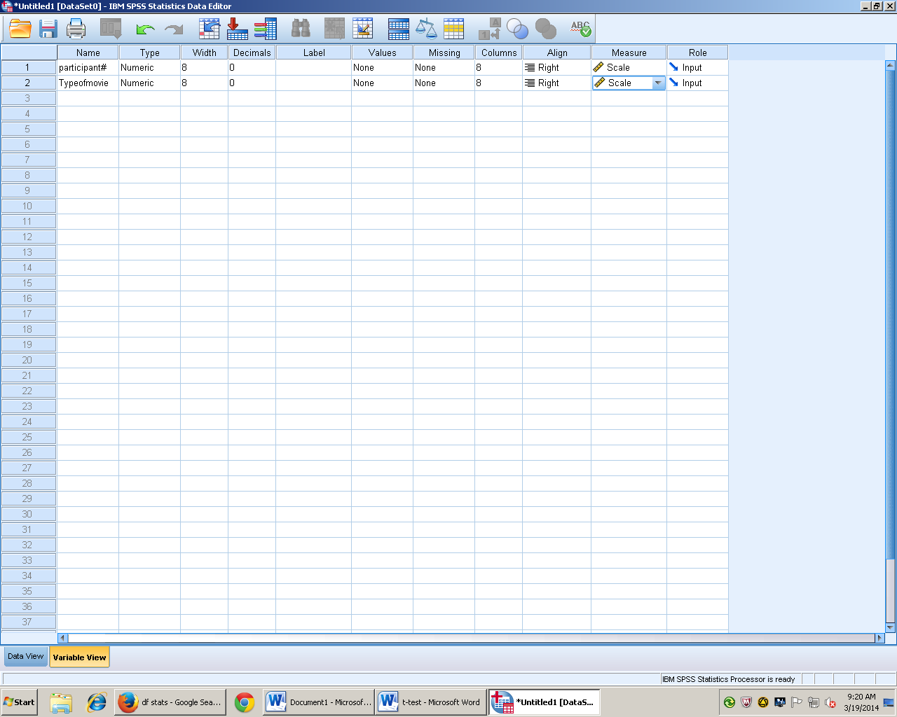
- Click values box and enter a value (any number) and a label (a word that the number represents In SPSS
- Do this twice once for each level of the test
- 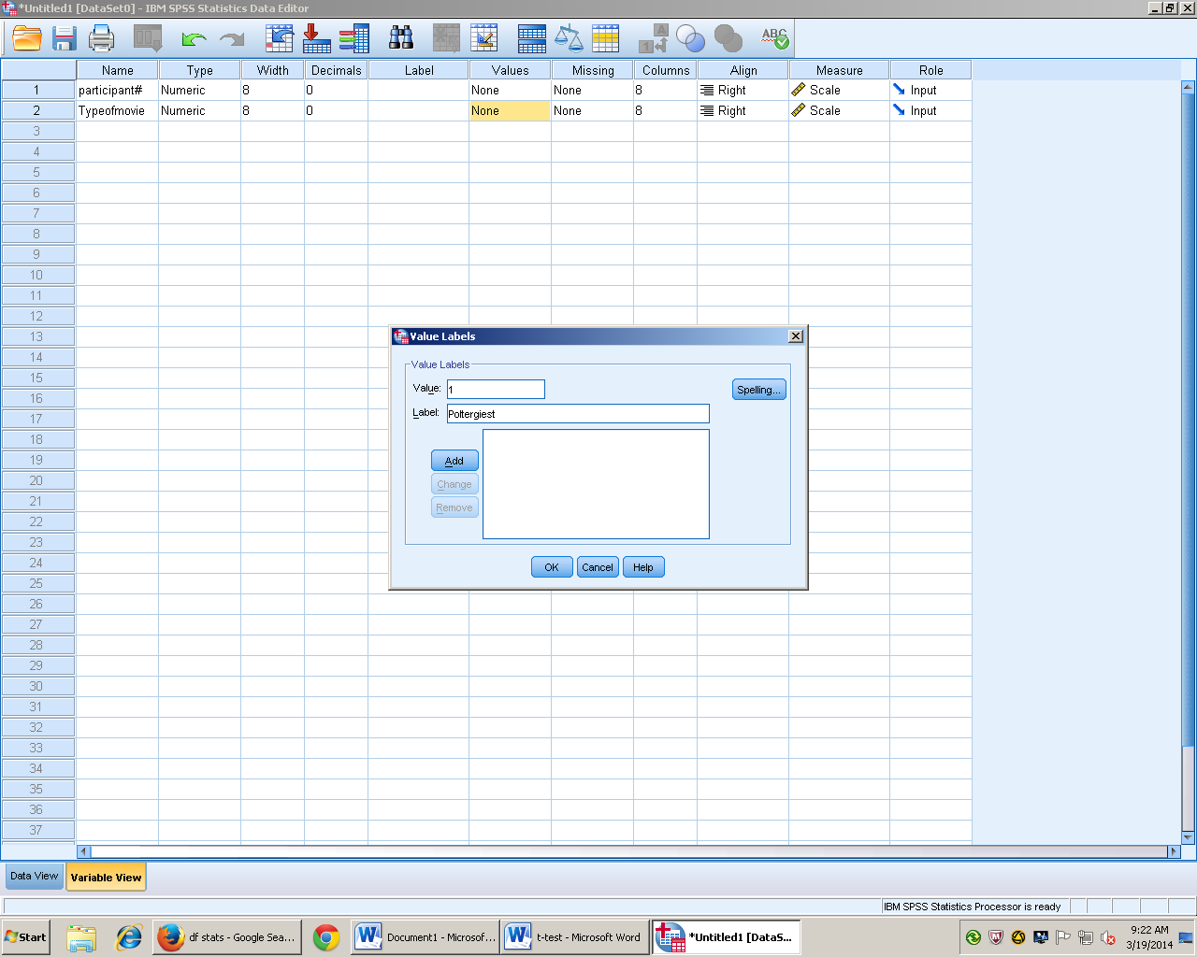
- Click add and enter second condition
- Click ok
- Next enter your values under your IV column in Data view there should be the same number of values as number of participants in each condition
- 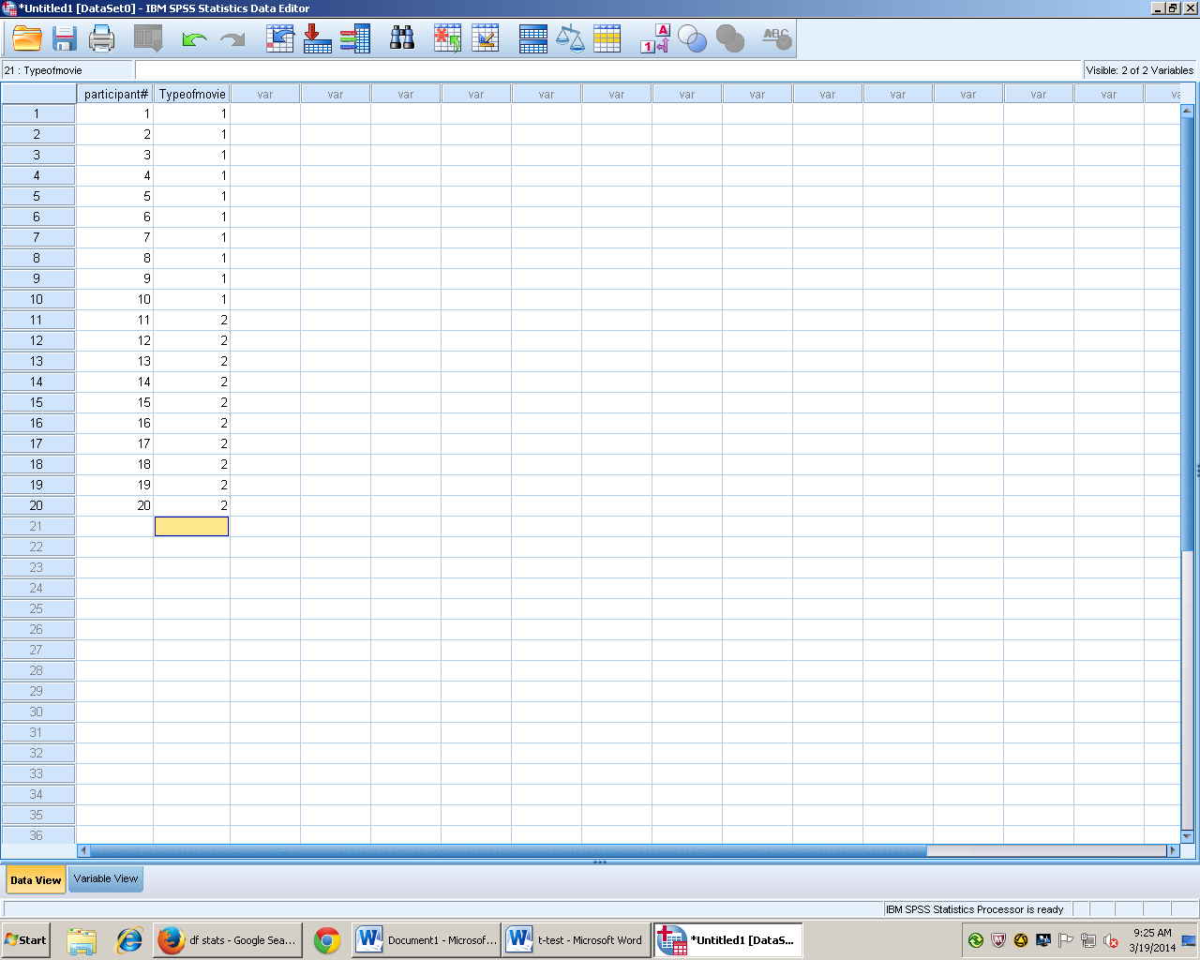
- go to view tab and click value labels 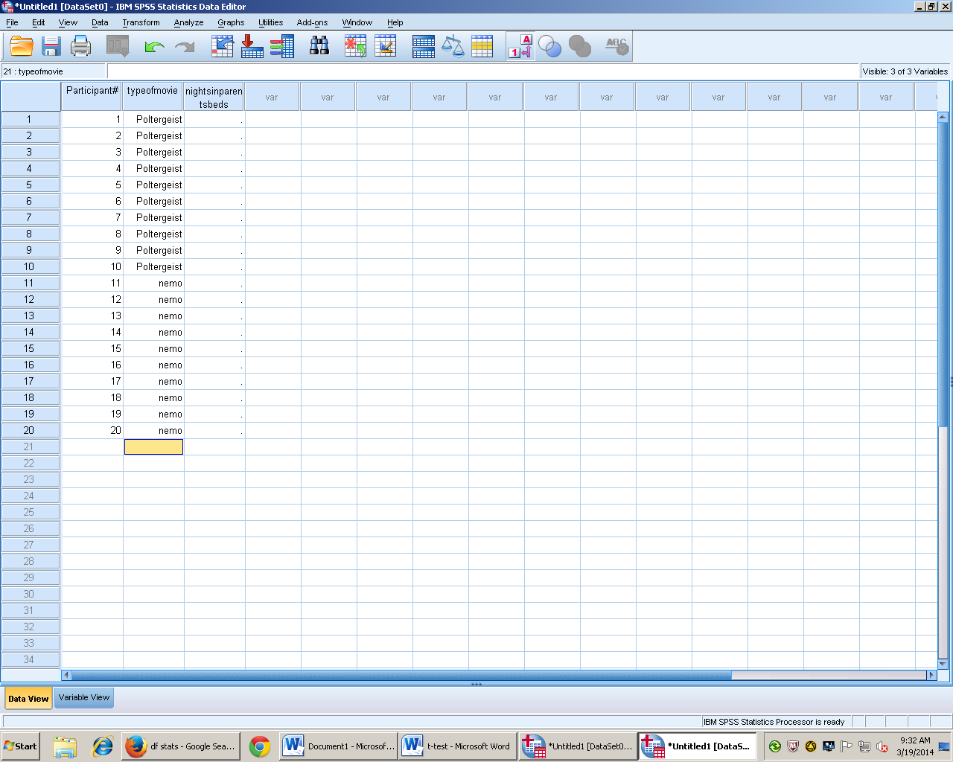
- The output in IV column should now be words instead of the values entered
- go back to variable view and in third column type in DV

- 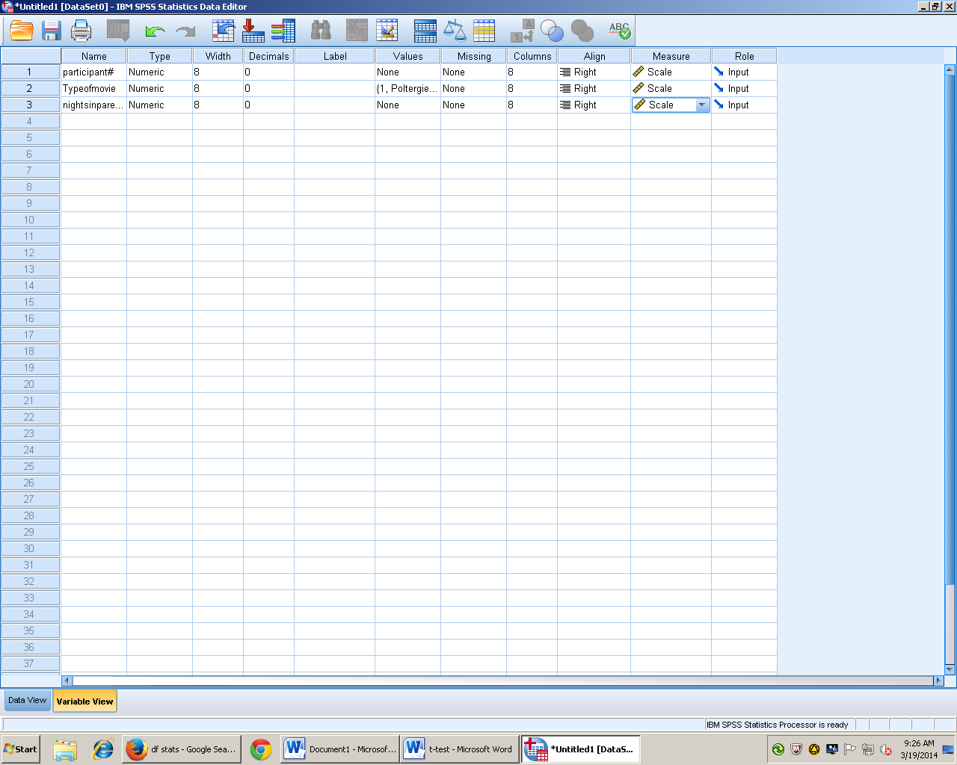
- go to data view and enter data for DV
- 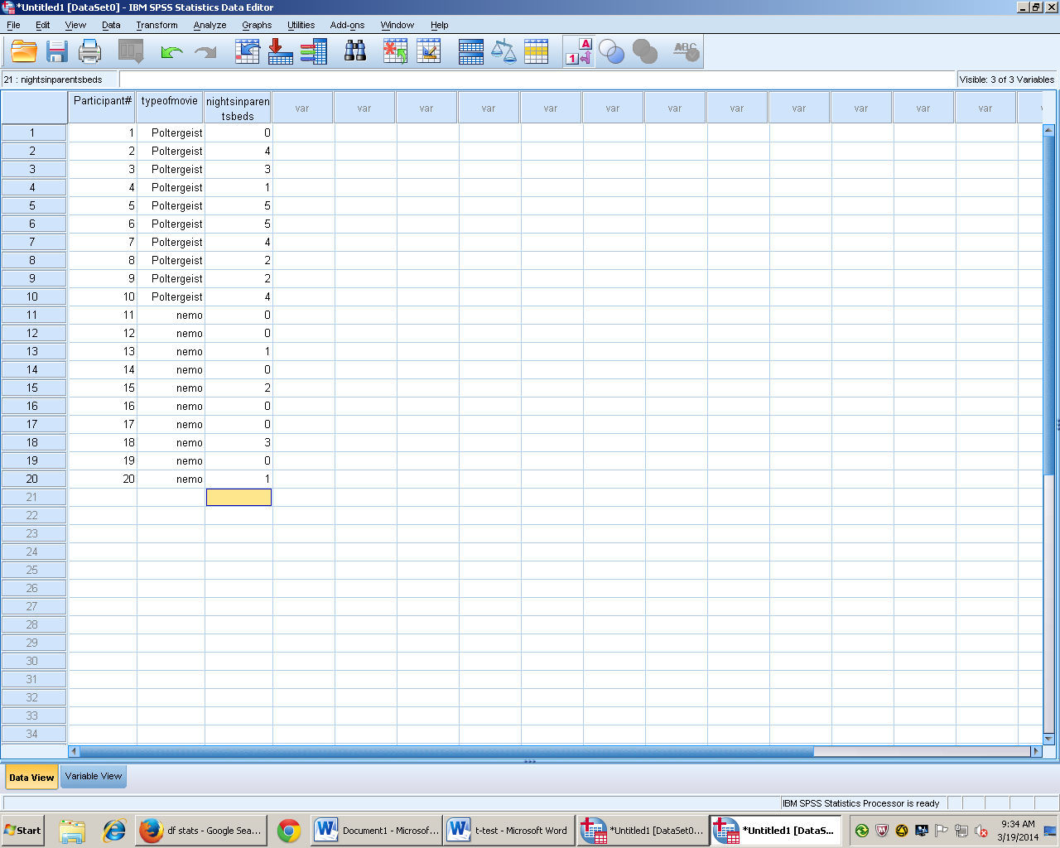
- Go to analyze and click compare means
- Choose independent samples t- test
- 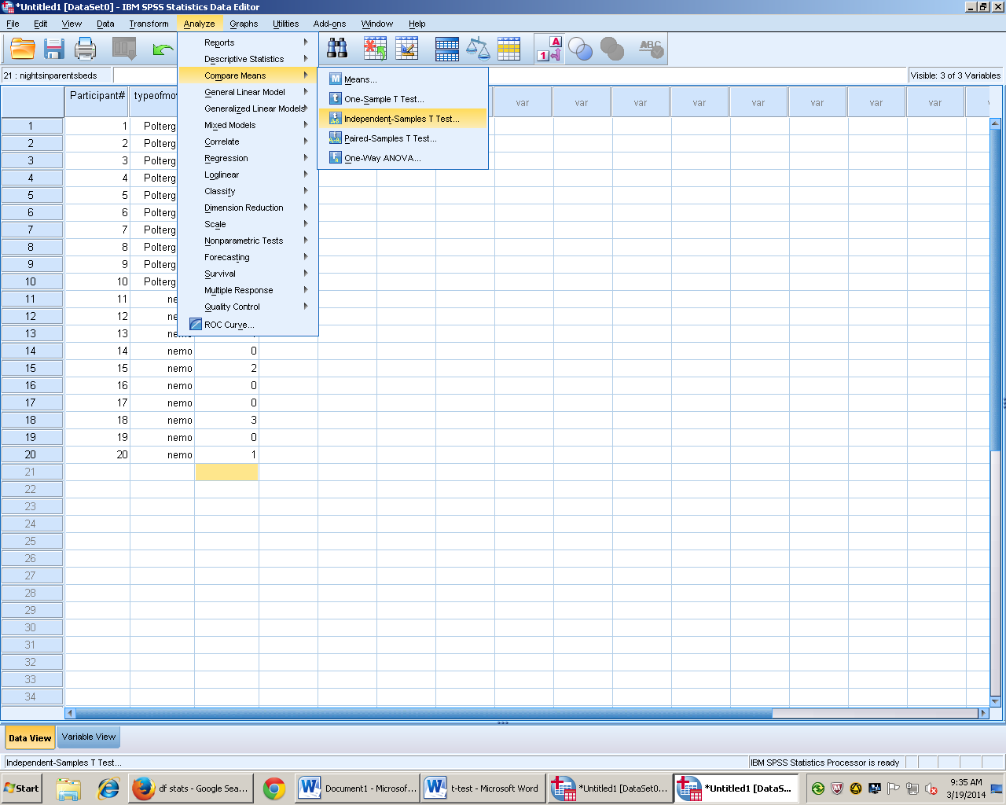
- The DV is arrowed over to the test variable
- The IV is arrowed over to Grouping variable
- 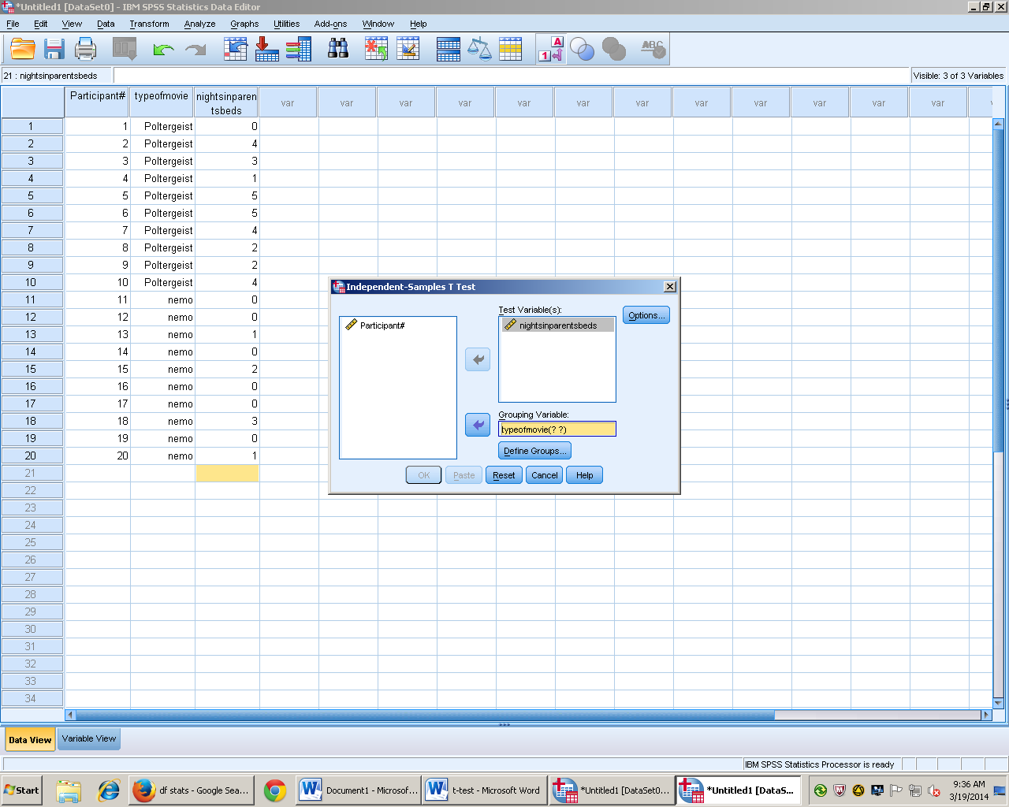
- Then enter define groups and put values from IV in the boxes
- Click continue and then ok to run test
- Makes sure to re-label output
- 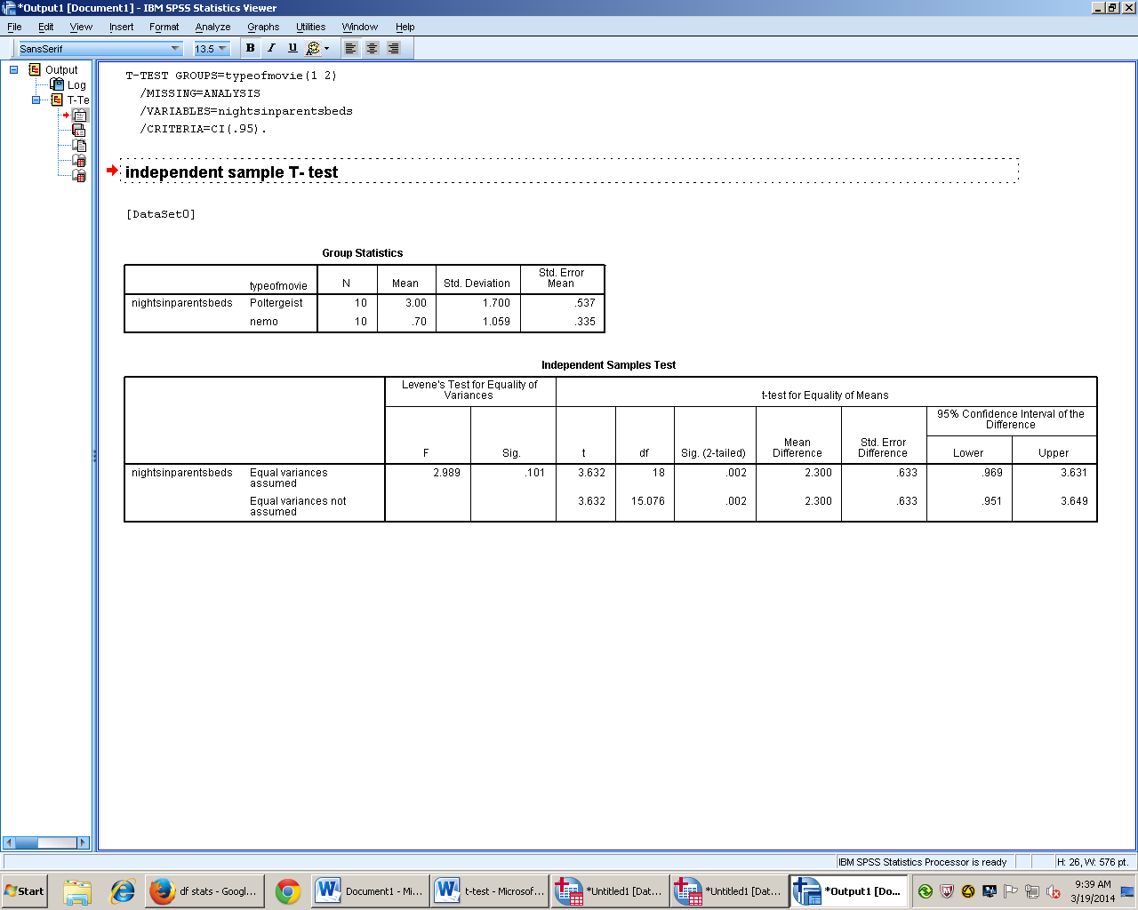

C. Results
Results
An independent t- test showed that a group of child participants that watched a scary movie spent more nights in their parents beds (M = 3.00, SD = 1.7) than a group of child participants that watched a kid friendly movie (M =.70, SD = 1.059). The two groups were significantly different from one another, t(18) = 3.362, p = .002, 95% CI[.969, 3.631].

Dependent t test
- Background
- One IV
- ≠Each group is made of the same people
- There is no population information
- H₀= X̅₁ = X̅₂
- H₁ = X̅₁ ≠ X̅₂
- df = N-1 ( sample number minus one)

B. SPSS
- Open SPSS
- Variable view
- Participant#
- Add variables in their own rows
- 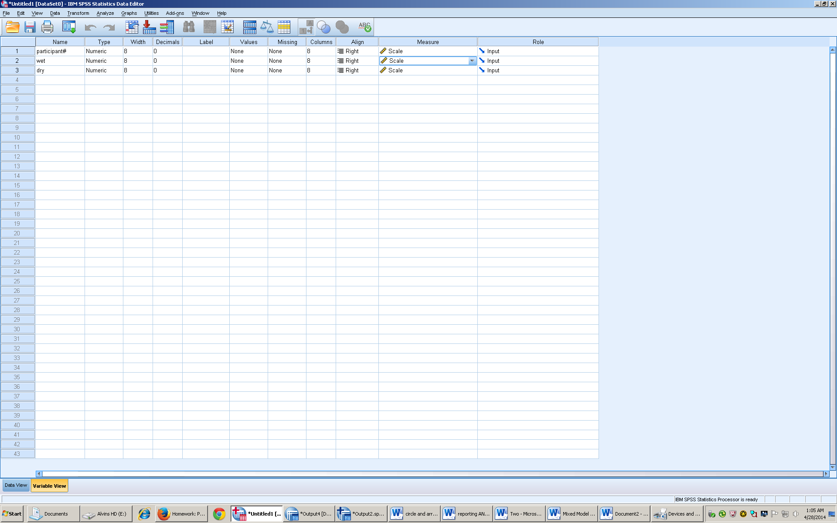
- Go to data view
- Enter data for each variable
- Go to analyze, compare means, paired samples t
- Arrow over variables that are being compared
- 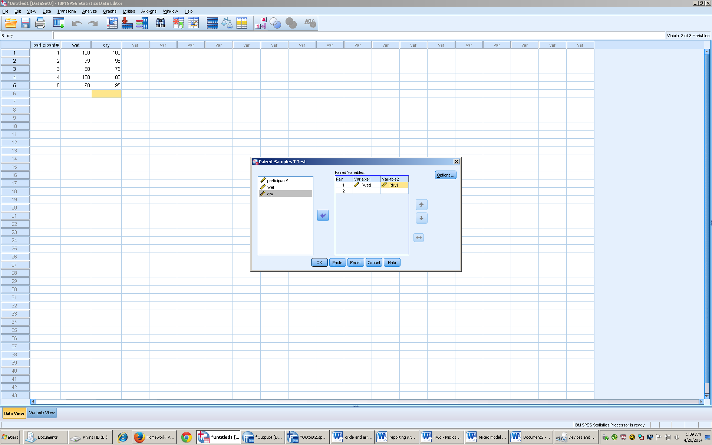
dependent t

Paired Samples Statistics
 |  | Mean | N | Std. Deviation | Std. Error Mean
Pair 1 | wet | 89.40 | 5 | 14.690 | 6.570
 | dry | 93.60 | 5 | 10.597 | 4.739

Paired Samples Test
 |  | Paired Differences |  |  |  |  | t | df | Sig. (2-tailed)
 |  | Mean | Std. Deviation | Std. Error Mean | 95% Confidence Interval of the Difference
 |  |  |  |  | Lower | Upper
Pair 1 | wet - dry | -4.200 | 12.911 | 5.774 | -20.231 | 11.831 | -.727 | 4 | .507

- Results

Results
An dependent t test showed that there was no difference in preference between wet dog food (M = 89.40, SD = 14.690) or dry dog food (M = 93.60, SD = 10.597), t(4) = .727; p = .507, 95%CI[-20.231, 11.831], Cohen’s d = .026.

One- Way Analysis of Variance
- Background

- analysis of variance
- 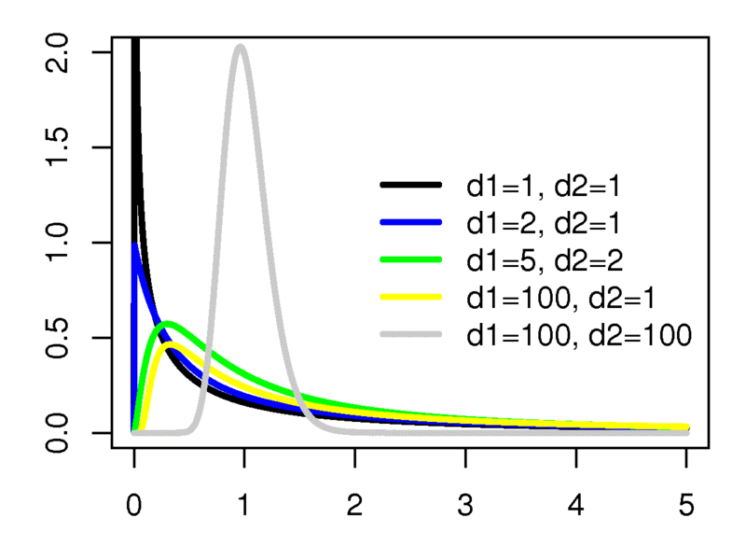

- F distribution has a positive skew and F values are always positive

- 1 IV

- 3+ Groups (levels)

- Between groups design

- Familywise error rate

  - Type 1 error
  - fw= 1 – (1 - )^{c}
- Formulate Hypothesis
  - H₀ = X₁= X₂=X₃= X₄
  - H₁
- F= variability between treatments
Variability within treatments
- ANOVA Summary Table

Source | SS | df | ms | f
between | ? | df_{bn} = k-1 | ms_{bn}= ss_{bn}  df_{bn} | ms_{bn}  ms_{wn}
Within | ? | df_{wn} = n-k | Ms_{wn}= ss_{wn}  df_{wn} | X
Total | ? | X | X | X

- SPSS

- Variable view participant number
- Create IV cell, change to scale measurement
- 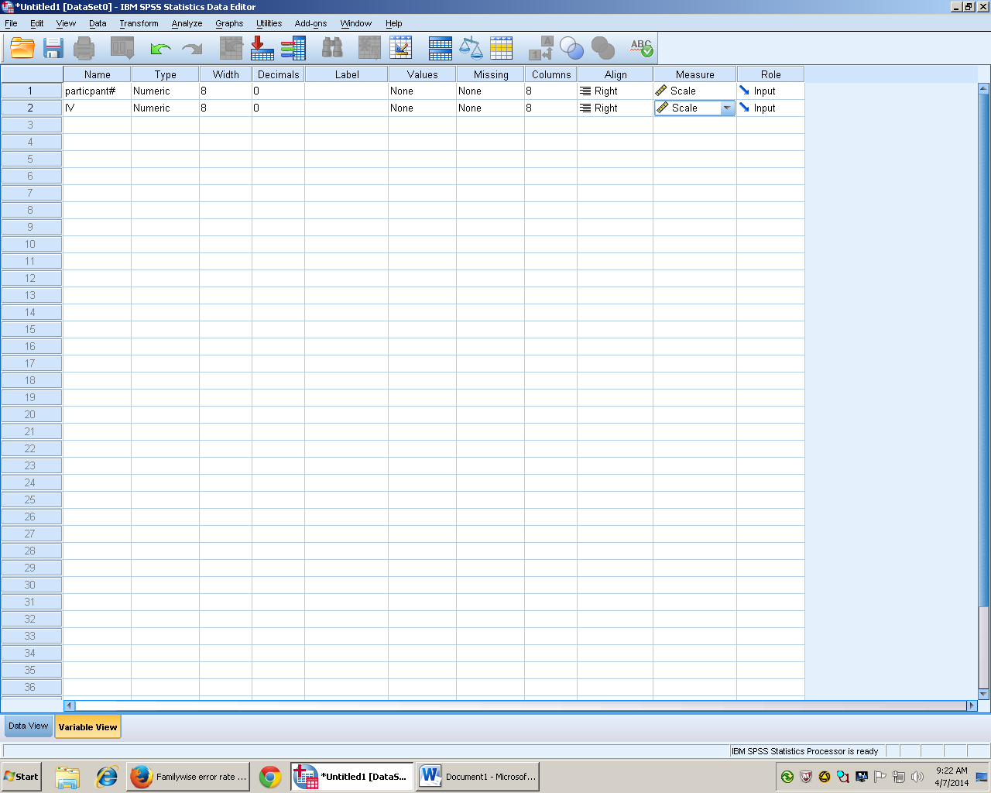
- Go to value labels and type in values
- 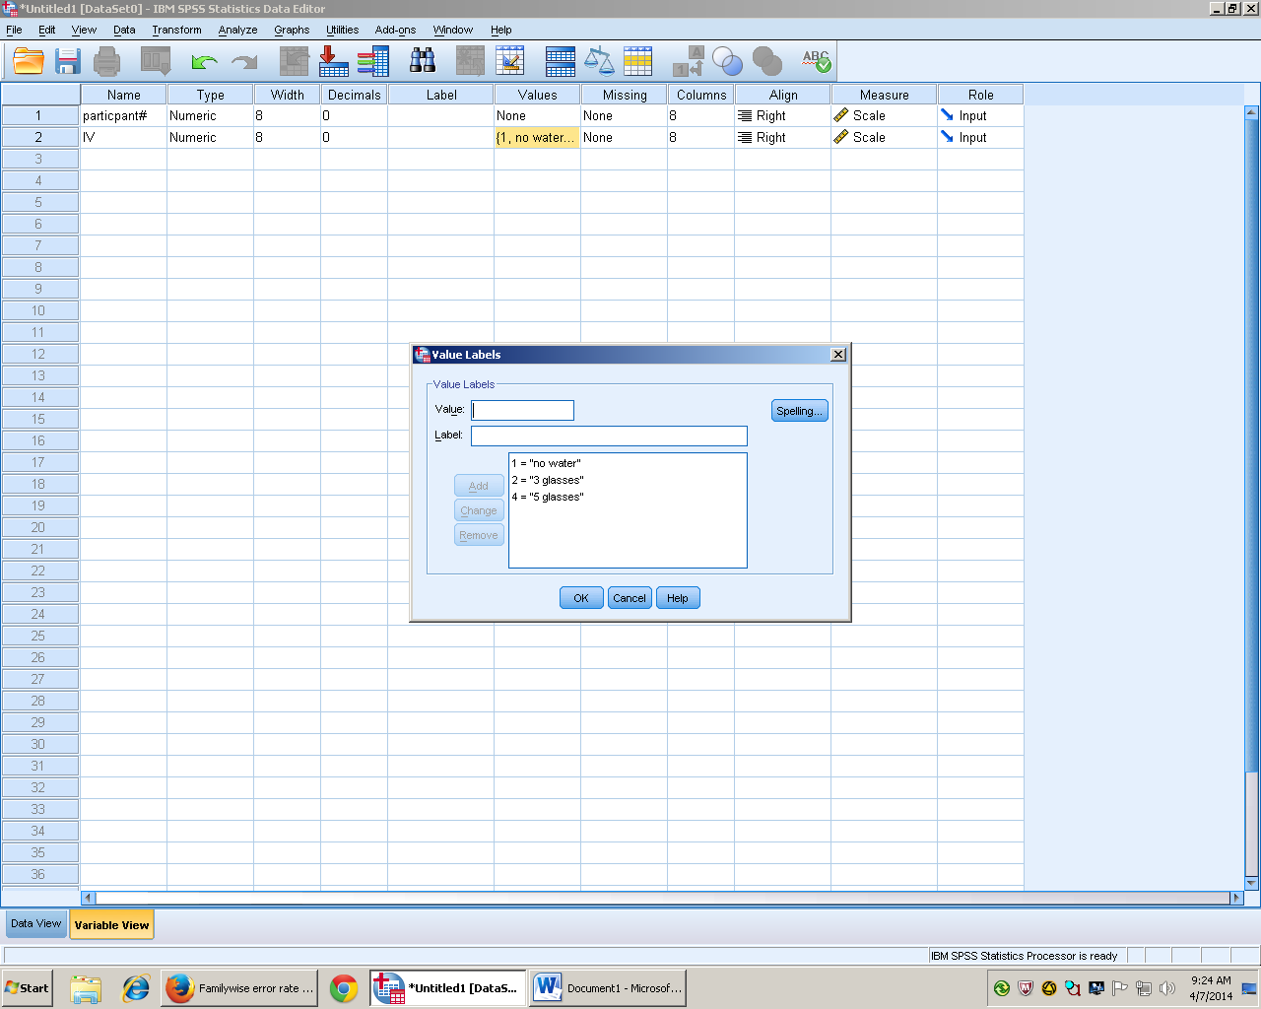
- Go to view and check variable view box
- 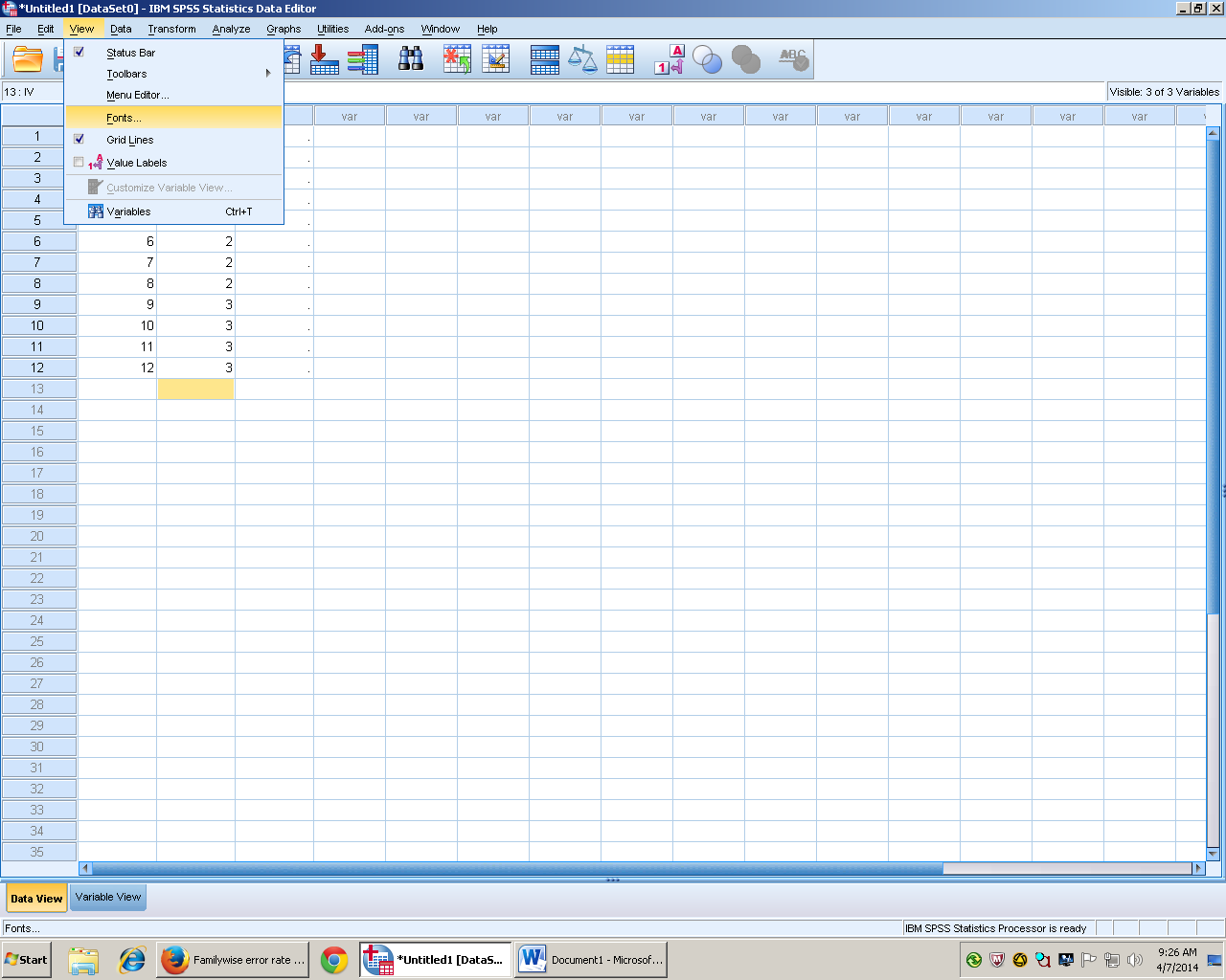
- Next dv column variable view
- Type data in data view

- Analyze, compare means, one way ANOVA
- DV in dependent list box and IV in factors box arrow over
- 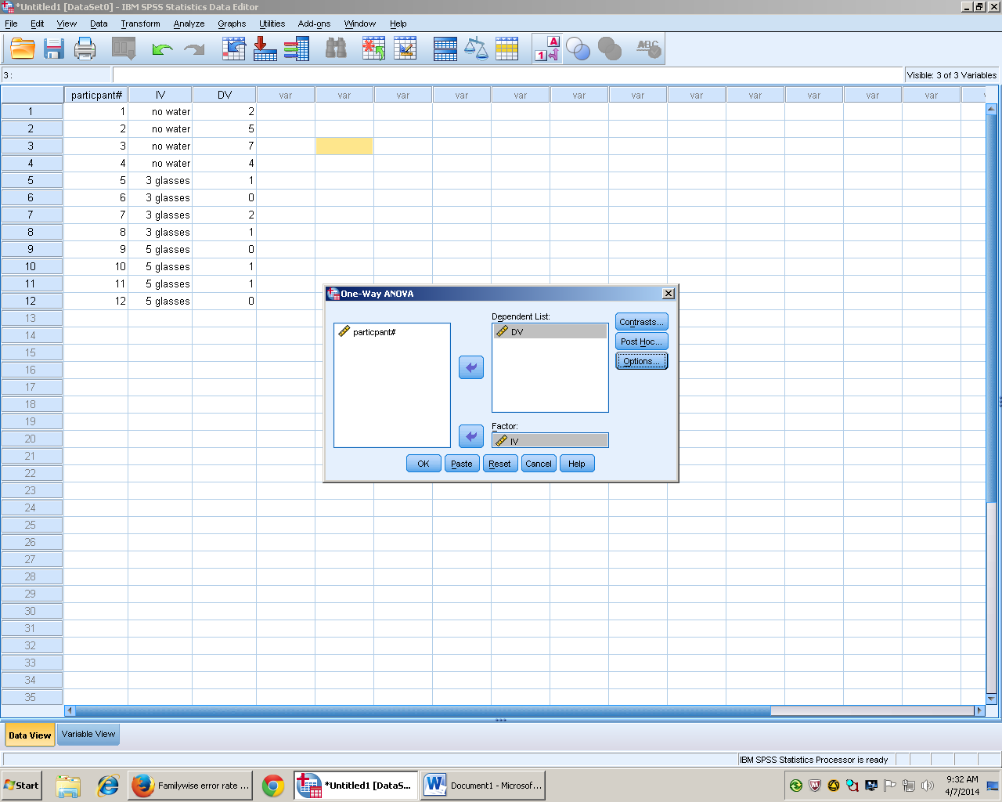
- Options check descriptive statistics
- Click ok
- Changes title
- 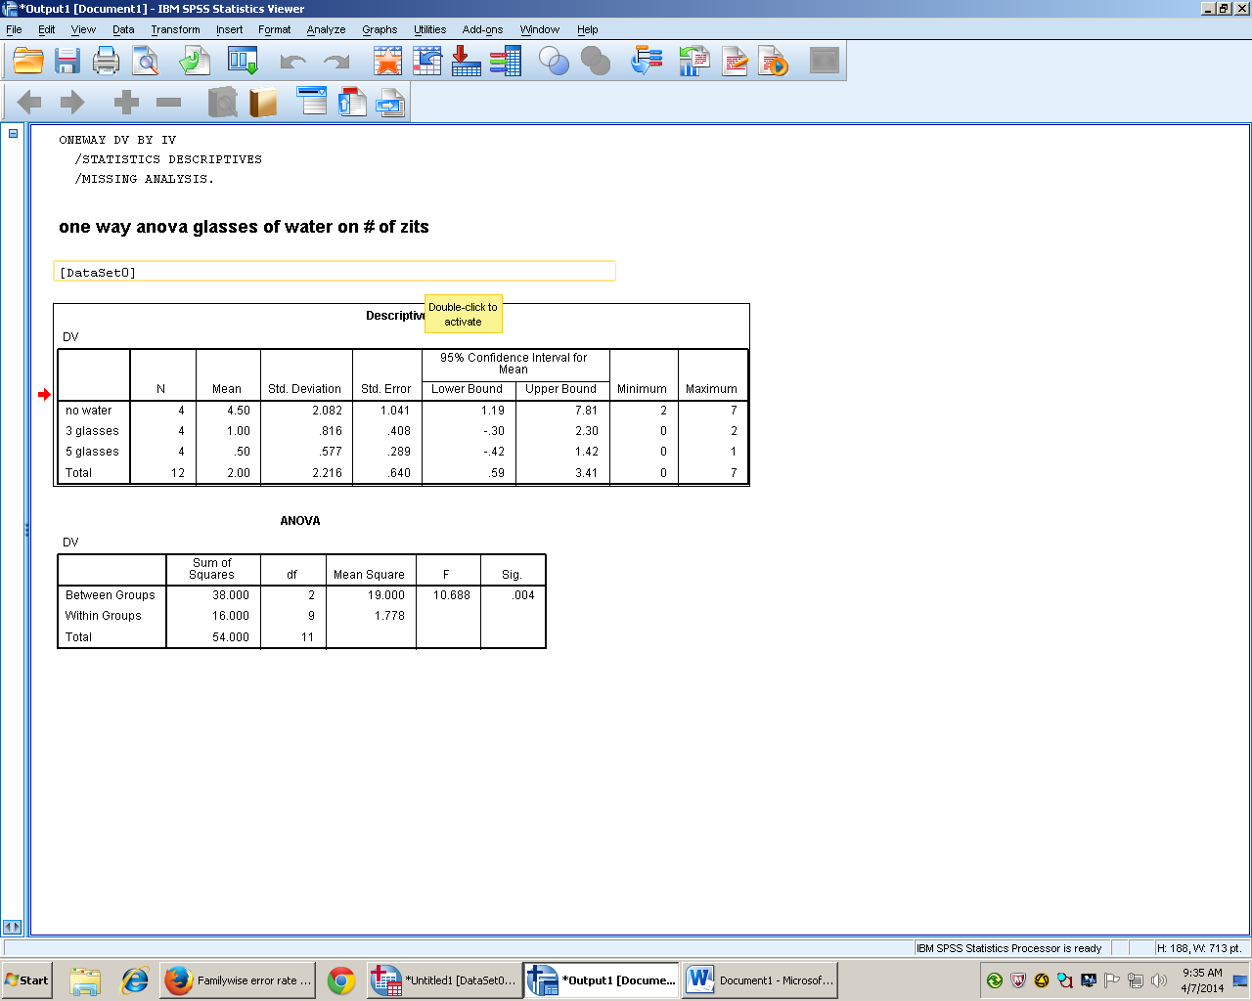
- Univariate method- creates effect size or
- Go to analyze, general linear model, univariate
- 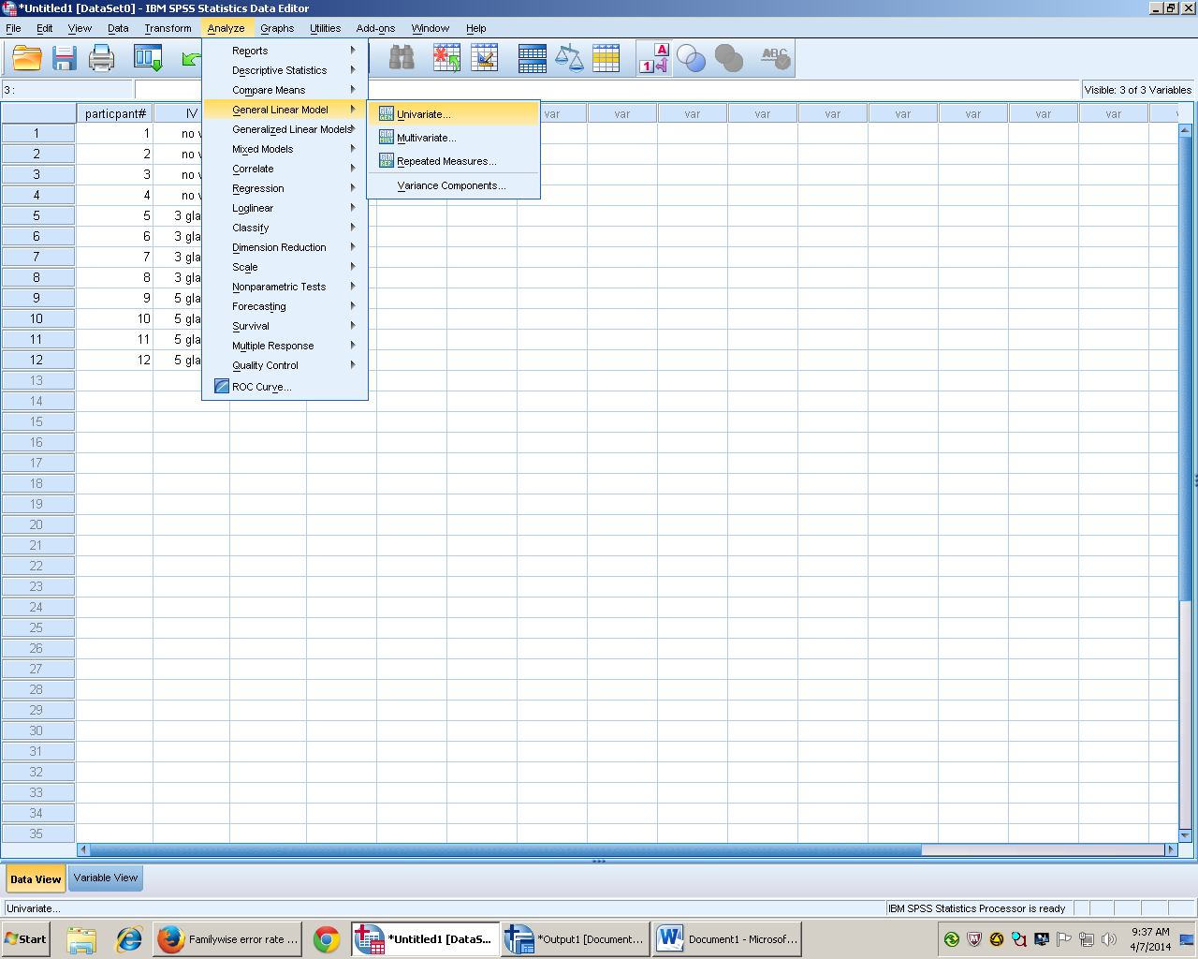
- DV arrow over to DV column and IV into IV column
- Options check descriptives, estimates of effect size, can change confidence intervals
- 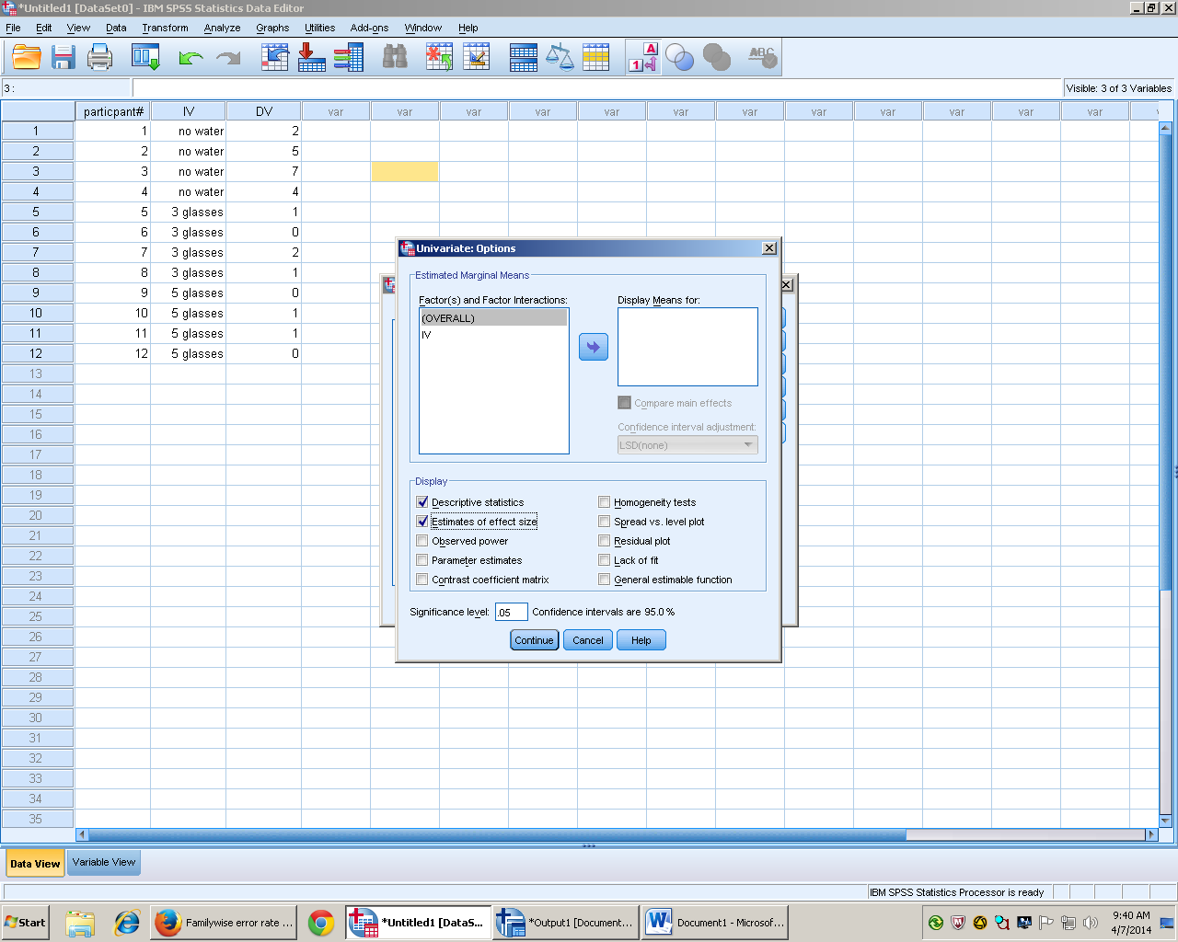
- Arrow over IV into display means for box
- 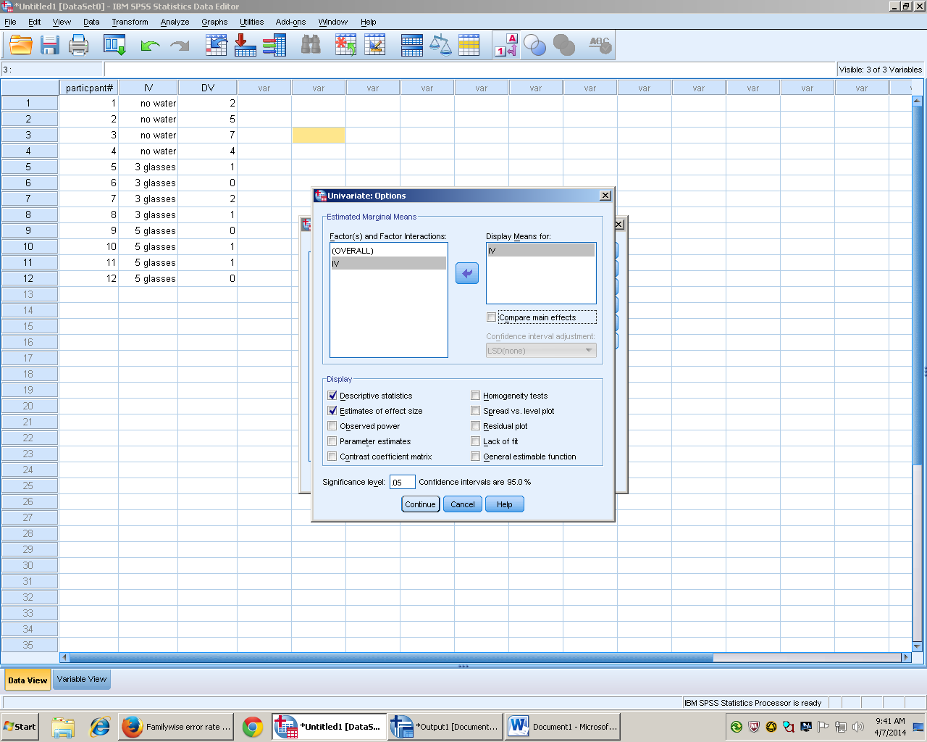
- Click continue for output
- Change title 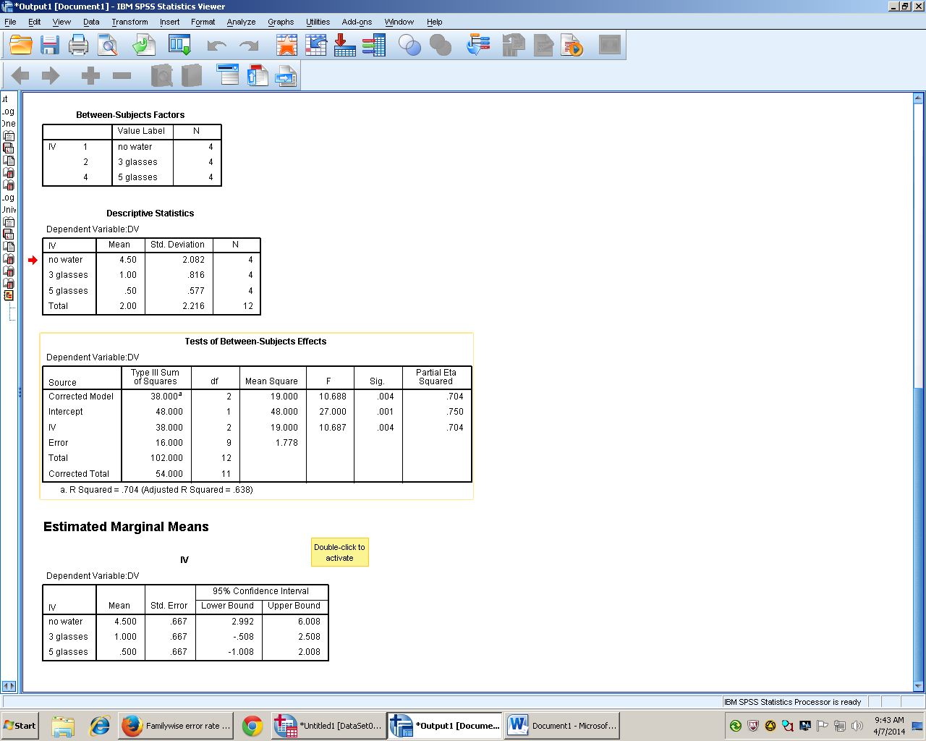
- Post HOC’s – Show which groups are significantly different
- If results are shown to be significant (sig level less than alpha)
- You can run a post Hoc in both ways of running a one way ANOVA after
- Analyze, compare means, one way anova click post hoc
- 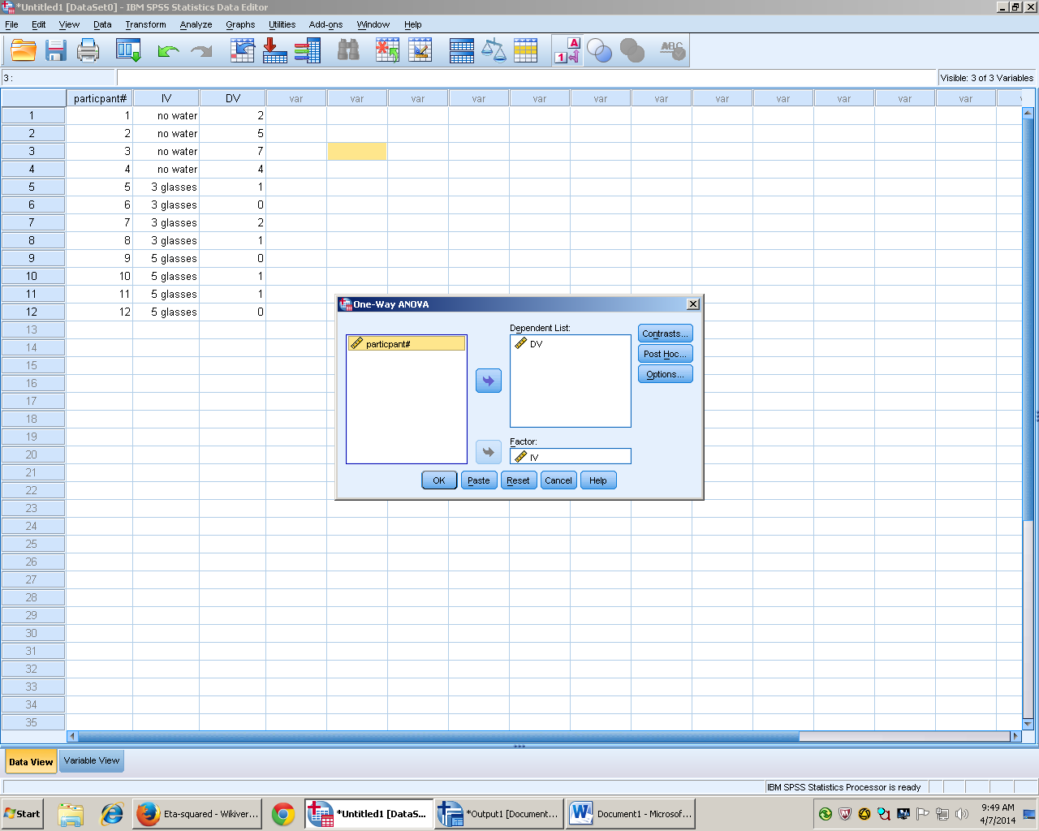
- LSD to liberal do not use, Scheffe is very conservative, choose Tukey

Multiple Comparisons
DV
Tukey HSD
(I) IV | (J) IV | Mean Difference (I-J) | Std. Error | Sig. | 95% Confidence Interval
 |  |  |  |  | Lower Bound | Upper Bound
no water | 3 glasses | 3.500* | .943 | .012 | .87 | 6.13
 | 5 glasses | 4.000* | .943 | .006 | 1.37 | 6.63
3 glasses | no water | -3.500* | .943 | .012 | -6.13 | -.87
 | 5 glasses | .500 | .943 | .859 | -2.13 | 3.13
5 glasses | no water | -4.000* | .943 | .006 | -6.63 | -1.37
 | 3 glasses | -.500 | .943 | .859 | -3.13 | 2.13
*. The mean difference is significant at the 0.05 level.

- Go to analyze, general linear model, univariate click post hoc
- Arrow over IV and click Tukey
- 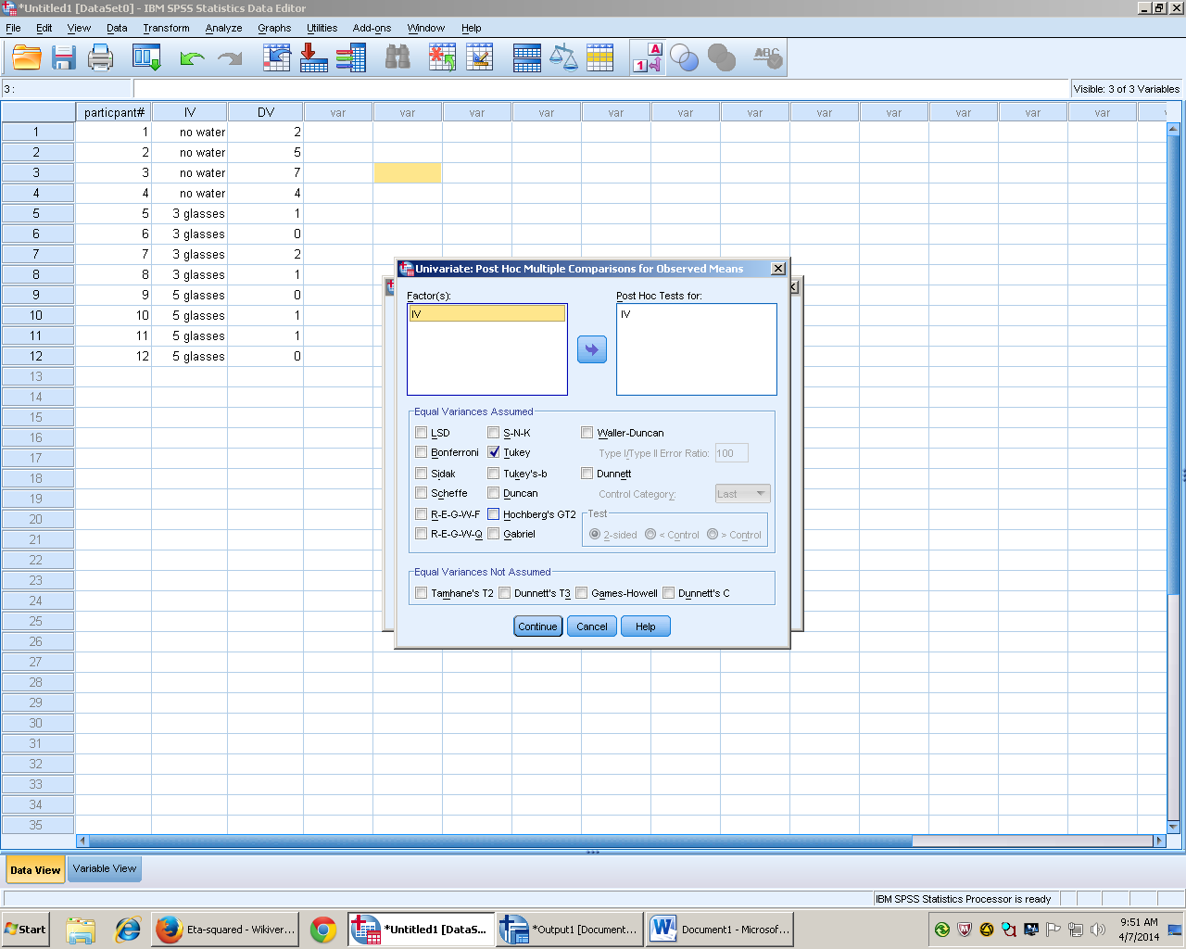
- Click continue
- Click ok for post hoc results
- Results
Results
A one- way analysis of variance showed that there is a significant difference in the number of zits on participants that drank three glasses of water (M = 1.0, SD = .816, 95% CI[-.508, 2.58]) or five glasses (M = .50, SD = .577, 95% CI[-1.008, 2.008]) and those that did not] (M = 4.5, SD = 2.08, 95% CI[2.992, 6.008]), F(2,12) = 10.688, p = .004, η² = .704. A Tukey post-hoc showed that there is a significant difference between the two groups that drank water in the 3 glasses, p = .021 and 5 glasses conditions p = .006 and the group that drank none, but not between the water groups.

