Real-Time Monitoring of the Crystal / Amorphous Transformation

in the β-Trehalose Molecular Compound

William Pagnoux¹ , Pierre Bordet¹, Pauline Martinetto¹, Aleksei Bytchkov², Jean-François Willart³, Emeline Dudognon³, and Marc Descamps³
¹ Institut NEEL, CNRS-Université Grenoble Alpes, BP166, 38042 Grenoble cedex 9 France
² Institut Laue-Langevin, 6 rue Jules Horowitz, BP 156, F-38042 Grenoble, France
³ UMET, Univ. Lille 1, F-59655 Villeneuve d’Ascq, France

A vast majority of “new” pharmaceutical compounds, in their crystalline form, are poorly soluble in water and need to be ground during the industrial fabrication process. These molecular crystals can undergo solid state transformations induced by the external stress, one of the most important being amorphization, known to generally improve bioavailability. Formulating drugs in the amorphous state is considered to be one of the most promising methods to improve dissolution properties. However, one main issue is the lack of understanding of the crystal-to-amorphous transformation mechanism.
Since now, the structural information on this transformation were obtained using ex-situ PXRD techniques. In this work, we have investigated in situ the evolution of the structure and microstructure of β-Trehalose during the milling itself. This provides a deeper insight into the amorphisation and recrystallization processes. This model molecular compound is well known to amorphize upon milling¹. We used Rietveld refinement and PDF analysis of high energy PXRD data. The former allows investigating the structure and microstructure but is limited to at least partly crystalline materials, while the latter can bring continuous information on particle size and internal arrangement whatever the crystallization state. Data were measured ex situ at the CRISTAL synchrotron beam line at SOLEIL and in situ as function of grinding time (ID15-ESRF) and temperature (ID11-ESRF). Samples were previously submitted to high energy milling for increasing times and characterized by DSC, Raman spectroscopy and laboratory PXRD. For the ID15 experiment, an oscillating milling device equipped with Perspex sample containing jars and zirconia balls was used².
Our study demonstrates that amorphization by energy milling is a 2 phase process, with immediate appearance of an amorphous fraction increasing with milling time, while the proportion and domain size of the remaining “crystalline” fraction decreases. High resolution data seem to indicate a modification of the local structure upon amorphisation, and temperature dependent data (figure) confirm a similar effect for the abrupt recrystallization occurring upon heating. The results of our investigations will be detailed during the conference.
This work is fund by the ANR project MiPhaSol ANR-12-BS08-0008
[1] J. F. Willart, et al., Solid State Communications 119 (2001) 501
[2] T. Friščić, I. Halasz, W. Jones & al., Angew. Chemie - Int. Ed. 2013, 52 (44)
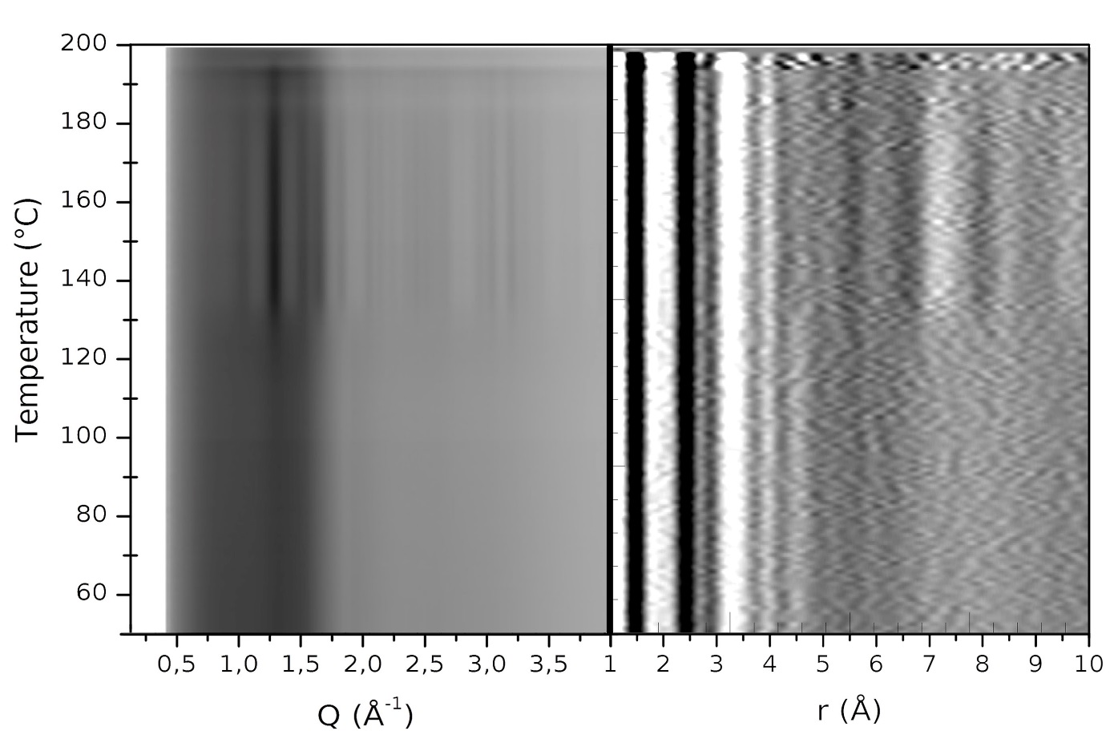
Figure: Temperature-dependent PXRD (left) and PDF (right) data of a 3h milled β-Trehalose sample, measured on heating at 3K/min on ID11-ESRF.

