Socrative may be just the interactive tool that you’ve been looking for! Socrative is a software application that allows you to ask impromptu questions and get real time feedback from your students. Socrative is a collaborative app, as well as a web tool, that lets you evaluate student understanding via their portable devices, i.e. Android tablets, Smartphones, or laptops.

Socrative is so easy to use with no expensive equipment to buy, no heavy case to carry, or software to download, just the benefit of an instant online student response system. Students do not have to buy anything and all you have to do spend a little time developing a quiz using the premade format in Socrative. Let’s give you a rundown of this exciting application!
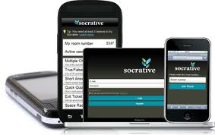
Socrative has a few ways to access it via web, smartphone, or tablet. For mobile devices, you can access via the website, or you can download their free teacher app for (Android or iOS). They have the student app for (Andriod and iOS) as well. I tested it out by visiting the Socrative teacher site on my computer and then also using the teacher app on my iPad that I downloaded from the app store for free. You can register for a free account here as well as find some useful videos to help you along.
After you have created your teacher account you can start creating quizzes. After you have created all your quizzes your students will login via web, via smart phone app, tablet app. Once a student has entered the classroom using the id number you have given them, they can participate in any of the assignments sent from you.
The activities include:
- Multiple choice
- Short answer
- True/false questions
- Quick Quiz
- Space Race
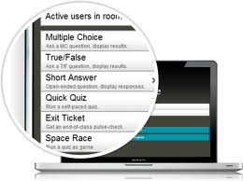
You may also add images to your questions in the classroom. The questions can be answered anonymously or with student names so that progress can be measured.
Socrative emails the Instructor with reports that include graded assignments for everything (except for short answer questions). You may also share your quizzes with other Instructors by giving your fellow Instructor the SOC# to access it. Here is a bit more on this feature. The drawback I found with Socrative is that it is limited to 50 users per activity.
As the Instructor you have access to live results and can see how your students are developing instantly. You can also create questions for students to answer during a "Space Race" where a student can answer as an individual or part of a team and try to finish the race first. I have found this to be pretty entertaining.
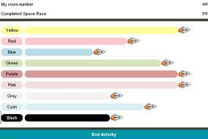
Socrative also has an "Exit Ticket" for quick end-of-class assessment of student understanding. You can send follow-up activities to measure a student’s comprehension.
In closing I am excited to see this incorporated this semester. I think that this application is a great tool for collaboration in your class. If you are interested in learning more, visit their website or for more information or contact CELT for additional training.
Want to Know More?
Socrative Video Introduction
Socrative in the Classroom
Socrative Tutorial (PDF)

