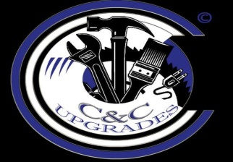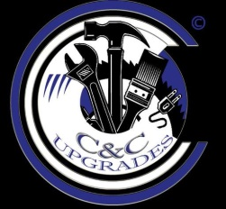
C&C Upgrades
We meet our deadline of perfection

We specialize in drywall, painting, and preservation clean-outs of foreclosed homes and so much more.
Three important things you should know about our company:
- Professionalism
- Satisfaction is guarantee
- Free Estimates on your requested job(s)

Call us today, so you can finally experience a company that cares about your professional needs.

(336) 575-6082
(336)422-8524
Email Address: C.C.Upgrades@gmail.com

C &C Upgrades other works includes:
- Cabinet & Door Hanging
- Lawn Care Owner: Christopher Witherspoon

