MyPath Builder
Five-Year Plan
- Executive Summary:

MyPath Builder is driven by the firm’s passion to grow with its clients in a lifelong partnership. An organization specializing in in-depth academic assistance and career placement does not exist. This is the need that MyPath Builder will fill. MyPath offers their clients a membership that begins with meeting with our councilors to begin to begin a long-term partnership. The first step for MyPath is to find out what a fulfilling career means to the client. The next step begins with building the clients career plan. Once a career path is chosen, a meeting with the Academic Dept. will be necessary. This sector of MyPath provides clients with a list of recommended universities that specialize in the client’s particular career. After the client has chosen a university, it’s MyPath’s job to make the academic experience as cost friendly, efficient, and beneficial as possible. This consists of assistance with financial aid forms, scholarship services, current listing of instructor ratings, book trade bank, and counseling service, assistance that exceeds that provided by a university. The next step for a MyPath member is to be hired on as an entry-level intern, part-time, or full-time worker within the clients desired industry through our vast resources. The ability to connect MyPath’s clients with work in the industry that they are studying for is a major advantage MyPath has over the competition. Upon graduation, MyPath’s role becomes that of an agent for the client, negotiating with companies to help provide the MyPath member with what was explained to the firm in the beginning as a fulfilling career. The following provides a detailed business strategy MyPath Builder has developed.

2. Company Description:
MyPath Builder is a startup firm consisting of 7 equal-share partners. Studying together at Oklahoma State University, a need was discovered. Many individuals lack an in-depth plan and committed resources that will ease and guide their growth from high school graduation through career excellence.
We are a hybrid firm combining the services of academic advisement and career placement with results that far surpass those provided by state universities and temp agencies. MyPath builder is a unique, single-source firm dedicated to partnering with its clients to assist with their career decisions, progress their academic journey based on their career path, and facilitate the placement of the individual into their desired industry. The unique approach and dedicated partnership with clients provides an experience that cannot be found at universities and traditional staffing agencies.
The strategy listed herein is a conservative outline of the startup process through the first 5 years. With first year sales projecting approximately 2 million, MyPath Builder’s revenue will grow approximately 35% within the first 5 years. MyPath Builder also plans to service individuals outside of Oklahoma after the initial 5 years by executing the same strategy.

3. Strategic Focus and Plan
The primary aspects that drive MyPath Builder’s business strategy consist of the mission, goals, competencies and competitive advantage.
Mission
To commit our passion in partnering with individuals to find and build a fulfilling career path by positioning them in the best academic realm to prepare for their industry and assisting people with employment within their desired occupation.

Goals
Within the first 5 years of operation, MyPath Builder is geared towards successfully completing their primary goals:
Nonfinancial
- Establish and grow fulfilling partnerships with thousands of students throughout the state of Oklahoma
- Establish and grow trusted relationships with businesses throughout the USA
- Build a vast textbook library to promote the trading of books for clients
- Expand comprehensive listing and ranking of professors based on client surveys
- Expand social media, high school, and college campus awareness of firm

Financial
- Obtain conservative growth in revenue of 7 percent each year
- Maintain a profit margin of 25 percent
- Position for expansion after first 5 years of operation

Core Competency and Sustainable Competitive Advantage
MyPath Builder’s hybrid approach separates the firm from competitors and reinforces our clients’ association, evaluation, and perception that our services cannot be provided by others. Being leaders in a new category, MyPath Builder is also positioned to sustain its advantage once competition is introduced through expansion of these competencies:
- College advisement based on desired career path. Schools generally place emphasize on, or are known for, particular industries; we will help match individuals with schools that best fit their career plans.
- Entry-level temp/intern positions in the clients’ desired career industry, allowing clients to get first-hand experience and determine if their chosen career suits them.
- Enrollment and Financial Aid assistance. Often times, many students applying to colleges for the first time do not understand the enrollment or financial aid process. We will have experts on hand to guide them.
- Scholarship services. College is expensive, and finding scholarships can be difficult if you are a first timer. We will match each student with a list of scholarships that is specific to their need.
- Semi-annual updates to a comprehensive listing and ranking of professors.
- Book bank for trading books. College textbooks are costly; allowing students to trade or buy discounted books saves our customers a substantial amount of money.
- Counseling for students struggling to stay on their chosen path.
- Negotiating with companies in order to maximize the employment aspects important to our customers.
- Situation Analysis
SWOT Analysis
Strengths
- Sole resource in industry
- Experienced and entrepreneurial management and board
- Specialized, unique services
- In-depth experience of career alternatives and industry preferences

Weaknesses
- Lack of product placement within competing universities
- Need more specialized employees in the field of staffing
- Lack of immediate contacts within major companies
Opportunities
- Exponential growth through satisfied partner-clients
- Expansion of contacts through growing reputation
- Establish relationships with large corporations
- Social media marketing popular amongst primary market
- Able to help clients with government finance
Threats
- People not seeking to try new staffing agency
- Pricing may not be as competitive as other companies
- Technological advancements
- Reduction in academic growth interests
These strengths allow feasible expansion of many opportunities. With knowledgeable personnel and a large market to grow, MyPath can aid in the growth of clients through many academic and occupational avenues. MyPath anticipates a solid rate in sales and growth within the first 5 years. Long-term connection with students provides opportunities for MyPath that will exceed other businesses that only provide a fraction of what MyPath offers.
MyPath’s weaknesses will be overcome easily within the first 5 years. These are matters that will be overcome through focused growth alone. The threats to MyPath are minor and will not significantly reduce the market share and will also be overcome through focused growth of the firm.

Customer and Competitive Analysis: Trends in academic advisement
Current enrollment, at the main campuses alone, of the three major universities in Oklahoma consists of approximately 53,373 students: Oklahoma University 26,068; Oklahoma State University 23,213; University of Tulsa 4,092. The company figures if it can connect with 3.5% of these students in the first year.
The staffing agency Express boasts 367,000 people hired around the nation. MyPath Builder is positioned to begin with solely staffing approximately 800 people a year.
The perceptual map depicted below reveals the separation MyPath has over its competition through its hybrid approach.

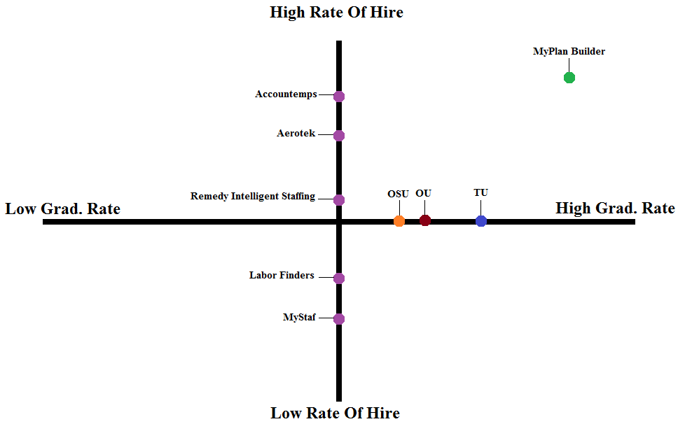

Company Analysis
The founders of MyPath Builder are Oklahoma State University students and have developed a passion for this service as they experienced a lack of this type of service. The consensus was the same: it should be easier to get help with academic advisement and career placement from the same source. The head of the team, Daniel Rainey brought 6 other classmates together and MyPath Builder was born. With each member of the team specializing in certain aspect of the business, they have accomplished their goal in establishing the firm.
The company is now the first of its kind as an academic advisement and staffing hybrid. With the ever growing need for their services the company’s potential is very attractive.
5. Market and Product Objectives

Marketing and Product Objectives
MyPath Builder’s marketing goal is to take full advantage of its potential to be a leader in the academic advisement and career placement industry. This will be accomplished with the following:
- Current Markets: Our current market will be grown by increasing consumer awareness of the products and services that we offer. We will distribute our materials to area high schools and form partnerships with local companies to offer internships or temporary positions.
- New markets and products: Long term goals include embarking on a new market, high schools students. We will offer college and scholarship planning for students starting in the 9th grade.

Target Markets
The customer groups are easily divided by age demographic. As the marketing grid depicts below, the customer groups are divided into 3 categories: high school graduate - 21, 22 - 29, and 30+. Data shows that the largest market group comes from recent graduates through the age of 21, looking to align their college plan with their career goals. The second largest service demand comes from the 30+ age group seeking to utilize our staffing opportunities. The 22-29 year old age group’s demand is consistently average across each type of service. The smallest need is from high school graduates - 21 year olds looking for staffing only and individuals 30+ looking for academic advisement only.
Market: Age Demographic | Type Of Service
 | Staffing & Advisement | Advisement Only | Staffing Only
High School Grad - 21 | L | M | S
22 - 29 | M | M | M
30 Plus | S | M | L

Points of Difference
The points of difference for MyPath Builder are what are going to make us the leader in the market. There are five very important areas that make MyPath Builder unique among our competitors:
- Our one of a kind hybrid approach gives us our greatest competitive advantage. By offering both academic advisement and career placement we aim to become one of the top three brands in our industry named among consumers.
- Offering our services at an affordable rate is the key to capturing our primary target (see below) as these people usually have very little financial resources. By offering great services at an affordable rate, we hope to maintain customer satisfaction and recommendation rates for our business.
- On top of offering our academic and career advisement services, we will also have scholarship services. These services will be built custom to each client that comes in. We will match them with scholarships that are specific to their characteristics and needs.
- The following two are very extreme points of difference; they are something that is not offered with any of the other services anywhere. MyPath is going to have a book bank for buying, renting, and trading books. Our book bank will have a rental plan to fit the need of every customer.
- Our last point of difference will be to offer counseling. Many companies offer their services and then never see or hear from their customers again but MyPath will be a part of each of our customer’s future until they have succeeded. We will offer counseling for suspension or probation from school, job counseling, and counseling for time management.

Positioning
Other companies in our market offer only either academic advising or career advisement/staffing. MyPath Builder combines these services, with this type of combination we will be positioned in consumers mind as the convenient one-stop-shop for all of their advisement needs.
- Marketing Program
Product Strategy
The hybrid approach of MyPath allows us to create a unique membership opportunity for students. Our membership is comprised of a complete Academic Advisement package. This package includes: enrollment and financial aid assistance, scholarship services, professor ranking, book sharing program, counseling, and career advisement and placement.
On top of the membership offered to students, we will also offer career placement to our secondary market seeking staffing only. We will provide them with temporary positions and internship opportunities.
Pricing Strategy
Getting the right price for services is the key to success for any company. MyPath has taken into consideration the inclusiveness of all of our services and the need for affordability to all students and has arrived at the price of $74.99 for a semester of full membership services.
Our internship placements will be no cost to students, instead we will partner with companies to provide the interns for a full semester for the price of $2,000 per intern received. This price comes from a calculation of paying for promotion of the position and pay of the position at $10/hour for 20 hours a week at 16 weeks, equating to around $3,200. At this price the companies are getting quite a steal.
Our last revenue generator will come from providing career placement for non-students. This will be done at a fee of $2 of their hourly wage for the 90 days for which they are staffed. The price that we came up with comes from a general average of what many temporary staffing agencies charge.
Promotion Strategy
Promoting our company will take a lot of hard work and a huge promotion effort by our staff. We will utilize social media to the fullest, much of our primary market utilize social media to get their information; this will be our largest effort. We will partner with high schools so that we can set up at career and college fairs. As stated previously our primary market is on the internet and or watching television much of their day so we will buy internet and television ads. Radio ads will also be utilized, although not to the extent the others are. Using the newspaper will be the best practice for getting our secondary market, many seeking employment often turn to the classifieds for opportunities. And lastly one of our cheapest forms of promotion will be word of mouth and networking.
- Financial Data and Projections
Financial data and projections were gathered and estimated based on revenue generated by providing the following services:
- Membership fees
- Charging employers for providing interns
- Temporary staffing
MyPath will earn revenue from memberships sold, internship contracts sold to employers, and a fee per hours worked by clients using the staffing services. Memberships are sold for $74.99 per semester. Internship contracts are between employers and MyPath agents and include a $2,000 fee per semester (16 weeks). Finally, revenue is earned through filling positions held by companies with MyPath clients. The charge to companies is $2/hour. Our projections are included below:
Enrollment Numbers:
Membership Cost: $74.99/semester
1st year: 1886 members (3.5% of 53,373—50% of students working at least 20 hours/week)
$141,431 first year membership revenue
Job Placement for Students: 25 hours/week, $2 off every hour from employers,
20 weeks, 45% (estimation) of 849 lower classmen members (382 looking for jobs)
$764,000 student job placement annual revenue

Internship Calculation: 1037 upper classmen, 65% looking for internships (674 members),
200 interns guaranteed, intern fee $2000 for employers,
$2000 x 100 interns= $200,000 x 2 semesters=
$400,000 first year intern placement revenue
Job Placement for Others: 200 people staffed every 90 days,
$2/hour of revenue per 40 hour work week, 12 weeks, 4 times a year
$768,000 first year staffing revenue

 | Year 1 | Year 2 | Year 3 | Year 4 | Year 5
Memberships | $141,431 | $148,480 | $158,904 | $173,227 | $193,999
Internships | $400,000 | $500,000 | $600,000 | $700,000 | $800,000
Student Job Placement | $764,000 | $802,000 | $858,354 | $935,606 | $1,047,878
30+ Job Placement | $768,000 | $768,000 | $768,000 | $768,000 | $768,000
TOTAL Revenue | $2,073,431 | $2,218,480 | $2,385,258 | $2,576,833 | $2,809,877

- Organization
All employees will be help with general duties such as advisement, staffing, and any client meetings.
- Implementation Plan
Introducing a new company into a metropolitan area will be very complex and will require a great marketing plan. MyPath will begin operations at its primary headquarters in Oklahoma City. There are several colleges and universities in and around the Oklahoma City area, this will ensure that we will have clients right out of the gate. MyPath will also open a secondary facility in Tulsa after the first year of operations. The diverse region and local colleges and communities will help our success in a smaller area.
Long term implementation plans include an expansion into the other states after the first 5 years of operation.

Appendix A. Biographical Sketches of Key Personnel
Daniel Raney – General Manager
Rachael Sourjohn – Vice President/Administration
Levi Bimba – Finance/Accounting
Nick Ristau – Finance/Contracts
Tylor Holderfield – Finance/Marketing
Daniel Ackermann – Marketing
Amy Pitts – Research and Development/Advisement
A degree in business management from Tulsa Community College, currently achieving a Bachelor’s degree in business management with a minor in marketing at Oklahoma State University. She has worked for the same company as a manager and trainer for 9 years. She has been a trainer and advisor for new employees for 7 years. With the experience of one-on-one with each new employee she has come to know how best to, place them in the most comfortable position so that they may shine.

Bibliography
(www.statisticbrain.com/eollege-enrollment-statistics, 2013) (Rita J. Kirshstein and Stven Hurlburt, 2010) (Oklahoma State University) (Oklahoma University enrollment) (US News) (Express)

http://collegestats.org/college/university-of-oklahoma-norman-campus

