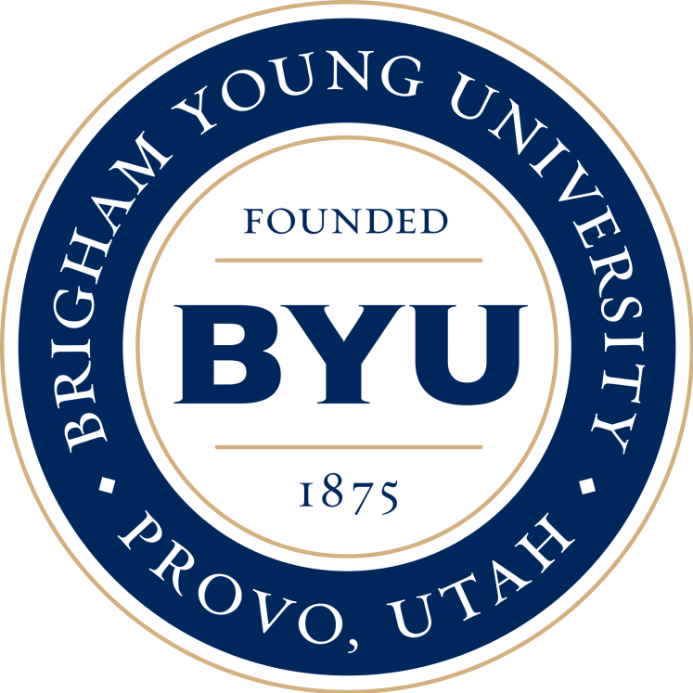
Brigham Young University
Majoring in linguistics to eventually be able to teach American Sign Language at an university level!

