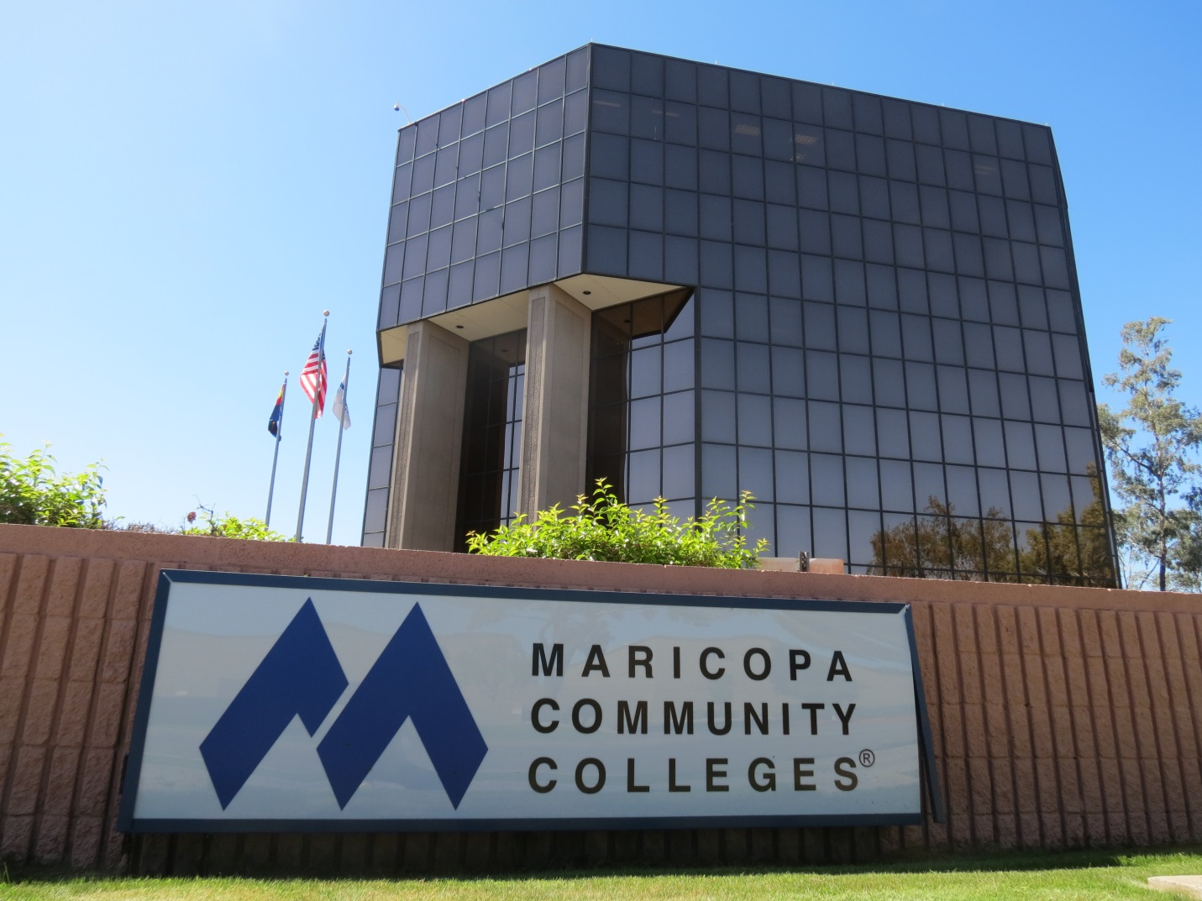
After high school I plan on going to one of the community colleges in the Maricopa County area. I achieved the President’s Scholarship and get two free years of tuition. I also want to pursue a spot on a basketball team, so that is the deciding factor of where I go. I’m still not sure what career path I want to pursue but, I’m leaning more towards marine biology/oceanography.

