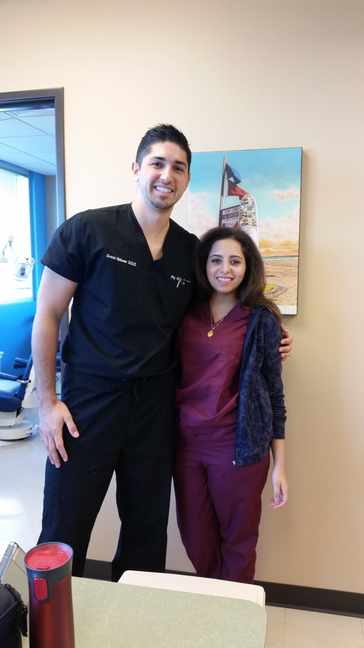
Doctor Ernie is the newest and youngest doctor in the office.
He put me into work and allowed me to shadow him and assist him.l

