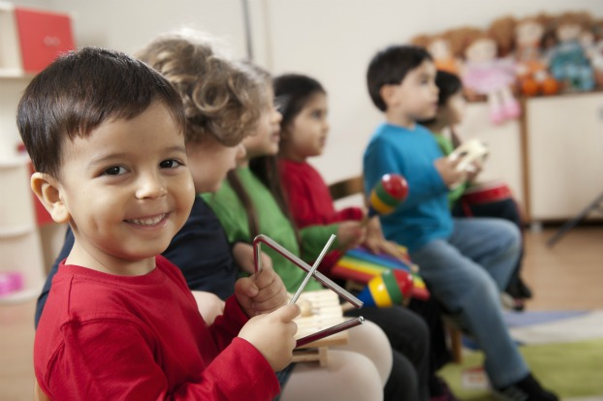
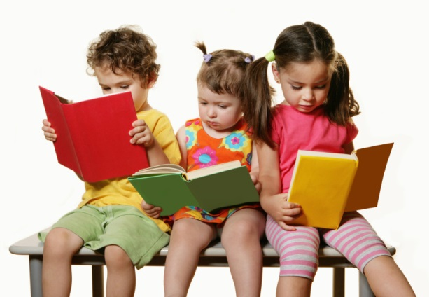
“Strive to Thrive”

A program committed to providing developmentally appropriate practices to children and families and a guaranteed leader in terms of providing quality education
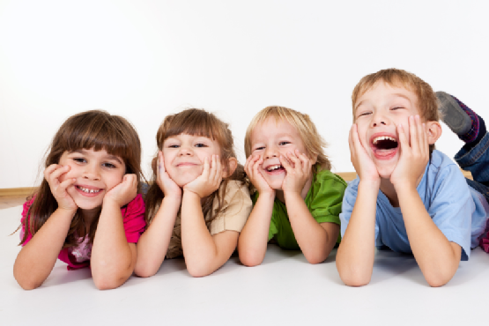

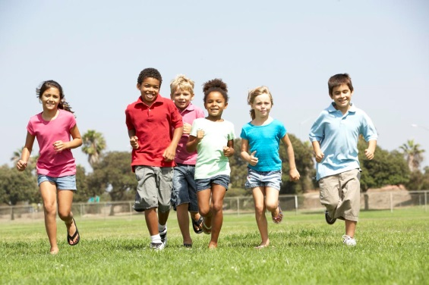
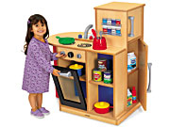
Niki Gotelli
Chld 282

1
CHLD 282 Final Project
Part 1: Program Philosophy
Every child is different and should be individually recognized for their unique characteristics. In my program, I will adjust the pedagogical manner in order to fit the needs of the individual child. Teachers will truly get to know the children in order to understand the ways in which they best learn and comprehend material. My program will be developmentally appropriate because the teachers will be working hard to understand the developmental abilities of the class and then base the curriculum off of these abilities. I believe the most effective strategy in helping most children learn is through scaffolding. Significant improvement seems to result when an instructor pushes a child just above their ability in order to help them progress and develop.
I most admire Piaget’s theory regarding mental schemas and the idea that children assimilate information into already existing knowledge. In my program, I want children to develop through exploration and manipulation of materials in order to add and integrate new information into their schemas. Teachers can simply facilitate the activity and ask the children questions in order to enhance their thinking. Based on Piaget’s theory, I think High/Scope curriculum would be especially successful in my program. I like this approach because it involves children personally manipulating and interacting with their environment. The plan-do-review involved in this approach can also be successful because it requires children to plan, engage in activities, and reflect on what they learned (Henninger, p. 67). These are important skills that they will need in order to develop independently. I want to influence children in the
2
most effective way possible so they can become sufficient in all areas of development and this type of curriculum has had a major influence on early childhood for over 40 years (Henninger, p. 66).
Children in my program will be treated equally despite ethnicity, race, and religion. They will value diversity and have the opportunity to share their culture with other students. Early educators must plan for a variety of experiences with diversity so they become a natural part of the daily activities of young children (Henniger, p. 222). If problems with diversity arise, I will make sure to address them with the children and not ignore them. I also want to work with the children’s parents, families, and the community in order to provide the children with the best possible education. Effective two-way communication, a climate of caring, and the involvement of parents and others in the educational process provide teachers, parents, and children with many benefits (Henniger, p. 7). With this personal relationship, teachers can learn more about their students and families can be knowledgeable on their child’s educational progress.
In my program, I will also emphasize the “Guides to Speech and Action” methods that we learned in this course because I think they are incredibly valuable in directing children in appropriate ways. Although I find each of them essential in early education, the guides that I think will most impact my program are “give the children the minimum of help in order that he may have the maximum chance to grow in independence, but give help when the child needs it” and “observe and take notes; increase your own awareness of what goes on” (Guides to Speech and Action). Children can enhance their cognition and gain confidence through independent problem solving. Through observation, instructors can evaluate the children’s
3
skills and build curriculum. These guidance strategies can also be effective for children with special needs. Teachers can observe these students and develop appropriate lesson plans and activities that are developmentally appropriate. With my philosophy and these values initiated, I think the children in my program will be extremely successful.

7
Part 2A: Environment Write-up
The environment for my program is designed with the objective of supporting children’s development in the most optimal way. The outdoor environment has resources available in order to fit the needs of the varying ages of children who will attend my program. In order to account for the infants and toddlers at my center, I have provided a separate area for them. I incorporated small hills and a tunnel that will allow them to practice their locomotor skills. According to Henniger, small hills, ramps, low steps, and tunnels may all be useful in facilitating physical development (p. 280). There is also an area for the teachers of these children to sit and watch them as many find the outdoor setting richly rewarding. In the outdoor environment, I have also provided a tricycle path as an option for older children to use. Tricycle paths challenge children to use their large muscles in new and interesting ways (Henniger, p. 278). There is open grass space in the outdoor environment for children to use as well. There is also a sand and water play area which can enrich the play experiences of children by incorporating a variety of digging, mixing, and pouring utensils. This allows them to manipulate objects and develop independently. For the school age children, I have provided a black top where they can play games such as hopscotch and foursquare.
The classroom is designed specifically for preschool children ages 4 to 5. In the indoor classroom, I provided a manipulative center where children can play games and interact with others to solve attractive puzzles. Throughout preschool, children show increasing interest in producing designs and patterns in art, puzzles, constructions, and letters and words (Copple & Bredekamp, p. 115). This center is available for them to work on their depth perception and
8
problem-solving skills. There is also an art center in the classroom that allows this age group to work on fine motor development. Preschoolers make progress through opportunities for open-ended activities that develop their hand muscles and find motor skills such as exploring drawing and painting, working with play dough, or constructing legos (Copple & Bredekamp, p. 117). With easels indoors and outdoors, children are able to creatively express themselves. There is a dramatic play area so children dress-up and interact with others and build their schemas regarding everyday situations. Children construct their understanding of a concept in the course of interaction with others (Copple & Bredekamp, p. 131). This area in the classroom allows children to mentally picture situations and learn a system of roles and rules.

10
Part 3: Curriculum
3A: Age Group: The age that I am planning for is preschool children ages 4-5.
3A Topic: “Who are you?!” I chose this theme because I want the children to have the opportunity to tell me about themselves. Too often, teachers go through the entire school year without really knowing each individual child on a deeper level. Knowing the individual child and having a connection with them can significantly impact their success in all domains of development. Through exploring their interests and biography, I can implement curriculum that will fit their needs and be of interest.
3C Curriculum Response Plans:
- Magazine Cut and Paste
- Activity
- Self and Social Development, Creative Arts, Physical Development, Language and Literacy
- Children are personally and socially competent.
- Measure 1: Identity of Self
Describes self and others in terms of preferences
Measure 8: Cooperative Play with Peers
Interacts with other children side by side as they play with similar materials
Measure 12: Shared Use of Space and Materials
Without adult prompting, invites others to share materials or space he or she is using
Measure 22: Emergent Writing
Makes scribble pictures of people, things, or events
Measure 40: Fine Motor Skills
Shows increasing refinement and detail in fine motor movements requiring finger strength or control
- Each child for this activity will have a piece of paper with their name on it. There will be a variety of magazines and newspapers on the table. The children will cut pictures or words that they like or that describe themselves and then paste them on their picture. This will allow the other children as well as the adults to get to know each individual’s interests and hobbies. Although their fine motor skills may not be fully developed, the children will have a large chunk of time to complete this activity and can receive help from adults if needed. During this
11
activity, children will have a lot of time to interact with their peers and learn about their classmates. These friendship skills are incredibly important and children who have an easier time making friends are more likely to be more self-regulated and to have better understanding of other’s thoughts and feelings (Copple & Bredekamp, p. 121). When completed, children will have the ability to share with their peers what they put on their paper. Without extended times of being able to interact with peers, children will not develop social competency.

- Show and tell (Brag time!)
- Family
- Language and Literacy Development, Self and Social Development
- Children are personally and socially competent.
- Measure 1: Identity of Self
Child accurately compares self to others and displays a growing awareness of own thoughts and feelings.
Measure 2: Recognition of own skills and accomplishments
Characterizes self positively in terms of generalized ability or skills.
Measure 15: Expression of self through language
Uses words that are relatively precise and makes longer sentences by connecting shorter sentences
- For this activity, children will be asked to bring something from home that describes them. This can be something they like to do, a family activity, or an item. They will then be asked to share this with the rest of the class. During the preschool years, children’s language development and their growing social understanding allow them to have conversations with their peers, chatting about interests, and adjusting their thoughts to make themselves better understood (Copple & Bredekamp, p. 122). Through sharing their interest or item, children and teachers will better be able to understand the child’s background and culture.

- Toss the Ball
- Interaction
- Self and Social Development, Language and Literacy, Physical Development
- Children are personally and socially competent.
- Measure 1: Identity of Self
Describes self and others in terms of preferences.
Shows recognition of self as individual, recognizing own name and names of familiar people.
Measure 5: Taking Turns
Uses adult structured procedures for taking turns, including rules and cues.
Demonstrates knowledge of rules and procedures for taking turns and abides by them most of the time.
Measure 15: Expression of Self Through Language
12
Produces phrases and simple sentences that communicate basic ideas and needs.
Measure 38: Gross Motor Movement
Participates in extended or integrated physical activities.
- Toss the ball involves the children to sit in a circle and the teacher to have a soft, squishy ball. The teacher will throw the ball to students around the circle and when the child catches the ball, they will share with the class their favorite ice cream flavor or another category. This is another way for the children and teacher to better know the student. This is a good activity because it encourages physical development and can be completed in an indoor environment or an outdoor environment. Preschoolers react joyfully to opportunities for creative movement, physical dramatic play, or being outdoors where they can move without constraint (Copple & Bredekamp, p. 113). They are able to identify themselves and their preferences. Long before preschool, children recognize themselves and they become self-aware (Copple & Bredekamp, p. 122).

- Emotion Chart
- Routine
- Physical and Health Development, Language and Literacy Development, Self and Social Development
- Children are safe and healthy.
- Measure 1: Identity of Self
Child accurately compares self to others and displays a growing awareness of own thoughts and feelings.
Measure 3: Expressions of Empathy
Shows awareness when others are unhappy or upset.
Accurately labels others’ feelings and may offer assistance
Measure 13: Comprehension of Meaning
Shows understanding of the meaning of simple words, phrases, stories, and songs.
Measure 14: Following increasingly complex instructions
Shows understanding of one- and two- step instructions and requests about familiar routines
Measure 29: Memory and Knowledge
Remembers a few key features of familiar objects and routines
Measure 40: Fine Motor Skills
Uses fingers to manipulate smaller objects or objects requiring precise hand-eye coordination.
- The emotion chart is a routine that each child will do when they enter my program. I will have a chart on the wall with each child’s name and each day the child is to choose their emotion (happy, sad, angry, ect.) and velcro it next to their name. This will allow the teachers to understand how the child is feeling and why. If a child is angry when entering the program and we determine the
13
cause, we may be able to help and increase their overall health. According to Copple and Bredekamp, many researchers believe that preschooler’s positive and negative emotions serve important functions, motivating every aspect of their development and learning (p. 123). Children gain greater understanding of their emotions at this age and they become better able to regulate these emotions. This chart will allow them to continue practicing this regulation.

- “A is for…”
- Environment
- Language and Literacy Development, Self and Social Development, Creative Arts, Physical Development
- Children are effective learners.
- Measure 1: Identity of Self
Describes self or others based on obvious physical characteristics.
Measure 8: Cooperative Play With Others
Interacts with children side by side as they play with similar materials
Measure 12: Shared Use of Space and Materials
With adult prompting, shares with another child material or space he or she is using or wants to use
Measure 14: Following Increasingly Complex Instruction
Shows understanding of three-step instructions and requests that are part of a familiar routine
Measure 15: Expression of self through language
Produces phrases and simple sentences that communicate basic ideas and needs
Measure 20: Phonological Awareness
Engages in play with sounds in words
Measure 21: Letter and Word Knowledge
Knows most of the letters by sight and name, recognizes some familiar whole written words, and understands that letters make up words and have corresponding sounds
Measure 22: Emergent Learning
Writes own name and simple words with most letters correct
Measure 40: Fine Motor Skills
Uses fingers to manipulate smaller objects or objects requiring precise hand-eye coordination
- “A is for…” involves the children to write their name on a piece of construction paper along with a word that describes them that starts with the same letter. This can be completed with the facilitation of an adult. A picture of the child will be placed on this paper as well and will be hung in the classroom. Thinking of a word that starts with the same letter as their name will help the children develop language. Language development is necessary for later reading comprehension and success in other subject areas such as science and social studies (Copple & Bredekamp, p. 142). Adults can help support children in this
14
activity and encourage them to look through books in order to find a word. Teachers need to intentionally introduce new words that children may not encounter in everyday conversation (Copple & Bredekamp, p. 145). This activity will allow teachers to see the developmental level of each child while also allowing the child’s family to see their picture when they enter the classroom.

15
References

Copple, C., & S. Bredekamp, eds. 2009. Developmentally Appropriate Practice in Early Childhood Programs Serving Children from Birth through Age 8. 3d ed. Washington, DC: National Association for the Education of Young Child

Henniger, M., eds. 2009. Teaching Young Children. 4th ed. Upper Saddle River, NJ: Pearson Education, Inc.

