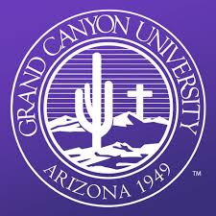
I am attending Grand Canyon University. At Grand Canyon I will start off doing my typical classes like math, science and English. I will then move on to taking all my medical classes. I will be applying and hopefully taking Grand Canyon’s nursing program. In the nursing program I will learn how to be a nurse. I will be able to work alongside a nurse at a hospital and at Grand Canyon they have simulation beds and simulation dolls that we can practice on. The beds are like real hospital beds and the dolls actually react to getting a shot, etc. I hope to be a CNA ( Certified Nurse’s Assistant) while attending college. I hope to finish college as a pediatric NP (Nurse Practitioner).

