Media Effects on Adolescents in Weight and Body Image
Cecilia Martinez
California State University, Chico

Abstract
The purpose of this study is to show how media affectsadolescents inbody image and weight. Adolescentsare constantly comparing their body image to what they see inmedia outlets such as magazines andtelevision. Adolescents get confused with dieting and exercising because of what is shown in media. Two questionnaires were given to 40 males and 60 females from the ages of seven to eighteen. Theimplication of this research concluded that media does affect the way adolescents see their body image and their weight problems.

Media Effects on Adolescents in Weight and Body Image
Adolescents are constantly worried about how they physically look. “Early adolescent girls are more likely to diet and are more likely to have a negative feeling about their bodies, while early adolescent boys are more likely to focus their concerns on muscularity and have more positive feelings about their bodies”(Ata, Laudden & Lally, 2006, p. 1025). The more adolescents are exposed to media, the more it affects them on how they think they should psychically look. This research focuses on how media and peersaffect adolescence when it comes to their own body image.It is an opinionfor children and adolescents to know that having a good body image can be achieved through eating right, but if it is not done correctly it can easily lead to eating disorders.
Media and peers have a big impact on the way adolescents see themselves, especiallywhen it comes to their body image.Media starts taking effect on how children see themselves as early as the age of 6 years. Children notice that having a thin body is important in society. Dohnt and Tiggemann(2006) conducted a research study on how magazine exposure can affect girls. The study consisted of 128 girls, ages 7 years to 15 years old. In magazines, it was reported that 35% of girls looked at magazines frequently while another 34% of girls looked at them every once in a while.The same research found that 83.6% of girls watch television most while 11.7% said that they watched music videos most. The groups of girls that were exposed more to media were more likely to engage in discussion with their peers about appearance related topics (Dohnt & Tiggermann, 2006).Girls who spoke about what they read in magazines or saw on televisions with their friends wanted to become skinner and thinner. According to Ata, Ludden and Lally, (2006) young female adolescents look at magazines and use the media as a source of information on how to improve their body image to fit the magazines. Some girls say that they want to look like the girls in the “magazines,” while others said they get inspired to diet and exercise to lose weight. Watching television and music videos alone increase girl’s awareness on how important it is to be skinny and thin as they get older.
Lask and Bryant-Waugh (as cited in Skemp-Artl & Karen M, 2006) found that adolescents knowledge about dieting wasn’t very high, which later lead to anorexia nervosa in adolescents. This wasreported to be about 1 in every 200 girls. There are also reports of anorexia occurring in children before puberty. The common age that bulimia nervosa usually starts is between 14 years to 25 yearsold (Bogliatto et al, as cited in Skemp-Artl & Karen M, 2006).The difference between dieting and not eating right are easily misinterpreted with adolescence. Dieting to adolescents is often understood as skipping meals or not eating throughout the day because they feel that skipping meals are the fastest way to lose weight and to have the ideal body they desire.
During high school, both males and females want to lose weight and look good. When it comes to girls, their goals are to lose as much body fat as they can, whereas, boy’s goals are to gain muscle and lose less fat. Girls do not want to be labeled as “fat” and boys do not want to be labeled as “skinny” because that is not what attracts the opposite sex with physical appearance. Ata, Ludden and Lally, (2006)found thatmales want to increase theirbody strength and size of their muscles because of stereotypic images of male shown by media. Males usually have a positive body imagine due to media, where girls have a negative body image due to media. Having a negative body image can lead to depression, lower self-esteem, and eating disorders. According to Skemp-Artl and Karen M (2006), dieting can include limiting the total amount of food eaten that needs to be eaten, avoiding certain types of food, and going without food for periods of time. Guys also report takingmeal supplement to help gain muscle, while some girls take diet pills to help with weight loss. Wood, Becker and Thompson, (as cited in Skemp-alt & Karen M, 2006), did a survey of 200 children between the ages of 8 years to 10 years old and revealed that 55% of girls and 35% of boys were dissatisfied with their weight.
It’s hard doing physical activities at school when peers are teasing each other based on how they look, which leads to embarrassment and uncomfortableness. According to Kirshnit, Ham, and Richards(as cited in Slater & Tiggemann, 2011), girls withdraw faster from athletic participation at earlier stages than boysdo. Getting teased during physical education lowers adolescent self-esteem on both boys and girls, making it hard for them to participate and get motivated to join any type of activity. Adolescent who sign up for a gym membership, only do certain things when their signed up for gym. For example, girls that go to the gym are more focused on cardio and losing weight and boys mainly focus on lifting weights and gaining muscle(Slater & Tiggermann, 2011).Concerns about being overweight are increasing over the years and are affecting younger children. Someadolescents try being on a “diet” that is bad and can lead to death, while others go to the gym to stay fit or to lose weight the healthier way. According to Slater and Tiggermann, adolescents who go to the gymdo it because they get embarrassed to physical education during school.Those who can’t afford to pay for a gym membership try dieting, but do not diet correctly. Even though their body image might look great to them, the way they diet harms their body.
There is a negative relationship between exposure to media and body image. Media is constantly showing that being thin is the ideal body that every girl wants and having muscles is what every boy should have. The media is constantly affecting the way adolescents think they should weigh or look, versus the way they really should weigh according to their age. More than half of adolescences are underweight thinking their overweight. Recent studies are showing that some adolescence are improving their knowledge based on exercising and dieting, although most of them do not eat correctly. It is important for adolescents to know the difference between dieting and exercising versus starving and skipping meals because that can help stop anorexia and bulimia from happening at a young age.
Method
Overview
The study of this research is to show how media affects adolescents in body image and eating disorders. This type of research is a correlational study and it is a non-experimental design because the variables are naturally occurring. The predictor variable is a ratioand the outcome variable is ordinal. Also, variable one is the media and variable two is body image.
Participants
Participants included 40 males and 60 female’sstudents ranging from ages 7 to 18 years old, from three schools in Northern California. All three schools were public and were co-ed. There is 40% Caucasian, 38% Hispanics, 10% Asians and 12% African Americans. The participants were all middle class families.
Measures
The two types of measurements that are going to be use are called Figure Rating Scale(Triggermann & Wilson Barret, 1989) and The Sociocultural Attitudes Towards Appearance Questionnaire-3(SATAQ-3) (Warren, Gleavas,Rakhkovskaya, 2013) is one of the most commonly used self-report measures of endorsement of Western appearance idealsand they are both qualitative data.
The figure rating scale is used as a tool to determine body dissatisfaction in women, menand children. The scale shows a picture of nine females and nine males, ranging from 1 is equal to very thin to 9 which is equal to very fatthen participants just have to answer two questions; which body image do you feel like more like you and which body image would you like to have. There are no revesed scores on this scale.
The Sociocultural Attitudes Towards Appearance Questionnaire has 30 fixed questionsand it’s a 5 point Likert, which rates from definitely disagree is equal to 1, mostly disagree is equal to 2, neither agree nor disagree is equal to 3, mostly agree is equal to 4, definitely agree is equal to 5. Numbers: 3, 4, 7, 8, 11, 12, 15, 16, 27 were general information. Numbers: 19, 20, 23, 24, 30 were question towards athletic people.Numbers: 2, 6, 10, 14, 18, 22, 26 were focused on pressure.Numbers: 1, 5, 9, 13, 17, 21, 25, 28, 29 were questions about media and physically attractiveness. There were reverse scores which were numbers: 3, 6, 9, 12, 13, 19, 27, and 28(Warren, Gleavas, Rakhkovskaya, 2013).
Procedures
IRB approval from California State University at Chico was obtained prior to beginning this study. The participants were recruited from three schools in Northern California, one elementary school, one middle school and one high school. Permission was obtained from the superintendent of a school district, school principals and teachers. Followed by parents’ consent will be obtained by a signed consent form since participants are under 18 years of age. Families and participants were provided with a written form about the research being studied. There was a signed consent form to be signed by parents, principals and teachers along with attached information about the study being done.To protect participant’sconfidentiality researcher will keep information in a file cabinet with a combination lock and not open it until the study is over and handed to the main person who is doing the research. There were no incentives for anyone participating in this research.

Statistical Analysis Plan
The purpose of this study is to find out how much media affect adolescence in how they see their body image and weight. The statistical analysis that would be used is the Pearson R Correlation because the variables are naturally occurring. The predictor variable would be the ratio and the outcome variable would be ordinal because this type of measurement can’t be manipulated.
The alpha sets a standard level for the researcher to identify whether or not the null hypothesis can be rejected. The p-value is compared with the alpha to determine whether the data is statistically significantly different from the null hypothesis. In this study the p=.05, shows there is a negative significant statistical relationship between exposure to media and body image.

Appendix
Table of Contents
- Demographic Questionnaire
- Figure Rating Scale
- Sociocultural Attitudes Towards Appearance Questionnaire-3 (SATAQ-3)

Demographic Questionnaire
Please select the following that applies to you.
Age:
__7 years to 10 years old
__11 years to 15 years old
__12 years to 20 years old
Gender:
__Male
__Female
Ethnicity:
__Caucasian __Hispanic or Latino
__African American __Asian American
__ Pacific Islander __other specify
Income:
__$0- $25, 000
__$25,001-40,000
__$40,001-75,000

Figure Rating Scale:
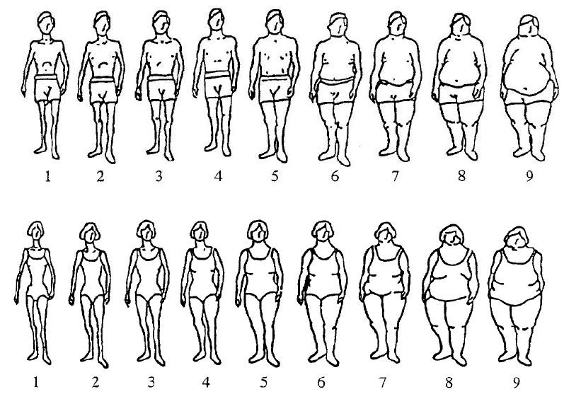
Please answer the following question.
- Which body image do you feel looks more like you?

- When body image would you like to have?

Sociocultural Attitudes Towards Appearance Questionnaire-3 (SATAQ-3)
Please read each of the following items carefully and indicate the number that best reflects your agreement with the statement.
Definitely Disagree= 1
Mostly Disagree= 2
Neither Agree
Nor Disagree= 3
Mostly Agree = 4
Definitely Agree = 5
- TV programs are an important source of information about fashion and "being attractive."______

- I've felt pressure from TV or magazines to lose weight.______

- I do not care if my body looks like the body of people who are on TV. ______

- I compare my body to the bodies of people who are on TV. ______

- TV commercials are an important source of information about fashion and "being attractive.”______

- I do not feel pressure from TV or magazines to look pretty. ___

- I would like my body to look like the models who appear in magazines.___

- I compare my appearance to the appearance of TV and movie stars. ___

- Music videos on TV are not an important source of information about fashion and "being attractive." ______

- I've felt pressure from TV and magazines to be thin. ___

- I would like my body to look like the people who are in movies. ___

- I do not compare my body to the bodies of people who appear in magazines.______

- Magazine articles are not an important source of information about fashion and "being attractive."______
- I've felt pressure from TV or magazines to have a perfect body.______

- I wish I looked like the models in music videos.______

- I compare my appearance to the appearance of people in magazines.______

- Magazine advertisements are an important source of information about fashion and "being attractive." ______
- I've felt pressure from TV or magazines to diet._____
- I do not wish to look as athletic as the people in magazines. _____
- I compare my body to that of people in "good shape."_____
- Pictures in magazines are an important source of information about fashion and "being attractive." ______

- I've felt pressure from TV or magazines to exercise._____
- I wish I looked as athletic as sports stars._____
- I compare my body to that of people who are athletic._____
- Movies are an important source of information about fashion and "being attractive."_____
- I've felt pressure from TV or magazines to change my appearance. _____

- I do not try to look like the people on TV._____
- Movie starts are not an important source of information about fashion and "being attractive."______

- Famous people are an important source of information about fashion and "being attractive."______

- I try to look like sports athletes._____

Reference
Ata R., Ludden, A., & Lally, M.(2007). The effects of gender and family, friend, and media influences on eating behaviors and body image during adolescence. Journal Youth Adolescence, 36, 1024-1037.
Bogliatto, C., Delvenne, V., & Flament, M. (1996).Early onset bulimia.Paper presented as the Seveth New York International Conference on Eating Disorders, New York.
Dohnt, A., & Tiggemann, M.(2006). Body image concerns in young girls: The role of peers and media prior to adolescence. Journal of Youth and Adolescence,35, 135-145.
Kirshnit, C.E., HamM., & Richards, M.H. (1989). The sporting like: Athletic activities during early adolescence. Journal of Youth and Adolescence, 18, 601-615.
Lak, B., & Bryant-Waugh, R. (1997). Prepubertal eating disorders. In D. M. Garner & P.E. Garfinkel (Eds). Handbook of treatment for eating disorders (2nd ed.; pp 429-437). New York: Brunner/Mazel.
Skemp-Arlt., & Karen M.(2006). Body Image dissatisfaction and eating disturbances among children and adolescents: Prevalence, risk factors, and prevention strategies. Journal of Physical Education, Recreation & Dance (JOPERD), 77, 45-51.
Slater, A., & Tiggemann, M.(2011). Gender differences in adolescent sport participation, teasing, self-objectification and body image concerns. Journal of Adolescence, 34, 455-463.
Triggermann, M., & Willson-Barret, E. (1998). Children’s figure ratings: Relationships to self-esteem and negative stereotyping. Int. J. Eat Disorder 23, 83-88.
Warren, S., Cortney., Gleaves, H., David., & Rakhkovskaya, M., Liya. (2013). Score reliability and factor similarity of the Sociocultural Attitudes Towards Appearance Questionnaire-3 (SATAQ-3) among four ethnic groups. Journal of Eating Disorders, 1:14,doi:10.1186/2050-2974-1-14.
Wood, K.C., Becker, J.A., & Thompson, J.K. (1996). Body image dissatisfaction in preadolescent children. Journal of Applied Development Psychology, 17, 85-100.

