U.S. Retail Banking Industry Analysis

A Recovering Industry
March 26, 2015
Presented by:
Alyssa Limones

The five largest U.S. financial institutions include JP Morgan Chase, Bank of America, Citigroup, Wells Fargo, and Goldman Sachs Company. These top five institutions hold retail investments of $5.633 trillion. These banks are just five financial institutions of more than 9,000 retail banks.
As more people bank online and via smartphone, banks are evaluating the future of the old-fashioned branch.
From 2006 to 2010, the number of most types of common transactions performed inside bank branches declined, from opening bank accounts to making deposits and resolving problems.
It's caused the industry to rethink the size, number and locations of bank branches and to look for more efficient, cheaper ways to conduct business. Neighborhood branches likely won't completely disappear, but they'll be smaller and have a smaller staff size. Self-service and technology are quickly becoming the name of the game.
Two of the most omnipresent trends evident in this year’s predictions were the heightened use of customer insight for the delivery of services and an enhanced customer experience, and the continued development of digital channels and associated digital services.
Changes in the industry in 2015 will be driven by increasing consumer demands combined with continued competition from outside the industry.
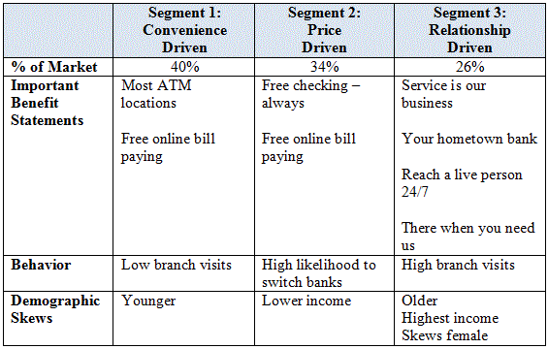
Customers switching their primary bank plus customers altogether new to banking increased at an average rate of about 3% in developed markets and 6% in developing ones over the past year.
In Texas, Frost Bank ranks highest in customer satisfaction, product offerings, account activities, fees and account information factors.
The top three U.S. banks are JP Morgan Chase, Bank of America, and Citigroup Inc.
JP Morgan Chase has assets totaling $2,520.34 billion and deposits totaling $1,319.75 billion.
Bank of America has assets totaling $2,170.56 billion and deposits totaling $1,134.33 billion.
Citigroup Inc. has assets totaling $1,909.72 billion and deposits totaling $965.73 billion.

