British music set to be celebrated by upcoming BBC awards ceremony
By Yasmin Dolman

It is recent news that the BBC are planning to launch their second musical called ‘The BBC Music Awards’, and it’s expected to be the biggest thing the BBC has arranged since Glastonbury!
Set to air on our television screens on the 11th December, the event will unite BBC One, BBC Radio 1 and BBC Radio 2 with Chris Evans and Fearne Cotton. The aim is to showcase the best of British musical talent but also get young children involved in classical music. Alongside the event, the BBC will also be showing a new documentary on twentieth century pop music.
The awards show will include live performances and awards including ‘British artist of the year’, ‘International artist of the year’ and ‘Song of the year’. The show will be annual and therefore rounding up musical success over the whole year. The BBC Music awards are to be held at Earls Court in London. Promising a "celebration of the best in popular music from the last 12 months", it is said that the new awards will be ‘like the Sports Personality of the Year awards but for music”.
The awards are expected to be extremely popular. The show is not only meant for the younger end of the market, but also the older generation as there is going to be various surprise live performances and collaborations with the help of the BBC Orchestra. The viewers and listeners can also get involved as they are the ones who will be voting on which artists are presented with an award.
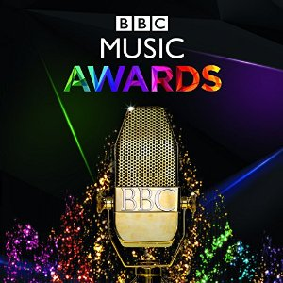
Another important aspect of the awards ceremony is to showcase new and upcoming musical talent and giving them the opportunity to perform live in front of millions. There is also the chance of some maybe collaborating with other big artists on stage.
The BBC’s music strategy also includes the introduction scheme of classical music to primary school children named Ten Pieces. There will be ten pieces of classical music screened especially for primary school children in cinemas across the UK. The schools are being invited to give children an insight and explore the work of musical composers including; Beethoven, Mozart and Britten through creative ideas such as art, dancing and their own compositions which are also expected to also be showcased in a “celebration” next year.
The whole idea is meant to be the biggest contribution and commitment the BBC has made to musical education, ever. Are you excited?

