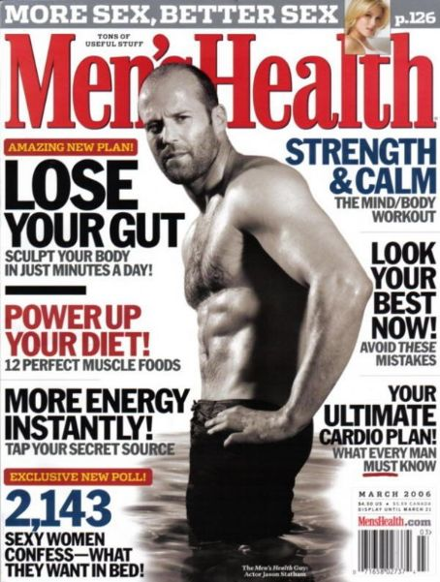
Men’s health
- “Tons of useful stuff. The men's guide to fitness, sex, women, workouts, weight loss, health, nutrition and muscle building from the world's largest men's magazine”
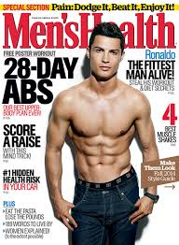
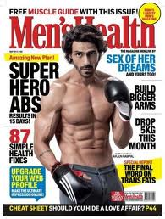
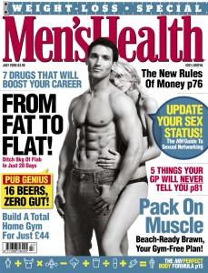
- Men’s health is a magazine aimed mainly at men between the ages of 16-40. Basically anyone who enjoys spending time at the gym, working out and taking care of their body by eating right and exercising regularly. The covers usually feature a man in more than “good shape” with his shirt off. The images are usually in black and white and the colour scheme (for the font) of mainly black and red doesn’t change. The image of the man is always place slightly on top of the title font as a type of overlay. There is always a sexual feel towards the cover showing the audience that if you look like these men on the covers, do as they tell you to within the magazine it’ll help you with women and your sexual life because that is what they want from a man. The covers sometimes feature a man and a woman, this shows you that the men on the magazines are desired by women creating a feeling of needing and wanting to be like them. This is an effective way to get buyers and readers because ultimately people enjoy looking good and therefore the male buyers admire the men on the covers. Like this cover featuring Jason Statham, sometimes buyers who may not really be interested in the magazine can be drawn towards them when they have somebody on the cover that they may know from music or film. This can make them buy the magazine. The semiotics within mens health are there to make you feel motivated and help you become a healthier person.

FADER
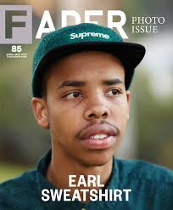
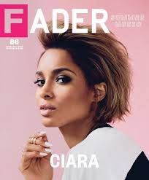
The covers chosen for FADER are always very simplistic and pure. It almost looks like an album cover. This is very appealing to the buyers because it is a music and culture magazine. FADER is known for having a singular image on the cover with minimal writing. FADER always features an artist for its cover, by having big names on the cover they let the star do the selling for them. when artists star on covers you are then appealing to their fan base who many not have been readers before, this is clever because FADER is very versatile with artists going from featuring rap artists, jazz, pop, hip hop ect. Because it ranges through the genres its audience is very wide and different. The same font is always used and always in white. The first letter of FADER “F” is always transparent with a coloured box around it. the colour then filling it is the image of the cover. The only thing that does change is the box around the “F” this is always decided through what goes best with the image I feel. The picture on the front is always a head shot rather than a full image. I think fader is aimed more at the younger generation. students, aspiring musicians, artists, photographers, and models. The minimalistic feel it carries is something that would also attract people who are into fashion, this is because the artists featured on the covers usually have a spread and story about them within the magazine, they could be somebody that you look up to and admire fashion wise.
