**Which Chocolate Is Good For You?**

*Ailin Darabi, Dominican University Dietetic Intern*

A confection produced from the fruit of the tropical tree Theobroma cacao. The fruit, known as cacao beans are fermented, dried, roasted and ground creating the product called cocoa liquor. Cocoa liquor is then separated into cocoa butter, a smooth and solid fat used in food, cosmetics and cocoa powder. Cocoa butter and cocoa powder are combined in various proportions with other ingredients to produce chocolate. Common varieties of [chocolate](http://candy.about.com/od/candybasics/a/chocguide.htm)s are [**dark chocolate**](http://candy.about.com/od/candyglossary/g/def_darkchoc.htm), [**milk chocolate**](http://candy.about.com/od/candyglossary/g/def_milkchoc.htm), and [**white chocolate**](http://candy.about.com/od/candyglossary/g/def_whitechoc.htm).

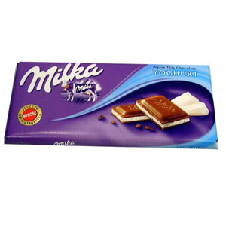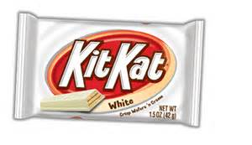

|  |  |  |
| --- | --- | --- |
| **Dark Chocolate** | **Milk Chocolate** | **White Chocolate** |
| * It contains far less milk than other kinds of chocolate, and sometimes no milk at all. * Higher percentages of cocoa solids and less sweet | * Most popular chocolate in term of commercial * It is made by adding milk, most often milk powder, to the traditional chocolate combination of cocoa solids, cocoa butter, sugar, and frequently vanilla flavoring. | * It is made with cocoa butter, sugar, milk, emulsifier, vanilla and sometimes other flavorings * It is pale yellow or ivory appearance * Emulsifiers' role in chocolate is to reduce chocolate's [viscosity](http://en.wikipedia.org/wiki/Viscosity) (the texture and way it flows) |

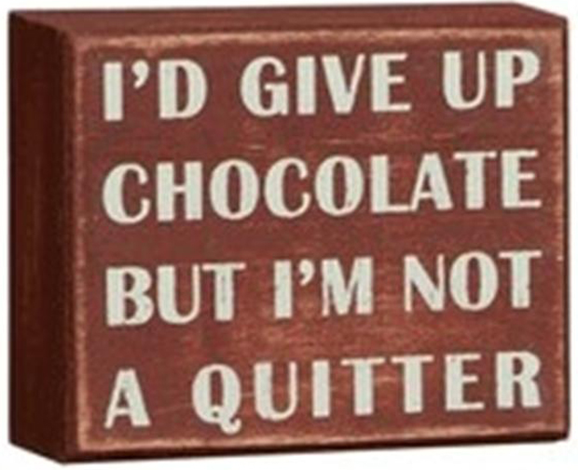 **Recommendation**

Choose dark chocolate with 65% or more cocoa content.

Limit yourself to around 3 ounces (85 grams) a day. The size is about the same as a package of dental floss

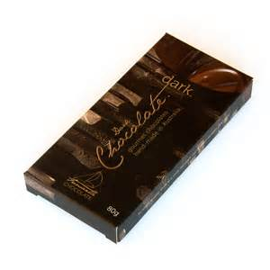**Benefits of Dark Chocolate**

|  |
| --- |
|  |

|  |
| --- |
| **High in Vitamins and Minerals:**  http://www.thevitaminmag.com/wp-content/uploads/2013/07/Vitamins-And-Mineral.jpgThe copper and potassium in dark chocolate help prevent against stroke and cardiovascular ailments. The iron in chocolate protects against iron deficiency anemia, and the magnesium in chocolate helps prevent type 2 diabetes, high blood pressure and heart disease  67% of the RDA for Iron , 58% of the RDA for Magnesium and 89% of the RDA for Copper |
| **Powerful Source of Antioxidants:**  http://2.bp.blogspot.com/-ZHvnres7zOI/Ub0371cv9fI/AAAAAAAACU0/kHRiDCPQjWk/s1600/AntiOx+Chocolate.jpgAntioxidants help free your body of free radicals, which cause oxidative damage to cells. Free radicals are implicated in the aging process and may be a cause of cancer, so eating antioxidant rich foods like dark chocolate can protect you from many types of cancer and slow the signs of aging. |
| **Dark Chocolate is Good for Your Heart:**  C:\Users\johnsc\AppData\Local\Microsoft\Windows\Temporary Internet Files\Content.IE5\X8WOC1BU\MP900384783[1].jpgEating a small amount of dark chocolate two or three times each week can help lower your blood pressure. Dark chocolate improves blood flow and may help prevent the formation of blood clots. |
| **Good for Your Brain:**  Dark chocolate increases blood flow to  http://midliferocksblog.com/wp-content/uploads/2012/11/exercise-for-brain-health.jpgThe brain |
| **C:\Users\johnsc\AppData\Local\Microsoft\Windows\Temporary Internet Files\Content.IE5\X8WOC1BU\MC900370476[1].wmf Helps Control Blood Sugar:**  The flavonoids in dark chocolate help reduce insulin resistance  by helping your cells to function normally and regain the ability  to use your body's insulin efficiently.It has a low glycemic index,  meaning it won't cause huge spikes in blood sugar levels. |

**What is your Chocolate IQ?**

1) The average American eats about this much chocolate each year?

A. 2 pounds

B. 6 pounds

**C. 12 pounds**

2) How many milk chocolate bars would you have to eat to get the caffeine in one cup of coffee?

A. 2

B. 8

**C. 14**

3) Why Chocolate is associated with love?

**A) It makes you happy**

B) Romeo gave it to Juliet

C) Its addictive

* Note:Chocolate has hundreds of chemicals, and some work on the brain. According to some research, eating chocolate stimulates your brain to make serotonin -- kind of giving you a natural high that makes you feel happy like when you are in love.

4) Which country consumes the most chocolate per person?

A) France

B) USA

**C) Switzerland**

* Note: An average Swiss will eat about 21 lbs of chocolate a year. The Swiss, however, have one of the lowest heart failure rates and obesity cases in the world plus most nobel prize winner.

5) Which has more sugar?

A) A dark chocolate bar

**B ) A glass of orange juice**

* Note: A dark chocolate bar has approximately 10-15g of sugar. A glass of orange juice has about 22g of sugar.

6) Which Chocolate is healthiest?

A. Milk

B. White

**C. Dark**