Healthy Heart Substitution
Ailin Darabi Dominican University, Dietetic Intern
Whipping up healthy recipes may be easier than you think. You can make simple ingredient substitutions to create healthy recipes that don't sacrifice taste and enjoyment. To create healthy recipes, first look at what's on hand in your own pantry. You may have healthier ingredients available and not realize it. If you don't have the ingredients on hand to create healthy recipes, just make a shopping list for the next time you hit the store. t's never too early to start eating healthier and taking care of your heart, especially if heart disease runs in your family. Many of these substitutions are so good that you’ll notice little or no difference in taste when they’re used in recipes. By substituting healthier foods, you can still keep the flavor while losing some or all of the fat.

A healthy heart diet is an eating plan designed to keep blood cholesterol low and prevent the risk of heart disease. This is usually achieved by eating foods that are low in saturated fat, total fat, cholesterol, and sodium.

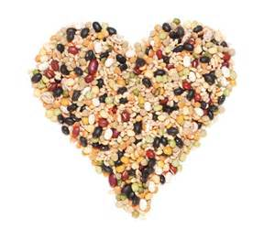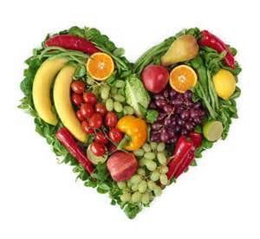

General Tips
- In general, it is a good idea to switch to healthier fats. You want to eliminate lard and shortening from cooking while using healthier oils instead like olive, canola, soybean, sunflower, sesame, peanut and cottonseed.
- Pay special attention to measurements when using substitutions. Using too much or too little of a substitution can affect the outcome of your meal.

Heart-Healthy Substitutions
Ingredient | Substitute |  | Why?
1 egg | 2 egg whites |  | cholesterol-free
1 cup of whole milk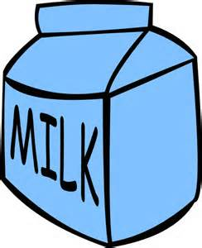 | 1 cup fat free or low fat milk |  | Less fat
1 Table spoon of butter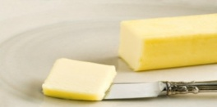 | 3/4 tablespoon liquid vegetable oil |  | Less saturate fat  Less cholesterol
1 oz unsweetened chocolate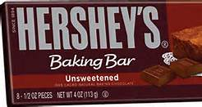 | 3 tablespoons unsweetened cocoa powder |  | Less calories  Less saturated fat
1 cup of heavy cream | 1 cup evaporated skim milk |  | Less calories  Less unhealthy saturated fat
8 ounces cream cheese | 8 ounces non-fat cottage cheese |  | Less saturated fat, less calories and less sodium
Ground bee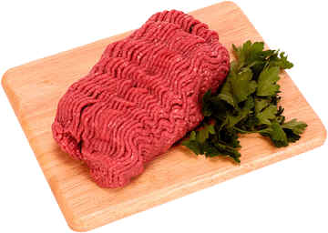 | Ground Turkey |  | Less saturated fat  Less calories
Pasta  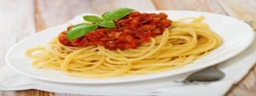 |  | Spaghetti squash | Less calories  Less carbohydrate
www.americanheartassociation.com

