THE IMPORTANCE OF COACHING EDUCATION

What are some reasons boys and girls play sports? For the fun; socialization i.e. being with their friends; exercise both their bodies and minds; and competition just to name some. What is the general trait found in all of these reasons? They are all life experiences. More often than not, the first person in which boys and girls come in contact with to teach them life skills are a coach. As Danish, Forneris, Hodge, and, Heke (2004) state, “We define life skills as those skills that enable individuals to succeed in the different environments in which they live, such as school, home and in their neighborhoods” (p.40).

Obviously life skills will be used well after athletic careers are over. So in order to prepare the youth of today for the future, coaches themselves must be prepared. NASPE, National Association for Sport and Physical Education, lists 8 domains and 40 standards to guide coaches. It can be equated to a checklist for coaches to make sure they are set to teach the skills necessary to be successful. The more a coach understands these domains and standards and implements them on a daily basis; the better inclined they will be.

Now let’s look at a brief overview of all 8 domains and highlight a few to explore more in depth.
The 8 domains of NASPE are as follows:
- Philosophy and Ethics
- Safety and Injury Prevention
- Physical Conditioning
- Growth and Development
- Teaching and Communication
- Sport Skills and Tactics
- Organization and Administration
- Evaluation
There are many roles that a coach has to take on. Let’s focus on three of them:
Domain 1: Philosophy and Ethics
Standard 1: Develop and implement an athlete-centered coaching philosophy
Athlete-centered. What exactly does this mean? In short, a coach should allow the athletes to figure out solutions on their own. Rather than telling them what to do and relying on their own experiences solely, create a big picture situation and enable the athletes to break it down, and come to a conclusion amongst them on the best way to accomplish a particular task. There are always different ways to achieve an objective. By allowing the athletes to have input in the solution, the outcome becomes meaningful to each of them and will create a point of reference in their minds next time the challenge presents itself. As Davies (2010) concluded; “player-centered learning decentralizes the control of what is learned and responsibility for how learning occurs. This responsibility shifts to both the individual players and the groups within which they interact and practice” (p. 28).
Domain 2: Safety and Injury Prevention
The two main types of stretching are static and dynamic. Both have their place in managing injury prevention if they are used at the proper time. Most coach’s stretching regiment is developed by their own personal experiences when they participated in sports. If they were brought up with bending over to touch their toes (static), then they will probably implement that same method before and after a practice. However, since most sports are centered on a quick burst here and there, it is more logical to employ dynamic stretching (full movement) since it provides a greater range of motion and a true total body warm up. Static stretching is ideal for after an activity to try and increase flexibility.
Domain 5: Teaching and Communication
Communication is the key to success. It is prevalent in everything a coach does. Coaches must understand two important aspects as it relates to communication. First, verbal communication and non-verbal communication are equally important. A coach must be able to convey ideas in an efficient, clear manner. The message needs to promote positivity and high energy. Unless these two concepts are met, a feeling of resentment and discouragement may be prevalent on a team. Second, a coach must understand that communication is a two way street and listening is more important than talking. Similar to the athlete-centered coaching philosophy mentioned earlier. Without effective communication, a team will not be successful.
Goal setting is similar to a roadmap, and used to achieve an outcome through directions. It is impossible to get from point A to point B unless you know what point B is and the steps necessary to get there. Goals should not be as Weinberg, Butt and Knight (2001) found in this comment by a basketball coach (p. 26).
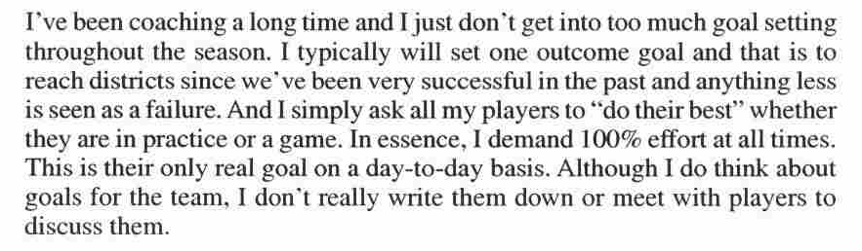
Instead, goals should be clear, specific, realistic and measurable. They should be both team and individually oriented and occur not only in games but practices as well. Also, goals need to be set with player input. Again, back to the athlete-centered philosophy. They should be established early on and regularly monitored and evaluated based on their effectiveness and altered if needed.
Practice planning goes hand in hand with goal setting and provides the means to an end. It is strongly recommended to write down your practice plans and any other significant notes that go along with them i.e. things to focus on or specifics that need improvement. This is clearly evident in Gallimore and Tharp (2004) during their research on the legendary coach John Wooden (p. 125).
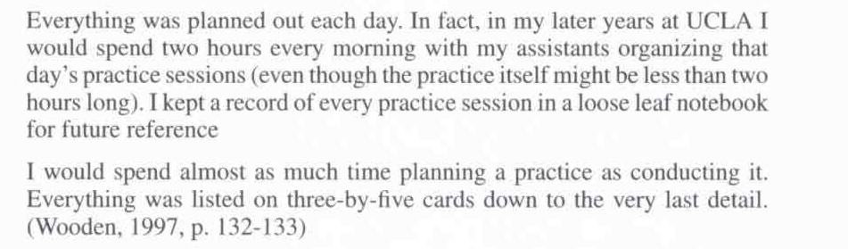
In conclusion, coaching education is extremely important, so coaches are adequately prepared to teach life skills to athletes that they will use well after the last whistle blows or the last buzzer sounds. A coach takes on many responsibilities, including teacher, planner, communicator, and in doing so has undertaken the task of shaping our youth for the future. With the amount of sports participation today, coaches may not realize the overall importance of their jobs. At times, coaching may seem like an unrewarding endeavor, but by being educated and ready for the challenge, the impact on society is immeasurable.

References
Danish, S., Forneris, T., Hodge, K., & Heke, I. (2004). Enhancing youth development through sport. World Leisure Journal, 46 (3), 38-49. doi: 10.1080/04419057.2004.9674365
Davies, N. (2010). Player-centered coaching: Enhancing player game sense. Strategies: A Journal for Physical and Sport Educators, 24 (2), 24-28. doi: 10.1080/08924562.2010.10590920
Gallimore, R. & Tharp, R. (2004). What a coach can teach a teacher, 1975-2004: Reflections and reanalysis of John Wooden’s teaching practices. Sport Psychologist, 18 (2), 119-137. Retrieved from http://www.humankinetics.com.proxy.library.ohiou.edu/
Mann, D., & Whedon, C. (2001). Functional stretching: Implementing a dynamic stretching program. Athletic Therapy Today, 6 (3), 10-13. Retrieved from http://www.humankinetics.com.proxy.library.ohiou.edu/
Margaret, G.D. & Kirubakar, S.G., & Kumutha, N. (2010). Communication skills: A cognitive-behavioural approach to enhance relationship skills in young sport coaches. British Journal of Sports Medicine, 44, 49-50.
McGladrey, B.W., & Murray, M.A., & Hannon, J.C. (2010). Developing and practicing an athlete-centered coaching philosophy. Journal of Youth Sports, 5 (2), 4-8.
National Association for Sport and Physical Education. (2006). Quality coaches quality sports: National standards for sport coaches (2nd ed.). Reston, VA: Author
Weinberg, R., Butt, J., & Knight, B. (2001). High school coaches’ perceptions of the process of goal setting. Sport Psychologist, 15 (1), 20-47. Retrieved from http://www.humankinetics.com.proxy.library.ohiou.edu/

